Title:- Effectiveness of HPV Vaccination During Adolescence in Reducing HPV Infection and HPV-Related Cancers in the UK: A Systematic Review.

Student name: Nilesh Ambalal Patil
Student ID: 2523930

Tutor Name: - Oluwadamilola Tayo

Module Name: - Practice- Based Research

Module Code:-LCHS7008
Module Name: - MSc Public Health and Social Care in Practice

Table of Contents
1. Prevalence of Problem 3
2. Introduction 3
3. Background and Literature Review 4
4. Rationale 6
5. Research Aim and Objectives 7
6. Research Question 8
7. Research Methodology 8
8. Research Design 9
9. Materials 9
10. Data Analysis Technique 10
11. Ethical Considerations 11
12. Implications of Research 11
13. Gantt Chart 12
Reference List 13

1. Prevalence of Problem
The human papillomavirus (HPV) is a significant public health problem in the UK due to its involvement in the pathogenesis of cervical cancers and other cancers caused by HPV (Sasieni and Falcaro, 2026). HPV Centre (2023) has provided an estimate of 3,791 new cases of cervical cancer and 1,121 deaths in the UK each year, with 3.2% of women infected with HPV-16/18. According to Figure 1, HPV-16 makes up 61.4% of HPV types involved in cervical cancer, while 17.6% of HPV types are attributed to HPV-18, demonstrating the importance of targeting oncogenic HPV types with the vaccine (HPV Centre, 2023). The overall burden of disease is also significant: according to Engelbrecht et al. (2023), there were 3,142 HPV-related cancer deaths and 47,911 years of life lost in the UK in 2019, along with a high cost of care. The level of coverage is still lower than needed, despite vaccination initiatives. In England, the coverage with the vaccine for the 2024-2025 period was 71.7% in Year 8 females and 67.0% in males (GOV.UK, 2026).
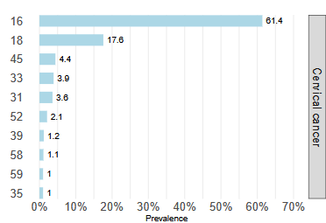
Figure 1: HPV Types Identified in Cervical Cancers in the UK
(Source: HPV Centre, 2023)
These figures reinforce the need to assess vaccination effectiveness and examine factors influencing equitable programme uptake nationally.

2. Introduction
Human Papillomavirus (HPV) is a common sexually transmitted disease and an important preventable cause of multiple cancers, especially cervical cancer. Vaccination against HPV is an important public health measure due to its ability to protect against high-risk types of HPV that are responsible for causing malignancy (NHS, 2023). Routine vaccination of HPV was introduced in the United Kingdom in 2008 for girls and in 2019 for boys, signifying increased understanding of its significance for the population (HPV Centre, 2023). However, differences in vaccine coverage and continued presence of diseases caused by HPV make continuous evaluation of the effectiveness of this program necessary (Waheed et al., 2023). Therefore, this study presents a systematic review of literature on the effectiveness of HPV vaccine in adolescents aged 12-18 years in the UK.

3. Background and Literature Review
Human papillomavirus (HPV) is a highly prevalent infection with established links to precancerous lesions and multiple malignancies (Wolf et al., 2024). Persistent high-risk HPV infection is implicated in cervical cancer and contributes to anal, penile, vulval, vaginal and oropharyngeal cancers, making HPV prevention an important public-health priority (Malik et al., 2023; Meng et al., 2025). Global figures provide insight into the scale of the problem. Zhang et al. (2025) suggest that there were 831,204 HPV-related cancer cases and 422,935 deaths in 2022, including 75.6% of cervical cancer cases. Meng et al. (2025), analysing the same GLOBOCAN 2022 database, along with other population-based databases, have produced a higher estimate of 1.5 million HPV-related cancers and 755,303 deaths. The discrepancy between these estimates is due to case attribution and disease definitions. Thus, HPV burden estimates can hardly be considered interchangeable.
It becomes clear that this disease is relevant to the adolescent age group since HPV infection occurs before cancer appears. Tomecka et al. (2025) report that HPV DNA is frequently detected in paediatric populations, with different clinical presentations depending on patient age and body location. However, most of the studies among children relate to either warts of the skin, vertical transmission of HPV, or unusual cases. Hence, such research is valuable for background information on the matter, but it does not prove the risk for the UK population at the age of 12 to 18. The importance of this fact lies in the rationale behind the adolescent vaccine.
The relationship between HPV infection and cancer is supported by persistent high-risk genotypes and cellular transformation. Malik et al. (2023) describe how high-risk HPV contributes to malignancy across several anatomical sites, while Zhang et al. (2025) identify substantial differences in cancer burden by sex, region and anatomical site. However, the evidence is dominated by adult cancer outcomes, meaning that cancer incidence cannot be used as an immediate measure of vaccination effectiveness among adolescents (Kamboj et al., 2024). Precancerous lesions and HPV infection therefore provide important intermediate outcomes when evaluating adolescent vaccination programmes.
The UK provides a particularly relevant setting for evaluation because HPV vaccination has been incorporated into a national prevention programme. Choi et al. (2023) report that the UK programme was introduced in 2008 and has been associated with reductions in HPV-related infection and cervical cancer burden. However, the review also reveals a lack of appropriate coverage and disparities in engagement in screening, with cervical cancer incidence found to be higher in disadvantaged communities (Wearn and Shepherd, 2024). Therefore, the implications of this review indicate that the success of the programme is not only dependent on the availability of the vaccine but also on its consistent and equitable uptake. As such, effectiveness at population level cannot be assumed solely from efficacy measured in controlled settings.
Moreover, evidence from other populations serves to strengthen the need for targeted prevention, although it needs to be interpreted with caution. The study by Tadese et al. (2025) demonstrates a greater burden of HPV infection and associated morbidity among people living with HIV than among people who do not have HIV. Even though the study population involves adults with HIV rather than UK adolescents, it provides some evidence for the case. In the same way, the findings by Zhang et al. (2025) and Meng et al. (2025) offer non-UK evidence. Nonetheless, their contribution to the literature is in highlighting the burden of the disease globally and not UK adolescent risk estimation. Vaccine effectiveness studies also confirm the importance of the age at which adolescents receive the vaccine (Goodman et al., 2022). According to Ellingson et al. (2023), vaccine effectiveness is greater where vaccination is initiated early and includes effectiveness of 86% for CIN3+ for girls vaccinated at 12-13 years. Markowitz et al. (2022) similarly reported effectiveness across dose schedules, but highlighted moderate or serious risk of bias across observational studies. Thus, effectiveness should be interpreted alongside age, dose and study quality rather than as a uniform outcome.
Overall, the literature demonstrates a strong epidemiological basis for HPV prevention, but important evidence gaps remain. Existing evidence differs in population, age, anatomical site, disease definition and geographical setting. UK-specific evidence is particularly important because programme delivery, vaccination coverage and healthcare inequalities may differ from other countries. Moreover, evidence describing HPV infection in adolescents does not necessarily translate into evidence of later cancer prevention. A systematic review is therefore warranted to integrate evidence on vaccination effectiveness, infection reduction, precancerous outcomes and cancer prevention while considering age, population characteristics and programme uptake (Wirtz et al., 2022). Such synthesis can determine whether current evidence consistently supports HPV vaccination as an effective UK adolescent cancer-prevention strategy for UK policy.

4. Rationale
HPV vaccination is considered an effective method of prevention against HPV infection and the associated diseases. However, the degree of effectiveness is not equal for all age groups, vaccination schedules, or outcomes. According to Ellingson et al. (2023), in their synthesis of 21 studies, the level of effectiveness of HPV vaccination decreased with an increase in the age at which vaccination occurred. This pattern is illustrated on the forest plot below, with many different estimates of effectiveness for adolescent population group aged between 12 and 17 years of age, which showed a significantly lower risk of having abnormal cells in comparison with non-vaccinated population (Figure 2). However, the highest estimate of effectiveness among those who were vaccinated between 12 and 13 years old was recorded in the Scottish study, being 86% for CIN3+ (Ellingson et al., 2023).
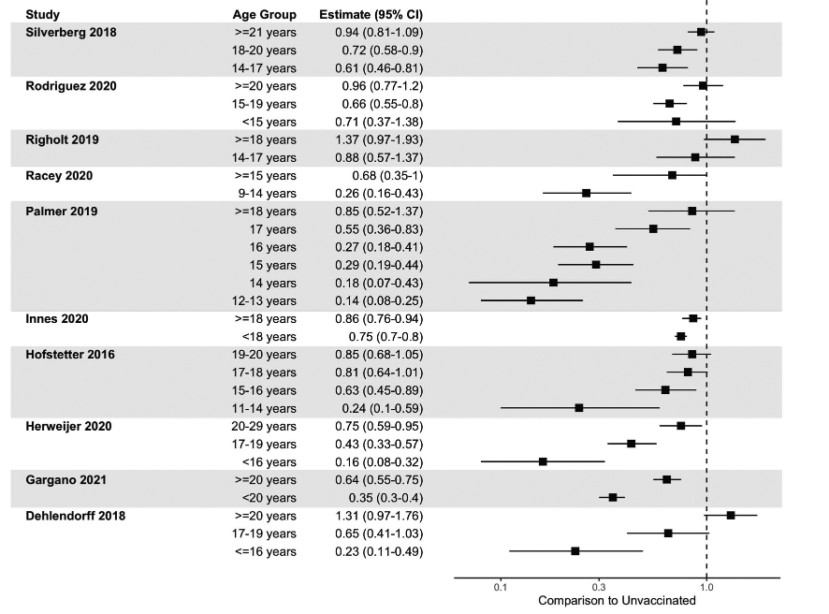
Figure 2: HPV Vaccination Effectiveness Against Cervical Abnormalities by Age
(Source: Ellingson et al., 2023)
Data showing longer-term precancerous consequences further strengthen the need for early vaccination. According to Dong et al. (2023), there is a reduced prevalence of CIN2+ in women who were vaccinated prior to age 20 with an adjusted Incidence Rate Ratio (aIRR) of 0.62, as compared to an aIRR of 1.22 in women vaccinated at age 20 or above. However, the situation in Norway restricts any generalisation to British teenagers based on these cumulative incidence graphs (Figure 3).
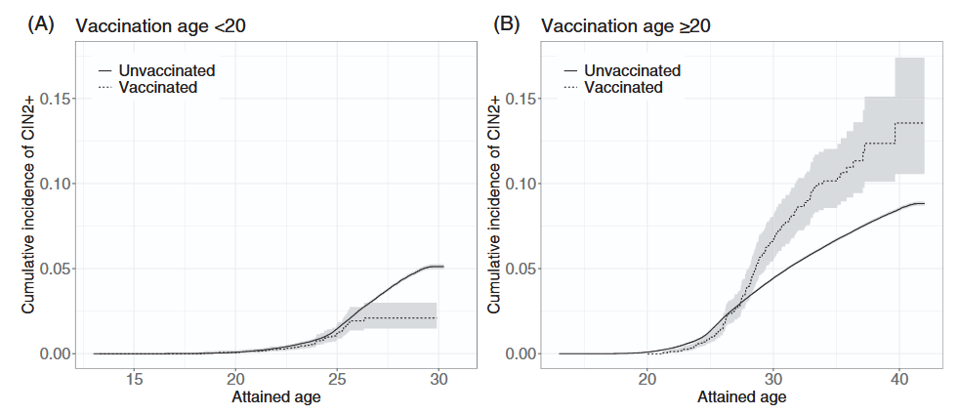
Figure 3: Incidences of CIN2+ among Vaccinated and Unvaccinated Women by Vaccination Age
(Source: Ellingson et al., 2023)
Methodological problems also support the need for a systematic synthesis. While Markowitz et al. (2022) found 35 observational studies demonstrating effectiveness in different doses, all had either moderate or high risk of bias. Hence, differences in effectiveness can be explained by some degree of confounding, time of vaccinations, and study design apart from just the vaccines themselves. On the other hand, the benefits for the UK population will also rely on their adoption. Karakusevic and Foss (2024) found consistent barriers associated with issues of consent, communication, and sociodemographic variables, while Essa-Hadad et al. (2024) pointed to health system barriers impacting disadvantaged groups. Thus, an updated systematic review for the UK is needed to synthesise the evidence.

5. Research Aim and Objectives
This research aims to systematically review and evaluate the effectiveness of HPV vaccination in reducing HPV infection and HPV-related disease outcomes among adolescents and young people in the United Kingdom.
The objectives of this study are mentioned below.
- To evaluate the effectiveness of HPV vaccination in reducing HPV infection rates among adolescents and young people in the UK.
- To examine the impact of HPV vaccination on HPV-related precancerous lesions/cancer and early indicators of cancer prevention.
- To identify factors influencing HPV vaccine uptake among adolescents in the UK, including barriers and facilitators affecting vaccination coverage.
- To synthesise current evidence and provide recommendations for improving HPV vaccination programmes and strengthening HPV-related cancer prevention strategies in the UK.

6. Research Question

What is the effectiveness of HPV vaccination administered during adolescence in reducing HPV infection and HPV-related cancers in the UK compared with no HPV vaccination?

7. Research Methodology

This study will use secondary research to conduct a systematic review of evidence on the effectiveness of HPV vaccination administered during adolescence in the UK. Page et al. (2021) describe systematic reviews as an appropriate approach for addressing research questions through structured identification, selection and synthesis of relevant evidence. The review will follow PRISMA 2020 principles, including identification, screening, eligibility, appraisal and synthesis of studies. No primary data will be collected and no participants will be directly recruited. Page et al. (2021) also highlight that systematic reviews allow evidence from different studies to be examined alongside the limitations of primary research. Similarly, Mishra and Mishra (2023) emphasise their value in supporting systematic searching, reproducibility and evidence synthesis. Therefore, this approach is appropriate for critically bringing together the available evidence on HPV vaccination in the UK.

8. Research Design

The research will use a systematic review design to identify, assess and synthesise existing evidence on HPV vaccination administered during adolescence in the United Kingdom. According to Shaheen et al. (2023), systematic reviews require clearly defined methods for searching, selecting and analysing evidence to reduce the risk of bias and increase confidence in the findings. The study will use predefined inclusion and exclusion criteria, systematic database searching and structured screening before studies are included. Different epidemiological study designs will be considered to avoid excluding relevant evidence on vaccine effectiveness. Kolaski et al. (2024) emphasise that careful methodological planning is important in evidence synthesis, as inappropriate methods may introduce bias. The quality of included studies will therefore be assessed using appropriate CASP checklists before the evidence is synthesised according to its characteristics and outcomes. The study-selection process will follow PRISMA 2020 guidelines to support transparency and reproducibility.

9. Materials
The literature review will use the MEDLINE/PubMed, Embase, CINAHL, Scopus, and Cochrane Library databases to uncover literature as well as grey literature sources. All these databases collectively have comprehensive coverage in terms of biomedical, public health, and interdisciplinary evidence; thus, the possibility of missing relevant research studies is considerably minimised (Shaheen et al., 2023). Both controlled vocabularies and free-text words will be used to search for studies, and they will be linked using Boolean operators. The reporting of the review will follow PRISMA 2020 guidelines.
Concept | Search terms
HPV | “human papillomavirus” OR HPV
Vaccination | “HPV vaccine*” OR “human papillomavirus vaccine*” OR immunisation*
Effectiveness | effective* OR impact OR prevention OR reduction
Outcomes | infection* OR prevalence OR incidence OR CIN OR precancer* OR cancer*
Population | adolescent* OR teenager* OR youth OR “young people”
UK | “United Kingdom” OR UK OR England OR Scotland OR Wales OR “Northern Ireland”
Table 1: Search Terms
Criterion | Inclusion | Exclusion
Population | UK adolescents aged 12–18 | Populations outside the age range
Intervention | HPV vaccination | Other vaccinations
Comparator | Unvaccinated/non-vaccinated groups | No relevant comparison
Outcomes | HPV infection, CIN/precancer, HPV-related cancer indicators, uptake and barriers | Unrelated outcomes
Evidence | Peer-reviewed studies and relevant official evidence | Editorials, opinions and unreliable websites
Date/language | Recent English-language evidence | Non-English or unjustifiably outdated evidence
Table 2: Inclusion and Exclusion Criteria
Screening will be done on the basis of predetermined criteria, and selected papers will be recorded for qualitative analysis. This method ensures consistency and reduces selection bias during evidence identification.

10. Data Analysis Technique
Qualitative thematic analysis will be used in the review for the synthesis of evidence around barriers and facilitators to HPV vaccination uptake, while the effectiveness evidence will be synthesised narratively according to outcomes, age, vaccination regimen, and study features. According to Braun and Clarke (2023), it should be noted that thematic analysis is a family of techniques and not a standard procedure that includes coherence of the analytical technique, assumptions of the research, and interpretations. Regarding the qualitative evidence, the reflexive thematic approach will be used to construct meanings around the barriers and facilitators rather than to create categories. As described by Byrne (2022), thematic analysis involves a six-phase cyclic process, including familiarisation, coding, theme development, reviewing, defining, and reporting. Effectiveness evidence will be compared narratively in terms of effect size and confidence intervals due to the potential limitations for pooling due to design and outcome differences.

11. Ethical Considerations
As this research will use a systematic review of published evidence, no participants will be directly recruited and no personal or identifiable data will be collected. Therefore, risks relating to informed consent, participant confidentiality and direct participant harm are not anticipated. Ethical approval will be sought from UWTSD before the research begins.
Ethical considerations will instead focus on responsible conduct throughout the review. All sources will be referenced accurately, plagiarism will be avoided and findings will be reported transparently. Predefined inclusion and exclusion criteria, systematic study selection and critical appraisal will be used to reduce the influence of researcher bias.
There is a small potential risk of stress or tiredness associated with reviewing a large volume of literature, as well as the possibility of errors when selecting studies or recording information. These risks will be managed through appropriate time management; regular breaks, careful checking of extracted information and regular discussion of progress with the research supervisor.
Research materials, including journal articles, data-extraction tables and dissertation drafts, will be stored securely on a password-protected personal laptop and backed up using the University's institutional cloud storage. Access will be limited to the researcher and, where necessary, the research supervisor. Files will be retained until the dissertation has been completed and assessed and will then be deleted in accordance with University data-management guidance.

12. Implications of Research
The results have practical implications for public health policies in the UK in relation to vaccination programs and prevention of cancer among adolescents. In light of the evidence on vaccine efficacy, the research findings could provide a rationale for continued investment in HPV vaccination in situations where earlier vaccination is associated with increased protection against HPV-induced illnesses (Ellingson et al., 2023). In addition, the review could shed light on factors that impede vaccine uptake, such as consent and communication issues and sociodemographic differences, thus guiding the development of more focused vaccination campaigns (Karakusevic and Foss, 2024). Therefore, the results will help improve school-based vaccination programs and communication efforts regarding vaccination.

13. Gantt Chart
Activity | W1 | W2 | W3 | W4 | W5 | W6 | W7 | W8 | W9 | W10 | W11 | W12 | W13 | W14 | W15 | W16 | W17 | W18
Finalising Research Proposal | ■
Finalising research question, aim & objectives | ■
Finalising systematic review methodology | ■ | ■
Ethical Approval | ■ | ■
Submission of ethics application | ■
Supervisor feedback & amendments |  | ■
Systematic Literature Search |  | ■ | ■ | ■
Finalising search terms & strategy |  | ■
Database searching |  | ■ | ■
Reference list searching |  |  | ■
Removing duplicate records |  |  | ■ | ■
Study Selection |  |  | ■ | ■ | ■ | ■
Title & abstract screening |  |  | ■ | ■
Full-text screening |  |  |  | ■ | ■
Applying inclusion & exclusion criteria |  |  |  | ■ | ■
Final selection of studies |  |  |  |  |  | ■
PRISMA flow diagram |  |  |  |  |  | ■
Critical Appraisal & Data Extraction |  |  |  |  |  | ■ | ■ | ■ | ■
CASP critical appraisal |  |  |  |  |  | ■ | ■ | ■
Structured data extraction |  |  |  |  |  |  | ■ | ■ | ■
Data Analysis – Narrative Synthesis |  |  |  |  |  |  |  |  | ■ | ■ | ■ | ■
Narrative synthesis of effectiveness evidence |  |  |  |  |  |  |  |  | ■ | ■ | ■
Analysis of uptake barriers & facilitators |  |  |  |  |  |  |  |  |  | ■ | ■
Comparison of findings & evidence gaps |  |  |  |  |  |  |  |  |  |  | ■ | ■
Dissertation Writing |  |  |  |  |  |  |  | ■ | ■ | ■ | ■ | ■ | ■ | ■
Introduction & literature review |  |  |  |  |  |  |  | ■ | ■ | ■
Methodology |  |  |  |  |  |  |  |  | ■ | ■
Findings/Results |  |  |  |  |  |  |  |  |  | ■ | ■ | ■
Critical discussion |  |  |  |  |  |  |  |  |  |  |  | ■ | ■ | ■
Implications & recommendations |  |  |  |  |  |  |  |  |  |  |  |  | ■ | ■
Conclusion |  |  |  |  |  |  |  |  |  |  |  |  |  | ■
Final Review & Submission |  |  |  |  |  |  |  |  |  |  |  |  |  |  | ■ | ■ | ■ | ■
Supervisor feedback & revisions |  |  |  |  |  |  |  |  |  |  |  |  |  |  | ■ | ■
Proofreading & reference checking |  |  |  |  |  |  |  |  |  |  |  |  |  |  |  | ■ | ■
Final formatting |  |  |  |  |  |  |  |  |  |  |  |  |  |  |  |  | ■
Submission of dissertation |  |  |  |  |  |  |  |  |  |  |  |  |  |  |  |  |  | ■
Figure 4: Gantt Chart (Source: Developed by Learner)

Reference List
Akl, E.A., Khabsa, J., Iannizzi, C., Piechotta, V., Kahale, L.A., Barker, J.M., McKenzie, J.E., Page, M.J. and Skoetz, N., 2024. Extension of the PRISMA 2020 statement for living systematic reviews (PRISMA-LSR): checklist and explanation. bmj, 387. https://dx.doi.org/10.1136/bmj-2024-079183

Braun, V. and Clarke, V., 2023. Toward good practice in thematic analysis: Avoiding common problems and be (com) ing a knowing researcher. International journal of transgender health, 24(1), pp.1-6. https://doi.org/10.1080/26895269.2022.2129597

Byrne, D., 2022. A worked example of Braun and Clarke’s approach to reflexive thematic analysis. Quality & quantity, 56(3), pp.1391-1412. https://doi.org/10.1007/s11135-021-01182-y

Choi, S., Ismail, A., Pappas-Gogos, G. and Boussios, S., 2023. HPV and cervical cancer: a review of epidemiology and screening uptake in the UK. Pathogens, 12(2), p.298. https://www.mdpi.com/2076-0817/12/2/298

Dong, L., Nygård, M., Støer, N.C., Klungsøyr, O. and Hansen, B.T., 2023. Real‐world effectiveness of HPV vaccination against cervical neoplasia among birth cohorts ineligible for routine vaccination. International Journal of Cancer, 153(2), pp.399-406. https://doi.org/10.1002/ijc.34489

Ellingson, M.K., Sheikha, H., Nyhan, K., Oliveira, C.R. and Niccolai, L.M., 2023. Human papillomavirus vaccine effectiveness by age at vaccination: a systematic review. Human vaccines & immunotherapeutics, 19(2), p.2239085. https://doi.org/10.1080/21645515.2023.2239085

Engelbrecht, K., Ovcinnikova, O., Ntais, D., Weston, G., Hughes, R. and Bencina, G., 2023. EE384 Indirect Cost of HPV-Attributable Cancer in the United Kingdom. Value in Health, 26(12), p.S124. https://doi.org/10.1016/j.jval.2023.09.650
Essa-Hadad, J., Gorelik, Y., Vervoort, J., Jansen, D. and Edelstein, M., 2024. Understanding the health system barriers and enablers to childhood MMR and HPV vaccination among disadvantaged, minority or underserved populations in middle-and high-income countries: a systematic review. European Journal of Public Health, 34(2), pp.368-374. https://doi.org/10.1093/eurpub/ckad232

Goodman, E., Reuschenbach, M., Kaminski, A. and Ronnebaum, S., 2022. Human papillomavirus vaccine impact and effectiveness in six high-risk populations: a systematic literature review. Vaccines, 10(9), p.1543. https://www.mdpi.com/2076-393X/10/9/1543

GOV UK, 2026, HPV Vaccination Coverage in Adolescents in England, Available at: https://www.gov.uk/government/statistics/human-papillomavirus-hpv-vaccine-coverage-in-england-2024-to-2025/human-papillomavirus-hpv-vaccination-coverage-in-adolescents-in-england-2024-to-2025 (Accessed on 10th August 2026)

HPV Centre, 2023, United Kingdom, Available at: https://hpvcentre.net/statistics/reports/GBR_FS.pdf (Accessed on 10th August 2026)

Kamboj, M., Bohlke, K., Baptiste, D.M., Dunleavy, K., Fueger, A., Jones, L., Kelkar, A.H., Law, L.Y., LeFebvre, K.B., Ljungman, P. and Miller, E.D., 2024. Vaccination of adults with cancer: ASCO guideline. Journal of Clinical Oncology, 42(14), pp.1699-1721. https://ascopubs.org/doi/pdfdirect/10.1200/JCO.24.00032

Karakusevic, A. and Foss, A.M., 2024. Acceptability of human papillomavirus vaccination in the United Kingdom: a systematic review of the literature on uptake of, and barriers and facilitators to HPV vaccination. Therapeutic Advances in Vaccines and Immunotherapy, 12, p.25151355241308313. https://doi.org/10.1177/25151355241308313

Kolaski, K., Logan, L.R. and Ioannidis, J.P., 2024. Guidance to best tools and practices for systematic reviews. British Journal of Pharmacology, 181(1), pp.180-210. https://doi.org/10.1111/bph.16100

Malik, S., Sah, R., Muhammad, K. and Waheed, Y., 2023. Tracking HPV infection, associated cancer development, and recent treatment efforts—a comprehensive review. Vaccines, 11(1), p.102. https://doi.org/10.3390/vaccines11010102

Markowitz, L.E., Drolet, M., Lewis, R.M., Lemieux-Mellouki, P., Perez, N., Jit, M., Brotherton, J.M., Ogilvie, G., Kreimer, A.R. and Brisson, M., 2022. Human papillomavirus vaccine effectiveness by number of doses: updated systematic review of data from national immunization programs. Vaccine, 40(37), pp.5413-5432. https://doi.org/10.1016/j.vaccine.2022.06.065

Meng, X., Yang, B., Yin, H., Chen, J., Ma, W., Xu, Z. and Shen, Y., 2025. Global burden and incidence trends in cancers associated with human papillomavirus infection: a population-based systematic study. Pathogens, 14(9), p.880. https://doi.org/10.3390/pathogens14090880

Mishra, V. and Mishra, M.P., 2023. PRISMA for review of management literature–method, merits, and limitations–an academic review. https://doi.org/10.1108/S2754-586520230000002007

NHS, 2023, HPV Vaccine, Available at: https://www.nhs.uk/vaccinations/hpv-vaccine/ (Accessed on 8th August 2026)

Page, M.J., McKenzie, J.E., Bossuyt, P.M., Boutron, I., Hoffmann, T.C., Mulrow, C.D., Shamseer, L., Tetzlaff, J.M., Akl, E.A., Brennan, S.E. and Chou, R., 2021. The PRISMA 2020 statement: an updated guideline for reporting systematic reviews. bmj, 372. http://dx.doi.org/10.1136/bmj.n71

Sasieni, P. and Falcaro, M., 2026. Cervical cancer mortality trends following HPV vaccination in England, 2001–24: an analysis of population-based mortality data. The Lancet, 408(10550), pp.162-168. https://www.thelancet.com/pdfs/journals/lancet/PIIS0140-6736(26)00918-9.pdf
Shaheen, N., Shaheen, A., Ramadan, A., Hefnawy, M.T., Ramadan, A., Ibrahim, I.A., Hassanein, M.E., Ashour, M.E. and Flouty, O., 2023. Appraising systematic reviews: a comprehensive guide to ensuring validity and reliability. Frontiers in research metrics and analytics, 8, p.1268045. https://doi.org/10.3389/frma.2023.1268045

Siewchaisakul, P., Fann, J.C.Y., Chen, M.K. and Hsu, C.Y., 2025. Genetic biomarkers associated with dynamic transitions of human papillomavirus (HPV) infection–precancerous–cancer of cervix for navigating precision prevention. International Journal of Molecular Sciences, 26(13), p.6016. https://doi.org/10.3390/ijms26136016

Tadese, B.K., You, X., Ndao, T., Tota, J.E., Chen, Y.T., Chowdhary, A., Pan, J., Costa, A.C. and Mugo, N., 2025. The burden of HPV infections and HPV‐related diseases among people with HIV: a systematic literature review. Journal of medical virology, 97(4), p.e70274. https://doi.org/10.1002/jmv.70274

Tomecka, P., Karwowska, A., Kuźnicki, J., Skinderowicz, K., Wojno, A., Markut, K., Typek, P., Ciesielska, U., Kulbacka, J. and Drąg-Zalesińska, M., 2025. HPV infection in children and adolescents—a comprehensive review. Journal of Clinical Medicine, 14(7), p.2425. https://doi.org/10.3390/jcm14072425

Waheed, D.E.N., Bolio, A., Guillaume, D., Sidibe, A., Morgan, C., Karafillakis, E., Holloway, M., Van Damme, P., Limaye, R. and Vorsters, A., 2023. Planning, implementation, and sustaining high coverage of human papillomavirus (HPV) vaccination programs: What works in the context of low-resource countries?. Frontiers in public health, 11, p.1112981. https://www.frontiersin.org/journals/public-health/articles/10.3389/fpubh.2023.1112981/pdf

Wearn, A. and Shepherd, L., 2024. Determinants of routine cervical screening participation in underserved women: a qualitative systematic review. Psychology & Health, 39(2), pp.145-170. https://www.tandfonline.com/doi/pdf/10.1080/08870446.2022.2050230

Wirtz, C., Mohamed, Y., Engel, D., Sidibe, A., Holloway, M., Bloem, P., Kumar, S., Brotherton, J., Reis, V. and Morgan, C., 2022. Integrating HPV vaccination programs with enhanced cervical cancer screening and treatment, a systematic review. Vaccine, 40, pp.A116-A123. https://www.sciencedirect.com/science/article/pii/S0264410X2101447X

Wolf, J., Kist, L.F., Pereira, S.B., Quessada, M.A., Petek, H., Pille, A., Maccari, J.G., Mutlaq, M.P. and Nasi, L.A., 2024. Human papillomavirus infection: Epidemiology, biology, host interactions, cancer development, prevention, and therapeutics. Reviews in Medical Virology, 34(3),p.e2537. https://www.authorea.com/doi/pdf/10.22541/au.168670985.56660105

Zhang, J., Ke, Y., Chen, C., Jiang, Z., Liu, H., Liu, Y. and Cao, H., 2025. HPV cancer burden by anatomical site, country, and region in 2022. Scientific Reports, 15(1), p.21048. https://doi.org/10.1038/s41598-025-06700-8

