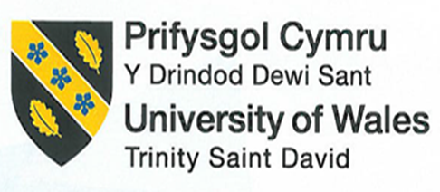
Assignment Title: Hotel Handbook for International Competence

Module: Cultural Awareness
BMIH5003
Lecturer Name: Rodrigo F Aguilera
Student Name: Naila Hossain Lipika
Student ID: 2107176

Executive Summary

Within the hospitality sector today, intercultural competency is essential for all employees. Cross-cultural communication skills, including learning multiple languages and cultural norms and values, are becoming increasingly critical for enhancing the guest experience. It is good to have an understanding of different cultures. Customers from varied origins may be catered to by hotel firms that have a strong grasp of multiculturalism. In the end, this results in improved customer experience and satisfaction during their stay, which is vaital for international hotel businesses.
The purpose of this study was to compare the cultural differences between the UK and Indonesia. Hampton by Hilton London Waterloo is the hotel of choice, located at 157 Waterloo Road, London SE1 8XA, UK. The six aspects of Hofstede’s Cultural Dimension framework are used to study the culture of each country. A critical analysis of how hotel personnel in the United Kingdom might better comprehend cultural differences between itself and Indonesia by identifying cultural variation is provided in this report. Examples of how Hampton’s management may demonstrate cultural understanding, sensitivity, and competence to provide excellent services to guests were provided to support the analysis. A summary sheet for hotel staff in the UK and Indonesia are included at the end of the report to help them enhance their cultural competence.

Introduction
Intercultural competency refers to the ability to interact effectively and appropriately in multicultural circumstances; adaptability to varied cultural contexts (Grobelna, 2015). With the use of Hofstede’s Cultural Dimension framework, this research investigates cultural variations between the United Kingdom and Indonesia. It analyses ways hotel workers in the UK can adjust to Indonesian cultural values. Finally, a summary sheet outlining the “Do’s” and “Don’ts” of cultural competency was provided.

Country A
The chosen country for Country A is the UK, and the chosen hotel is Hampton by Hilton London Waterloo, 157 Waterloo Rd, London SE1 8XA, UK (Hilton.com, 2022).
Analysing UK’s Culture

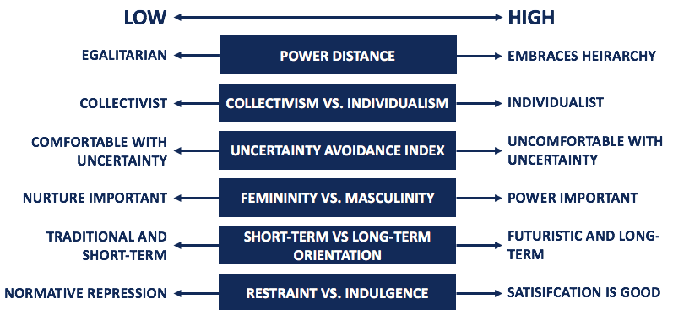

Source: (Corporate Finance Institute, 2022)

Power Distance: The 35 score indicates that people in the UK feel that inequities should be reduced, and people should be treated fairly. So, the hotel may treat all of its visitors the same regardless of their socioeconomic status.
Individualism: An individualistic UK culture means hotel personnel may just focus on their job roles and not establish connections because of the country’s independent culture.
Masculine: Hotel workers in the United Kingdom are driven by competitiveness because of the country’s masculine culture (Minkov and Hofstede, 2014). In order to make a guest’s stay more enjoyable, they may go the “extra mile.”
Uncertainty Avoidance: With a low score of 35, the hotel personnel may not always have strict guidelines and be flexible when serving guests.
Short/Long-term Orientation: With a balanced orientation, some employees may prioritise short-term gains and achievements, while others may prefer long-term connections with customers.
Indulgence: The UK culture is an indulgent one, meaning that most UK guests may look for leisure. So, guest service should align with guest expectations.
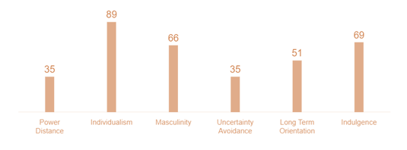

Source: (Hofstede Insights, 2022)

Country B

The report has chosen Indonesian as Country B and will utilise Hofstede’s model to analyse the country’s culture.
Analysing Indonesia’s Culture
Power Distance: Indonesia has a 78 of high score in power distance, and the Indonesian culture accepts high inequalities. Rich Muslim families, for instance, will desire more luxurious guest service than working-class people.
Individualism vs Collectivism: Individuals in Indonesia are said to act more in the interests of the community than in their personal self-interest. So, guests may travel in groups and won’t tolerate mistreatment towards any of their members.
Masculine vs Feminine: Gender roles are expected to be observed in Indonesia due to the country’s traditionally masculine culture. Guests may expect a manager to be male and the housekeeping personnel to be mostly female.
Uncertainty Avoidance: Uncertainty avoidance is at a level of 80, which indicates that the culture adheres closely to established beliefs and customs and does not tolerate unconventional behaviour or ideas.
Short/Long-term Orientation: The low score of 36 indicates that Indonesian culture follows short-term orientation and is likely to prioritise and respect traditions and achieve quick results.
Indulgence vs Self-restraint: Indonesian indicate both indulgent and restrained culture when it comes to controlling their impulses.

79 62
60 48
38
14

Power

Distance Individualism Masculinity Uncertainty Long-Term Indulgences
Avoidance Orientation

Figure 3: Indonesian Cultural Analysis

Source: (Hofstede Insights, 2022)

Critical Analysis
There’s a significant disparity between the UK and Indonesia when it comes to power distance. Indonesian guests won’t like being treated as ordinary guests and will expect Hampton hotel to provide luxurious facilities. Hampton’s management has to adapt when serving Indonesian guests, such as by offering a special menu, in-room entertainment facilities, reserving hall rooms, etc. (Genç, 2014). Otherwise, these guests may feel disappointed during their stay.
As Indonesians are collectivistic and often travel by groups, Hampton’s management has to ensure every member of their group receives equal importance. Hampton’s staff should attentively listen and provide a solution to every guest’s problem (Koc, 2020). Helping a couple of them and not others may be interpreted as mistreatment, making their stay unpleasant.
Moreover, as the Indonesian adhere closely to established beliefs and customs and do not tolerate unconventional behaviour or ideas, Hampton’s management and staff should learn about their cultural norms, their social traditions, what they appreciate, and what triggers their dissatisfaction (Thayarnsin, 2020). For instance, the front desk shouldn’t hand the key card using the left hand as it’s considered disrespectful.
Also, Indonesian prioritise and respect traditions and desire to achieve quick results. So, if an Indonesian guest is faced with a problem such as an unclean bedsheet or missing amenities, then Hampton’s management must solve the problem quickly as otherwise, the guest might become dissatisfied (Huang and Crotts, 2019). Further, learning about cultural and religious sentiments is crucial for Hampton hotel as it can have a direct impact on the hotel’s image (Yurur, Koc, Taskin and Boz, 2018). Hampton hotel’s restaurant waiters/waitresses shouldn’t offer alcohol and pork as it is considered Haram in Islam. Such mistakes have the potential to destroy Hampton’s image globally (Mullins and Dossor, 2013).

Handbook
In both the UK and Indonesia, hotel personnel may use these illustrated guidelines to help them follow the proper etiquette.

Etiquettes |  | Do’s and Don’ts
Greetings | UK | - Offer a gentle handshake  - Use last names to address guests  - Avoid prolonged eye contact
Greetings | Indonesia | - Offer a handshake to male guests and say “AsSalaamu ‘Alaykum”  - Avoid physical contact with someone of the opposite gender
Nonverbal-communication | UK | - Personal space should be maintained  - Avoid speaking loudly
Nonverbal-communication | Indonesia | - Eat, wave or pass items using the right hand only  - Avoid checking the time while assisting a guest (Cultural Atlas, 2022)
Attire | UK | - Wear formal clothes and maintain dress code  - Don’t wear a blazer to the workplace
Attire | Indonesia | - Wear clothes that cover legs, arms, and shoulders  - Women should wear scarfs in Indonesia
Dining | UK | - Offer to take the plates only when the guest puts together the knife and fork side by side  - Avoid asking for orders repeatedly
Dining | Indonesia | - Use the right hand to serve food  - Avoid offering alcohol or items containing pork
Others | UK | - Avoid staring (Ediplomat.com, 2022)  - Avoid trying to sound British
Others | Indonesia | - Address guests using their titles  - Male staff should avoid talking to female guests

Table 1: Summary Sheet for Hotel Staff in the UK & Indonesia
Source: Own

Conclusion
The report started off by discussing and analysing the culture of the UK and Indonesia It has chosen Hampton by Hilton London Waterloo to show the significance of intercultural competency considering the two countries. It further presented a critical analysis based on the cultural differences between the UK and Indonesia, with a focus on how Hampton hotel in the UK should address these cultural differences. The report ends with a summary sheet for hotel personnel in the UK and Indonesia to improve their cultural competency.

References
Country Comparison. 2022. Hofstede Insights. [online] Available at: <https://www.hofstede-insights.com/country-comparison/the-uk/> [Accessed 19 February 2022].
Country Comparison. 2022. Hofstede Insights. [online] Available at: <https://www.hofstede-insights.com/country-comparison/saudi-arabia/> [Accessed 19 February 2022].
Genç, R., 2014. International hotel and restaurant management. Charleston: CreateSpace Independent Publishing Platform.
Grobelna, A., 2015. Intercultural Challenges Facing the Hospitality Industry. Implications for Education and Hospitality Management. Journal of Intercultural Management, 7(3).
Hofstede’s Cultural Dimensions Theory. 2022. Corporate Finance Institute. [online] Available at: <https://corporatefinanceinstitute.com/resources/knowledge/other/hofstedes-cultural-dimensions-theory/> [Accessed 19 February 2022].
Huang, S. and Crotts, J., 2019. Relationships between Hofstede's cultural dimensions and tourist satisfaction: A cross-country cross-sample examination. Tourism Management, 72.
Koc, E., 2020. Cross-cultural aspects of tourism and hospitality. 1st ed. Abingdon, Oxon: Routledge.
Minkov, M. and Hofstede, G., 2014. A replication of Hofstede’s uncertainty avoidance dimension across nationally representative samples from Europe. International Journal of Cross Cultural Management, 14(2).
Mullins, L. and Dossor, P., 2013. Hospitality Management and Organisational Behaviour. 5th ed. London: Pearson.
Thayarnsin, S., 2020. THE IMPACTS OF INTERNATIONAL GUESTS' EXPERIENCE ON LOYALTY IN HOSTELS. Journal of Tourism, Hospitality and Environment Management, 5(21).
Yurur, S., Koc, E., Taskin, C. and Boz, H., 2018. Factors Influencing Intercultural Sensitivity of Hospitality Employees. International Journal of Hospitality & Tourism Administration, 22(1).

