Module Name - Contemporary Themes in the Hotel and Hospitality Sector

Student Name - Mariana Mironov
Student ID-2232725
Lecture name: Lola Villard-Coles

AI Acknowledgement Statement

I declare that I have not incorporated any AI tools in executing and writing this assignment. I did not submit any materials that have been generated by artificial intelligence as my own work.
I acknowledge that I have copies of my drafts, notes, other referenced resources used by me.

Table of Contents
Introduction 5
Literature Review 6
Method 9
Conclusion 12
Recommendation 13
References 14

Introduction

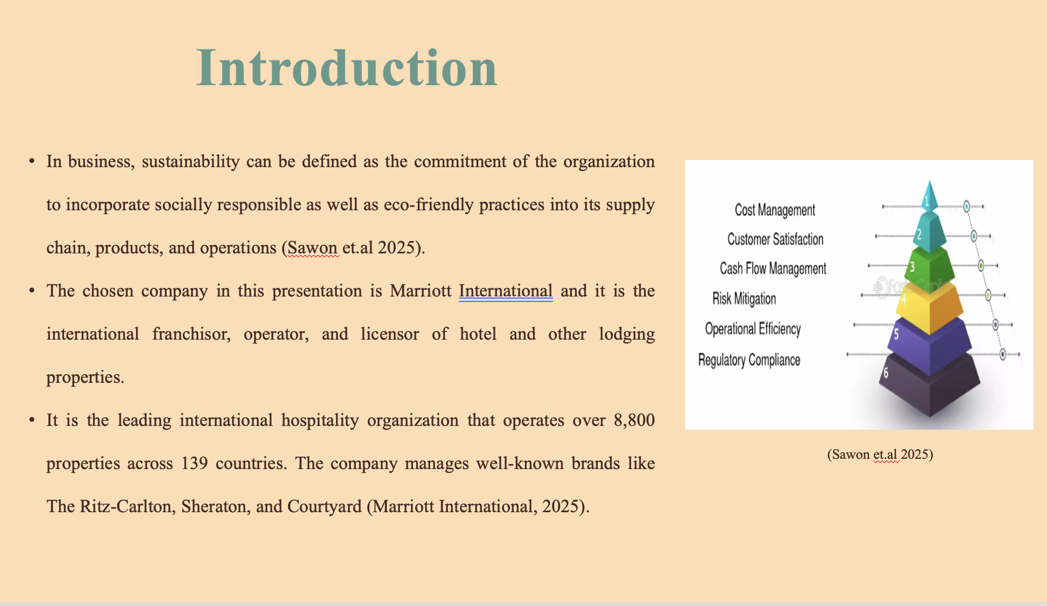
It has been addressed that the Hotel are the huge contributor of food waste that leverage the revenue and also provide negative impact on environment. This report will discuss the significance of sustainability within the hospitality industry and will also evaluate the PESTLE analysis.

Literature Review

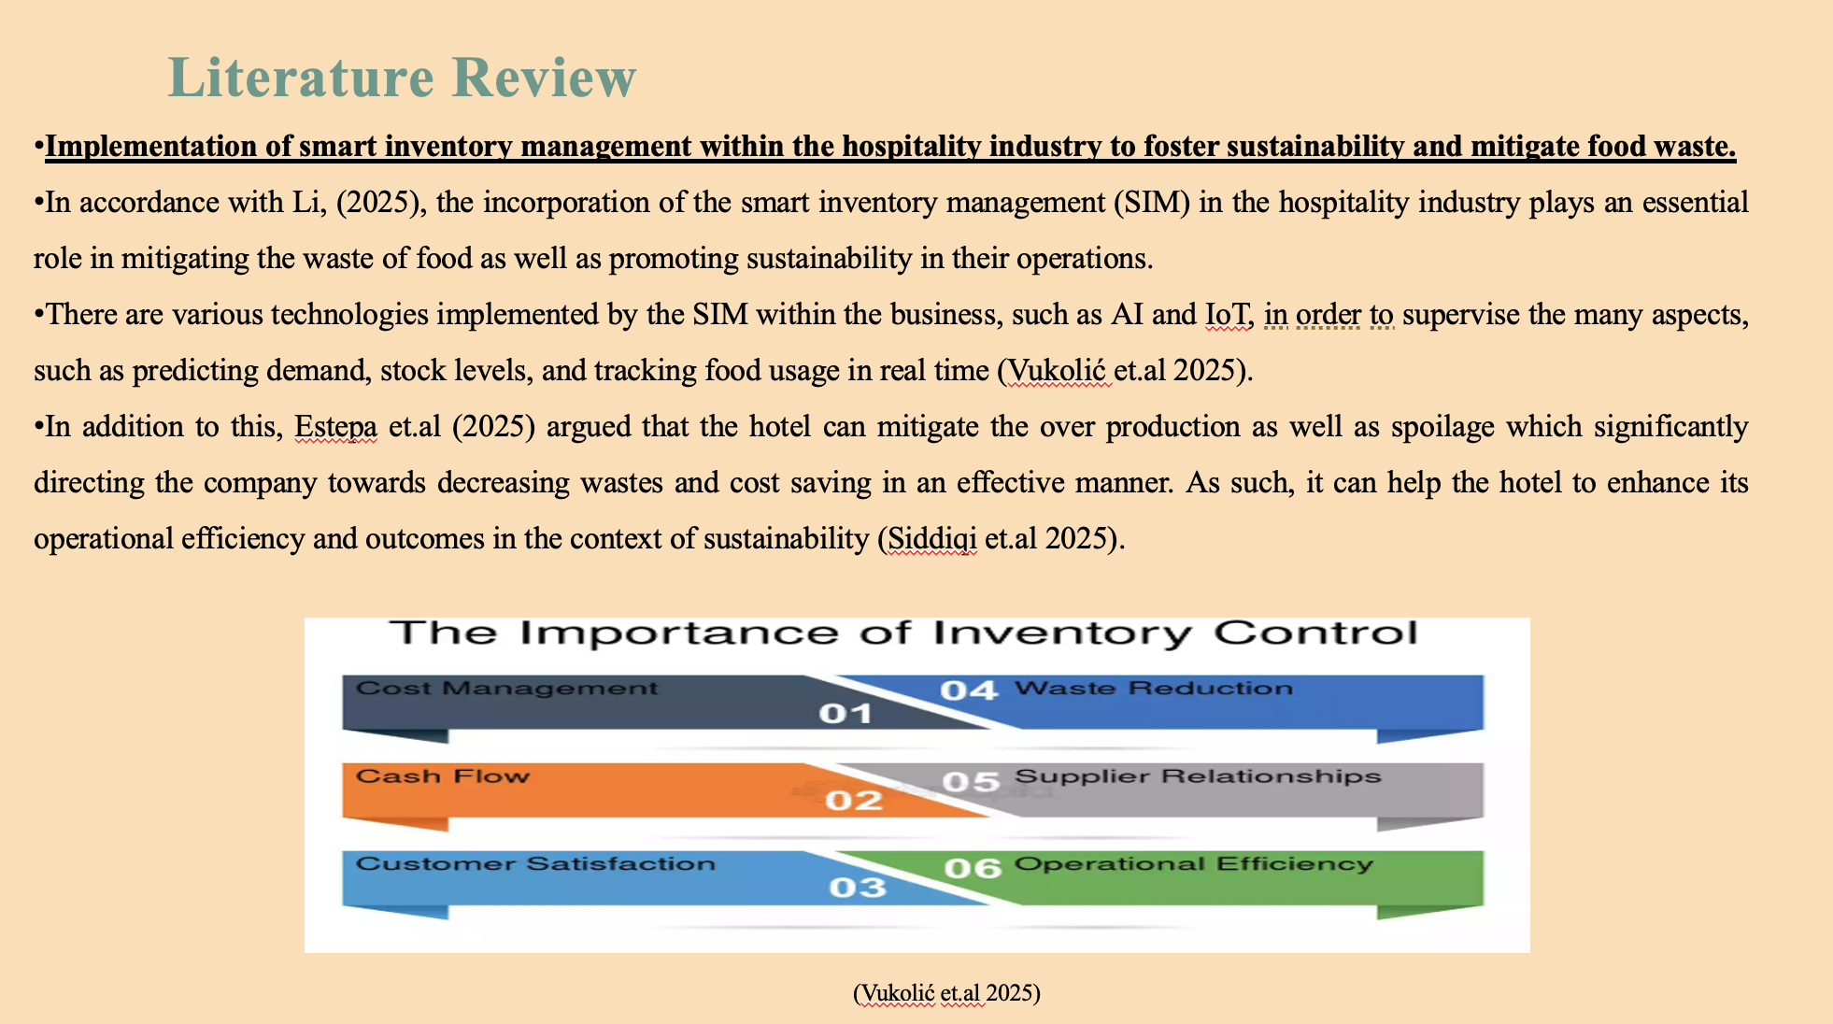
The term smart inventory management system can be defined as a state-of-the-art inventory solution that is significantly powered by various advanced technologies, such as AI, smart shelves, IoT, and RFID tracking. For example, Marriott International integrates an AI-driven inventory system that crucially associates the preparation of the food with the demand of consumers.
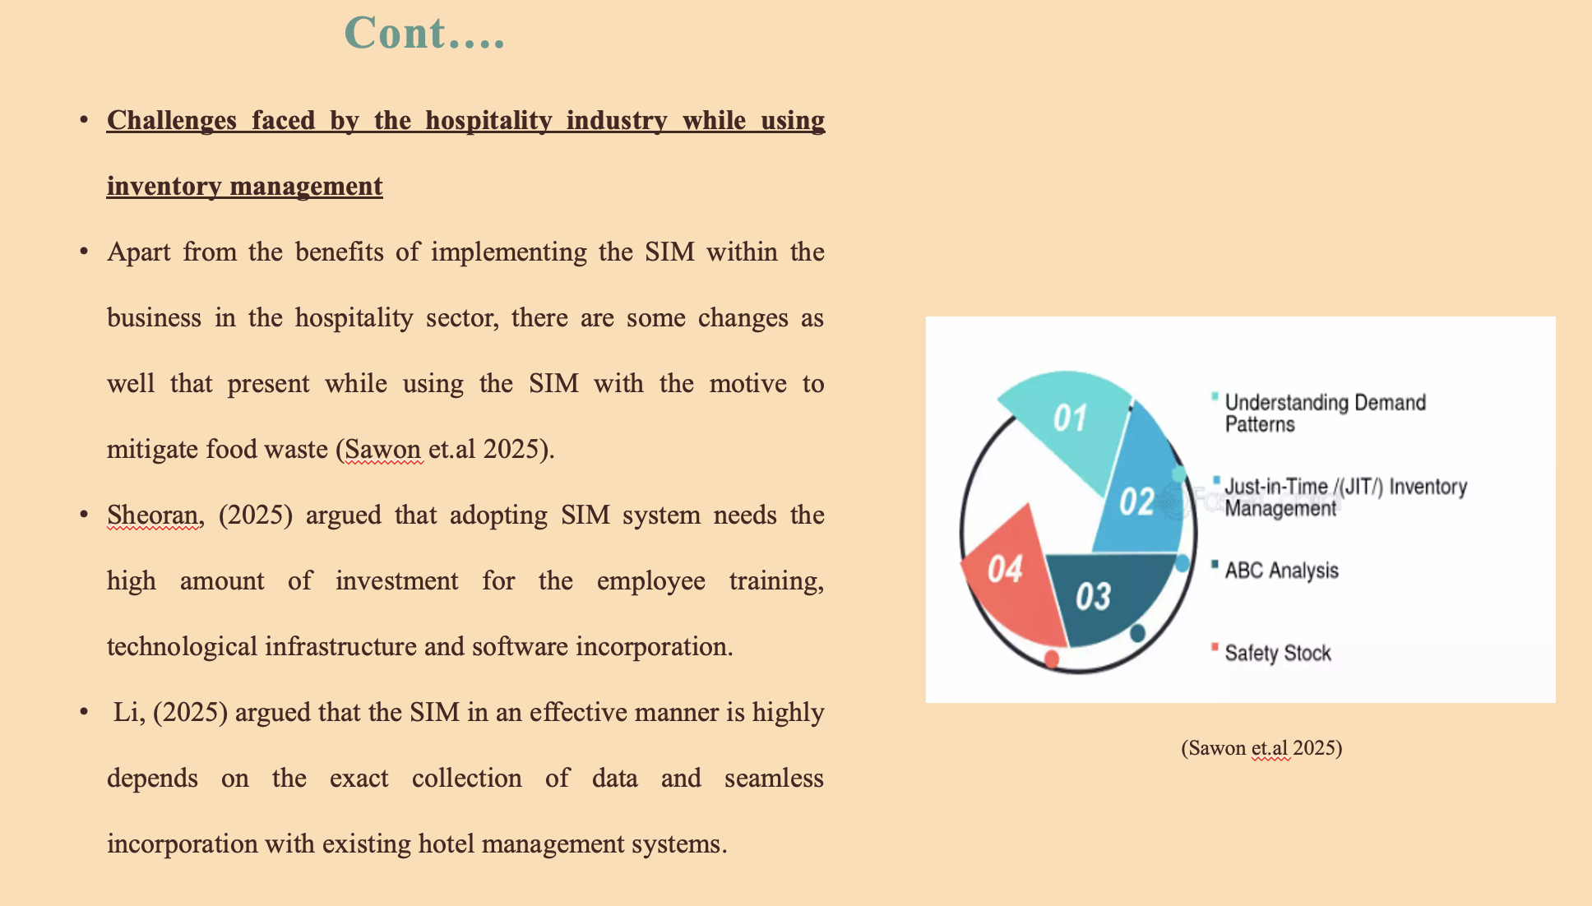
One of the major issues in the application of SIM is considered to be the high implementation cost. Data precision and system integration are other issues experienced by the hotels in implementing the SIM system in their business model. Factors such as inadequate connectivity, unpredictable prediction, and outdated software can lead to erroneous prediction that affects the operation and generate food waste.
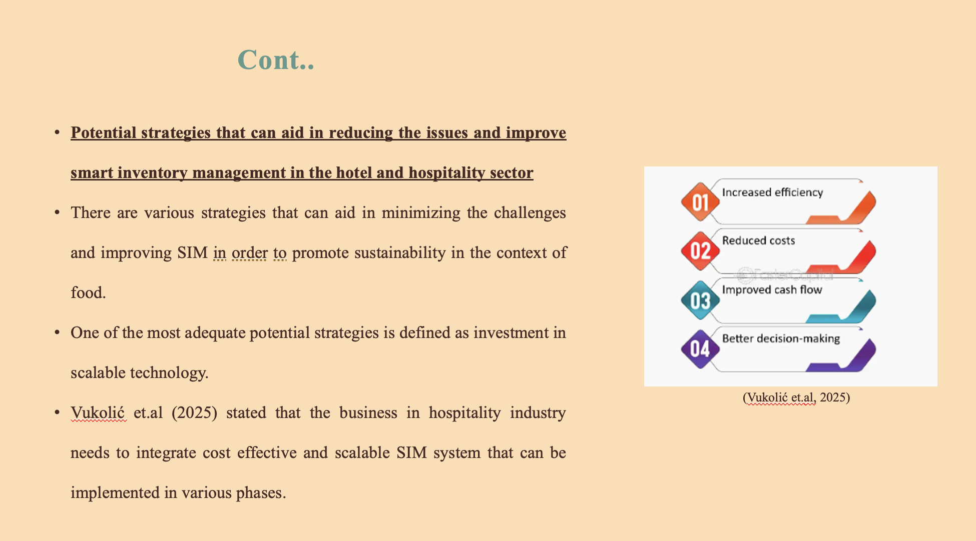
It began with pilot projects that can enable the business to assess the performance and justify the larger investment.
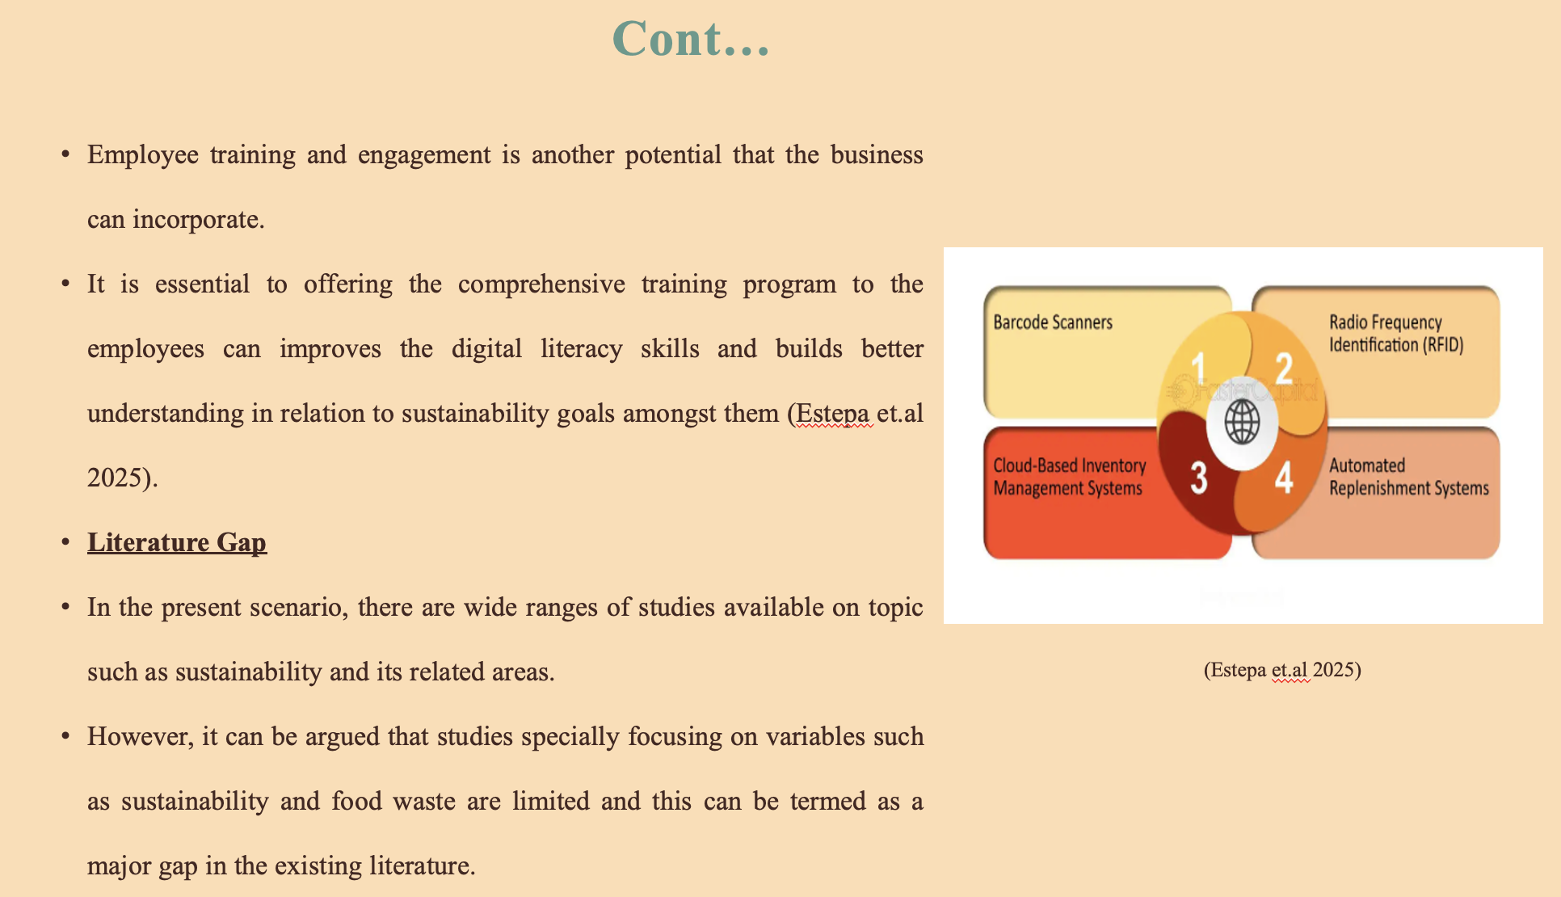
Engaging with the staff with the help of incentive schemes and regular awareness sessions can promote responsibility and support the continuous utilization of SIM tools. In addition, studies focusing more on techniques such as smart inventory management and companies such as Marriott are also limited and this is another identified with regards to the existing literature available. The findings of this study emphasize on reducing the identified gaps

Method

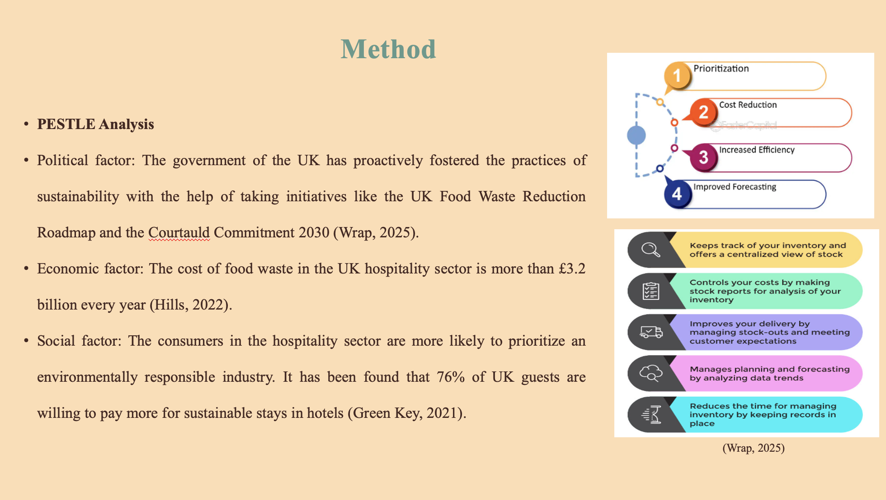
The main aim of this initiative is to halve the waste of food by the year 2030. These policies can compel hotels to adopt efficient food management systems to align with national sustainability goals. However, the contradictory regulations across the various countries impose compliance changes. Additionally, the rising rate of inflation and fluctuating food supply costs can make it economically essential to adopt SIM to optimize purchasing and condense overproduction. For the socially concern consumers, Marriott employs the strategy of serve 360 program in order to maintain sustainability. As per stakeholder theory, it is necessary of the company to develop value for stakeholders.
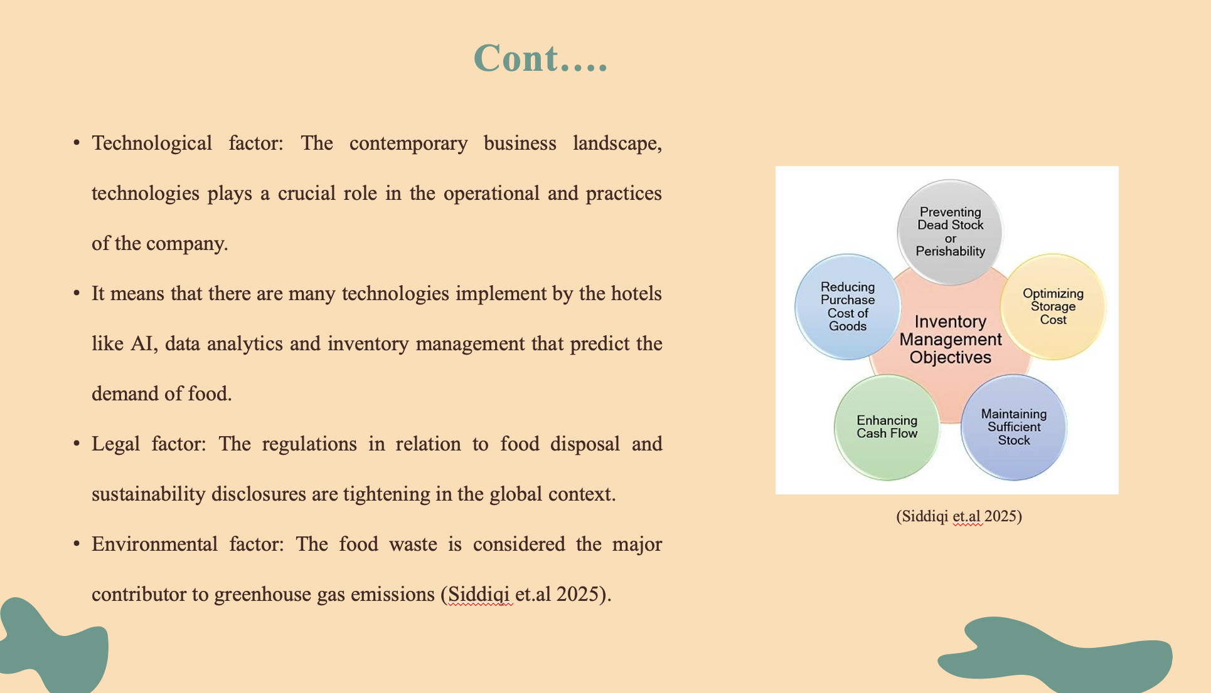
The technological tool like Winnow vision implement by the Marriott whose work is to identify food waste. Marriott remains committed to these regulations through transparent sustainability reporting that significantly aligns with frameworks like the Global Reporting Initiative (GRI). It is necessary forth business in hospitality industry to compliance with environment regulations according to the country in which they are operating.
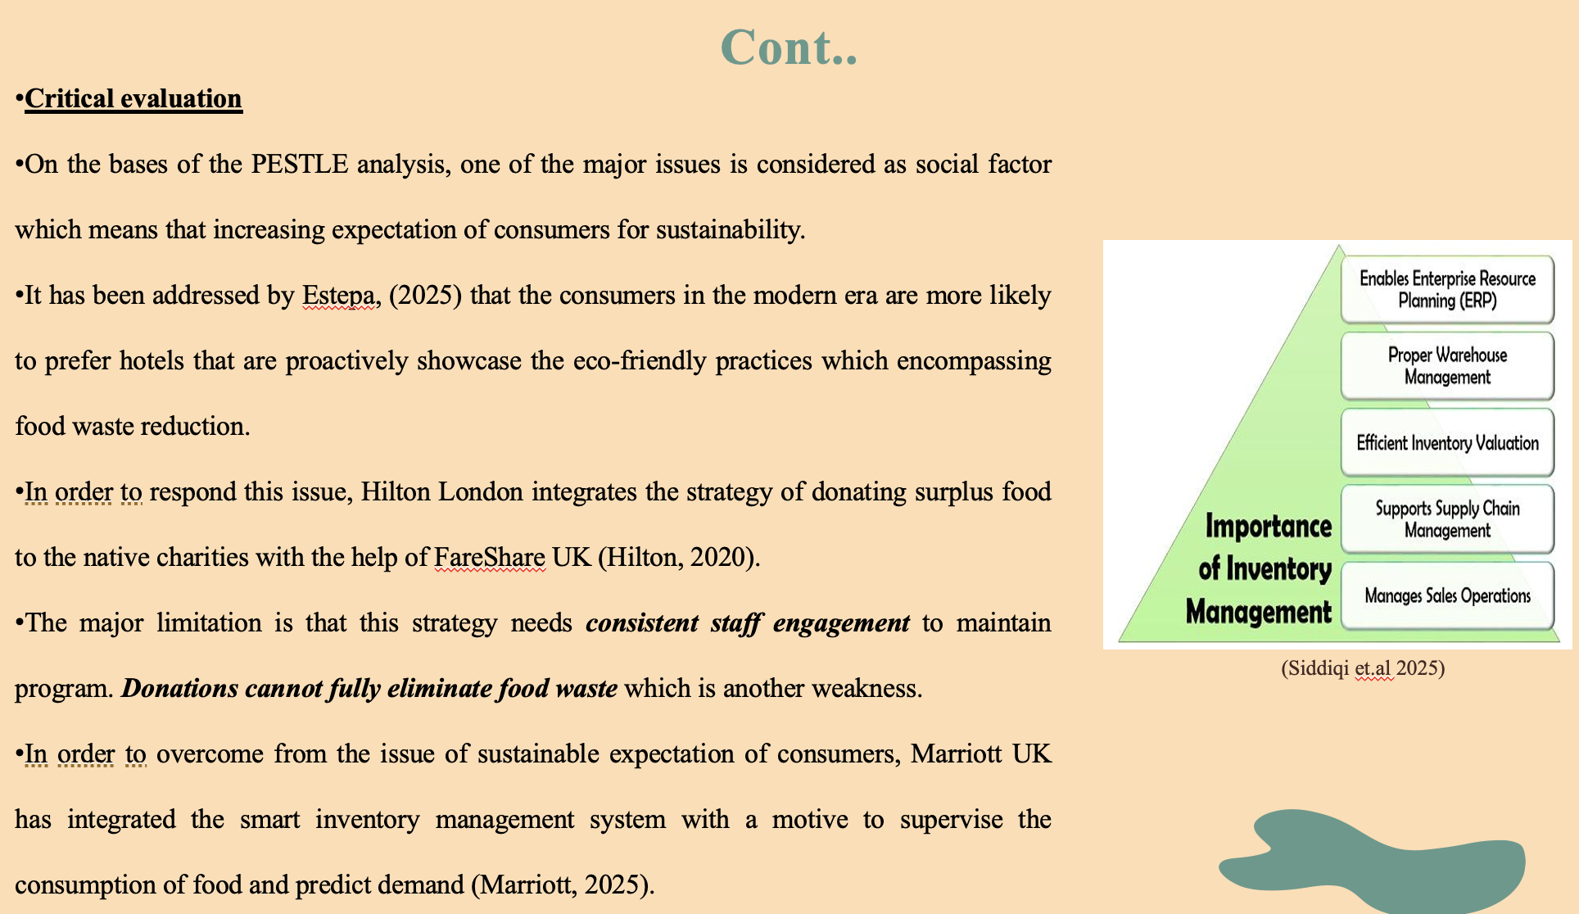
However, this approach showcases the transparent commitment in order to mitigate the negative influence on the environment and also improve the satisfaction of customers. The major strength of this strategy is that it enhances the reputation of brand and reinforces the loyalty of customers. Strength is that it mitigating the waste of food with offering huge contribution to the environmental sustainability. The significant strength of approach is accurate monitoring of food and operational cost. Another strength is that it enhance the ESG reporting through associating with corporate sustainability goals. The major weakness is high initial costs for system. Additionally, this strategy relies heavily on accurate data entry and trained staff so the poor training can crucially mitigate the overall effectiveness of the system.

Conclusion

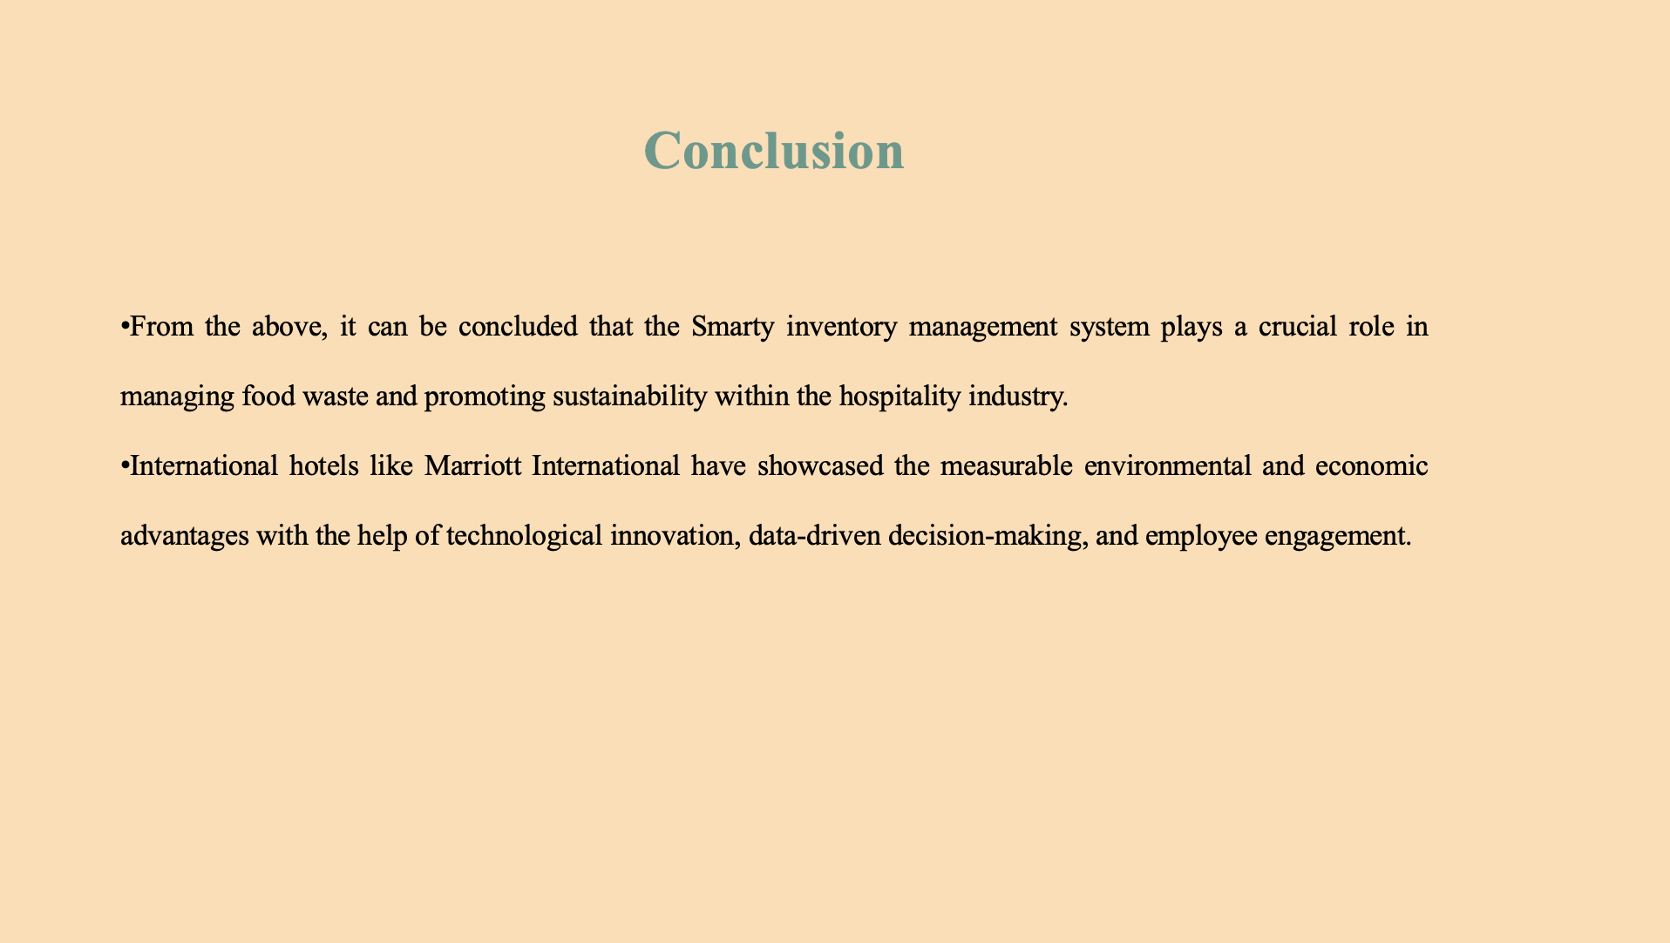
In addition to this, there are various challenges experienced by businesses within the hospitality industry, such as cost and staff adaptation, and strategic implementation.

Recommendation
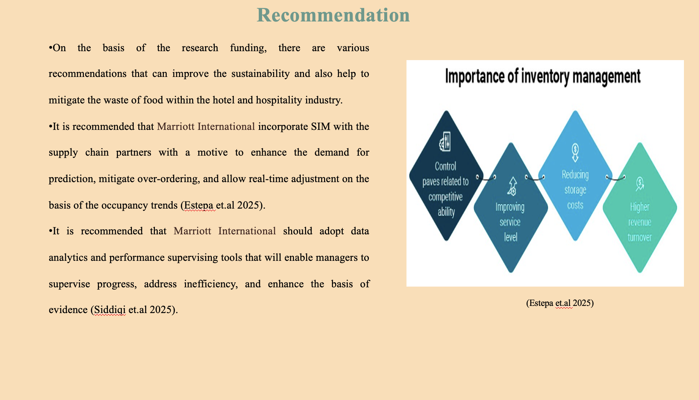
It is essential for the organization to collaborate with the native suppliers, which can further mitigate waste. At last, governments and industry associations should support hotels, which can be done by incentives, tax reliefs, and training partnerships that encourage green innovation.

References
- Estepa, L. S., Adem, M. D., Villanueva, E. R., Rufon, J. F., and Galang, E. M. (2025). The Technology Acceptability of the Inventory Management Application on Selected Catering Services. Puissant, 6, 2605-2631.
- Green Key., (2021). 76% of travellers pledging to seek out accommodation that has sustainability accreditation. [Online]. Available Through: <https://www.greenkey.global/stories-news-1/2021/7/13/76-of-travellers-pledging-to-seek-out-accommodation-that-has-reputable-third-party-sustainability-accreditation > [Accessed on: 22th October 2025].
- Hills., (2022). Hospitality Sector Waste - Managing the Costs. [Online]. Available Through: < https://www.hills-waste.co.uk/news/managing-waste-costs-for-the-hospitality-sector > [Accessed on: 22th October 2025].
- Hilton., (2020). Waste Not Want Not: Hilton Supports Fight Against Food Surplus and Feeds Those in Need. [Online]. Available Through: < https://stories.hilton.com/releases/hilton-helps-feed-those-in-need-with-food-surplus > [Accessed on: 22th October 2025].
- Marriott., (2025). The Power Of Marriott​. [Online]. Available Through: < https://www.hotel-development.marriott.com/power-of-marriott > [Accessed on: 22th October 2025].
- Li, D. (2025). Intelligent Inventory Management System: Innovation and Implementation of Restaurant Food Management. Economics and Management Innovation, 2(1), 112-123.
- Marriott International., (2025). We Are Marriott International. [Online]. Available Through: < https://www.marriott.com/marriott/aboutmarriott.mi > [Accessed on: 22th October 2025].
- Sawon, M. M. H., Hossain, M. A., and Talukder, M. B. (2026). Revolutionizing Hospitality Through Smart Logistics: Innovations in Supply Chain and Inventory Control in Hospitality Industry. In Smart Operations and Enhancing Guest Experience in the Hospitality Industry (pp. 95-124). IGI Global Scientific Publishing.
- Sheoran, M. (2025). Hospitality Industry: Insights and Perspectives. Educohack Press.
- Siddiqi, M. T. H., Rasel, M. A. B., Ahmed, H., Rahman, R., and Khan, M. S. (2025). The role of technology in optimizing customer-centric supply chains for hospitality and retail. Supply Chain and Digital Management Innovations, 25(1), 112-130.
- Vukolić, D., Gajić, T., Cabral, Ó., Veljović, S., and Knežević, S. (2025). Revolutionizing the hospitality industry: the impact of AI technologies on efficient food management and reduction of food waste. Journal of Tourism Futures, 1-29.
- Wrap., (2025). UK Food and Drink Pact: Food Waste Reduction Roadmap. [Online]. Available Through: < https://www.wrap.ngo/take-action/uk-food-drink-pact/food-waste-reduction-roadmap > [Accessed on: 22th October 2025].

