Developing Relationships & Workplace Achievement

Module Code- BMSW5102
Student Name- Md Humaun Kabir
Student ID-1712646
Teacher Name- Ze Zook

Executive Summary
The overall discussions will be based on to improve strategies for performance management and personal and professional development in the employment section. It will include a case study of Susan Taylor who is currently working in “Insight Enterprise LTD” and that’s why all the discussions will be assessed by considering developing relationships and the ways to accomplish the workforce’s achievement. Moreover, the discussions will also include different management theories which will be applicable to consider dissimilar methods and theoretical practices. Finally, the indicative content of the overall study will include performance appraisal, monitoring, feedback, Personal Development Plan, career development etc. to demonstrate the appropriate understanding of developing relationships and workplace accomplishment (Negash et al, 2008).

Table of Contents:
Executive Summary 2
Introduction 4
Aims 4
A Case Study of Susan Taylor 5
1. A critical assessment of the potential benefits to “Insight Enterprise LTD” and personally developing individuals in the workplace 6
1. Examining the expectations and requirements of people 6
2. Administering people following guidelines and career pathways 8
3. Managing career development of people 9
4. Managing performance and succession planning 11
5. Support structures within “Insight Enterprise LTD” 13
2. The development vehicles available to “Insight Enterprise LTD” and the how they are appropriate in meeting the development needs. 15
6. Techniques for supervision and formal appraisal 15
7. Methods of ensuring fair and objective assessment/appraisal 16
8. Methods to monitor, evaluate and record individual feedback 17
9. Reporting performance appraisal including the importance of confidentiality 18
10. Learning styles and the range of training/development opportunities available 18
11. Mechanisms to provide appropriate feedback to individuals 19
3. Develop a plan to meet the identified development needs and expectations of an individual. 21
12. Career development strategies including the wider context of sustainability 21
Conclusion 23
References 24 & 25

Introduction
Developing relationships means ways to improve individual relationships with others where workforce achievement refers to the accomplishments of the specific business goals and objectives. Developing relationship among all the involved employees is highly compulsory for accomplishing the exact workforce achievement which includes supporting, training, developing and controlling. That’s why the anticipated discussions will consider the exact issues of workforce achievement and the ways to improve the relationships which will upsurge the productivity to accomplish the organisational objectives properly. For achieving all the proposed indicative content, a case study of Susan Taylor and the organisational perspectives of “Insight Enterprise LTD” will be considered for meeting the core goals of this module properly (Trompenaars et al, 2011).

Aims
Performance Management Helps to create Employee Development Strategies. Every company has an individual’s performance management and career development process in the workplace.

A Case Study of Susan Taylor
Susan Taylor has joined in “Insight Enterprise LTD” about 2 years ago. Since then, Susan Taylor must experience lots of challenges and things within the workforce context. When Susan Taylor joined in his assigned roles as the Operation Manager then he has to deal with a different problematic situation which sometimes is supported by his skills or sometimes he is not available to fill up all the requirements properly. The core roles of Susan Taylor are to supervise the employee performance, reporting the performance, gets them engaged to meet the business objectives properly, motivating them to improve their required skills etc. Susan Taylor has experienced that to perform any assigned roles; all the employees need to be available with the essential skills. Though the required skills can be improved through the effective training programmes, in this case, he also needs to be capable with these skills. Moreover, Susan Taylor has observed that a good relationship with one employee to another is highly recommended to attain the shared business objectives properly. Susan Taylor always wants to improve him based on the specific job requirements because the dynamic business background requires the contemporary skills to accurately perform the assigned roles and responsibilities. That’s why Susan Taylor assess own skills and the performance of his employees and provide them with suitable feedback for improving themselves properly (Weske, 2012).

1. A critical assessment of the potential benefits to “Insight Enterprise LTD” and personally developing individuals in the workplace

1. Examining the expectations and requirements of people
The expectations and requirements of employees depend on the purposes of business and the assigned roles within the job segments. Here, being an operational manager of “Insight Enterprise LTD”, Susan Taylor also seeks some requirements from the organisational context such as as….
Display a positive and respectful attitude
A positive attitude within the workplace context is highly required because it supports to feel important for the respective organisation. Moreover, respectful behaviour will be supportive to develop the inter-personal relationship to work collaboratively. For example, Susan Taylor needs support, respect and a positive performance appraisal from “Insight Enterprise LTD” which will increase his productivity.
The availability of necessary training programmes
The employee needs the appropriate training programmes which increase their productivity and give him enough support to accomplish business objectives. For example, “Insight Enterprise LTD” needs to ensure the appropriate training program to familiarize with the organisational activities and to increase the productivity for better performance (Peng et al, 2017).
Ensuring a better work environment with flexibility
A better workplace is highly required for performing all the assigned roles because if the engaged employees get flexible and supportive environment then they can easily share the viewpoints where they will feel like the important part of the organisation. For example, if Susan Taylor gets enough support and opportunities from the workplace then he can share and apply his innovative ideas within the assigned roles (Zott et al, 2011).

Appropriate performance appraisal
The appropriate performance appraisal will be supportive to identify the strengths and weakness of the employees in response to their performance. For example, if Susan Taylor gets the proper performance appraisal then he will satisfy these significant job roles and try to improve himself to enhance his professional skills.
Fair wages and compensation
Fair wages and the appropriate compensation are one of the core requirements of every employee because employees get engaged with the work for earning money as their livelihood. That’s why when Susan Taylor gets the fair wages and appropriate compensation based on his performance then he will satisfy and gives his topmost for accomplishing the organisational objectives (Neumann et al, 2010).

2. Administering people following guidelines and career pathways
The administration of people requires for managing, to provide guidelines and to control them according to the organisational objectives and the assigned roles & responsibilities. The administration of people according to the career pathways includes career awareness, the controlling of performance, the arrangement of seminar and training programs to increase the productivity etc. As we can see that the core roles of Susan Taylor are to supervise the employee performance, reporting the performance, gets them engaged to meet the business objectives properly, motivating them to improve their required skills etc. (Keevy et al, 2018). Then Susan Taylor must administrate the employees following career pathways and guidelines to perform any assigned roles, all the employees’ needs to be available with the essential skills. Susan Taylor has experienced that the dynamic business background requires the contemporary skills to accurately perform the assigned roles and responsibilities. For example, Susan Taylor needs to set up standard organisational policies and minimum requirements where every employee is bound to perform according to the specific guidelines. Here, Susan Taylor always wants to improve him based on the specific job requirements because if he is available with the proper skills to manage his employees then the employees also give their topmost effort in return. Above all, the administration must be supported with the proper control, monitoring and performance evaluation techniques as Susan Taylor can provide effective guidelines to their employees (Moore et al, 2017)

3. Managing career development of people
Career is considered a lifelong process which is developed by depending on the proper skill, training, hard work etc. A man will be developed if he works hard and all-time keep patience in his life. Moreover, when a man was born, he needs to pass many stages which are the turning point to develop his career. These stages include establishment, exploration, mid-career, late-career and decline. For example, Susan Taylor needs to maintain some strategy because it will help to develop his career properly. There has some strategy which is given below….

Figure: Managing career development (Author)
Self -Assessment
The self-assessment means the evaluation approaches by which one individual can justify himself properly which is more important to develop his career. To justify thyself is so significant because if a man knows himself very much, he will be confident about his skill, knowledge and talent properly. For example, Susan Taylor needs to know him properly as he wants to develop his career which is the prerequisite for the development phases. Moreover, when Susan Taylor knows him properly, he may work more effectively and improve his career according to his weakness (Negash et al, 2008).

Career Awareness
Fundamentally, it is needed for every man to justify his career properly because if he justifies his career, he may know which career is important for his life. Besides, if a man wants to raise awareness about his career then he needs some things like skill, talent, proper knowledge etc. Here, Susan Taylor needs to justify his career through the appropriate understanding of his career including all the career-related information (Moore et al, 2017)
Goal Setting
The employee must need to select his plan because if he selects his dream, he may work accordingly then he reaches his goal properly. For example, Susan Taylor needs to select his plan as he wants to shine in life. Moreover, if there have face any challenges to reach his goal, he may keep patience and only work for his dream so that one day he may reach his goal very easily (Zott et al, 2011).
Skill Training
Fundamentally, skill training refers to train a proper skill that means a man do any work in a different way than others by taking different tactic and training accordingly. If a man wants to develop his career, he must need to skill training because skill training increases their acquire knowledge, talent and justifying product properly. Moreover, Susan Taylor also needs to train his skill as he wants to develop his career.
Performing
Finally, performing plays a vital role because if a man can perform well of his work, he may develop his career. Fundamentally, Susan Taylor needs to perform well of his work then his customer will satisfy with his work and want to buy more product from him. Moreover, it will also help him not only increase profit but also developed his career too (Keevy et al, 2018).

4. Managing performance and succession planning
Performance management strategies include utilizing management software, offering frequent feedback, discussing outcomes, identifying the strength and weakness of an organisation. Performance management plays a great role to improve company profit and productivity properly. Moreover, it will also help to increase brand values and quality-based products by managing performance properly. For example, “Insight Enterprise Ltd” needs to ensure performance management by following some necessary steps which are given below:
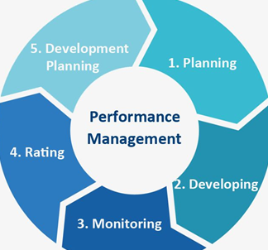
Figure: Performance Management (Marston et al, 2011).
Planning
Planning is the method of thinking about what a company do, when to do, how to do and where to do the activities properly. When a company wants to do any work, they must plan their activities based on some key criteria which will help to save both money and time accordingly. For example, “Insight Enterprise Ltd” needs to consider planning well when they start their works. Besides, they need to maintain planning such as strategic, operational, contingency and tactical which will help them to work effectively (Carrol et al, 2014).

Developing
A company development depends on their employee performance if the company arrange all necessary elements for their employees so that they can show good performance as the company can develop very soon. For example, “Insight Enterprise Ltd” needs to maintain their employees’ performance such as they can arrange many rewards system so that the employees can work more effectively. Moreover, “Insight Enterprise Ltd” needs to find the employee strengths and weakness that will be available to develop them properly (Teece, 2010).
Monitoring
Fundamentally, monitoring is the process to maintain not only products but also all daily activities of the employees. If a company can monitor their employees properly, they can identify their employees’ problem and solve it accordingly. For example, “Insight Enterprise Ltd” needs to try to monitor their employee’s performance which will be supportive to assess the employee performance (Moore et al, 2017)
Rating
A company always try to select the legal rating systems for their product otherwise their customer can’t be interested in their product. Here, “Insight Enterprise Ltd” can play a great role to select the legal rate of their product. They need to ensure that their customer shows interest with the product whichever is preferred and affordable to the most (Neumann et al, 2010).

5. Support structures within “Insight Enterprise LTD”
As the Operation Manager of “Insight Enterprise LTD”, Susan Taylor must experience different challenges within a different situation and that’s why Susan Taylor needs to consider the appropriate structure which will be effective for accomplishing the core objectives. Here, “Insight Enterprise LTD” considers a hierarchical organisation structure. Hence, “Insight Enterprise LTD” considers the CEO as the upper level, manager as the mid-level and finally foreman, salespersons as the lower-level employees. So, Susan Taylor is the mid-level employee of “Insight Enterprise LTD”. The organisational structure of “Insight Enterprise LTD” is given below such as (Jhonson et al, 2008).
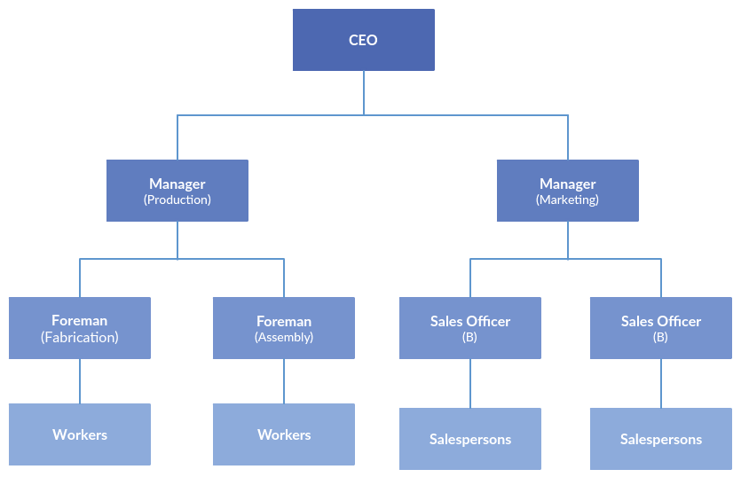
Figure: Organisational structure of “Insight Enterprise LTD” (Keevy et al, 2018).
Management Theory
“Insight Enterprise LTD” can consider the succeeding management theories based on dissimilar situational aspects such as…
Scientific Management Theory
Scientific Management Theory is a concept of management theory that synthesizes workflows and improving economic productivity, especially labour efficiency. For example, “Insight Enterprise Ltd” always maintain Scientific Management Theory so that they will get many benefits such as better-quality product, increased wages, saved time etc.

Administrative management Theory
The administrative management theory includes all the managerial approaches based on the administrative bodies and standard action planning according to the organisational policies. For example, “Insight Enterprise LTD” needs to manage the organisational aspects when it is based on the strict administration and official policies according to the administrative theory (Arnold et al, 2019)
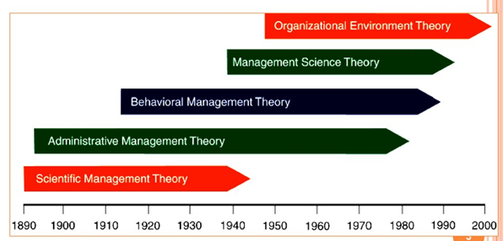
Figure: Management Theories (Dawson et al, 2018).
Behavioural Management Theory
Behavioural Management Theory was popular in 1890 to1980 and it requires a company how to behave with their employees. Besides, “Insight Enterprise Ltd” always tries to create well behave with their employees so that the employees also try to behave well with their manager properly.
Organisational Environment theory
Organisational environment theory is based on the managerial approach which considers the organisation environment at priority. For example, if “Insight Enterprise LTD” considers the internal environment and external environment then they need to consider two different management approaches based on the theory (Mumford et al, 2017).

2. The development vehicles available to “Insight Enterprise LTD” and the how they are appropriate in meeting the development needs.

6. Techniques for supervision and formal appraisal
As the Operation Manager, Susan Taylor needs to supervise all his employees within “Insight Enterprise LTD” workforce’s context such as…

Figure: Techniques for supervision (Author)
Live Observation
Live observation refers to the monitoring approaches which observe an employee performance on a real time basis. For example, Susan Taylor can observe the performance of his line manager through the direct observation approaches by standing beside him and instruct them what to do or what not to do.
Digitalized techniques
The usages of digitalized techniques include the computerized approaches to monitor and to supervise the employee by giving different instructions. For example, Susan Taylor can supervise his employees by using digitalized devices like CC TV to supervise his employee’s activities (Turban et al, 2010).

Modelling and Role Play
The supervision technique can also be possible by modelling and role-play which will justify the specific employee’s performance based on playing a role which will present the specific situation and performance of the respective employees.
Coaching
Finally, “Insight Enterprise LTD” can supervise their employees according to coaching approaches which will supervise some employees at the same time on the same topic. Though the required skills can be improved through the effective training programmes, in this case, he also needs to be capable with these skills (Dawson et al, 2018).

7. Methods of ensuring fair and objective assessment/appraisal
To be successful in life, every person must have clear and applicable goals to accomplish based on his capabilities and interest. That’s why the justification of the objective assessment is very important because it will be supportive for him to justify either is effective or not such as…
Comparing objectives with a real-life situation
When a person set up his goals then he must need to assess the possibility to implement the goals and objectives in the real-life scenario. For example, when Susan Taylor sets his goals to be an Operation Manager then he needs to justify his abilities based on the specific job requirements to justify either it is effective or not.
Assessing individual strengths and weakness
The effectiveness of the objective can also be assessed based on individual strengths and weakness according to the specific job requirements. For example, the core strength of Susan Taylor is communication and managing skills where the core weakness of Susan Taylor is analytical skills (Mackenzie et al, 2009)

8. Methods to monitor, evaluate and record individual feedback
“Insight Enterprise Ltd” considers their main purpose is to satisfy their customer by giving them proper facilities. Moreover, if “Insight Enterprise Ltd” can ensure the legal rate systems then all the customers get enough support to buy their product properly from the other customers' reviews. Susan Taylor can monitor his performance according to some key applicable strategies to justify the performance such as…
Feedback without judgment
Susan Taylor needs to judge the performance of him based on the fair and ethical considerations which will be supportive for him to do better in his upcoming activities. If Susan Taylor feels shame or biased then it will not effective to resolve his weakness at all (Nation, 2017).
Establish credibility
Susan Taylor needs to ensure the credibility to “Insight Enterprise LTD” within all his assigned roles and responsibilities. It will increase his self-appraisal and gives supports him to perform his assigned roles and responsibilities more confidently.
Being honest & real-time coaching
If Susan Taylor is honest and ethical to all of his practices then the specific feedback to his performance will be supportive to maintain an appropriate balance in his performance along with coaching approaches because it will supervise some employees at the same time on the same topic (Keevy et al, 2018).

9. Reporting performance appraisal including the importance of confidentiality
Reporting performance appraisal to the respective employee is highly essential because it is the performance results within the assigned roles. Besides, the importance of confidentiality is also high because the privacy issues of the corresponding employees should be kept secret to the specific employees only. The core rationale is that if the negative performance appraisal can be a reason of insult or responsible for any problematic situation which will not be supportive for the employees to work flexibly. For example, the supervision techniques depend on the effectiveness of which techniques will be more supportive to monitor the target employees according to the standard policies. Besides, the formal appraisal should be based on the official structural form to accomplish the organisational objectives properly (Dawson et al, 2018).

10. Learning styles and the range of training/development opportunities available
“Insight Enterprise LTD” can use different learning styles for their employees and ensure the best development opportunities based on the training needs. For example, here Susan Taylor can use Kolb’s Learning Styles which considers the four key issues. Fundamentally, the training needs will create pathways to the development phases. Then, “Insight Enterprise Ltd” will try to arrange suitable seminars for their employee based on the employee requirements and necessities to improve themselves that will help them to save money and time properly (Negash et al, 2008).
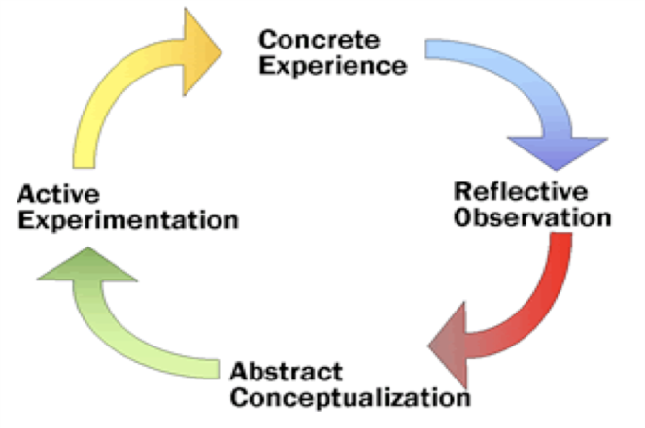
Figure: Kolb’s Learning styles (Dawson et al, 2018).

11. Mechanisms to provide appropriate feedback to individuals
To provide appropriate feedback, the 360 Degree is important because both the employee and employer get feedback from their performance. Here, “Insight Enterprise Ltd” also takes feedback from Susan Taylor so that “Insight Enterprise Ltd” will make some necessary changes to their performance.
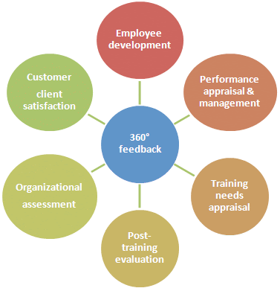
Figure: 360 Degree feedback (Marston et al, 2011).
Employment development
A company’s development depends on the employee performance because if an employee works more effectively a company will develop properly. So, a company needs to arrange all necessary facilities for the employee such as proper fair wage, reward system, proper encouragement and proper training.
Performance appraisal & management
The 360-degree feedback is more useful for raising a manager or a leader performance properly because when an employee provides feedback to his manager to improve his performance, he may consider it and wants to maintain it. Moreover, after taking this feedback “Insight Enterprise Ltd” will increase their profit and productivity too (Mackenzie et al, 2009)

Training needs appraisal
Fundamentally, 360-degree feedback is also important to appraise training needs for the manager. This feedback will give a manager to appraise his time management and conflict resolution skills properly. Moreover, Susan Taylor also gives feedback “Insight Enterprise Ltd” to improve their training then “Insight Enterprise Ltd” will justify which training is needed for them.
Post-training evaluation
Post-training is important for a company or organisation because it helps an employee to adapt within a different place. Moreover, it also helps them to increase their skill and knowledge which gives an impact on their companies’ development. For example, “Insight Enterprise Ltd” can play an important role e.g. they can arrange many different seminars so that as an employee Susan Taylor feedback them which seminars are more effective and which aren’t (Keevy et al, 2018).
Organisational assessment
Fundamentally, organisational assessment is a methodical process for attaining valid news about the activities of an organisation and the issues that affect performance. “Insight Enterprise Ltd” can analyse organisational assessment by knowing the organisation strength and weakness, collecting data, justify the organisation aims and goals properly. Besides, Susan Taylor always tries to give an organisational assessment to “Insight Enterprise Ltd”.
Customer/ client satisfaction
A company can also take feedback from customer or client if the company’s performances are well then, the customer or client will satisfy their job properly. Moreover, the “Insight Enterprise Ltd” also takes some feedback from Susan Taylor; Susan Taylor gives them in the past year information on his satisfaction (Jhonson et al, 2008).

3. Develop a plan to meet the identified development needs and expectations of an individual.

12. Career development strategies including the wider context of sustainability
The career development strategies can be supported through Scientific Management theory and Behavioural Management theory by considering the following strategies such as…
Set and communicate clear goals
One of the very first career development strategies is setting up career goals. When Susan Taylor knows about the strength and weakness of “Insight Enterprise Ltd” he can provide feedback on what is important for him to do more effective works. Moreover, Susan Taylor can provide feedback to their company manager to develop technical and facility system as he can improve his communication and work skills properly (Dawson et al, 2018).
Create an open feedback loop
An effective feedback loop will be supportive to develop the career. For example, “Insight Enterprise Ltd” also takes feedback from Susan Taylor so that “Insight Enterprise Ltd” will make some necessary changes to their performance. For example, “Insight Enterprise Ltd” always maintains all necessary facilities for the employee that’s why as an employee Susan Taylor also gets more benefit from “Insight Enterprise Ltd” (Teece, 2010).
Create a portfolio of your accomplishments
All the proposed achievements should be available with flexibility, interest and ability to capture the specific career objectives. When “Insight Enterprise Ltd” takes this information, they are trying not only increase their facilities but also make many verities product which is more satisficed for Susan Taylor or another employee (Maxwell et al, 2015).

Here, Susan Taylor needs to devise a Personal Development Plan based on his weakness to develop the career pathways such as…
Personal Development Plan
What are my big goals | Which actions are required? | Which obstacles did I face? | How can I improve? | Review | When do I meet achieve?
Communication skills | To communicate through rights ways | Ineffective channels | By communicating effectively | Best | Within six months
Interpersonal skills | To increase the interpersonal relationships | Shame, nervousness etc. | Engaging with people with well-behaviour | Good | Within six months
Team working skills | To collaborate with team members | Imbalanced with others | Collaborating with others | Good | Within 1 year

Conclusion
Thus, the overall case study of Susan Taylor and his workplace mainly “Insight Enterprise Ltd” has achieved successfully. After all, we can say that “Insight Enterprise Ltd” should ensure a better workplace environment along with a good interpersonal relationship among the employees. Moreover, Susan Taylor should asses his skill more accurately and tries to improve him according to his specific job recruitment. Finally, “Insight Enterprise Ltd” should develop their interpersonal relationship and ensure better workplace achievement (Peng et al, 2017).

References
# Arnold, E.C. and Boggs, K.U., 2019. Interpersonal Relationships E-Book: Professional Communication Skills for Nurses. Elsevier Health Sciences.
# Bartfeld, E. and Lass, A., Irody Inc, 2010. System and method for real-time management of a drug regimen. U.S. Patent 7,747,454.
# Boissy, A., Windover, A.K., Bokar, D., Karafa, M., Neuendorf, K., Frankel, R.M., Merlino, J. and Rothberg, M.B., 2016. Communication skills training for physicians improves patient satisfaction. Journal of general internal medicine, 31(7), pp.755-761.
# Cottrell, S., 2017. Critical thinking skills: Effective analysis, argument and reflection. Macmillan International Higher Education.
# Custódio, C., Ferreira, M.A. and Matos, P., 2019. Do general managerial skills spur innovation? Management Science, 65(2), pp.459-476.
# Danish, S.A., 2011. Sms texting and its potential impacts on students' written communication skills. International Journal of English Linguistics, 1(2), p.222.
# Dawson, P. and Guare, R., 2018. Executive skills in children and adolescents: A practical guide to assessment and intervention. Guilford Publications.
# Johnson, M. W., Christensen, C. M., & Kagermann, H., 2008. Reinventing your business model. Harvard business review, 86(12), 57-68.
# Keevy, M. and Mare, D.J., 2018. Pervasive skills development for aspirant chartered accountants: Academic versus training programmes. Journal of Economic and Financial Sciences, 11(1), pp.1-9.
# Mackenzie, A. and Nickerson, P., 2009. The time trap: The classic book on time management. Amacom.
# Marston, S., Li, Z., Bandyopadhyay, S., Zhang, J., & Ghalsasi, A., 2011. Cloud computing—The business perspective. Decision support systems, 51(1), 176-189.
# Maxwell, S.M., Hazen, E.L., Lewison, R.L., Dunn, D.C., Bailey, H., Bograd, S.J., Briscoe, D.K., Fossette, S., Hobday, A.J., Bennett, M. and Benson, S., 2015. Dynamic ocean management: Defining and conceptualizing real-time management of the ocean. Marine Policy, 58, pp.42-50.
# Trompenaars, F., & Hampden-Turner, C., 2011. Riding the waves of culture: Understanding diversity in global business. Nicholas Brealey International.
# Turban, E., Sharda, R., & Delen, D., 2010. Decision Support and Business Intelligence Systems (required). Google Scholar.
# Weske, M., 2012. Business process management architectures. In Business Process Management (pp. 333-371). Springer, Berlin, Heidelberg.

