Assignment 2
Sarah Campion (2123395)
Marketing Management (BMMB7012)
Deadline – Wednesday 29 June 2022

Title

Executive Summary
Patagonia Inc. are a clothing and gear brand that specialises in garments for use in outdoor sports and activities. They are widely known for their high quality, high price, and long-lasting products but what they are most known for is their relentless approach towards environmentally sustainability and doing what is right for the planet. This ethos guides their marketing strategy and is evident throughout all actions.
The aim of this review was to provide information surrounding Patagonia Inc.’s current marketing strategy, focusing on elements such as their marketing mix, the target market, forms of marketing media and how successful along with the macro and microenvironment. How these have all shaped and influenced their marketing strategy have been discussed in depth. This built upon an initial environmental audit of the company which was carried out through a PESTLE analysis, use of Porters 5 Forces Model and a Marketing Audit Tool which identified issues to be addressed.
It was found that the way in which they have segmented their target market and positioned themselves has resulted in high sales, strong brand loyalty and an excellent reputation amongst their current market but it also revealed that certain generations were not targeted which could imped on their growth as a company in the future. What was revealed was that Patagonia are struggling with online sales and they have mixed reviews regarding engagement on their website and social media platforms requires some improvement to incorporate a mixture of traditional and digital marketing. In support of the findings, a wealth of literature has been explored through online articles, journals and printed publications.
Following the analysis, conclusions were drawn and a suggested marketing plan has been created following the SOSTAC model. This plan demonstrates where Patagonia is now, where they need to be and suggested ways of how they are going to get there. It discusses ideas such as repositioning within the market, a differentiated marketing strategy to target different segments of consumers and improving and increasing their online sales and social media presence to remain relevant in the digital world and to be able to compete with competitors and target other generations.

Contents

1. Introduction 4
1.1 About Patagonia 4
1.2 An Overview of Patagonia’s Marketing Approach 4
2. Main Findings 5
2.1 Macro and Microenvironment 5
2.2 The Target Market 5
2.3 The Marketing Mix 6
2.4 Marketing Media & Their Success 7
3. Conclusion 12
4. Recommendations 13
5. Reference List 15
6. Appendices 19

Table of Figures
Figure 1 8
Figure 2 8
Figure 3 10

1. Introduction

1.1 About Patagonia

Patagonia Inc. is an American outdoor clothing and gear brand which is suitable for a range of different sports from climbing to fishing and available worldwide (Morin,2020). It is privately owned by Yvon Chouinard; a lover of outdoor sports and a strong advocate for protecting our natural world. The brand known as Patagonia was founded in 1973 but it’s initial inception as Chouinard Equipment began in 1965 and from here their journey has continued to evolve. Globally, they are known for their strong environmental and sustainable ethos and practices and are often described as ‘one of the world’s most active and responsible brands when it comes to caring for people and the planet’ (Fat Buddha Store, 2022).
Patagonia set the benchmark for any company striving to be environmentally conscious and sustainable within the retail industry. This report does not suggest that there should be a move way from their successful, sustainable, and responsible model but to take a closer look at Patagonia’s current marketing strategy and identify options for improvement and expansion in the future.

1.2 An Overview of Patagonia’s Marketing Approach

Fahy and Jobber (2019) describe marketing as an essential activity both inside and outside of business. Additionally, what goes on around us plays a significant role in shaping a company’s behaviour and how they interact with their consumers. Marketing is an activity that is fairly fluid and requires a variety of resources in order to be effectively implemented. Errington (2021) categorises marketing resources as tangible and intangible. Tangible resources include money, staffing, information systems and customers whereas intangible resources refer to items that are not physically seen such as knowledge, expertise, branding and organisational culture. These are also demonstrated in Appendix 3. What is evident about Patagonia’s approach to marketing is that it is certainly not a number one priority and aside from some of their more memorable campaigns, they do not take partake in many other forms of advertising (Rogers, 2018). Instead, they use their marketing strategy to build a community of people, share values and encourage environmental protection. It is guided by purpose and follows a common theme of the 5 R’s – Reduce, Reuse, Repair, Reimagine and Recycle (Deshmukh, 2021).

2. Main Findings

2.1 Macro and Microenvironment

Performing a PESTLE analysis (Appendix 1) and adopting the use of the Porters 5 Forces Model (Appendix 2) and Marketing Audit Tool (Appendix 3) allowed for a thorough initial assessment of their current marketing environment and for a detailed and improved understanding of their Macro and Microenvironment to be gained.
The analysis of their macro environment (economic) highlighted a particularly apt issue as following the Covid-19 pandemic, many families are now impacted by a cost-of-living crisis which is subsequently influencing purchasing habits (Reid,2022). For Patagonia, this could be viewed in both a positive or negative light where on one hand individuals now might not be able to afford the high price tag of their items and on the other by minimising their purchasing, it would align with their strategy of changing consumer’s perceptions, buying one item and fully maximising it’s use. It is highly unlikely that Patagonia are unable to alter their pricing points due to the number of available suppliers. This price pointing is opposed by Petro (2022) who argues that there should not be a higher cost associated with sustainable products but suggests an area for development in the future. By successfully identifying this, it would lead to success for the company (Camilleri,2018).

2.2 The Target Market

As a result of the intended purpose of their clothing, the current primary target market is those individuals interested in outdoor pursuits but also those whose environmental values and beliefs align with theirs. This was evidenced during an audit conducted on the brand in 2014 which also illustrated a customer base of individuals between the ages of 18 and 35, men and woman and those who have access to disposable income (Sublett, 2021). Segmenting the market this way has since resulted in high sales, exemplary brand loyalty and a strong following of customers. However, Hepburn (2013) raised that their sales now also indicate that their customer base is changing, and items are being purchased beyond the intended user group.
It was identified that they are not positioned to target generations such as Generation ‘Z’ who can be defined as individuals who were born post 1995. Research recommends that any business who are centred around sustainability should be inclusive of Generation Z (Petro,2022). This advice is strongly supported by Wessel (2022) who stated that if you are a product-based business such as Patagonia then this generation should be targeted. Other studies reveal that this particular demographic are keen to purchase ‘green’ products, adopt environmentally sustainable practices and positively encourage others to do the same (Lee, 2020). This suggests the potential further success that Patagonia could experience should they expand their marketing mix. In order to do achieve this, intangible repositioning would be required which involves keeping the product the same but looking at a different market (Jobber, 2019).
Consideration of both green and non-green customers
Patagonia’s customer base is currently designed around targeting green consumers. Barbaraossa & De Pelsmacker (2014) describe green consumers as those who use the environment as a reason for engaging in a particular way or purchasing a certain product. The analysis illustrates that Patagonia is a strong advocate for other environmental agencies (Patagonia Inc.,2022) which is an action that White, Hardisty and Habib (2019) suggest as a great way of targeting green consumers; a good practice that Patagonia that have already adopted.
Limited marketing towards non-green consumers was highlighted on their Patagonia website and they are defined as individuals whose purchases are driven by different reasons other than environmental reasons. Further segmentation of the market would beneficial here to gain a detailed understand their buying behaviour as you could determine what an individual is looking for in terms of needs. It would identify how best to be able extend their user group and communicate with them in the most effective way (Jobber, 2019). This is also supported by Barbaraossa & De Pelsmacker (2014) who feel that this would be an effective criterion to segment customers.
Another strategy which Patagonia has adopted is sharing the negative environmental impacts of producing garments and whether this is unintended, it is a good strategy in targeting both green and non-green consumers. This was proven in a study by Munerah, Koay and Thambiah (2020) who explored the purchasing of green beauty products, and by utilising this tactic it positively influenced the non-green consumers to start using green beauty products.

2.3 The Marketing Mix

All information obtained from the initial environmental audit and this review forms part of the marketing mix which is made up of the 7 P’s – Price, Product, Promotion, Place, Process, Physical Evidence and People. By identifying these key business activities, it allows a company to be fully informed about the actions and decisions they are making (Fahy & Jobber, 2019). It is also important to consider that these not fixed and can be reviewed at any point. Ideally, it would be recommended that the marketing mix is reviewed regularly to ensure relevance and up to date. The marketing mix for Patagonia is illustrated below in Figure 1.
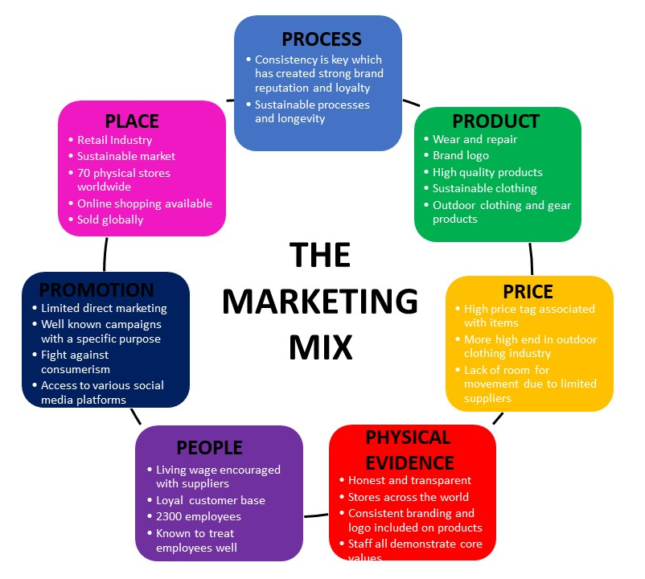
Figure 1

2.4 Marketing Media & Their Success

Campaigns and Messaging
To capture their target market, Patagonia Inc utilise a consistent way of communicating and engaging with their customers. Their messaging is consistent, they have retained their branding and logo throughout their lifecycle and have always remained transparent regarding the production of their products. They have created some extremely innovative and unique campaigns such as 2016’s Black Friday where they promised to give all the revenue generated to groups aimed at protecting the environment and the ‘Don’t Buy this Jacket’ (Deshmukh,2021) as seen in Figure 2. This campaign was in response to consumerism which Kotler (1971) defines as ‘a social movement seeking to augment the rights and power of buyers in relation to sellers.
Figure 2
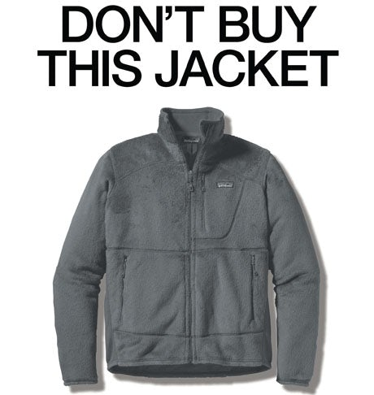

The message of anti- consumerism is apparent across interviews, their website, and instances of engagement with their customers. Kotler (1971) stated that those who adopt this approach are likely to reap the rewards. The result of both campaigns accurately reflects this statement with both campaigns going beyond anticipation and increasing Patagonia’s sales by a significant 30% (Deshmukh, 2021). The intended purpose of this campaign was to discourage individuals from buying large numbers of clothing and to only buy what was needed (Allchin, 2013). This unconventional campaign of sharing all the reasons to not purchase a product is rarely adopted and could be described as a strategy known as de-marketing which is where organisations discourage consumers from buying. This can often be used a differentiation strategy (Gerstner, Hess and Chu, 1993) or on the contrary, Hepburn (2013) shares that this could be viewed by some as double greenness, where individuals are buying into something that Patagonia are trying to move away from. This is a fine line that Patagonia need to be aware of when launching campaigns similar to this.
Digital Marketing Methods
Patagonia host a main company website as well as Facebook, Instagram and Twitter accounts however despite this they still struggle to increase their online sales (Business Strategy Hub, 2020). This poses the question over whether Patagonia’s lack of social media presence will inhibit them from growing any further as a company. All businesses should be recognising the impact whether that be positive or negative that social media is having on their business. An article by Brannon (2022) found elements of their website to be useful, however it lacked interactivity and engagement from consumers or other companies. The benefits of interacting with others is discussed by Jobber (2019) who advised that the more people that are including within the social media community, the higher the likelihood that they will interact together which subsequently results in a much more interesting experience for all involved.
Countering some of the negative findings, some feel that Patagonia’s approach to social media is appropriate in that they utilise a variety of platforms, they use different accounts for different locations in the world and they use photographs produced by their customers on their website to increase the community spirit. sense of belonging to the brand and also their values are splattered all over their pages. People are loyal to the brand and not the product and this is clear (McGowan, 2019).
A recent YouTube video (Exposure Ninja, 2022) took an in-depth look at their approach to social media and website and their main findings have been summarised below in Figure 2. It provided a balanced viewpoint and reflected the opinions of both McGowan (2019) and Brannon (2022).

Figure 3
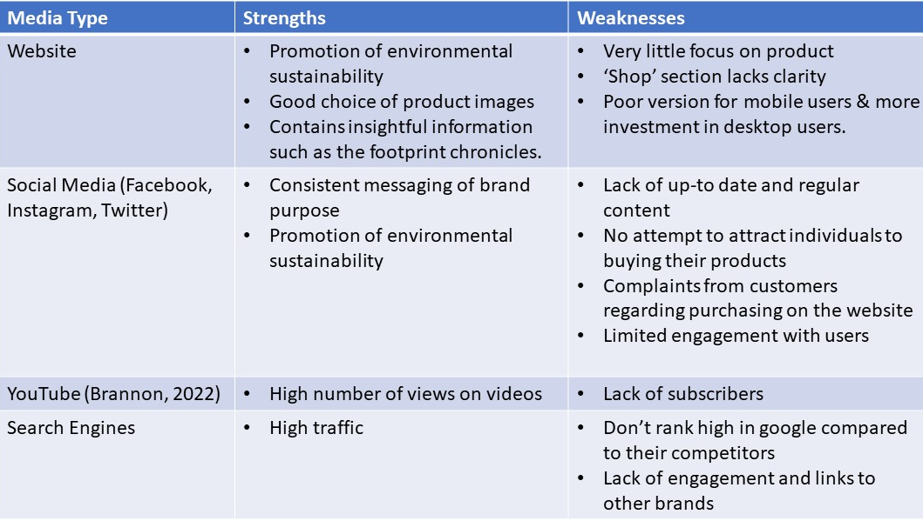
From the above, there is recognition that their poor presence on social media is potentially having a detrimental effect on the customer experience of their current long-term customers as well as potential new ones. Would receiving complaints on your social media be enough to evidence and introduce change?
The video also revealed that Patagonia don’t access tik Tok which is a trend setting application accessed by a wide user group that they have the potential to target. Jobber (2019) highlighted an excellent example of a retail company who have fully invested in the digital world and the benefits that this has brought for them. Gucci’s approach covers all platforms, and their online store has been highly complimented. Taking into account the differences in product but is this an example that Patagonia could take some lessons from being in the same industry.
Alike with many other areas of business, there has been a shift towards utilising digital methods as opposed to/in conjunction with traditional methods and this is also relevant for marketing. Many demographics are digitally advanced with technology playing a central role in many aspects of day to day lives (Pichler, Kohli and Granitz (2021). Research shows that the amount of individuals purchasing online is increasing rapidly with the highest numbers reported in the 25-54 demographic (Balasescu and Balasescu, 2020). One can only anticipate that post covid pandemic that this has increased tenfold.
Advances in digital technology have enabled companies to implement developments and streamline processes, it’s just a different way of getting to the end goal. Patagonia need to maximise the benefits that digital applications have to offer and in order for companies to be successful Jobber (2019) suggests that marketing strategies should be incorporating both web and mobile based applications.
From the identified marketing media, there is clearly more of a focus on the environment, but should their digital performance be sacrificed in light of this (Exposure Ninja,2022).
Environmental and responsible approach
Members of the retail industry are trying their best to improve the impact that their business is having on the environment, however the rate of consumption and fast fashion is moving quicker than they can operate (Niinimaki et al., 2020). From the literature that has been explored, Patagonia’s continued emphasis and approach to sustainability, environmental protection and producing high quality products is widely complimented. This forms the basis for the majority of their marketing activities, selling of products and engagement with the community. Being able to apply this successfully is commendable as Jobber (2019) states that sustainability is one of the biggest challenges for marketers in the 21st century. However, with all organisations having to be carbon neutral by 2050 as per the Paris agreement (United Nations, 2022) other competing brands such as The North Face (The North Face, no date) are now developing their own sustainable ranges. How are Patagonia going to be able to have the competitive edge?
Patagonia will often prioritise the environmental strand of their brand over other competing aspects which was recently demonstrated when they decided to cease production of their products that included additional corporate logos due to the subsequent impact that adding an additional logo to their garment creates (Gilbert, 2021). This attitude was also reflected in their response to a governmental action to remove the protected status of land which resulted in them suing the Trump administration and suspending all Facebook and Instagram activity (Deshmukh,2021).

3. Conclusion

The review of Patagonia’s marketing strategy has revealed some interesting approaches in this area of business and proven that being different can truly be effective with their methods of marketing being described as ‘completely opposing other company’s’ (Deshmukh,2021). They have gained success in innovative and creative campaigns with the company reaping unanticipated but significant rewards. Patagonia Inc. have demonstrated that taking risks really pays off.
The analysis illustrated that although their current target market is quite varied and expanding it does not include the generation z demographic, which research shows to be the most environmentally friendly focused generation. Segmenting the marketing also highlighted the importance of segmenting green and non-green consumers. Patagonia Inc. do not have a strong social media presence and their website lacks clarity for shoppers, therefore moving forward there needs to be a focus on improving online sales and engaging in social media in line with the speed that digital marketing is progressing.
They have undoubtedly demonstrated that their continued commitment to their core values and building a community is one of the key reasons for their success today. With the retail industry receiving substantial criticism over their approach to be being environmentally friendly, ethical and socially appropriate, Patagonia are driving the way forward and setting a high standard for other companies aiming to be sustainable.
It has however raised the question over whether this continued commitment to environmental issues is at a cost of something else and will this eventually hinder their potential future growth as the number of competitors within the market increase and legally having to make their own contribution to becoming environmentally friendly. How are they going to differentiate themselves from the rest of the market, also considering in a time that is experiencing a cost-of-living crisis and fast fashion is being encouraged everywhere you look. Is having a strong brand loyalty, honest and transparent approach going to be enough for the future.

4. Recommendations

Following the analysis of Patagonia’s marketing activity, a marketing plan has been devised that targets the key areas for improvements and suggested ways of addressing previously identified issues. The SOSTAC model has been followed which incorporates – Situation Analysis, Objectives, Strategy, Tactics, Actions and Control (Evans,2022). Consideration has been taken towards available budget and the probability that the plan will need to be continually reviewed as according to Balasescu and Balasecu (2020) the marketing environment is constantly changing and is becoming difficult to control. In terms of measuring success, not everything is quantitative but qualitative such as customer feedback and experience.

5. Reference List

“Don’t Buy This Jacket” – Patagonia’s Daring Campaign (2020) Available at: “Don’t Buy This Jacket” — Patagonia’s Daring Campaign | by Kenji Explains | Better Marketing (Accessed on: 15 June 2022).
Allchin, J. (2013) Case study: Patagonia’s ‘Don’t buy this jacket’ campaign. Available at: Case study: Patagonia’s ‘Don’t buy this jacket’ campaign (marketingweek.com) (Accessed: 15 June 2022).
Bălăşescu,M. and Bălăşescu, S. (2020) ‘Methods of analyzing and evaluating the marketing environment specific to online trading’, Proceedings of the International Conference on Business Excellence, 14(1), pp. 797–806. doi: 10.2478/picbe-2020-0076
Barbarossa, C. and De Pelsmacker, P. (2016) ‘Positive and Negative Antecedents of Purchasing Eco-friendly Products: A Comparison Between Green and Non-green Consumers, Journal of Business Ethics, 134(2), pp. 229–247. doi: 10.1007/s10551-014-2425-z.
Bhardwaj, V. and Fairhurst, A. (2010) ‘Fast fashion: response to changes in the fashion industry’, The International Review of Retail, Distribution and Consumer Research, 20(1), pp.165-173. doi: 10.1080/09593960903498300
Business Strategy Hub (2020) Patagonia Swot Analysis. Available at: Patagonia SWOT Analysis | Business Strategy Hub (bstrategyhub.com) (Accessed: 27 June 2022).
Brannon, A. (2022) Social Media Marketing Example #16: Patagonia. Available at: Social Media Marketing Example #16: Patagonia | Ignite Social Media (Accessed: 17 June 2022).
Camilleri, M. A. (2018) ‘Market Segmentation, Targeting and Positioning’, In Travel Marketing, Tourism Economics and the Airline Product, pp. 69-83. Available at: Microsoft Word - Market Segmentation Targeting and Positioning (um.edu.mt) (Accessed: 22 June 2022).
Camilleri, M.A. (2018) ‘The Marketing Environment’, In Travel Marketing, Tourism Economics and the Airline Product, pp. 51-68. Available at: Microsoft Word - The Marketing Environment (um.edu.mt) (Accessed: 15 June 2022)
Deshmukh, R. (2021) Patagonia’s Purpose Driven Marketing Strategy. Available at: Patagonia's purpose-driven Marketing Strategy - The Strategy Story (Accessed: 11 June 2022).
Errington, K. (2021) Marketing resources and capabilities for growth. Available at: Marketing resources and capabilities for growth (equinetmedia.com) (Accessed: 27 June 2022).
Evans,D. (2022) ‘SOSTAC Framework’ [PowerPoint Presentation]. BMMB7012: Marketing Management. University of Wales Trinity St David. Available at: https://uowtsd.sharepoint.com/:p:/r/teams/BMMB7012-MarketingManagement_GRP/Shared%20Documents/General/SOSTC-Recommendations%20Assignment%202.pptx?d=w3911ec29d1e14215a2ea50e4f88302b1&csf=1&web=1&e=ph2b1h (Accessed: 25 June 2022).
Exposure ninja (2022) Good ethics, poor digital marketing (Patagonia marketing analysis). Available at: Good ethics, poor digital marketing (Patagonia marketing analysis) - YouTube (Accessed: 17 June 2022).
Fahy,J. & Jobber (2019) Foundations of Marketing. Sixth edn. London: Mcgraw-Hill Education.
Fat Buddha Store (no date) Patagonia brand timeline. Available at: Patagonia Timeline - The History of Patagonia | Fat Buddha (fatbuddhastore.com) (Accessed: 11 June 2022).
Gerstner, E., Hess, J. and Chu, W. (1993) ‘Demarketing as a differentiation strategy’, Marketing Letters, 4(1), pp.49-57. Available at: Demarketing.pdf (uh.edu) (Accessed: 15 June 2022).
Gilbert, B. (2021) The finance bro uniform is officially dead as Patagonia stops adding corporate logos to its ubiquitous fleece vests. Available at: Patagonia No Longer Adding Corporate Logos to Its Clothing (businessinsider.com) (Accessed: 15 June 2022).
Hepburn, S. (2013) ‘In Patagonia (Clothing): A Complicated Greenness’, Fashion Theory: The Journal of Dress Body and Culture, 17(5), pp. 623–645. doi: 10.2752/175174113X13718320331035.
Jobber,D. and Ellis-Chadwick, F. (2019) Principles and practice of marketing. 9th edn. London: McGraw-Hill Higher Education.
Kotler, P. (1971) ‘What consumerism means for marketers’, Harvard business review, 50(3), pp. 48 – 57. Available at: HBRWhatconsumerismmeansformarketers-with-cover-page-v2.pdf (d1wqtxts1xzle7.cloudfront.net) (Accessed on 15 June 2022).
Law,J. (2016) ‘Demarketing’, A Dictionary of Business and Management. Oxford: Oxford University Press. Available at: https://www.oxfordreference.com/view/10.1093/acref/9780199684984.001.0001/acref-9780199684984-e-1849 (Accessed: 15 June 2022).
Lee, Y. (2020) ‘The Relationship between Green Country Image, Green Trust, and Purchase Intention of Korean Products: Focusing on Vietnamese Gen Z Consumers’, Sustainability, 12(12), pp. 5098–. doi: 10.3390/su12125098.
McGowan, V. (2019) How Patagonia is doing social media right. Available at: How Patagonia is Doing Social Media Right | by Victoria McGowan | Medium (Accessed: 17 June 2022).
Mialki, S. (2022) What is Demographic Segmentation with 5 Examples. Available at: What is Demographic Segmentation with 5 Examples (instapage.com) (Accessed: 22 June 2022).
Morin, C. (2020) Patagonia’s customer base and the rise of an environmental ethos. Available at: Patagonia's Customer Base and the Rise of an Environmental Ethos | CRM.org (Accessed: 15 June 2022).
Munerah,S., Koay, K. Y. and Thambiah, S. (2021) ‘Factors influencing non-green consumers’ purchase intention: A partial least squares structural equation modelling (PLS-SEM) approach’, Journal of Cleaner Production, 280. doi: 10.1016/j.jclepro.2020.124192.
Niinimäki, K. et al. (2020) ‘The environmental price of fast fashion’, Nature Reviews Earth & Environment, 1(4), pp.189-200. Available at: (PDF) The environmental price of fast fashion (researchgate.net) (Accessed: 27 June 2022).
Patagonia Inc. (2022) Give back. Available at: Environmental Activism - Patagonia (Accessed: 27 June 2022).
Petro, G. (2022) Gen Z and Sustainability: The Disruption Has Only Just Begun. Available at: https://www.forbes.com/sites/gregpetro/2022/02/18/gen-z-and-sustainability-the-disruption-has-only-just-begun/?sh=501a0033eb74 (Accessed: 22 June 2022).
Pichler, S., Kohli, C., & Granitz, N. (2021) DITTO for Gen Z: A framework for leveraging the uniqueness of the new generation. Business Horizons, 64(5), pp. 599–610. https://doi.org/10.1016/j.bushor.2021.02.021.
Rarick, C.A. and Feldman, L.S. (2008) ‘Patagonia: Climbing to new highs with a smaller carbon footprint’, Journal of the International Academy for Case Studies, 14(7), pp.121-124.
Reid, S. (2022) Cost-of-living crisis: Outlook for retail sector ‘increasingly bleak’ as consumers rein in spending. Available at: Cost-of-living crisis: Outlook for retail sector 'increasingly bleak' as consumers rein in spending | The Scotsman (Accessed: 27 June 2022).
Rogers, C. (2018) Patagonia on why brands ‘can’t reverse into purpose’ through marketing. Available at: Patagonia: You can’t reverse into purpose through marketing (marketingweek.com) (Accessed: 27 June 2022).
Robbins, D. (2022) Why Marketers Should Go Beyond Demographics – and How to do so. Available at: Why Marketers Should Go Beyond Demographics—And How To Do So Effectively (forbes.com) (Accessed: 22 June 2022).
Sublett, C. (2018) Consumer Profile. Available at: Consumer Profile - Patagonia Brand Audit (weebly.com) (Accessed: 11 June 2022).
Talbot, P. (2021) Best Practices for Marketing to Gen Z. Available at: Best Practices For Marketing To Gen-Z (forbes.com) (Accessed: 11 June 2022).
The North Face (no date) Recyle.Reward.Renew. Available at: Clothes the Loop (thenorthface.co.uk) (Accessed: 27 June 2022).
United Nations (2022) For a liveable climate: Net-Zero commitments must be backed by credible action. Available at: Net Zero Coalition | United Nations (Accessed: 27 June 2022).
Wessel, K. (2022) Three Tips for Building a Gen Z Marketing Plan. Available at: Three Tips For Building A Gen Z Marketing Plan (forbes.com) (Accessed: 11 June 2022).
White,K., Hardisty,D. and Habib,R. (2019) The Elusive Green Consumer. Available at: The Elusive Green Consumer (hbr.org) (Accessed: 21 June 2022).

6. Appendices

Appendix 1
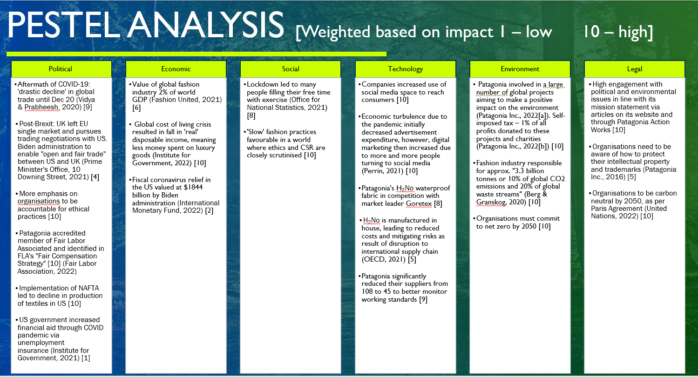

Appendix 2
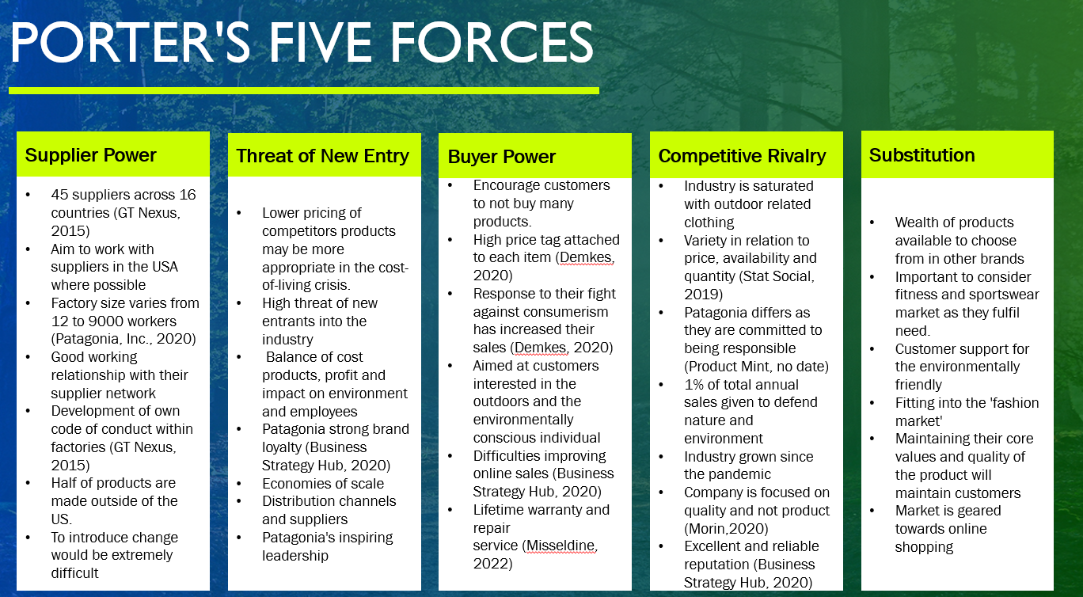
Appendix 3


