
HOTEL TRINITY

BRASSERIE
Hotel Trinity 15 Elliott St, West Swansea, United Kingdom
Contact: +44 2548 567677 Our Website: www.hoteltrinityswansea.com

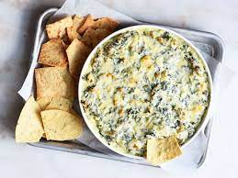  Appetizer | 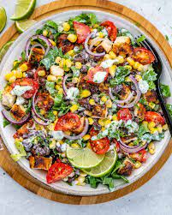  Salads
Spinach & Artichoke Dip  (gf) - £ 6 | Grilled Chicken Salad  sliced chicken marinated in our special sauce, then grilled to perfection. served atop crisp iceberg-£ 12
6 Piece Shrimp Appetizer  your choice of scampi, grilled, beer-battered, breaded, coconut or cocktail (v, gf) -£ 8  Starter of the day  Please ask the server -£ 10 | Grilled Steak House Salad  10 oz. steak, romaine lettuce, cucumbers, tomatoes and cheddar cheese-£ 15
 | Mediterranean Salad of cucumber, tomato & capsicum olives, Fetta with balsamic dressing-£ 20
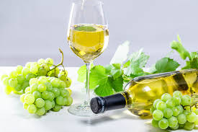  White Wine  Pinot Grigio, Monette, Veneto, Italy  250 ml-12 Bottle- £ 25 | Spring Cobb Salad  spring mix lettuce, ham or turkey, egg, cucumbers, red onions, tomatoes-£20
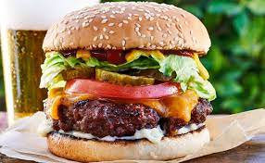
Burgers

SAUVIGNON BLANC, Brancott Vineyards, Marlborough New Zealand  250 ml: 15 Bottle- £ 32 | Angus Beef Burger-150g beef patty with bacon, cheese, beetroot, lettuce, Tomato, onion -£20  BBQ Pulled Pork & Slaw Burger  Pulled pork and BBQ sauce with cheese, house slaw on a milk bun- £25
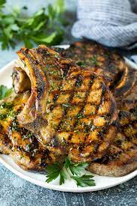
Mains

BBQ Pork Ribes-Served with choice of sides, slaw & seasoned skin-on and red wine flavoured
(gf) 22
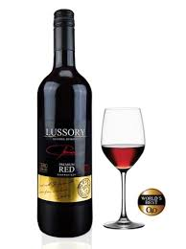
Red Wine
Sungiovese Rosemount Estates  Australia 250 ml-15 Bottle-£25 | Grilled Pork Sirloin with bacon mushroom and cream sauce - served with choice of sides-£25
Rioja, Ramon, Bilbao  Spain 250 ml- 15 Bottle-£30 | Crumbed Chicken Schnitzel  Ham napolitana sauce and cheese-£30
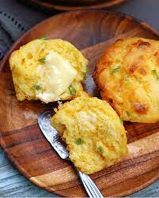  Sides | 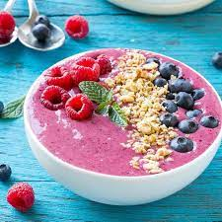  Smoothie Bowls
Red Roasted Potatoes-£ 5 | Snickers Smoothie Bowl  Banana, peanut butter, fermented protein powder, cacao nibs, chocolate sauce, cashew milk, coconut yogurt, activated chocolate-£20
Jalapeno Corn Muffins-£ 8  Chive Smashed Potatoes-£10 | Acai Smoothie Bowl Acai berry with banana, coconut water, coconut yogurt, activated deluxe burkinis, seasonal fruit-£15
 | Green Goddess Smoothie Bowl Banana, mango, spinach, medjool date, cashew milk, raw greens, coconut yogurt -£18

Please order your food and wait a bit as we prepare everything fresh. We assure our customers that our food and cooking is completely free of allergens and safe. However, if you have any special dietary issues, please let your server know.
We only accept contactless payment through cards and apps.
gf - Gluten Free | n - Nuts | vg - Vegan
References:
Ozdemir, B. and Caliskan, O., 2015. Menu design: A review of literature. Journal of Foodservice Business Research, 18(3), pp.189-206.
Reale, S. and Flint, S.W., 2016. The impact of menu label design on visual attention, food choice and recognition: An eye tracking study. Journal of Sensory Studies, 31(4), pp.328-340.

