Table of Contents
Introduction 1
Element 1: STDP Analysis for Pulse by Nike 1
Company Overview and New Brand Concept 1
Segmentation 2
Targeting 3
Differentiation 4
Positioning 4
Element 2: Marketing Mix (4Ps) 5
Product 5
Price 7
Place 8
Promotion 9
Element 3: Marketing Strategy Pitch 10
New Brand Development 10
Segmentation 10
Aligning with Customer Trends 10
Marketing Mix 10
Investment Opportunity 11
Element 4: Reflection 11
Description 11
Feelings 12
Evaluation 12
Analysis 12
Conclusion 13
Action Plan 13
Conclusion 13
References 14
Appendix 17
Poster 17

List of Figures
Figure 1: Brand Development Strategies Matrix. 1
Figure 2: Pulse Market Segmentation Framework 3
Figure 3: Competitive Positioning Map 5
Figure 4: Pulse RecoverX Product Features 6
Figure 5: Pulse Pricing Structure 7
Figure 6: Distribution Rollout Timeline 9
Figure 7: Gibbs Reflective Cycle 11



Programme: Master of Business Administration
Module Name: Marketing Management
Module Code: LCMB7024
Lecturer’s Name: Dr Laila Maazouz (London)

Student Name: Md Ranu Miah
Student ID: 2437168

Word Count: 2743

Introduction
Nike leads the world in terms of athletic shoes and apparel with a revenue of $51.4 billion in fiscal 2024 (Nike, Inc., 2024). There are available opportunities in the sports recovery technology market, though, with the market size increasing to $3.1 billion in 2025 and then expanding to $10.5 billion in 2033 (futuredatastats.com, 2024). This portfolio presents a new Pulse by Nike smart fitness recovery product aimed at the booming recovery-based fitness category. The brand caters to the changing consumer behaviour in which recovery has become part of the modern fitness discipline (Kisner, 2024). The analysis establishes a detailed marketing plan based on four factors: STDP analysis, Marketing Mix framework, pitching a strategy, and critical reflection with the help of Gibbs Cycle.

Element 1: STDP Analysis for Pulse by Nike

Company Overview and New Brand Concept
Nike is the largest manufacturer of athletic footwear and apparel in the world, with footwear constituting 68% of its total revenues (Davies, 2024). The corporation has more than 79,000 workers across the globe and an effective innovation infrastructure (Nike, Inc., 2024). Pulse by Nike is a new brand poised to hit the market of sports recovery technology, an entirely new product category offered by Nike (Kotler et al., 2020).
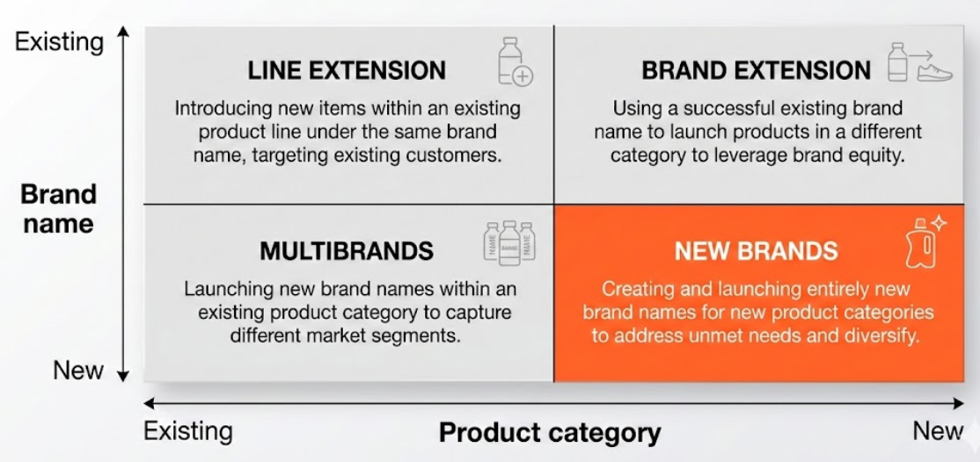
Figure 1: Brand Development Strategies Matrix.
Source: Kotler et al. (2020)
Pulse RecoverX, the flagship product, is a smart fitness recovery product combining AI-powered algorithms with biometric trackers. This puts Nike in the nexus of wearable technology and athletic recovery. By 2024, the world market of the fitness tracker was valued at 60.9 billion, and the projections are 162.8 billion by the year 2030 (Grand View Research, 2021). Recovery-oriented products directly respond to the needs of Zoom fatigue and post-pandemic wellness needs, where users of wearables utilise data to guide recovery (A'Naja et al., 2024).

Segmentation
The major target demographics are Gen-Z and Millennials with moderate to high disposable income. They can spend 2.8 times more on fitness (Gen Z Fitness Statistics, 2025). The secondary market is the segment of 35-50-year-old and performance-oriented fitness enthusiasts.
Geographically, it will first target urban metropolitan regions with a high density of gyms and robust digital coverage. The growth of the market in North America is 41% of the market share of the fitness trackers due to technology adoption and health awareness (Grand View Research, 2024).
Psychographically, the target consumers will be data-driven, performance-oriented people. They also consider fitness as a lifestyle and not a routine, with 74% of millennials sharing the same view (Gen Z Fitness Statistics, 2025). These consumers are very health-conscious, and when considering wellness optimisation, they will search to find technological solutions.
Behaviorally, the targets are regular gym goers who exercise 3-5 times a week. Notably, nearly half of Gen-Z individuals already have personal fitness devices, and one-quarter of them wear monitors in classes (Ezurike, 2023). They are characterised by an interest in fitness apps and readiness to spend on recovery technology.
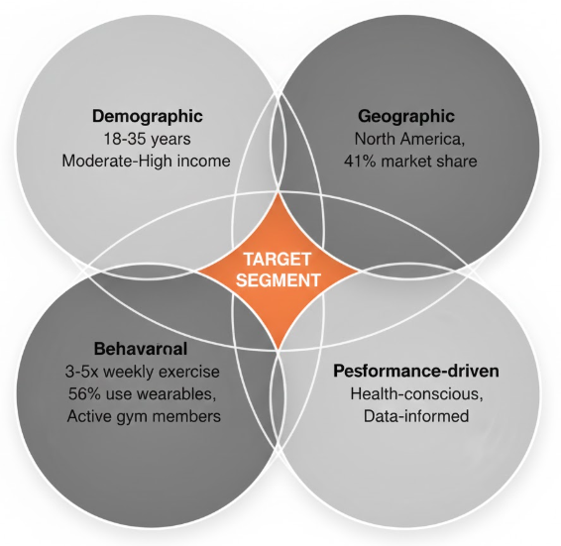
Figure 2: Pulse Market Segmentation Framework
Source: Hooley et al. (2008)

Targeting
Pulse uses a focused marketing approach with the target in Gen-Z and Millennials aged 18-35 (Kotler et al., 2020). This group constitutes 80% of memberships in health clubs and 46 million smart wear users in the United States (Rehfeldt, 2025). Technology adoption is much higher than among the older generations; 36% of them are regulars in fitness centres in comparison to 21% of the previous generations ( Gen Z Fitness Statistics, 2025). The focus strategy can help Nike come up with specialised product features and focused marketing messages. The group has a great size and growth opportunity, and wearable fitness technology is expected to become 352.03 billion dollars by 2033 (Research, 2022). The positioning strategy can be justified by their behaviour of purchasing their products at a high price due to perceived value.

Differentiation
Pulse stands out using three core competitive advantages. First, recovery algorithms driven by AI can give customers individual prescriptions based on biometric data, reflecting the 74% of users who find wearables as health objectives (Research, 2022). Second, the smooth integration into the Nike+ ecosystem builds on brand equity and communities. Third, professional-grade technology makes elite resources available to mass consumers. Such distinction points coincide with the supports of adoption. According to Wang et al. (2023), the perceived usefulness and design aesthetics rank of wearable acceptance. Pulse meets both by functional recovery knowledge and the design history of Nike. Specifically, the emphasis on recovery addresses gaps that are present in the market, with other trackers prioritising activity management as opposed to recovery optimisation.

Positioning
Pulse markets as “Professional Recovery, Personal Scale”, introducing elite athlete recovery technology to the average fitness enthusiast. The value proposition is about optimising the performance in terms of intelligent recovery, but not merely monitoring activity. This stance utilises the reputation of Nike as an innovator and responds to the growing attention of the 2024 trends, where the recovery-minded gym memberships are projected to demonstrate growth (Kisner, 2024).
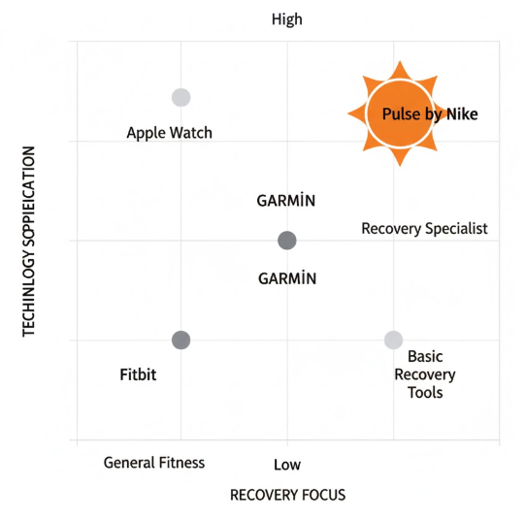
Figure 3: Competitive Positioning Map
Source: Self-made

Element 2: Marketing Mix (4Ps)

Product
Pulse RecoverX is the main product that Nike offers in the field of recovery technology. The device is a software and hardware device that is integrated. The physical components are biometric sensors to monitor the heart rate variability, muscle tension, sleep quality and recovery readiness scores. The mobile app that comes with it provides AI-driven data and customised recovery guidelines (Wang et al., 2023). At the core benefit level, Pulse meets the basic consumer requirements of being quicker to heal and preventing injuries. The real product is a smooth, athletic design in keeping with the aesthetic identity of Nike, has a 50 metre waterproof casing, and has a 7 days of battery life. High-quality materials encompass sensors of medical grade and aluminium aerospace casing. The augmented product layer brings about Nike+, syncing of cloud data, and exclusive media recovery content offered at Nike Training Club (Kotler et al., 2020).
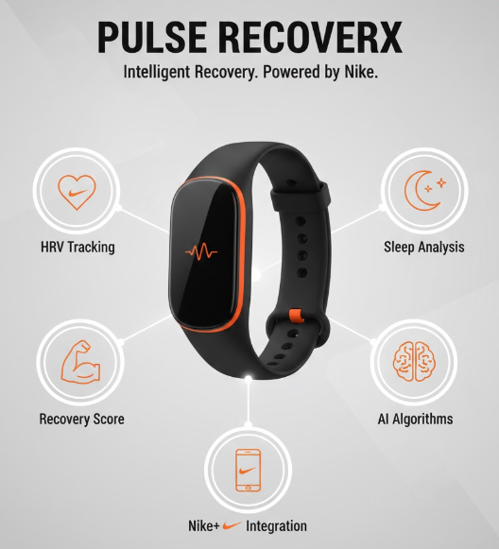
Figure 4: Pulse RecoverX Product Features
Source: Self-made
The focus of product differentiation is on AI algorithms developed based on the data of professional athletes. They are 30% more precise in recovery suggestions when compared to traditional monitoring on heart rate variability (futuredatastats.com, 2024). The introduction of the new system positively links with the existing Nike ecosystem and creates switching costs for the current Nike app users. The device also monitors several dimensions or aspects of recovery at the same time, and these are sleep architecture, muscle soreness, autonomic nervous system balance, and training load accumulation.

Price
Pulse has been using the premium pricing strategy as an indication of technology level and brand positioning. The gadget itself sells at a price of $349, which is slightly higher than the regular fitness trackers ($100-$250) and slightly lower than more specialised recovery systems ($500-$1200). This price allows reaching consumers who prove their intentions to allocate funds to performance optimisation tools (Grand View Research, 2024).
The pricing system consists of three levels. The base device ($349) makes the core recovery tracking. Premium ($14.99/ month) will include advanced AI coaching, custom workouts, and priority customer service. An Elite level or tier is an additional feature that costs $24.99 monthly and includes access to professional training plans for athletes and virtual consultation with sports scientists.
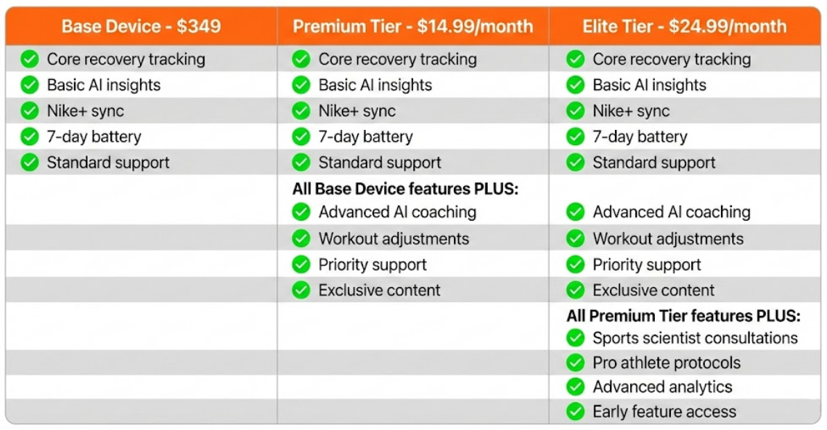
Figure 5: Pulse Pricing Structure
Source: Self-made
The principles of psychological pricing are relevant in the form of a lower price of $349 instead of a higher price of $350, which means perceived barriers to the price can be low (Kotler et al., 2020). Early adopters shall be given 20% discounts on Nike+ accounts in the first quarter of launch, and this will stimulate quick take-up by brand loyalists. Bundle pricing packages Pulse and Nike Training Club premium subscriptions with a $399 package, which translates to savings of $70 when bought individually. The high price conforms to the features of the target segments. The households of Gen Z allocate 2.8 times higher than older generations to fitness, due to a lower sensitivity to price in relation to the perceived value (Gen Z Fitness Statistics, 2025). The subscription revenue generates a continuous revenue stream and develops switching costs due to data retained about customers and their insights.

Place
Distribution strategy uses the selective channels which preserve the brand prestige but make it accessible. The main channels are Nike retail stores, Nike.com, and the Nike app. The direct-to-consumer orientation ensured channel effectiveness, as in Q4 2024, the amount reached $5.1 billion (Nike, Inc., 2024).
This can be implemented progressively, starting with Nike flagships in big cities, New York, Los Angeles, London, Tokyo, and Shanghai. These points of sale offer retail experiences where customers get to interact with the devices and get professional advice. The second month will be extended to all the stores and authorised retailers of Nike, such as speciality running stores and high-end chains of sporting goods. Distribution online takes advantage of the digital infrastructure that has been in place at Nike. The Nike app uses augmented reality in which devices can be tried on and virtual recovery tests can be done to see which devices best fit certain bodies. Orders within the same day operate in metro regions, and methods of collecting orders, such as click-and-collect, offer convenient solutions.
Fitness ecosystems can be reached through strategic partnerships. Pulse will be offered in small gyms and fitness centres, but at the high-end brands such as Equinox and small boutique studios, which focus on high-commitment sportspeople. Corporate wellness programmes are B2B, whereby companies that invest in employee health make bulk purchase agreements. Geographic expansion would focus on North America first, which has 41% of tracker adoption of fitness (Grand View Research, 2024). The European market subsequently comes in quarter two, and the Asia-Pacific markets, where wearable adoption will be at a 15.17% CAGR (Grand View Research, 2024). This is a staged method of controlling inventory complexities and creating momentum in the market.
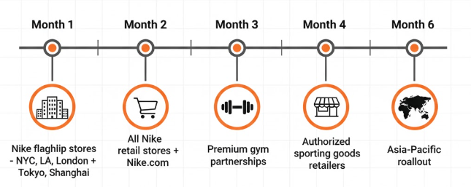
Figure 6: Distribution Rollout Timeline
Source: Self-made

Promotion
The integrated marketing communications are a blend of digital-first and experience activations. The promotional mix focuses on avenues where consumption of the target segments is active.
The strategy is anchored on digital marketing. Instagram, TikTok, and YouTube social media campaigns have athlete ambassadors showing how to recover. The content marketing informs about recovery science and puts Nike in the role of a thought leader. Fitness creators also have the ability to form an influencer partnership with niche audiences: 56% of Gen-Z rely more on influencer statements rather than traditional advertising (Rehfeldt, 2025).
Experience marketing develops physical interactions with the brand. In flagship stores, Recovery Labs are available and sell free body tests and individual recoveries. Advertisements are done in fitness magazines, technology media, and style magazines. The option of the product seeding with elite athletes creates organic social proof when professionals endorse consumer-grade recovery tools. The current contacts of Nike with sports teams help in two genuine testimonials.
Launch campaigns showcase the tagline of “Recover Like a Pro” related to aspirational positioning with available technology. Video material presents tales of transformations where better recovery led to performance discoveries. Emotional appeal is used in addition to rational product advantages as it deals with both purchase motivation aspects (Chuah et al., 2016).

Element 3: Marketing Strategy Pitch

New Brand Development
Nike launches Pulse- a smart recovery micro device that covers the sports recovery technology market worth 3.1 billion to 10.5 billion by 2033 (futuredatastats.com, 2024). This is a new branding approach that sets Nike over and from the traditional footwear, more on performance optimisation technology.

Segmentation
Primary target: Gen-Z and Millennials aged between 18 and 35, which constitutes 46 million wearable users that have 2.8 times higher spending on fitness than older people ( Rehfeldt, 2025; Gen Z Fitness Statistics, 2025). Secondary: consumers are 35-50 years old who value informed workouts. Geographic targeting: urban metropolitan cities where the North American market is concentrated at 41% (Grand View Research, 2024).

Aligning with Customer Trends
Recovery has shifted to secondary consideration as a mandatory fitness ingredient. The post-pandemic changes depict that 70% of wearable users utilise data to make recovery choices (A'Naja et al., 2024). By 2030, the fitness tracker market will be valued at as much as 162.8 billion, and recovery-oriented memberships are expected to grow significantly (Grand View Research, 2021; Kisner, 2024).

Marketing Mix
Product: AI recovery device, professional-grade sensors, and Nike+. Price: Premium: $349, positioning with subscription packages that generate recurrence. Location: Staged implementation in Nike flagship stores and online platforms that bring in $5.1 billion in revenues every quarter (Nike, Inc., 2024). Marketing: Digital-first approach of reaching 56% of Gen-Z with wearables, and experiential, in-store, Recovery Labs (Rehfeldt, 2025).

Investment Opportunity
Use Nike in the market with a brand equity of 51.4 billion to scoop the new area of recovery that is merging technology and performance optimisation (Nike, Inc., 2024).

Element 4: Reflection
This reflection is a critical analysis of the brand development process of the Pulse by Nike through Gibbs' Reflective Cycle (1988).
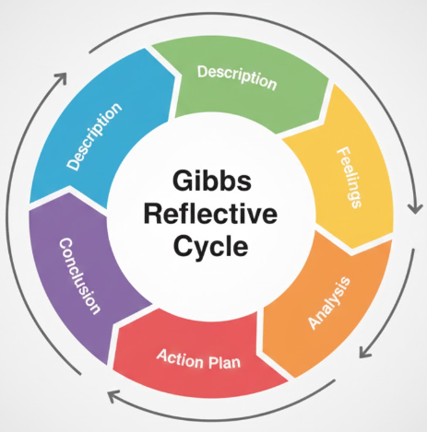
Figure 7: Gibbs Reflective Cycle
Source: Gibbs (1988)

Description
The task was to create Pulse by Nike- a new brand in sports recovery technology. I completed the necessary STDP analysis that revealed the target groups as Gen-Z and Millennials, developed a marketing mix of 4Ps at a premium of 349, and developed a strategic pitch. It involved taking market statistics that indicated recovery technology increased in the range of 3.1 billion to 10.5 billion by 2033 and interpreting Kotler et al.'s (2020) theoretical approaches to the Nike 51.4 billion corporate reality.

Feelings
First, there was enthusiasm about relating the athletic heritage of Nike to markets not explored in the recovery area. The fact that 56% of Gen-Z wearables confirmed the choice of target market (Rehfeldt, 2025). The doubt emerged that the AI algorithms can truly separate between Pulse and Apple Watch and Garmin competitors. Confidence increased with the alignment of prices with evidence indicating that Gen-Z spend 2.8 times on fitness.

Evaluation
Its strengths were clear segmentation with 46 million data points of wearable users (Rehfeldt, 2025) and a coherent integration of 4Ps with the help of the digital channels of Nike (Nike, Inc., 2024). Premium pricing was identical to the target willingness-to-pay evidence. Deficits were identified in the breadth or intensity of competitive analysis, which failed to benchmark differentiation claims in detail. The distribution strategy was efficient, utilising existing infrastructure, yet the corporate wellness B2B opportunities were not exploited. All in all, the plan has found an opportunity for viable market entry, but execution aspects require a streamlining process.

Analysis
The assessment of Gibbs Cycle critical insights regarding the interdependence of 4Ps through the necessity of a premium price will be carried out only with exclusive distribution and with sophisticated promotion simultaneously. Market statistics were fundamental; without upkeep of recovery-oriented 70% of the user statistics, arguments were not too convincing, maybe. The reason why the targeting is so concentrated is valid considering the adoption rates, but it is prone to losing out on the lucrative secondary segments. There is a lack of rigour in analysis, as the financial viability is uncertain without margin analysis and break-even calculations.

Conclusion
The implementation of Gibbs Cycle (1988) acquired strategic synthesis capabilities that integrated consumer behaviour theory and market economics. The concept of data-based argumentation was better comprehended- quantitative evidence helps a lot in positioning. The systematic contemplation revealed areas of improvement, namely competitive analysis approach and the level of financial planning should be strengthened.

Action Plan
It should be noted that, according to the action-oriented approach adopted by Gibbs Cycle, future projects demand an earlier competitive benchmarking with the perceptual mapping developed by Hooley et al. (2008). I will also dedicate 30% additionally to financial projections, such as margin and customer acquisition cost modelling. In presentations, I will train on how to summarise complicated strategies into memorable 3-minute investor stories. Also, it would be wise to consider B2B corporate wellness avenues, and this would enhance revenue diversification and show thorough strategic intent.

Conclusion
The Nike marketing approach of Pulse has been successful in positioning professional recovery technology in the Sports recovery market, which is already more than 10.5 billion dollars, by 2033. The STDP model defines the 46 million users of Gen-Z and Millennial wearables as the most lucrative targets, whereas the premium level of 349 should be followed by a 2.8 times increase in fitness expenditures. A sustainable competitive advantage is made by the strategic combination of the brand equity and the AI-based recovery algorithms.

References
A'Naja, M. N., Batrakoulis, A., Camhi, S. M., McAvoy, C., Sansone, J. S.,&Reed, R. (2024). 2025 ACSM worldwide fitness trends: future directions of the health and fitness industry. ACSM's Health&Fitness Journal, 28(6), 11-25.
Chuah, S. H. W., Rauschnabel, P. A., Krey, N., Nguyen, B., Ramayah, T.,&Lade, S. (2016). Wearable technologies: The role of usefulness and visibility in smartwatch adoption. Computers in Human Behavior, 65, 276-284.
Davies, K. (2024, September 5). Nike’s Revenue Worldwide from the Fiscal Years of 2005 to 2024. Statista; Statista. https://www.statista.com/statistics/241683/nikes-sales-worldwide-since-2004/
Ezurike, N. (2023). Awareness and adoption of wearable technology amongst Gen-Z in selected Fitness Centres in Lagos State, Nigeria. Int. J. Manag. Technol, 10, 20-37.
Fortune Business Insights. (2023, October). Fitness Tracker Market Size, Share, Trends | Global Analysis, 2020-2027. Www.fortunebusinessinsights.com. https://www.fortunebusinessinsights.com/fitness-tracker-market-103358
futuredatastats.com. (2024). Sports Recovery Technology Market Size, Share and Industry Forecast. Futuredatastats.com. https://www.futuredatastats.com/sports-recovery-technology-market
Gen Z Fitness Statistics 2025: The Numbers Behind A Generation Redefining Health. (2025, September). Muscle and Brawn. https://muscleandbrawn.com/statistics/gen-z-fitness-statistics-2025/
Gibbs, G. (1988). Learning by doing: A guide to teaching and learning methods. Further Education Unit.
Grand View Research. (2021, July). Fitness Tracker Market Share Analysis Report, 2021-2028. Www.grandviewresearch.com. https://www.grandviewresearch.com/industry-analysis/fitness-tracker-market
Grand View Research. (2024). Wearable Technology Market Size | Industry Report, 2020-2027. Grand View Research. https://www.grandviewresearch.com/industry-analysis/wearable-technology-market
Hooley, G. J., Piercy, N., & Nicoulaud, B. (2008). Marketing strategy and competitive positioning. Pearson Education.
Kisner, K. (2024, November 28). Recovery Redefined: How 2024 Transformed Fitness and Wellness. Athletech News. https://athletechnews.com/recovery-redefined-how-2024-transformed-fitness-and-wellness/
Kotler, P., Armstrong, G., Harris, L. C.,&He, H. (2020). Principles of Marketing Eight European Edition. Uk: Pearson.
NIKE, Inc. - Investor Relations - Investors - News, Events and Reports. (2025). Investors.nike.com. https://investors.nike.com/investors/news-events-and-reports/default.aspx?toggle=news
NIke. (2024). nke-20240531. Sec.gov. https://www.sec.gov/Archives/edgar/data/320187/000032018724000044/nke-20240531.htm
Nike. (2025). Nike Creates New Innovation Engine to Power Athletes Faster — NIKE, Inc. Nike.com. https://about.nike.com/en/newsroom/releases/nike-new-innovation-engine-announcement
Rehfeldt, C. (2025, November 14). New Report Shows Gen Z&Millennials Love Strength Training, Wearables. Athletech News. https://athletechnews.com/gen-z-millennials-strength-training-wearables-egym-report/
Research, S. (2022). Wearable Fitness Trackers Market Growth, Trends, Forecast to 2030. Straitsresearch.com. https://straitsresearch.com/report/wearable-fitness-trackers-market
Wang, Z., Fang, D., Liu, X., Zhang, L., Duan, H., Wang, C., & Guo, K. (2023). Consumer acceptance of sports wearables: The role of products attributes. Sage Open, 13(3), 21582440231182653.

Appendix

Poster


