Assignment Title: Assessment 2
Environmental Analysis of an industry

Programme: BA Business Management
Module: The Global Business Environment

Student ID:
Student name:

Contents
Introduction 3
Impact of the pandemic 4
Decreasing vehicle sales 4
China parts issues 4
Production of new cars 4
Cyclical impact from higher unemployment 5
Demand for electric vehicles 5
Supply chains be adjusted due to Covid-19 5
Survival and success factors 6
Megatrends 6
Recommendations 7
Conclusion 9
Reference list 9

Introduction

There is maybe no any industry apart from the medical which is seriously impacted from the pandemic. The damages are not only for short term and we will be witnesses for impact in the next at least five years. Only for the 2020 nearly every country across the globe lost average 3% of the GDP. Other serious issue is the inflation which impact every country despite the level of the pandemic the inflation issues impacted the average spend and people incomes with very strong levels. The automobile industry is one of the most suffered and with high damages industry, because of the pandemic stress and challenges people stop spending high value purchased which impact immediately the company net profit (Machlica,2021).

Figure 1
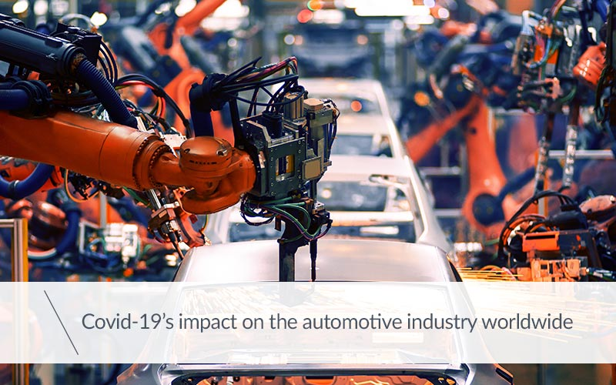
(Yeh,2021).

Impact of the pandemic
The major areas such as global supply chains, trade, agriculture industry, automotive industry, electronic industry, travel, transportation and tourism industry, and so on have been severely disrupted because of the outbreak of COVID‐19.
The COVID19 epidemic has wreaked havoc on the global economy and humanity. The governments of all countries have imposed a nationwide lockdown in an attempt to contain the pandemic. Although the quarantine may have helped to contain the disease's spread, it has had a devastating impact on the country, disrupting entire value chains in the country's most important industries. The epidemic is having a significant impact on all aspects of industry, including the automobile sector, with key manufacturers either closing completely in response to local government orders or operating with the bare minimum of staff at manufacturing units to ensure the safety of their employees (Yeh,2021).

Decreasing vehicle sales
Due to the COVID19 the customers spending decreased dramatically and this lead to significant decreasing of the automobile sales and companies profit in the industry. Many high profile auto brands decreased the car production levels as respond of the decreasing the customers demand. The China plans were to produce in next one year over 30 million cars, but was hit and completely changed with the covid19 pandemic (Shanmuganathan,2021).

China parts issues
China is the highest parts manufacturer worldwide for auto parts for many different brands and companies. The pandemic decreased and set serious challenges for the parts production worldwide due to the restrictions and the social distancing. This issues set serious challenges in front of the auto brands like Toyota, Mercedes, Lexus, Audi, Honda, Range Rover and many others which normally have high level of sales and profit (Yeh,2021).
Chine market contributing up to 40% of the world cars production and the pandemic issues made serious negative impact over the global automobile market.

Production of new cars
The global GDP decreased with average 3% and with the combination with high inflation this lead the potential clients to postponing this type of expenses and to focus over the savings. This global customer behavior impact very negative way the car industry as even the credit option purchase decreased significant due to the increased inflation. The prices of all first need family items also increased significantly and with the combination of the risk of losing your job this one’s again made the decision of new car purchases canceled (Yeh,2021).

Cyclical impact from higher unemployment

Due to the fast changing environment the people behavior changed too and the individuals start returning to most preferring healthier way of life where they can cycling up to their work or up to their home with no cards involved at all. If we look even before the pandemic people trend start for cycling and now due to the lockdowns this trend start increasing even more and this impact negative the car sales in global measure, not only in UK (Shanmuganathan,2021).
Other trend decreasing and impacting negative way is the electrical scooters as this spread very quickly all across the world and many people start preferring this way of moving to work and back home so they don’t need second car which impact the car sales.

Demand for electric vehicles
Prices for the fuel increasing significantly every month and there is serious high taxation across the EU if you drive diesel car. All this seriously move the customers demand into hybrid and electrical cars. Currently this demand cannot be properly covered due to the high prices of the electrical cards and the expensive maintenance of this type of cars (Yeh,2021).
The process of moving to hybrids and electrical cars will continue and will keep increasing the volume of thiscars within the market. This process negatively impacting the automobile industry due to increased fuels, expensive cost electrical cars and the people start looking for other solutions (Shanmuganathan,2021).

Supply chains be adjusted due to Covid-19
Due to the decreased sales the market reacts and shrinks the supply chains, because the companies start focus over decreasing the loss and damages due to the pandemic. Due to the and above issues we can see from the figure 2 below that during the 2020 is the highest percentage of shrink for the last 20 years.

Figure 2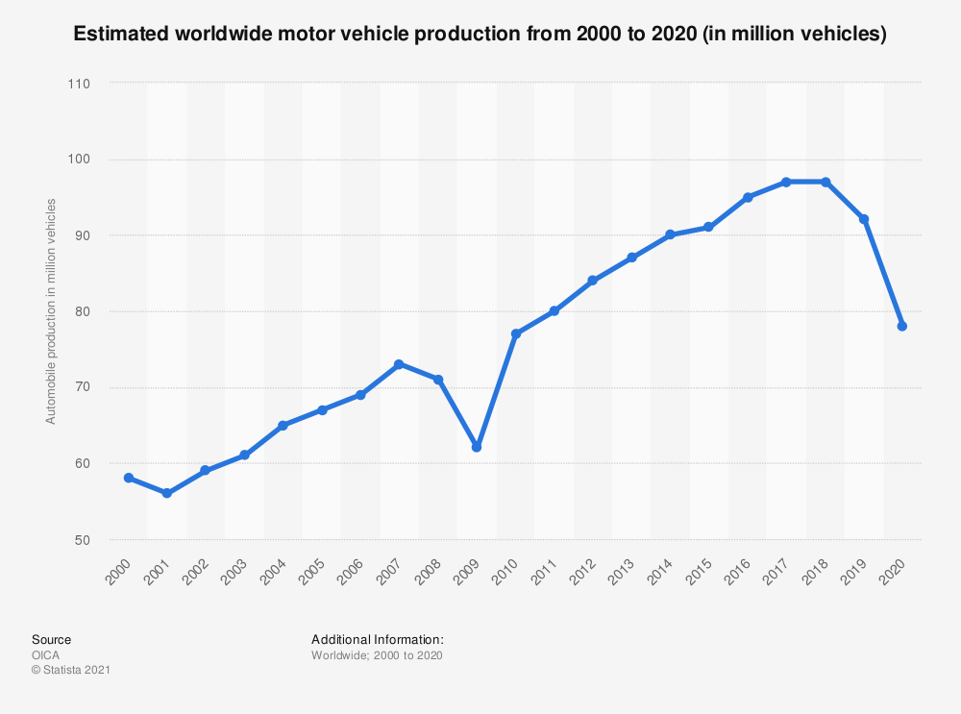
(Chakraborty,2021).

Survival and success factors

We anticipate that the automotive sector's regeneration from pandemic recessions will truly begin in 2021. After light-vehicle sales in the United States fell far short of expectations in 2020 (14.6 million versus our initial prepandemic estimate of 16.5 million), we anticipate a low-double-digit percentage growth to 16.0 million-16.2 million in 2021.
On a worldwide scale, we anticipate a 9 percent -13 percent revival in light-vehicle supply in 2022, following a 15% decline in 2021. The ongoing COVID-19 consequences provided a few forecasting difficulties, so we kept our prediction range two percentage points broader than usual to account for ongoing COVID-19 uncertainties and supply chain restrictions due to a microchip limited supply.
The most brand names like Toyota, Mercedes, Audi, Lexus start producing the hybrid and electrical models in order to catch up the Tesla success, but with much more affordable prices. These innovations can support the more efficient and productive market and industry recovery in next five years (Shanmuganathan,2021).

Megatrends
Below we will describe and explain the automobile megatrends which are increasing significantly for the last two years:
Autonomous Vehicles
With the Tesla models where the driver can sleep and the car is moving from in advance set point one to point two on his own, this seriously rise the level for all other popular high brands like Mercedes, Audi, Toyota and all others in the auto market (Mor,2021).
Connectivity, Electrification, Shared Mobility, Artificial Intelligence, Big Data & Data Analytics, Human-Machine Interface and Block chain.
Figure 3

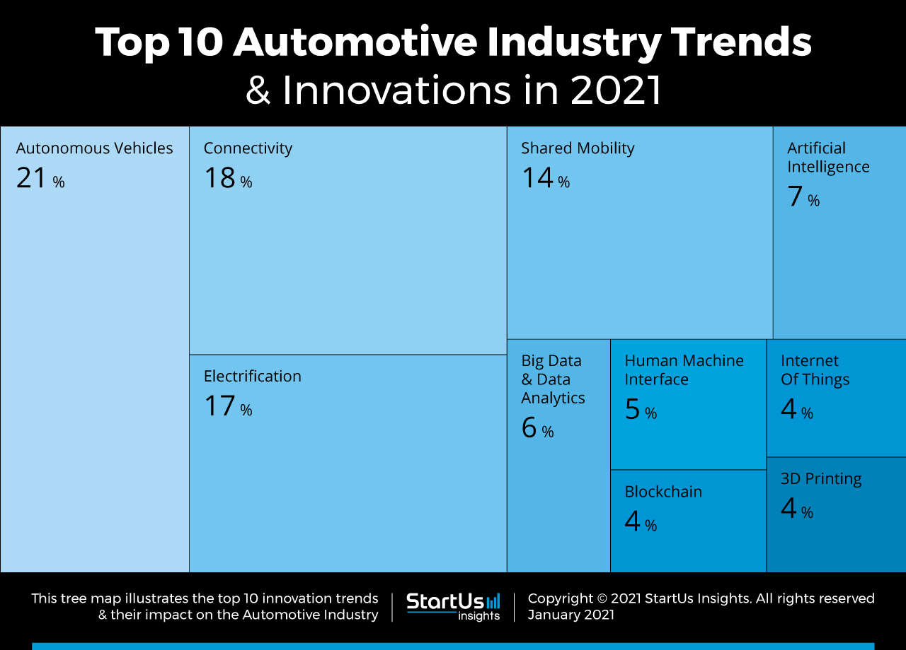

(Yang,2021).

Recommendations

Based over the challenges below the recommendations are:

- Focus over demand for innovations
- Focus over demand for saving the climate and environment
- Improving the electrical cars availabilities and people awareness from the benefits
- Working over reducing the price of the electrical cars in order to make them more affordable.
- Offering better deals and conditions for the hybrid and electrical cars
- Giving the options more flexible for the owners of old cars to return them for parts and to take monthly payments for purchase of new car (Strupczewski,2021).
- Improving the quality of the parts
- Decreasing the prices for new cars purchases in order to motivate people to spend and buy second or third car in the family.
As per a research firm Bernstein, the worldwide number of vehicles on the road and kilometers flown in airliners will well almost double by 2040.
Cars are expected to hit two billion by 2040, while air transport kilometers are expected to hit 20 trillion during that time frame.
Bernstein predicts that the majority of this transportation growth will occur in emerging economies such as China and India, as world's population is likely to increase with another two billion within next 25 years to 9.2 billion.
We can see from the above data how huge are the automobile industry and market and the only way this predictions to be achieved is focus, smart decisions and keep following the new innovations and trends in order to fulfill the people demands and needs.
The high brands like Mercedes, Audi, Honda, Toyota need to focus over future innovations and new electrical cars as this will be demand for the new year plus the TESLA self-driven cars which need more improvement and growth.
Cars are an essential part of most American households' daily lives. Including the us Department of Transportation, there really are 276 million cars registered in the United States. In fact, 91 percent of people have access to a car, and research shows that the average American uses 101 minutes per day driving. Unlike public transport services, our automobiles provide a more private and secure expertise. Moreover, in an urgent situation when you don't have seconds to spare, your vehicle is easily accessible.

Conclusion

Automobile industry is having very serious impact over the world economics and the recovery process is of high importance for the world improvements and going back to normal sales and net profit from the 2019 levels. There is need of strict and serious actions and decisions which can improve the auto market so the recovery can be achieved with much more fast temps. Governments need to set supporting and effective decisions in order to support the customer purchase of new cars (Shanmuganathan,2021).

Reference list
Srinivasan, N. and Eden, L., 2021. Going digital multinationals: Navigating economic and social imperatives in a post-pandemic world. Journal of International Business Policy, pp.1-16.
Nayak, J., Mishra, M., Naik, B., Swapnarekha, H., Cengiz, K. and Shanmuganathan, V., 2021. An impact study of COVID‐19 on six different industries: Automobile, energy and power, agriculture, education, travel and tourism and consumer electronics. Expert systems.
Pal, S., Dey, B., Chattopadhyay, B., Samanta, S., Roy, D.S., Roy, T.D. and Chakraborty, S., 2021, February. Recent Developments and Future Scopes of Electrical Vehicles in Power Market on Covid-19 Pandemic situation. In Journal of Physics: Conference Series (Vol. 1797, No. 1, p. 012058). IOP Publishing.
Khan, S.A.R., Yu, Z., Umar, M., de Sousa Jabbour, A.B.L. and Mor, R.S., 2021. Tackling post-pandemic challenges with digital technologies: an empirical study. Journal of Enterprise Information Management.
Klonowska, A. and Strupczewski, G., 2021. What Can the Covid-19 Pandemic Change in the Global Insurance Business? Identification of the Major Challenges.
Klein, C., Høj, J. and Machlica, G., 2021. The impacts of the COVID-19 crisis on the automotive sector in Central and Eastern European Countries.
Chen, H.C. and Yeh, C.W., 2021. Global financial crisis and COVID-19: Industrial reactions. Finance Research Letters, p.101940.
Yang, J., 2021. Challenges and Opportunities for Touring Industry and New Energy Automobile Industry. In E3S Web of Conferences (Vol. 252, p. 03006). EDP Sciences.
Zhang, X., Li, Z. and Wang, J., 2021. Impact of COVID-19 pandemic on energy consumption and carbon dioxide emissions in China's transportation sector. Case Studies in Thermal Engineering, p.101091.
Belhadi, A., Kamble, S., Jabbour, C.J.C., Gunasekaran, A., Ndubisi, N.O. and Venkatesh, M., 2021. Manufacturing and service supply chain resilience to the COVID-19 outbreak: Lessons learned from the automobile and airline industries. Technological Forecasting and Social Change, 163, p.120447.
Barbieri, D.M., Lou, B., Passavanti, M., Hui, C., Hoff, I., Lessa, D.A., Sikka, G., Chang, K., Gupta, A., Fang, K. and Banerjee, A., 2021. Impact of COVID-19 pandemic on mobility in ten countries and associated perceived risk for all transport modes. PloS one, 16(2), p.e0245886.
Contractor, F.J., 2021. The world economy will need even more globalization in the post-pandemic 2021 decade. Journal of International Business Studies, pp.1-16.
Yang, J., 2021. Challenges and Opportunities for Touring Industry and New Energy Automobile Industry. In E3S Web of Conferences (Vol. 252, p. 03006). EDP Sciences.
Kaitwade, N., 2021. COVID-19 shatters global automotive industry; sales of metal powder take a nosedive amid wavering demand. Metal Powder Report, 76(3), pp.137-139.

