UNIVERSITY OF WALES
TRINITY SAINT DAVID

STUDENT: GABRIEL WITOWSKI
STUDENT NUMBER: 1916799
MOODLE: THE GLOBAL BUSINESS ENVIRONMENT
ASSIGNMENT: THE GLOBAL ENVIRONMENT- ASIGNMENT 1
LCBB4005-A1
PROGRAMME: BA BUSINESS MANAGEMENT
LEVEL 4/TERM 1/GROUP 3
LECTURER: SYED JAFFERY

Table of Contents
Introduction 3
Task 4
Conclusion 11
Reference list 12

Introduction
Understanding business environment is one of the major requirement for managing the operations and business activities of the organisation. In the current world of globalisation, there has been increasing number of competitors in every industry. In this study, discussion on the business environment of car manufacturing industry of UK shall be done with the use of Pestle and porter’s five forces model. In addition, critical assessment of challenges and opportunities related with car manufacturing company such as Aston Martin, which is a leading car manufacturer of UK will be done. Aston Martin is a British independent manufacturer of sports cars and others, which is founded in year 1913 having headquartered in Gaydon, UK (astonmartin, 2020).

Task
(a)Explain the major forces shaping the business environment of the car manufacturing industry. In your analysis, you should explain how the industry has changed in the last few years.
Car manufacturing industry is one of the best-known industries for sports car and premium cars. In year 2018, the industry is found to have a turnover of around £82 billion.
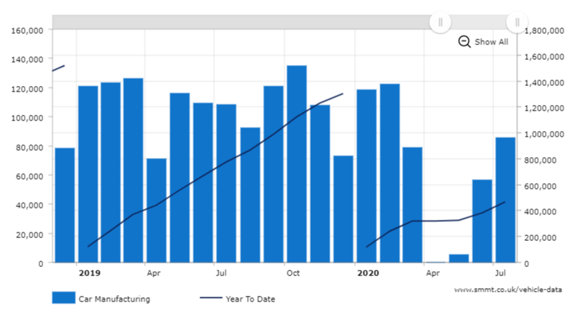
Figure 1: Changes in growth rate of car industry in the UK in past few years
(Source: smmt, 2020)
The port of SMMT (society of motor vehicles and traders) found that over 1,300,000 cars have been built in the UK in the year 2019 and around 14.7% cars are exported with 1,055,997 shipped in global areas (smmt, 2020). Hence, it can be analysed from the data that the car manufacturing industry has gone through a significant change in the UK market. However, car production in the UK has been down significantly in November with only 107,753 manufactured units as per the report of SMMT.
Pestle analysis of car manufacturing industry
Pestle is the tool that is used for evaluating the external environment of the industry by focusing on different macro factors. Below pestle analysis has been presented for UK car manufacturing industry.
Political: UK is found to have stable political environment with 0.05 political stability indexes as recorded in year 2018 (the global economy, 2020). On the other hand, UK is facing issues of Brexit uncertainties that have affected the growth rate of car production in last few years. One of the positive impacts on the manufacturers of car is that Tax rate of business has declined from 19% to 18% in 2020 (gov, 2020). In case of Aston Martin, it can be said that Brexit has created issues in gaining relevant suppliers for car manufacturing due to the exit of UK from the EU. This has brought declination in the sales and production level of the sports car in 2019.
Economical: UK is considered as 5th largest economic nation in the UK in GDP. However, current situation of Covid-19 has brought sudden recession in the car manufacturing industry. This has brought a major change in rate of unemployment, which implies companies such as Aston Martin is facing challenge in gaining employees. Inflation rate in the year 2019 was recorded as 1.79% that is quite low from year 2018 when it was 2.48% (Tightening and McMahon, 2020). This indicates the prices of cars has decreased that can help in increasing production rate of the companies. However, major lockdown has reduced the economic growth of car manufacturing industries.
Social:The customers of UK are found to have shift in their preferences, increasing disposable incomes, which has increased the demands for the luxurious cars. Moreover, population of UK is expected to increase up to 74 million by 2039, whichbrings a huge opportunity for car manufacturers in gaining potential consumers (Ons, 2020). Apart from this, 99% is the literacy rate of UK that implies consumers are having knowledge of luxurious car brands. Hence, companies such as Aston Martin are able to gain consumers as the vehicle market is found to have 14% growth rate in last 5 years.
Technological: UK is considered as one of the advanced technological nations in the entire world. Car manufacturing industry is focused on using technologies in their operations for developing competitive advantage in the market. UK government has supported companies with an investment of £28 billion in technology. For example, implementation of self-driving vehicle technology has helped this industry in creating better opportunities in business. Another example can be observed in Aston Martin, which shows the company has launched Electric future Event in 2019 by launching new products like Rapide E, electric sports cars because of having R&R and hybrid car technology (astonmartin, 2020).
Legal: Car manufacturing industry has developed new legislations and rules related to safety norms, which has helped in managing the sales and profit margins of the manufacturers. Compliance with policies, regulations of governments and others has helped in raising the capitals along with research costs of the companies. On the other hand, car manufacturers of UK are found to follow Companies Act 2006 for managing business policies (legislation, 2020). Hence, this has helped Aston Martin in following the regulations while manufacturing cars with reduced harmful emissions and fuels. Moreover, new and safety regulations are used in the product design for ensuring compliance and boosting the brand value of the companies.
Environmental: Ecological trends and chances are found to have direct impact on the supply chain, usage of product and resource availability (Youniset al., 2016). Factors such as changing climatic patterns, rising concerns on the effects of air quality because of automotive emissions are found to have negative impact on this industry. Hence, car-manufacturing industry of UK is focused on developing automotive solutions for managing the issues of changing climatic patterns. For example, Aston Martin is concentrating on different CSR initiatives and launching of electric cars that runs on battery to reduce the fuel emissions that are produced in the environment.
Porter’s five forces
With the use of porter’s five forces, the major forces related to the business environment of car manufacturing industry of UK have been explained below:
Bargaining power of suppliers: The suppliers of UK car manufacturing industry are having strong power as they offers quality raw materials and assemble parts, which are of great value. In this case, the suppliers of this industry are found to demand high prices for enhancing the quality and efficiency of the products and services (Khurramet al., 2020).
Bargaining power of customers: The power of customers is strong which are found to influence directly to the suppliers profitability in the market. Moreover, choosing clients becomes vital for car manufacturers. It is found that customers are quite choosy in buying cars and they demands for high quality and services which implies Aston Martin needs to satisfy them properly by using different convincing skills so that the buyers agree to purchase sport cars and others.
New entry threat: As per the analysis, it is found that new entry threat in the sector of car manufacturing is low because it takes much time to set business in this industry. Moreover, as Aston Martin is one of the leading companies, hence, it becomes tough for new entrants in developing similar reputation and size in the industry (astonmartin, 2020). Furthermore, cost of entry, raw material access and barriers associated with technical and cultural standards are having a strong position for managing decisions of the new entrants.
Substitution threat: The threat of substitution in the business of car productions are found to be high because there are many companies in the industry those are found to provide quality products to the consumers. The products delivered by Aston Martin are found to be developed with technological and innovation concepts. However, there are other companies, which are using similar concepts, which increase the threats of substitutions.
Rivalry threat: In the car manufacturing industry, the threats of competitions is huge because different companies such as Jaguar, Nissan, BMW, and others are found to focus on meeting the demands of latest requirements of customers. This shows that Aston Martin is having tough competition from these companies for managing their profit and sales level in the market. Rivalry among car manufacturers has improved in the past years due to the boost up in this industry since 2015. Manufacturing of vehicles in UK has reached 2 million in a year (carmagazine, 2020). In accordance to the market share in UK, Ford has acquired 9.37% and Volkswagen has obtained 8.55%. Toyota has 8.05% and BMW has achieved 7.32% in UK market (statista, 2020). Thereafter, industry rivalry is enhancing among car brand in these years.
Criticisms: Five factors in an industry are being chosen through the help of this model. However, it ignores the other aspects of the business organisation. Porter’s five forces ignore factors like consumer taste and changes in technology in Aston Martin. It cannot be applied on all kinds of industries as companies are not always a perfect fit in the industry (Max, 2018). Additionally, the framework compares Aston Martin with the overall car industry in UK hence; it can be difficult to ascertain the factors for attainment of competitive advantage of the organisation.
Product life cycle
Product life cycle is the attempt for recognising the stages of sales history related with the product. In this cycle, four different stages are found that are introduction, growth, maturity, and decline (Ali et al., 2019).
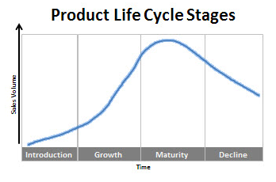
Figure 2: Product life cycle
(Source: Ali et al., 2019)
In case of car-manufacturing firm, Aston Martin, it is found that in the introduction stage, the company has focused on the use of effective marketing strategy. For example, in year 1913, the company was developed with a purpose of selling automobiles that was built by Singer. Gradually, the company improved their R&D for managing the needs of the consumers. In the growth stage mainly from year 1947, the company created new line of car models called DB such as DB2/4, DB4 and others, which helped company in reaching profit margins. In the next stage of maturity, the company has been able to establish new niches and sharpen ability of meeting delivery schedules by reducing the chances of developing defective product. Aston Martin is observed to have declination in the sales and profit margins because of increasing competitions where the company is advised to focus on acquiring new strategies for managing innovation.
(b) Provide a critical assessment of the opportunities and challenges that these forces present and discuss how firms can best position themselves to gain a competitive advantage.
SWOT analysis
SWOT is the internal marketing tool that is used for assessing the strengths, weaknesses, opportunities, and challenges of the company, which is useful for understanding the business internal operations.
Strengths  - The company is having high brand value and strong reputation in car manufacturing industry of UK.  - The suppliers of Aston Martin are using cutting edge and advanced technological features in car models.  - The company perform strong branding and marketing using advertisements (astonmartin, 2020). | Weaknesses  - The company is having limited product portfolio in the emerging economies.  - There is a vital risk surrounded with the strategy of geographical growth.  - The company is dependent on the dealers for promotions and sales.  - There are liquidity issues which outbreaks the luxury carmakers.
Opportunities  - The company has opportunity of capturing new customer segments.  - They can expand their business in different global regions using brand value.  - They can increase market penetration with the use of increasing promotions and extensive distribution. | Threats  - Current pandemic issue has sheds threat on the employment condition of Aston Martin.  - Increasing rates of competition from rivalries such as Nissan, Toyota, Jaguar, and others has created pressure on Aston Martin.  - Growing fuel costs and strict policies of government has affected sales of the company.
Table 1: SWOT analysis of Aston Martin
Based on the analysis of the above table, is has been analysed that Aston Martin is facing serious challenges that can be met with the use of potential opportunities. The company can expand in the global nations by maintaining government policies. Additionally, for dealing with competition threat, company can use exclusive promotions to develop competitive advantage in their business.
Porter’s value chain
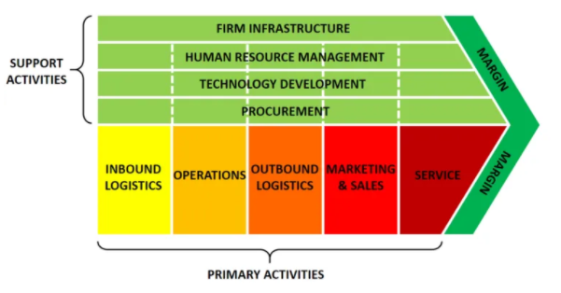
Figure 3: Porter’s value chain
(Source: Zamora, 2016)
With the use of value chain analysis, both primary and support activities of the company are analysed (Zamora, 2016). In Aston Martin, it is found that major inbound logistics are inventory control, vehicle scheduling and others. Moreover, operations related with the company are testing of vehicles, packaging, assembling parts, and others. In case of outbound logistics, Aston Martin focuses on processing orders and managing delivering. For managing marketing and sales, the company uses advertising and promotional strategies. Finally, in services such as installation, repairing and others are managed. However, all these primary activities are carried out with the supporting activities such as HRM, procurement, R&D, infrastructure and so on in car manufacturing firms such as Aston Martin.
Aston Martin can implement flexibility and sustainability in its operational activities and this way it can position itself differently in the competitive market. It can help the organisation to maintain flexible procurement of raw materials in the entity (manufacturingglobal, 2020). Suppliers will be able to maximise the amount of supply of products in the organisation within time. Besides that the organisation can introduce sustainability in supply chain management. Thereafter, the organisation can obtain raw materials in a larger amount to reduce the consumption of fuel. It can be beneficial to reduce the cost of fuel in supply chain management. Additionally, the organisation will be able to attain competitive advantage by reducing expenditures in the organisation.

Conclusion
From the entire study, it has been identified that major macro and micro forces are responsible for shaping the business environment of the car production and manufacturing firm. The trends of the industry has been analysed that has been taken place in last few years. Additionally, the assessment of challenges and business opportunities has been discussed with the use of SWOT and other significant frameworks. It has been found that product life cycle has helped in understanding the different stages of car manufacturing business. The negative aspects that are analysed from Pestle analysis and porter’s five forces can be minimised with the use strategies such as advertising, improving customer services, maintaining legal policies and others.

Reference list
Ali, M.M., Rai, R., Otte, J.N. and Smith, B., 2019. A product life cycle ontology for additive manufacturing. Computers in Industry, 105, pp.191-203.
astonmartin.com. 2020. ASTON MARTIN LAGONDA SHOWCASES ELECTRIC FUTURE [Online] Available at: <https://www.astonmartin.com/en-gb/our-world/news/2019/11/05/aston-martin-lagonda-showcases-electric-future> [Accessed 29 August 2020].
astonmartin.com. 2020. Aston Martin. [Online] Available at: <https://www.astonmartin.com/welcome>[Accessed 29 August 2020].
carmagazine.co.uk2020. UK car manufacturing to hit record high by 2015[Online] Available at: <https://www.carmagazine.co.uk/car-news/industry-news/nissan/uk-car-manufacturing-to-hit-record-high-by-2015/#:~:text=Britain%20is%20on%20track%20to,year%20in%20three%20years'%20time.> [Accessed 1 September 2020].
gov.uk. 2020. Corporation Tax main rate at 19% in 2020 and charge and main rate for 2021. [Online] Available at: <https://www.gov.uk/government/publications/changes-to-corporation-tax-rates-from-1-april-2020/corporation-tax-main-rate-at-19-in-2020-and-charge-and-main-rate-for-2021> [Accessed 29 August 2020].
Khurram, A., Hassan, S. and Khurram, S., 2020. Revisiting Porter Five Forces Model: Influence of Non-Governmental Organizations on Competitive Rivalry in Various Economic Sectors.
legislation.gov.uk. 2020. Companies Act 2006. [Online] Available at: <https://www.legislation.gov.uk/ukpga/2006/46/contents> [Accessed 29 August 2020].
manufacturingglobal.com. 2020. Aston Martin Targets More Flexible Supply Chain | Lean Manufacturing | Manufacturing Global[Online] Available at: <https://www.manufacturingglobal.com/lean-manufacturing/aston-martin-targets-more-flexible-supply-chain> [Accessed 1 September 2020].
Max, K., 2018. Three Business Plan Models to Help a Start-up with Strategic Analysis: Lessons from using SWOT, Porter’s Five Forces, and Price Equalizer to write a business plan.
ons.gov.uk. 2020. National Population Projections - Office for National Statistics. [Online] Available at: <https://www.ons.gov.uk/peoplepopulationandcommunity/populationandmigration/populationprojections/bulletins/nationalpopulationprojections/2015-10-29> [Accessed 29 August 2020].
smmt.co.uk. 2020. UK Vehicle Manufacturing Data - SMMT monthly data. [Online] Available at: <https://www.smmt.co.uk/vehicle-data/manufacturing/> [Accessed 29 August 2020].
statista.com2020. Car brands' UK market share by month 2020 | Statista[Online] Available at: <https://www.statista.com/statistics/300467/leading-car-companies-market-share-in-the-united-kingdom/#:~:text=Leading%20car%20companies'%20monthly%20UK%20market%20share%202020&text=In%20June%202020%2C%20Ford%20was,8.55%20percent%20of%20the%20market.> [Accessed 1 September 2020].
theglobaleconomy.com. 2020. United Kingdom Political stability - data, chart | TheGlobalEconomy.com. [Online] Available at: <https://www.theglobaleconomy.com/United-Kingdom/wb_political_stability/#:~:text=United%20Kingdom%3A%20Political%20stability%20index%20(%2D2.5%20weak%3B%202.5%20strong)&text=The%20average%20value%20for%20the,from%202018%20is%200.05%20points.> [Accessed 29 August 2020]
Tightening, W. and McMahon, T. 2020. Annual Inflation Rate Chart, Inflationdata.com. [Online] Available at: <https://inflationdata.com/Inflation/Inflation/AnnualInflation.asp> [Accessed 29 August 2020].
Younis, H., Sundarakani, B. and Vel, P., 2016. The impact of implementing green supply chain management practices on corporate performance. Competitiveness Review.
Zamora, E.A., 2016. Value chain analysis: A brief review. Asian Journal of Innovation and Policy, 5(2), pp.116-128.

