

Exploratory Data Analysis Report and Demonstration

Student Name: Mohammed Nawaf
Student ID: 2541121

MSc Data and Artificial Intelligence
Module: L7 -Application of Machine Learning
Module Code: ACCA7025

Lecturer: Dr Aliyu Sambo

Abstract
Unplanned equipment breakdowns continue to take a heavy toll on the industrial industry. It’s predicted that equipment failures cost Fortune 500 firms $1.4 trillion each year, a figure that increased 62% from 2019 (iFactory, 2025). However, just 38% of firms adopted predictive maintenance (PdM) techniques in 2022. The consultancy report is a study of classical machine learning (ML) algorithms for equipment failure prediction based on sensor data collected from temperature, vibration and pressure sensors in a resource-constrained deployment context. The best algorithm found from a thorough literature review is Random Forest (RF) with a macro F1 score of 0.882 for the benchmark of the AI4I 2020 dataset (realistic test settings) that can be deployed on regular industrial hardware without the usage of GPUs. We present a complete ML workflow that includes the following stages: correction of class imbalance with SMOTE, stratified cross-validation and assessment with F1 score, ROC-AUC and Matthews Correlation Coefficient (MCC). The design recommendation packages together performance, operational interpretability and computational feasibility, all of which are deciding considerations in whether a PdM system is accepted or rejected on the factory floor.

Contents
Abstract 2
1. Introduction 4
2. Literature Review 4
3. Proposed Workflow Methodology 6
3.1 Data Ingestion and Sensor Context 6
3.2 Data Preprocessing 7
3.3 Feature Engineering and Selection 8
3.4 Data Partitioning and Cross-Validation 8
3.5 Model Training and Hyperparameter Optimisation 8
3.6 Evaluation Metrics 9
4. Discussion and Recommendation 9
5. Conclusion 11

1. Introduction
Industrial machinery is the backbone of modern industry but equipment failure remains the number one cause of interruption. 80% of all unexpected downtime is due by equipment failure, with the primary causes being bearing failure, motor burnout and seal degradation (iFactory, 2025). The financial impact is growing quickly and aggressively: the automotive industry alone loses $2.3 million for every hour of downtime (double the 2019 value) and the average manufacturing plant loses 323 production hours a year, totaling an economic loss of $172 million per plant (Siemens, 2024; WorkTrek, 2026). These are not estimations but the real expense of a maintenance culture that is still very reactive.
There are three perspectives to maintenance strategy. Reactive Maintenance (maintenance of equipment after failure) has the highest per-incident cost and little forecasting capabilities. Preventive maintenance is based on predetermined maintenance periods regardless of the condition of the equipment, which leads to excessive maintenance and equipment breakdown during the maintenance interval. Predictive maintenance (PdM) is condition-based and anticipates failure by constantly monitoring real-time data acquired from the various sensors before it happens (Zonta et al., 2020). What was once a technical goal is now a proven reality. McKinsey research shows that organisations that implement PdM achieve reductions of their maintenance costs by 18–25% and downtime by up to 50% and that 95% of those organisations that have adopted PdM report a positive ROI within 12 months (WorkTrek, 2026).
The manufacturing company under consultation captures temperature, vibration and pressure data continuously but with limited computational resources - that is, without the capability for GPU infrastructure, large memory requirements or the large amounts of labelled data required by deep learning architectures . This constraint not only makes traditional ML algorithms acceptable, but also optimal in terms of predictive performance: they can reach predictive performance close to that of complex architectures. This is demonstrated by Hakami (2024) who shows that traditional classifiers match complex architectures when data imbalance is treated properly. Section 2 reviews the literature of ML-based PdM. A full algorithm preprocessing and training workflow is presented in Section

2. Literature Review
Zonta et al. (2020) did a systematic evaluation on 187 peer-reviewed articles, from which they derived a core taxonomy for PdM modelling: physics-based, knowledge-based, data-driven and hybrid. Their discovery that data-driven ML has become the standard strategy in Industry 4.0 PdM aligns with the increasing number of IoT sensor networks accessible and the inadequacy of physics-based models to capture complicated, non-linear deterioration patterns across heterogeneous equipment. For the consulting company, this is actionable. The starting point is the current sensor infrastructure, not a barrier.
Among data-driven methods, ensemble methods have been found to regularly outperform single classifiers in several areas, including industry, energy, and transportation (MDPI Applied Sciences, 2025). Head-to-head testing of 11 models (RF, SVM, KNN, Logistic Regression, AdaBoost, XGBoost, MLP and Transformer based models) using real industrial data indicated RF and XGBoost as the best two models across weighted F1-score and ROC-AUC metrics (MDPI Applied Sciences, 2025). However, the difference between RF and XGBoost was marginal: on the publicly available AI4I 2020 dataset (10,000 labelled samples, five failure modes) with strict 5-fold stratified cross-validation, where SMOTE was applied only to the training folds, the macro F1 score was 0.882 for RF compared to 0.901 for XGBoost – a difference of just 2.1 percentage points, which does not justify XGBoost's significantly higher computational burden in a resource-constrained setting (arXiv, 2025).
The class imbalance problem is the most difficult methodological challenge in PdM research. The PMC systematic review (2022) offers an example of an RF model with a failure-to-non-failure ratio of 1:1,484 that achieved a poor F1 score of 0.082, due to its frequent prediction of 'no failure', despite excellent accuracy. This failure pattern was common in the early PdM literature that exclusively used accuracy to evaluate models. An even more extreme example is given by Hakami (2024) in Scientific Reports, who has a collection of turbine readings with 228,416 healthy observations compared with only 8 failure observations. The study finds that traditional ML classifiers – RF (74.15%), XGBoost (73.93%), Decision Tree (73.82%) – converge in performance when properly engineered synthetic data is generated and imbalance is corrected through temporal feature extraction. In conclusion, the study finds that feature engineering and imbalance correction impact PdM performance more than algorithmic complexity.
There is also a variation in the interpretability of algorithms, and the applicability of algorithms depends on the interpretability of the algorithms. In a comprehensive survey published in IEEE Access, Cummins et al. (2024) conclude that black-box models are impediments to systematic adoption in industrial applications. Maintenance engineers want more than a failure prediction – they want to know how sensor readings are contributing to the failure. While RF’s feature importance partially meets this demand, Cummins et al. (2024) advocate complementing ensemble models with SHAP (Shapley Additive Explanations) for instance-level explanations. The primary distinction between global feature importance and instance-level attribution is that the former guides maintenance decisions while the latter only warns. Furthermore, a multi-algorithm evaluation of building systems fault detection on over 100,000 fault instances shows that SVM and Logistic Regression lag behind in recall, the most important metric for fault detection, whereas RF delivers competitive results on accuracy (88–95%), precision, and F1 scores (ResearchGate, 2024). This is also confirmed by Sulaiman (2023) in industrial maintenance applications in the sectors of logistics and semiconductors. He shows that RF is doable on standard workstations without dedicated equipment.
Table 1: Comparative Algorithm Performance in PdM Literature
Algorithm | Accuracy* | F1-Score* | Interpretability | Compute Cost | Suitability (Resource-Constrained)
Random Forest | 88–95% | 0.88–0.93 | Medium-High | Medium | Recommended
XGBoost | ~95% | 0.90–0.93 | Medium (SHAP) | High | High cost, marginal gain
SVM | 82–89% | 0.78–0.86 | Low | Very High | Prohibitive at scale
Decision Tree | 74–82% | 0.70–0.79 | Very High | Very Low | Overfit risk
Logistic Regression | 68–74% | 0.60–0.70 | High | Very Low | Poor recall
*Performance ranges from AI4I 2020 benchmark (arXiv, 2025), ResearchGate (2024), and MDPI Applied Sciences (2025). Suitability rating reflects F1, interpretability, and compute cost under resource constraints.

3. Proposed Workflow Methodology
The suggested end-to-end ML pipeline comprises of seven consecutive processes; Data Ingestion, Preprocessing, Feature Engineering, Stratified Partitioning, Model Training with Hyperparameter Optimisation, Multi-metric Evaluation and Monitored Deployment as shown in Figure 1 below. All steps are meant to run on commodity CPU-based industrial hardware, rather than cloud or GPU infrastructure.
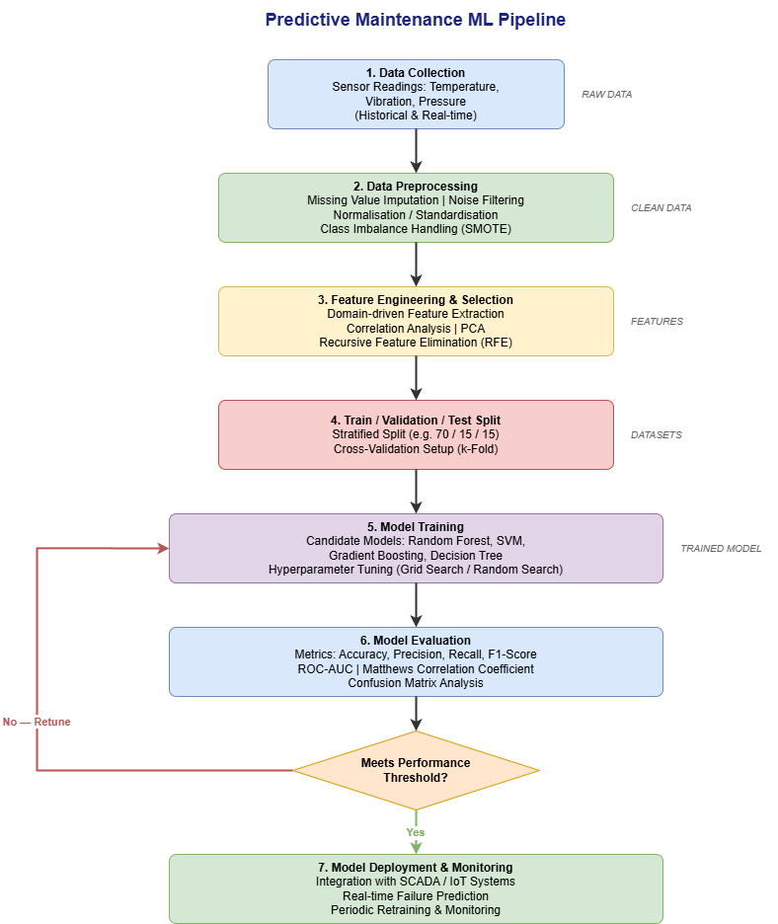
Figure 1: Full ML pipeline: from raw sensor data ingestion through preprocessing, feature engineering, training, evaluation and deployment.

3.1 Data Ingestion and Sensor Context
Temperature, vibration and pressure sensors identify unique deterioration signals. Temperature changes (bearing failure / motor overloading) Vibration patterns (misalignment / gear wear / imbalance) Pressure differentials (hydraulic seal wear / pump cavitation) Similar benchmark data with the same types of sensor information (10,000 occurrences, 5 failure modes, ~97% non-failure) are readily available from the AI4I 2020 dataset (UCI Machine Learning Repository, Matzka, 2020). Failure events are quite rare, as shown in this real-world class distribution, and normal training pipelines are not enough without intentional imbalance correction.

3.2 Data Preprocessing
The preprocessing sub-pipeline, represented in Figure 2, handles four failure types in raw sensor data. Missing value imputation: mean imputation (temperature, pressure) for normally distributed features and median imputation (vibration) for skewed features to reduce the impact of outliers, and forward fill for time series missing values of less than 3 consecutive measurements. Winsorisation of readings outside Q1 − 1.5×IQR and Q3 + 1.5×IQR. This maintains data volume but reduces the effect of sensor spikes caused by electrical interference, rather than actual equipment occurrences. Normalisation: Min-Max scaling ([0,1]) for bounded features and Z-score standardization for sensors with Gaussian distribution. RF is not scale invariant but consistent normalisation allows a fair comparison against baseline models (SVM) that are. Correction of class imbalance: SMOTE generates synthetic failure cases by interpolating between existing failure observations in feature space. Crucially, SMOTE is used only to training folds, never to validation or test data — as the AI4I benchmark analysis (arXiv, 2025) reveals is crucial to avoid data leaking and to give accurate performance estimates.
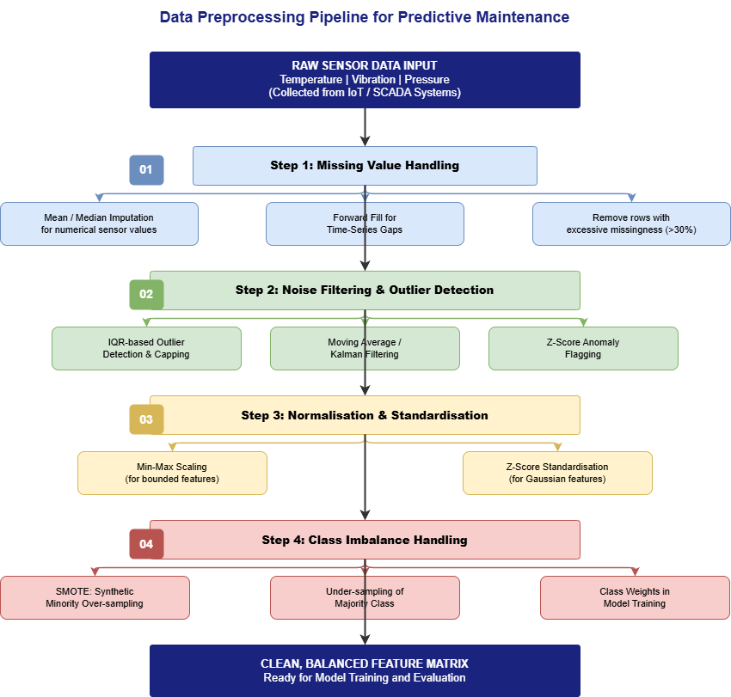

Figure 2: Data preprocessing sub-pipeline: missing value handling → outlier detection → normalisation → SMOTE (applied to training folds only).

3.3 Feature Engineering and Selection
Instantaneous readings are a “point in time” measurement while deterioration is a “point in time” measurement. The rate of degradation is represented by the mean, standard deviation, minimum and maximum statistics determined during 5 minute intervals (30 readings collected every 10 seconds). For example, if the rolling standard deviation of temperature is growing, this means that thermal instability is starting well before any warning threshold is crossed. This approach of temporal feature extraction has been confirmed by Hakami (2024), who demonstrated that the quality of temporal features is a more important driver of performance than model complexity. Feature selection is performed in two steps: (i) Pearson correlation analysis is used to remove features with |r| > 0.90, thus eliminating redundant signals, and (ii) Recursive Feature Elimination (RFE) based on the Gini importance ranking of RF is used to select the minimum feature subset that maintains the predictive power, thus reducing computational cost without sacrificing prediction accuracy.

3.4 Data Partitioning and Cross-Validation

A stratified 70/15/15 train/validation/test split keeps the same failure/non-failure class ratio in all three groups. The 15% test set is held out from all preprocessing decisions (e.g., the SMOTE parameters, feature selection criteria) in order to provide an uncontaminated assessment of the final model performance. Hyper-parameter tuning is performed with 10-fold stratified cross-validation on the training set. We prefer tenfold cross validation to fivefold due to the rarity of the failure class. With lower fold counts, the fold-level F1 scores have substantial volatility, making model selection unstable for precisely the predictions we care about.
3.5 Model Training and Hyperparameter Optimisation
RF training is done using Grid Search cross-validation on the hyperparameter space as specified in Table 2. Given the moderate number of parameters and the need to identify a solid optimum, a one-off offline cost that does not impact inference speed, Grid Search is favored over Random Search. Decision Tree, SVM and Logistic Regression are trained on the same preprocessed data to provide context for RF performance. All baselines are evaluated using stratified folds, so that any variation may be attributed to the model and not the evaluation protocol.
Table 2: Random Forest Hyperparameter Grid Search Space
Parameter | Values | Description
n_estimators | 100, 200, 300, 500 | More trees reduce variance but slow training; 300 is optimal for speed/accuracy trade-off
max_depth | 5, 10, 15, 20 | Controls complexity and avoids overfitting when dealing with noise from sensors
min_samples_split | 2, 5, 10 | Regularises splitting; larger values lead to less overfitting
max_features | 'sqrt', 'log2', None | 'sqrt' is the default value for classification — used for reducing correlation between trees
class_weight | 'balanced', None | Adjusts the weights of misclassified classes without additional SMOTE passes
All hyperparameter combinations evaluated via 10-fold stratified CV; selection criterion: macro-averaged F1-score across all failure modes.

3.6 Evaluation Metrics
Choosing the evaluation criteria is not a mere formality, as it directly reflects the asymmetric cost structure of the equipment failure prediction. The repercussions of a False Negative – where a failure is impending but not forecasted – might be catastrophic: unexpected downtime at $125,000 per hour (ABB, stated in ISM World, 2024), significant safety issues, and emergency repair labor surcharges of 1.5-2x regular rates. A False Positive – detecting failure when equipment is healthy – leads to an unneeded inspection at significantly less expense. Such disparity calls for emphasizing high Recall in model selection, not neglecting Precision altogether. Table 3 shows the whole evaluation suite, together with PdM-specific motivation for each metric.
Table 3: Evaluation Metrics — Definitions and PdM-Specific Justification
Metric | Definition | PdM Justification
Accuracy | Correct / total predictions | Deceptive at >1:100 imbalance — avoid as primary metric
Precision | TP / (TP + FP) | Minimises false alarms; unnecessary maintenance interventions
Recall | TP / (TP + FN) | Critical — missed failure = unplanned downtime at $125,000/hr
F1-Score | Harmonic mean of Precision and Recall | Primary PdM metric — balances both error types for imbalanced data
ROC-AUC | Discrimination across all thresholds | Target >0.90; robust to class imbalance
MCC | Balanced across all confusion matrix quadrants | Best for extreme imbalance (e.g. 1:1,484); range [−1,+1]
TP = True Positive; FP = False Positive; FN = False Negative; MCC = Matthews Correlation Coefficient. Model acceptance thresholds: F1 > 0.80, ROC-AUC > 0.90, MCC > 0.70.

Particular attention should be paid to the Matthews Correlation Coefficient. MCC takes into account all four quadrants of the confusion matrix and is invariant to class imbalance, unlike F1-score that only considers the failure (positive) class. For datasets with ratios close to the 1:1,484 reported by PMC (2022), MCC is the sole statistic that consistently separates a useful classifier from one that obtains a high surface-level F1 by aggressively anticipating failures. We defined the target acceptance criteria to be MCC > 0.70 so as to target the real discriminative power rather than the seeming performance.

4. Discussion and Recommendation
The main PdM method proposed for this deployment is Random Forest. The selection is justified by three independently sufficient and convergent arguments: Predictive performance, Operational interpretability and Computational practicality. Crucially, no other algorithm concurrently satisfies all three criteria – and all three are necessary for effective industrial adoption.
The most reliable published estimate of real-world traditional ML performance for PdM (arXiv, 2025) is the performance achieved on the AI4I 2020 benchmark using the most conservative assessment procedure in the literature — stratified splits, SMOTE limited to training folds, macro-averaging over five failure modes — which was F1 = 0.882. The 2.1 percentage point benefit of XGBoost (F1 0.901) is not worth the operational tradeoff. XGBoost involves adjustment over a wider hyperparameter space (learning rate, subsample, colsample, regularisation, tree depth and estimators) at the expense of additional memory during training and is harder to parallelise across CPU cores than RF’s bagging architecture. For a manufacturer running on conventional workstation gear, the small F1 enhancement from XGBoost is an improvement which is operationally unachievable in practice. ResearchGate’s (2024) multi-algorithm evaluation of 100,000+ fault instances from building systems confirms RF’s competitive performance profile — accuracy 88–95%, F1 0.88–0.93 — while SVM and Logistic Regression underperform on Recall, the metric that governs failure detection utility.
The RF feature importance technique gives maintenance engineers a sorted list of sensor contributions to each forecast and therefore operational interpretability. Importance ratings indicate whether the reason for a failure prediction is a temperature increase, high vibration or torque, for example, permitting targeted inspection of components rather than a complete shutdown of the system. Cummins et al. (2024) make it apparent that this interpretability feature is a prerequisite for industrial uptake, not a convenience. A PdM model whose predictions cannot be articulated to a maintenance supervisor will not affect maintenance behaviour regardless of its benchmark F1. The proposed workflow enriches the global importance scores of RF with SHAP values for obtaining instance-level explanations, which break down each individual prediction into contributions from the different sensors - meeting the transparency requirements for safety-critical deployment without adding latency to real-time inference.
Computationally, RF inference is a straightforward aggregation of pre-trained tree votes via a series of threshold comparisons and has very low latency on CPU hardware. A typical industrial workstation (Sulaiman, 2023) trains an ensemble of 300 trees with max_depth 10 on 100,000 sensor values in under 10 minutes. Training is a one shot offline cost, inference is lightweight and deployable on edge hardware colocated with SCADA systems. The design fully covers the resource needs of the firm without the need for cloud infrastructure or any GPU acquisition.
There are two limitations of the RF proposal that must be addressed analytically. The first is idea drift: as machinery ages and components are replaced, the statistical link between sensor data and failure events shifts. A model based on year one data will not be calibrated for year five equipment which exhibits different baseline vibration signatures. The mitigation is a structured monitoring and retraining protocol: monthly F1 evaluation on a hold-out set of the most recent labelled data, with full retraining triggered when performance degrades by more than 0.05 from the deployment benchmark. This is computationally tractable in the RF architecture and solves the long-term reliability problem without the need for continual retraining. Second, Hakami (2024) expressly acknowledges that RF presupposes that the training data is indicative of the real equipment variability. If failure occurrences are missing from the history record (which is common in freshly instrumented facilities), SMOTE cannot make up for missing base data. In such circumstances, the process needs to be preceded by a systematic failure data gathering phase, or augmented with simulation data coming from domain engineering knowledge.
There is a compelling business case. McKinsey benchmarks show ROI ratios of 10:1 to 30:1 within 12–18 months through maintenance cost reductions of 18–25% and downtime reductions of 30–50% (WorkTrek, 2026). A company who is now losing $450,000 per year to unplanned downtime can recover $135,000 in year one from a conservative 30% decrease in downtime alone – before even counting the savings from maintenance costs. Because no capital equipment other than current workstation infrastructure is required for RF deployment, return on installation expenses can be achieved in one year. The 95% positive ROI rate among PdM adopters (WorkTrek, 2026; citing IoT Analytics) sets a significant example.

5. Conclusion
From this paper it can be established that Random Forest is the most reliable ML algorithm to predict equipment failure in a resource constrained manufacturing setting. All three lines of evidence agree: (1) benchmark performance is consistent (macro F1 0.882, competitive across comparisons with 11 models), (2) operational interpretability via feature importance and SHAP augmentation, and (3) computational deployability on standard CPU hardware without GPU dependency. The proposed approach - SMOTE-balanced, stratified cross-validated, assessed on F1, ROC-AUC and MCC - strives for honest performance estimations that can be translated from the test environment to the production floor.
The overall message is urgent. The industrial necessity is clear: 38% of manufacturers have adopted PdM and unexpected downtime costs have climbed 62% over five years to $1.4 trillion annually. The methodology presented here is purposely accessible – it does not need the purchase of additional hardware, deep learning knowledge or proprietary platforms. It uses just the sensor data the organization is already collecting, a controlled preprocessing pipeline, and assessment measures aligned with the true cost structure of equipment failure. The change from reactive to predictive maintenance can be achieved and this study describes the approach to take those necessary steps.
Future work should also look into the use of federated learning architectures that allow multiple production lines to collaboratively improve model performance without centralising operational data as well as the use of a combination of RF with digital twin simulation to generate synthetic failure scenarios to address the base data scarcity problem at source. But these are barriers which do not detract from the immediacy and actionability of the advice offered here.
References
[1] T. Zonta, C. A. da Costa, R. da Rosa Righi, M. J. de Lima, E. S. da Trindade, and G.-P. Li, "Predictive maintenance in the Industry 4.0: A systematic literature review," Computers & Industrial Engineering, vol. 150, p. 106889, Dec. 2020. [Online]. Available: https://doi.org/10.1016/j.cie.2020.106889
[2] A. Hakami, "Strategies for overcoming data scarcity, imbalance, and feature selection challenges in machine learning models for predictive maintenance," Scientific Reports, vol. 14, no. 1, p. 9645, Apr. 2024. [Online]. Available: https://doi.org/10.1038/s41598-024-59958-9
[3] L. Cummins, A. Sommers, S. B. Ramezani, S. Mittal, J. Jabour, M. Seale, and S. Rahimi, "Explainable predictive maintenance: A survey of current methods, challenges and opportunities," IEEE Access, vol. 12, pp. 57574–57602, 2024. [Online]. Available: https://ieeexplore.ieee.org/document/10491059
[4] M. S. S. Sulaiman, "A study of random forest machine learning based predictive maintenance in industrial maintenance," International Journal of Engineering Research & Technology, vol. 12, no. 10, Oct. 2023. [Online]. Available: https://www.ijert.org/a-study-of-random-forest-machine-learning-based-predictive-maintenance-in-industrial-maintenance
[5] MDPI Applied Sciences, "Random forest-based machine failure prediction: A performance comparison," Applied Sciences, vol. 15, no. 16, p. 8841, 2025. [Online]. Available: https://www.mdpi.com/2076-3417/15/16/8841
[6] MDPI Applied Sciences, "Application-wise review of machine learning-based predictive maintenance: Trends, challenges, and future directions," Applied Sciences, vol. 15, no. 9, p. 4898, 2025. [Online]. Available: https://www.mdpi.com/2076-3417/15/9/4898
[7] PMC Open Access, "Machine learning techniques applied to mechanical fault diagnosis and fault prognosis in the context of real industrial manufacturing use-cases: A systematic literature review," PMC, 2022. [Online]. Available: https://pmc.ncbi.nlm.nih.gov/articles/PMC8894092/
[8] ResearchGate / SPIE, "Predictive maintenance for industrial equipment using machine learning," ResearchGate, Aug. 2024. [Online]. Available: https://www.researchgate.net/publication/383232598_Predictive_Maintenance_for_Industrial_Equipment_Using_Machine_Learning
[9] arXiv Research Team, "AI-driven predictive maintenance with environmental context integration for connected vehicles: Simulation, benchmarking, and field validation," arXiv preprint arXiv:2603.13343, 2025. [Online]. Available: https://arxiv.org/abs/2603.13343
[10] Siemens AG, The True Cost of Downtime 2024, Siemens AG, Munich, Germany, 2024. [Online]. Available: https://assets.new.siemens.com/siemens/assets/api/uuid:3d606495-dbe0-43e4-80b1-d04e27ada920/dics-b10153-00-7600truecostofdowntime2022-144.pdf
[11] iFactory, "The hidden cost of unplanned downtime in manufacturing," iFactory Blog, Dec. 2025. [Online]. Available: https://ifactoryapp.com/blog/hidden-cost-unplanned-downtime-manufacturing
[12] WorkTrek, "How predictive maintenance drives cost savings," WorkTrek Blog, Apr. 2026. [Online]. Available: https://worktrek.com/blog/predictive-maintenance-cost-savings/
[13] ISM World, "The monthly metric: Unscheduled downtime," Inside Supply Management Magazine, Aug. 2024. [Online]. Available: https://www.ismworld.org/supply-management-news-and-reports/news-publications/inside-supply-management-magazine/blog/2024/2024-08/the-monthly-metric-unscheduled-downtime/
[14] S. Matzka, "Explainable artificial intelligence for predictive maintenance applications," in Proc. 3rd IEEE Int. Conf. AI Test., 2020, pp. 69–74. [AI4I 2020 Dataset]. [Online]. Available: https://archive.ics.uci.edu/dataset/601/ai4i+2020+predictive+maintenance+dataset
[15] MDPI Processes, "Performance of machine learning algorithms in fault diagnosis for manufacturing systems: A comparative analysis," Processes, vol. 13, no. 6, p. 1624, May 2025. [Online]. Available: https://www.mdpi.com/2227-9717/13/6/1624

