

Hospitality and Guest Service Management
Assignment 2 - Report
The importance of effectively monitoring guest service approaches

Student name: Petre Chiriac
Student ID: 2246594
Module: Hospitality and Guest Service Management BMIH4003
Lecturer Name: Charlotte Joyner
Word Count: 1606

Executive Summary
The study presented a vividaccount of the hospitality sector in the UK. It stressed the enhanced competition in the hotel industry in the UK and also provided an idea about the growth of the sector. The study provided statistical data and information to illustrate the revenue earned by the hospitality industry in the UK in 2022. The work also presented the key aspects that can affect the hospitality industry and the requirement of maintaining quality and standards in service. The study provided a vivid account of the use of advanced technologies in the hospitality industry and also discussed its influence on the customer satisfaction level.
Table of Contents
Introduction 4
Main Findings 5
Background of the Hospitality Industry 5
Hotel standards 6
Effect of using advanced technologies 6
Customer Loyalty and Reputation Management 7
Service Culture 8
Service failure 9
Conclusion 10
Recommendations 11
References 12

Introduction
The report will provide an account of the hospitality industry and will discuss the necessity of maintaining service standards. The report will also illustrate the present situation of the hospitality sector in the UK and the impact of using modern and advanced technologies in the hospitality industry. The study aims to focus on the benefits of customer loyalty and the use of reputation management. The report also aims to highlight the reasons that influence the failure of the hotel industry.

Main Findings

Background of the Hospitality Industry
The hospitality industry in the UK as well as in the global market has become highly competitive. The competition has increased due to a boost in the tourism industry and the development of numerous hotels. The presence of luxurious hotel brands in the UK has raised the competition in the hospitality industry.
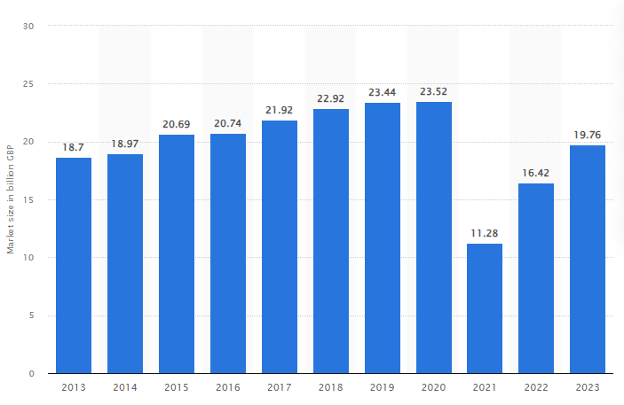
Figure 1: Market share of the hospitality industry in the UK
(Source: Statista, 2023)
The market shares of the hospitality industry in 2022 was around 16.42 billion British pounds which was around 11.28 billion British pounds in 2021 (Statista, 2023). The sharp growth in the market share of the hospitality industry reveals the competition. Thus, the growing competition in the hospitality sector in the UK has compelled hotel brands to adapt to the change and to ensure that the best quality of service is provided by them to satisfy their customers (Walker, 2021). JW Marriott is one of the leading hotel brands in the UK that is known for its luxury and quality of service. The hotel offers unparalleled guest services and is known for its service culture and standards (JW Marriott, 2023). Therefore, to match the growing competition, the hospitality sector is evolving rapidly.

Hotel standards
It is very important to maintain standards in the hospitality sector in terms of service quality to ensure the growth and development of the hotel. It allows the hotel industry to gain the trust of the customers and enhance their guest retention rate. With improved customer service, proper safety measures, a hospitable approach and facilities an enriching relationship with the guests is successfully established (Ford, 2020). Therefore, to strengthen the customer base these aspects are constantly monitored by the hotel industry to deliver the best possible service to their guests. For instance, the behaviour and approaches of the employees associated with the hospitable sector play an influential role in attracting the customers and growth of the business. Therefore, it becomes highly crucial for the managers to monitor the guest service approaches of the staff. Moreover, monitoring customer feedback is also highly essential for the hospitality sector to maintain its standards in regard to its service and facilities. JW Marriott frequently conducts audits in different departments in order to monitor the behaviour and approach of their organisation in relation to guest satisfaction.

Effect of using advanced technologies
The use of advanced technologies provides huge benefits to the hotel industry in every aspect. The use of the latest technologies not only eases the way of operation but also plays a significant role in satisfying customers. For instance, the use of AI and Chabot can enhance the experience of the guests and provide them satisfaction. It helps in booking hotel rooms and checking the offers or availability of facilities and many more (Solomon, 2018). On the other hand, the use of technology also proves beneficial for the hotels to manage their operations effectively. For instance, it helps them to maintain the records of their resources or to track the attendance of the staff. Thus, the use of technology in the hospitality sector improves its productivity, makes these processes fast and also reduces the possibility of any error (Heppell, 2015). Many leading international hotels use their apps to monitor the performance of their employees.
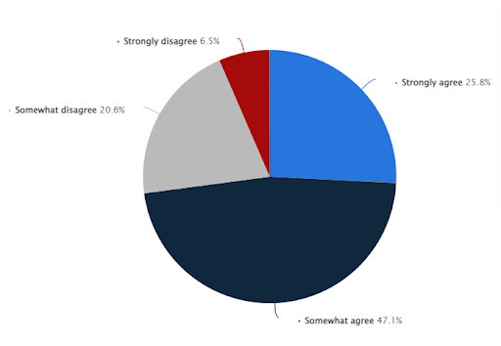
Figure 2: Opinion of customers regarding technologically advanced hotels
(Source: Statista, 2023)
A survey in 2022 highlighted that around 47 % of the respondents stated that they prefer technologically advanced hotels as it minimises contact staff while only 6.5% disagreed with this statement (Statista, 2023). Additionally, these apps are also customer-friendly in nature which makes it more convenient for the guests to order their food, use the code provided in the app as room key and many more. For instance, Marriott uses the Bonvoy app which facilitates mobile check-in and check-out facilities (Marriott International, 2023). Such approaches not only offer an enriching experience to the guests but also provide a touch of innovation which attracts the guests. Furthermore, the use of robots in hotels can reduce the task of the human workforce and can be more productive which in turn, may reduce the expenditure of the hotel. Leading hotels like Hyatt International, Premier Inn and The Savoy use modern technologies to provide unparalleled service to their guests and also compete against others in terms of adoption of innovative measures.

Customer Loyalty and Reputation management
Customer loyalty and the reputation of the hotel are highly related to each other. Reputation management is a tool that is used by hotels to monitor their performance with the aim of enhancing their services (Wood, 2015). The hotel brands monitor reviews and feedback provided by their customers on online platforms that are accessible to the masses. In present times almost every hotel has social media handles and an official website of their hotel where people give ratings and feedback about their services and facilities (Tsao, 2018). JW Marriott has its websites and social media channels which the hotel uses to monitor the feedback of their customers. Moreover, these feedbacks also serve to identify the positive and negative aspects of their services. The positive feedback provides scope for the hotel to attract new customers as well as retain the existing ones while the negative feedback provides an adverse effect and harms the reputation of the hotel. Thus, the hotels are highly concerned about their reputation and perception of their customers on the global platform as it directly affects their customer loyalty (Rather and Camilleri, 2019). Thus, to maintain the reputation and enhance customer loyalty it is necessary for the hotel industry to monitor their guest service approaches.

Service Culture
The term service culture in terms of the hospitality sector refers to the mission and vision of the hotel to serve its customers in the best possible manner. It is the approach which shows that the foremost goal of the hotel is to serve the customers and to provide them with a satisfying and enriching experience (Hu et al., 2022). Improving the service culture is highly essential for the growth and development of business in the hospitality sector. Such an approach will have a positive impact on the minds of the guests and as a result, the possibility of the hotel earning good ratings and feedback will be enhanced. Thus, from the business perspective monitoring the service culture is highly essential from the perspective of the hotel (Panno, 2020). The adoption of such approaches also involves the employees closely. For instance, customer service can only be enhanced with the guest-serving approach and capabilities of the hotel staff. A positive and good service culture creates a hospitable environment in the hotel which plays a major role in gaining the loyalty of the customers. Most hotels adopt strategies like collecting feedback from customers and offering personalised offers to the customers to satisfy their guests (Bharwani and Mathews, 2021). JW Marriott also offers its services with a similar approach and possesses a similar vision in terms of customer service.

Service failure
The failure to deliver proper services to the customers affects the business of the hotel industry adversely. It reduces the loyalty of the customers which in turn results in dropping the ratings (Morgesonet al., 2020). The low ratings and negative feedback on the online platforms on the other hand create a sense of reluctance among the new customers which results in depletion of the business. There are diverse reasons that prevent hotels from delivering quality services. For instance, the lack of proper infrastructure or implementation of new innovative techniques fails to attract customers as the present trends demand for such features (Panno, 2020). Thus, failure to adapt to the change also results in service failure due to increased competition in the hospitality sector. Moreover, lack of proper customer support, delayed resolution of problems, inadequate facilities and many such aspects also result in failure of service in the hospitality sector.

Conclusion
The report provided a detailed analysis of the hospitality sector regarding the aspects that influence the customer satisfaction rate. The study also mentioned the key reasons that enhanced the competition in the hospitality sector in the UK. It discussed the advantages of using modern technologies in the hotel industry and also discussed customer loyalty and reputation management. The study also highlighted the major reasons that lead to service failure and loss in business. As per this report it has been identified that the market share of the hospitality industry of the UK is high. The entire hospitality industry focusses on customer care and the entire service to maintain their brand image and reputation in the competitive business market effectively.

Recommendations
- The hospitality industry can enhance itself further by establishing a dedicated department for problem resolution of guests. It will help in providing a satisfying experience to the guests (Wood, 2015). In this way, it can boost the sales of the hotel and can positively affect the industry.
- Tracking the feedback and response of the guests in order to construct KPIs. Monitoring feedback provides scope for addressing the issues actively (Tsao, 2018). It can also help in setting a trend in the hospitality industry.

References
Bharwani, S. and Mathews, D., 2021. Techno-business strategies for enhancing guest experience in luxury hotels: a managerial perspective. Worldwide Hospitality and Tourism Themes, 13(2), pp.168-185.
Ford, R.C., 2020. Managing hospitality organizations: Achieving excellence in the guest experience, SAGE Publications
Heppell, M., 2015. Five Star Service: How to deliver Exceptional Customer Service, Pearson, London
Hu, F., Trivedi, R. and Teichert, T., 2022. Using hotel reviews to assess hotel frontline employees’ roles and performances. International Journal of Contemporary Hospitality Management, 34(5), pp.1796-1822.
JW Marriott. 2023. Luxury Hotels & Resorts: Mindful Experiences | JW Marriott. [online] JW Marriott. Available at: https://jw-marriott.marriott.com/ [Accessed 6 Oct. 2023].
Marriott International. 2023. Hotel Technology. [online] Available at: https://www.marriott.com/meeting-event-hotels/meetings/mobility-and-tech.mi#:~:text=The%20Marriott%20Bonvoy%20App%20provides [Accessed 6 Oct. 2023].
Morgeson III, F.V., Hult, G.T.M., Mithas, S., Keiningham, T. and Fornell, C., 2020. Turning complaining customers into loyal customers: Moderators of the complaint handling–Customer loyalty relationship. Journal of Marketing, 84(5), pp.79-99.
Panno, A., 2020. Performance measurement and management in small companies of the service sector; evidence from a sample of Italian hotels. Measuring business excellence, 24(2), pp.133-160.
Rather, R.A. and Camilleri, M.A., 2019. The effects of service quality and consumer-brand value congruity on hospitality brand loyalty. Anatolia, 30(4), pp.547-559.
Solomon, M., 2018. The heart of hospitality: a great hotel and restaurant leaders share their secrets, SelectBooks
Statista. 2023. Guests more likely to stay at hotels with self-service technology 2022. [online] Available at: https://www.statista.com/statistics/1398133/likelihood-hotel-stay-self-service-technology-worldwide/ [Accessed 6 Oct. 2023].
Statista. 2023. Hotel industry market size UK 2022. [online] Available at: https://www.statista.com/statistics/1364712/hotel-industry-market-size-uk/#:~:text=UK%20hotel%20industry%20market%20size%202013%2D2023&text=In%202022%2C%20the%20market%20size [Accessed 6 Oct. 2023].
Tsao, W.C., 2018. Star Power: the effect of start rating on service recovery in the hotel industry
Walker, J. 2021. Introduction to Hospitality, Pearson, London
Wood, R.C., 2015. Hospitality Management: a brief introduction, Sage, London

