Communications Skills: Bullying at Workplace

Name; BANDEKILA JACQUES NKENDA
I.D; 1604635
LECTURER NAME; ANITA NAN
EMPL4004

Contents
Introduction 3
Communication Theories 4
Bullying at the Workplace 4
Causes of Workplace Bullying 5
Sources of workplace bullying: UK 5
Causes of bullying 7
Impact of Workplace Bullying 8
Solutions 9
Conclusion 10
Appendix 1 11
Appendix 2 11
Appendix 3 12
List of References 13

Communications Skills Break down: Bullying at Workplace

Introduction
Communication is defined as a two-way process where the participants exchange information, ideas and their feelings. In addition, the participants create and share the meaning of the information, ideas, and feelings clearly for mutual understanding. It can also be defined as the process in which the sender and the receiver of the message use a media to exchange thoughts, ideas, and messages by writing, speech, and signals. Any communication process must have the basic components such as the message or the information idea, statement to be conveyed to another party in a written, visual, audio, graphics and oral form. The sender is the originator/creator of the message. The channel is the medium utilized for transmitting the message or signal. The receiver is the person to whom the message is directed. Feedback is the response or reaction provided by the receiver of the idea, statement or information. Context is the environment surrounding the process of communication.
Communication usually takes place every day at the workplace where the managers, employees and all stakeholders of a company take part in the exchange of meaningful information. An effective communication is important to the success of the operations and overall success of the organization. However, a breakdown in information can occur resulting in misunderstanding and other adverse effects on the operations and general success of the company. Therefore, it is significant that the people communicating with each other master appropriate communication skills which will help in making the messages clear to both of the communicators. An appropriate communication skill requires the sender to match their body language, vocal tone and expressions with the messages’ contents. On the other hand, the receiver of the message is required to be a good listener who is not distracted by the surroundings. The receiver should be able to provide feedback to let the other party now that they have understood the message or they need further clarification.

Communication Theories
Communication is relevant and significant to most organizations as it defines their organization and determines the organization’s success. In an organizational setting the most relevant theories include that one of Weber which assumes that since organizations have clearly defined responsibilities as well as roles, the communication should be structured, hierarchical and clear. The Tompkins and Cheney’s organizational control theory states that organizations should be having controls to their communication processes and to the powers exercised. These controls include the concertive, simple, bureaucratic and technical controls. In addition, Deetz’s managerial theory recommends that organizations include democratic ambitions of the individuals and the centers of power in the organization in order to control the communication processes (Anderson 2007; Robbins 2007). All these theories advocate for a control system to be put in place in any organization for effective communication and better organizational outcomes.

Bullying at the Workplace
Bullying is the intentional and persistent series of actions at the place of work meant to break down an individual’s self-esteem. Bullying takes place through the channels of communication in the organization which is used as tools for domineering over colleagues or employees (agency central 2016). According to the Ryan (2016) workplace bullying is the repeated, mistreatment, conduct or verbal abuse which is threatening, health-harming, humiliating, and intimidating. Thus, Workplace bullying range from exclusion, verbal insults, sexual advances, spreading of rumors, preventing the advancement in career, overly criticism, and humiliations among other forms.

Causes of Workplace Bullying
The financial pressure in the economy is linked to the workplace bullying (Samnani et al. 2015). The financial pressure creates an uncertainty in the market when it takes a downward turn because of circumstances such as the recession. As a result, the job security of the workers in the company is at a spotlight. The workers are forced to compete and assert domination over others to survive. Thus, through the strategies of other employees trying to assert their dominance over others and the reactions to the pressure, they are exercising workplace bullying over others (Agency central 2016). The workplace hierarchy is also identified as one of the causes of workplace bullying. The organizational structure of an organization can play a significant role in how the people in the same organization treat each other. The levels of the organization come with the difference in the status of the individuals occupying these roles. In the UK the line managers have the highest probability of instigating workplace bullying to their juniors.

Sources of workplace bullying: UK
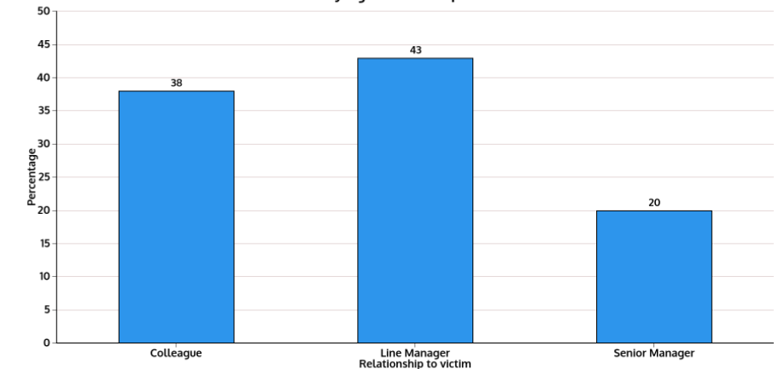
Sources of workplace bullying: London
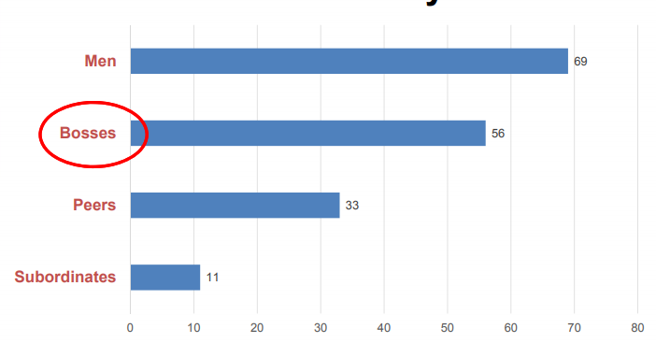
The study carried out by Napoletano, et al. (2015) presented its findings which indicated that 43% of the victims of the workplace bullying had experienced bullying from the line managers. In addition, 38 percent of the people under survey reported that they experience bullying from their fellow colleagues at the workplace. Moreover, one out of five employees interviewed reported that they had been bullied by their senior or the executive manager. These actions of bullying juniors and colleagues stem from the fact that the higher authority these people have makes them feel that they are indispensable for reprimand. The difference in the hierarchy and the organizational structures in most organizations make it impossible for the victims of these abuses to report an indecent action against them while at work.
The organisational culture of any workplace plays a significant role in the execution of the workplace bullying. The culture created by the employees in the place of work gives rise to the problem of bullying in the workplace. Some cultures allow bullying to be a way of achieving goals thus supporting aggression as a motivation (Kelloway, Nielsen & Dimoff 2017). The ambition of employees in the organisation to perform and be better than others can lead to bullying of the weaker individuals in the organization. Thus, a negative attitude leads to the increase in the cases of bullying in the company and nonreporting of bullying. Pastorek et al. (2015), states that employees fear being ridiculed, terminated or being seen as weak by fellow employees. Lenience towards the indiscipline behavior of employees can be a contributing factor to the bullying problem in the firm.
On the national level, the weak bullying legislation which does not provide a clear perspective of the workplace bullying and the protection available to employees are contributing to the workplace bullying (Yamada 2015). The disordered place of work with no proper organizational structure, policies and objectives can be a stepping stone for the bullies to exact their agendas.

Causes of bullying
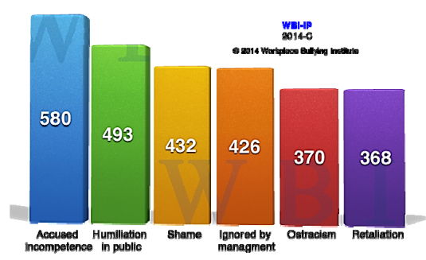

Impact of Workplace Bullying
The people who were bullied at their place of work were mostly women Namie and Namie’s (2014). Despite the workplace bullying not being classified as sexual harassment, it has a significant effect on the employees and the organization as a whole (Eriksen et al. 2016). The consequences of bullying on an individual level include stress, physiological effects, and depression. The organization can have decreased productivity, increased rate of absenteeism, sickness, and turnover. The employees get discouraged, feel alienated and may feel psychological and physically unwell. The victims and the witnesses of the bullying in the workplace are most prone to experience health problems such as enviousness, stress, and disturbed sleep, loss of concentration, short-tempered, being on guard continually, easily startled, headache and nightmares as well as flashbacks (Namie 2014).
The psychological effects of bullying include burnout, depression, prolonged duress disorder, anxiety, lowered self-esteem, panic, psychological trauma, anxiety attacks, suicidal thoughts, substance and alcohol abuse, lack of motivation and other issues which are detrimental to the wellness of the individuals (Murphy 2013). Bullying does not stop at causing psychological harm to the victims and witnesses but it also causes physical harm to them. According to (Barrow et al. 2013), bullying can cause cardiovascular disease. Moreover, if the illness continues for some time the employees might be forced to stay at home and also have financial problems with their medication. Consequently, the employees have more stress and their self-esteem which makes it difficult for them to interact with others and engage in everyday issues at work (Eriksen et al. 2016).
The workplace bullying does not only affect the employees but also has a significant impact on the organization. Namie (2014) asserts that organization incurs great financial costs as a result of workplace bullying. Workplace bullying is causing companies globally millions of Euros in terms of the lost productivity and the lost time. The high employee turnover increases the cost of operation and reduces the products and the services' quality. Consequently, the company experiences economic drain. For instance, the Harrison associates wasted 180 Euros because of the lawsuits filed by their employees in regards to bullying (Crumpton 2014). This is the litigation costs and costs of the time and productivity lost while dealing with the bullying issues.

Solutions
The major aspect which may have a significant impact on the bullying problem in the organization is putting in place a proper organization structure which will be the driving factor to the success and effectiveness of the organization (Tong et al. 2015). The organizational structure has the capability of developing a positive environment for work. This is because the culture of an organization is the mirror to the leadership of the company. Therefore, the management and the leadership of the company should set up mission, goals, structures, and procedure to govern the organization. The missions, values and the goals of the organization will form the culture of the organization which will be used for solving both the internal and the external problems (Schein 2004, p. 26). As a result, the problems such as workplace bullying will be solved through the installation of positive organization culture into the company through the development of values basing on the culture of the organization.
Consequently, the positive corporate culture will support the goals and productivity of employees and the company as a whole following the leadership’s framework (Pilch & Turska 2015). An excellent cultural foundation and Strong leadership have a significant influence on the success and achievement of organizations as the negative behaviors such as bullying will be minimized by the strong leadership.

Conclusion
Communication can be defined as a two-way process where the participants exchange information, ideas and their feelings. Communication is vital in the workplace where the managers, employees and all stakeholders of a company take part in the exchange of meaningful information. An effective communication is important to the success of the operations and overall success of the organization. Therefore, it is significant that the people communicating with each other master appropriate communication skills which will help in making the messages clear to both of the communicators. However, a breakdown in information can occur resulting in misunderstanding and other adverse effects on the operations and general success of the company.
One example is the workplace bullying which can be defined as the intentional and persistent series of actions at the place of work meant to break down an individual’s self-esteem. Basically, bullying takes place through the channels of communication in the organization. Some of the causes of workplace bullying are financial pressure in the economy, workplace hierarchy, organizational structure and the general laws of the country governing bullying in organizations. The victims and the witnesses to bullying experience psychological and physical harm which interfere with their productivity at work and their financial status. The organization also experiences financial greater financial costs due to the loss of time and productivity. Moreover, the litigation costs can be greater for companies sued for bullying. The major solution to the problem of bullying is putting in place proper organizational structure and leadership which will be the framework for every activity in the organization. As a result, the negative behaviors such as bullying will be mitigated as the employees will be following the framework set by the leadership of the organization.

Appendix 1
Sources of workplace bullying: UK

Appendix 2
Sources of workplace bullying: London

Appendix 3
Causes of bullying

List of References
Agency central. (2016). Does the UK have a workplace bullying problem? Retrieved from https://www.agencycentral.co.uk/articles/2016-05/uk-workplace-bullying-problem.htm
Anderson, C. (2007). The Long Tail. New York: Random House.
Robbins, S.F., Judge, T.A. (2007). Organizational Behavior. 12th Ed. New York: Pearson Education Inc.
Barrow, L. M. S., Kolberg, S., Mirabella, J., & Roter, A. (2013). Are rational self-interested leadership behaviors contributing to the workplace bully phenomenon in Canada and the United States? American Journal of Industrial and Business Management, 3(6), 33-38. doi:10.4236/ajibm.2013.36a004
Crumpton, M. A. (2014). The costs of having a bully in the library. The Bottom Line, 27(1) 17-21. doi:10.1108/BL-02-2014-0004
Eriksen, T. L. M., Hogh, A., & Hansen, Å. M. (2016). Long-term consequences of workplace bullying on sickness absence. Labour Economics, 43, 129-150. doi: 10.1016/j.labeco.2016.06.008
Kelloway, E. K., Nielsen, K., & Dimoff, J. K. (2017). Leading to Occupational Health and Safety: How Leadership Behaviours Impact Organizational Safety and Wellbeing. John Wiley & Sons
Murphy, S. V. (2013). Perceptions of bullying in the workplace: A phenomenological study (Doctoral dissertation). Available from ProQuest Dissertations and Theses database. (UMI No. 3570580)
Namie, G. (2014). 2014 WBI U.S. Workplace Bullying Survey. Retrieved from Workplace Bullying Institute website: http://workplacebullying.org/multi/pdf/WBI-2014-USSurvey.pdf
Namie, G., & Namie, R. (2014). 2014 Workplace Bullying Institute Survey. Retrieved from http://www.workplacebullying.org/wbiresearch/wbi-2014-us-survey/
Napoletano, A., Elgar, F. J., Saul, G., Dirks, M., & Craig, W. (2015). The view from the bottom: Relative deprivation and bullying victimization in Canadian adolescents. Journal of Interpersonal Violence, 31(20), 3443-3463. doi:10.1177/0886260515585528
Pastorek, S., Contacos-Sawyer, J., & Thomas, B. (2015). Creating a no-tolerance policy for workplace bullying and harassment. Competition Forum, 13(2), 232-240. doi:10.1g647/t53681-h54
Pilch, I., & Turska, E. (2015). Relationships between Machiavellianism, organizational culture, and workplace bullying: emotional abuse from the target’s and the perpetrator’s perspective. Journal of Business Ethics, 128(1), 83-93. doi:10.1007/s10551-014
Ryan, M. (2016). Management: Besting the workplace bully. Reference & User Services Quarterly, 55(4), 267-269. doi:10.5860/rusq.55n4.267
Samnani, A.-K., Boekhorst, J. A., & Harrison, J. A. (2015). Institutional level bullying: Exploring workplace bullying during union organizing drives. Journal of Occupational and Organizational Psychology, 89(2), 377-395. doi:10.1111/joop.12129
Schein, E. H. (2004). Organizational culture and leadership (3rd ed.). San Francisco, CA: John Wiley & Sons
Tong, C., Tak, W. I. W., & Wong, A. (2015). The impact of knowledge sharing on the relationship between organizational culture and job satisfaction: The perception of information communication and technology (ICT) practitioners in Hong Kong. International Journal of Human Resource Studies, 5(1), 19-47. doi:10.5296/ijhrs. v5i1.6895

