Title: Marketing Plan for Holiday Inn Hotel

Student ID: 2246469
Student Name: Nicusor Florin Mistode
Module Title: BMIH4005 MARKETING ESSENTIALS
Lecturer’s name: Dale Clarke
Word count: 1250

Introduction
The purpose of the current marketing plan is to prepare the key areas of marketing for the chosen hospitality company Holiday Inn as a number of challenges are thrown up to the current marketing landscape. SWOT analysis, PESTLE analysis and the marketing mix are the essential factors that are going to be covered. A marketing plan would help with effective product development and help the company to grow more (Ferrell, et al., 2021). Hence in the current task, the marketing plan is focused on the organisational factors of Holiday Inn.

Situation Analysis - 5Cs
- Company: SWOT analysis (Microanalysis)
Strengths | Weaknesses
- In the financial year 2022, the marketing revenue of Holiday Inn has increased largely (statista.com, 2023)  - The strong global consumer base | - High revenue loss in pandemic years  - Limited investment capacity
Opportunities | Threats
- It can focus on further market expansion  - It can focus the destinations with High consumer demand | - High inflation rate  - Changing market structure

-Customers:
Segmentation and Targeting
Customer profiles SimilarWeb
Segment A: Business Travellers
Segment B: Corporate
Segment C: General Tourists
-Competitors:
Perceptual positioning map
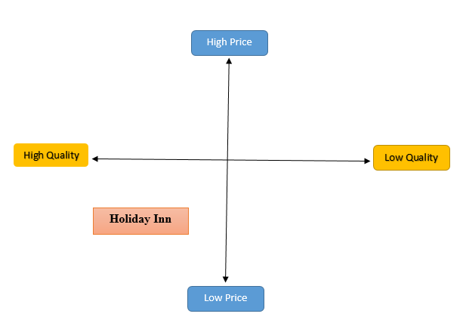
Figure 1: Perceptual positioning map
(Source: Developed by the Author)
Bowman's strategy clock
There are mainly eight segments of Bowman’s strategy clock and these are low price and value-added, hybrid, low price, differentiation and focused differentiation, risky high margins, pricing monopoly, and reducing market share (Morgan, et al., 2019). These factors help in terms of effective brand positioning and marketing for the chosen hospitality brand Holiday Inn with respect to low price, focused differentiation, as well as pricing monopoly strategy.
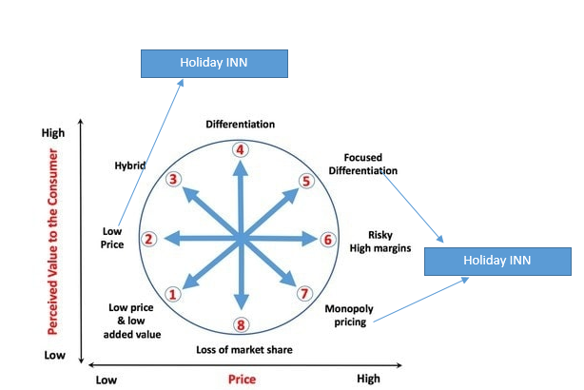
Figure 2: Bowman's strategy clock
(Source: Developed by the Author)
-Collaborators
B2B Relationships | As a hospitality service provider, Holiday Inn is going to collaborate with travelling service providers and travel agent companies who would further help to promote themselves.
Partnerships | In terms of hospitality service providers, Holiday Inn can partner with travel marketing agents who use various channels to promote various travel brands.
Franchises | In order to expand into new regions, Holiday Inn offers a globally recognised hospitality franchise in the corporate terms of IHG which has nearly 6,000 hotels.

-Climate: PESTLE (Macro analysis)
Factors | Analysis | Impact
Political | - Brexit issue  - Taxation | Currently, all the UK branches of Holiday Inn have been dealing with the new business rules and regulations presented whereas effective low taxation policies can present an effective business atmosphere.
Economic | - Inflation  - GDP | Due to a number of effective economic strategies observed by the UK government, the inflation rate has been reduced whereas the GDP has been stabilised and this is effective for the UK hospitality groups (Gooding, 2023).
Social | - Changing buyer’s habit | Changing consumer habits are making organisations adapt to effective and impactful marketing strategies such as digital promotion, Holiday inn can also try promoting themselves by observing the new marketing trends.
Technological | - AI and IT services | Integration of technical innovations in the form of IT and AI are some of the tech-based improvement strategies that various Hospitality companies can take up (Kingsnorth, 2022).
Legal | - Data Protection 2018 | Abiding by the data protection rules and regulations is essential for the chosen hospitality company Holiday Inn and the implementation of IT is the most effective in this context.
Environmental | - Net-Zero Carbon | Becoming net-zero carbon is essential as environmental issues and concerns are increasing heavily.

Marketing Mix
Product | Rooms, Lodging
Price | Competitive pricing strategy
Place | Birmingham and Buckinghamshire of UK
Promotion | Various Digital marketing channels including Facebook and Pinterest mainly

Objectives
Marketing plan:
To develop an advanced neuromarketing strategy for the chosen hospitality brand Holiday Inn for improving the customer satisfaction level in the Post-pandemic era
- SMART target
Specific: To be specific in terms of providing satisfaction for the target market
Measurable: To measure the customer satisfaction score (CSAT)
Achievable: To achieve this target with an advanced neuromarketing strategy via social media platforms
Relevant: To build an understanding of the relevance of the current marketing plan with the help of skilled digital marketing specialists of Holiday Inn
Time-bound: Approximately six months
Strategy
The value proposition strategy is to be followed in terms of building a new marketing plan for the chosen hospitality brand. Hence it’s going to provide effective and safe services to its consumers. The objectives and the USP of the new marketing plan are to be delivered through Digital marketing channels.
Ansoff’s matrix
Diversification is one of the four effective growth strategies in terms of the Ansoff matrix which can be an effective tool for marketing for the business. Diversification involves penetrating a new market with a new product base and services and this can be risky for the company. The factors of advanced neuromarketing strategy are to be aligned with the factors of market diversification for the chosen hospitality company. The company has decided to offer new travel services with the use of electrical transport so that carbon emissions can be reduced effectively. In this context, the product pricing is also going to be controlled and Birmingham is the new market that is to be taken into consideration by Holiday Inn.
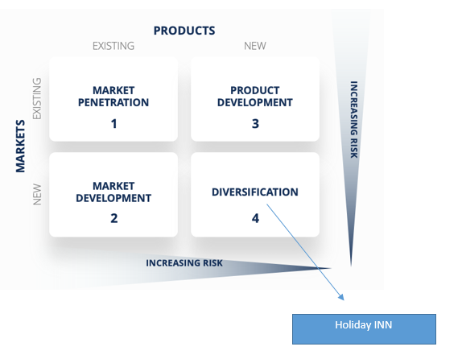
Figure 3: Ansoff Matrix
(Source: Developed by the Author)
Marketing mix
Product | Sustainable Travelling services
Price | Value-driven pricing strategy
Place | Birmingham of UK
Promotion | Instagram-based Marketing Strategy

Tactics
What strategies? RACE/ Communications Mix
Plan | With respect to the prepared SMART goals for the company Holiday Inn's New marketing strategy, the plan for promotional activities is to be prepared.
Reach | Reaching new buyers would be effective with the use of Instagram as it is often viewed as an effective platform for learning new ideas and trends. Promoting the importance of sustainable transport and the Holiday Inn's new strategy of providing these services would be effective with the use of visual inspiration to the customers.
Act | In this section, the business has to try generating leads for adding value to its activities and with the use of paid promotion and other effective strategies the organisation has to focus on increasing its conversion rate.
Convert | As per the previous marketing insights and by running detailed marketing with effective as well as relevant content in terms of target audience the customer profiles are to be built and the sales rate can be increased.
Engage | In terms of engaging more and more customers with the organisation in terms of building strong social media channels and relevant content customers can be engaged and taking feedback from the customers is an essential part of all these.

Action
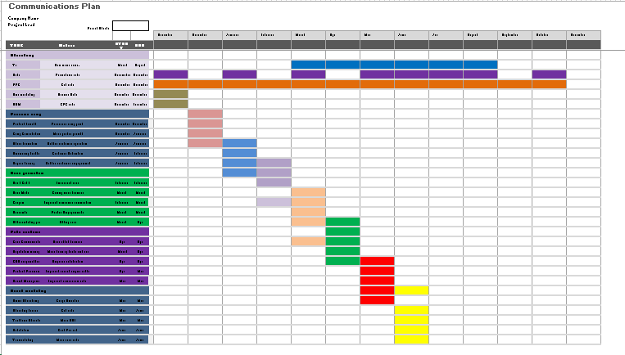
Mainly the digital marketing plan is to be followed by the company as users are spending more time on search platforms like Google and Bing. In addition to that, Social media promotion is also to be preferred over other traditional promotion activities as it would increase visibility.

Control
As observed by Desai, and Vidyapeeth, (2019), in terms of gaining control over the total marketing process the regular evaluation of the marketing plan is an essential part of the company’s task. In the context of the present marketing plan for the chosen company Holiday Inn, the revenue increase is to be taken into consideration. Google Analytics would also help the company to understand how many new consumers are visiting their websites every day. KPIs such as Repeat purchases and advocacy would help with this understanding.

Conclusion
For understanding the new communications strategies in order to address the issues identified in terms of situational analysis, the RACE model has been applied which would enable the chosen business to effectively plan, reach, act, convert and engage in the task of effective promotion. In addition to that the SWOT and PESTLE Frameworks are to be applied in order to understand the marketing environment of the UK-based Hotel industry.

References
Desai, V. and Vidyapeeth, B., 2019. Digital marketing: A review. International Journal of Trend in Scientific Research and Development, 5(5), pp.196-200. https://www.academia.edu/download/90185943/ijtsrd23100.pdf
Ferrell, O.C., Hartline, M. and Hochstein, B.W., 2021. Marketing strategy. Cengage Learning. https://books.google.com/books?hl=en&lr=&id=SewfEAAAQBAJ&oi=fnd&pg=PP1&dq=marketing+strategy&ots=PgWzwvDn2a&sig=YtABwjrQ7EbPPei4LE6CefPWe6s
Gooding, P. 2023. Consumer price inflation, UK: March 2023, Consumer price inflation, UK - Office for National Statistics. Available at: https://www.ons.gov.uk/economy/inflationandpriceindices/bulletins/consumerpriceinflation/march2023#:~:text=These%20differences%20sum%20to%20the,from%209.2%25%20to%208.9%25 (Accessed: 08 June 2023).
Kingsnorth, S., 2022. Digital marketing strategy: an integrated approach to online marketing. Kogan Page Publishers. https://books.google.com/books?hl=en&lr=&id=acdsEAAAQBAJ&oi=fnd&pg=PP1&dq=marketing+strategy&ots=Ztip4XCxpN&sig=iHnZqovVm2u4jDc5BbuE0WhQ-38
Morgan, N.A., Whitler, K.A., Feng, H. and Chari, S., 2019. Research in marketing strategy. Journal of the Academy of Marketing Science, 47, pp.4-29. https://link.springer.com/article/10.1007/s11747-018-0598-1
statista.com, 2023. Holiday Inn Express hotels gross revenue worldwide 2022, Statista. Available at: https://www.statista.com/statistics/223347/holiday-inn-express-hotels-revenue/#:~:text=Holiday%20Inn%20Express%20hotels%20worldwide%20generated%20approximately%208.3%20billion%20U.S (Accessed: 08 June 2023).
Component B




