
Sports Industry Research
Project

Student Name
Rory Thomas

Project Title
Primary School teachers perceived challenges in delivering the ‘Health and Wellbeing’ strand – Wales New Curriculum

Contents Page
- Introduction………………………………………………………….
- Aims and Objectives………………………………………………..
- Literature Review…………………………………………………...
- Research Methodology……………………………………………..
- Results and Findings………………………………………………..
- Conclusion...................................................................................
- Recommendations………………………………………………….

1.0 Introduction
“An introduction is important as it is the most important part of a dissertation as it is the beginning of a dissertation project which brings focus into theme and is a quick summary of what to expect as you read through”.
In here will be multiple sections of data that I have collected over the last few months whilst preparing for my dissertation. What I will be looking for in this project is the understanding primary school teachers have on the new health and well-being strand that is taking place in schools all over Wales very shortly. During my findings I will have to gather many resources like questionnaires and interview teachers to see what they know or what they do not know.
My reasons for using questionnaires and interviews will be explained later on in the project talking about why and how it helped my gain my findings.
During this project I will also be going into more depth about the questionnaires and the interviews, what was said and also the results I had from them.
Also throughout this project I will be talking about what my aims and objectives were to complete this, also be going into detail about my research methodology, then I will be showing my results and findings and explaining that in better detail and lastly I will be talking about my conclusion and recommendations if I ever had to do it again. For example, what I did well or what can be improved on for next time.
When I will talk about these different sections, it will all be from my work and all the data I will show has been collected by myself from staff at Brynhyfryd Primary School and then it will all go into this project I am talking about now.

2.0 Aims and Objectives
Aims
“Aims are statements of intent. They are usually written in broad terms. They set out what you hope to achieve at the end of the project”.
The aims I had set myself to gather my findings was to make sure I understood what the topic was I going to be talking about and also making sure that the questionnaires and interviews I have set up and created that they were good and structured about the topic.
Another aim I had was to make sure that I had the ability to find and get these results, for this I had to make sure I could interview school teachers in Brynhyfryd Primary School and that it was not going to be a problem.
Setting these aims for my project was easy enough but then I had to make sure I would get them all completed by a certain time.
Achieving these aims meant that I had to make sure I gave myself enough time to one hand the questionnaires out and then allowing them to fill it out and then for myself to get it back. Secondly, it was trying to arrange an interview, but I had to make sure that I was allowed and also we could only do it when the teacher had a free lot in her timetable.
Objectives
“Objectives should be specific statements that define measurable outcomes”.
Now to complete the aims I had set myself I had to think of different ways on how I would be able to gather and find the results I was looking for.
So, I decided to gather my results and findings setting up an interview with one schoolteacher and then asking them multiple questions about the Health and Well-being strand and then I would take down their answers.
Another way to achieve my aim and gather results I decided to make 10 questionnaires and hand them out to different teachers so I can get a different answer from different teachers and not having to just base my results on one teacher.
Another objective of mine was to make sure that I would be able to complete the aims I had set out. So, I needed to sort times and ask the teachers if they are available and then I could start to plan everything out and try and achieve my aims and also achieve my objectives.

3.0 Literature Review
Primary Physical Education, Coaches and Continuing Professional Development (2011)
Primary school physical education (PE) in England has traditionally been taught mostly by generalist class teachers (Garrett & Wrench, 2007), with a small percentage taught by specialist primary PE teachers.
Physical education in primary schools are taking place but not correctly, the reason being is because most of the PE lessons are taken by teachers who don’t have enough knowledge and how to deliver a PE lesson, but in some primary schools you will have teachers who are specialised in that area of subject and are able to deliver a lesson properly.
Qualified primary teachers have spent at least four years in higher education, with at least one of those years learning to teach across the full range of curriculum subjects taught in primary schools, including PE. However, more recently, some PE in primary schools has been taught by people other than the class teacher; in particular, coaches (particularly football coaches; SportscoachUK, 2004, 2007a).
If primary schools are going to employ sports coaches to cover PE lessons and allow teachers to take PPA time, it is essential that they have the knowledge, skill, understanding and expertise to carry out specified work. However, coaches who have learnt to coach through NGB awards, and through their own experiences, may not have the background, experience, knowledge, understanding or skill to carry out specified work within the National Curriculum for Physical Education (NCPE).
Methods
The sample for this study was 21 Football in the Community Coaches, Schools will employ coaches who will then work predominately with 5 -11-year-old children, in both school and community settings. Coaches will be employed by the Community Sport Trust (a community department of a professional football club that has charitable status) of one English Premier League) club during the 2007 calendar year. Part of the work of these coaches involved undertaking specified work in PE lessons to cover primary teachers’ PPA time.
Results and Findings
Results collected in January 2007 (Blair & Capel, 2007) showed that this group of coaches did not plan for the short and medium term as a matter of course and did not value or understand the importance of planning. As a result of participating in this CPD programme, results showed these coaches increased their awareness of the importance of the planning process in both short term and medium terms.
“Starting the lesson with something short and interesting will help settle the students and engage them with the lesson.” (S.Umair’s, 2015)

A Professional Development Program to Enhance Primary School Teachers Knowledge and Operationalization of Physical Literacy
The purpose of this study was to devise, implement, and evaluate a professional development program that works in a primary school environment to enhance their knowledge and operationalization of physical literacy. Despite the increase of research and implementation, the physical literacy continues to be largely misinterpreted by practitioners.
Despite the increased interest and attention around the concept of physical literacy on a global and political level (Dudley, Cairney, Wainwright, Kriellaars, & Mitchell, 2017), it continues to be largely misinterpreted by practitioners, including school teachers (Edwards, Bryant, & Jones, 2015).
Although physical literacy is relevant throughout the life course, currently, school66 based physical education (PE) lessons have been recognised as the most common environment in which children and adolescents can develop their physical literacy (Edwards et al., 2018).
Methods
Following institutional level research ethics committee approval, a purposive sampling procedure was employed to select the schools for this study (Patton, 2002). Specifically, Welsh-medium schools were selected because it was a key requirement of the funding body, the Coleg Cymraeg Cenedlaethol. Written informed consent from two head teachers and three primary school teachers was collected to allow participation in the study.
Further, year six (fifth grade) pupils in their final year of primary school (aged 10-11) who received two one-hour PE lessons per week, were the key focus of this study, given that physical literacy should be nurtured in primary before transitioning to secondary school (Zeedyk et al., 2003).
Results and Findings
Pupils are able to use correct language to describe what they do and what effect it has on the body. In contrast to physical literacy, literacy in PE refers to developing the skills of speaking, listening, reading, and writing in PE lessons (Department for Education and Skills, 2002).
The collaborative discussions developed an awareness of teachers’ responsibility in ensuring positive outcomes to pupils’ health in later life from quality PE provision was prominent.

Pre – service primary school teachers experiences of physical education
Schools play an important role in supporting children to develop the knowledge and skills to lead physically active lifestyles,4 and key to this is the delivery of high-quality physical education. Many schools did not have a PE policy, plan or program and many had highly sedentary PE lessons that did not sufficiently focus on fundamental movement skill development. Research suggests that schools often face a number of barriers in the provision of quality PE lessons. These include a lack of staff time due to a crowded curriculum, a lack of teacher expertise and confidence, and school prioritisation of other learning areas.
Methods
To work with universities to enhance the PE skills of graduate primary school teachers. Critical to enhancing the skills of graduate primary teachers, however, are opportunities to observe, practice and receive feedback regarding the teaching of PE to children as part of their university in-school teaching practicum.
Preservice primary school teachers may be required to undertake a final year practicum teaching experience within schools of 20-50 days. In October 2010, we conducted a paper survey with pre-service primary school teachers from one university in NSW, who were in week nine of their final 10-week teaching practicum, to identify the nature of PE teaching experiences while on practicum.
Results and Findings
More than half (59%) of the pre-service teachers had been provided the opportunity to teach PE one day per week or less. Of these, 21% did not teach a PE lesson during their nine weeks in the school. Many had observed their colleague teachers discipline students by excluding them from PE (48%), use PE as punishment (63%) or cancel a PE program because of other events in the school or because of poor weather (58%).
Opportunities to teach PE during practicum are critical to ensure the appropriate development of pre-service teacher skills. However, they may then be undermined once students are employed in schools which do not have a culture which values and practises quality teaching of PE.

Understanding primary schools teachers perceptions and ideologies around the value of physical education
It is suggested that non-specialist teachers are under qualified and they also lack knowledge when it comes to teaching the physical education. It is very important that primary school teachers understand the perceptions and ideologies and making sure that they also have the proper understanding of physical education.
Primary school teachers fail to acknowledge the importance of PE in comparison to other subjects such as Maths and English, which are viewed as the more ‘academic’ subjects (Barney and Deutsch 2009).
The National Curriculum for Physical Education (NCPE) in Wales aims to ensure that all pupils are able to develop competence in order to excel in a variety of physical activities, to ensure they become physically active for sustained periods of time through engagement in a range of activities and competitive sports, whilst also leading active and healthy lives for the pupils.
Methods
Semi-structured interviews will be thoroughly planned and conducted professionally, with appropriate questions in order to ensure that the process was efficient and effective. Sparkes and Smith (2014) suggest that one main strength of semi-structured interviews is that the flexibility in which participants can respond to questions being asked, which then enables participants to express their ideas and thoughts with potentially more meaning.
This method is enabled for a subjective and in-depth understanding of individual teachers’ perceptions of high-quality physical education to potentially be gained and understood better.
Results and Findings
Through the identification of key themes, patterns and trends in responses from participants, whilst comparing and analysing these alongside pre-existing literature and theories to develop an understanding of the creation of the teaching identity, and also how their previous experiences help to shape their dispositions towards PE (Sparkes and Smith 2014).
The analysis of the data indicated that previous experiences within PE or early sporting experiences allowed for the construction of teaching dispositions of perceived goods practice of physical education and also ideologies of how to implement these dispositions of perceived good practice in order to deliver quality physical education lessons.
The lack of in-depth understanding of teaching perceptions and ideologies of primary school physical education teachers, and their influence on delivering structured PE lessons.

The effects of a professional development programme on primary school teachers perceptions of physical education
During the growth of primary school teachers far too many of them have received nothing more than an introduction to physical activity which has then resulted in them having limited knowledge and also can lack confidence in the subject.
In some primary schools there does not seem to be enough teachers who are educated in physical education and this causes problems and impacts the pupils ability to learn in that area. With there not being any specialised teachers in PE then PE lessons are then taken by classroom-based teachers, this is a problem because some primary school teachers do not understand how to deliver a well-structured PE lesson which would help the children benefit.
Primary school teachers tend to hold a negative attitude towards PE as compared to the core subjects such as Maths, English and Science as they have more knowledge of these subjects.
Methods
Primary PE in England emerged in 2005 where primary school teachers had become entitled to be released from 10% of their timetabled lessons so they can plan, prep and do assessments (Workforce Agreement Monitoring Group 2003). This then opened up the opportunities for external groups (coaches) to come into school and deliver the curriculum PE and also leads to calls for a high quality assurance procedures to make sure that groups have had the correct and professional competence to target pupils learning and raise attainment (Sport England 2005).
An increasing number of Headteachers are making indiscriminate use of the coaches to deliver physical education and also school sports. With this happening it is threatening the high-quality provision in primary schools.
Results and Findings
Primary school teachers expressed negative perceptions and anxieties about teaching PE, they lacked confidence in teaching many PE subjects like Gymnastics. Research shows that 82% of primary school teachers did not hold a PE or sports science degree.
The failure of primary PE-ITT has been a long-standing concern in England (Physical Education Association of the United Kingdom 1998, 2000, CCPR 2004) and has been raised as an important issue by the government’s own problems for schools (Ofsted 2000,2009).

The effect of non-specialist physical education primary school teachers experiences of physical education
Physical education is currently in a state of neglect in primary schools and is one of the many reasons for this being, the lack of input from teacher training courses to have an effect on teachers’ confidence, knowledge and understanding needed to teach PE.
The concept of PE presents opportunities whereby children can make substantial development (Murdoch & Whitehead, 2013) which are focused upon four broad domains: physical, social, affective and cognitive, all of which aim to promote lifelong physical activity (PA) (Pickup & Price, 2007: Bailey et al., 2009).
Qualified PE specialists are more likely to teach higher quality lessons whereas the classroom teacher would not (Fletcher&Mandigo, 2012). One of many different reasons why qualified PE teachers would benefit more compared to classroom teachers is because they are going to feel more confident when preparing and delivering a lesson and will also find it very enjoyable.
As primary PE is very important in schools and also for pupils development debates arose as to whether non-specialist classroom teachers, who currently take a greater percentage of primary PE (Graber et al., 2008) are best suited to teach primary PE in comparison to a specialist PE teacher (Fletcher & Mandigo, 2012).
Methods
There are multiple methods to help collect the data to help understand why. Semi-structured interviews will be used as they are beneficial as it lets specific questions to be answered using a progressive structure to maintain focus (Patton, 2002, Walliman, 2011).
However, allowing this type of structure is better because it gives the participants a chance to elaborate on their answers and go into depth on the points they have made (Gratton&Jones, 2004; Walliman, 2011).
Another method that can be used to see if a classroom or qualified PE teacher lessons are better is to get them both to deliver a lesson and then at the end see which one had a better outcome. Also asking the pupils and some teachers to see if they think bringing a qualified PE teacher in would be more beneficial and would see greater results for PE in primary schools.
Results and Findings
Results have shown that primary schools still need to play a huge part to help primary school teachers learn more about physical education. Also, primary schools would benefit more if they employed primary teachers who are specialised in physical education as it will help the pupils increase their knowledge on PE and with having structured PE lessons within schools then pupils gain more. It also is better having a PE teacher and not a classroom-based teacher as there is a different attitude between them both and most classroom teachers would probably gain more out of not having to deliver a PE lesson.

- Research Methodology

“The process used to collect information and data for the purpose of making business decisions. The methodology may include publication research, interviews, surveys and other research techniques.”
“A philosophical stance of worldwide that underlines and informs a style of research. (Sapsford,2006,p.AS)
There were two other methods I used, and these were called quantitative and qualitive methods. These two were the most important methods to me and the only two that were applicable to my project and that could get me the best and most realistic answers.
Quantitative I used was for the surveys and Qualitative was for the interview side of the project.
Research design comes with two different sections that again could have been used towards my project. The two sections are ontology and epistemology.
Ontology means it is concerned with the nature of reality which results in it being the ‘science or study being’.
Next, we have epistemology which is something that is concerned on the general basis of something, also means that this method is different ways of gaining knowledge about something.
Both ontology and epistemology can be used in a research question as it is the foundation of approach to it.
The research methodology side to my project is the most important as it will allow me to find everything I need to and there are multiple ideas I could have done to help me with this but as I mentioned before I will be using something called ‘interpretivism’.
“Interpretivism is a more qualitative approach to social research. Interpretivists are of the view that individuals are complex and intricate people”.
Another method I could have looked to use is the ‘positivism’. The way the positivism method would have worked is that I would have had to gather my results and findings by doing experiments on either teachers or some of the school pupils. Unfortunately, due to my question the positivism is something I ruled out straight away and then I looked at the interpretivism which I chose as it suited what I was doing better and I felt I could gain better and more structured answers.
Interpretivism is a method I will be using to gain my findings and to do so I will be using humans to help me gain these. How I will be doing this is that I set up an interview with one schoolteacher for an interview about the Health and Well-being strand and then listening to what they have to say but then also taking down additional notes about it.

Why did I want to use questionnaires and an interview?
The reasons why I wanted to use these are because they will be a great way for me to gain my results and also would get me better answers from multiple teachers within the school.

For the questionnaires I decided to just leave enough space so that the teachers could write in the answer. The questionnaires were done via person and I gave them a week to make sure it was filled in and completed.

For my questionnaires I came up with 10 different questions about the Health and Well-being strand which would end up giving me different answers to go by and look at. The questions were all based around the strand and also there were a few questions if they understood what it was and if they did not how they could gain better knowledge on it.

Once I had got all my questionnaires filled out and handed back to me it was time to see what the teachers had to say about it. Looking at the results from the questionnaire was interesting and they will be talked about in the results and findings section of my project.

After I had my questionnaires back, I then arranged an interview with one of the teachers from the school. The interview only went on for about 5 minutes and in that interview, I asked 5 questions around the Health and Well-being strand which Mrs Bevan was going to answer back honestly.

The interview was set up to be informal so it would make myself and the teacher more relaxed and not feel any pressure when asking or answering the questions. The interview got interrupted as pupils and staff kept walking in on us, which resulted in as having to slow the interview down and lose focus on what we were actually doing.

Again, for using methods such as these benefited me hugely as I managed to get some interesting answers through my questionnaires especially. The questionnaire I think worked the best for me as there was a range of questions which gave the teachers the chance to express their answers and their answers gave me some good findings which I looked at.

As I said doing the questionnaires and interview was the better option for me and it worked well with me gathering results, but I do feel there was some weaknesses for me whilst doing it.

The questionnaires I had created were not detailed enough for me to get the proper answers that I could have gained. Therefore, if I did put more detail into the questionnaire, I would have then gained better results.

Now we talk about the interview part, this was not as I wanted it as it only lasted 5 minutes with 5 questions. Now to be able to gain the results I wanted then I should definitely have made the interview longer by adding more questions and going into detail about them.

So, looking at my research methodology I can say it was the right decision to go with the methods I chose as it did give me some good results and helped me with my project. These methods I would chose to use again as they were the most important ones and helped me very well with my project question and was the most suitable for it to.

5.0 Results and Findings

In this section it will all be based on the results I have gathered from completing the interview and also with the questionnaires I handed out to the teachers allowing them to answer them honestly. I decided to use a bar chart too show my findings as I thought it would be the better option for me and would show the results better than anything else.
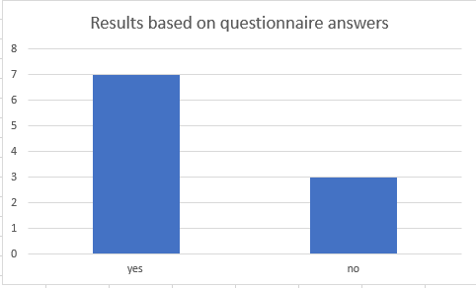
As you can see from the chart below the results, I gained this from was because of the question I had asked at the start of the questionnaire and these were the results.

The chart above gave me the results out of 10 teachers that answered my first question which was ‘Are you aware of the new Health and Well-being strand that is being introduced to schools in Wales?’. As you can see from that question 7 out of the 10 teachers were aware of the new strand coming in whereas 3 teachers were still unaware of the strand coming in.
Looking at the 3 teachers who were not made aware of the strand then went on to say that they would be very interested in finding out about more about the Health and Well-being strand, so wanting this to happen they will have the options to take multiple courses regarding the strand and to also take some time of their own and learn more about it that way.
Now we move on to the 7 teachers who were made fully aware of the new Health and Well-being, resulting in them understanding the strand they also gave multiple reasons how they knew about it. The most common answers I received was the fact that the teachers had taken courses to help them understand and increase their knowledge on the whole Health and Well-being strand. It is extremely useful for teachers to attend these and they will keep increasing their knowledge about it which for the future becomes more beneficial.
Out of the 10 teachers that took part in the questionnaire they were all very helpful and willing to participate to the best of their ability.

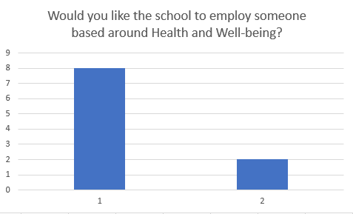

Chart 2 as shown above is another chart we will go into detail about, I asked the question to the teachers if they would prefer the school to employ someone who has a better understanding of the Health and Well-being strand and as it shows 8 teachers have said they should not employ new staff and 2 teachers have said yes and think it would be a good idea if they employed someone with better knowledge.

8 members of staff have said that they would not like if they employed someone else to come in and help deliver this strand. They also went on to say that the school should give every member of staff the opportunity to learn and understand the Health and Well-being strand, again they mentioned how it would save the school money instead of using that money to employ another member of staff. I then wondered how they would be able to educate the teachers on this strand and spoke to Mrs Bevan who is one of the teachers in Brynhyfryd. Teachers can be educated about the Health and Well-being by schools being able to set up meetings or sending us on different courses to help, also teachers can learn it by themselves when they are free (Mrs Bevan, 2019).

Now where 8 teachers have said they would not appreciate employing someone to come in and teach this strand, whereas, 2 teachers have said that they would like the idea of the school employing someone who has more knowledge on the strand. The 2 teachers went on to talk about how it would benefit them, employing someone who has a particularly good understanding of Health and Well-being will be able to deliver and quality and structured lessons. Another reason they said is that it would give the teachers a chance to continue with their work that needs to be done and they can get on with planning or other things they need to get on with.

So, overall, the majority of the schoolteachers would not like the school to employ another member of staff to help deliver the Health and Well-being strand. Looking at the results I have gathered from this question it is clear to say that I do not think schools will be employing anyone and they will focus more on the fact they can increase the knowledge of the members of staff that they have already employed. Schools should now look to be seeing how they can increase the knowledge of their staff by introducing courses that they can attend every so often so they can keep up with the strand.

“Schools have a responsibility to teach, model, build behaviour practices and implement curriculum requirements that support a learning environment where the connection of learning about health and wellbeing is supported by alignment of action across a whole school approach”.

“Schools have a critical role in supporting students to make healthy lifestyle choices and to understand consequences on lifelong health and wellbeing”.

As quoted as above schools are the most important when it comes to giving the children the best, they possibly can so by making sure they use the Health and Well-being correctly and make sure the children have a great understanding of it. Schools have a critical role in making sure pupils make and have healthy and active lifestyles so in the future they can have a greater and better understanding of the Health and Well-being strand.

Another part of the questionnaire that grabbed my attention was when I asked the question:
For up and coming teachers who are in ‘teacher training’ how can they get the strand into their teaching strategies?
The most common answer that kept coming up was when they wrote about the Health and Well-being strand so be made compulsory in the teacher training courses. Now looking through my questionnaires I can see that this answer came up a lot and then I asked them to explain why or how they thought it could be introduced into this and what again came up is when teachers are sent to a school to complete their training then the Health and Well-being strand should be something that teachers must give a lesson on.

This way consists of two different options on how it can be achieved and that is they can either do classroom-based lessons and use the physical activity side of things. Either one of these would be a great way to get the children to understand just how important health and well-being can be for themselves. For example, teachers could use classroom-based lessons to show the benefits and how important it is to lead a healthy lifestyle. Then the teachers could then use to physical side to show different situations on how they can keep up with the physical side of things, so by doing fun activities with children will make them realise that being able to do a certain sport/fitness activity will be beneficial for them in the future.

Learning in health and wellbeing ensures that children and young people develop the knowledge and understanding, skills, capabilities and attributes which they need for mental, emotional, social and physical wellbeing now and in the future. (GOV.UK, 2018)

So as looking at the results from the question it shows just how important it would be for the teaching courses to make the Health and Well-being strand compulsory as there would be a number of different benefits for up and coming teachers and also schools and children too.

By introducing the Health and Well-being strand into courses would result in newly qualified teachers (NQT) being able to gain all the knowledge they would need to know and successfully deliver a well-structured lesson to the children.

Secondly, if NQTs already have the understand and knowledge for health and well-being then it would result in the school saving money and not having to employ new members of staff who are specifically designed for the strand.

Lastly, the children would gain a huge benefit from teachers who already understand the strand because they would have structured lessons and the children themselves would be able to get a better understanding of the whole health and well-being situation and how important it is.

Now we move onto the last part of my results and findings, we will now go into some detail about the interview that had taken place. The interview took place in the schools staffroom.

The interview I sat was with some of the teachers in Brynhyfryd called Mrs Bevan. The interview consisted of 5 questions all based around the new Health and Well-being strand and lasted for around 5 minutes, so it was quite a short and simple interview. The answers Mrs Bevan were all incredibly good and there were some interesting answers that were said. Considering Mrs Bevan did not have a great understanding on the strand she still gave great answers which were really helpful to me and helped me with this.

Interviews are a great way to gather results and actually get the answers you are looking for, when interviewing face to face the majority of the time the answers you get are the ones you need.

Questionnaires are good because you get an idea of what everyone thinks of a certain thing, whereas, it can also be negative to do questionnaires as you will not guarantee that the answers you can are truthful.

My results and findings have been really helpful for me to be able to put this project together where I was lucky enough to gather some great findings and also get the help of the schoolteachers. The schoolteachers all gave up their time to fill out the questionnaire and then hand them back to me.

6.0 Conclusion

In this section I will be talking about what I found out, what went good and bad, if there is enough evidence for future study and then I will go onto and talk about the recommendations.

During the time of me handing out questionnaires for teachers to fill out, the interview I done and also just the gathering all of that back and then trying to look at the results and see what has been said, there were some interesting answers from both the questionnaires and the interview. If it were not for Brynhyfryd School and the teachers I would not have been able to gather all of these findings and also would not have been able to do my project.

Throughout the whole time of putting this project together and also working with Brynhyfryd School there were obviously a few challenges whether it be trying to collect the data or just putting it together. I am now going to talk about the things that went good for me either it be this project or just the whole questionnaires and interview situation.

Throughout the time I had to gather results and everything I found out that the school are extremely interested to find out more about this Health and Well-being strand that is coming into schools across Wales very soon. The teachers at the school have some of understanding and do know what to expect when this strand comes into their curriculum. However, the teachers who do not understand or have any knowledge are still interested in learning as they are wanting to attend many courses and are willing to learn about it in their own time as they want to gain the knowledge they need to help educate the children.

The questionnaires and interview I put together I thought it worked really well. With the questionnaires it was the right idea to hand out 10 to 10 different teachers as I could get a better understanding on what they thought about the new strand. Obviously, with 10 questionnaires the majority were bound to have different answers and with that being the result it helped me gather and put together this project. The answers that I had received from them and also the interview was good and like I said it was great to be able to use their answers to help myself with my understanding and most importantly my work.

Thirdly, when I created the questionnaires and done the interview there was times that the work I done could have been improved and could have potentially given me more and better results. The questionnaires for example went well but it also let me down, the questions I had typed were good questions but it resulted in them giving me short answers because I did not put them in more detail or give them an option to explain their answer properly. Again, I could have added in more questions too which would have made me get more answers to look at and would have resulted in better answers.

Next, the interview I had done gave me some good answers but again the interview was extremely poor from my side and this is because there were only 5 questions and the interview only lasted for a short amount of time. I did not put enough time and effort into the interview which resulted in the interview being useless to me in some ways, if I would have put more time and effort into the questions and add more questions it would have resulted in me being able to increase the length of time of the interview and then also would have my interviewee a better chance to go into more depth when answering the questions set out.

So with the questionnaires and in the interview if I had put a little more time and effort into them both then it would have benefitted me a lot more as I would have had more in depth answers to go on instead of the short answers. But them two situations are the only things I felt that I could have improved on as everything else was good and went well.

After gathering all the findings from the questionnaires and interview it is quite easy to say that this is enough evidence for something like this to be studied again. The Health and Well-being strand will shortly come into all schools across Wales so for there to be a future study it would be ideal. To be able to make sure that the Health and Well-being strand can be studied again then there could be different ways on how to collect the data.

If this strand were going to be studied again then one way, they could collect evidence is by doing a practical experiment. For example, going back into a primary or secondary school and then when there are physical education (PE) lessons on it would be a good idea to see how many people take part and then ask them if they are taking part for fun or if they know why it is important to exercise. Then there should be a lesson on about the benefits of health and well-being and how it can improve your physical and mental state. If pupils were soon to realise the benefits of this then comparing the numbers in the first PE without knowledge on the health and well-being should be compared to the numbers of pupils participating after the lesson on it.

Secondly, the questionnaires would be another great idea to help collect more data if this were to happen again. The questionnaires should contain 10 different questions all based around the Health and Well-being strand, but they should have enough detail in them for the person to be able to answer the question and be able to give a good enough reason why. The more detailed the questionnaire the better results you can get.

Next, interviews can be a great way to get a persons full understanding on something, so for a future study on this the best way to gain data from interviews is to set the right amount of questions and to also to have multiple interviews. By holding more than one interview you can get you different opinions from different people which then gives you multiple results to look at and compare against other data.

Also, another great way for future studies to collect data is to compare the old data to the new ones that will be taken. If future studies were to go ahead then on the Health and well-being strand then the best idea would be to gather the data before the curriculum is in place. Once the data for before hand has been collected it would be an idea to then wait until the Health and Well-being strand is finally part of the curriculum and once this is in place then the data collection is ready to go.

Looking at the old data that has been collected, it would then be a good idea to then plan the new data collection around the old one. Also, when comparing the data try to see if there has been a positive from something or an increase of such. Once this is done you will be able to put the questionnaires and interviews together to try and help gain enough evidence and see what the difference was of the Health and Well-being strand before and after it was introduced into the curriculum.

7.0 Recommendations

My recommendations for this whole project are to see what can be improved or developed to make it all better. The only two recommendations I would have is about my questionnaires and interview, I still think they should have been much better than I did. My questionnaires and interview were poor because of the standard of the questions that I created, the questions for both were not detailed nor did I give the teachers a chance to elaborate on their answers. If I would have allowed the questions to give a deeper answer then the data I could have collected would have been much more usable and more beneficial.

Recommendations regarding the Health and Well-being strand is that I should have learnt and understood the strand more because then that would have given me more of an idea on what to base my questions on when creating the questionnaires and the interview.

So, for future reference the recommendations I would give myself is to make sure the questionnaires and interviews are both in full detail and allows the teachers to give a good and detailed answer next time.

As I come to the end of my project I would like to say a big thank you to Brynhyfryd Primary School for allowing me to use them in my project and help me gather the results I needed to do so. Another big thank you to the teachers of Brynhyfryd School for again allowing me to use them in my projects whether it have been in the questionnaires or the interview. Either way without any of the Brynhyfryd staff or even the school itself I would not have been able to gather all this data, even increased my knowledge on multiple stuff too.

Another thank you to Andrew Thomas and James Prosser for helping me achieve and complete my dissertation, I appreciate the help and guidance you have both given me throughout the year.

“There is no talent here, it is all hard work” (Connor Mcgregor, 2018)

Appendix
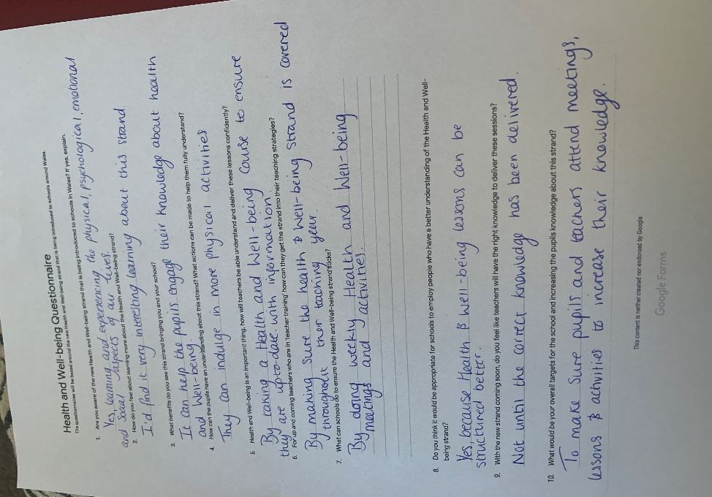
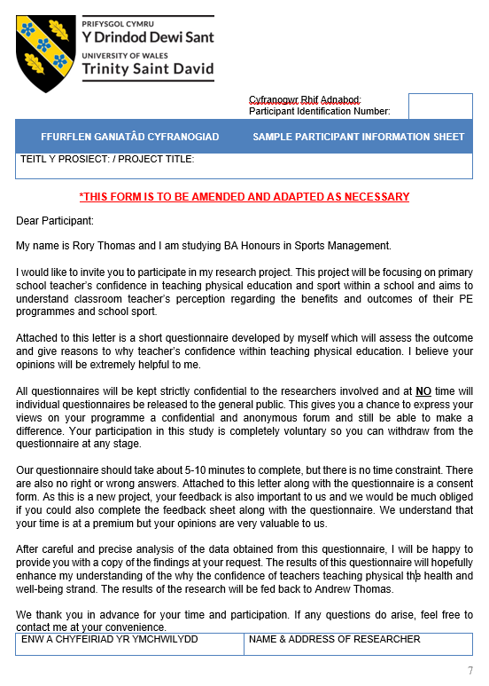
questionnaire

References
Nexus.uwinnipeg.ca. (2015). Importance of Good Lesson Plan - University of Winnipeg. [online] Available at: https://nexus.uwinnipeg.ca/d2l/lms/blog/view_userentry.d2l?ou=6606&ownerId=12756&entryId=1725&ec=1&iu=1&sp=&gb=usr [Accessed 10 Dec. 2019].
Edwards, L., Bryant, A., Morgan, K., Cooper, S., Jones, A. and Keegan, R. (2019). A Professional Development Program to Enhance Primary School Teachers’ Knowledge and Operationalization of Physical Literacy
Nathan, N., Wolfenden, L. and Morgan, P. (2013). Pre-service primary school teachers' experiences of physical education. Australian and New Zealand Journal of Public Health, 37(3), pp.294-294.
Morgan, D (2015) ‘Understanding Primary School Teachers Perceptions and Ideologies Around The Value Of Physical Education
Harris, J., Cale, L. and Musson, H. (2010). The effects of a professional development programme on primary school teachers’ perceptions of physical education. Professional Development in Education, 37(2), pp.291-305.
Porter, L. (2015) The Effect of non-specialist physical education primary school teachers experiences of physical education during their school centred initial teacher training course on their confidence, knowledge and ability to teach physical education pp.6-8.
Philip Morgan & Vibeke Hansen (2007) Recommendations to Improve Primary School Physical Education: Classroom Teachers' Perspective, The Journal of Educational Research, 101:2, 99-108, DOI: 10.3200/JOER.101.2.99-112
Byrne, J., Rietdijk, W. and Pickett, K. (2018). Teachers as health promoters: Factors that influence early career teachers to engage with health and wellbeing education. Teaching and Teacher Education, 69, pp.289-299.
Rainer, P., Cropley, B., Jarvis, S. and Griffiths, R. (2012). From policy to practice: the challenges of providing high quality physical education and school sport faced by head teachers within primary schools. Physical Education & Sport Pedagogy, 17(4), pp.429-446.
Terzieva, G. (2019). A CONCEPT FOR INCLUSIVE PHYSICAL EDUCATION TRAINING PROGRAM FOR FUTURE PRE-SCHOOL AND PRIMARY-SCHOOL TEACHERS. Trakia Journal of Sciences, 17(2), pp.97-100.
Learn.solent.ac.uk. n.d. Writing Dissertations: Aims And Objectives. [online] Available at: <https://learn.solent.ac.uk/mod/book/view.php?id=116233&chapterid=15294> [Accessed 29 April 2020].
Quora.com. 2019. [online] Available at: <https://www.quora.com/What-is-the-difference-between-ontology-and-epistemology> [Accessed 29 April 2020].
Publicdocumentcentre.education.tas.gov.au. n.d. [online] Available at: <https://publicdocumentcentre.education.tas.gov.au/Documents/Student-Health-Initiative-Facts-and-Research.pdfhttps://publicdocumentcentre.education.tas.gov.au/Documents/Student-Health-Initiative-Facts-and-Research.pdf>.
Pro-updates.com. 2019. Why Introduction Is So Important In Dissertation Writing. [online] Available at: <https://www.pro-updates.com/2019/12/why-introduction-is-so-important-in.html>

Submission Evidence

Faculty Office (1 x Paper Copy, Bind Professionally)
+
Online Turnitin Submission (prior to Deadline)



BA Sports Management Portfolio

Research Project
Report

UWTSDSport

