02/03/2026
Morgan Jenkins (2528481)
University of Wales Trinity St David
Digital Degree Apprenticeship
Bsc Applied computing (Software engineering)
ACCA 4025: Learning in the Digital Era
Morgan Jenkins 2528481
Assignment 1

Contents
E-Portfolio 2
Task 1 2
Task 2 3
Task 3 4
Task 4 5

E-Portfolio
Here is the link to my e-portfolio
And here is a screenshot of my home page
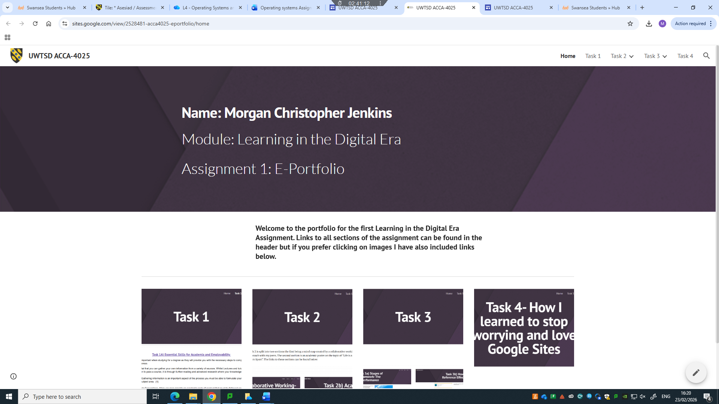

Task 1
Below is the screenshot for task 1 in the e-portfolio
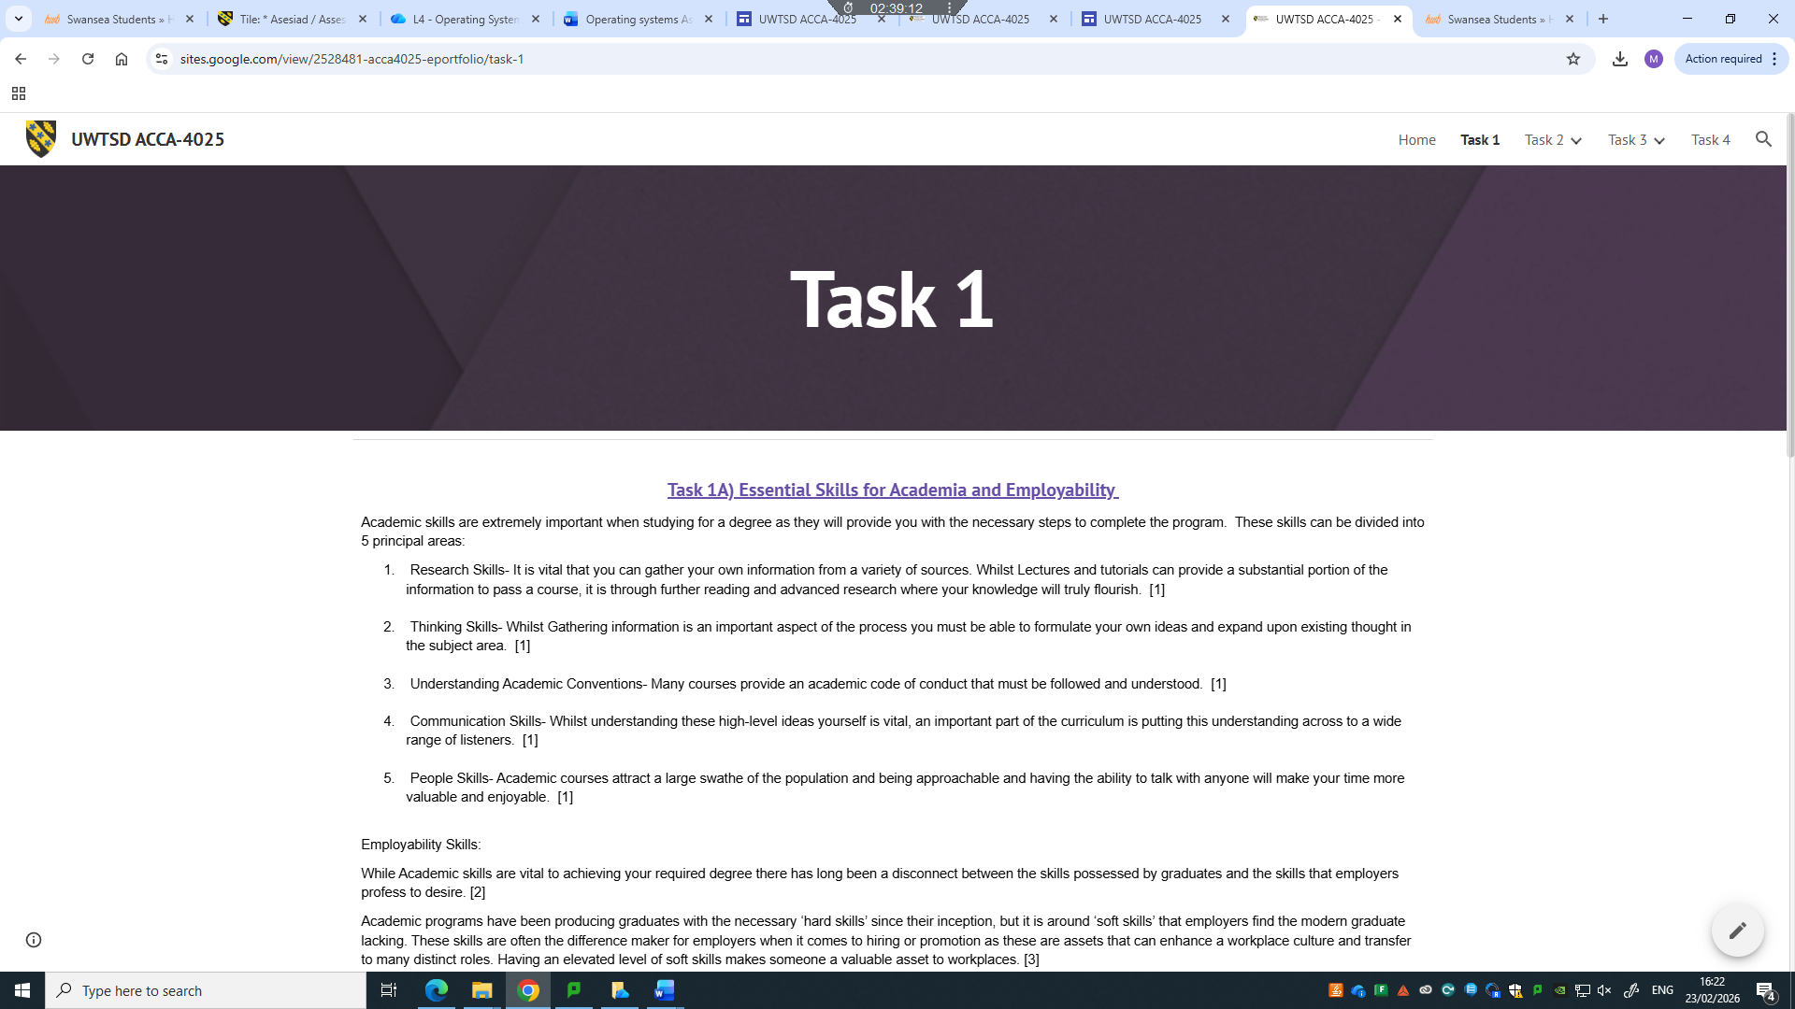

Task 2
Below is the screenshot for the mind map

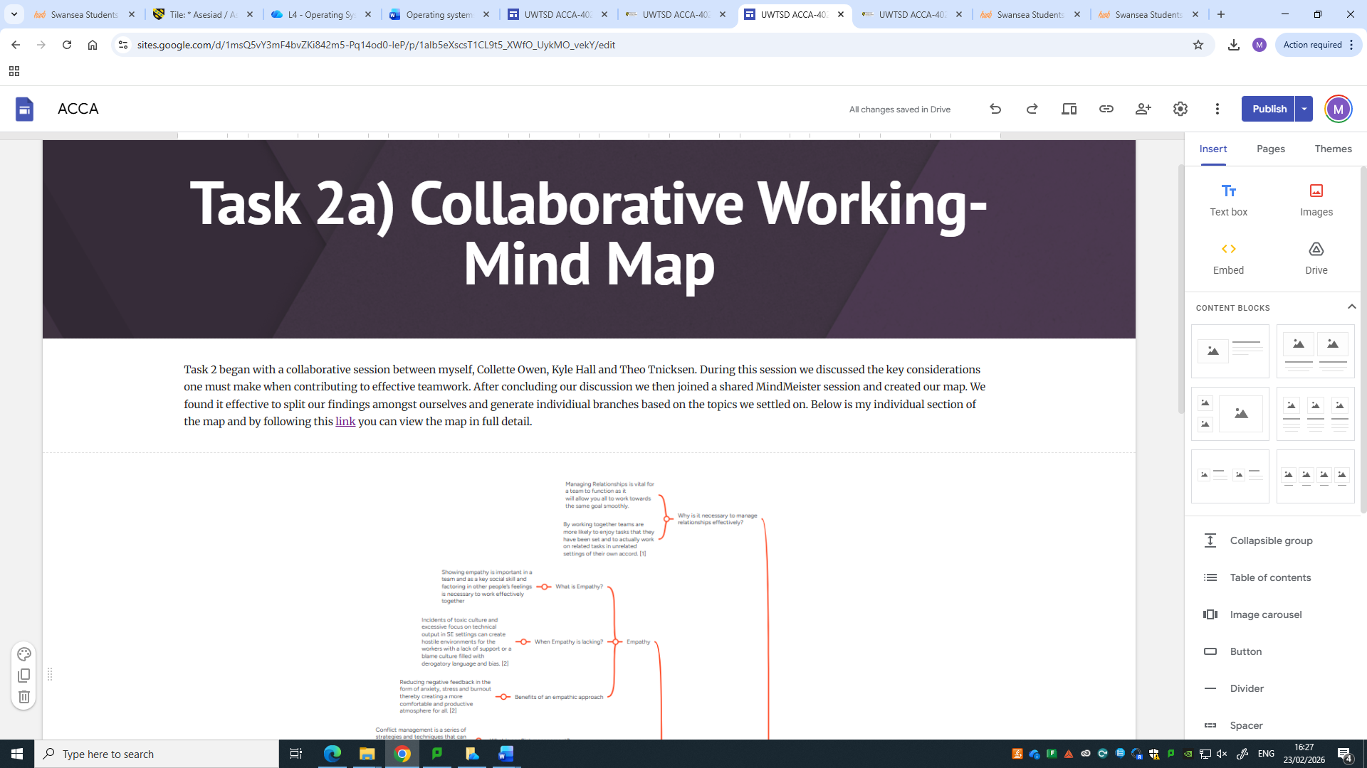
Follow this link for the full map
Below is the screenshot for the poster

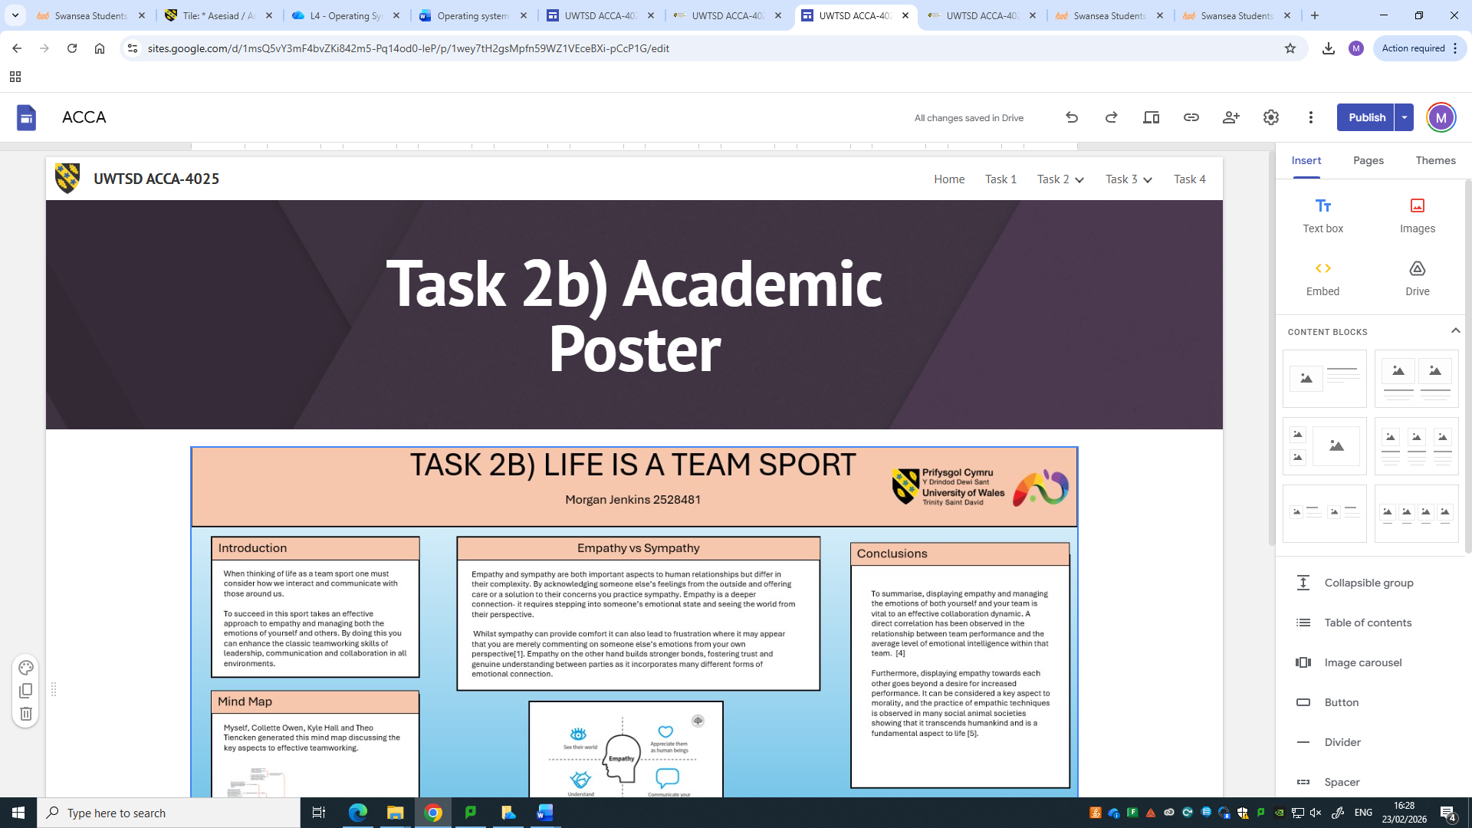
The link to the one drive location is here

Task 3
Below is the screenshot for Task 3 in the e-portfolio

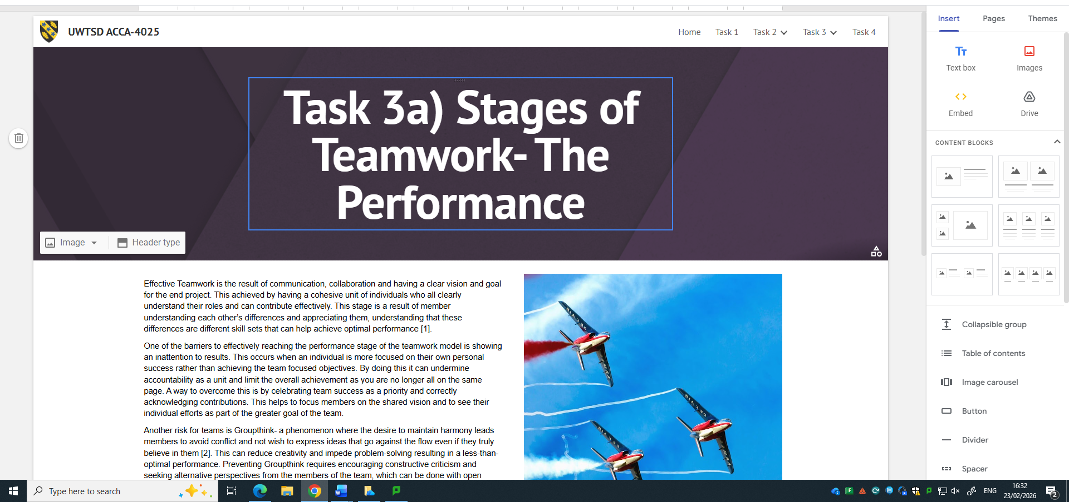
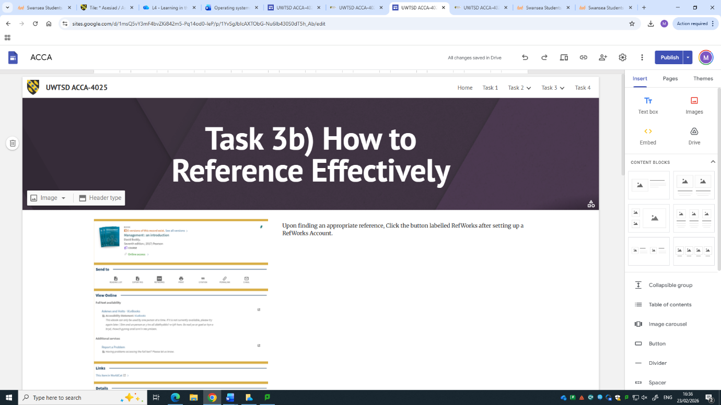

Task 4
Below are the screenshots for Task 4:
Home Page

Task 1
Task 2a)
Task 2b)
Task 3a)
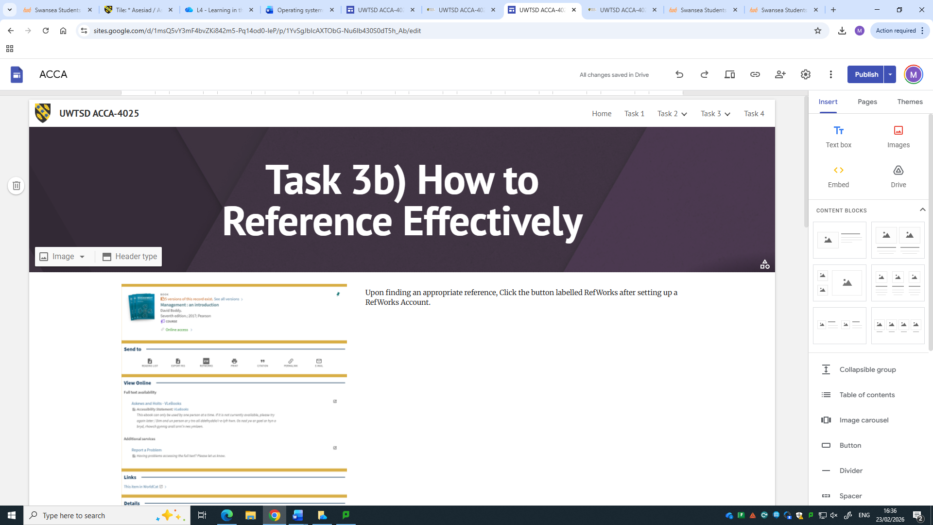
Task 3b)
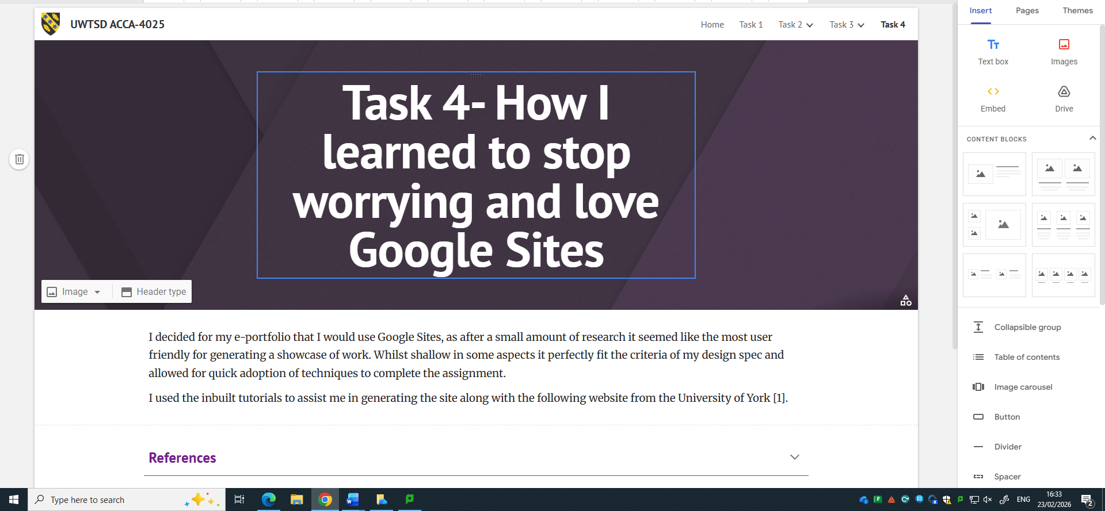
Task 4

