Component 2: Written Assignment (Report)

Critical Examination of Social Anxiety Disorder: Classification, Diagnosis, Treatment, and Rehabilitation in ICD-11

Student Name: Salma Bibi
Student ID: 2315819
Module: BMHP6029: Psychological Classifications and Provisions
Lecturer's Name: Kennedy Obohwemu

Table of Contents
1. Introduction 3
2. Classification and Diagnosis 3
2.1 ICD-11 Classification of Social Anxiety Disorder 3
2.2 Diagnostic Procedures and Criteria 3
2.3 Terminology in Classification (Disorder, Condition, Illness) 4
2.4 Development of Classification (ICD-10 vs ICD-11) 4
3. Treatment and Rehabilitation 4
3.1 Standard Treatment Approaches (Medication, Therapy, etc.) 4
3.2 Rehabilitation Approaches in ICD-11 and Practice 5
3.3 Effectiveness and Limitations of Current Approaches 5
3.4 Cross-Cultural and Systemic Differences in Treatment 5
4. Current Debates and Emerging Issues 6
4.1 Debates on Classification and Diagnostic Boundaries 6
4.2 Neurodivergence and Reclassification Issues 6
4.3 Impact of Changing Diagnostic Criteria on Practice and Policy 6
4.4 Political, Cultural, and Social Influences on Perception and Treatment 7
4.5 UK Legislation and Guidelines 7
5. Recommendations 8
5.1 Improving Classification and Diagnosis 8
5.2 Improving the Treatment and Rehabilitation Strategies 8
5.3 Policy and Practice Implications 8
5.4 Future Research Recommendations 8
6. Conclusion 9
References 10

Introduction
Social Anxiety Disorder (SAD) is a widespread mental condition, the symptoms of which include elevated and chronic anxiety about social experiences or performance, leading to avoidance and dysfunction (Koyuncu et al, 2019). It is among the most common anxiety disorders on earth, with a prevalence rate of about 7 per cent (Emmelkamp et al, 2020). SAD typically starts in adolescence, and without treatment, it may persist into adulthood, resulting in comorbidities of depression, substance abuse, and poor quality of life (Neufeld et al, 2020). The choice of this disorder was informed by the assumption that it imposes a high burden on the health of the people, and it is questionable whether it should be defined and treated as a disorder or not. This is merely a critical analysis of SAD in the view of ICD-11 classification, diagnosis, treatment, and rehabilitation. It will also present current controversies, cultural interests, and policy implications, and provide evidence-based recommendations.

Classification and Diagnosis

ICD-11 Classification of Social Anxiety Disorder
In ICD-11, Social Anxiety Disorder (SAD) falls under the 6B04 Anxiety or fear-related disorders, with the latter one being defined as a persistent fear of social impact or a circumstance of acting where individuals might feel they would be judged by others (WHO, 2025). The classification denotes the central emphasis of over-fearing the negative assessment, avoidance, and disruption of the normal functioning of everyday life.
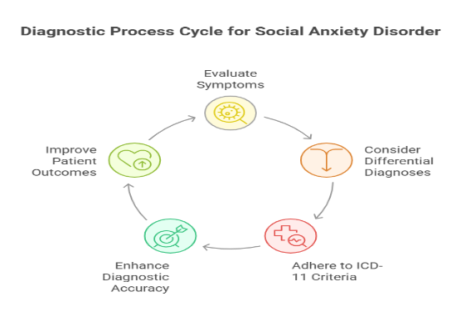
Figure 1: Cycle for SAD (Rebello et al., 2019)

Diagnostic Procedures and Criteria
The SAD will be diagnosed under the ICD-11 as excessive symptoms of at least several months in length but could not be better accounted for by some other medical or psychiatric condition (Rebello et al., 2019). Clinicians assess such vital traits as excessive fear, fear of social situations, and considerable distress in the work sphere, study sphere, or interpersonal sphere. Screening tools such as the Liebowitz social anxiety scale (LSAS) are usually employed to help in the clinical evaluation and structured interviews.

Terminology in Classification (Disorder, Condition, Illness)
The ICD-11 does not employ such terms as illness, condition, or disease; rather, it employs disorder. It is a marker of the emphasis of clinically identifiable behavioural or experience patterns, resulting in extreme distress or impairment (Lebel et al., 2020). The term disorder does not imply a medical model that takes into consideration the psychosocial aspects of SAD.

Development of Classification (ICD-10 vs ICD-11)
The current ICD-10 refers to SAD as social phobia (F40.1) and is much more concerned with the fear of social performance situations. This definition of ICD-11 is furthered to feature not just the functional effects of avoidance, performance, and interactional fears (Domschke et al., 2025). The change may be considered the manifestation of the complexity of SAD, early development, and high comorbidity with other disorders (Gaebel et al., 2020). The shifts in the terms and scope of ICD-11 diagnosis are more akin to those in DSM-5 and promote consistency of the diagnostic systems.

Treatment and Rehabilitation

Standard Treatment Approaches (Medication, Therapy, etc.)
The most common types of treatment are cognitive-behavioural therapy (CBT) and pharmacological intervention towards the treatment of Social Anxiety Disorder (SAD). CBT, especially exposure-based therapies and cognitive restructuring, has been deemed as the first-line therapy, which is long-term effective in minimising the anxiety- and avoidance-related behaviours (Pelissolo et al., 2019). Selective serotonin reuptake inhibitors (SSRIs) like paroxetine and sertraline, as well as serotonin-norepinephrine reuptake inhibitors (SNRIs), are pharmacological treatments that can be used to treat the core symptoms (Hope et al., 2019). The benzodiazepines can be used temporarily but not in the long term because of the risk of dependence.
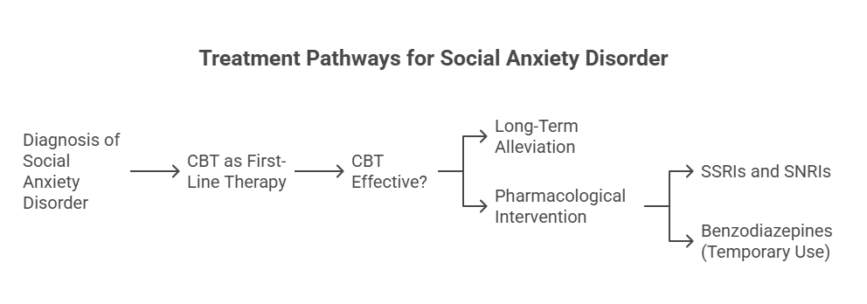
Figure 2 Treatment pathways (Pelissolo et al., 2019)

Rehabilitation Approaches in ICD-11 and Practice
According to ICD-11, rehabilitation must be aimed at the recovery of social performance and quality of life. These involve psychoeducation, social skills training, and workplace or academic accommodations to lessen the stigma and allow involvement. The use of group-based CBT is also discussed as an effective intervention practice in which peer support and isolation reduction are encouraged (Mulder et al., 2022).

Effectiveness and Limitations of Current Approaches
CBT and SSRIs are effective; however, not every patient reacts equally. There are still concerns of relapse, especially when treatment is stopped. Side effects of the use of pharmacological treatments can include nausea, insomnia, or sexual dysfunction, and lower adherence (Bach et al., 2022). In addition, cost, waiting time, and geographical differences tend to restrict access to specialised therapy.

Cross-Cultural and Systemic Differences in Treatment
The methods of treatment are different in healthcare systems. CBT and SSRIs are accessible in high-income nations, and in low-income and middle-income nations, pharmacological intervention might be more popular since trained therapists are not always readily available (Jefferies et al., 2020). Help-seeking is also cultural, with symptoms being perceived as shyness in collectivist cultures instead of a clinical disorder, postponing treatment (Yuchang et al., 2019). Such differences underscore the need to have culturally specific interventions.

Current Debates and Emerging Issues

Debates on Classification and Diagnostic Boundaries
Social Anxiety Disorder (SAD) is still subject to controversy; the most pertinent question is on the limits of its diagnosis. Opponents claim that the ICD-11 and DSM-5 guidelines threaten to pathologise shyness and common social phobias and will therefore be overdiagnosed (Park et al., 2020). Alternatively, some argue that diagnostic thresholds are highly strict, and people with subclinical symptoms, but who still severely suffer and are impaired, are left out (Lane, 2020). The controversy is indicative of larger disagreements between a categorical and dimensional method of psychiatric classification. A dimensional model could be more effective in describing the range of social fears in question, the ones that may be mildly uncomfortable and those that are debilitating (Alomari et al., 2022).

Neurodivergence and Reclassification Issues
The other controversy is the association of SAD with neurodivergence, especially autism spectrum disorder (ASD). Other researchers hold that having a diagnostic overlap makes it difficult to differentiate between SAD-related avoidance and ASD-related social communication issues (Wilson et al., 2024). This may lead to misdiagnosis and the misplacement of interventions, where a person may be subjected to anxiety-oriented Programmes instead of autism-oriented Programmes. This introduces some questions of whether SAD should be conceptualised more relaxed and accept some overlaps with neurodevelopmental conditions, yet be able to draw distinct diagnostic boundaries.

Impact of Changing Diagnostic Criteria on Practice and Policy
The change from ICD-10 to ICD-11 has policy implications. The renaming of social phobia into social anxiety disorder is the result of the understanding of the wider and more debilitating nature of the condition (WHO, 2019). Such reclassification can enhance the awareness of the population and minimise stigma because it will package SAD as a disorder, not associated with performance-related fears (Reed, 2025). Nonetheless, alterations in diagnostic thresholds can be equally problematic to the healthcare systems, which can result in more people being eligible to receive treatment or needing greater access to mental health services (Nolan, 2022). Policymakers have been challenged with the issue of diagnostic inclusivity and sustainable provision of services.

Political, Cultural, and Social Influences on Perception and Treatment
The perception and treatment of SAD are greatly affected by cultural differences. SAD is well-known as a clinical state in the Western world, but avoidance of social situations may also be seen as signs of politeness or modesty in the collectivist culture and not as psychopathology (Holly, 2024). As an example, a culturally specific variant, taijin kyofusho, defined by the fear of offending the other person, is identified in Japan to be overlapping but not the same as Western conceptualisations of SAD (Chavira et al., 2020). Diagnosis and access to treatment are further influenced by political and social determinants such as healthcare funding, stigma, and mental health literacy. The stigma in society may prevent them from seeking help, and the systemic disparities imply that disadvantaged populations are likely to experience some further barriers to care (Good et al., 2019).
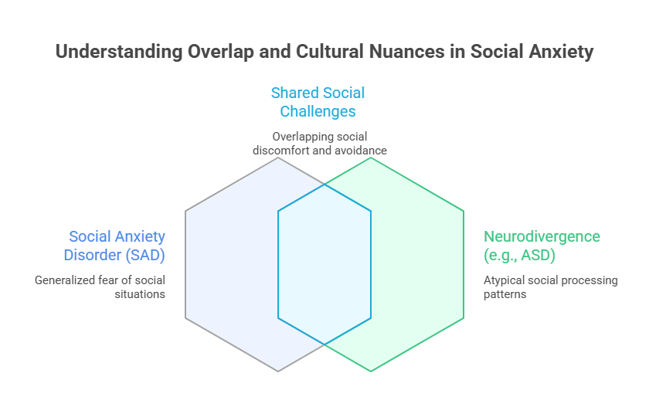
Figure 3: Understanding overlap and cultural Nuances in SAD (Good et al., 2019)

4.5 UK Legislation and Guidelines
In the UK, SAD is a disease that is treated and managed in accordance with the legislation and clinical guidelines. Laws on the issues of compulsory treatment are determined by the Mental Health Act 1983, yet the Act is not very relevant to SAD, as the majority of patients receive treatment voluntarily (NHS, 2023). Stronger are the NICE guidelines, which prescribe CBT as the initial intervention that should be followed by SSRIs, in case of non-response to the treatment (NICE, 2013). Also, the Equality Act 2010 safeguards those with SAD against discrimination in employment and education, as the disorder is known to be a potential disability where there is a significant degree of functional impairment (Bailey, 2024). However, NHS service delivery has issues in demand response, where the waiting lists are very long, and different areas have unequal access (Warnock-Parkes et al., 2020). These institutional problems point to the difference between the intent of the policy and how it is actually implemented.

Recommendations

Improving Classification and Diagnosis
Social Anxiety Disorder (SAD) has the potential to be better classified using a dimensional approach, in which the severity of the symptoms is determined along a continuum instead of using categorical thresholds (Fathi et al., 2020). This would minimise the risks of over- and under-diagnosis, especially in people with subclinical symptoms who have functional impairment. Culturally sensitive diagnostic tools ought to be used as well to reduce misdiagnosis, particularly among cultures that do not regard social withdrawal as an issue (Koyuncu et al., 2019).

Improving the Treatment and Rehabilitation Strategies
The setting of treatment may be enhanced by introducing more access to evidence-based CBT programmes, especially online, which have been equally as effective as in-person treatment (Andrews et al., 2018). Pharmacological treatment is not to be discontinued but strictly monitored because of side effects and the risk of relapse (Warnock-Parkes et al., 2020). To improve functional recovery, rehabilitation plans (social skills training and workplace accommodation) should be more fully incorporated (NHS, 2023).

Policy and Practice Implications
At the policy level, it is essential to extend the mental health services of the NHS to limit the waiting time and inequality across regions (Hur et al., 2020). CBT remains the most favoured intervention based on NICE guidelines, although other new modalities like acceptance and commitment therapy (ACT), which are found to be effective in the treatment of SAD, should be considered as the first-line intervention (Fang et al., 2019). In addition, the stigma might be minimised by means of public health campaigns that should promote early help-seeking.

Future Research Recommendations
The interaction between SAD and neurodivergence, in particular in autism, is an issue that needs to be discussed more to help define the scope of diagnosis. It also requires longitudinal studies to establish the effects of treatment in the long-term, prevention of relapse, and cultural factors in establishing how disorders manifest (Chavira et al., 2020). With the help of this evidence, more specific, comprehensive, and efficacious interventions will be made.

Conclusion
Social Anxiety Disorder (SAD) has been discussed in this report considering its diagnosis, treatment, ICD-11 classification, and rehabilitation. SAD is now regarded as a complicated problem that integrates performance and interactional phobia, and the traditional evidence-based treatments involve CBT and SSRIs. The recent discussions provide the limitations of diagnosis, the issue of neurodivergence, and the cultural factor, along with the issue of the provision of medical care. The returns are enormous; however, areas of access, cultural sensitivity, and long-range treatment outcomes are unsatisfactory. The primary domains that are significant in bettering practice and policy involve the enhancement of diagnosis, enhancing therapeutic selection, and enhancing research. Finally, there should be a more context-sensitive and inclusive approach that will help alleviate the burden of SAD in the world.

References
Alomari, N.A., Bedaiwi, S.K., Ghasib, A.M., Kabbarah, A.J., Alnefaie, S.A., Hariri, N., Altammar, M.A., Fadhel, A.M., Altowairqi, F.M., Ghasib, A., and Kabbarah, A., 2022. Social anxiety disorder: Associated conditions and therapeutic approaches. Cureus, 14(12).
Bach, B. and Mulder, R., 2022. Clinical implications of ICD-11 for diagnosing and treating personality disorders. Current Psychiatry Reports, 24(10), pp.553-563.
Bailey, R., 2024. Why health anxiety needs NICE clinical guidelines. The Lancet Psychiatry, 11(3), pp.164-165.
Baroni, D., Caccico, L., Ciandri, S., Di Gesto, C., Di Leonardo, L., Fiesoli, A., Grassi, E., Lauretta, F., Lebruto, A., Marsigli, N. and Policardo, G.R., 2023. Measurement invariance of the Liebowitz Social Anxiety Scale‐Self‐Report. Journal of Clinical Psychology, 79(2), pp.391-414.
Chavira, D.A., Ponting, C. and Lewis-Fernández, R., 2020. Cultural and social aspects of anxiety disorders. The American Psychiatric Association Publishing textbook of anxiety, trauma, and OCD-related disorders, 59.
Domschke, K. and Zwanzger, P., 2025. Taxonomy of anxiety disorders—a comparison of ICD-10 and ICD-11. Der Nervenarzt, pp.1-5.
Emmelkamp, P.M., Meyerbröker, K. and Morina, N., 2020. Virtual reality therapy for social anxiety disorder. Current psychiatry reports, 22(7), p.32.
Fang, M.L., Canham, S.L., Battersby, L., Sixsmith, J., Wada, M. and Sixsmith, A., 2019. Exploring privilege in the digital divide: implications for theory, policy, and practice. The Gerontologist, 59(1), pp.e1-e15.
Fathi, S., Ahmadi, M., Birashk, B., and Dehnad, A., 2020. Development and use of a clinical decision support system for the diagnosis of social anxiety disorder. Computer Methods and Programmes in Biomedicine, 190, p.105354.
Gaebel, W., Stricker, J., and Kerst, A., 2020. Changes from ICD-10 to ICD-11 and future directions in psychiatric classification. Dialogues in clinical neuroscience, 22(1), pp.7-15., W., Stricker, J., and Kerst, A., 2020. Changes from ICD-10 to ICD-11 and future directions in psychiatric classification. Dialogues in clinical neuroscience, 22(1), pp.7-15.
Good, B.J. and Kleinman, A.M., 2019. Culture and anxiety: Cross-cultural evidence for the patterning of anxiety disorders. In Anxiety and the anxiety disorders (pp. 297-324). Routledge.
Holly, L.E., 2024. Cultural and Social Aspects of Anxiety Disorders. Psychiatric Clinics, 47(4), pp.775-785.
Hope, D.A., Heimberg, R.G., and Turk, C.L., 2019. Managing social anxiety: A cognitive-behavioural therapy approach: Workbook. Oxford University Press.
Hur, J., DeYoung, K.A., Islam, S., Anderson, A.S., Barstead, M.G., and Shackman, A.J., 2020. Social context and the real-world consequences of social anxiety. Psychological Medicine, 50(12), pp.1989-2000.
Jefferies, P. and Ungar, M., 2020. Social anxiety in young people: A prevalence study in seven countries. PloS one, 15(9), p.e0239133.
Koyuncu, A., İnce, E., Ertekin, E. and Tükel, R., 2019. Comorbidity in social anxiety disorder: diagnostic and therapeutic challenges. Drugs in context, 8, p.212573.
Koyuncu, A., İnce, E., Ertekin, E. and Tükel, R., 2019. Comorbidity in social anxiety disorder: diagnostic and therapeutic challenges. Drugs in context, 8, p.212573.
Lane, R., 2020. Expanding boundaries in psychiatry: uncertainty in the context of diagnosis‐seeking and negotiation. Sociology of Health & Illness, 42, pp.69-83.
Lebel, S., Mutsaers, B., Tomei, C., Leclair, C.S., Jones, G., Petricone-Westwood, D., Rutkowski, N., Ta, V., Trudel, G., Laflamme, S.Z., and Lavigne, A.A., 2020. Health anxiety and illness-related fears across diverse chronic illnesses: A systematic review on conceptualisation, measurement, prevalence, course, and correlates. Plos one, 15(7), p.e0234124.
Mulder, R. and Bach, B., 2022. Assessment and treatment of personality disorders within the ICD-11 framework.
National Institute for Health and Care Excellence (NICE) (2013) Social anxiety disorder: recognition, assessment and treatment (CG159). London: NICE. (Reprinted with updated copyright 2024) [online]. Available at: https://www.nice.org.uk/guidance/cg159 (Accessed: 1 October 2025).
Neufeld, C.B., Palma, P.C., Caetano, K.A., Brust-Renck, P.G., Curtiss, J., and Hofmann, S.G., 2020. A randomised clinical trial of group and individual cognitive-behavioural therapy approaches for social anxiety disorder. International Journal of Clinical and Health Psychology, 20(1), pp.29-37.
NHS (2023) ‘Social anxiety (social phobia)’ [online]. Available at: https://www.nhs.uk/mental-health/conditions/social-anxiety/ (Accessed: 1 October 2025).
Nolan, M., 2022. Implications for the Construction of Diagnostic Identity Following the Reclassification of Asperger’s Syndrome in the DSM-5: A Scoping Review (Doctoral dissertation, RMIT University).
Park, S.C. and Kim, Y.K., 2020. Anxiety disorders in the DSM-5: changes, controversies, and future directions. Anxiety Disorders: Rethinking and Understanding Recent Discoveries, pp.187-196.
Pelissolo, A., Abou Kassm, S. and Delhay, L., 2019. Therapeutic strategies for social anxiety disorder: where are we now?. Expert review of neurotherapeutics, 19(12), pp.1179-1189.
Rebello, T.J., Keeley, J.W., Kogan, C.S., Sharan, P., Matsumoto, C., Kuligyna, M., Domínguez-Martínez, T., Stona, A.C., Grenier, J., Huang, J. and Zhong, N., 2019. Anxiety and fear-related disorders in the ICD-11: results from a global case-controlled field study. Archives of medical research, 50(8), pp.490-501.
Reed, A., 2025. Association of Social Anxiety With Core Symptoms of Autism Spectrum Disorder (Doctoral dissertation, University of Hartford).
Warnock-Parkes, E., Wild, J., Thew, G.R., Kerr, A., Grey, N., Stott, R., Ehlers, A., and Clark, D.M., 2020. Treating social anxiety disorder remotely with cognitive therapy. The Cognitive Behaviour Therapist, 13, p. 30.
Wilson, A.C. and Gullon-Scott, F., 2024. ‘It’s not always textbook social anxiety’: A survey-based study investigating the nature of social anxiety and experiences of therapy in autistic people. Autism, 28(11), pp.2923-2936.
World Health Organisation (WHO) (2025) ICD-11: MMS browser [online]. Geneva: WHO. Available at: https://icd.who.int/browse/2025-01/mms/en (Accessed: 1 Oct 2025).
Yuchang, J., Junyi, L., Junxiu, A., Jing, W., and Mingcheng, H., 2019. The differential victimisation associated with depression and anxiety in a cross-cultural perspective: A meta-analysis. Trauma, Violence, & Abuse, 20(4), pp.560-573.

