University of Wales Trinity Saint David
School of Engineering
Combustion Emissions, Calculations and Mapping For
Efficiency
Patrick Tobin
P140983
BEng Motorcycle Engineering
Powertrain and sustainability
M3X8824

Contents
1. Table of Figures 1
2. Introduction 1
2.1. Background 1
2.2. Assumptions 2
3. Methodology 3
3.1. Determining Enthalpy Released 3
3.2. Determining Initial Temperatures 4
3.3 Calculating the Temperatures 5
3.4 Calculating NOx Concentration 6
3.4.1. Calculating N2 &O2 7
3.4.2. Kmols/$m3$/second and Kmols/ degree 7
3.4.3. Calculating Kmols in the Exhaust 8
3.4.4. Parts Per Million 9
3.5. Effect of EGR on NOx 11
4. Analysis 13
4.1. Nox production when EGR is added 16
5. Effectiveness of Calculations 19
References 20
Bibliography 20
7. Appendix 21

Table of Figures
Figure 1: NOx porduction 2
Figure 2:KMOLS/m^3/second 9
Figure 3:NOx ppm 10
Figure 4: EGR ppm 12
Figure 5: Temperature rise for equivalence ratio 13
Figure 6: Adiabatic flame rate 13
Figure 7:3D graph of NOx production 14
Figure 8: Temperature change with EGR 16
Figure 9:3D graph of NOx production with EGR 17
Figure 10: KMOLS/m^3/sec with EGR 18
Figure 11:Product increase with EGR 19

Introduction
The purpose of this report is to develop a NOx model operating on the lean side of stoichiometric. The report will be looking at isooctane burning at 0.99 to 0.95 at 0.1 intervals and 0.95 to 0.6 at 0.5 intervals. The rise in pressure at the start of combustion increases linearly, from 10 bar to 50 bar in 2 bar/degree increments. A comparison of NOx produced as the engine burns leaner will be made and the effect of adding EGR (exhaust gas recirculation) from 1% to 20%. The engine used is 1600cc, four cylinder, running at 1800rpm.

Background
NOx is a term used to describe nitrogen oxides found in pollution. NOx term means a molecule containing a nitrogen atom combined with one or more oxygen atoms. NOx generally refers to NO and NO2 both of which are produced during combustion.
When NOx reacts with volatile organic compounds it forms smog. When exposed to VOCs and UV light NOx reacts to create O3 (OZONE) ozone is harmful to humans.
NO2 N2+O
The single O atom can combine with O2 molecule to make O3. (NASA, n.d.)
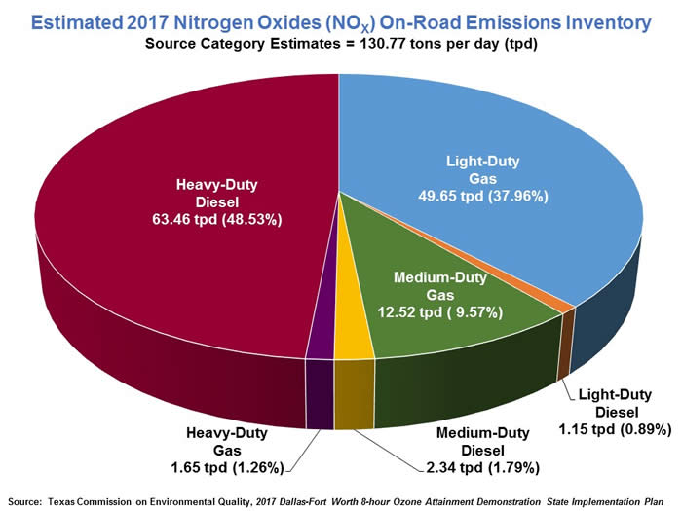
Figure 1: NOx porduction
(North Central Texas Council of Governments , 2017)

Assumptions
- Universal gas constant is 8316 jkmol-1K-1
- Polytropic index for burnt zone up to peak pressure is 1.2
- N2& o2 stay constant during combustion
- Fuel equivalence ratio is constant though out cylinder volume
- This is a one zone model
- Rise in pressure after start of combustion is linear in 2bar intervals
- Inlet air temperature is 20 degrees Celsius
- Volumetric efficiency is constant at 40%
- Pressures at start and end of combustion are assumed to be 10 and 50 bar
- Pressure in the cylinder at inlet valve closing is 1 bar
- Combustion process lasts for 20°

Methodology

Determining Enthalpy Released

In order to calculate the enthalpy needed and enthalpy released for any given temperature, an excel spreadsheet of the given enthalpy values needed to be created. This was done for O2, N2, CO2 and H2O. From the data graphs of temperature/ enthalpy were created and a sixth order polynomial added to each graph. The polynomial enables the prediction of values anywhere along the graph line.
In a second sheet temperature values were input. These ranged from 200 to 3500 in 0.1 degree increments from 298 to 3500. The value of total enthalpy at each temperature value was calculated.
 | $$Total Enthalpy needed=CO2*enthalpy+O2*enthalpy+H2O*enthalpy+N2*enthalpy$$ | (1)

The enthalpy released for each fuel equivalence ratio at each temperature could then be calculated.
 | $$Enthalpy Released=((CO2 ×393.5)+(H2O×241.8))×∅$$ | (2)

Determining Initial Temperatures

The initial temperatures at the start of combustion (SOC) were calculated for each equivalence ratio by finding where: $Enthalpy Released-Total Enthalpy=0$ and taking the temperature value associated. The temperature increments were not small enough to produce any zero values so instead the value closest to zero would be used. The excel formula used to find the value closest to zero was:
=INDEX($N$4:$N$32025,MATCH(MIN(ABS($N$4:$N$32025)),ABS($N$4:$N$32025),0))
A further excel function could then be used to find the temperature associated with that value. The first values either side of zero could be interpolated to find the exact temperature at zero.
Table 1:Adiabatic flame tempratures
Ф |  | Temp
1 | 0.0807 | 2486.1
0.99 | -0.0512 | 2466.4
0.98 | 0.04604 | 2446.6
0.97 | 0.1022 | 2426.8
0.96 | 0.11687 | 2407
0.95 | 0.08957 | 2387.2
0.9 | 0.10698 | 2287.9
0.85 | 0.04123 | 2188.2
0.8 | 0.03722 | 2088
0.75 | -0.0633 | 1987.3
0.7 | 0.06628 | 1885.9
0.65 | -0.0849 | 1783.9
0.6 | -0.0355 | 1681

Calculating the Temperatures

Once the initial temperatures had been determined the temperature at every degree thereafter could be calculated. The ideal gas law was used to calculate the new temperatures. The assumption of a polytropic combustion and that n stayed constant was made, the value of n was assumed to be 1.2.
The ideal gas law needed to be transposed before it could be used.
 | $$PV=mRT$$ | (3)

 | $$V=mRT/P$$ | (4)

 | $$P1{×\left(\frac{mRT1}{P1}\right)}^{n}=P2×({\frac{mRT2}{P2})}^{n}$$ | (5)

 | $$\frac{P1 {T1}^{n}}{{P1}^{n}}=\frac{P2 {T2}^{n}}{{P2}^{n}}$$ | (6)

 | $$\frac{{T1}^{n}}{{P1}^{n-1}}=\frac{{T2}^{n}}{{P2}^{n-1}}$$ | (7)

 | $${T2}^{n}={T1}^{n}\left(\frac{{P2}^{n-1}}{{P1}^{n-1}}\right)$$ | (8)

 | $$Finale Equation T2=T1({\frac{P2}{P1})}^{\frac{n-1}{n} }$$ | (9)

Table 2:Combustion tempratures

Calculating NOx Concentration

The ideal gas law can also be used to calculate the value of n
Before completing any further calculations a simple fuel calculator was produced in excel, this made calculations for different fuel equivalence ratios easier to do.
Ideal gas law
 | $$PV=nRT$$ | (10)

This can be rearranged to form:
 | $$n=\frac{PV}{RT}$$ | (11)

The volumetric efficiency = 40%, the cylinder displacement =400cc
Volume
 | $$=0.4×400=160cc$$ | (12)

 | $$n=\frac{{10}^{5}×160×{10}^{-6}}{8314×293}=6.57×{10}^{-6}$$ | (13)

Once the value of n was known a value for alpha could be calculated for each fuel equivalence ratio. Alpha was calculated by dividing the number of kmols in the reactant by the n value.
The fuel calculator was used to determine the number of kmols for each fuel equivalence ratio.

Calculating N2 &O2

The value of n2 was calculated
 | $$N2=\frac{Coefficient ×alpha}{burn volume }$$ | (14)

The coefficient for N2 stays the constant at 47 moles, this is because only the fuel is affected by the fuel equivalence ratio. The amount of N2 in the product is unchanged.
The value of 02 was calculated using the same equation, however the coefficient for O2 changes for every fuel equivalence ratio.
 | $$O2=\frac{reactant-\left(Co2*2+H20\right)}{2}$$ | (15)

Kmols/$m^{3}$/second and Kmols/ degree

With all previous calculations carried out the Kmols/$m^{3}$/second and Kmols/ degree could be calculated. The following equations were used
Kmols/$m^{3}$/second
 | $$=4.7×{10}^{13}×N2×{O2}^{0.5}×Exponent$$ | (16)

Kmols/ degree
 | $$=kmols.m^3.second×\left(\frac{1}{6×1800}\right)$$ | (17)

The value calculated in equation (16) was multiplied by the burn volume, this gave the total amount of NOx per degree. This was calculated for every degree and each fuel equivalence ratio. The total amount of NOx produced during combustion was calculated by summating the amount produced per degree.

Table 3: Total NOx example

Calculating Kmols in the Exhaust

The fuel calculator was used to give the total number of kmols in the product.

 | $$Total=CO2+H20+O2+N2$$ | (18)

This was done for each fuel ratio. With the total know it was multiplies by the alpha value of the same fuel equivalence ratio. This gave the number of Kmols in the exhaust. The last part was to calculate the parts per million.

Figure 2:KMOLS/m^3/second

Parts Per Million

Parts per million was calculated using the equation:
 | $$PPM=\frac{total NOx×{10}^{6}}{Kmols in Exhaust}$$ | (19)

The value for NOx ppm far exceed the expected number given in a number of publications , John Heywood says, “The relative amount depend on engine design and operating conditions but are in the order: NOx, 500 to 1000ppm” (B.Heywood, 1988). The maximum PPm calculated in this model was 139953.7032. Similar values are calculated in (Magnus Andersson, 2006) though this model was far more inclusive.
Appendix 1 shows the results for ppm if the Zeldovich model in discussed in (B.Heywood, 1988) which was slightly different was used. Replacing figures in Heywood’s equation with ones calculated in this study gives values similar to the predictions in (B.Heywood, 1988).

Figure 3:NOx ppm

Table 4:NOX Results

Effect of EGR on NOx

New value for kmols of molecules produced were calculated by multiplying the values at 0.95 fuel equivalence ratio by the percentage of EGR being added. These new values were inserted into equation (1), the equation for enthalpy needed. This was done using a vlookup. A new initial temperature for each EGR percentage is produced.
T2 was then calculated in the same way as in equation (9). The other calculations thereafter were the same and were automatically recalculated calculated by excel.
Kmols in the equation needed to be calculated for each percentage using the formula:

 | $$KMOLS=60.45+(egr percentage*kmols out)$$ | (20)

60.45 is the kmols at 0.95 fuel equivalence ratio at 0% EGR
“Exhaust gas recirculation is the principal technique used for the control of SI engine NOx emissions” (B.Heywood, 1988). The addition of EGR reduces the burnt gas temperatures, therefore reducing NOx formation.
EGR reduces combustion rate making stable combustion difficult to achieve if EGR is too high. The amount of EGR an engine can take depends on speed, load and equivalence ratio. Increasing EGR has the adverse effect of increasing hydro carbons. Mass of gas with in the cylinder is comprised of Mass air+ Mass EGR+ Mass Residual Gas. (Jun Yu, 2013). The residual gas has not been considered in this model but
Table 5: NOx Results with EGR
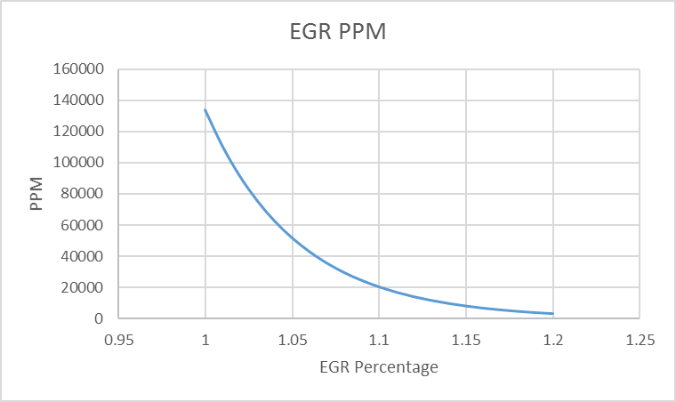
Figure 4: EGR ppm

In this NOx prediction model the Zeldovich model was used to predict the amount of NOx produced, with and without the addition of EGR. …. States that the basic Zeldovich model can only predict NOx at relatively high temperatures and so when adding high amounts of EGR the extended Zeldovich model is needed due to the lower temperatures.

Analysis

NOx production without any added EGR

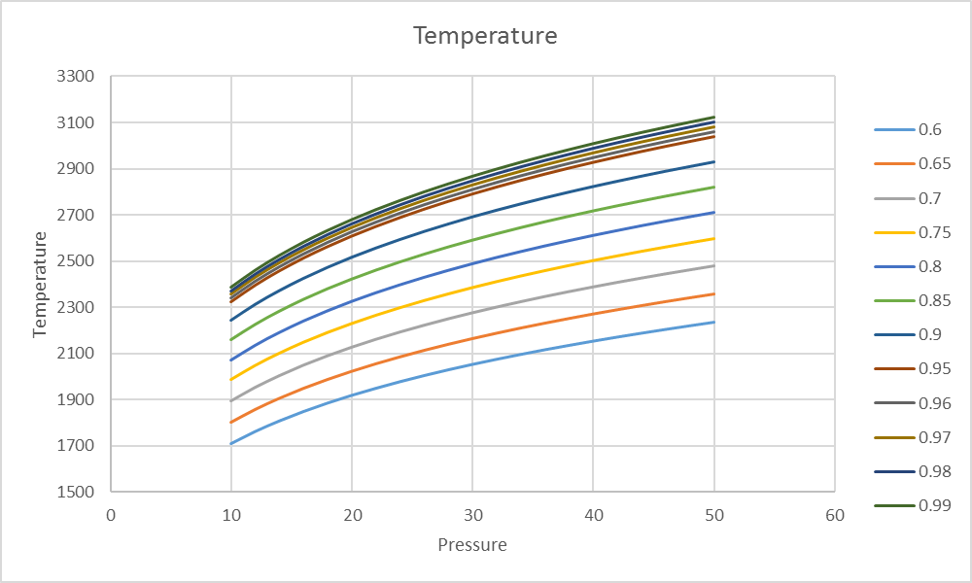
Figure 5: Temperature rise for equivalence ratio
The flame temperature increased with pressure, the ideal gas law shows this to be the case. $T2=T1({\frac{P2}{P1})}^{\frac{n-1}{n} }$ An increase in p2 results in an increase in T2. The temperature decreased as the fuel equivalence ratio went down. The effect on enthalpy required by change in fuel equivalence ratio is very small. As the enthalpy released has decreased the temperature require for enthalpy needed to match it is lower. Therefor a lower adiabatic flame temperature is produced.
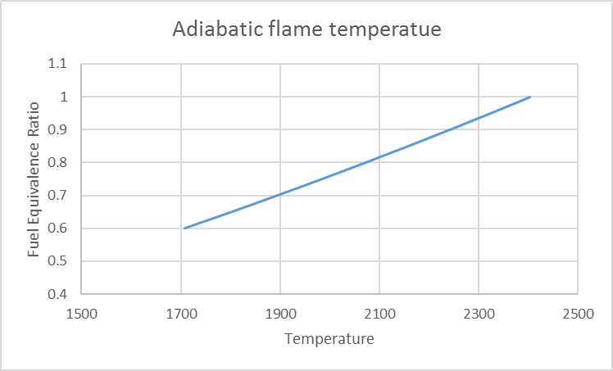
Figure 6: Adiabatic flame rate
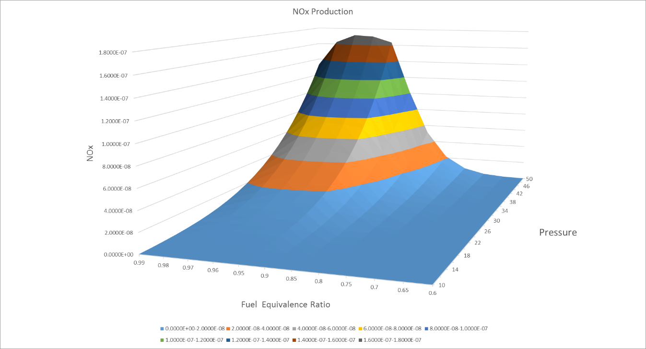
Figure 7:3D graph of NOx production

The NOx produced at 50 bar 0.6 fuel equivalence ratio was almost as low at that produced at 10 bar 0.9. This shows the effect leanness has on NOx production.
Table 6:NOx production
Table 7 shows the NOx produced was higher when the temperatures were higher.

Nox production when EGR is added

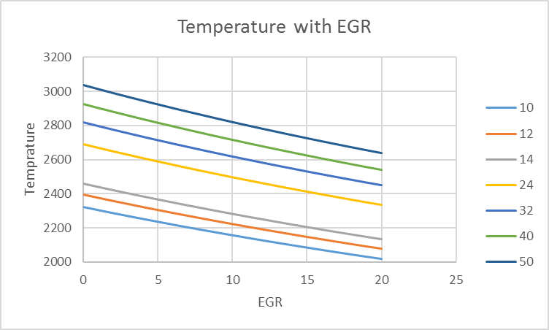
Pressure
Figure 8: Temperature change with EGR
Figure 8 shows the temperature change at 0.95 fuel equivalence ratio when EGR is added. At each pressure temperature decreases when more EGR is added. The temperature reduced because the addition of EGR reduces the oxygen content. The exhaust gas forms an inert part of the mix, it has no part in the chemical reaction. The combustion process is slower as the exhaust gas impedes the chemical reactions from molecule to molecule. The exhaust gas doesn’t burn but it does heat up this takes heat energy from the air fuel combustion reducing the temperature. (Robinson, 2000)

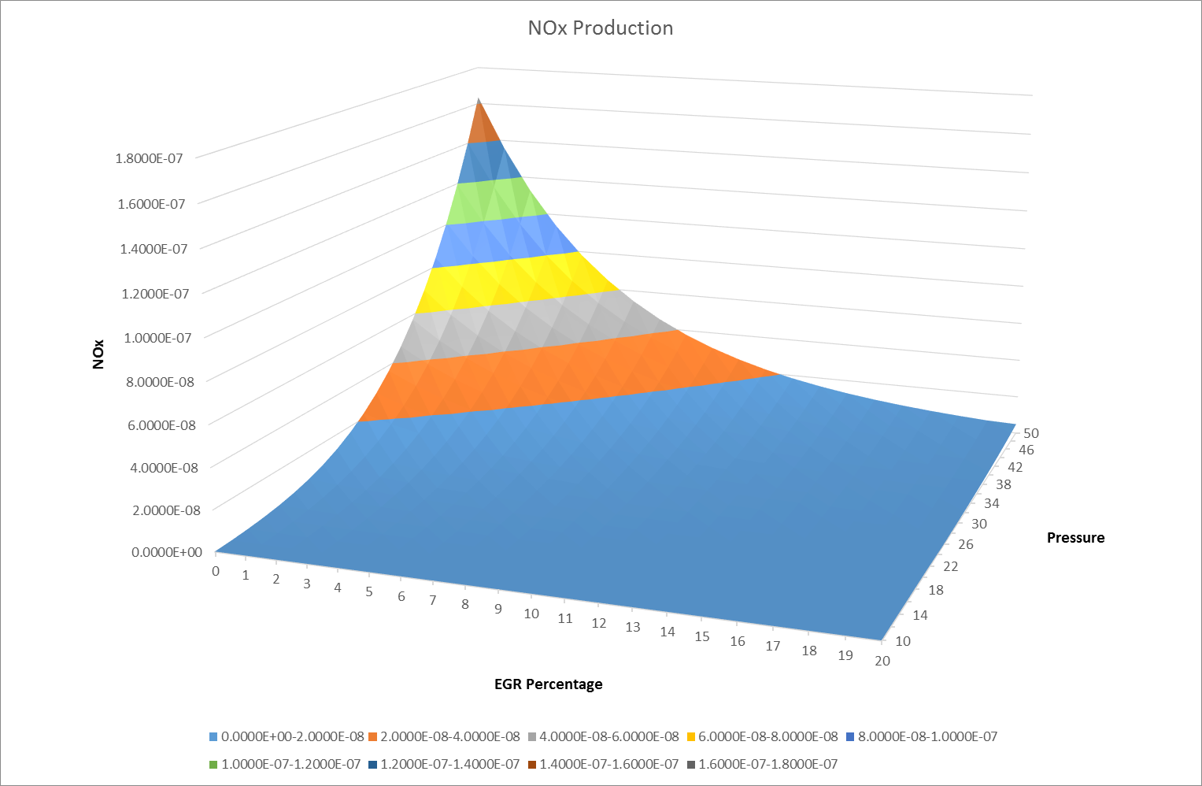
Figure 9:3D graph of NOx production with EGR
Figure 9 shows the drastic reduction of NOx when EGR is added. At 50 bar and 20% EGR, 4.9073E-09 NOx was produced. The maximum NOx produced in a real scenario may be even lower as with reduced combustion temperatures comes a reduction in peak pressure.
For the calculation of ppm with EGR, alpha was not kept constant. When EGR is added the kmols in the equation increased, the formula for alpha = n/kmols in equation. Changing alpha had a small finale effect on ppm compared with keeping it constant.
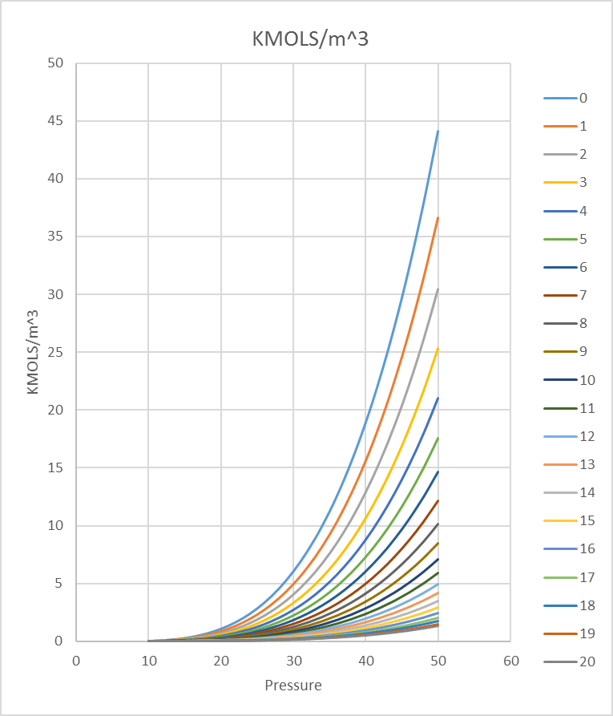
Figure 10: KMOLS/m^3/sec with EGR
The reduction in temperatures had also reduced the reaction rate, the reaction rate has the biggest effect on the value of kmols/m^3/second therefore as EGE percentage was increased the kmols/m^3/second went down.

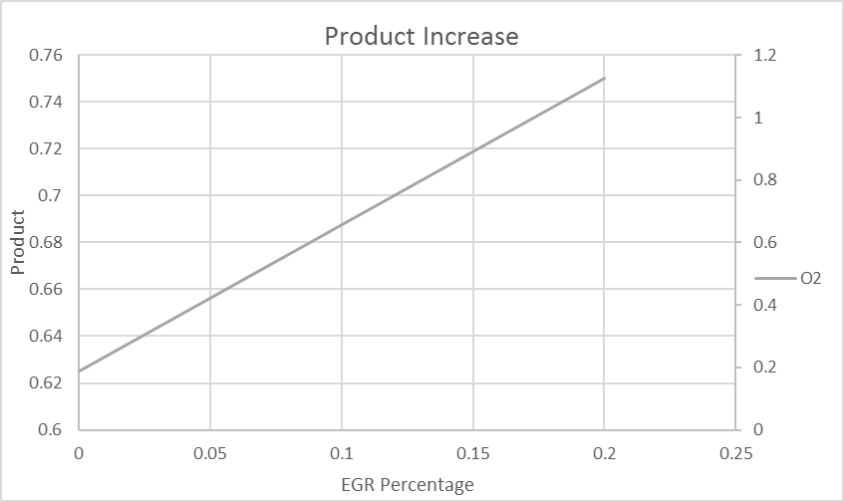
Figure 11:Product increase with EGR

Effectiveness of Calculations
The initial calculations performed to obtain enthalpy for each temperature were slightly off as the polynomial equations didn’t predict correctly. Evidence of this was; the known enthalpy values obtained from the NASA table didn’t correlate with the values predicted by excel. At 300°c the NASA table shows an enthalpy value of 0.062 MJ/kmol for H20 the polynomial predicted 0.094.
The calculations made were effective at showing how the fuel equivalence ratio and EGR percentage effected the temperature and the development of NOx. Due to the assumptions made and the simplification of the combustion chemistry and the combustion process being this model would be ineffective at predicting true NOx concentration.

References
B.Heywood, J., 1988. Internal C ombustion Engine Fundamentals. 1st ed. New york: McGraw-Hill.
Jun Yu, S. H. C., 2013. The Development of Real-time NOx Estimation, USA: SAE International .
Magnus Andersson, B. J. a. A. H., 2006. A Predictive Real Time NOx Model for Conventional and, New york: SAE International .
NASA, n.d. The earth observatory. [Online]
Available at: https://earthobservatory.nasa.gov/Features/ChemistrySunlight/chemistry_sunlight3.php
[Accessed 11 01 2018].
North Central Texas Council of Governments , 2017. http://www.nctcog.org. [Online]
Available at: http://www.nctcog.org/trans/air/ozone/sources.asp
[Accessed 10 01 2018].
Robinson, J., 2000. Motorcycle Fuel Systems TechBook. somerset: Haynes.

Bibliography
B.Heywood, J., 1988. Internal C ombustion Engine Fundamentals. 1st ed. New york: McGraw-Hill.
Jun Yu, S. H. C., 2013. The Development of Real-time NOx Estimation, USA: SAE International .
Magnus Andersson, B. J. a. A. H., 2006. A Predictive Real Time NOx Model for Conventional and, New york: SAE International .
NASA, n.d. The earth observatory. [Online]
Available at: https://earthobservatory.nasa.gov/Features/ChemistrySunlight/chemistry_sunlight3.php
[Accessed 11 01 2018].
North Central Texas Council of Governments , 2017. http://www.nctcog.org. [Online]
Available at: http://www.nctcog.org/trans/air/ozone/sources.asp
[Accessed 10 01 2018].
Robinson, J., 2000. Motorcycle Fuel Systems TechBook. somerset: Haynes.

Appendix

Appendix (1)

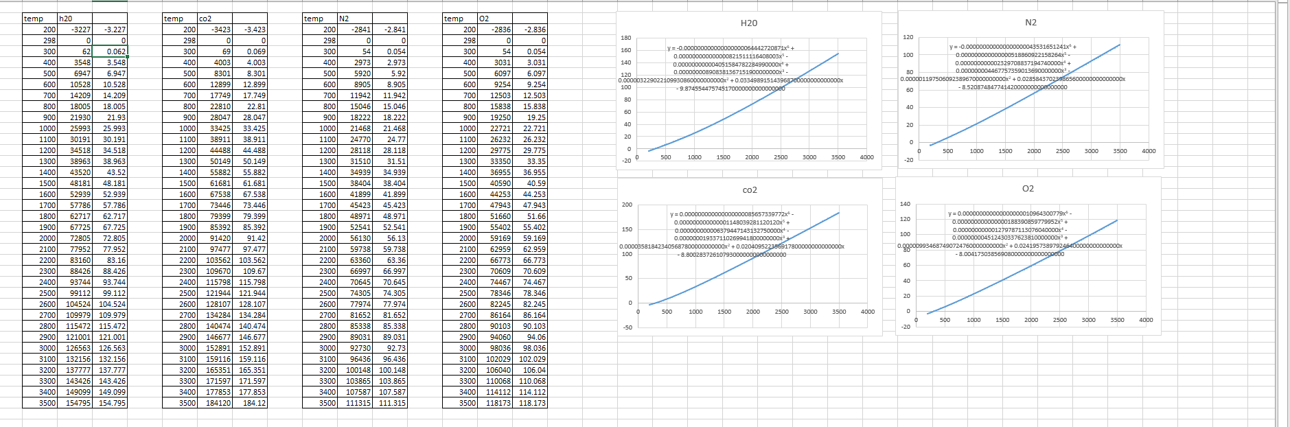

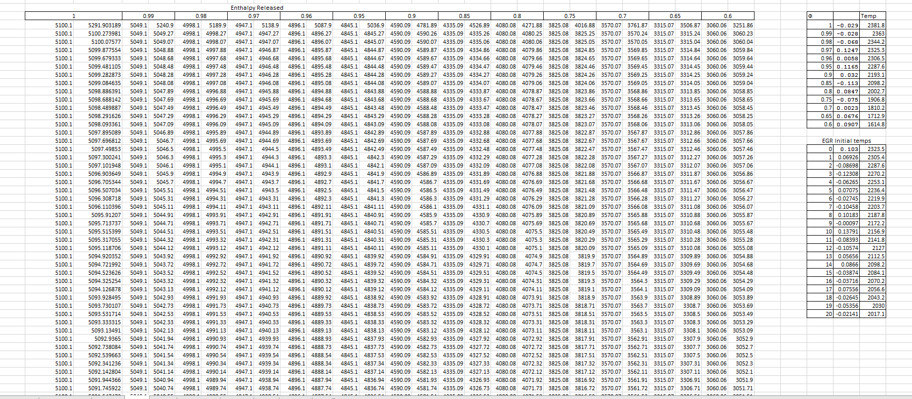

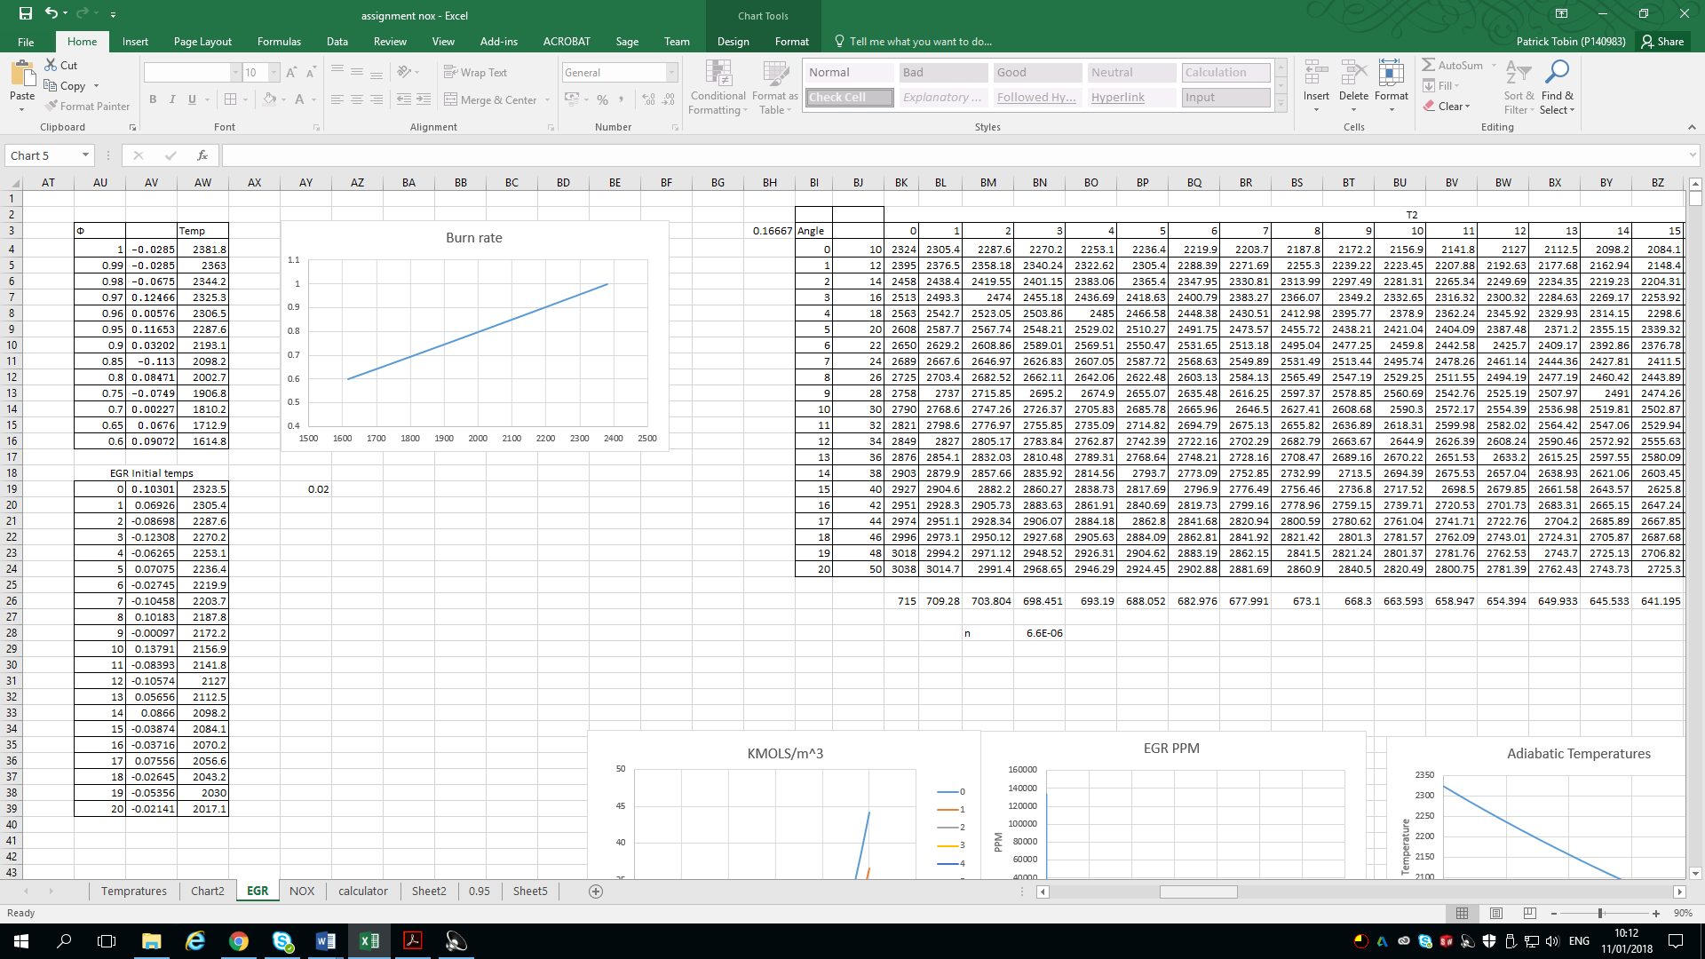
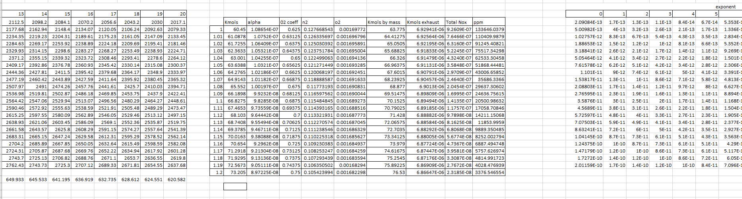
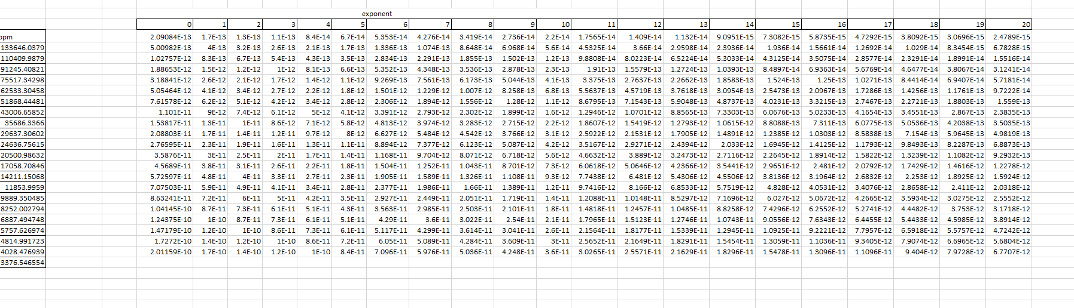
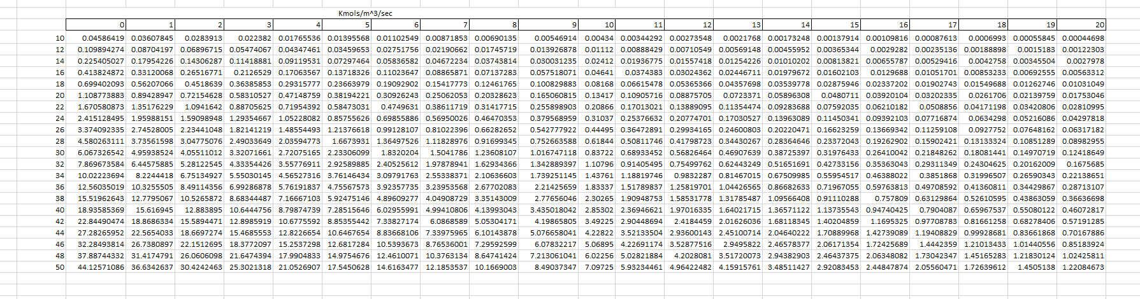
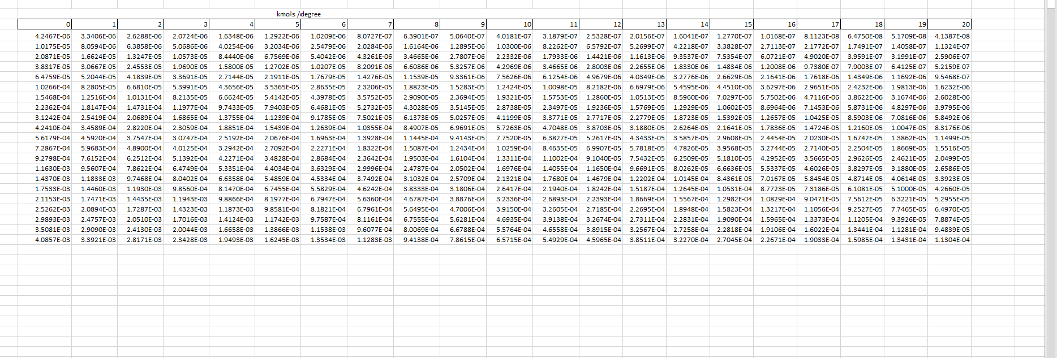
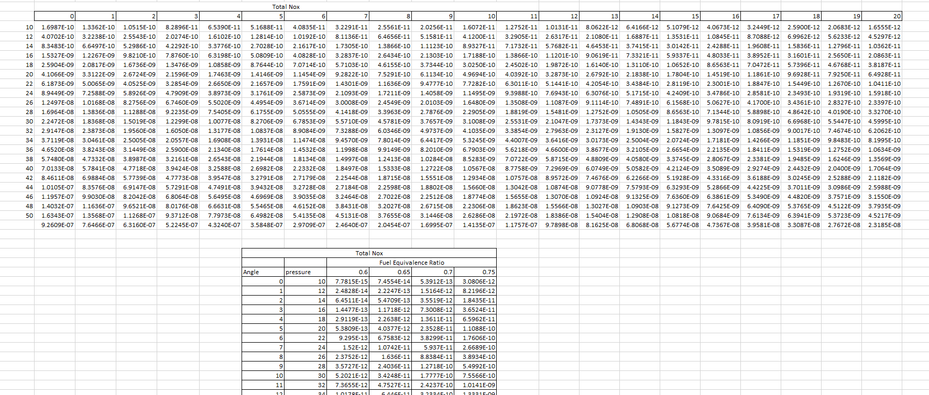

Nox


