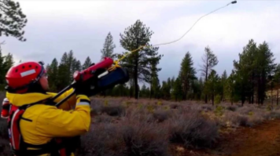

Line Launcher
  - Design project
Dewi Perkins, Luke Davies, Jay Niewiadomski | HNC – Mechanical Engineering | January 2020
Contents
Introduction 2
Design Specification 3
Initial Individual Research 4
Initial concept design evaluations 8
Final Design Evaluation 13
Conclusion 14
References 14
Appendix - Firing range components. 14

Introduction
A written research report in the design of a Line Launcher, to be applied to be fired between ships or for other rescue scenarios.
Such a device will entail controlled and safe methods of energy and line storage and a reliable release mechanism.
This device is intended to fire a squash ball and can be an accessible answer to a real-world problem.
Line launchers currently used, fire lines between shipping vessels for the armed forces and a safety feature to many sailing vessels. It could be used to transfer supplies or in cases of emergency when a person has fallen over-board.

Design Specification

- Simulate a rescue line launch.
- Able to fire from a fixed location pin to a designated target.
- Able to launch a Dunlop competition yellow dot squash ball, attached through its center.
- The line used is a 30lb Spectra Extreme Yellow Braided fishing line.
- A series of rings mounted over a round container will be used as a target area.
- Device is to be attached to the firing pin using a 10mm washer and wing nut. Clear wing nut access is needed to enable the launcher to be easily secured or removed without being taken apart.
- Devices must be as safe as possible; thought should be given to user protection and any risks of entanglement or entrapment.
- The device must include a device which prevents accidental firing once armed.
- The maximum working envelope, even during firing, is 600x600x600mm.
- The device must be placed on and not overhang the edge of the launch table at any point.
- The device must have a quick and simple method of attaching and detaching the line, without requiring the use of tools.
- Devices must fire remotely, using a low voltage switch and a minimum of 2m cable length. The only components not included in the above dimension limitations are the firing switch and wiring.

Initial Individual Research

Dewi Perkins – The line launchers found during the initial research were shotgun styles, where the line was fired from a 45/70 caliber gun. Easy to set-up. Ranges vary from 76m to over 228.6m, depending on the type of line used and the conditions. The lines used with this launcher are nylon braided, 70,140 and 450lb weight. The gun is based on the U.S naval issue 45/70 caliber rifle. It uses blank cartridges, loaded into the chamber. The projectile is loaded into the barrel, with the line tied onto the eye at the tip. It’s then fired in the direction of where it’s needed.
Based on the dimensions of the case box, the gun itself is approx. 838mm in length.
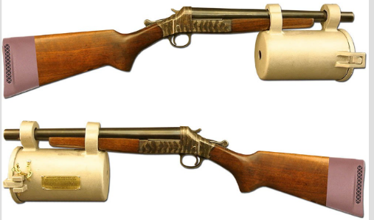 (Picture 1)
The model seen was the Bridger Model 85 line throwing gun, shown in picture 1.
At the time of writing, this model was discontinued, however there is a similar model in the works. Dates for this new model was stated as late 2019, however there is nothing on the website yet.
Another line launcher was a hand-held type. Its description included ‘Batman style’.
Designed by a former Navy Officer working as a Technical Director and Technology Lead Teacher at STEM – Engineering for kids in Azerbaijan.
Spring loaded, the back of the inserted projectile is pulled back and caught in trigger. When the trigger is pressed, the coil releases and launches the projectile. Like the action of a child's action figure.
It uses a steel cable, which can reach 9m, however without the cable, the projectile could reach around 20m.
Spring loaded is easy to recharge and can be repeated. Making it simpler and usable in any situation.
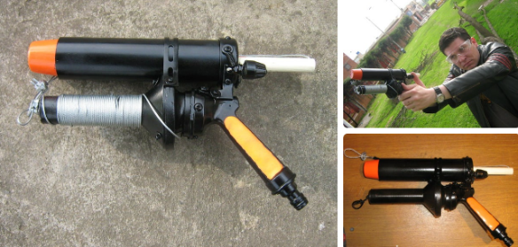 (Picture 2)

Jay Niewiadomski - SS Series Rescue Line Launcher
The SS Series Rescue Kit Contains $530.00
- Launcher with canister
- 2 spools of 600 braided nylon string
- 1 plastic missile
- 1 coated aluminum missile
- 100 of each power load (green, red) in water / airtight containers
- Launcher cleaning kit
- Rugged watertight storage case
Weight 18.00 lbs.
Dimensions 26.00 x 20.00 in
- Uses a .22 Cal blank to launch the dummy with line attached
- Aluminum canister houses a spool of string
- String is 600’ of braided nylon with rated break strength of 150 lbs
- Canister is easily reloaded with new spool by simply removing the end cap and sliding in the replacement spool
- Combination of a pistol grip, full length shoulder stock and an aero-dynamic missile allows for very precise placement of the line
- Stock of the launcher separates into two pieces for easier storage and transportation
- Three power loads are available – Green will launch the missile 40’-100, Red 100 – 250'+
- The distance will vary depending on the missile and the angle of the shot
- There are two different styles of missiles available.
- Plastic Missile is made of very dense but light-weight polypropylene foam with aerodynamic shape
- Coated Aluminum Missile. It is machined solid aluminum stock with a rubber coating and weighs approximately 8 ounces. Due to its aerodynamic design and its mass it will travel the farthest of the two missiles.
﷟HYPERLINK "https://www.diverescueintl.com/product/ss-series-rescue-line-launcher-kit/"https://www.diverescueintl.com/product/ss-series-rescue-line-launcher-kit/
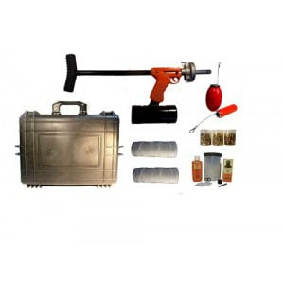
(Picture 3)
Luke Davies - Line Launcher
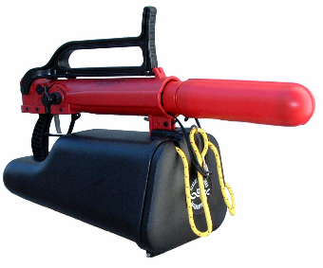(Picture 4)

This line launcher is priced at £1060
- Launch Distance: 60m-120m
- The Size Of Rope: 7mm*150m(land use) 6mm*92m(water use)
- Accessories:
- One Launcher, warhead
- one 150m 230bar tension force rope with rope case
- one 92m 1000bar tension force rope with rope case
- air charging system
- Regenerative lifebuoy
- one launch bottle, launch bottle case
- carry bag
https://www.alibaba.com/product-detail/life-saving-equipment-water-rescue-equipment_60633132364.html
Description
For situations where speed is of the essence and the distance from the ground to the lift cable is great.
The Line Launcher features a comfortable pistol grip, a bright orange body for high visibility, thumb operated latch for ease of loading of the self-extracting breech.
Capable of shooting a Launcher Projectile and attached avalanche cord over 80 yards! Extremely accurate and easy to use. P
Ourloads come in Low, Medium and High and will propel the Projectile (without line) approximately 40, 60 and 80 yards respectively.
Distances were measured on a horizontal plane with the projectile launched at a 45-degree angle.
http://carletonrescue.com/product/line-launcher/

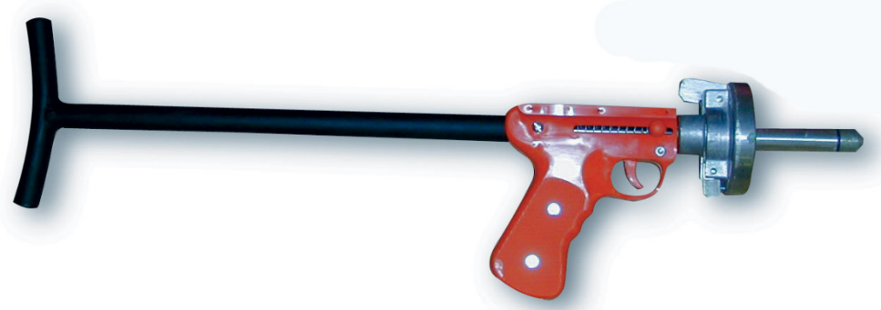(Picture 5)

Initial concept design evaluations

Dewi Perkins – Group 1
Table 1
 | Points: | Weighing | Design 1 score: | Design 2 score: | Design 3 score:
1 | Able to fire a Dunlop squash ball attached to a yellow fishing line from a fixed location to a designated target | 10 | 10 | 10 | 10
2 | Requiring clear access to fixing location wing-nut to be easily secured/removed without dis-assembly. | 10 | 9 | 5 | 7
3 | Safe and reasonable, with consideration to guarding if there is a risk of entanglement or entrapment. | 9 | 8 | 4 | 4
4 | Safety mechanism to prevent the device being accidentally fired once armed. | 10 | 7 | 5 | 9
5 | Fit within a maximum working envelope of 600x600x600mm. | 8 | 7 | 7 | 7
6 | Quick and simple method of attaching and detaching the line, without requiring the use of tools. | 8 | 8 | 5 | 8
7 | Must be fired remotely via a low voltage electrical switch with a minimum cable length of 2m. | 8 | 8 | 5 | 8
8 | Materials can be easily accessed within a workshop environment. | 8 | 8 | 7 | 6
9 | Simple in design to be able to replicate if needed. | 9 | 8 | 8 | 5
10 | Design to take Environmental impact into consideration | 7 | 6 | 6 | 6
 | Average scores | 8.7 | 7.9 | 6.2 | 7

Chart 1
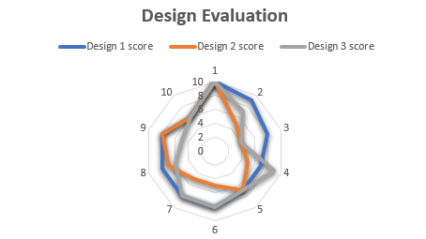

Design 1 – Score 7.9
This design is based on the cannon concept, giving it a long firing range. It gives good aiming capabilities by adjusting a bar which will adjust the trajectory.
The system works by using a firing elastic fixed to each side of the ball carrier and barrel. The ball carrier is fitted inside a 50 mm tube with a 42mm hole through it for the ball carrier. The ball is loaded into the top of the pipe barrel and sits on top of the carrier inside.
The ball carrier is held at it’s ready position by two hooks, fitted to a mechanical device that drops the arms out of its position when activated. Once they drop, it releases the elastic piece and propels the ball carrier and ball through the barrel. When it reaches the end, the ball and line are thrown towards the target area.

Design 2 – Score 6.2
This design incorporates a catapult concept. Using a launching arm for the ball and line to sit inside.
The catapult has a very good throwing distance, enabling the items to be thrown to the target. However, this doesn’t have the scope for angle adjustments. Leaving it to become time consuming to set to the correct distance of aim.
A spring is connected to the launching arm, at the opposite end to the carrier. The arm is balanced on a connecting pin, sitting between the two side panels. When the arm is pulled down, the spring is activated and pulled to a stretch. The arm is pocked into position by a mechanical hook.
When activated, the hook is released, and the ball is thrown from the carrier.

Design 3 – Score 7
This catapult design concept fits onto a base board and elevated centre piece. Fitted with two threads on the underside of the catapult, it can be fixed to the elevated centre piece.
The string is pulled back to fix into a locking nut system that holds it in place for the ball to be placed into the ball holder attached to the string.
A small mechanical device will be fixed to the trigger, releasing the string and firing the ball towards the target.

Jay Niewiadomski – Group 2

Table 2
Key areas identified | Design 1 | Design 2 | Design 3 | Weighing
Cost | 8 | 9 | 8 | 8
Materials | 7 | 8 | 9 | 5
Manufacture | 5 | 6 | 4 | 6
Lifespan | 9 | 7 | 6 | 7
Aesthetics | 6 | 8 | 9 | 6
Recyclability | 6 | 8 | 7 | 7
Time | 4 | 6 | 6 | 6
Function | 8 | 10 | 9 | 10
Safety | 5 | 8 | 7 | 8
Performance | 6 | 8 | 7 | 7
Quality | 6 | 8 | 7 | 7
Total | 68 | 86 | 79

Chart 2
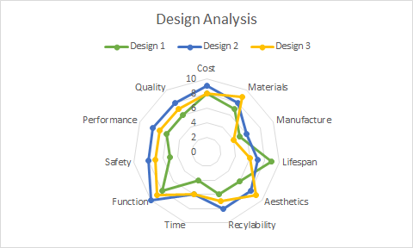
https://www.wooduchoose.com/BlogPost/?Wood-Price-League-Table

Luke Davies – Group 3

Final Design Evaluation
Table 4
 | Points: | Weighing | Group 1 score: | Group 2 score: | Group 3 score:
1 | Cost | 8 | 7
2 | Materials | 6 | 5
3 | Manufacture | 8 | 6
4 | Lifespan | 5 | 4
5 | Aesthetics | 9 | 8
6 | Recyclability | 9 | 8
7 | Time | 9 | 8
8 | Function | 7 | 6
9 | Safety | 6 | 5
10 | Performance | 8 | 6
11 | Quality | 9 | 8
12 | Average | 7.63 | 6.64

Chart 4

As shown in the above chart, the top design from group 1 came in above the other two group designs.

Costings

Part No | Part Reference | Cost (£)
1 | MDF Base Board 400 x 15 x 10mm | 6
2 | Steel Rod 10mm Dia x 100mm | 2
3 | 500 x 400 x 5 mm Acrylic Side Panels | 6
4 | Pipe Barrel 400 mm x 42mm Dia | 1
5 | Pipe Ball Carrier 85mm x 42mm Dia | 1
6 | Elastic Cord | 1
 | Total | 17

Conclusion
The aim of this project was to design a ball and line launcher. Capable of firing a squash ball attached to a fishing line into a target hole from a designated firing point.
This report shows that line launchers can be used for a variety of reasons both serious and for fun, but the main reasons are safety and tactical response for the armed forces.
The situation relating to this design was not as serious as the ones mentioned, but the objective is the same. To be able to aim and fire an object from one designated spot to another, as safely as possible.
The initial designs show that a variety of methods could have been used to achieve this, within the parameters set by the brief. Some of the most common initial design ideas use the basic catapult method. This allows for a simple arm swing, fired by a spring.
More complex designs were in the form of a crossbow elevated from the base board. This type of design allows for a more powerful shot. However, it was decided that this would be too complex to create the correct bow string and locking position.
Throughout the report, Design 1 consistently covered all the required specifications given in the brief, as shown in table 1 and 4.
There was a slight modification made for this since the initial design. The side boards were re-designed to be simpler. Enabling the construction and cutting to be easier, reducing the risk of mistakes and extra materials being used.
As of date of submission. My team members only contributed what is in the above report under their names, Luke Davies and Jay Niewiadomski. All other work, including the poster is my work, Dewi Perkins.

References
Pictures 1 & 2
First out Rescue. (n.d.). Bridger Line Thrower. Retrieved from First out Rescue: https://www.firstoutrescue.com/index.php/bridger-line-throwing-gun.html
Langer, M. (n.d.). Emergency Line Gun Project. Retrieved from Indistructables Living: https://www.instructables.com/id/The-Mini-Emergency-Line-Gun-Project-includes-SUGR/

Appendix - Firing range components.

Dunlop Competition Squash Ball 12 pack:
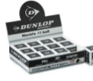
https://www.amazon.co.uk/Dunlop-Competition-Squash-Ball-Yellow/dp/B004GWN0QO/ref=sr_1_9?crid=1O8ZNFJAVVY6Y&dchild=1&keywords=dunlop+competition+squash+balls&qid=1580903663&sprefix=dunlop+competition+%2Caps%2C148&sr=8-9

110L Yellow colour, Plastic bin.
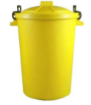
https://www.amazon.co.uk/110L-Yellow-Plastic-Rubbish-Dustbin/dp/B00MK1TS4G/ref=sr_1_2?keywords=110L+YELLOW+plastic+rubbish+dustbin&qid=1580905452&sr=8-2
Spectra Extreme Braided Fishing Line Yellow 30lb Test 100m.
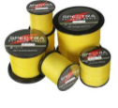
https://www.amazon.co.uk/Spectra-Extreme-Braided-100m-2000m-190Yards/dp/B01BZPX9IS/ref=sr_1_2?dchild=1&keywords=spectra+extreme+braided+100m+2000m&qid=1580905906&sr=8-2
Launch Table.
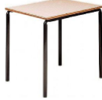
https://www.officefurnitureonline.co.uk/scholar-crush-bent-square-tables.html
Bolt.
https://www.screwfix.com/p/easyfix-bzp-steel-set-screws-m10-x-50mm-50-pack/11372
Washer. At the time of writing, the original 10 pack given on the component sheet was discontinued. Closest, cheapest substitute is shown below.
https://www.screwfix.com/p/easyfix-steel-large-flat-washers-m10-x-2-5mm-100-pack/447ft
Wing nut.
https://www.screwfix.com/p/easyfix-zinc-plated-steel-wing-nuts-m10-10-pack/5195t?_requestid=479587
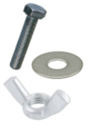
Layout of target and dimensions.


