[M3X9111] Strategic Management and Sustainability Word count: 2750
CASE STUDY: adidas-THE report into the competitive strategy


Student Number: 1704358
Student Name: Guiyan Zhang
Table of Contents
1.0 Executive Summary 2
2.0 Introduction 4
2.1 Background of the organisation 4
2.2 Strategy 5
2.2.1 Three levels of Strategy 6
2.3 Competitive Advantage (CA) 7
3.0 Main Body 7
3.1 Porter’s Generic Strategy 8
3.1.1 Cost leadership Strategy 8
3.1.2 Differentiation strategy 10
3.1.3 Focus strategy 11
3.1.4 Stuck in the middle 11
3.2 Applying Porter’s Strategy Model to Adidas 12
3.2.1 Examples of Differentiation strategy within Adidas 14
4.0 Conclusion 18
5.0 Recommendations 20
5.1- Implement hybrid strategies 20
5.2-Take full advantage of celebrity to conduct more CSR activities. 20
6.0 References 21

1.0 Executive Summary
The aim of this report is to critically evaluate the strategies for competitive advantage by use of the case study of Adidas which is a large, multifaceted and global organisation which produce sports lifestyle products.

Key findings of this report :
In order to gain competitive advantage, Adidas use the Strategy of Differentiation which is described by Porter’s Generic Strategies. They achieve this by implementing differentiation strategy to differentiate themselves to become unique in the sport field.

Advantages of Differentiation:
- To increase the price of the product
- To increase unit sales
- To gain consumer loyalty to the brand
- To have the opportunity to charge a premium for the good or service

Limitations of Differentiation：
- It is challenging to change customers’ perceptions
- High cost
- Easily imitated by competitors

Recommendations:

- Implement hybrid strategies
- Collaborate with fashion luxury brands to achieve the implementation of focus differentiation, increase fashion elements, and attract more clusters of customers so that Adidas will expand customer groups.

- The development and innovation of the product and fierce market competition has caused an increase in investment costs. Adidas should try to implement cost leadership strategies based on existing assets and markets, and reduce costs through effective ways to gain competitive advantage. At the same time, it can achieve sustainable development of enterprises.

- Take full advantage of celebrity to conduct more CSR activities.
- It is suggested that Adidas can take full advantage of celebrities to conduct more CSR activities. It enables Adidas to improve their reputation, at the same time, it is a significant way to fully reflect the brand culture.

2.0 Introduction
This report will include theories and models regarding competitive advantage and strategic management.

2.1 Background of the organisation
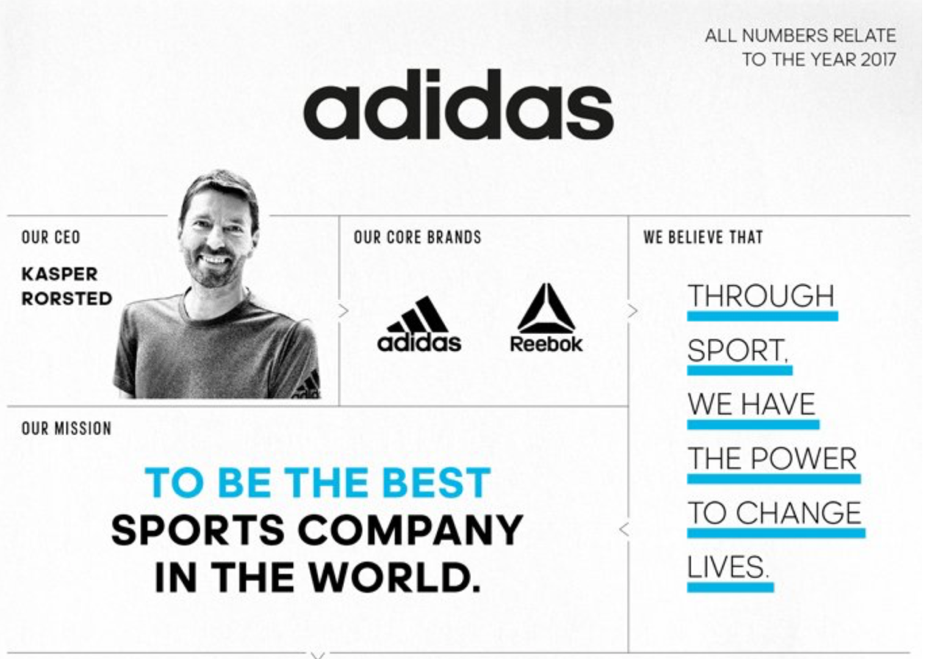
Figure1- FACTS AND FIGURES (Adidas-group, 2018a)

Adidas is a company with a vast product portfolio, including clothes, state-of-the-art sports footwear and accessories such as eyewear, bags, watches, hat and other sports-related goods and equipment. The Adidas Group has over 46,000 world-wide employees, and consists of around 170 subsidiaries including Reebok, Rockport, Taylor Made- Adidas Golf, and CCM-Hockey (UCLA, 2010). As the basic facts can be seen on Figure 1 above.

Adidas makes full use of concept marketing in brand construction, and divides the brand into three series (Fig 2), including Adidas Performance series (adidas TERREX), Sports Originals series (formerly classic series) and fashion series called Adidas Neo (divided into three sub-brands: Y-3, SLVR, Porsche Design sport，NEO LABEL) (You, 2011; Sahni, 2016).

Figure 2 – Originals, Three stripes (Adidas performance) & Neo(Sahni, 2016)

2.2 Strategy

Strategy is the corporate long-term direction of a company (Johnson, Whittington and Scholes, 2011). Thomposon, Strickland and Gamble (2007) identify strategy as the action of management for conducting operations and running businesses. They further assert the strategy in a company which includes the business approaches and competitive initiatives that managers use in developing their business, attracting and delighting customers, successful in competition, conducting business, and achieving targeted organisational performance levels. Thus, strategic management entails numerous steps that include the strategy formulation, implementation and monitoring, environmental scanning process, evaluation and review of the process to ensure efficient and effective implementation of the organisation’s long-term objectives (Tapera, 2014).

2.2.1 Three levels of Strategy
Multiple literature states that organisational strategies can be broadly classified into three different levels：corporate-level strategy, business-level strategy and functional-level strategy (Hax and Majluf, 1984; Grant and King, 1982; Bourgeois, 1980). By examining an organisation's business-level strategy, it is possible to identify the market orientation adopted by organisations in their specific industry sectors. These strategic orientations or market positions will have a significant impact on organisational performance rather than corporate-level strategy and functional strategy (Veettil & Nandakumar Mankavil Kovil, 2008).

2.3 Competitive Advantage (CA)
What Porter (1996) found was that competitive strategy is about being unique, and also means deliberately choosing a range of different activities to provide an individual combination of values. Henry (2011) states that formulating strategies enable organisations to gain a CA. CA was identified as the essential partner of Competitive Strategy (Porter,2008).

Porter's Generic Strategy (1980) can be a useful choice to conceptualize and empirically operate in this field. It is a suitable type for acceptability, adaptability, and the applicability of contemporary corporate competitive strategies (eg, Kim, Nam, & Stimpert, 2004). At the same time, it has gained most of the attention from numerous researches compared to other types of business strategy (Mo Koo, Koh, & Nam, 2004).

3.0 Main Body
There are three generic strategies described by Michael Porter (1980),which are alternative and optional approaches to gain CA and then it will be applied into Adidas.

3.1 Porter’s Generic Strategy
Porter’s Generic Strategy (1980) was used to attain a CA in the enterprise field (fig 3). It has quickly become one of the most wide-spread and useful approaches for considering key strategic choices (Magretta, 2012).

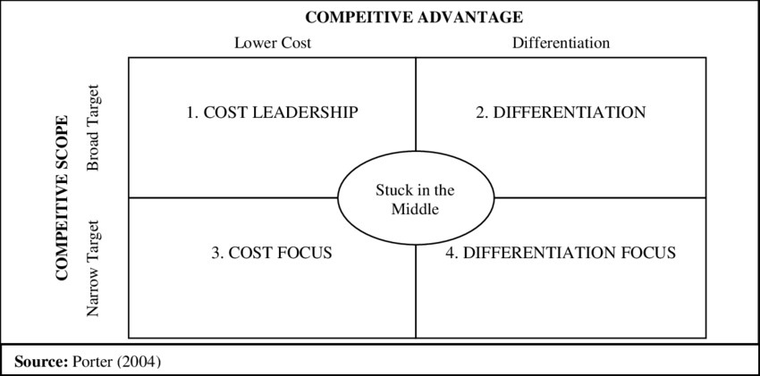
Figure 3 - Porter’s Generic Strategies (Porter, 2004)

This theory shows three alternative and viable strategic approaches to gain CA: Differentiation, Cost Leadership and Focus. At the same time, it cannot be ignored that there is a poor strategic condition namely “Stuck in the middle”, which lacks contribution to the CA for enterprises (Porter, 2004).

3.1.1 Cost leadership Strategy
In order to achieve cost leadership in an industry, including numerous implementations: Focus on building effective scale facilities, actively pursue cost reduction in experience, strictly control costs and indirectly control costs, avoidance of marginal customer account and achieve cost minimisation in research and development, service, sales, advertising and other so on (Porter, 2004).

Successful implementation of a cost leadership strategy can increase the market share because the companies that can offer products at lower than typical market prices often get more business from buyers with limited budgets. At the same time, low-cost operations can achieve higher profit margins. If you can sell products and services at a lower cost basis and at a competitive price, then your profit margin will be higher than those that invest more to produce similar quality products (Hassan, 2015; Futureofworking, 2018).

On the contrary, companies may reduce costs in key areas such as customer service in order to maintain a low-cost position. These cost reductions are likely to drive away some customers seeking better customer service. Another issue for customers is the lack of innovation or new products. R&D costs are required for companies to introduce new products or features into their products. However, for low-cost strategists, these additional costs should be eliminated.Therefore, this delay in innovation can have a negative impact on customers who are eager to innovate (Hassan, 2015; Futureofworking, 2018).

3.1.2 Differentiation strategy
This strategy creates products or services that are considered unique within the industry (Porter, 2004). If successful, it allows the business to charge a premium for the good or service. Keep in mind, however, that the business often encounters higher costs to offer the unique product or service and thus, needs to be successful in attracting customers to cover that extra cost (Whiting, 2018).

Successful implementation of a differentiation strategy allows companies to demand higher prices for their products and will increase unit sales, as additional buyers will be attracted by differentiated functions and features. At the same time, companies will also gain loyal consumers of their brands (Thompson and Strickland, 2001).

There are some limitations. One is that it is a challenge to change customers’ perceptions. The majority of consumers believe that the product is equivalent to optional products provided in the low-price marketplace. At the same time, the implementation of differentiated strategies requires companies to make larger financial investments. In order for the company to convince consumers that its products contain unique features, it needs to pay for high advertising costs to spread this information to consumers (McIntosh, 2017). In addition, Thompson and Strickland (2001) and Johnson and Whittington and Scholes (2011) concur by emphasizing the fact that companies’ differentiation strategies would fail if they were easily imitated by competitors.

3.1.3 Focus strategy
Porter (2004) states that focus strategy is divided into 2 parts: Focus Differentiation and Focus Cost Leadership. The similarities between them are the focus on specific clusters of consumers, and a segment of geographic market and product line. The successful implementation of the focus strategy relies on an industry segment that is large enough to have potential of growth，at the same time, it is not important for the success of other major competitors (David and David, 2016). In an article which analyses Porter’s work, Wright (1987) emphasises that for medium and large enterprises, only a combination of differentiation strategies or cost leadership-based strategies are able to effectively pursue the focus-based strategy.

3.1.4 Stuck in the middle
Porter proposed a new term - Stuck in the Middle - for those organisations that are unable to make a choice between a cost leader and differentiation or focus, or that use all of these strategies simultaneously. Porter (2004) argues that a firm which is stuck in the middle is likely to fail, because a company which is stuck in the middle has no strategy at all, and if a company is in this position it can be successful for a shorter period of time, but in the long run it will fail.
Later scholars refuted Porter’s argument, by identifying that it is uncertain that a firm which simultaneously uses cost leadership and differentiation strategy will fail (Magretta, 2012 ;Bambang Baroto et al., 2012). Because recent studies have shown that the businesses pursuing both generic strategies can be successful. Most popular example of this is Toyota, which uses both generic strategies, and resulted in a higher performance (TWMG, 2014), and other examples such as Tesco and IKEA can be evidenced (Explorer, 2010; Learning, D.A., 2010; Siddiqui, 2012) .

3.2 Applying Porter’s Strategy Model to Adidas
Applying the generic strategy model described by Porter (1980) to Adidas, Differentiation would be applicable for it. Adidas could be a significant case study example highlight the importance of innovation and diversity, which is also a vital reason why it attained CA. Moreover, Adidas still becomes the primary choice of the majority clusters of customers, especially for young generations (News.ef360., 2017).

Customers’ loyalty is at the core of Adidas' business, and the successful implementation of a differentiated strategy has enabled Adidas to build deep relationships with its customers. In terms of the view of Repucom, Nike has twice as more Facebook fans as Adidas in 2016, but Adidas is almost four times more likely to the number of participation than Nike, suggesting that Adidas fans are often more involved in the brand (Rivera, 2018).

In contrast, in order to implement differentiation strategy, inevitably high cost is the situation we cannot ignored. In 2006, in order to further compete with Nike and expand its market share and influence in the US market, Adidas bought Reebok，which is the second largest sports brand in the US, for US$3.8 billion (Sohu, 2017).
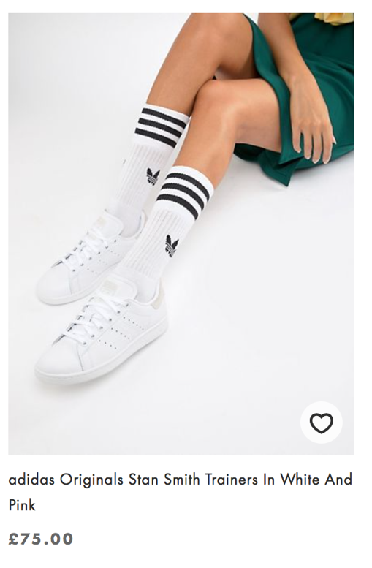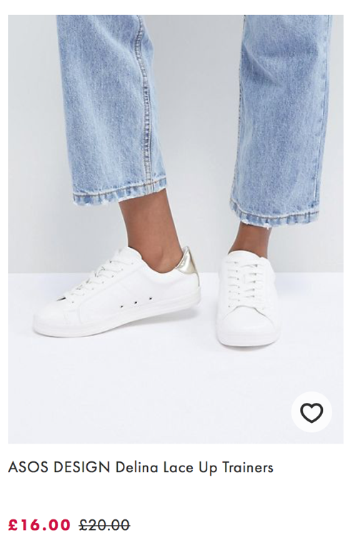
Figure 4 - Cheaper alternatives of adidas vs Adidas Originals (ASOS, 2018).
In addition, as shown on Figure 4 on above which shows a cheaper alternative example product of Adidas versus Adidas Original. Jiecheng Luo, the founder of Magic House believed that in order to gain consumers' long-term consumption behaviour should be something that really brings value to consumers. This is nothing more than genuine low price (Lieyunwang, 2018). In other words, the key demand of consumers is low price. Hence it is possible for the majority of consumers to choose the cheaper alternatives of Adidas.

Moreover，Adidas had a five-year trademark infringement case with Adivon. Undoubtedly, in the dispute between Adidas and Adivon, it reflects the characteristics of Adidas that it is easily to be imitated and copied (Beijing Business Today, 2013).

3.2.1 Examples of Differentiation strategy within Adidas
Adidas focuses more on the broad differentiation strategy. In general, the corporate level strategy of Adidas focuses on innovation, trying to produce new products, services and processes in order to cope up with the competition. The group's multi-brand portfolio gives them an important CA. The global sales function was also split into two departments, wholesale and retail, which catered to the various needs of both these business models. This was done in order to sustain their corporate level strategy for the long run so that these divisions could emphasise and work hard in their respective departments in order to make the most of their efforts. (Adidas Group, 2018b)

3.2.1.1 Innovation and differentiation of Product and Service
The organisational culture of Adidas group obligates employees to be innovative. This culture forces them to produce goods which are highly innovative and with the use of the latest technology their products with high quality (Adidas-group, 2018c; Phelps, 2015).

From the stadium to the fashion show, from the gymnasium to the street, Adidas reflects the innovation of combining fashion elements on the basis of sports (Sports.Sina, 2011).


Figure 5 - Y-3 Spring Summer collection 2018 (Yoka, 2017)

Moreover，the joint cooperation with the "old rival" Nike (Adidas × Yeezy) also reflects product innovation at the same time, while attracting consumers, it also occupies most of the market share (Adidas-group, 2016).

On the other hand, marathon, roadshows, star storytelling and other public events also reflect the diversity of Adidas services. Not only they can attract a wide range of customers, but it also better reflects the brand culture, which greatly enhances the brand's competitive advantage and stands out in the industry (Chan, 2015).

3.2.1.2 Implementation multi-brand strategy

Figure 6 - Y-3 Official Site (Y-3, 2018)

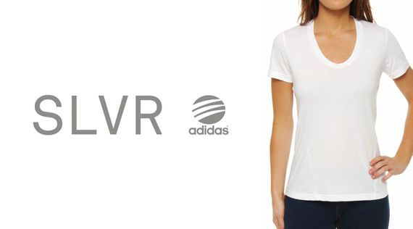
Figure 7 - Brand Spotlight: Adidas SLVR (Wells, 2014)

Regarding to alternative series of sub-brands which shown on Figure 2 and Figure, Adidas makes full use of concept marketing in brand construction. It divides different series of sub-brands with different prices and styles, completely implemented a multi-brand strategy by having a diverse brand portfolio which allowed them to cater all segments of the market from players to almost everyone. This helped them to keep a unique identity and concentrate on their core competencies (Wu, 2015)
.

3.2.1.3- Multiple celebrities’ endorsement


Figure 8 - Part of entertainment/athletic spokesperson in Adidas, adapted from (Adidas group, 2018d; New.qq, 2017)

Adidas spokesperson has a strong line-up(as shown on Figure 8). The reason why the entertainment/athletic spokesperson is different from other brands, in addition to the intention of developing the fan economy, is also to start ahead and resist the competition of competitors(Sohu.com, 2017).
Cashmore (2002) and Horne (2005) and defines spokesperson as “living advertisements” , they commodities their own right and shows the vision of better lives that others aspire, Beckham and Jordan can be a symbolic example. As celebrities guarantee or promote their products, brands can increase awareness, trust and familiarity, which are important variables in the purchasing decision process. If their products are marketed by celebrities they admire or pay attention to, consumers will be more sympathetic to the brand. This is a simple psychological effect: in the subconscious, people think that buying a product that is promoted by the celebrities they admire will enable them to imitate the qualities that celebrities want, or to attract similar people into their lives. They link celebrity success, beauty, and athletic skills to specific products(Guided Selling Blog, 2016).
In the year of 2017, NBA star James Harden participates in the charity event held in Adidas in Hangzhou. A basketball training class for the children of the Hangzhou Children's Welfare Institute showed the important role that basketball can play in helping the socially disadvantaged groups. It also demonstrates Adidas' commitment to continue to practice corporate social responsibility(CSR) in China (Prnasia, 2017).

4.0 Conclusion
Adidas have successfully implemented the Differentiation strategy so that it has attained a CA in sport field. In this strategy, Adidas is able to improve CA base on the strategy of differentiation so that they can retain to be unique to differentiate themselves keep distance between them and another branch.

Approaches in which Adidas applied differentiation strategy:
- Innovation and differentiation of Product and Service:
Innovation is the key driver of the success of Adidas. It takes innovation to the extreme in both product and service.
- Implementation multi-brand strategy:
Implementing multi-brand strategy has become a vital approach for helping Adidas to differentiate them from others.
- Multiple celebrities’ endorsement
Adidas has taken advantage of the multi-star endorsement to expand consumer clusters and market share.

Implementing the Differentiation strategy, the organisation is able to gain competitive advantage by providing products or services to customers which can differentiate themselves between competitors. Also, it is able to increase the demand of price and unit sales. At the same time, as mentioned previously, it will have opportunity to demand to charge a premium for the good or service if it is implemented successfully
Finally, based on the current cluster of customers, it can gain more consumer loyalty to its brand.

The limitations of implementation of differentiation in Adidas:
High cost of advertisement for attracting customers for purchasing their unique products or services.
Innovation may cause the opponent to imitate and match.
It would be a challenge of changing customers’ perceptions.

5.0 Recommendations
There are 3 recommendations on 2 significant aspects.

5.1- Implement hybrid strategies
Collaborate with fashion luxury brands to achieve the implementation of focus differentiation, for example (Fendi×FILA) increase fashion elements, and attract more clusters of customers so that Adidas will expand customer groups (Boykins and Leung, 2018).

The development, innovation of product and fierce market competition has caused an increase in investment costs. Adidas should try to implement cost leadership strategies based on existing assets and markets, and reduce costs through effective ways to gain competitive advantage. At the same time, it can achieve sustainable development of enterprises.

By implementing these recommendations, Adidas can attract other customer bases based on existing customers, and improve their reputation so that it can achieve their objectives and mission during short period of time.

5.2-Take full advantage of celebrity to conduct more CSR activities.
It is suggested that Adidas can take full advantage of celebrities to conduct more CSR activities. It enables Adidas improve their reputation, at the same time, it is a significant way to fully reflect the brand culture.

6.0 References
Adidas-group. (2016). YEEZY - ADIDAS AND KANYE WEST MAKE HISTORY WITH TRANSFORMATIVE NEW PARTNERSHIP ADIDAS + KANYE WEST. [online] Available at: https://www.adidas-group.com/en/media/news-archive/press-releases/2016/adidas-and-kanye-west-make-history-transformative-new-partnershi/ [Accessed 25 Nov. 2018].

Adidas-group (2018a). FACTS AND FIGURES. [image] Available at: https://www.adidas-group.com/en/group/profile/ [Accessed 25 Nov. 2018].

Adidas-group. (2018b). CORPORATE STRATEGY. [online] Available at: https://www.adidas-group.com/en/investors/group-strategy/#/rolle-unserer-vertriebskanale/ [Accessed 25 Nov. 2018].

Adidas-group. (2018c). INNOVATION. [online] Available at: https://www.adidas-group.com/en/sustainability/products/sustainability-innovation/ [Accessed 25 Nov. 2018].

Adidas-group (2018d). Official Website. [image] Available at: https://www.adidas.com.cn [Accessed 26 Nov. 2018].

Asos. (2018). Women's Shoes | Shoes, Sandals & Boots | ASOS. [online] Available at: https://www.asos.com/women/shoes/cat/?cid=4172&nlid=ww|shoes|shop+by+product [Accessed 25 Nov. 2018].

Bambang Baroto, M., Baroto, M., Abdullah, M. and Wan, H. (2018). Hybrid Strategy: A New Strategy for Competitive Advantage. [online] Academia.edu. Available at: http://www.academia.edu/10500645/Hybrid_Strategy_A_New_Strategy_for_Competitive_Advantage [Accessed 22 Nov. 2018].

Beijing Business Today. (2013). Adivon trademark "surrender" Adidas. [online] Available at: http://www.bbtnews.com.cn/2013/0503/566.shtml [Accessed 25 Nov. 2018].
Bourgeois, L . J. (1980). 'Strategy and environment: A conceptual integration'. Academy of Management Review, 5, pp. 25-39
Boykins, A. and Leung, A. (2018). Fendi & FILA Build off Their Milan Fashion Week Tease With Full “Fendi Mania” Collection. [online] HYPEBEAST. Available at: https://hypebeast.com/2018/10/fendi-fila-fendi-mania-collection-release [Accessed 25 Nov. 2018].

Cashmore, E. (2002). Beckham. Cambridge: Polity.

Chan, J. (2015). Adidas Originals story-telling by superstars, let's count the superstars of Super Moment. [online] Toodaylab.com. Available at: https://www.toodaylab.com/69854 [Accessed 25 Nov. 2018].

David, F. and David, F. (2016). Strategic Management: A Competitive Advantage Approach, Concepts and Cases, Global Edition. 16th ed. London: Pearson.
Explorer, S. (2010). Do you have a competitive strategy: Bases of Competitive Advantage- The Strategy Clock. Retrieved from www.strategyexplorers.com/whitepapers/Do-you-have-a-competitive-strategy.pdf
Futureofworking. (2018). 14 Advantages and Disadvantages of Cost Leadership Styles | FutureofWorking.com. [online] Available at: https://futureofworking.com/14-advantages-and-disadvantages-of-cost-leadership-styles/ [Accessed 25 Nov. 2018].

Guided Selling Blog. (2016). Impact of Celebrity Endorsement on Consumer Buying Behavior. [online] Available at: https://www.guided-selling.org/impact-of-celebrity-endorsement-on-consumer-buying-behavior/ [Accessed 25 Nov. 2018].
Grant, J. H. and King, W. R., (1982). The Logic of Strategic Planning. Boston: Little Brown and Co.
Grant, R. (2002). Contemporary Strategy Analysis: Concepts, Techniques, Applications. 4th ed. Boston: John Wiley and Sons.
Hax, A . C . and Majluf (1984). 'The Corporate Strategy Planning Process'. INTERFACES, 14(1), pp. 47-60.
Henry, A. (2011). Understanding Strategic Management. 2nd ed. Oxford: Oxford University Press, pp.189-225.

Horne, J. (2005). Sport In Consumer Culture. Basingstoke: Palgrave, p.82.

Johnson, G., Whittington, R. and Scholes, K. (2011). Fundamentals of strategy. 2nd ed. Pearson, p.2.
Learning, D. A. (2010). Hybrid Strategy: Sustainable competitive advantage. Retrieved from www.daanassen.com/hybrid-strategy-sustainable-competitive-advantage
Kim, E., D. Nam and J. L. Stimpert, (2004). ‘The Applicability of Porters Generic Strategies in the Digital Age: Assumptions, Conjectures, and Suggestions’, Journal of Management, Vol. 30, No. 5, pp. 569-589.
Koch, J. (2018). Economies of Scale and Economies of Scope - strategy, levels, system, examples, advantages, type, company, business. [online] Referenceforbusiness.com. Available at: https://www.referenceforbusiness.com/management/De-Ele/Economies-of-Scale-and-Economies-of-Scope.html [Accessed 21 Nov. 2018].

McIntosh, K. (2017). Strengths & Weaknesses of a Differentiation Strategy. [online] bizfluent. Available at: https://bizfluent.com/info-8385815-strengths-weaknesses-differentiation-strategy.html [Accessed 25 Nov. 2018].
Mo Koo, C., Koh C, and Nam K. (2004). An examination of Porter’s competitive strategies in electronic virtual markets: A comparison of two online business models. International Journal of Electronic Commerce, 9 (1): 163–180.
News.ef360 (2017). There are 7 characteristics of sports consumption of the generation after 95. The loyalty to sports brands is higher than imagination.. [online] Available at: http://news.ef360.com/Articles/2017-9-13/364181.html [Accessed 21 Nov. 2018].

New.qq (2017). Why should Adidas spend a lot of money on Yang Mi to endorse?. [image] Available at: https://new.qq.com/omn/20171219/20171219G0MNNN.html [Accessed 26 Nov. 2018].

Phelps, S. (2015). Culture Is King: Three Ways Adidas Is Striving to Build a Culture of Extraordinary. [online] Forbes. Available at: https://www.forbes.com/sites/stanphelps/2015/04/15/culture-is-king-three-ways-adidas-is-striving-to-build-a-culture-of-extraordinary/#18edaa5d73a1 [Accessed 25 Nov. 2018].

Porter, M. (1980). Competitive strategy: techniques for analyzing industries and competitors. New York: The Free Press.

Porter, M. (1996). What Is Strategy?. [online] Ais.ku.edu.tr. Available at: https://ais.ku.edu.tr/course/17479/3_WhatisStrategy.pdf [Accessed 19 Nov. 2018].

Porter, M. (2004). Competitive Strategy：Techniques for analysing Industries and Competitors. New York: Free Press.

Porter, M. (2008). Competitive advantage：Creating and Sustaining Superior Performance. New York: Free Press.

Prnasia. (2017). Adidas and NBA star Harden host a charity event in Hangzhou. [online] Available at: https://www.prnasia.com/story/185054-1.shtml [Accessed 25 Nov. 2018].

Rivera, F. (2018). Top 5 European companies with highest customer loyalty. [online] Europeanceo.com. Available at: https://www.europeanceo.com/business-and-management/top-5-european-companies-with-highest-customer-loyalty/ [Accessed 26 Nov. 2018].

Sahni, G. (2016). Originals, Three stripes & Neo. [image] Quora. Available at: https://www.quora.com/Why-does-ADIDAS-has-two-different-logos [Accessed 25 Nov. 2018].

Siddiqui, A. (2012). IKEA: Making a success of being "Stuck in the middle"?. Scientific Essay.

Sohu.com. (2017). Adidas accelerates in the Chinese market. [online] Available at: http://www.sohu.com/a/146467689_115533 [Accessed 26 Nov. 2018].

Sohu. (2018). Fitness is a niche market? Reebok gambled 30 million euros. [online] Available at: http://www.sohu.com/a/165025463_284045 [Accessed 24 Nov. 2018].

Sports.Sina. (2011). Adidas launches the largest scale of brand history. Several venues in Shanghai are free.. [online] Available at: http://sports.sina.com.cn/o/2011-03-18/00565493431.shtml [Accessed 25 Nov. 2018].

Tapera, J. (2014). www.theinternationaljournal.org > RJSSM: Volume: 03, Number: 11, March-2014 The Importance of Strategic Management to Business Organizations. The International Journal's-Research Journal of Social&Science Management, (2251-1571), p.127.

Thomposon, A., Gamble, J. ‎ and Strickland, A. (2007). Crafting and Executing Strategy: The Quest for Competitive Advantage: Concepts and Cases. Mcgraw Hill.

Thompson, A& Strickland, A. J., (2001). Strategic management: concepts and cases 12th ed., Boston, Mass.: McGraw-Hill/Irvin.

TWMG (2014). The Importance of Hybrid Strategy for Your Business. [online] Digital Agency Sydney | TWMG Blog. Available at: https://blog.twmg.com.au/the-importance-of-hybrid-strategy-for-your-business/ [Accessed 25 Nov. 2018].

UCLA (2010). Planning effective marketing strategies for a target audience. Summative Activity – Adidas. [online] p.1. Available at: https://www.coursehero.com/file/17178525/Adidas/ [Accessed 24 Nov. 2018].

Veettil, Nandakumar Mankavil Kovil (2008). STRATEGY FORMULATION AND IMPLEMENTATION IN MANUFACTURING ORGANISATIONS - THE IMPACT ON PERFORMANCE. Middlesex University Research Repository. [online] London: Middlesex University London, p.110. Available at: https://eprints.mdx.ac.uk/8114/1/Veettil-phd.pdf [Accessed 19 Nov. 2018].

Wells, J. (2014). Brand Spotlight: Adidas SLVR. [image] Available at: http://blog.herroom.com/adidas-slvr/ [Accessed 25 Nov. 2018].

Whiting, B. (2018). Differentiation Strategy: Definition & Examples. [video] Available at: https://study.com/academy/lesson/differentiation-strategy-definition-examples.html#/lesson [Accessed 21 Nov. 2018].

Wright, P. (1987). A refinement of Porter's strategies. Strategic Management Journal, 8(1), 93-101.Yin, R.K. (2013).Case study research: Design and methods. London: Sage Publications.
Wu, S. (2015). Adidas NEO Label summer road show national tour begins, the first stop in Chengdu. [online] toodaylab. Available at: https://www.toodaylab.com/69854 [Accessed 25 Nov. 2018].

You, Y. (2011). Y-3, SLVR, Porsche Design Sport Brand Fashion Center opened in Shimao Department Store. [online] Vogue. Available at: http://m.vogue.com.cn/invogue/news_1241cad0f2b607fc.html [Accessed 25 Nov. 2018].

