
Skills for the Workplace
Module Assignment Submission
Student Name: | Dwayne McDaid
Student Number: | 1811561
Module No: | BMSK4006
Module Title: | Managing Enterprise in the 21st Century

Statement of Confirmation of Authenticity
By the act of making this submission, the student declares that this is the work of the student named above. The work has not, in whole or in part, been knowingly presented elsewhere for assessment, or where assessment has been built on a previous assessment, this has been identified. Where materials have been used from other sources it has been properly acknowledged. If this statement is untrue, the student acknowledges that an assessment offence has been committed.
Attention is drawn to the plagiarism and unfair practice policies of both the University and of ILM.
Permission for ILM to use this script
ILM uses learners’ submissions – on an anonymous basis – for assessment standardisation. By submitting, both the centre and the learner agree that ILM may use this script on condition that identifying information is removed. However, if you are unwilling to allow ILM use this script, please refuse by ticking the box: □

Table of Contents
Introduction 7
Identify a personal skill-set and knowledge relevant to the project 7
Demonstrate a range of employment skills in the completion of a group project 10
References 13
Appendix 1 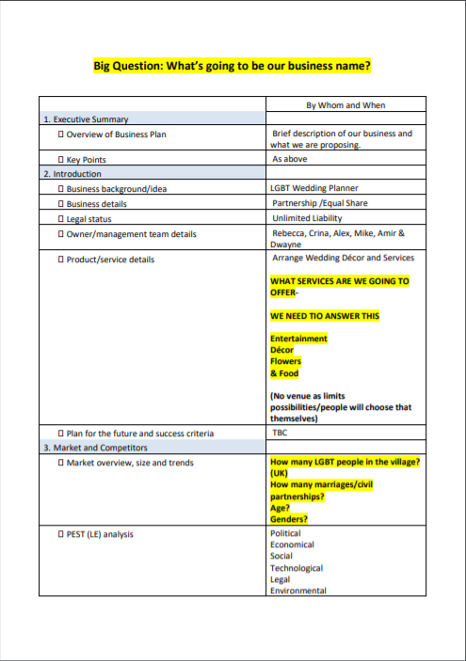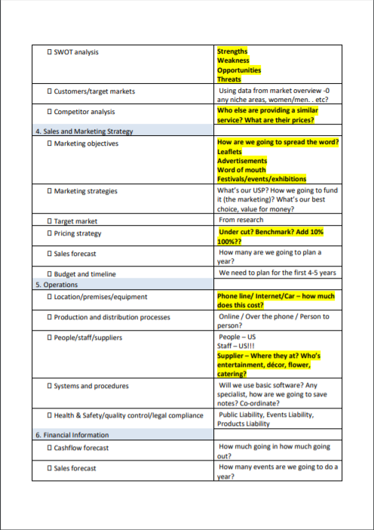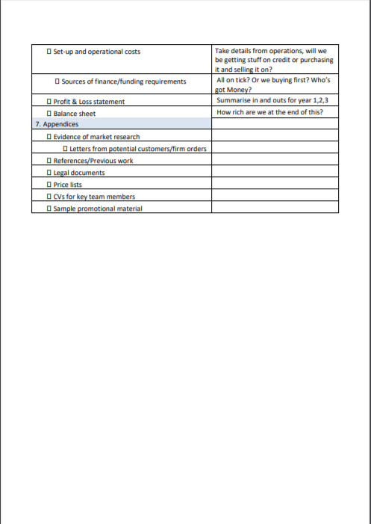 14
Appendix 2 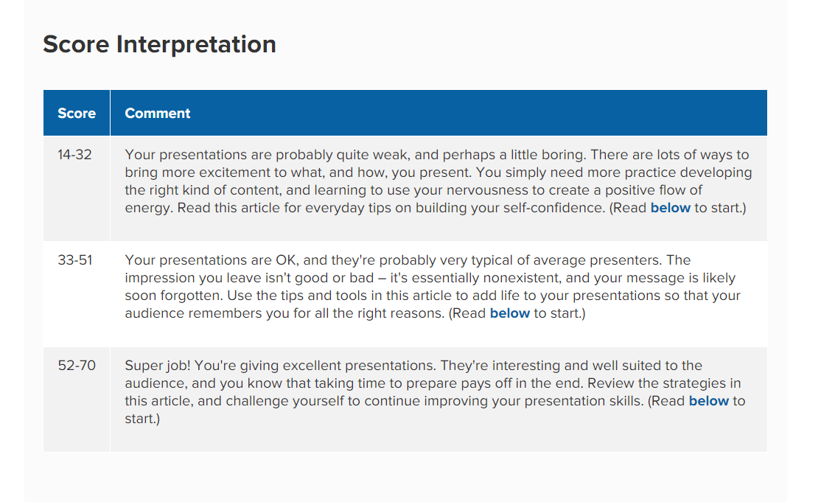 17

Introduction

I am a 28 year old university student who also has full time employment in an insurance company. I have enrolled in university as I wish to enhance my employability skills and my own personal knowledge. The following assignment is a reflection on skills I have learned and developed whilst completing a group project. We were tasked with creating and presenting a business plan. I have used the Gibb’s reflective cycle throughout this reflection. Gibb’s cycle is helpful in making you think through all the phases of an experience, activity or project. You start by describing what you did. You then talk about the feelings you encountered whilst carrying ou the task. You evaluate the good and bad experiences you experienced and then analyse what sense you can make of it. From this you draw a conclusion which helps build a plan to how you will improve next time you carry out the same or similar task.

Identify a personal skill-set and knowledge relevant to the project

The first skill I will reflect on is research skills. ‘Research skills are the ability to search for, find, collect, analyse, interpret and evaluate information that is relevant to the subject being studied.’ (Research Skills n.d.). It is important as we would build our business plan and its projections off the information we had gathered.
For the business plan there was a lot of information we I had to research. We had to look up legislation surrounding our industry. Look up statistics to get an idea of our market. Find out the potential operational costs for our business and how much we should spend on marketing and advertising.
I felt good about researching as I like finding out facts and figures. I got to use my IT skills to search databases and news articles. However, as we had chosen a wedding planning business I was wary I had very little existing knowledge to help point me in the direction to what I needed to find.
I was able to find stats related to same sex marriages and numbers on how many people identified as LGBT+ in England and Wales from the office of national statistics. This was very beneficial as the ONS are a well-respected statistical institute.
My personal interest in technology also helped in finding out prices for operational costs such as business phones, laptops and internet hosting. I managed to establish a range of high and low end prices to work out a medium. It also helped me to identify what was the best price for what we needed.
The downside of my research is I couldn’t find more specific data for our business. I could find national statistics but I was unable to obtain numbers relevant to our local market. Whilst researching I also forgot to look into specific competitors. I established that wedding planners and venues were our biggest competitors but I did not identify individual ones that we would compete with, within our local area.
Whilst the research made it more helpful to understand the market as a whole the lack of more specific data meant I knew very little about the market within my region. The particular customers I would be hoping to gain and the other businesses I would have to compete against to get them. I should have narrowed down my focus more and established these for my business plan.
In the future I will make sure to understand my market both nationally and locally. I will use this information to give me a better understanding of my target market and I would use them as a benchmark or a case study. Learning from them to develop my own business and make it better.
Organization skills ‘help a person to plan, prioritize, and achieve his or her goals.’ (Doyle 2019). They were particularly vital for this assignment as there were six people contributing to the business plan. To complete the work, we would need a lot of collaboration and communication if we wanted it to succeed.
I felt we were on good stead for this final assignment. A lot of people had left the course on our last group assignment and I though that those remaining were committed to the end.
Together we chose which part of the business plan we wanted to do. We met regularly to start with and discussed the areas we had chosen. We set timelines of when we were going to complete certain parts by and established who we needed to pass this information on to so they could complete their section. This worked well as everyone knew who was doing what. We even elaborated on the checklist that was provided to us (Appendix 1) so we understood what questions we had to answer. This gave us a plan.
After the first few meets it then became disorganised. One member became unresponsive. Some did not turn up to meetings. Others could not due to other personal commitments. This meant some sections weren’t complete at all. It inhibited other team members as they needed the findings of the unfinished work, to start theirs.
Due to some work being incomplete I had to take on the task of researching and compiling information, outside of my delegated section of the business plan, so others could carry out their work. To aid us in our organization we should have reconvened, to redistribute the sections each team member was in charge of completing.
In the future I will use an organizational tool such as a Gantt Chart. This will help establish what needs to be done by when; and what needs to be completed before we can proceed with the next part.

Presentation skills were another key attribute. For the second part of the business plan we had to do a presentation. We provided our lecturer with a copy of the business plan and answered any questions he had.
I felt confident going into the presentation as I had done a lot of the work that went into it making it. I had done a lot of the research and a majority of the writing. I did feel doubtful of a couple of my colleagues’ ability to answer questions due to their minimal contribution and wondered if this would affect my overall mark.
During the presentation I was able to answer a lot of the questions put forward. I could generally answer them quickly with ease and did not need to refer to the plan to remind me of its content.
However, the overall presentation could have gone much better. The plan had to be printed last minute and was nor bound or presented in a folder, diminishing the presentation of the document itself. In the plan itself there were not enough visual aids to break up the monotony of words. Furthermore, as this was a formal meeting, I feel our attire was also too relaxed.
Overall this gave the presentation a lacklustre feel and gave the impression it was rushed and unfinished. To make our plan more enticing and easier to read we should have included more variety, such as graphs and images. We could have also agreed to dress more appropriately as a team.
In the future I will make sure to include a wider range of mediums in my plan. I will also make sure the plan itself is bound inf a folder prior to the meeting. I will dress more appropriately i.e. in shirt and tie, which is expected in such a meeting. To help my presentation skills I also completed a survey on MindTools (Appendix 2). I scored 45 which was mid-range. I will use the information provided by the website to better plan for future presentations.

Demonstrate a range of employment skills in the completion of a group project

One employment skill I developed and exhibited during the course of this project was strategic planning. Strategic planning is setting goals, deciding what action needs to be taken and then helping carry out those actions to achieve goals. Throughout the duration of creating our plan I communicated with all my colleagues via a range of mediums. Face to face, instant messenger and emails. I set out tasks, I advised on what needed to be found out and I helped my team members by sharing my information and knowledge with them.
I was surprised at how well I manged to organize myself as well as others for the task in hand. I did feel some trepidation that my colleagues would not fully co-operate as I don’t often take such a lead role, on the administrative side, in group work. I manged to delegate sections fairly evenly to all members. I was also very flexible in my approach to when work was complete. Taking into consideration external influences such as family and work that limited our available time. However, I wish I was a little more disciplined and enforced deadlines more assertively as some team members were delayed by others completing their work late.
Another downside to my strategic planning was that I took the word of my team members that the work was complete. I did not check the work itself until I got to writing the business plan. Some of the work that was submitted did not have enough information or was unhelpful altogether. This meant that I had to personally make up for their shortcomings leaving myself with more work to do then I planned.
I should have asked for my colleagues work earlier than I did. This would have given us more time to address any information that was missing; that was needed for the plan. It would have given my colleagues time to revise their work too.
In the future I will check the work submitted more frequently along the timeline. I will give my colleagues feedback on their work, how they can improve it and give them time to develop it.

I displayed great interpersonal communication skills during the course of this assignment. Interpersonal skills help you influence attitudes and behaviours, express personal needs and understand those of others. Even in it’s most basic form they can be used to give and collect information. I feel very confident in my interpersonal skills. This is due to my 15 plus years’ experience in a customer focused industry and my generally extroverted personality.
During the assignment I constantly contacted my colleagues to see how they were doing both personally and professionally. This built connections and opened up channels for communication and feedback. It also meant I could support my team members when they needed me to as they felt comfortable to confide in me. This meant I could engage their attitude to work, their satisfaction and how well they were manging there work load.
Unfortunately, this did not work with all team members. One team member stopped responding to our messages and in turn never submitted any work. I did not anticipate this and it left us with short comings as a team. Also, some team members understood what exactly what I expected of them. Other team members did not. The work they submitted was not what I wanted or needed at all. From this I can see that I did not communicate clearly enough what was required of them. I should have spent additional time communicating with these team members so we came to a mutual understanding of the work in hand.
In future, I will spend more time communicating my expectations of my colleagues. I will then spend more time asking for feedback so I can confirm whether they understand them.

References

Alison Doyle, 2019. Organizational Skills List with Examples. Skills & Keywords, The Balance Careers. Available from: https://www.thebalancecareers.com/organizational-skills-list-2063762 [Accessed 17 September 19].
Mind Tools Content Team, n.d.. How Good Are Your Presentation Skills?. Mind Tools, Mind Tools. Available from: https://www.mindtools.com/pages/article/newCS_96.htm [Accessed 17 September 19].
The Big Choice, n.d.. Research Skills. Careers Advice, The Big Choice. Available from: https://www.thebigchoice.com/graduate-jobs/careers-advice/research-skills [Accessed 17 September 19].

Appendix 1

Appendix 2

