
UNIVERSITY OF WALES TRINITY SAINT DAVID
Y Drindod Dewi Sant Prifysgol Cymru
Lecturer: Taonga Kaonga Sobere-Snithers
Student ID: 2513316
Student Name: Harpreet Singh Rana
Portfolio: Presentation, Report, Reflection
Marketing Management
Master of Business Administration

Table of Contents
Element 1: Sustainable Brand Extension Poster Presentation 3
Element 2: STDP Analysis 4
Market Segmentation 4
Targeting 5
Differentiation 5
Positioning 6
Element 3: Marketing Mix 6
Introduction and Justification for Using the 7Ps 6
Product 6
Price 7
Place 7
Promotion 7
People 8
Process 8
Physical Evidence 8
Element 4: Reflection 9
Developing the Sustainable Brand Extension Strategy 9
Preparing and Delivering the Poster Presentation 10
Key Skills, Knowledge, and Insights Gained 10
Contribution to Personal and Professional Development 10
Areas for Future Enhancement 10
Reference list 12

Element 1: Sustainable Brand Extension Poster Presentation
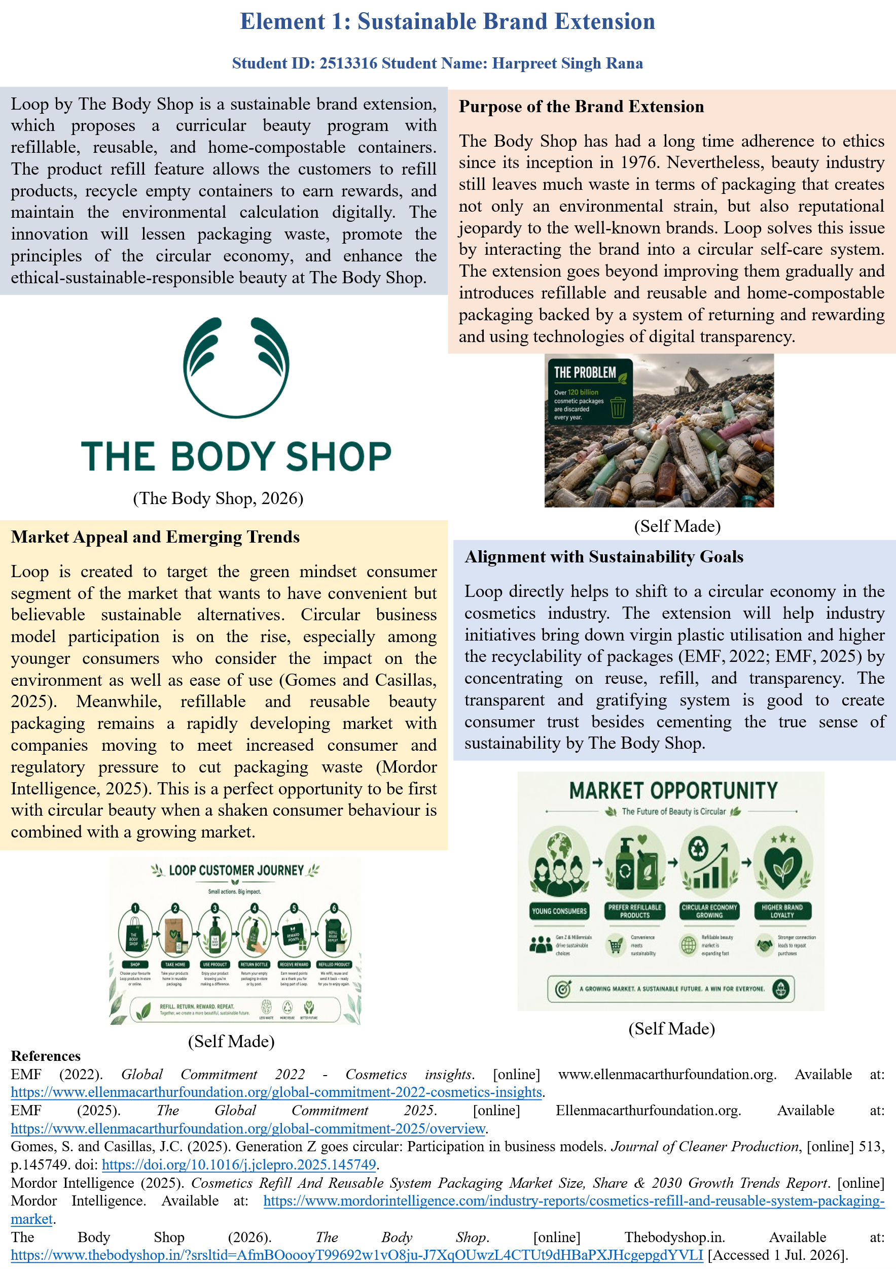

Element 2: STDP Analysis
The Body Shop should have an excellent launch of Loop that requires effective segmentation, targeting, differentiation, and positioning. Being a sustainable brand extension dedicated to circular self-care, Loop has to appeal to the consumers who care about being environmentally responsible and conveniently. This part uses the STDP concept to determine market areas of importance, a key target market, differentiation strategy, and strong position in the market.
Market Segmentation
Market segmentation refers to the process of splitting the prospective market into different groups in terms of similar traits. Loop is segmented using four key variables.
Geographic segmentation concentrates on cities within the United Kingdom and Western Europe. These places contribute to current The Body Shop store chains with refill networks and increased customer environmental consciousness.
Demographic segmentation will define the segment of the target adult consumer base that has moderate to high disposable income and high education levels. Such a population is more likely to be exhibiting increased interest with ethical and sustainable product lines.
Psychographic segmentation aims at consumers that have a great sense of environmental values, who are interested in the brand having some authenticity, and who are ready to make changes in their consumption patterns to limit the environmental impact. These people usually study the sources of products and those brands with clear information regarding sustainability performance are favoured.
Behavioural segmentation takes into consideration consumers who make regular purchases in the personal care sector and willingness to participate in refill and returns. They react well to reward programmes that reward sustainable behaviour and are most probably to use digital tools to monitor their own impact on the environment.
Table 1: STDP Summary for Loop by The Body Shop
Segmentation Variable | Key Characteristics | Relevance to Loop | Supporting Evidence
Geographic | Urban UK and Western Europe | Existing refill infrastructure and awareness | Industry reports
Demographic | Ages 25–40, higher income and education | Capacity and willingness to engage with circular options | Fu et al. (2024)
Psychographic | Strong environmental values, seek authenticity | Alignment with circular self-care values | Testa et al. (2024)
Behavioural | Frequent buyers open to refill and return schemes | High potential engagement with reward systems | Gomes and Casillas (2025)
Targeting
The main target audience of the Loop is UK and Europe environmentally conscious urban consumers aged 25-40 fulfilling users who are already loyal to ethical beauty brands. This segment is related to The Body Shops sustainability spirit and current clientele. These consumers will pay to buy checked sustainable products and adopt circular solutions when it is effortless and the reward goes. The appeal to this population enhances customer loyalty and brings new sustainability-oriented customers (Fu et al., 2024; Gomes and Casillas, 2025).
Differentiation
Differentiation is the development of unique features of an advantage that makes Loop different to the competitors. Loop stands out by merging together product and service components to create an entire circle. Although some beauty companies provide a few options on refillable, with few implementing a complete model that links refillable packaging, product-return and reward systems, and digital product passports.
The combination of the two brings about the functional and emotional differentiation. In practice, Loop minimizes packaging waste and provides convenience by having a rather high level of access to refills. On the emotional level, it supports consumer identity as people who are environmentally responsible. The extension builds upon the previously built ethical brand name of The Body Shop, yet it tackles the current issue of greenwashing by making visible and measurable circular activities (Roozen et al., 2024). This will aid Loop to be singled out in an overcrowded ethical beauty market where authenticity is becoming increasingly questioned.
Positioning
Positioning entails establishing a unique location of Loop in minds of target consumers compared with competing offers. Loop is poised as the available, but believable, circular option to conscious consumers who cannot say no to both sustainability and convenience.
The Loop positioning statement is: To a sustainable-minded, urban customer between the age of 25 to 40 who would like to achieve less negative environmental effect without compromising the product performance or convenience, Loop by The Body Shop can offer a comprehensive circle of self care system that makes the idea of sustainability tangible, rewarding, and easy.
This branding capitalizes on a brand equity of The Body Shop in ethical beauty and creates Loop as a visionary product that can address existing market requirements. It sets the extension apart against all mass-market natural brands and more activist-oriented rivals through focus on practical circularity with transparency. An efficient positioning of the sustainable brand extensions must be communicated up front regarding the environmental benefits as well as the functional performance to surmount some scepticism by consumers (Hesse et al., 2022). Loop attains this balance by ensuring that circularity has become visible to us with refill stations, reward systems, and digital passports.
Element 3: Marketing Mix
Introduction and Justification for Using the 7Ps
The Body Shop uses the 7Ps framework as the basis of marketing mix of Loop instead of the 4P framework. This is the right choice as Loop is not a mere product extension or service-based circular system with refill stations, return-and-reward mechanisms, and digital transparency tools. These other components of People, Process, and Physical Evidence are thus critical towards providing a coherent and believable customer experience. All the elements of the mix are created to underpin the overall strategy to make Loop a real and convenient circular beauty providing and enhancing the ethical brand positioning of The Body Shop.
Product
Loop is an expansion of The Body Shop product line into concentrated refills and solid formats and reusable or home-compostable products. The product application will be completely based on minimising material consumption but preserving the brand standards of natural and vegan formulations. In addition to tangible goods, Loop has a layer of service in the form of refill stations and a return programme. This is a product-service mix that will directly respond to increased consumer demand of convenient circular solutions in beauty. Rather than ongoing sustainability measures, Loop introduces a unique product with a design that would help achieve the long-term goal of waste reduction in the cosmetics industry because it is designed to be circular since its inception.
Price
A pricing strategy of a premium pricing is applied to Loop. That strategy can be explained by the fact that the perceived growth of value by circular design and confirmed transparency, as well as the ethical reputation that has been formed over the years, has been established by the brand. When the environmental claims seem to be legitimate and convenience is observed, the consumers marked by the focus on sustainability tend to be more willing to pay. The encouraging measures of introductory pricing on refill starter packages and immediate repayment on packaging returns will be employed as a framework in enticing trials and recurrence participation. The structure of pricing strikes a balance between commercial goals and the need to strengthen the premium positioning of the extension without creating the perception of taking advantage of the notion of sustainability as a marketing instrument.
Place
Distribution strategy targets maximisation of convenience and enhancing circular flows. Loop will be sold at current locations of the Body shop store chain where preference will be given to those points currently having refill systems. It will be possible to subscribe to refill options and provide easy returns via the online channels that will be supported by reverse logistics associates. This multi-channel strategy makes it accessible to the target market, but allows packaging to be brought back physically to be reused or recycled. Circular business requires such a strategy to place as it is important since the convenience of both forward and reverse channels will significantly affect the participation rate of consumers.
Promotion
Loop will be promoted with the focus on true storytelling and online transparency. The circular benefits of the extension will be emphasized in campaigns by the use of short-form video content, user testimonials, and impact data distributed via the brand app and social media. QR codes on packaging will lead consumers to additional information on sourcing of ingredients and environmental impact. Educational content with regular brand messaging is quite effective, though, when it comes to digital marketing strategies to create a sustainable brand equity. Partnerships with influencers will only be done with credible voices in sustainability instead of the more traditional beauty influencers so as to appear authentic and minimize the chances of being sceptical.
People
Training of the staff is a vital element of marketing mix. Certain training will be provided to store teams about the explanation of the process of refill and return, the environmental sense of Loop. Workers who get and buy into the circular model will find it easier to sell the merits to customers. Hiring and training employees who can meet the ethical standards of The Body Shop will provide some assurance that the engagement between employees and customers will strengthen, not weaken, the extension.
Process
Circularity at scale would have to be redesigned to enable operational processes to support the new design. These will involve effective handling of refill stations and use of effective packaging and systems of returning packages as well as correct data capturing on digital product passports. The cleaning, inspection and redistribution of returned packaging should have clear procedures in place to ensure products quality and customer confidence. Properly designed processes minimize friction among consumers and enhance the chances of a re-use of the circular system. Even superb circular offerings that are well planned may not achieve their sustainability pledges without strong operational procedures.
Physical Evidence
Physical evidence is crucial in bringing to reality the circularity of Loop. Refill points are going to be well placed and will be presented in a fashionable way, that matches the natural image of The Body Shop. There will be clear labelling on packaging regarding circular qualities and easy instructions to be returned. The electronic passport that will be accessed with the help of QR codes is one more indicator of transparency and development. The visible and uniform physical indicators make the consumers know and believe in the circular system thus enhancing the overall brand experience.
Table 2: Loop by The Body Shop – Marketing Mix (7Ps) Summary
Element | Key Actions for Loop | Strategic Justification | Contribution to Brand Extension Success
Product | Concentrated refills, solid formats, reusable packaging | Reduces virgin plastic and supports circular design | Creates distinctive circular offering
Price | Premium pricing with return rewards | Reflects added value of verified circularity | Protects brand positioning while encouraging trial
Place | Existing stores + online with reverse logistics | Maximises convenience and enables packaging recovery | Supports scalable circular model
Promotion | Storytelling + digital transparency (QR passports) | Builds trust and counters greenwashing perceptions | Strengthens authenticity and consumer engagement
People | Targeted staff training on circular benefits | Ensures credible and consistent customer communication | Reinforces brand values at every touchpoint
Process | Efficient refill, return, and data capture systems | Enables closed-loop operations at scale | Critical for delivering on circular promises
Physical Evidence | Visible refill stations and clear circular labelling | Makes sustainability tangible and trustworthy | Enhances customer understanding and trust
Element 4: Reflection
Developing the Sustainable Brand Extension Strategy
The idea of creating the Loop brand extension allowed me to apply marketing theory to a context of an actual business to weigh the goals of commercial and sustainability. I identified the need of operational viability, consumer behavior, and brand authenticity. It reinforced my belief that plausible sustainability strategies need viable mechanisms to back up environmental assertions and prevent greenwashing.
Preparing and Delivering the Poster Presentation
Creating the poster made me to condense some of the complex strategies concepts in a concise a visual persuasive format that would be appropriate in a brief presentation. I had to balance important messages and at the same time make the poster captivating and easy to read. This experience enhanced my skills in strategic communication planning in a limited situation. Presentation of the work also helped me become confident with outlining marketing recommendations to a crowd. I discovered the importance of utilising visuals to complement and not substitute verbal presentation, and the need to practice to ensure that one delivers the presentation in a natural manner which fits within the time limit given.
Key Skills, Knowledge, and Insights Gained
This assignment greatly benefited my knowledge in sustainable brand development. I learned more about how segmentation, targeting, and positioning should be changed in the cases of environmentally aware consumers who are becoming more critical of claim of corporate sustainability. It also reinforced my skills in terms of critically assessing marketing frameworks and implementing them in an integrated approach. I also gained greater understanding on how operational factors, process and physical evidence, can be applied toward creating believable sustainability experiences. Moreover, the experience of working on circular business models increased my understanding of how marketing can be proactive in influencing a more sustainable consumption pattern instead of reacting to the current demand.
Contribution to Personal and Professional Development
My strategic thinking was reinforced with the help of this project as it was able to balance brand building with ethical and sustainability. It enhanced my skills in using marketing theory in real world situations, developed my visionary quality of communication and presentation, earned my confidence to face complicated marketing situations through critical thinking/analysis, imagination/innovation, and fair decision making.
Areas for Future Enhancement
I will also devote additional time to primary research and financial research in future projects to enhance marketing decisions and evaluate commercial viability. I also intend to enhance my visual designing and presentation. The reflection has noted the areas that should be developed and will assist me to become a confident marketing professional.

Reference list
Azhar, N.M. (2024). Digital Marketing Strategies for Sustainable Brand Development. Deleted Journal, 1(1), pp.164–173. doi: https://doi.org/10.62207/szpd8p72.
EMF (2022). Global Commitment 2022 - Cosmetics insights. [online] www.ellenmacarthurfoundation.org. Available at: https://www.ellenmacarthurfoundation.org/global-commitment-2022-cosmetics-insights.
EMF (2025). The Global Commitment 2025. [online] Ellenmacarthurfoundation.org. Available at: https://www.ellenmacarthurfoundation.org/global-commitment-2025/overview.
Fu, H., He, W., Feng, K., Guo, X. and Hou, C. (2024). Understanding consumers’ willingness to pay for circular products: A multiple model-comparison approach. Sustainable Production and Consumption, [online] 45, pp.67–78. doi: https://doi.org/10.1016/j.spc.2023.12.005.
Gomes, S. and Casillas, J.C. (2025). Generation Z goes circular: Participation in business models. Journal of Cleaner Production, [online] 513, p.145749. doi: https://doi.org/10.1016/j.jclepro.2025.145749.
Hesse, A., Bündgen, K., Claren, S. and Frank, S. (2022). Practices of brand extensions and how consumers respond to FMCG giants’ greening attempts. Journal of Brand Management, [online] 29(29). doi: https://doi.org/10.1057/s41262-022-00274-w.
Mordor Intelligence (2025). Cosmetics Refill And Reusable System Packaging Market Size, Share & 2030 Growth Trends Report. [online] Mordor Intelligence. Available at: https://www.mordorintelligence.com/industry-reports/cosmetics-refill-and-reusable-system-packaging-market.
Purnamasari, N., Utama, G.L. and Ramadhan, R. (2026). Circular Economy Implementation in Community-Based Plastic Waste Management: A Case Study of Waste Bank Amal Haqiqi Garut, Indonesia. Industrial and Domestic Waste Management, 6(1), pp.30–46. doi: https://doi.org/10.53623/idwm.v6i1.1007.
Roozen, I., Raedts, M. and Henderix, M. (2024). Exploring the role of green brand extensions and greenwashing in the fashion industry. Journal of Global Fashion Marketing, pp.1–15. doi: https://doi.org/10.1080/20932685.2024.2396612.
Testa, F., Marullo, C., Gusmerotti, N.M. and Iorio, V. di (2024). Exploring circular consumption: Circular attitudes and their influence on consumer behavior across the product lifecycle. Business Strategy and the Environment. doi: https://doi.org/10.1002/bse.3849.
Webb, B. (2026). Refillable Packaging: What Happened to Refillable Beauty? [online] Vogue. Available at: https://www.vogue.com/article/what-happened-to-refillable-beauty.

