
Skills for the Workplace
Module Assignment Submission
Student Name: | Sophia Taher
Student Number: | 2016413
Module No: | BMSK4005
Module Title: | Professional Career Development

Statement of Confirmation of Authenticity
By the act of making this submission, the student declares that this is the work of the student named above. The work has not, in whole or in part, been knowingly presented elsewhere for assessment, or where assessment has been built on a previous assessment, this has been identified. Where materials have been used from other sources it has been properly acknowledged. If this statement is untrue, the student acknowledges that an assessment offence has been committed.
Attention is drawn to the plagiarism and unfair practice policies of both the University and of ILM.

Contents
Introduction 3
Professional career development 3
VARK 3
Honey & Mumford 4
Dantec 4
SWOT Analysis 5
Learning Barriers 6
Gap Analysis 7
Personal Development Plan 8
MY REFLLECTION TERRY BORTON (1970) 10
Conclusion 11
REFERENCES 12
Appendix 1 Job Application 13
Appendix 2 Cover Letter 18
Appendix 3 Curriculum Vitae 19

Introduction
In my assignment I will be talking about professional career development, I will be sharing mine and my peers different learning styles, learning barriers and PDPS. I will also be comparing our results

Professional career development
We are in an ever-changing world, that requires employees to adapt their skill sets to the needs of a company. As individuals we need to keep improving our learning development so we can achieve our own personal goals, in order to do this we need to develop new learning techniques so we can adapt to different situations in different ways. It is important for employers and employees to acknowledge their learning styles so that the company can grow, as well as allowing the employee to understand how they learn. Self-development is a key part of growth and is needed to achieve your full potential. You can outline your own learning styles using specific learning models. There are various models used in practice that can help people to find how they learn best.

VARK
One way in which you can acknowledge your learning styles is by completing the VARK questionnaire. The VARK model (1960) is used to find peoples preferred learning techniques. They recognised 4 different learning styles; visual; oral; read/write; kinaesthetic.
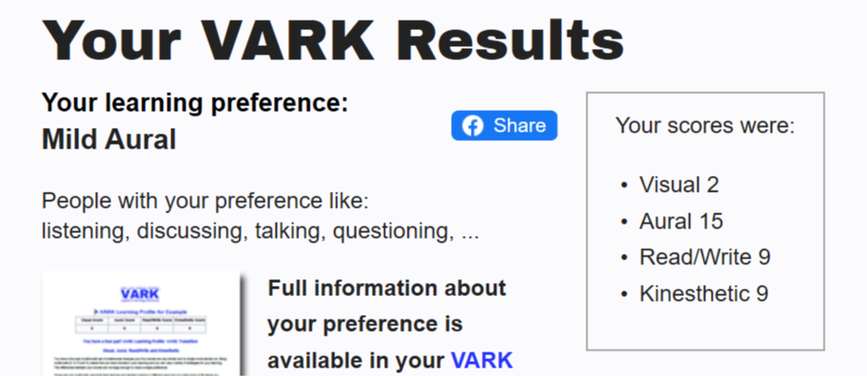
I have completed the VARK questionnaire and here are my results:

From the results, I am classed as a mild aural. This would mean that I prefer listening, rather than reading. I learn better when in social situations with people discussing their opinions. I like to challenge myself and try new things. I do agree with this, however, I do not enjoy speaking out loud as I lack confidence. Regardless, I do think I am an aural learner and enjoy group discussions where I can listen and observe others.
My peer also took the VARK test and got reflector. They agreed with their results as they like to listen to conversations and find it easier to learn visually, rather than through reading and writing. This differs from my results, highlighting how important it is, as a manager, to know that each employee of yours will learn differently and how you need to adapt your teaching techniques to each person.
When looking at the results, I also got high scores in the read/write category, along with the kinaesthetic section. In terms of read/write, I do not agree with the questionnaire. I am not very good at written communication and find it hard to learn in situations where I must read or write. I enjoy activities where I am surrounded by people, rather than learning by myself. As a kinaesthetic learner you enjoy physical activities, you often fidget with pens and dislike reading. I agree with scoring a high mark in this section. As I do not find that reading helps me whilst I am learning, and I also tend to fidget and like to challenge myself with new things.
I believe that the results are correct and that I am an aural learner. Although I do have traits from the other categories, I feel that I enjoy better when listening and in group discussions.

Honey & Mumford
Another way in which you can recognise your preferred learning style is through Honey & Mumford test (1982). They outlined 4 different styles that you can use to learn. They are activist, pragmatist theorist and reflector.
After completing the test, I found out that I was an activist this would mean I like to deal with new problems and experiences. I agree with this. I have worked in fast food restaurants before, but I have never been a waitress until now. As it is a new experience, I feel that I have been able to adapt quicker than my colleagues. In my current workplace there are many challenges that I have overcome, such as learning the menus, making cocktails, and using my verbal communication skills to speak with customers. On the weekends in work it can get very busy and I need to ensure that I am focused and ready for the challenge. Food and drink orders quickly multiply which results in me having to be on the ball. This is a prime example of how an activist would learn. They enjoy challenges and work well when in challenging positions or situations. Furthermore, I strongly agree that I am an activist. As seen from the examples, all the ways in which I learn are similar to the ways an activist would.
Similarly, my colleague was also an activist. They really enjoy having new experiences and by completing tasks. This is shown in their day to day life. They work in a busy, fast paced environment, but it does not phase them. They are up to the challenge and can adapt easily to any situation they are put in. As a manager, I would make sure that I gave this person activities that were task based to complete when training them to ensure that they reach their full potential.

Dantec
I also did a dantec questionnaire and I was considered as a auditory learner this means that I mainly learn through listening to directions, take notes from speeches, like to talk on the phone and remembers verbal directions. I partly agree with my results apart from talking on the phone as I find I prefer texting as talking on the phone can make me anxious which causes me to stutter. I agree with taking notes from speeches as this helps me to take in the information and to remember it. I also agree that I learn from listening to directions and remembering verbal directions.

SWOT Analysis
Knowing your strengths and weaknesses is important in allowing personal growth. Using a swot analysis will enable you to develop your strengths and weaknesses.

One of my strengths is I am a supportive person. This is shown in my workplace when I advise colleagues and offer to help any customers, should they need it. We recently had a new starter with minimum waitressing experience I took it upon myself to train and guide her on doing the new role this involved me having to support her so she could move forward independently and confidently.
Another strength I have is good leadership skills. An example of this would be in my current role I am responsible for training up new waitresses. I need to teach them all the skills needed to work in a busy restaurant environment I lead by example and I try my best to teach new starters to a high standard.
A weakness that I have is being unorganised. Although I am very proactive, I find it hard to organise myself and stick to timeframes and plans. I can overcome this by having a to do list or a plan that will allow me to have a written idea of what I need to do.
Another weakness I have recognised is how forgetful I am. I find it hard to memorise and remember things, even when it is important information. This is not good in my workplace. I am a waitress and so need to remember what people have ordered and which tables have ordered which. To improve on this, I could invest in a watch that I could log things down that I know I tend to forget. However, this would not be possible in work. So, for working situations, I would need to have written down notes that will allow me to remember which tables food is which. For instance, I could write the tables number on the top of the note pad when taking orders.
One of my opportunities would be gaining a qualification in which I am currently studying for, this will enable me to have more career progression and allow me to learn new skills for my future development. Another opportunity would be to get a better job. I am currently working as a part time waitress. This is not the job I would choose to do. By studying I am making myself more employable to open my options to a range of different jobs which I would find more suitable and more rewarding.
A threat I have faced is having to undergo major brain surgery this has impacted me massively, in terms of employability and education. To overcome this threat, I could ask for help from the student services to support my learning and offer any additional help.
My colleague also created a SWOT analysis and identified that her main strength was her written and verbal communication skills. This is important in her job as she works in a call centre so she would need excellent verbal skills.
However, my peer also recognised that she had a few weaknesses. Her main fault was her organisational skills. To overcome this, she stated that she could invest in a note pad and write down a daily to-do list where she prioritised tasks that she needed to do. This would allow her to complete her tasks and be as organised as possible. As a manager, you would need to ensure that all your staff are organised to guarantee that your company is successful. If this were my employee, I would make sure that they are organising themselves correctly and completing their tasks. If I feel they are not achieving their targets, I will call them into a meeting to discuss this issue further.
Alluding to this, a threat my colleague noted was that she has children. This limits her opportunities as her time is occupied with mothering duties. To overcome this, she could invest in childcare, or go part-time. By cutting down her hours she would ensure that she completes her tasks needed at home with her children, such as laundry and lunches. On the days she is in she will not need to worry about her tasks at home and can have a clear head when working.
An opportunity my colleague identified was completing her University course. She has recently enrolled on a Management course and feels this will give her a foundation to build upon and way in which she can leave her current job and find a job more fulfilling and enticing.

Learning Barriers
SWOT analysis is important when looking at ways to overcome your weaknesses and threats and allows you to identify your strengths. However, it does not consider any barriers that could stop you from achieving your goals and full potential. Therefore, it is vital you recognise your learning barriers. My learning barriers are below:
An important external barrier that I need to overcome is that I do not currently hold a driving license. This causes a lot of difficulties in my life. I cannot apply for jobs that are not on bus or train routes. This limits my opportunities. To conquer this, I have started learning to drive so that hopefully by next year I have my own access to a mode of transport.
When discussing barriers with my colleague, we both identified an external barrier as our lack of qualifications. This results in a lack of confidence, which would be classed as an internal barrier. Both are important to overcome. My colleague and I constantly worry, especially when applying for jobs, that we are not worthy of the job or that other applicants will have better resumes, academically, than us. This then causes us to be uncertain of our abilities. To overcome this, we have both recently enrolled at University. By the end of our studies we will have an Honours Degree and so feel a lot more confident in our resumes and academic abilities. We will not feel that we shouldn’t apply for certain jobs due to our lack of qualifications, as we will now be overqualified for certain jobs.
Additionally, I currently have an overcrowded schedule. I currently work part-time as a waitress and try my best to help my family at home, whilst also saving time for me to socialise with friends. This could hinder my ability to study effectively. To ensure that I am studying and learning, I enrolled on a University course that is flexible and works around mature, working students’ timetables. This then allows me to work and socialise during the week and have most weekends to myself to study. Similarly, my colleague has obligations at work that means studying could be limited or hindered. To overcome this, she ensures that she sets certain days in the week where she can complete assignments and revisit the previous lectures. This allows her to juggle her already busy schedule, whilst she tries to better herself and get a degree.
An internal barrier I struggle with is my brain surgery. It has left me with various issues that I find hard to overcome, such as forgetfulness, concentration, and motivation. These could have a detrimental effect on my studies and ability to work as I may be deemed as not fit to work, or could not have the motivation or concentration to complete tasks and assignments set by my tutors. To ensure this is no longer a barrier, I could arrange a meeting with a psychologist to discuss my issues further and see if there is any help they can offer. Additionally, I could also contact student support and arrange a meeting with them to discuss my disability further and, again, see if they can offer me any additional help.

Gap Analysis
Another way of identifying your development needs would be gap analysis this tool is very useful in finding out what your current skill is and developing your desired skill you can do this by finding out where you are at present and where you would like to be in your skill set and learn ways to improve.

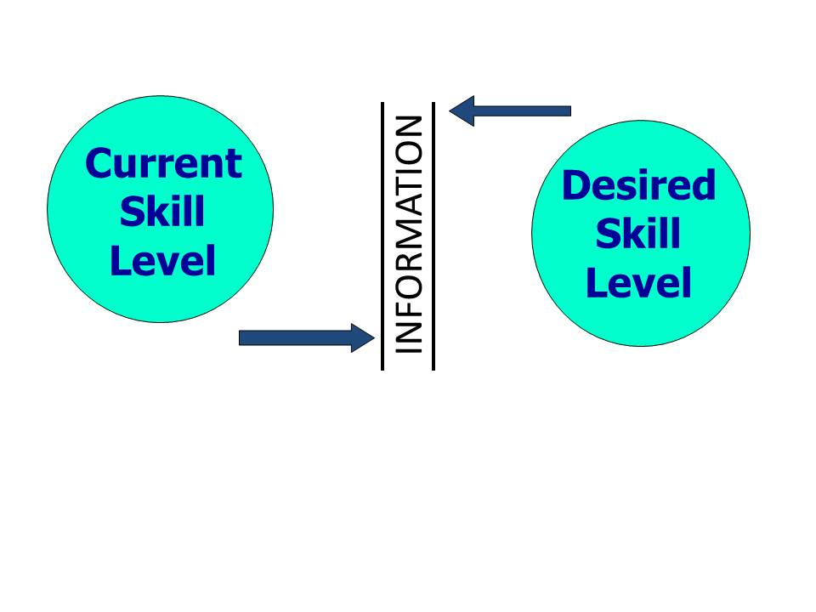

Personal Development Plan
Personal development plans are a way in which managers and employees can discuss any concerns they have and detail them in an organised plan. A PDP will identify areas an employee may need to improve and give tasks to them to make sure that they develop this weakness.
I created a PDP for myself and a colleague below:

I recognised 3 key areas that could become issues when studying or working. These were punctuality, communication skills and use of Microsoft word. I feel these are all relevant areas to my University course and will help me develop in the future.
To overcome my lateness and lack of attendance, I tasked myself with the mission of investing in an alarm clock, being more organised and travelling earlier than I have done. This has been a constant barrier for me to conquer. So far, I have attended most of my lectures and engaged in learning. I am always early to work and make sure that I consistently organise my belongings the night before I have a shift or a lecture to save me time in the mornings. This has been extremely effective. Without creating a PDP, I would not have had the initiative to do these things that have made my life a lot easier.
Additionally, I identified an area of concern as my communicational skills. I feel that I am not very confident in class discussions and do not voice my opinions or concerns so can sometimes come away from lectures feeling I haven’t understood the premise of the topic we had learnt. To overcome this, I suggested I could attend online courses that would give me tips as to how I can regain my confidence of speaking in front of other people. The online course gave me good techniques that I can use in my lectures and allowed me to revisit ways in which I could regain my confidence. I will be sure to apply these new skills in my lectures and class discussions. Similarly, my colleague also found that they had issues with their social skills. They too devised a plan to be more involved in class discussions so that they could understand the material they were learning. After catching up and revisiting our PDP’s, we both agreed that my way of overcoming my lack of communicational skills was better as it was more proactive and gave me tips and techniques to use. My colleague thought that by being more head-on and using their weaknesses as a building block would be effective, unfortunately it was not. They said that next time they would attend online courses to overcome any weaknesses they had.
When revisiting our PDP’s, I feel I could have highlighted a few more concerns, such as the writing skills weakness my colleague highlighted. I find it hard to complete assignments and write large pieces of text, so I feel next time I would focus on this skill and try to perfect it. My colleague also highlighted how beneficial it was attending meetings with the student support team. They were tested for dyslexia and ADHD and now have constant support from the team during their studies. I, too, feel this is something I could benefit from and would be something I would do in the future.
Using a PDP allowed me to have tasks that I knew I had the ability to complete. There was no pressure for me to complete these tasks and the time frame could be extended if needs be. It also helped me to look within myself and see which areas I could improve on to fulfil my potential and achieve my goals. I managed to achieve a weakness that I had had difficulties beating for several years. This was my punctuality. It has been noted by previous employers and my duration at school that I was not very punctual. By investing in an alarm clock and being more organised I erased this area of concern and became more punctual, which will help me in the future when attending interviews or jobs. This PDP will help me if I ever feel I am falling back into my old habits, such as not being punctual to important meetings. I can reassess my areas of concern and ensure that there are tasks on my PDP that will allow me to reach my goals and overcome my weaknesses. It makes it much clearer identifying my weaknesses in a table that also has ways in which I can overcome them.

MY REFLLECTION TERRY BORTON (1970)

WHAT?
I applied for a job and the first process of applying was filling out a job application I heard back from the company 5 days after and I was invited to participate in the second stage of the interview process. This involved a video call via teams where I was asked several questions involving the role. I felt totally relaxed at the first stage of the process and found it easy to complete the job application form. The second part of the interview via teams I felt more nervous as I have never done an interview on a video call before. I also felt a bit worried as I didn’t really research the company before my interview, so I was a bit clueless. However, when I spoke to the interviewer, she introduced herself to me and was very welcoming which made me feel more relaxed.
The teams interview started with the interviewer asking me to tell her a bit of myself I found this part of the interview easy as I was confident in the information that I was relaying to her. She then went on to ask me competency questions, I struggled at this point as I hadn’t fully prepared myself for these type of questions which led for the interviewer to prompt me and break the questions down this led to me feeling embarrassed and not prepared in the way I should’ve been. The rest of the interview continued this way with me needed to be prompted and constant support throughout the interview process.
In hindsight I learnt that I was not prepared for the interview due to me not researching the company enough and I did not understand the terminology of the questions. This led to me feeling very awkward and silent and waiting for the interviewer to prompt me for an answer. This impacted on my self-esteem and confidence.

SO WHAT?

As a result of my learning moving forward I will make sure that I fully research the company so i am fully prepared for whatever eventualities. This will erase any issues with the face to face process of the interview as I would be able to answer their questions and know what we were discussing. I could also write some notes for the interview. I knew that it would be on teams so could have had some notes to prompt me on the competency questions. These would then have helped me answer their questions to a higher quality.
If I was a manager, I would prepare my applicants and ensure that they are aware of the interview process to erase any issues, like the ones with me. I would continue to be friendly and welcoming, as my interviewer was, but may not have been so condescending when me, as the interviewee, was not able to answer the competency questions. When this happened, I felt embarrassed and my confidence was at an extreme low. As the interviewer, I could have asked the interviewee if they wanted to skip this question and move onto something, they were more familiar with.
NOW WHAT?
In other interviews I would look to be more clued up and researched on the company and what types of questions they will ask. As I previously stated, I could have notes ready to prompt me if the interview was via teams. If it was not, I could have contacted the company and interviewers to receive more information on the interview and the company so that I had prior knowledge to the interview.

Conclusion
To conclude I feel that its important to be self-aware and use methods like the learning styles and pdp to monitor your progress. I feel that although the learning styles are very important to know they might not always be correct. I was classed as a mild aural but I do not agree with this. However, I can see the benefits of knowing your preferred learning style.
With the learning barriers, it was very insightful to outline different aspects of my life that are limiting me from reaching my full potential. To be the best you can be you would need to know your barriers and how you can overcome them.
The PDP allows you and your manager to discuss different tasks that will help you overcome your weaknesses and turn them into strengths. A PDP is a vital method used by employers to measure your growth and performance. It is key to your personal development.
Looking at past interviews also allows you to grow and improve on areas where you may not have performed well. Using a model, like Bortons, you can assess your interview and analyse ways where you can develop next time (1970).
In conclusion, I think that the different methods discuss throughout the essay are important when trying to develop in a personal or career sense. You need to make sure that you are self-aware through self-assessment and can do this using the variety of methods mentioned previously.

REFERENCES
Fleming, N. (1987) ‘Vark’ New Zealand.
Dante’s, C., Diouri, M., Goodchild, L. (2006) ‘Dantec’ Southampton: University of Southampton.
Honey, P., and Mumford, A.(1982) ‘Manual of learning styles’ London: P Honey.
Humphrey, A. (1960) ‘SWOT Analysis’ California: Stanford University.
Morgan, P.(2017) ‘The Business Students Guide to Study and Employability’ London: SAGE.
Borton, T. (1970) Reach, touch, and teach: Student concerns and process education. New York,: McGraw-Hill Paperbacks.
Westland, J. (2019) ‘How Gap Analysis Can Improve Your Project Management; Texas: PMC.

Appendix 1 Job Application

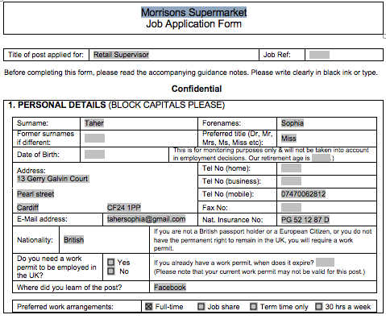

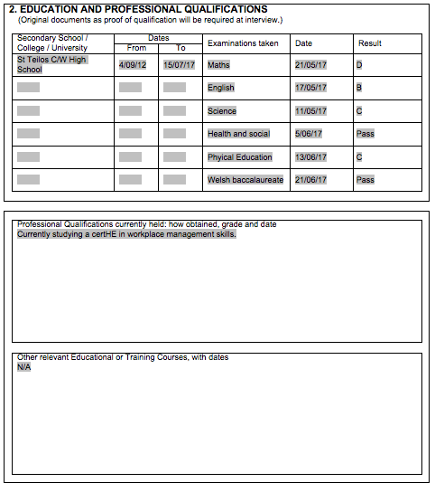

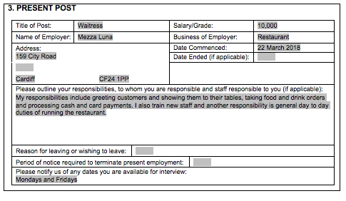

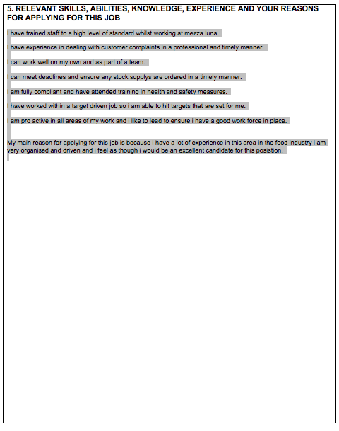

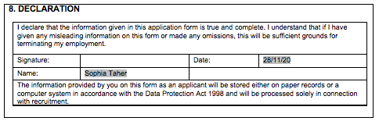

Appendix 2 Cover Letter

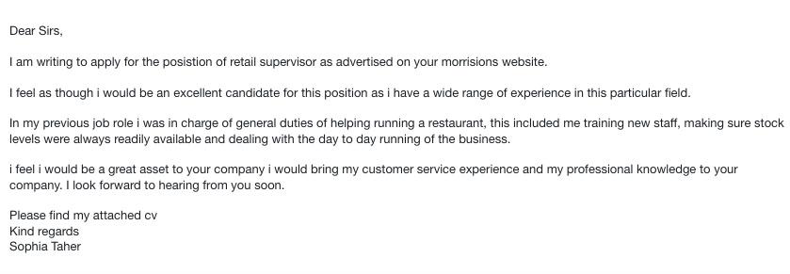

Appendix 3 Curriculum Vitae



