Creativity and Innovation - BMSW5031_Card
Critically detailing and discussing an innovative/creative solution to an operational problem.

University of Wales Trinity Saint David

Lecturer: Chris Wilkin

Student name: Rana Rajjoub
Student number: 2312015

I acknowledge the use of Claude and ChatGPT as instructed for this assignment.

Table of Contents
Part 1 3
Introduction: 3
2.Creativity and Innovation and issues in capitalist methodology 5
3. Innovations and the 4Ps innovation methods 8
4. The creative process 10
5. Evaluation of ideas using Lewin’s Force Field analysis 12
6. organisational climate for innovation 14
Part 2 16
Executive summary 16
Report: 17
Reference list 20
Appendix 23

Part 1

Introduction:
Seren Coffi is an independent coffee shop located in Cardiff. When Seren Coffi first opened it stood out from other coffee shops as its identity was focused on ethical and community-based sourcing. This approach to business was apparent to the customers as Seren Coffi shared the coffee bean origins, shipping methods and cooperation involvement, signs also included the Welsh language, and the furniture was reclaimed or locally made. Seren Coffi also built a strong connection with the community by hosting events such as poetry nights, Welsh language exchange and gatherings, and identifying with cultural and historical roots of the location. This has created a strong base of loyal customers for Seren Coffi
After the initial success and boom when Seren Coffi was first opened, by January 2026 the business is struggling. Although Seren Coffi built its place within the community with clear values, it does not have the organisational structure to support its long-term success, which can be evident in several aspects of running the café. For example, extensive and lengthy discussions of each issue as decision process became strenuous, tieing values with specific methods meant those values were abandoned in difficulty, no financial buffers meant the business couldn’t adapt to the pressure and adapting to market pressure by imitating it only created supply without demand.
The overall operation fatigue and decline in staff and co-founder engagement and availability due to burn out meant the business is not able to handle the pressures of function in capitalist market, where varying prices of supplies and changes in equipment manufacture and repair are constant. This staff fatigue is also apparent when a co-founder started a new part time role, and decisions were made due to convince and ways that did not match the core values of the café. This pressure on staff also lead to the cancellation of community engaging activities such as poetry, which created further reduced the footfall and created further pressure on the business. Even though the café still attracted some customers and has high customer loyalty the staff and co-founders losing the initial spirit of the café it is struggling to maintain a unique atmosphere and the community focus which made it popular.
This report will critically analyse the creativity and innovation in the business in relation to growth and capitalist pressures. This report will also propose innovation solutions which will focus on rebuilding Seren Coffi’s connection with the community with events, collaborations and premium products. Finally, the report will evaluate the viability of these ideas and assess whether the business organisational culture is supportive of this innovation.

2.Creativity and Innovation and issues in capitalist methodology
Creativity is a process that has been directly and extensively connected to human nature. Throughout history we can see significant cultural, social and scientific advancements that stemmed from the creativity pf human beings. In more recent times creativity has been mostly linked to artistic careers it is necessary to expand this view to develop creative skills to change situations through innovate solutions (Barros, Resende and Pontes, 2025). In this context, creativity is the ability utilise one’s cognitive ability, environmental influences and motivation to generate novel and useful solutions (Graciano et al., 2023). Although creativity and innovation are interconnected, they are still distinct constructs, where creativity can generate new ideas, innovation is a practical process of how these ideas can be implemented into working tangible solutions (Amabile and Pratt, 2016). The type of relationship between creativity and innovation is present with in an organisation is often determined by the organisational culture, leadership, and motivational factors (Mehraein, Visintin and Pittino, 2023). Innovation is one of the main drivers for economic growth in a business as it enables the organisation to gain a competitive edge, especially in a capitalist market and economies as businesses are competing for profit, customers and market shares (Śledzik, 2013). In leadership models where psychological safety is prioritised employees feel encouraged to take risk and propose creative ideas directly impacting the innovation capacity (Hughes et al., 2018). Furthermore, companies which integrate creativity into their innovation methods are more adaptable and gain a competitive advantage (Sarooghi, Libaers and Burkemper, 2014)
When Seren Coffi first opened the team demonstrated strong creativity through the cooperation of Welsh Language, historical and cultural context, local suppliers, transparency with prices, and community events which helped differentiate the café from its chain competitors. Even though, Seren Coffi initially fostered creativity through collaborative decision-making and community engagement, these practices became difficult to maintain when the pressure increased and making decision became paralysing. This shows that creativity not only requires a supportive culture but also a clear structure and resources to thrive. For Seren Coffi, the innovation to incorporate their creativity is important since the business is operating in an increasingly competitive market where the competition can offer lower prices, faster service and larger marketing. Without this innovation and adaption Seren Coffi is losing their customers, place in the market and becoming less relevant.
However, there is a struggle to applying creativity and innovation within a capitalist business model. Businesses in capitalist economies are focused on efficiency, profitability and growth, which can create tension as creativity often involves a large amount of experimentation, uncertainty and risk (Cammaerts et al., n.d.). New ideas will require investments in staff, time, marketing and training before financial profit is seen. Which is why many small businesses such as Seren Coffi can struggle to support new ideas as they have more limited financial resources compared to larger business or chains. For example, when Seren Coffi responded to the new chain café extending opening hours it created an increased pressure on the already fatigued staff, and increased costs. Which highlights a key issue of capitalist competition: business feel pressure to prioritise short-term financial survival over long-term creativity. The proposal from the hospitality group illustrates the tensions between innovation and ethical entrepreneurship. From a capitalist perspective, the partnership offers access to economies of scale, marketing expertise, and operational efficiencies that could improve profitability. However, the proposed standardisation of menus, suppliers, and governance structures risks undermining Seren Coffi's distinctive value proposition: its authenticity, community focus, and commitment to local sourcing. This highlights the case's central challenge that commercially viable solutions are not always strategically or ethically appropriate. Innovation within values-led businesses must therefore be assessed not only in terms of financial outcomes but also according to its impact on organisational identity and stakeholder relationships.
To be able to adapt with the pressures of capitalist market Peter Durker suggested that innovation should be adapted as structured and purposeful process to help businesses grow (Becker, 2024). This could be particularly useful for Seren Coffi as the café’s strength is its creativity and authenticity, and structured innovation can help to carefully plan future steps that built on the strength’s rather than risky changes. An innovation process which could be applied to take advantage of these strengths is the Market Pull strategy, which occurs when the business responds to customer demands and fill a gap in the market (Dobrovič et al., 2021). Seren Coffi’s customer value authenticity, creativity and commitment to the community. Therefore, proposing event based activities is a strategy based on the demand and market gap rather than pushing a new product.
However, it is important to consider the limitations of innovation application within a small business that focuses on ethical practices. Seren Coffi’s values are based around fairness, transparency and supporting local communities, therefore utilising methods and strategies that prioritise expansion or profit will cause the cade to appear less authentic and damage the overall reputation. Focusing on the community based events and ensuring the café has the organisational structure to support these events would ensure that the café maintains it’s identity while ensuring the ethical based business model is sustainable in the long term. For example, rather than founders and staff organising the events, use the café as a rent out space for community based events led by organisations and volunteers, work on revenue shared arrangements with local artists and businesses and creating “guest curator” evenings managed by local organisations. his approach preserves the café's community identity while reducing pressure on staff and limiting operational costs. Such an approach represents process innovation rather than product innovation, as it changes how value is created and delivered rather than simply reinstating previous activities. For small ethical businesses such as Seren Coffi, innovation should not be understood solely as expansion or market growth. Instead, innovation may involve developing more sustainable operating models that enhance organisational resilience while preserving core values. This challenges traditional capitalist assumptions that equate innovation with continuous growth and demonstrates the importance of adopting alternative measures of success, including community impact, employee wellbeing, and social value.

Overall, creativity and innovation are powerful tools which can be used to ensure Seren Coffi’s survival as it they can be utilised to maintain the distinctive business identity within a competitive market. Overall, creativity and innovation remain essential for Seren Coffi's long-term viability; however, the case demonstrates that innovation must extend beyond new products or events to include governance structures, decision-making processes, and partnership models. The challenge is not simply to compete more effectively with chain cafés but to develop forms of innovation that strengthen organisational resilience without compromising the values that differentiate the business.

3. Innovations and the 4Ps innovation methods
Since the idea that Seren Coffi was based on is proofed to be successful initially shows that there is a market demand to be filled and the issue was maintain the customer retention. So, the ideas discuss are focused on restoring the community focused identity that originally made the café successful while creating new streams of revenue. Rather than competing with larger chains which focus on speed and profit, Seren Coffi can differentiate itself by providing a slower and more intentional experience to its customers. It is possible to analyse possible solutions through the 4Ps of innovation framework.
Rather than competing directly with large compititors that focus on speed, convience and profitability, Seren Coffi differentiates itself by providing a slower more intentional and culturally authentic experience. However, this far we can see that founder-led community events became unsustainable due to staff fatigue, employee disengagement and operational pressure. Therefore redesigning how these activities are organised and delivered can resolve the issue we have seen in the business this far. Tidd and Bessant identified 4 key aspects of innovation, paradigm innovation which is shifting the mental model, process innovation which focuses on changing the company internal operational processes, position innovation which focuses on switching the market and/or target audience and finally product innovation which encompasses the creation or development of new services or goods.
To help resolve the issues Seren Coffi is facing we will use the process innovation framework which includes changing the ways a product is delivered. Although Seren Coffi has been successful and creating community engaging events, it is the staff fatigue and operational stress that hindered the success of those business.
For example, with hosting book clubs instead of the staff working on organising the event, hosting and serving, the café can collaborate with local social groups such as the Cardiff girls network, the and the Cardiff Social club discord server. The Café then stay engaged with the community by providing the space for those clubs and charge a fee, for example a £10 per person charge that include a drink or pastry.

The proposal also demonstrates elements of Position Innovation, which involves changes in the context in which products and services are introduced (Tidd and Bessant, 2012). By adopting a co-created event model, Seren Coffi can strengthen its position as a cultural and community hub rather than simply another café. This differentiation is particularly important within a competitive market where larger chains can offer lower prices, longer opening hours, and greater convenience. Re-evaluating marketing strategies through newsletters, social media partnerships, and collaborations with local organisations can help communicate this unique positioning to both local customers and tourists seeking an authentic Welsh experience.

There are also aspects of paradigm innovation in this proposal, is that instead of Seren Coffi instead of viewing itself as a café only, it can reposition itself as a community hub, or an open platform. Although there are a lot of Cafés in Cardiff that have created their own authentic identity, an issue that a wide range of people face is the lack of space to just sit down and connect as most cafes have limited seating and space. Refocusing the identity of Seren Coffi from a café that acts as social hub to a physical space for people and groups to socialise where they can enjoy warm drinks will enable the founders refamiliarize themselves with the goals and priorities of the café. While the hospitality group's proposal could improve profitability through standardisation and operational efficiencies, it risks undermining the authenticity, local identity, and community values that differentiate Seren Coffi from chain competitors.

Overall, the proposed innovation extends beyond introducing new products or events. Instead, it focuses on developing more sustainable processes that enable Seren Coffi to maintain its distinctive identity while reducing reliance on founder input and preventing staff burnout. By improving how value is created and delivered, Seren Coffi can strengthen both its financial sustainability and its contribution to the local community.

4. The creative process
The creative process is a series of stages that guide an individual or businesses from conception of ideas to realizations. It usually follows 4 steps, preparation, incubation, illumination and verification (Julia Tukkanen​, 2025)

During the preparation stage we identified that Seren Coffi, is facing several challenges, including rising operating costs, increased competition from chain cafés, staff fatigue, founder burnout, and a decline in customer engagement. Analysis of the case study revealed that many of the activities that initially contributed to the café's success, such as the daily updated blackboard, poetry nights, and community events, had gradually been abandoned as operational pressures increased, and co-founders became fatigued with decision making process. This stage highlighted that the café's primary issue was not product quality or lack of demand, but the erosion of its community presence and the unsustainable reliance on founders to maintain customer engagement.

During the incubation stage, a range of possible solutions were considered, including lowering prices, extending opening hours, increasing marketing activities, and accepting support from a hospitality group. However, these options were rejected because they would either increase pressure on already fatigued staff, require significant financial investment, or risk compromising the café's ethical values and community-based identity. Reflection on these limitations led to a reconsideration of previous assumptions regarding growth and competition, highlighting that innovation for Seren Coffi should focus on sustainability and resilience rather than expansion.

The illumination stage occurred when it became clear that Seren Coffi's strongest competitive advantage was its connection to Welsh culture, local suppliers, and community engagement. Rather than simply reintroducing previous events, the key insight was that the delivery model needed to change. This inspired the idea to outsource organising those events to local social groups and Seren coffi can focus on hosting. Finally, the verification stage involved evaluating whether these ideas could be implemented at Seren Coffi in an affordable and sustainable manner. The proposed co-creation model builds on activities that have previously demonstrated customer demand while reducing reliance on staff and founders. By sharing responsibility for event planning with external partners and community members, Seren Coffi can minimise operational costs, reduce employee workload, and strengthen customer relationships. Furthermore, the proposal aligns with the café's ethical values by supporting local businesses and preserving its community-focused identity, demonstrating that innovation can enhance long-term sustainability without compromising organisational authenticity.

5. Evaluation of ideas using Lewin’s Force Field analysis

Lewin’s force field analysis is a management tool to analyse the forces that push/ drive change and forces that resist/restrain organisational change (University of Cambridge, 2016). This tool is often used to assess the viability of proposed innovations. The overall model suggests that innovate change is more likely to happen when the driving forces outweigh the restraining forces.
For Seren Coffi, there are several driving forces that support the proposed innovation. For example, the café already has an established reputation within the community which is centred around being ethical, creative and community focused. Since the customers are already familiar with the café for events such as poetry nights and Welsh Language exchange so there’s no need to go through an identity shift or a rebrand. Also, in the more recent years there has been a growing demand for third spaces and authentic local experiences especially between young professionals and university students. With the rise of social media there has been a preference for small and unique café experiences compared to chain cafes.
There are two main restraining forces for this innovation. First is the fatigue and low morale between the staff. The staff and employees maybe resistant to idea of running more events if they believe it will increase their workload. The café also has limited financial resources, therefore large-scale strategies are not possible, and it is more difficult to compete with a chain café that can always adapt by lowering prices, higher more staff, or introduce new products more regularly.
To evaluate how strong or weak each force is we assigned each one a score from 1 (weakest) to 5 (strongest). The driving factors were scored as such Seren Coffi’s strong community presence is 5, and demand for authentic experiences is 4, as those are the factors which give Seren Coffi it’s unique place in the market. Using social media for advertising is 5, it is a low-cost marketing strategy, is an effective way to update loyal customers and can help introduce the café to a wider group of people. The restraining factors were scored as such: staff fatigue 5 as it is major issue that is causing hinderance to the business, however this can be countered by working with social groups to organise events, such as Cardiff Social Circle, volunteer sign up or local partners can co-host. Limited financial funding 2 since the café has a small fund of £2000, those can be allocated to any urgent repairs needed, limited financial funds have not been allocated a higher score as this was not identified as an issue that is hindering the business. Also, more funds can be acquired by charging ticket fee for events and engaging with customers, so they stay longer and order more.

Overall, the innovation is viable because it builds on Seren Coffi pre-existing strengths and utilises the resources that are already available while avoiding expensive expansions or price competitions.

6. organisational climate for innovation
An organisation’s culture is an important aspect to consider when analysing any possibility of innovation. Within a business an organisational culture is the system of shared values and prioritise which directly impacts how people behave within an organisation and often leave a lasting effect and impression on the public (Hattangadi, 2020). We can use Schein’s organisational culture model to better understand the organisational culture at Seren Coffi. The definition of organisational culture according to Edgar Schein is “Organisational culture is the pattern of basic assumptions that a given group has invented, discovered, or developed in learning to cope with its problems of external adaptation and internal integration, and that have worked well enough to be considered valid, and, therefore, to be taught to new members as the correct way to perceive, think, and feel in relation to those problems” (Schein 1984)
The model identifies three distinct levels in an organisational culture:
- Underlying assumptions and beliefs
- Expectations of appropriate attitudes and behaviour
- Artefacts that may reflect the beliefs and behaviour (Kiziloglu, 2021)
Seren Coff’s organisational climate is both supportive and unsupportive of the innovation. The underlying assumption of the business is to create value for the community is rather than simply maximising profit, it’s attitudes and behaviour is to be transparent, fairness, and support for local people, and the artefacts are Welsh Signage, locally resourced and community events.
This culture is supportive of innovation because employees and customers already expect Seren Coffi to be creative and different from chain cafés. The café has also successfully introduced new ideas in the past, such as poetry nights and language exchanges, showing that innovation is already part of its identity. However, the staff burnout, low morale and limited resources are real barriers to the innovation as the staff seem to be reluctant to experiment with new ideas, and the café seems to be struggling with overall leadership. The proposal of working with external organisations and social clubs will outsource some of the overwork that has been placed on the founders. When the founders were responsible for organising those events they had to consider several complicated aspects, such as scheduling, space capacity, providing food and refreshments, organising what will happen in the events, manage attendees list, promotion as well as set up and clean up, all of this combined requires a lot of physical and mental investments from co-founders and it takes up a lot of time that can be taken to address other issues. Working with external organisation such as Cardiff Girls Network will offload organising the event, scheduling, creating an attendance list and marketing so the café staff can focus on set up, clean up and providing refreshments. Through the Greiner’s five stage growth model we can assess which stage Seren Coffi is at. This model is used to frame how businesses go through different phases to achieve growth and what are they type of crisis that can occur at each milestone (Lucidity, 2022). Through this model we can see that the café is still at stage 1, in which the business is young and is grown through creativity, and is now is facing a revolution stage, in which the company is facing a challenge due to the lack of leadership which is evident by the informal decision-making and overall lack of structure and direction. To overcome this step Seren Coffi needs to develop a clear plan, future direction and stronger leadership so innovation can be implemented successfully which the business has the cultural climate.

Part 2

Executive summary
This report evaluates the use of artificial intelligence, specifically the large language model Claude, in developing an innovation strategy for Seren Coffi. AI was used to support idea generation, improve the structure of the proposed strategy and identify strengths and weaknesses of different innovations. Claude was particularly useful in developing the original ideas further by suggesting ways to reconnect the café with its Welsh identity and community focus. For example, it proposed linking poetry nights with writing groups, turning Seren Coffi into a bilingual community hub and creating stronger collaborations with local bakeries through “meet the maker” events.

AI was also helpful in comparing which ideas would be most realistic and profitable to implement first. Claude suggested that bakery partnerships could generate quicker revenue than larger themed events and offered practical marketing suggestions. However, some recommendations were not suitable for Seren Coffi. For example, the suggestion of a paid membership scheme conflicted with the café’s values of inclusivity and accessibility. In addition, some answers were generic or lacked local detail.

Overall, AI was valuable as a support tool because it generated ideas quickly and provided alternative perspectives. However, human judgement remained necessary to ensure that the final strategy was realistic, ethical and aligned with Seren Coffi’s identity.

Report:
Large language models (LLMs) are a type of learning models trained on a vast amount of data, which makes them capable of understanding, analysing, and generating language and a wide range of other tasks. LLMs are huge leap of how people interact with technology, as they are the first AI system that handle unstructured human language which then allows natural conversations with machines (IBM, 2023). As people have adapted to use LLMs in their daily lives, LLMs are also getting adapted into business models to drive innovation by automating complicated workflows, personalise customer experience and accelerating research and development. In innovation AI is useful for providing cognitive insight by using algorithms to analyse data and detect patterns and predict customer behaviour. It also aids in improving overall efficiency and generate alternative perspectives (Mikalef et al., 2023). In this report, I used AI to support idea generation and consider strengths and weaknesses of each solution. It also helped generate more creative ideas.

After providing Claude with the Seren Coffi case study and an outline of my initial innovation proposal, I asked how the ideas could be further developed and refined. My original proposal focused on reducing founder burnout by outsourcing the planning and promotion of community events to local social clubs, while Seren Coffi would continue to host the events and provide refreshments.
Claude initially analysed the proposal using a SWOT framework and identified that the concept addressed the café's primary challenge of founder fatigue by removing the decision-making and organisational burden associated with events. However, it also highlighted that the proposal did not address wider operational issues, including rising costs, equipment maintenance, and the café's consensus-based decision-making culture.
Following this, I asked Claude to evaluate the likelihood of the proposal succeeding, considering operational challenges, staff capacity, customer reactions, financial sustainability, and the risk of damaging Seren Coffi's image. Claude suggested that the proposal was more likely to stabilise the business than completely resolve its challenges, arguing that it addressed one important symptom of decline, namely the loss of community engagement, without tackling the underlying structural issues.
When I clarified that the external social clubs would be responsible for creating, promoting, and organising the events, while café staff would only provide the venue, refreshments, and basic set-up, Claude revised its assessment. It recognised that the proposal was better aligned with the specific type of fatigue described within the case study, as the founders appeared to be exhausted primarily by continuous decision-making and coordination rather than by day-to-day service activities.
Claude then suggested several ways to further develop the proposal. It recommended reimagining the events programme to strengthen Seren Coffi's Welsh identity by positioning the café as a bilingual cultural hub. For example, it proposed linking individual events together, such as developing poetry nights into ongoing writers' groups or introducing curated music residencies featuring local Welsh artists rather than informal open-mic sessions. Claude also suggested using local bakery partnerships to create seasonal menu items based on Welsh ingredients and organising "meet the maker" events to connect customers directly with local producers.
Additionally, Claude recommended exploring partnerships with local councils, community organisations, and Welsh language groups, as well as using the café space during quieter daytime periods for community activities and language tutoring. These suggestions encouraged a broader view of Seren Coffi's role within the local community and reinforced the importance of differentiating the café through its cultural identity rather than competing directly with chain cafés on price or convenience.
Several of Claude's recommendations were incorporated into the final proposal. In particular, its emphasis on strengthening Seren Coffi's bilingual Welsh identity helped refine the innovation strategy by making it more distinctive and closely aligned with the café's existing values. The suggestion to expand local bakery collaborations beyond exclusive products to include storytelling opportunities and community engagement activities also strengthened the proposal.
However, not all of Claude's recommendations were adopted. For example, it suggested introducing a paid membership model to support community events. This idea was rejected because it conflicted with Seren Coffi's commitment to accessibility and inclusion, particularly given the café's previous use of pay-what-you-can initiatives. Implementing a membership scheme could create divisions between customers and undermine the sense of openness that forms a core part of the café's identity.
Similarly, some suggestions risked increasing the burden on staff rather than reducing it. While activities such as "meet the maker" events and expanded collaborations could strengthen community engagement, they would still require coordination and could contribute to the same operational pressures that caused previous events to decline. This highlighted the importance of critically evaluating AI-generated ideas against the specific constraints identified within the case study.
There were also practical limitations associated with using Claude. Response times were inconsistent, with some prompts requiring multiple attempts before generating an answer. In comparison, alternative AI tools such as ChatGPT and Gemini produced responses more quickly and were able to provide more current information when local recommendations were requested. Claude also occasionally generated generic suggestions that lacked specificity. For example, when asked to suggest seasonal menu items, it proposed products commonly found in many cafés, such as mince pies, flapjacks, and focaccia, rather than ideas that reflected Seren Coffi's unique Welsh identity.
Overall, Claude proved valuable as a tool for developing and refining the original innovation proposal. It generated alternative perspectives quickly, identified potential risks, and encouraged greater consideration of Seren Coffi's cultural positioning and community role. However, the exercise demonstrated that AI-generated recommendations require careful evaluation, as some suggestions were either inconsistent with the café's values or insufficiently tailored to its specific context. The final innovation strategy was therefore strongest when AI-generated ideas were critically assessed, adapted, and combined with an understanding of Seren Coffi's organisational culture, customer expectations, and ethical principles. This demonstrates that AI can effectively support creative problem-solving but cannot replace human judgement in the development of business innovations.

Reference list
Amabile, T.M. and Pratt, M.G. (2016). The dynamic componential model of creativity and innovation in organizations: Making progress, making meaning. Research in Organizational Behavior, 36(1), pp.157–183. doi:https://doi.org/10.1016/j.riob.2016.10.001.
Barros, R. de , Resende, L.M. and Pontes, J. (2025). Exploring creativity and innovation in organizational contexts: A systematic review and bibliometric analysis of key models and emerging opportunities. Journal of Open Innovation: Technology, Market, and Complexity, [online] 11(2), p.100526. doi:https://doi.org/10.1016/j.joitmc.2025.100526.
Becker, E. (2024). Master Peter Drucker’s 7 Sources of Innovation for Business Success | innosabi. [online] Innosabi.com. Available at: https://www.innosabi.com/resources/post/peter-druckers-7-sources-of-innovation.
Cammaerts, B., Derand, L., Mckenna, E. and Larman, A. (n.d.). Media@LSE MSc Dissertation Series Can creative labor coexist under an industrial capitalist model? A qualitative analysis of worker subjectivity in production work in Vancouver’s film and television industry. [online] Available at: https://www.lse.ac.uk/media-and-communications/assets/documents/research/msc-dissertations/2022/Larman.pdf.
Dobrovič, J., Čabinová, V., Gallo, P., Partlová, P., Váchal, J., Balogová, B. and Orgonáš, J. (2021). Application of the DEA Model in Tourism SMEs: An Empirical Study from Slovakia in the Context of Business Sustainability. Sustainability, 13(13), p.7422. doi:https://doi.org/10.3390/su13137422.
Graciano, P., Lermen, F.H., Reichert, F.M. and Padula, A.D. (2023). The impact of risk-taking and creativity stimuli in education towards innovation: A systematic review and research agenda. Thinking Skills and Creativity, 47, p.101220. doi:https://doi.org/10.1016/j.tsc.2022.101220.
Hattangadi, V. (2020). Edgar Schein’s three levels of Organizational Culture. Juni Khyat Journal, [online] 10(6), pp.112–118. Available at: https://www.researchgate.net/publication/392206304_Edgar_Schein.
Hughes, D.J., Lee, A., Tian, A.W., Newman, A. and Legood, A. (2018). Leadership, creativity, and innovation: a Critical Review and Practical Recommendations. The Leadership Quarterly, 29(5), pp.549–569. doi:http://dx.doi.org/10.1016/j.leaqua.2018.03.001.
IBM (2023). What are large language models (LLMs)? [online] Ibm.com. Available at: https://www.ibm.com/think/topics/large-language-models.
Julia Tukkanen​ (2025). 4 Stages of the Creative Process Explained. [online] Coworking in Budva MONTECO. Available at: https://montecoworking.me/different/understanding-the-four-stages-of-the-creative-process/.
Kiziloglu, M. (2021). The effect of organisational culture on organisational performance: the mediating role of intrapreneurship. The Irish Journal of Management, 41(1), pp.20–36. doi:https://doi.org/10.2478/ijm-2021-0008.
Lucidity (2022). Guide to Greiner’s Growth Model | Lucidity. [online] getlucidity.com. Available at: https://getlucidity.com/strategy-resources/guide-to-greiners-growth-model/.
Mehraein, V., Visintin, F. and Pittino, D. (2023). The dark side of leadership: A systematic review of creativity and innovation. International Journal of Management Reviews, 25(4), pp.740–767. doi:https://doi.org/10.1111/ijmr.12334.
Mikalef, P., Lemmer, K., Schaefer, C., Ylinen, M., Fjørtoft, S.O., Torvatn, H.Y., Gupta, M. and Niehaves, B. (2023). Examining how AI capabilities can foster organizational performance in public organizations. Government Information Quarterly, 40(2), p.101797. doi:https://doi.org/10.1016/j.giq.2022.101797.
Sadler-Smith, E. (2015). Wallas’ Four-Stage Model of the Creative Process: More Than Meets the Eye? Creativity Research Journal, 27(4), pp.342–352. doi:https://doi.org/10.1080/10400419.2015.1087277.
Sarooghi, H., Libaers, D.P. and Burkemper, A.C. (2014). Examining the relationship between creativity and innovation: A meta-analysis. Academy of Management Proceedings, 2014(1), p.11224. doi:https://doi.org/10.5465/ambpp.2014.11224abstract.
Schein, E.H. (1984). Coming to a New Awareness of Organizational Culture. [online] MIT Sloan Management Review. Available at: https://sloanreview.mit.edu/article/coming-to-.
Śledzik, K. (2013). Schumpeter’s View on Innovation and Entrepreneurship. SSRN Electronic Journal, [online] pp.89–95. doi:https://doi.org/10.2139/ssrn.2257783.
Tidd, J. and Bessant, J.R. (2012). Managing innovation : integrating technological, market and organizational change. New Dehli: Wiley-India.
University of Cambridge (2016). Force field Analysis. [online] Cam.ac.uk. Available at: https://www.ifm.eng.cam.ac.uk/research/dstools/force-field-analysis/.

Appendix

Ai promotes:
I have attached a case study for a struggling cafe, there is demand for the product but there's managerial fatigue. Since the business module is sound but the staff are struggling I suggested that the cafe out sources organising events to social club and the cafe can host, and provide drinks and snacks during the events. Please summarise the strengths, weaknesses, opportunities, and risks of this proposal.
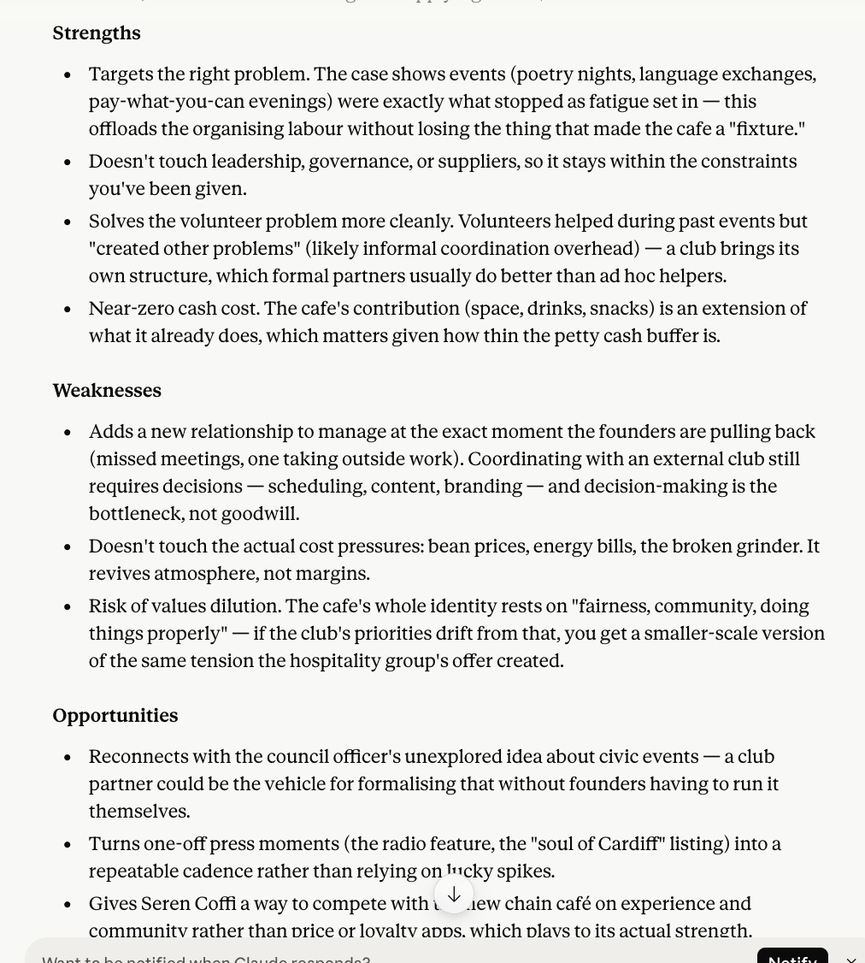
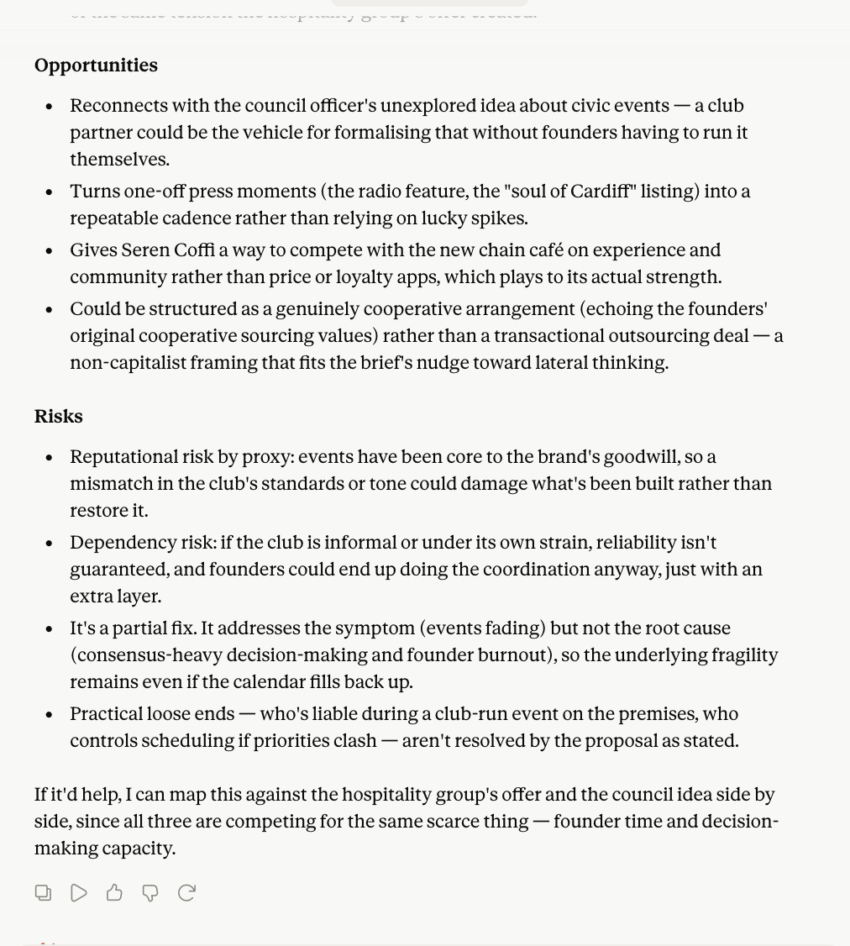

Is this idea likely to fail or succeed, give the reasons why. Consider operational challenges, staff capacity, customer reaction, financial sustainability, and the risk of losing the cafes image.

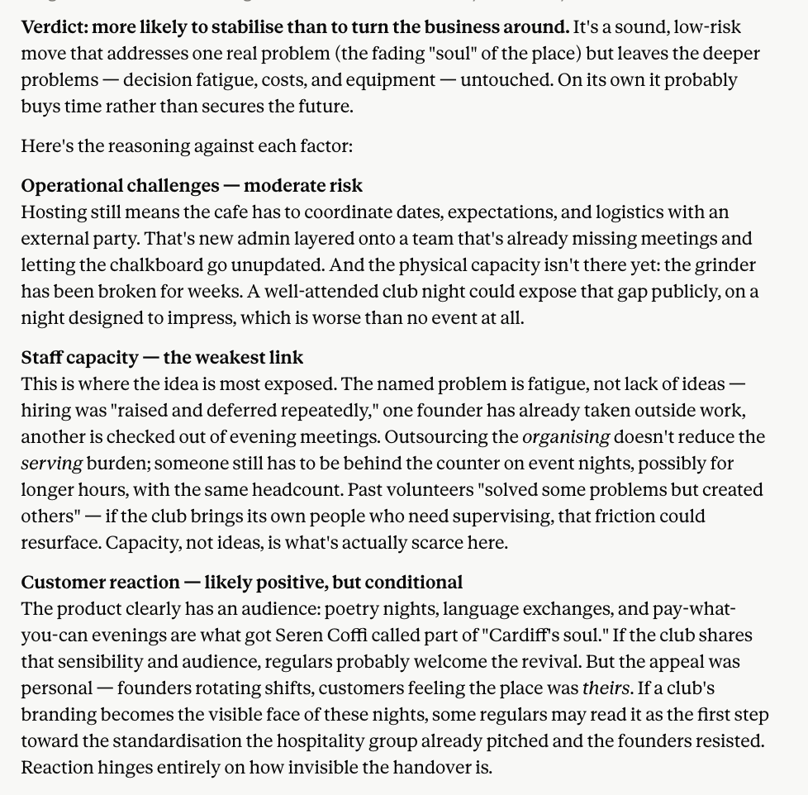

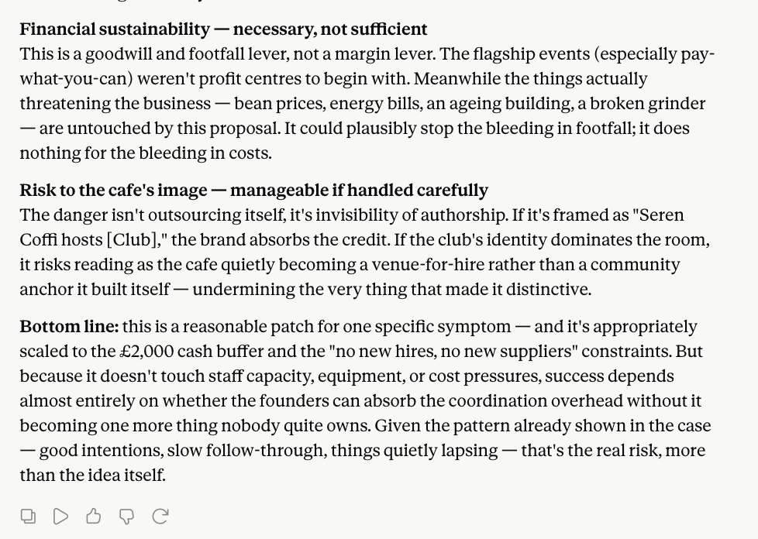

I thought since working with external social club, they would work on creating the events and getting people to attend. The cafe staff would only have to focus on being present to set up, clean up and provide drinks and pastries. Wouldn't this elevate the pressure and fatigue the staff is feeling since they won't have to run these events and focus on making the space suitable and providing drinks

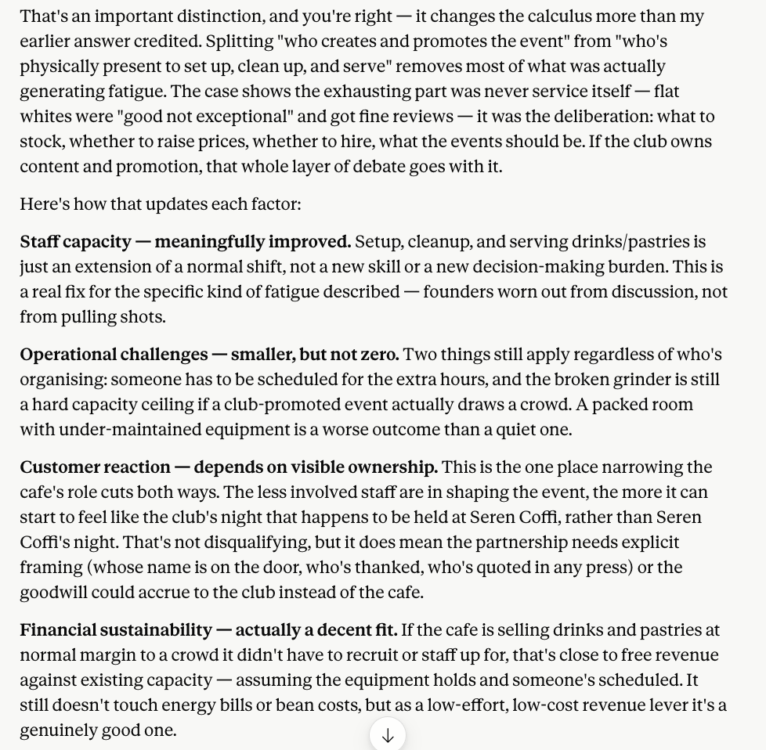

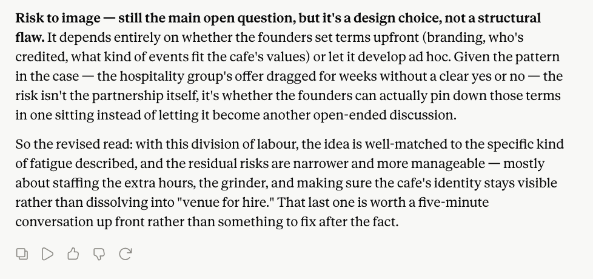

The café previously ran community events successfully, but these stopped due to founder burnout and staff fatigue. How does this model address these underlying problems? What additional changes would be required to ensure the model is sustainable?

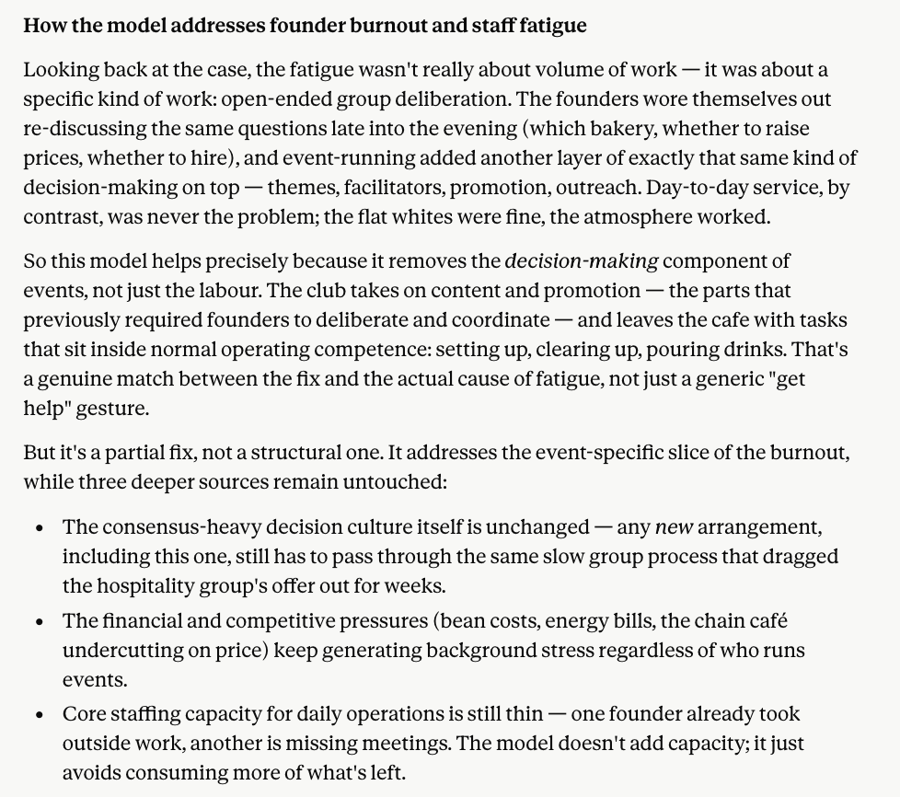
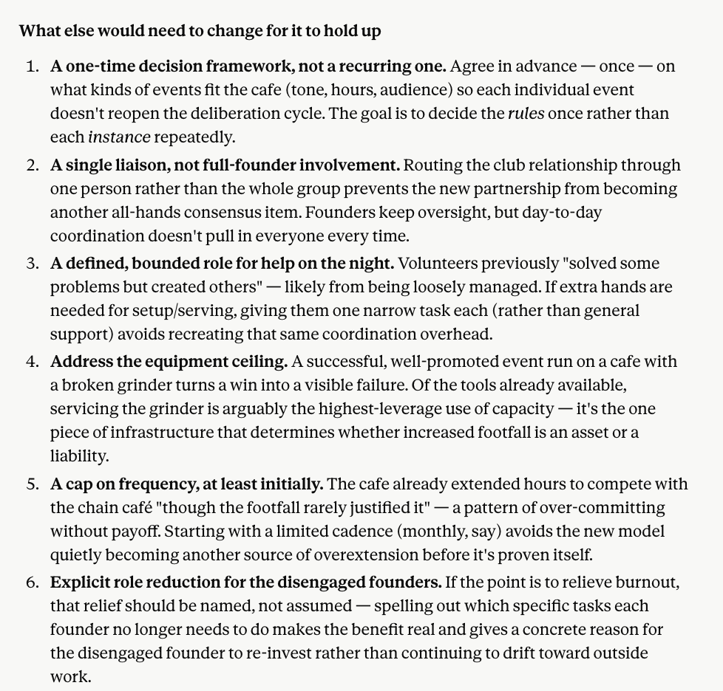

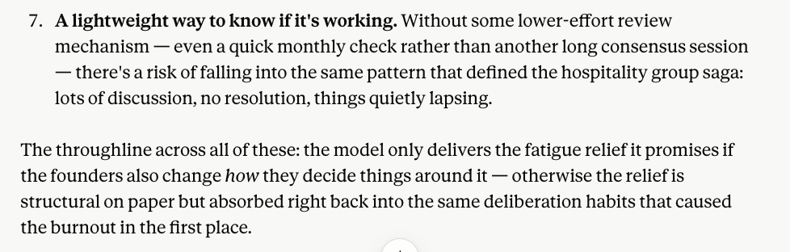

what else can the cafe do so the changes are concrete and the benefits last long term

