Finding the specific heat capacity of aluminium from constant pressure polystyrene cup calorimetry
C. Doherty, UWTSD
L4 Chemistry (OME), Lab Group 1
This paper used calorimetry to find the specific heat capacity of aluminium. The specific heat capacity was found to be 0.84 J/g°C which is different than the widely researched value of 0.9 J/g°C. This was because of the errors which have been highlighted in the report, which arise from the lack of precise measuring tools. The paper discusses the applications of OME and suggests ideas for future repeat experiments.
Date of Experiment: 27/03/2025

Introduction

Calorimetry is a quantitative technique that is used to measure the amount of heat transferred in a chemical or physical process. The technique relies on the first principle of thermodynamics and equates the heat change of the system to the heat change of the surroundings (Eq. 1).
$Q_{system}=-Q_{surroundings}$ (Eq. 1)

When the reaction gives out heat it is exothermic, and when heat is absorbed, it is endothermic. Calorimetry is performed using a calorimeter, which provides an isolated and controlled environment that prevents external influence. The calorimeter was first used in 1789 by Antoine Lavoisier, who named the device from the Greek verb “metron” (to measure) and the Latin noun “calor” (heat) [1]. Lavoisier’s calorimeter was made of metal and contained 3 layers – snow on the outside, ice in the middle, and a guinea pig at the centre. Using the change in temperature of the ice, its mass and specific heat capacity, Lavoisier found the energy associated with the guinea pig’s respiration, concluding that it was an exothermic and combustive process (Eq. 2).

$Q=mc∆T$ (Eq. 2)

The experiment within this paper looks at finding the heat capacity of aluminium by heating the metal and measuring the change in temperature when combined with cold water. Originally the aim was to then find the molar heat capacity of a HCl and NaOH reaction but there were time and product constraints in place. By knowing the rate at which the temperature changes, aluminium’s heat capacity (heat needed to change the temperature by one degree) can be calculated (Eq. 3). When the mass is known, the specific heat (heat capacity per unit mass) can then be found (Eq. 4).

$HC=\frac{Q}{∆T}$ (Eq. 3)

$C=\frac{Q}{m∆T}=\frac{HC}{m}$ (Eq. 4)

This experiment also factors in the heat capacity of the calorimeter, which in this case is a polystyrene cup. This is needed as the cup will absorb heat at a different rate than the water it contains, despite acting as a thermal insulator. Hot and cold water were combined within the calorimeter with the resulting temperature change measured. From this, the energy of hot and cold water (Q_{HW} and Q_{CW}) was calculated (Eq. 5) (Eq. 6).

$Q_{HW}=m_{HW}c_{W}∆T_{HW}$ (Eq. 5)
$Q_{CW}=m_{CW}c_{W}∆T_{CW}$ (Eq. 6)

Then, using Eq. 1, the energy change of the calorimeter was found (Eq. 7), leading to the heat capacity (Eq. 8). For the experiment to determine the heat capacity of the calorimeter, the independent variable would be the initial temperature of both waters, with the dependent variable being the time and temperature.

$Q_{cal}= -(Q_{HW}+ Q_{CW})$ (Eq. 7)

${HC}_{cal}= \frac{Q_{cal}}{∆T}$ (Eq. 8)

After performing the second experiment including the heated aluminium strip, using the max temperature, starting temperature of each component, and heat capacity of the calorimeter, the specific heat capacity of the aluminium is found (Eq. 9).

$C_{Al}= -\frac{(Q_{w}+Q_{cal})}{m_{Al}∆t_{Al}}$ (Eq. 9)

The independent variable for this experiment would be the temperature of the aluminium, and the dependent variable would be the temperature change of the water. The controlled variables associated are the mass of water and aluminium, the initial temperature of the water and the dimensions and type of calorimeter. If this experiment was to be performed multiple times, then the transfer time should also be controlled. The attached hypothesis is that the water will increase in temperature as it reaches a thermal equivalence point, showing an endothermic reaction from the water in respect to the system.

Method

A measuring cylinder (±2mL) was used to measure out 50mL of water and added to two stacked Styrofoam cups with the temperature of water recorded (24.1°C). This will act as the calorimeter and the temperature change of water is equal to the temperature change of the calorimeter. Then, another 50mL of water is measured out and heated in a beaker using a Bunsen burner until it reaches 80°C, and left to cool until 60°C. This is measured using a thermometer of ±0.05°C. Once it reached 60°C, it was combined with the colder water in the calorimeter with the lid placed on top with a thermometer poking through. The maximum temperature reached in this experiment was 47.2°C.

To find the specific heat capacity of the aluminium: the metal was heated in a water bath using a Bunsen burner and left until it reached thermal equilibrium. It is important to leave it as otherwise the temperature of the water will not reflect the temperature of the aluminium; in a future experiment if a laser thermometer is available then this step can be skipped as it can directly read the temperature of the metal. 50mL of water was then added to the calorimeter with its temperature measured (24°C) and the hot metal was then added to the calorimeter. The lid was placed on top and a thermometer added. The temperature was recorded every 10 seconds (see Figure 1).

Results

The heat capacity of the calorimeter, using Eq. 3, came to -99.66 J/°C, with the minus representing the direction of the transfer of heat (in this case, exothermic). The data collected and inputs used can be seen in Table 1.

 | Water (hot) | Water (cold) | Calorimeter
Temp (°C) | 60.00 | 24.10 | 24.10
∆Temp (°C) | 12.80 | 23.10 | 23.10
Mass (g) | 50.00 | 50.00 | N/A
Q (J) | -2532.53 | 4834.83 | 2302.30
Table 1. Measured data used to find heat capacity of calorimeter.
Shown in Figure 1, the maximum temperature reached by the water is 32.2°C before losing heat to the surroundings. The water started out at 24°C and the aluminium started at 90°C, giving a difference of 8.2°C and 57.8°C respectively. This suggests that water has a much greater specific heat capacity than aluminium due to the temperature of the water raising less than what aluminium lost. It takes more energy to increase the temperature of water than it does to aluminium, per unit mass.
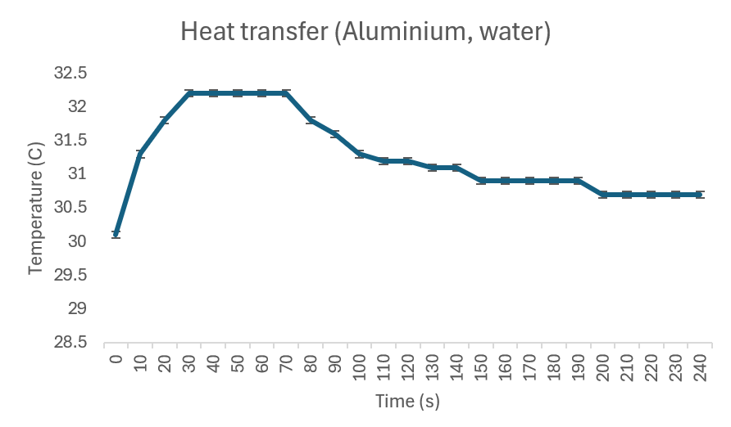
Figure 1. The plotted results of the temperature change for 90°C aluminium with 24°C water every 10 seconds
Using Eq. 9, the specific heat capacity of the aluminium strip came to 0.84 J/g°C, for which the inputs can be seen in Table 1. The change in temperature of the calorimeter is equivalent to the change in temperature of the water, as they start out in thermal equilibrium.
 | Metal | Water | Calorimeter
Temp (°C) | 90.00 | 24.00 | 24.00
Mass (g) | 18.60 | 50.00 | N/A
∆Temp (°C) | -57.80 | 8.20 | 8.20
Q (J) | -898.99 | 1716.26 | -817.27
Table 2. Measured data used to find specific heat capacity of aluminium strip.
For both Table 1 and Table 2, the difference in energy for the system and the surrounding is net 0, showing agreement with Eq. 1 and demonstrating that the system was properly insulated by the calorimeter.
Discussion

There were many sources of error within these experiments, but for the purpose of the report only a few large errors will be discussed. Firstly, the measuring cylinder had a large error of ±2ml, providing a considerable difference in the volume of water. This is further exacerbated when combining the hot and cold water together, giving ± 4ml. The thermometer also had an error ±0.05°C. Using equipment with smaller increments would reduce this error and allow for more precise data. There was also an error in the calorimeter itself, as the lid used had gaps which allowed for leakage of air and therefore temperature. With this, there was also an error when considering the time taken to transfer the hot substances, as doing so would decrease its temperature. Stirring the liquid to incorporate the added hot substances also propagates the error, and even introduces some extra energy into the system. To get rid of such errors in future experiments, instantaneous addition of the hot substance is necessary (done via robotic automation, or using a completely closed system), and an ongoing magnetic stirrer is recommended. Another error can be identified when considering that the reading of the time and the temperature were done by a human. It physically takes a few moments to process that the interval has been reached and to read the numbers on the thermometer, making it hard to read the temperature at exactly 10 seconds apart. An error like this could be mitigated by having an automatic temperature reader that can be programmed to record at a set interval, which reduces the human error in taking measurements. In addition, the cup was being touched by human skin throughout the experiment to keep the thermometer in a readable position, allowing the heat from the skin to potentially transfer to the reaction. This error could simply be avoided by avoiding contact with the cup.

Figure 1 starts at 30°C, however this should theoretically start at 24°C, the initial temperature of the water. The difference implies that the timer started moments after combining, and not at a true 0 seconds. However, as the maximum temperature is above 30°C this does not affect any calculated results.

When comparing the results of this paper to the wider academic research, a typical value for the specific heat capacity of aluminium is shown to be roughly 0.9 J/g°C [2]. The value obtained within this report is 0.84 J/g°C, a difference of 0.06 J/g°C, suggesting that the value obtained here is accurate but not precise. The difference may come down to the large errors found within the experiment.

An interesting use of calorimetry can be seen in the OME sector where it is currently used to investigate the exact transfer of heat during the combustive process. This process is tricky to measure as the nature of calorimetry needs to be an isolated system, and in the case of a constant pressure environment there lacks the correct oxygen balance for complete combustion [3]. Some studies have already taken this into account and have manipulated the environment to contain different gaseous fillers, providing energy data for different environments. Mixtures of RDX with specific aluminium particles (Al90 and Al5) were shown to produce a large amount of energy in air with ~16000 J/g, but equally so in argon-rich environments with ~17000 J/g (20/80 oxygen to argon) [4]. Measuring the total energy and heat transfer rate of an explosive mixture is helpful when figuring out the quantity needed for a desired result.

Conclusion

Calorimetry has been shown to be an effective and precise quantitative technique when used to find the heat capacity of a reaction. The main hypothesis of the experiment was proven as the water gained heat in response to the addition of a hot aluminium strip, however the aim of the experiment was to finalise by finding the molar heat capacity of an acid-base reaction which was constrained due to time. To further back this hypothesis, the experiment should be repeated, however many sources also point to a value like the one obtained in this report. If repeated, then the acid-base molar heat capacity would be of particular interest. Aluminium was shown experimentally to have a specific heat capacity of 0.84 J/g°C which differs to the accepted value of 0.9 J/g°C due to some of the errors discussed within this report, and largely due to the lack of precision in measurements which should be rectified by use of smaller graduated cylinders for future repeat experiments. The relation found in the OME sector is particularly important and it helps highlight how critical this technique is, and how important it is to fully understand the heat transfer of an explosive.

References

[1] A. L. Lavoisier, Elements of Chemistry. 1790.

[2] Florida State College, “Changing temperatures,” web.fscj.edu, 2024. https://web.fscj.edu/Milczanowski/psc/lect/Ch4/slide5.htm

[3] A. L. Kuhl and H. Reichenbach, “Combustion effects in confined explosions,” Proceedings of the Combustion Institute, vol. 32, no. 2, pp. 2291–2298, 2009, doi: https://doi.org/10.1016/j.proci.2008.05.001.

[4] W. Kiciński and W. A. Trzciński, “Calorimetry studies of explosion heat of non-ideal explosives,” Journal of Thermal Analysis and Calorimetry, vol. 96, no. 2, pp. 623–630, Apr. 2009, doi: https://doi.org/10.1007/s10973-008-9100-5.

Appendix

See scanned copy of worksheets below (Figure 2) (Figure 3).

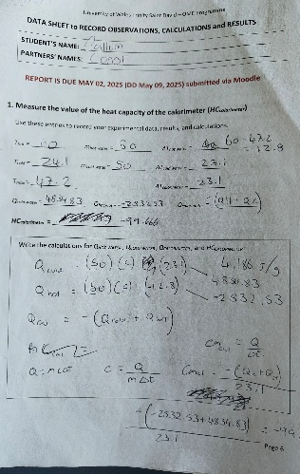
Figure 2. Scanned copy of worksheet for heat capacity
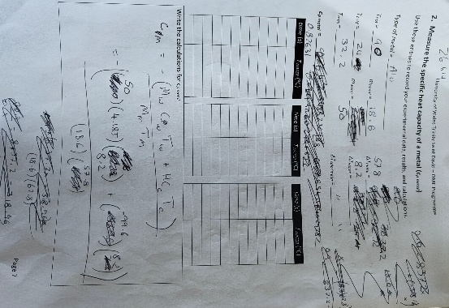
Figure 3. Scanned copy of worksheet for specific heat capacity

Equipment list
- Two stacked Styrofoam cups
- Lid for cup
- Thermometer
- Stirring rod
- Clamp stand
- Clamp
- Bunsen burner
- Heating rack
- Aluminium
- Water
- Measuring cylinder
- Stopwatch
- Beaker

Method to perform experiment for the heat capacity of the calorimeter.

- Set up the calorimeter and gather all equipment.
- Use a water bath to heat 50mL of water until it reaches 80 degrees, then turn it off and wait for it to reach 60 degrees.
- Set up 50mL of cold water in a calorimeter, measuring the initial temperature.
- Once the hot water reaches 60 degrees, add this to the calorimeter.
- Measure the maximum temperature that the mixture reaches.

Method to perform experiment for the specific heat capacity of aluminium.

- Set up the calorimeter and gather all equipment.
- Weigh the aluminium strip and record the mass.
- Use a water bath to heat the metal, allowing it to heat for at least 5 minutes to reach thermal equilibrium.
- Measure 30mL of water and add it to the calorimeter, measuring the temperature of the water.
- Measure the temperature of the water that the aluminium is heating in, then remove it and add it to the calorimeter.
- Stir the calorimeter initially and measure the temperature every 10 seconds.
- Continue recording the temperature until the temperature reaches a maximum and then drops by 2 degrees.

