

Cover Page

Student Name: Susannah Moriarty
Student Number: 2331924
Module Name: Changemakers: Building your Personal Brand for Sustainable Employment
Module Code: BMHP5015
Lecture Name: Olufemi Oluranti
Submission Date: 25th March 2026

Contents Page
Page 3…………………………………… Task 1: Personal Branding

Page 4…………………………………… Task 2: Network Map and Rational

Page 5…………………………………… Task 3: Blog

Page 6……………………………………. Task 4: NHS Equality, Diversity, and Inclusion Quiz

Page 9…………………………………… Task 5: A Letter to Yourself

Page 10…………………………………... Task 6: GANTT Chart

Page 11…………………………………… Task 7: Making Changes – Report

Page 12……………………………………Task 8 Self Reflection

Page 13……………………………………. Reference List

Task 1 – Personal Brand
Write about your own person brand and how you could develop this to enable you to reach your employment goals (200 words- 2 referenced sources)
Personal Brand
Personal branding is defined as the strategic process of managing how others perceive your professional identity and the unique value you offer (Ilies, 2018). In the charity sector, a strong brand is vital for establishing the trust and credibility required to support vulnerable families effectively.
Currently, my personal brand is centred on informal advocacy and community support. Working in a public-facing role, I have become a trusted point of contact for individuals needing help with complex tasks, such as navigating housing correspondence, managing prescriptions and arranging appointments. These experiences have built my strengths in empathy, discretion, and practical problem solving. However, to transition into a formal “enabler” role within family outreach services, I must improve my understanding of professional boundaries and statutory safeguarding policies. As Cottrell (2021) suggests, professional development involves identifying the gap between current skills and the specific competencies required for a target career. Strengthening these areas will allow me to move from informal community help to a structured professional role.
By combining my practical experiences with formal training, I will evolve my brand into that of a qualified advocate. This development is essential for achieving my goal of helping families access the resources they need to change their lives.

Task 2 - Network Map and Rationale
Create a map of your own network considering career, support, social and community dimensions. Additionally you should provide a supporting rationale explaining and critically assessing this (200 words- 2 referenced sources).
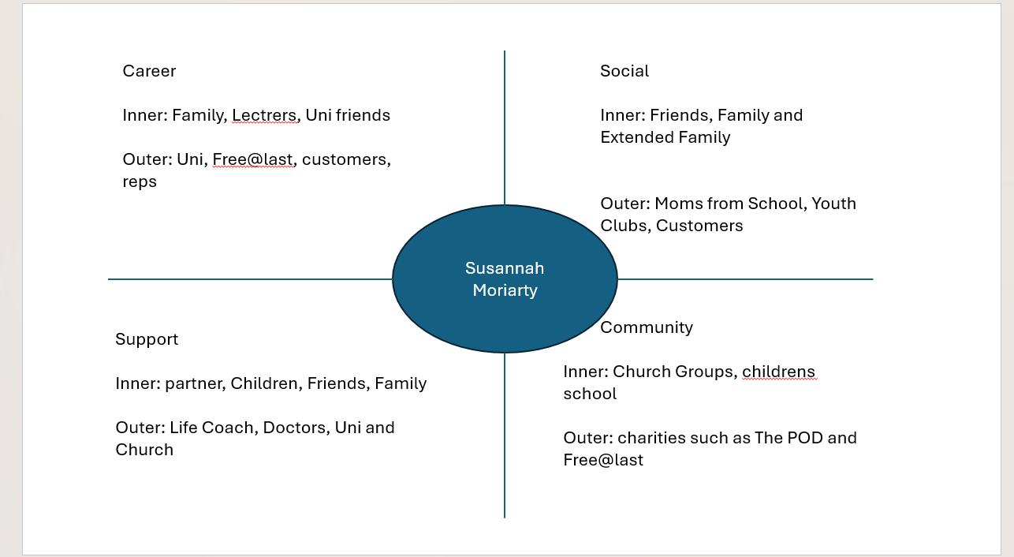
I currently possess a hybrid network that combines a high-density personal core with broad, active social connections. My core social capital is built on bonding ties, my work in our family business and my support system, my partner, three children and 5 close friends, provides essential emotional resilient (Aldrich, 2012). My community dimension is particularly strong and multi complex as my social life, church, and children’s schools are interconnected through shared events such as christenings, community gatherings and parent workshops.
However, a critical assessment reveals that while my social reach is wide through public facing role school and community-based activities, my linking capital connections to formal professionals and hierarchies are a weakness. According to Lin (2021), social capital consists of resources embedded into a social structure that are accessed and used in purposive actions. To address my lack of professional assets, I am considering accepting a Student Ambassador role. A strategic move to introduce a professional dimension, allowing me to build linking ties with university management and bridging ties with diverse student groups. This transition ensures my networking is not just socially active but professionally structured too, allowing me to develop an independent professional identity outside of my established family and community roles.

Task 3- Blog
Write a blog exploring a current topic or issue of your choice within the health and social care sector in the UK. The purpose of this is to inform a specific target audience of your choosing (300 words)
Mind the Gap: Why 2026 is a Turning Point in Young Adults Mental Health.
For many young adults, turning 18 may feel less of a celebration and more of a cliff edge. In the health sector, this is where many children transition from child centred support (CAMHS) to adult services. Where too often they fall between the gaps.
The Growing Challenge
Recent data from The Health Foundation (2024) highlights a stark reality, the proportion of young people (aged 17-19) with a probable mental disorder has surged to over 23%. Locally Birmingham faces even greater pressure, according to Birmingham City Council Health Strategy, the city has even higher than average prevalence of depression and anxiety compared to the rest of England.
Local Innovations, The Birmingham “Drop-In” Model
To combat this, our region is moving toward “low barrier” support. A prime example is the Pause Hub located near Birmingham’s Bullring. Run by Forward Thinking Birmingham (2026), this service recently became part of a new “all-age” integrated system designed to ensure:
- No “Cliff-Edges”: By serving ages 0-25, the hub ensures continuity of care during vital transition into adulthood.
- Immediate Access: Young people can “drop-in” without a GP referral, bypassing long waiting lists.
- Stigma-Free Care: By placing support on the high-street, care becomes as normal as a coffee date.
Your Voice Matters
Mental health is a vital sign of a healthy society. Innovations like the Pause Hub prove that when we bring care to where young people are, we save lives
What do you think? Should mental health “drop-ins” be standard in every city centre? Join the conversation and visit The King’s fund (2026) for more on social care reform.

Task 4- NHS Equality, Diversity and Inclusion Quiz (250 words equivalent)
- What is the primary goal of the NHS Equality, Diversity, and Inclusion Improvement Plan?
(Answer in one or two sentences.)

The primary goal is to foster a more inclusive and equitable workplace culture that improves the experience of all staff. By addressing systemic inequalities and diversifying leadership, the plan aims to ensure that the NHS can better attract and retain talent, ultimately leading to improved patient care and outcomes.

- How does the NHS EDI Improvement Plan propose to tackle the gender pay gap?
(Answer in one to two sentences.)

The plan proposes tackling the gender pay gap by implementing flexible working policies from day one employment to support work life balance and career progression. It also focuses on removing bias from recruitment and promotion processes to ensure woman have equitable access to sinior, higher paid leadership roles.

- What is meant by the term ‘intersectionality’ as used in the NHS EDI Improvement Plan?
(Answer in one to two sentences.)

In the context of the NHS EDI Improvement Plan, intersectionality refers to the understanding that staff may possess multiple protected characteristics (such as race, gender, and disability) that overlap to create unique, cumulative experiences of discrimination or advantage. The plan uses this lens to ensure that inclusion efforts don’t just treat these identities in isolation, but by addressing the complex, layered barriers individuals face.

- Why is it important for the NHS to create a psychologically safe work environment?
(Answer in one to two sentences.)

Creating a psychologically safe environment is vital because it empowers staff to speak up about concerns, errors, or new ideas without fear of blame, which is essential for patient safety and continuous learning. When staff feel safe to be themselves, it reduces burnout and fosters a culture of belonging and innovation that directly improves the quality of care provided.

- How does the NHS EDI Improvement Plan suggest improving the experience of internationally recruited staff?
(Answer in one to two sentences.)

The NHS EDI Improvement plan suggests improving the experience of internally recruited staff by providing comprehensive inductions and pastoral support addressing professional and personal transitions. It mandates organisations create an inclusive environment where staff have equitable access to career development and are protected from harassment and discrimination.

- What role does leadership play in advancing EDI objectives according to the NHS Improvement Plan?
(Answer in one to two sentences.)

The NHS EDI Improvement Plan identifies leadership as the primary driver for change, requiring senior leaders to be personally accountable for embedding EDI into the core strategy of their organisations. By modeling inclusive behaviors and being measured against specific EDI performance objectives, leaders ensure that diversity and inclusion are treated as business critical priorities rather than optional extras.

- Identify one way the NHS EDI Improvement Plan aims to reduce health inequalities within the workforce.
(Answer in one to two sentences.)

The NHS EDI Improvement Plan aims to reduce workforce health inequalities by ensuring that staff from all backgrounds have fair access to health and wellbeing support specifically designed to their diverse needs. By addressing the unbalanced impact of work pace stress and physical health risks on minority groups, the plan seeks to create a healthier, more resilient workforce that can provide better care.

- Why does the NHS EDI Improvement Plan emphasise the importance of collecting and analysing data on protected characteristics?
(Answer in one to two sentences.)

The NHS Improvement Plan emphasises data collection because it allows organisations to identify gaps in representation and experiences that might otherwise remain hidden. By analysing this data, the NHS can move from anecdotal evidence to evidence-based actions that directly address the root cause of workplace inequality.

- Explain how flexible working policies can contribute to equality and inclusion in the NHS workforce.
(Answer in one to two sentences.)

Flexible working policies contribute to equality and inclusion by removing barriers for staff with caring responsibilities, disabilities, or diverse lifestyle needs, allowing them to remain in and progress within the workforce. By offering various pattens of work the NHS can attract a more diverse talent pool and ensure that career advancements are not limited to ridged, traditional scheduling.

- What is one strategy mentioned in the NHS EDI Improvement Plan to combat bullying and harassment in the workplace?
(Answer in one to two sentences.)

One key strategy is the implementation of evidence-based training and support for all staff and managers helping them recognise, challenge and report bulling and harassment effectively. The plan also mandates that organisations create a clear accessible reporting route, ensuring visible, senior level accountability for addressing any reported incidents promptly.

Task 5- A Letter to Yourself
Think of a time in the past when you may have been experiencing issues or difficulties, and after considering what you have learned in this module about emotional intelligence and resilience write a letter to your younger self explaining how these attributes were important at that time and perhaps how developing these areas could have been useful (250 words)

Hey Girl!

I am writing to you from the future; a future you wouldn’t have imagined during those trying times. I see you struggling with a world that feels like it’s not built for you or your brain. You don’t know it yet but that fog, the dizziness and questionable choices aren’t a lack of ability or character, it’s undiagnosed ADHD and Dyslexia.

I wish I could have gifted you Emotional Intelligence (EI) back then. Because your mind felt so unfocused, you often made “silly choices” just to try and find your footing. Developing self-regulation a core pillar of EI, would have helped you steady that dizziness. Instead of acting out of impulse or frustration, you could have recognised that your brain just processed the world differently. As Brackett (2019) says, giving yourself permission to feel is the first step to taking control.

You will face failed relationships and will rebuild from some very dark places. In those moments, remember resilience is what you’re building every time you get back up. You’re never on your own on this path as God has never left your side, providing grace and mercy that keeps you moving forward when thing feel impossible.

Look at us now, 2 years into university, doing really well. Two teen boys one a music student and the other ready to sit his GCSEs, plus a young daughter who make us smile every day! Your house is a loving home with a supportive partner who helps make all this possible.

Keep going beaut,

I love you Suzzy!

Task 6- GANTT Chart (200 words equivalent)
Compile a Gantt chart which illustrates the tasks you have to complete to achieve your future employment goals

Task | Start Date | End Date | Duration | Dependencies (if any)
Complete Level 5 | May 2025 | April 2026 | 12 months | Keep up to date with course work
Accept Student Ambassador role | March 2026 | April 2027 | 12 months | None
Start level 6 | May 2026 | April 2027 | 12 months | Level 5 Coursework needs to be passed
Gain Work Experience (e.g. voluntary work) | June 2026 | TBC | 12+ months | DBS check
Graduate | June 2027 | June 2027 | 1 day | Completion of  Work
Apply for Jobs | January 2027 | TBC | 1month + | CV & Cover Letter Complete
Prepare for Interviews | January 2027 | TBC | 1 month | Job Applications Submitted
Secure and Start Role | TBC | TBC | 1 day | Successful Interviews

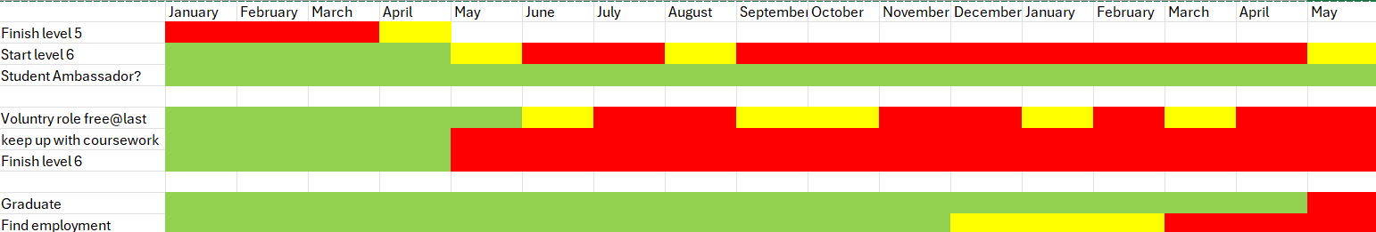

Task 7- Making Changes- Report
You are the manager of a care home and want to make changes your workplace. Identify one specific change that you want to implement and write a brief report on how this is going to be achieved considering the necessary skills needed and addressing possible barriers to success. Relevant change models can be highlighted (250 words- 2 referenced sources).

Introduction
As manager, I am implementing Microsoft Teams at The Towers Care Home. Moving from paper-based handovers to a digital hub is essential for improving real time safeguarding, staff collaboration and transparency.
Planning the Change
I will use Lewin’s change model (Hussain et al., 2018) to move the team forward. First, I’ll “unfreeze” our old habits by showing the staff how easy information gets lost on paper. During the “change” phase, I’ll set up specific Teams “Channels” for each team and provide hands on training. Finally, I’ll “Refreeze” this new way of working by making Teams our official home for all daily reports.
Skills Required
Success requires Digital Leadership to model the app’s use and Change Management to transition staff from information-secure communication to a professional, GDPR-compliant platform. I must also demonstrate patience when supporting staff who are less confident using the new platform.
Barriers and solutions
Barrier: Staff Resistance may be seen as extra work.
Solution: Appoint Digital Champions on every shift to demonstrate how effective Teams is in reducing time looking for and through paper files. As suggested by Grol and Wensing (2020), identifying “local option leader” is key to successful implementation.
Barrier: Hardwear Access. Not all staff have company issued devices.
Solution: Install Communication Stations for tablets and other portable devices, ensures all staff can access the hub without using personal phones.

Conclusion
Microsoft Teams bridges the gap between departments. It ensures our care home operates as a cohesive unit, directly improving the safety of our residents.

Task 8- Self-Reflection
Using one of the highlighted models of reflection, reflect on what you have learned about yourself during this module, as well as the knowledge you have gained, and explain how this has developed your skills and informed your future practice (250 words- you must reference the model you use)

Self-Reflection (Gibbs, 1988).
Description
In this module, I explored my personal brand and social capital, focusing on how my roots in the Birmingham community and my journey with ADHD/Dyslexia shape my identities as a future family advocate.
Feelings
I feel a great sense of pride in my multi-complex community. My ties to our Church local school, youth and community centre are my Emotional Anchor. However, I also felt a sense of urgency to ensure these informal strengths are recognised by formal qualifications with formal organisations. I realise that to effectively help families, I must be seen as both a trusted part of the community and a qualified professional.
Evaluation and Analysis.
The most successful part of this module was realising that my Bounding Capital (Aldrich, 2012) is a massive strength. However, analysing my network through Lin’s (2021) theory helped me see a gap. I had plenty of community trust but lacked Linking Capital, the ties to formal hierarchies. This isn’t a problem with my community; it is simply a missing piece of my professional puzzle.
Conclusion and Action Plan
I have concluded that my brand needs the structure of Professional Boundaries (Cottrell, 2021) to be effective in a charity setting. My action plan is to use my Student Ambassador role to bridge the gap. By combining my community heart with professional linking ties, I will be ready to serve families in the community as a qualified advocate.

Reference List
Aldrich, D.P. (2012). Building Resilience: Social Capital in Post-Disaster Recovery. Chicago: University of Chicago Press
Birmingham and Solihull Mental Health NHS Foundation Trust (2025) Annual Report and Accounts 2024/25. Birmingham: BSMHFT. Available at: https://www.bsmhft.nhs.uk (Accessed: 21 Feb 2026).
Brackett, M. (2019) Permission to Feel: Unlocking the Power of Emotions to Help Our Kids, Ourselves, and Our Powers Thrive. New York: Celadon Books.
Cottrell, S. (2021). Skills for Success: Personal Development and Employability. 4th edn. London: Red Globe Press.
Department of Health and Social Care (DHSC) (2024) Care Data Matters: A Roadmap for Better Data in Social Care. London: HM Stationery Office. Available at: https://www.gov.uk (Accessed: 22 Feb 2026).
Forward Thinking Birmingham (2026) Pause Birmingham: wellbeing drop-in service. Available at: https://www.childrenssociety.org.uk/information/young-people/well-being/services/pause (Accessed: 21 Feb 2026).
Gibbs, G. (1988). Learning by Doing: A Guide to Teaching and Learning Methods. Oxford: Further Education Unit.
Grol, R. and Wensing, M. (2020). Improving Patient Care: The Implementation of Change in Health Care. 3rd edn. London: Wiley-Blackwell.
Hussain, S. T., Lei, S., Akram, T., Haider, M. J., Hussain, S. H. and Ali, M. (2018) ‘Kurt Lewin's change model: A critical review of the role of leadership and employee involvement in organizational change’, Journal of Innovation & Knowledge, 3(3), pp. 123-127.
Ilies, V. (2018). Strategic Personal Branding: The Brand Called You. Expert Journal of Marketing, 6(1), pp. 1-7
The Health Foundation (2024) Young people’s future health inquiry: a healthy foundation for the future. London: The Health Foundation. Available at: https://www.health.org.uk (Accessed: 21 Feb 2026).
The King’s Fund (2026) NHS priorities for 2025/26: our expert insights. Available at: https://www.kingsfund.org.uk (Accessed: 21 Feb 2026).

