A critical essay about a piece of architecture post 1945.
Le Grand Louvre / I.M.Pei

INTRODUCTION
This essay looks at writing a “critical essay about a piece of architecture post 1945”. This will include information about the location of the buildings, the architect and the client. It will also consider looking at the landscape context of the building while obtaining the planning application and look into if there were any objections made against it. Also, research into if any planning conditions were made in order for the structure to be built. Various sources will be used by reading up articles, using the internet and finding some interviews, found in the architects journals. The essay will illustrate some of my own sketches on the building with specific details that are relevant to my point of text. Observation and analyzation details of the building, with also expressing my opinion as well as critic it.
The building that I have chosen to write about is the Louvre Pyramids, based in Paris by architect IM Pei (Walsh, 2019). The essay will be looking at history of the building with the meaning behind the design, the purpose and also the effects of completion of the building. Research about the architect himself will be included to understand the how the building had an influence on himself with the meaning throughout his features.

HISTORY / BACKGROUND
The Louvre Pyramid was designed by firm Pei Cobb Freed and Partners, but IM Pei was the key architect involved (Dickinson, 2017). The client brief that IM Pei received was from the French President, Francois Mitterrand in 1983. The brief was more of a commission rather than a competition, which was a challenge to “overhaul one of the world’s most celebrated museums” (Dickinson, 2017). Mitterrand called this challenge his “Grand Louvre project”, which IM Pei had to take time to consider before he was unison with the project. Even though this was “one of finest collections of art in the world”, the historic buildings that surrounded the Louvre were in “disrepair”, the gallery buildings were “disjointed” and even one of the visitors “got lost” in the corridors while trying to find “one of two public restrooms” (Dickinson, 2017). With this making it a challenging approach to the project, IM Pei decided to take this challenge and “keep it a secret from his firm”, which is very questionable. Why would he keep it secret? There were previous issues regarding the Louvre, with the French Minister of Finance trying to declare the “Richelieu Wing” for offices. This became a desperation for space in the galleries as there was not enough “behind-the-scene space” for management and storage of the art work (Dickinson, 2017). Pei made many trips to Paris in order to study the Louvre with its buildings and grounds. He analyzed the entrance and the space in centre of the courtyard enclosed by the existing buildings. This centre space was filled with” Cour Napoleon gravel”, where he concepted a new entrance to the infrastructure (Dickinson, 2017).

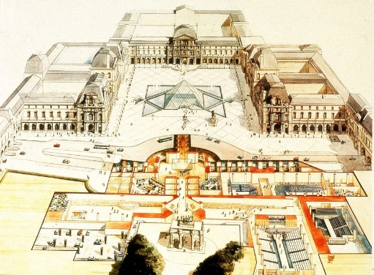
(Dickinson, 2017)

PURPOSE / AIMS FOR THE BUILDING
Pei wanted a pyramid as a structure to have some delicacy to avoid a “muscle-bound structure” (Dickinson, 2017). The triangular forms would allows reflectiveness of different angles of perception to compliment the surrounding buildings. The choice of this pyramid was to allows views of all facades of the Louvre (Weymouth, 2019). This new infrastructure could insert a “new, functional and welcoming reception area” for its collection of historic building and galleries of work. Peis aims were to locate the “translucent sculptural gesture” in middle of the courtyard to emphasize the underground light while still respecting the historic buildings surrounding the space (Dickinson, 2017). This suited Pei, as he was known for his “clean edge modernism and bold use of geometric shapes.” (Hidalgo, 2019). After this analysis, he went to Mitterrand and “accepted the commission”. Pei unveiled the ignominious design of his 71 foot tall glass and metal pyramid to the public after Mitterrand released the investment of the “Grand Louvre project” in the French election (Dickinson, 2017). Mitterrands made his decision of choosing Pei for this project was rather controversial as he disregarded French firms in favour of the Chinese American architect. Before the construction of this design even started, many were “infuriated” by the French presidents decision.

TECHNICAL DETAIL AND STRUCTURE
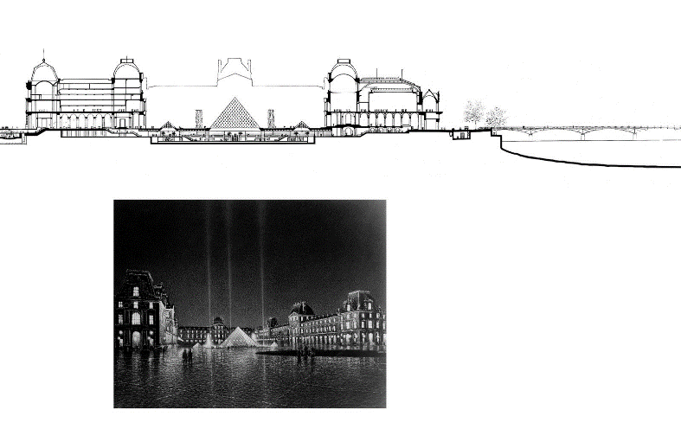
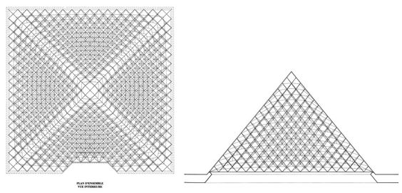
The Louvre Pyramid stood as the main entrance to the Louvre Museum. Its sole structure was built with glass segments which rose to a height of roughly 71 feet, with its square base sides of 35 metres (Bostjan, 2019). The construction was made up from 70 triangular and 603 rhombus shaped glass segments (Bostjan, 2019). Due to the mass numbers of visitors who came to visit the Louvre, there just was not enough capacity which led to the underground lobby beneath the glass reception (Bostjan, 2019). It was designed to attract 4.5 million visitors a year, which this figure doubled in 2014 (deconincks, 2019). This became a utile feature in the project as visitors could descend into the space. Pei decided on method of clear glass pane construction to minimize the impact of the structure. This was certainly a very worthy feature as it did not hide the history of the surrounding building. The glass panes would allow light and view into the space to avoid any solid structure to block different points of view. The design was completed to help improve the circulation and access into the Parisian galleries (Lomholt, 2019). Pei worked with many others to assist with the structure of this design. The pyramid was held together by rigging which was built by Navtec Rod Rigging of Littleton, Nicolet Chartrand Knoll and Rice Francis Ritchie engineered the pyramid structure (Lomholt, 2019). The concept of this design was thought out very precisely and never aimed to have this glass pyramid structure overrule the existing buildings. Pei did not want the building taller than the top line of the highest point if the existing surrounding buildings, as he aimed to not break into the landscape of the location (Dickinson, 2017). Some may argue with this as to say how does a 71 foot tall glass pyramid not break into the landscape view of the location as to it being such a contrasting shape to its surroundings. I personally think as he has managed to maintain the height of the pyramid with comparison to the surrounding building, he has managed to silence the critics with this fact. During this work, construction team founded a set of historic rooms “containing 25,000 historic items” (Bostjan, 2019) those of which were incorporated into rest of the spacious underground exhibition area. This added a very precious feature to the design and some meaningful purpose to the exhibition area, being able to flaunt these historic and valuable pieces (Bostjan, 2019).
(Partners, 2021)
(Partners, 2021)
OUTCOMES OF THE BUILDING
Outcries for this building began in early stages of the completion of this project. Pei was mocked by many and torn down by the public.
Pei said “When I first showed the idea to the public, I would say 90 percent were against it”. (Dickinson, 2017)
This must have been an agonizing time for Pei, as he would have spent time on this decade long project to impress and express the beauty of the Louvre galleries.
Pei also said “The first year and a half was really hell. I could not walk to streets of Paris without people looking at me as if to say: There you go again. What are you doing here? What are you doing to our great Louvre?” (Dickinson, 2017)
Again, this being very hard to listen to for an architect. Especially when the French President has set a challenge for you. Not only comments were made to Pei during this time, but members of the public starting gathering comments about the pyramid itself. Comments were made as the pyramid was “an architectural joke, an eyesore, an anachronistic intrusion of Egyptian death symbolism in middle of Paris, and a megalomaniacal folly imposed by Mr Mitterrand.” (Dickinson, 2017). For comments to be made about this at such an early stage was shocking. As there was already an uproar before the design was unveiled with the French president having chosen IM Pei for the architect of this project, I personally think the public had already made their minds up that they were not going to side by the design, and to pick up on anything they could find wrong with it.
In regards to these comments, I can see to why these comments were said. With such a contrasting shape to its surroundings, it may cause an eyesore to some people. Others may think differently due to this fact of such a contrasting shape, it catches the eyes of tourists which is one of the main focuses for this special location. People may question to why chose this shape? Why could it not have been a cube? A sphere? Or any other shape? One of the main critics about this design is the shape. The first initial location in mind if someone was to mention a pyramid is Egypt, no doubt. Many felt that the pyramid was the symbol of death from ancient Egypt (Raje, 2019). Even more controversy rose when many claimed that the number of glass panes came to exactly 666 panes, which is a number much associated with Satan. This was in fact was published in the official brochure in the 1980s, which was later denied over time by Pei’s offices (Raje, 2019). Frustration must have built up from this mistake as it created confusion and argument between Pei and the public.
Even though some may agree with the comments made about the Egyptian symbolization, many would side with the thought process and the meanings behind this design made by Pei. His mains aims were to keep the perception of color of the existing buildings by using slightly reflective glass but also transparent glass (Dickinson, 2017). This would allow views through and on face of the structure. This effect would have strengthened the perception of form which is not what Pei had aimed for (Dickinson, 2017). To argue against this decision, people may have said why could he have not chosen a different shape, if this was his aimful outcome. This would have then avoided the backlash of criticism of the pyramid with its representation of Egypt. People may counter this again by saying that having this pyramid in middle of the Louvre, it gives the location its own uniquity and drawing feature to visitors. Which has been proven statistically in 2014 with the figure doubling as mentioned above (deconincks, 2019).
During the construction of this pyramid, Pei faced some issues. One being that the surrounding buildings “had a couple hundred years of soot on them from burning coal.” (Dickinson, 2017). Without the thought and analysis of these buildings, alongside with the pyramid, it became clear that Pei was also thinking about the other factors in this location, and not just a single tunnel mind on his individual structure. Another issue faced for this project was the transparency of glass (Dickinson, 2017). How clear the glass was, was a really important component to the design. The usual glass back in that time had a “greenish tinge” as that is the way that they were manufactured (Dickinson, 2017). In this day and age, clear glass is easy to come across, but in their time, there was less demand which meant not many factories produced them. Pei had spent a lot of time in order to find a specific factory that manufactured these, which seemed to be time well spent as it supported his idea of a transparent glass pyramid. Features like the power of light that shone from this structure coming from the Cour Napoleon, led to it being a key element in attracting people to the space and bringing a warm and welcoming mood.

CONCLUSION
To sum up everything that has been stated so far, there has been some ups and downs to the project. Initially the project being mocked and hated by locals. This may have come from the fact that French President Mr Mitterrand choosing Pei, a Chinese American architect for an important and meaningful French project. This actively demonstrates that the French thought Pei was not sufficient enough and aware of the French background and history. For Pei to be under enormous amounts of pressure for this project, he successfully managed to recreate a new and unique look to the Louvre. Many factors were considered, the importance of these external factors such as circulation, where Pei managed to redesign alleviating congestion from the thousands of visitors daily. A grand entrance provided a convenient central lobby space, which provided a focal point for cyclical process of the experience through the galleries.
There are many questions on the longevity of this structure. Questions such as, strength and stabilization of the structure to withhold negative external factors. These factors may be criminal activity. Would the glass panes be strong enough to parry the likes of rocks being thrown at it? People climbing on it? Due to weather changes, would it be stable enough to fight against wind? This was answered by the choice of material and structure made by Pei. The build up of triangular forms of panes prove to be a very solid structure due to loads being spread. Also, the choice of ‘metal framework” was chosen to match the colour of the surrounding buildings to blend in, but not to be overdone.
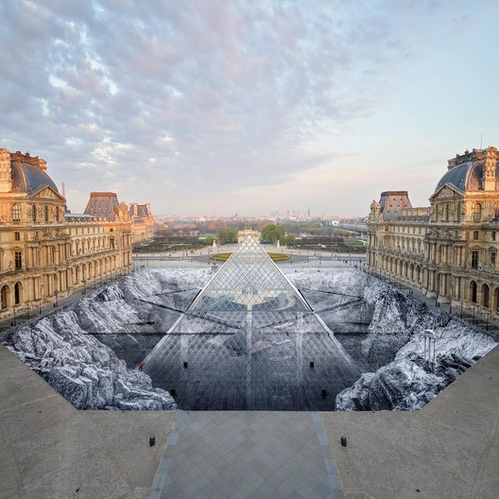
Even with all the controversy that we’ve come across, years later, This project is credited with boosting visitor numbers from 3.5 million in 1989 to more than 10 million in 2018 (Noce, 2019). This renovation managed to pave the way of professionalism to the museum. Through the critics where he was fiercely attacked politically and architecturally, he powered through the project. This became one of his most significant projects ever. It has led to winning many awards, such as the AIA 25-year award back in 2017 (Howarth, 2017). On the 30th anniversary of the project, a magical illusion was painted at the Louvre. The artist JR created this dramatic collabrotive art which filled the Napoleon Court (Walsh, 2019). 400 volunteers intervened in creating this piece of art using 2000 strips of paper to create the illusion. This brought another feature to the structure which again and a beautiful attraction for tourists to see all around the world.

(Walsh, 2019)

Bibliography
Bostjan, 2019. architectuul.com. [Online]
Available at: http://architectuul.com/architecture/louvre-pyramid
deconincks, 2019. constructionandinfrastructure.wordpress.com. [Online]
Available at: https://constructionandinfrastructure.wordpress.com/2019/07/11/louvre-pyramid/
Dickinson, E. E., 2017. architectmagazine.com. [Online]
Available at: https://www.architectmagazine.com/awards/aia-honor-awards/louvre-pyramid-the-folly-that-became-a-triumph_o
Hidalgo, L., 2019. The battle of the Louvre Pyramid [Interview] (9 December 2019).
Howarth, D., 2017. dezeen.com. [Online]
Available at: https://www.dezeen.com/2017/04/28/im-pei-grand-louvre-receives-american-institute-architects-aia-25-year-award/
Lomholt, I., 2019. e-architect.com. [Online]
Available at: https://www.e-architect.com/paris/louvre-pyramid-building
Noce, V., 2019. theartnewspaper.com. [Online]
Available at: https://www.theartnewspaper.com/analysis/louvre-pyramid-scheme-pays-off
Partners, P. C. F. &., 2021. pcf-p.com. [Online]
Available at: https://www.pcf-p.com/projects/grand-louvre-modernization/
Raje, S., 2019. sawdust.online. [Online]
Available at: https://www.sawdust.online/do-you-know-trivia/whats-the-controversy-surrounding-louvre-pyramid/
Walsh, N. P., 2019. archdaily.com. [Online]
Available at: https://www.archdaily.com/914264/a-dramatic-optical-illusion-celebrates-the-louvre-pyramids-30th-anniversary
Weymouth, Y., 2019. The battle of the Louvre pyramid [Interview] (9 December 2019).

