BMSW5104

MANAGING PROJECTS IN THE ORGANIZATION-Task 1

STUDENT ID: 1713839

NAME: ALEXANDRU-MARIAN BALSANU

PROFESSOR: REXON NTING

PROJECT MANAGEMENT PLAN
Table of Contents
Introduction 3
“Critically evaluate the usefulness of project management tools and techniques for managing a project in ST Thomas hospital” 4
Project management techniques 4
Project management tools 5
“Plan the implementation of the project of appropriate complexity in ST Thomas hospital” 7
Description of the project 7
Project life cycle model 7
Work breakdown structure 9
Resource analysis 11
“Critically evaluate the ability to manage the project in ST Thomas hospital” 12
Communication models and strategies 12
Risk Assessment 13
Conclusion 14
Reference 15

Introduction
An individual is engaged in the process of managing projects since the early time of human activity performance was introduced. Managing the project in a company refers to the process by which they collaborate, coordinate amongst the strategic organization, management of the project authorities, manage the portfolio and most importantly manage projects (Demirkesen and Ozorhon, 2017). The project management in an organization is utilized for arranging the practices of the managing project along with the workplace framework. Project management has been seen as an utmost important factor in the post-pandemic period which aids all parts of the business to run smoothly. This report is about managing projects in the healthcare sector in the United Kingdom during the post-pandemic period. Managing projects in the healthcare sector mainly influence the process with regards to the functioning of the healthcare sector improvement (Müller et al., 2019). As part of the growth in the post-pandemic period, the sector is managing to provide more employment and service to the patient within all the post-pandemic criteria. The report has analyzed the project management in “St Thomas Hospital” and its undertaking during the time of post-pandemic period. The report will briefly elaborate on “the usefulness of project management tools and techniques for managing a project in St Thomas hospital”. Also, a plan that will be implemented with the context of the “project of an appropriate complexity in ST Thomas hospital”. Lastly, it will “evaluate the ability to manage the project in ST Thomas hospital”.

“Critically evaluate the usefulness of project management tools and techniques for managing a project in ST Thomas hospital”
This has been noted that the healthcare sector is a huge part of the budget in the government. The management of the project is a strategic approach that promotes the implementation of the changes within the firm and also a practice that aids in improving the performance of the firm (Picciotto, 2020). Thus some of the efficient tools and techniques of project management can be the ideal practice to overcome the threats of functional enhancement. This is with regard to bringing better work performance during the post-pandemic period at St Thomas Hospital.

Project management techniques
“Classic techniques”
The classic technique refers to the process in which the firms implement proper planning and undertaking with regards to all upcoming workplace practices. This technique makes sure that the performance is clear and understandable, the chain of application that explains the responsibilities and role and many more. Implementing classic techniques in “St Thomas Hospital” has resulted in extensive functioning, arranging, preparation and supervising in all the divisions in the workplace environment (Jovanovic and Beric, 2018). As per the analysis, it has been noted that the majority of employees were unclear of the method and responsibilities in the specific sectors. This resulted in the lack of verbal communication and issues resolution are the topmost issue. Also, the issue related to the delegation of the responsibilities was noticed at a certain time more than delegation of authorities. This technique has helped “St Thomas Hospital” to provide a clear execution of the roles and responsibilities and delegate the power properly in a functional way.
“Agile Project Management”
The “Agile Project Management” refers to the technique in which the initial big projects are broken down into smaller sprints. This will aid the firms to promote a better understanding of the undertaking and practices in order to achieve an effective developing system. This technique of project management aids in productive and adaptable arrangements as per the requirements and changes needed in the management project to gain desired outcomes (Dasović et al, 2020). “St Thomas Hospital” comprises huge sections that are sometimes unable to operate together. The hospital has faced lots of issues related to healthcare storages staffing and the managing workplace in the particular division. Implementation of the Agile technique in “St Thomas Hospital” has promoted the process of authoring the workforce to rapidly assess and mention the issues related to “care delivery”, “medical supply acquisition”, “personnel scheduling”, and “numerous other healthcare-related tasks”.

Project management tools
“SWOT analysis”
The SWOT analysis is a tool that is used to analyze the basic “strengths”, “weaknesses”, “opportunities” and “threats” of the firms. SWOT is considered to be one of the best tools that will help the firm in managing the project. This tool has the benefit of being quick when it comes to implementing and better understanding (Wren, 2018). The understanding of the “strengths”, “weaknesses”, “opportunities” and “threats” will help the firm to attain the results of the internal and external factors. This tool has provided a piece of brief information regarding various factors impacting St Thomas Hospital. It has been noted that “St Thomas Hospital” has highly skilled expertise, talents and an effective workforce which can be the strengths of the firms. However, despite all these the firm lacks in introducing a marketing plan that will help the firm in near future. The highly skilled expertise, talents and effective workforce promote digital therapeutics and other innovative ideas during the post-pandemic period such as online check-ups, personal pharmacy sites, etc. Managing all the functions can lead to impact in the supply chain sometimes which can be a threat to the firm.
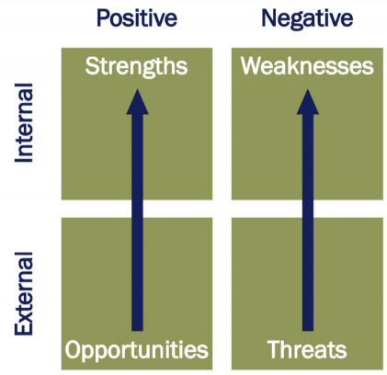
Figure 1: SWOT analysis
(Source: Dohe and Pike, 2018)
“Risk map”
The map of risk is a tool that will help the firm to maximize the risk probability and ensure the categories are made as low, medium or high, along with the same division for the influence if the materialises are risked. The two factors that are considered to be the important combined risk division are the high probability and high influence. The risks that have been analyzed in the “St Thomas Hospital” are “consideration of the sources of risk”, “their consequences”, “the likelihood that those consequences may occur with patient safety” and “persons involved in providing healthcare”.
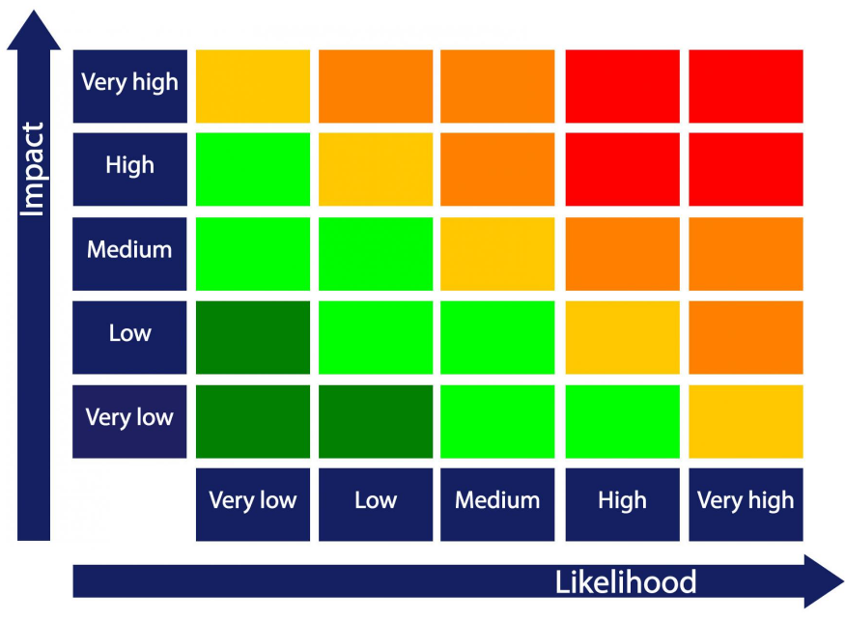
Figure 2: Risk map
(Source: Desmond, 2017)

“Plan the implementation of the project of appropriate complexity in ST Thomas hospital”

Description of the project
Developing a project management plan with regards to the business expansion of “St Thomas Hospital” incorporates a detailed depiction. The hospital has decided to undertake an expansion of its business in a few segments within the premises of the UK. Therein it has come up with the establishment of a set up lying-in hospital facilitating a new maternity based set up for the pregnant ladies named as“ BABY BLOSSOMS”. This is done with an aim to provide safe facilities for pregnant women to deliver their babies amidst the post-pandemic period. This is in lieu of providing the best protection measures to the new infants against the Covid 19 that might affect the newborn baby as well as the mother (Wuensche et al., 2021).
Scope of the project
The scope of the project is to provide the basic amenities and betterment to the patients irrespective of whether they are giving birth and have already given birth to the babies amidst pandemic. The project consists of the management of the blood bank sector so that few cases of pregnant women are saved when it comes to blood scarcity (Zhou et al, 2018). The hospital will introduce some best amenities to protect the newborn baby from the destructive disease of COVID 19. This project management of the business expansion of “St Thomas Hospital” will ensure that the plan is executed and the precautions that will help prevent COVID 19(Mueller et al., 2020).

Project life cycle model
The first stage of initiation- this stage was the first stage of the project of “St Thomas Hospital” where the project was not completely established but the structure of the project was nearly ready (Burmistrov et al, 2018). As “St Thomas Hospital” is an established hospital so the resource and the information that acquire gain from previous healthcare experiences. Soon after the project was approved, it started to arrange all the objectives of the firm. Its mission was clear as it was with respect to building a maternity based unit to ensure covid free and secured deliveries of babies.
The second stage of planning- the planning is the most important phase in the project life cycle. This stage of planning has ensured that the objectives of the “St Thomas Hospital” are aligned and provide the resources and information of the process to the stakeholders to initiate the planning’s. The “St Thomas Hospital” can break the rigid practices into smaller units so that there are fewer chances of conflict and confusion so that the process can be carried out smoothly. This involved the recruitment of the key project managers, and other professional experts heading this project. It involved health care experts to lay down the clinical and infrastructural planning framework.
The third stage of execution- the third stage will ensure that the planning that was executed is taken into action. “St Thomas Hospital” will implement its plans into various actions such as infrastructure development, building and premises construction, medical equipment, separate ward development and many more. This involved discussions with the vendors and suppliers. Gathering the requisite medical equipment that would be needed for the delivery of the baby, adding other multi-specialty services to ensure holistic care to both the mother and the child. It involved developments of IT work, software installations, providing training to the staff members. Setting up the workflow systems and HMIS are the key contextual requisites of this stage.
The fourth stage of termination - this is the last stage of the product where the outcomes can be adhered to as soon as possible in the post-pandemic period. Once all the undertakings have been completed the constructor and the staff wrap up all the process and “St Thomas Hospital” should make sure the planning that was made is similar to the outcomes. This process consists of handing over all the documents, cancellation of the contracts, clearing the workforces and announcement of the closure of the project. Once the RIDS is built, all the installations are complete, the management authorities finally terminate the project marking its actual operational beginning of this new “ BABY BLOSSOMS” hospital, a unit of St Thomas Hospitals.
Stakeholders analysis
Some of the stakeholders at “St Thomas Hospital” are “ Guy's and St Thomas' NHS Foundation Trust”, “King's College London University”, “Industry Partners”, “Wider NHS & NIHR Landscape” and “Representatives and Influencers”. “Guy's and St Thomas' NHS Foundation Trust” is the NHS charitable body of the “National Health Service”. “King's College London University” is a social university and an allied university situated in London. “Industry Partners” are some of the selected organizations that are generally forerunners in managing changes. “Representatives and Influencers” are generally famous, renowned and personalities. They exert a tremendous influence on the decision making process for this “BABY BLOSSOMS” project for the moms.

Work breakdown structure
Particulars | Start date | End date | Duration (days)
Identification of mission, objectives and target | 1-Oct-2021 | 3-Oct-2021 | 3
Recruitment of key healthcare experts and management | 4-Oct-2021 | 7-Oct-2021 | 4
Planning the clinical program | 8-Oct-2021 | 13-Oct-2021 | 6
Key discussion with contractors and suppliers | 14-Oct-2021 | 16-Oct-2021 | 3
Gathering medical equipment | 17-Oct-2021 | 23-Oct-2021 | 7
Fostering IT and infrastructural developments | 24-Oct-2021 | 30-Oct-2021 | 8
RIDS building | 31-Oct-2021 | 7-Nov-2021 | 8
Incorporating staff, HMIS and workflow systems | 8-Nov-2021 | 14-Nov-2021 | 7
Training of personnel and staff with equipment installations | 15-Nov-2021 | 20-Nov-2021 | 6
Going live with the work | 21-Nov-2021 | 26-Nov-2021 | 6
Table no 1: (Work breakdown structure)
(Source: created by the learner)

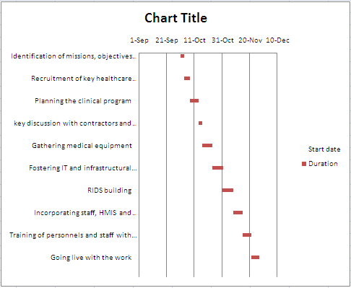
Figure 3:(Gantt chart)
(Source: created by the learner)

Resource analysis
Health care professionals- the health care expertise are the type of people who provide health-related services. Such as “physicians”, “nurse practitioners”, “physician assistants” and many more.
Management experts and planners- the Management experts and planners as the people who execute plans and ensure that the undertakings are undergoing properly such as managers and leaders of the company.
Key stakeholders- the stake owner are the party that linked to the organization and are the members of the corporation such as “investors”, “employees”, “customers”, and “suppliers”
Equipment- in the hospital the equipment is a part where all the devices are incorporated to intend the medical in the healthcare sector (Vaalma et al., 2018).
Infrastructural developments- infrastructural development is the process of constructing the general operational process with regards to enhancing the growth of the economy.
Nursing staff- the nurses provide personal facilities of caring towards the patients and workers. The role of the nurse is to assess patients, supervise patients and nurture them.
Cost analysis

Resource inputs | Cost incurred
Health care professionals | $15,000 per person
Management experts and planners | $ 25,000 per person
Key stakeholders | $ 50,000 person
Equipment | $ 50,000
Infrastructural developments | $ 1,00,000
Nursing staff | $ 55,000
Total cost | $ 2,95,000
Figure 2: (Cost analysis)
(Source: created by the learner)

“Critically evaluate the ability to manage the project in ST Thomas hospital”
Action plan
Strategic objectives | Actions undertaken | Key personnel | Duration
Providing training to the staffs | The basic rules and regulations regarding the hospital criteria and framework of the implementation | This includes the new staff, nurses, doctors and other medical staff. | 15 days
Complete vaccination to each patient to ensure covid free deliveries | Weekly vaccination process to all the newborn babies and the mothers as per the schedule | Newborn baby and mother. | 7 days( per week until the course)
Complete risk management | Preplanned management for the risk such as a sudden fire in the sector and additional facilities provided to the external patients | All the medical staff and external patients referred from the hospital | 10 day
Execution of the complete project with infrastructural development | IT work, software installations, providing training to the staff members | Constructors, suppliers, investors and many more. | 1 month
Table no 3: Action plan
(Source: created by the learner)

Communication models and strategies
The two communication models and strategies are the “Shannon and Weaver model” and “patient-centered care”. “Shannon and Weaver model” is an effective model mainly for the management of which includes the sender and the receiver that decrease the barriers of communication. Further, it consists of various factors such as “transmitter”, “Noise”, “channel”, “message”, “ receive”, “channel”, “ information destination”, “encode” and “decode” (Norrving et al., 2018).
“patient-centered care” is a process of treating all the patients creating a great medium of communication with esteem and dignity regards healthcare.

Risk Assessment
The risk assessment involved in the expansion of the “Baby Blossoms” maternity unit of “St Thomas Hospital” was measured by the risk mapping model as mentioned above. Few risks that are analyzed from the piece of information provides are as follows:
- If in case there is an emergency of catching fire, the firm should prepare for the situation at that time and be ready to bear all the damage incurred and after the result, the firm should always have insurance for all the equipment.
- The “Baby Blossoms” maternity unit of “St Thomas Hospital” should also be prepared for a sudden covid patient at the spot so that they can be provided with some cures and facilities for the covid patients as well.

Conclusion
The following report concludes that the efficient tools and techniques of project management can be the ideal practice to overcome the threats of functional enhancement. This is with regard to bringing better work performance during the post-pandemic period at St Thomas Hospital. The project management tools are “Classic techniques” and “Agile Project Management”. The project management techniques are “SWOT analysis” and “Risk map”. Therein it has come up with the establishment of a set up lying-in hospital facilitating new maternity based set up for the pregnant ladies named as “BABY BLOSSOMS”. The two communication models and strategies are the “Shannon and Weaver model” and “patient-centered care”.

Reference
Burmistrov, A., Siniavina, M. and Iliashenko, O., 2018. Project Management Life Cycle Models to Improve Management in High-rise Construction. In E3S Web of Conferences (Vol. 33, p. 03005). EDP Sciences.
Dasović, B., Galić, M. and Klanšek, U., 2020. A survey on integration of optimization and project management tools for sustainable construction scheduling. Sustainability, 12(8), p.3405.
Demirkesen, S. and Ozorhon, B., 2017. Impact of integration management on construction project management performance. International Journal of Project Management, 35(8), pp.1639-1654.
Desmond, C., 2017. Project management tools-software tools. IEEE Engineering Management Review, 45(4), pp.24-25.
Dohe, K. and Pike, R., 2018. Integration of project management techniques in digital projects. In Project management in the library workplace. Emerald Publishing Limited.
Jovanovic, P. and Beric, I., 2018. Analysis of the available project management methodologies. Management: Journal of Sustainable Business and Management Solutions in Emerging Economies, 23(3), pp.1-13.
Mueller, J.T., Thiemann, K.M., Lessow, C., Murad, M.H., Wang, Z., Santrach, P. and Poe, J., 2020. The mayo clinic hospital mortality reduction project: description and results. Journal of Healthcare Management, 65(2), pp.122-132.
Müller, R., Drouin, N. and Sankaran, S., 2019. Modeling organizational project management. Project Management Journal, 50(4), pp.499-513.
Norrving, B., Barrick, J., Davalos, A., Dichgans, M., Cordonnier, C., Guekht, A., Kutluk, K., Mikulik, R., Wardlaw, J., Richard, E. and Nabavi, D., 2018. Action plan for stroke in Europe 2018–2030. European Stroke Journal, 3(4), pp.309-336.
Picciotto, R., 2020. Towards a ‘New Project Management’movement? An international development perspective. International Journal of Project Management, 38(8), pp.474-485.
Vaalma, C., Buchholz, D., Weil, M. and Passerini, S., 2018. A cost and resource analysis of sodium-ion batteries. Nature reviews materials, 3(4), pp.1-11.
Wren, A., 2018. The project management A–Z: A compendium of project management techniques and how to use them. Routledge.
Wuensche, C.A., Villela, T., Abdalla, E., Liccardo, V., Vieira, F., Browne, I., Peel, M.W., Radcliffe, C., Abdalla, F.B., Marins, A. and Barosi, L., 2021. The BINGO Project II: Instrument Description. arXiv preprint arXiv:2107.01634.
Zhou, M.J., Lu, B., Fan, W.P. and Wang, G.A., 2018. Project description and crowdfunding success: an exploratory study. Information Systems Frontiers, 20(2), pp.259-274.

Managing Projects in the Organisation- Task 2
EVALUATION OF PROJECT MANAGEMENT PLAN

STUDENT ID: 1713839

NAME: ALEXANDRU-MARIAN BALSANU

PROFESSOR: REXON NTING

Table of Content
Introduction 19
Key findings 20
Techniques used in project management of St. Thomas Hospital 20
“Project management tools” 20
“Description of the new project” 21
An analysis made on the resources 21
“Evaluation of the ability to manage the project” 22
Applied models and strategies for communication 22
Assessment of the risk 22
Recommendations 23
Challenges and limitations hindering recommendations 23
Conclusion 23
Reference 25

Introduction
- The below context is all about "managing projects in the organization".
- It includes the key findings wherein the techniques that were used in the project were mentioned, the tools used in project management.
- The overall description of the new project will be provided along with the analysis that has been conducted on resource utilization, evaluation will be done on the ability to manage the project.
- Thereafter, strategies and models that will be applied for the communication will be mentioned along with the description of the risk assessment will be provided.
- Further, the recommendations will be suggested along with the limitations and challenges that can arise in the recommended section.

Key findings

Techniques used in project management of St. Thomas Hospital
- There were two techniques used in the project management, which are the "classic techniques" and "agile project management".
- Implementation of classic techniques has helped St. Thomas Hospital to function, prepare, arrange and supervise extensively in all the departments of the hospital. It has also helped to understand the responsibilities and roles clearly and developed the idea of proper distribution of the work.
- Agile project management has significantly helped in developing the arrangements required in the project in order to gain successful outcomes (Nicholas and Steyn, 2020).
- It has also helped in promoting the authoring process and also identified the issues related to "personnel scheduling", "medical supply acquisition", "care delivery" and "healthcare-related task".

“Project management tools”
- There are two types of tools that are used in this project management, are the SWOT analysis and risk map.
- Through SWOT it was analysed that St. Thomas has quite an effective and skilled workforce, despite that the company lacks in developing proper marketing strategies (Pérez et al., 2018).
- However, this expertise promoted "digital therapeutics" and other useful ideas like personal pharmacy and online check-ups after the pandemic situation.
- The threat as explained is that functional management can significantly lead to the supply chain crisis.
- Whereas, risk maps have analysed the sources of risk, their consequences and their effect on the safety of the patients and healthcare providers.

“Description of the new project”
- The new expansion decided by the hospital is to set up a new segment in the maternity department for the pregnant ladies, which is to be named "BABY BLOSSOMS".
- In order to provide sufficient safety to the pregnant women while delivering the baby during the post-Covid situation.
- With the help of the blood bank sector and providing the best amenities post-covid will significantly save the mother and child from blood scarcity and getting infected by Covid-19 (Mbatuegwu and Obi, 2021).
- Thereafter a project was initiated, planned, executed and terminated with the final deliverables which involved the successful installation of RIDS, wherein the project will be terminated and "BABY BLOSSOMS" will be all set to operate officially.
- Some organizations act as the forerunners, who had a huge influence on this project of "BABY BLOSSOMS".

An analysis made on the resources
- For the health care professionals like gynaecologists, paediatricians, assistant doctors, nurses etc. $15,000 per head will be incurred.
- Planners and management experts who ensure that the project is being implemented in a proper manner $25,000 per head will be incurred (Marino and Quattrone, 2019).
- $50,000 will be incurred by the stakeholders who are basically the employees, investors, suppliers and customers. $50,000 will be incurred for the equipment used in the project.
- From the development of the infrastructure which is one of the main factors for the significant growth of the economy $1,00,000 will be incurred and $55,000 will be incurred for the nursing staff.
- Therefore, the total cost analysis leads to $2,95,000.

“Evaluation of the ability to manage the project”
- During the training, which will take place for 15 days, hospitals' basic rules and regulations including the framework were significantly elaborated to the doctors, staff and nurses.
- Being particular about the vaccination to "ensure covid-free deliveries" and regular vaccination of the babies and the mothers will be taken care of (Wen and Qiang, 2019).
- 10 days of training was provided to the medical staff for planning the risk management.
- Infrastructural development will take place for a month involving the suppliers, investors, constructors for the installation of new software, IT sections and related training to the members will be provided.

Applied models and strategies for communication
- “Shannon and Weaver model” and “patient-centered care” are the two models that were implemented in the process.
- “Shannon and Weaver model” is basically used for the management wherein only sender and receiver is involved in order to reduce the communication barrier (Zerfass et al., 2018).
- “Patient-centered care” is about treating the patient with utmost respect and dignity and taking care of every requirement and making every decision with their consent.

Assessment of the risk
- In order to prevent the hospital from catching fire, the hospital must have fire extinguishers on every floor.
- Another preventive measure can be having issuance for the equipment and the building.
- “BABY BLOSSOMS” must be well prepared to encounter covid-19 infected people and must take preventive measures and provide facilities and cures to the infected patients.

Recommendations
- In order to execute the new project, the hospital must hire skilled constructors and workers in order to build an organized section for "BABY BLOSSOMS" to attract more people.
- To provide a covid free atmosphere for the mothers and the babies, the hospital must have proper screening test facilities for the patients and their family members.
- The covid ward of the hospital and its entrance must be different from the maternity ward and it should be avoided by patients and staff working in the maternity ward.
- Different sections in the pharmacy for the covid patients must be provided in order to avoid infection. Technically advanced equipment must be implemented for better services.

Challenges and limitations hindering recommendations
- Hiring skilled and renowned constructors and workers will significantly increase the expenses of the project.
- In spite of providing covid free atmosphere, there will always be chances of the mother and the child getting infected.
- Therefore, different sections must be arranged for Covid infected mothers and newborn babies.
- Installing technically advanced equipment will not only increase the expenses but will also increase other related charges like maintenance of the equipment and electricity bills (Islamadina, 2021).
- Apart from everything one key element that should be kept in mind before planning for the project is that it should be completed within the provided timescale.

Conclusion
- In the above context, the "managing projects in the organization" what's been explained.
- Wherein, the key findings from task 1 have been provided under which the techniques used in the project management are described.
- The entire description of the project and analysis on the resource utilization has been made along with the evaluation of the project management has been provided.
- Furthermore, the models used for communication and risk management have been covered in this section.
- Also, the preferred recommendations and the challenges that might take place due to the suggested recommendations have been mentioned.

Reference
Islamadina, A.N., 2021. Model Risiko Dalam Rantai Pasok Halal Dengan Kombinasi Metode FMEA, Multi-Phased QFD, Dan Risk Matrix (Doctoral dissertation, Institut Teknologi Sepuluh Nopember).
- Marino, D. and Quattrone, G., 2019. A proposal for a new index to evaluate hospital resource allocation: The case of Italian NHS rationalisation. European Research on Management and Business Economics, 25(1), pp.23-29.
- Mbatuegwu, F.A. and Obi, P.K., 2021. COVID-19, FAMILY AND MATERNAL HEALTH: A CRITICAL DISCOURSE. International Journal of Sustainable Development, p.57.
- Nicholas, J.M. and Steyn, H., 2020. Project management for engineering, business and technology. Routledge.
- Pérez-Uribe, R.I., Torres, D.A., Jurado, S.P.B. and Prada, D.M., 2018. Cloud Tools for the Development of Project Management in SMEs. In Handbook of Research on Intrapreneurship and Organizational Sustainability in SMEs (pp. 95-120). IGI Global.
- Wen, Q. and Qiang, M., 2019. Project managers' competencies in managing project closing. Project Management Journal, 50(3), pp.361-375.
- Zerfass, A., Verčič, D., Nothhaft, H. and Werder, K.P., 2018. Strategic communication: Defining the field and its contribution to research and practice. International Journal of Strategic Communication, 12(4), pp.487-505.

