Name: Oana Gabriela Marin
Student Number: 1909897
Programme: BA Business Management
Module Code: LCBB5004
Module Title: Managing People
Module Lecturer’s Name: Mary March
Assessment 1: Report

Executive Summary
Human resource management provides positive changes in an organisation. Therefore, this study explores and evaluates the role of HR professionals with CIPD profession map. It also analyses objectives of selected tourism business of Apex Hotels followed by resource activities.

Table of Contents
Introduction 3
Task 1 3
Evaluation of HR professional with CIPD Profession Map 3
Task 2 5
Organisational Objectives 5
Resource Activities 6
Planning 6
Recruitment 7
Selection 8
HR functions for accomplishing operations 10
Conclusion 11
References 12

Introduction
Human resource provides specific changes on the part of employees and functions with operations in organisations. Therefore, preliminary aim of this study is to analyse the role and contribution of human resources professionals and further improvement of HR, which is being aligned with the CIPD professional map. In addition to this, study emphasises presenting objectives of the selected organisation of Apex Hotels, based on markets of UK. This study discusses improvement of performances with the help of planning, recruiting, and staffing in Apex Hotels, which helps in analysing human resource functions for accomplishment appropriately. It also analyses the role and contribution of human resource professionals towards presenting transformation in tourism business of Apex Hotels in UK regions. This study facilitates recommending steps that lead to improving business functions of Apex Hotels on part of staffing, directing, and planning to meet organisational objectives.

Task 1

Evaluation of HR professional with CIPD Profession Map
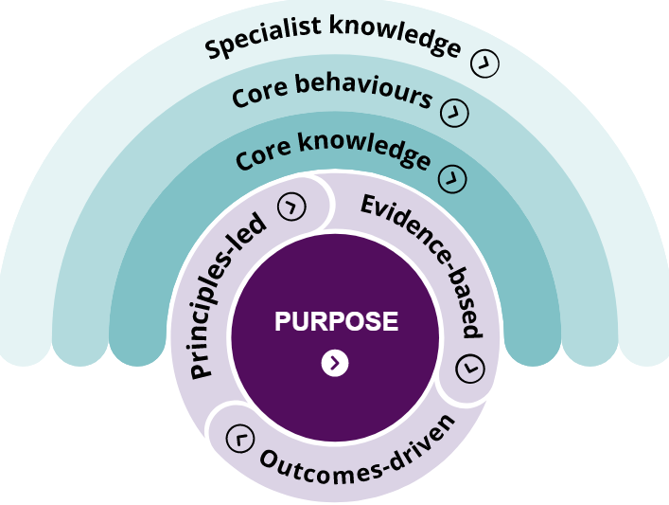
Figure 1: CIPD Profession Map
(Source: CIPD, 2020)
Apex Hotels was founded by Norman Springford and built it’s headquarter, which is situated in Edinburgh, Scotland. This tourism business appeared in UK markets in 1996 and served well to customers by active involvement of human resource professionals (APEXHOTELS, 2020). Human resource director of Apex Hotels is Robert Allan, who has been chartered as per CIPD, so that performance can be positively affecting growth of this tourism business. However, CIPD profession map has been maintained in the company of Apex Hotels, which has been supported for selection of human resource directors in an efficient way. On the other hand, propagation of CIPD profession maps comes up with principle-based, evidence, and outcomes-based n lead to improve selection of the human resource department properly by analysing core skills and traits required to exist. According to Tosey and Marshall (2017) development of organisational performances majorly depends on employee involvement, which is directly managed by the human resource department. Thus, it helps in analysing that increased efficiency on part of human resource professionals can be improved by taking CIPD profession map into consideration. Similarly, Apex Hotels would also be able to gain a positive impact on management as selection of human resource professionals would be selected as per CIPD profession map. In this manner, it has been understood that implementation of CIPD professional maps helps in analysing skills and qualities required for being a responsible human resource in an organisation. Applying this type of professional map based on CIPD would guide Apex Hotels to gain profitable outcomes as employees' performances would be improved by selection of deserving candidates in human resource positions.
Human resource professionals in Apex Hotels work efficiently as CIPD profession map is being followed, and directors have been appointed accordingly. Apart from this, it has been found that human resource professionals work effectively by monitoring and controlling feedback obtained from the customer's end on its own website. This has helped Apex Hotels to receive a successful outcome based on £1.5million, which has been possible due to proper form of investments in presenting customer facilities (Best Companies, 2020). Moreover, prevalence of positive outcomes has emerged in Apex Hotels due to an involvement of dedicated human resource professionals. Other than this, regulation of CIPD profession maps would guide in managing professional skills of human resources by inputting core knowledge, positive working attributes followed by enabling to understand organisational purpose. Armstrong and Taylor (2020) asserted that improvement of human resource management supports resolving internal issues and ensures to stabilise peaceful working environments. From this, it has been understood that improvement of professionalism on part of human resources in Apex Hotels would help in improving work culture by presenting CIPD profession maps to employees. This would result in the imposition of positive qualities, and employees would be able to perform well as per knowledge obtained by evidence, principles, and outcomes. In this regard, Apex Hotels would be receiving positive outcomes and able to compete with rival tourism businesses in UK regions.

Task 2

Organisational Objectives
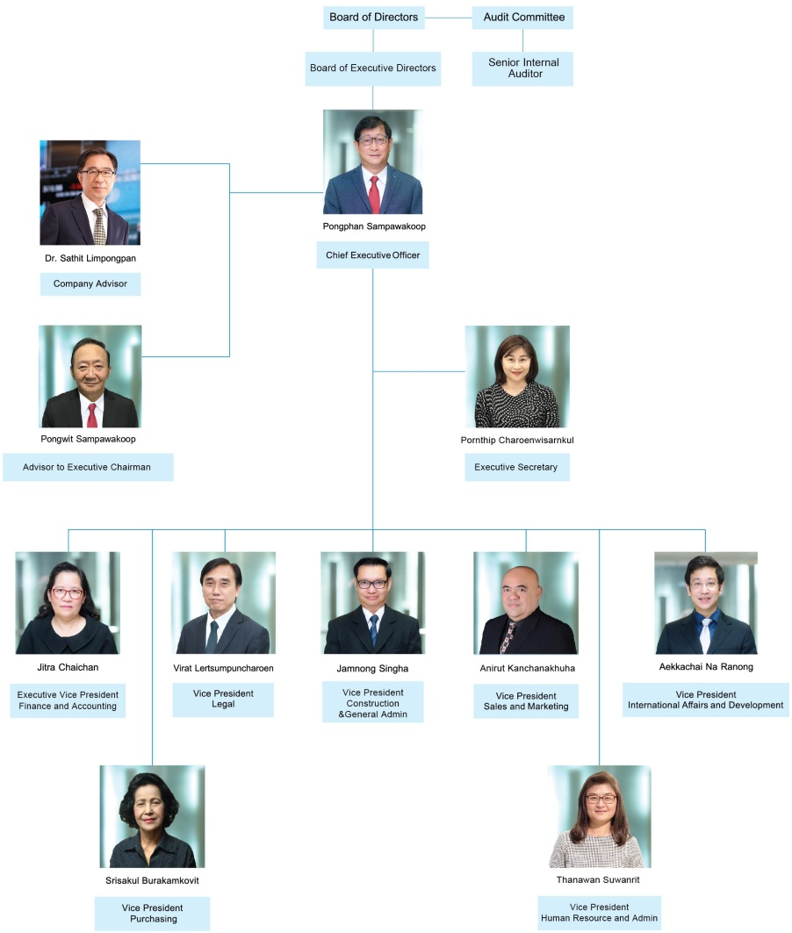
Figure 2: Corporate Structure of Apex Hotels
(Source: APEXHOTELS, 2020)
A collaboration of employees with human resource professionals has been focusing on improving work culture in tourism business of Apex Hotels has helped in managing positions in UK regions. A strong connection between employees on part of corporate structure has been supportive of tourism business to retain in markets appropriately in terms of accomplishing objectives. However, Apex Hotels comes up with objectives based on “delivering wellbeing practices to address demands of customers by active members of Apex teams” (APEXHOTELS, 2020). From this, it has been understood that management of Apex Hotels focuses on development of performances from employee's end, due to which customer services would gain a positive impact as per organisational objectives. In this regard, Apex Hotels would be able to achieve subjective goals related to good treatment to clients and customers with good quality of food served and facilitation of high-class accommodation. Kew and Stredwick (2016) explained the improvement of organisational functions that place by engagement of human resource professionals in workplaces. From this, it has been understood that further development in Apex Hotels can be feasible by improvising role of human resource professions.
Objective of Apex Hotels is to increase sales points followed by an increase in customer touch points. In terms of completion of this objective of this tourism business, Apex Hotels would be able to expand further in UK regions. Additionally, development of human resource professionals would guide in involvement of employees in a convenient manner. Boussebaa (2020) opined that proposition of human resource professions aid in involving leadership traits, due to which employees learn to manage difficult situations. In this regard, it can be conveyed that improvement of human resource profession would guide in managing functions and objectives of Apex Hotels in a convenient manner. In accordance with improved manner of participation of employees, trained by human resource professionals, would be supportive in accomplishing recognised objectives.

Resource Activities

Planning
Improvement of resource activities can be effectively managed by human resource professions of tourism business of Apex Hotels in regions of UK. Moreover, it has been observed that objectives of Apex Hotels also focus on serving customers with a “friendly face", which helps in explaining friendly behaviour of staff to customers (APEXHOTELS, 2020). In this manner, customer services would be affecting business of Apex Hotels in a positive way. Therefore, it is beneficial for human resource professions to plan accordingly, which would guide in managing involvement of qualified and suitable employees for serving customers. This would significantly help in accomplishment of proposed objectives from senior management of Apex Hotels in an efficient manner. Wehrmeyer (2017) stated that improvement of work culture is directly associated with proper forms of planning, as per which employee's actions take place. From this, it can be analysed that evaluation of proper planning with the support of human resource professionals in Apex Hotels would result in a profitable outcome. Similarly, regulation of advanced forms of planning would guide this tourism business to expand further in overseas markets and help in increasing retain ability in competitive business fields.
Evaluation of planning can be projected by presenting training to employees, which would help in improving performance quality of staff in Apex Hotels. Plan based on provision of training and mentoring programs would also permit human resource professionals to monitor and control internal risk factors. According to Villares-Varela (2020), positive working attributes, hard work, and faith in employees help in establishing good employee relations in an organisation. In case of Apex Hotel, planning needs to be associated with improvement of employees so that this tourism business is able to meet its own organisational objectives. Therefore, it can be conveyed that provision of training programs for staff, which would be recruited and directed by human resource professionals, would be beneficial for Apex Hotels. In this manner, it has been understood that incorporation of planning based on presenting training, recruiting along with staffing and directing would facilitate developing opportunities for Apex Hotels to increase customer touch points.

Recruitment
Recruitment is an essential part of improving service quality in an organisation. However, making positive changes on part of Apex Hotels needs to be presented by the support of an effective form of recruitment, which can be specifically managed by human resource professions. Through means of initiation of recruitment, qualified and skilful candidates would be selected, which would significantly aid in improving work culture of Apex Hotels by receiving formal training. Bibb (2016) noted that regulation of “talent management strategy” focuses on transforming recruitment programs by reviewing skills and traits of opted candidates. Thus, it can be suggested for Apex Hotels that application of talent management strategy from human resource professionals would lead to providing advanced forms of techniques. In this respect, the tourism business of Apex Hotels would be gaining positive outcomes due to which the rest of this business would be receiving required impacts. From this, it has been understood that development of business can be effectively managed by imposing advanced forms of recruitment.
Recruitment programs can be conducted by specifying required qualities of candidates, which would be meeting expectations of management in companies. Thus, it can be stated that involvement of criteria by human resource professions would help in maintaining recruitment programs in Apex Hotels in a convenient way. Development of business functions takes place by regulation of processes based on recruitment and ensures the quality of working techniques in a proper manner and focuses on development of overall functions. According to Boyce and Ville (2017), changes in an organisation take place by recruiting qualified and skilful candidates, and it becomes easier for companies to accomplish objectives strategically. Thus, it has been understood that regulation of recruitment programs would aid Apex Hotels in interpreting positive changes, and as per objectives recruiting employees can be feasible. Additionally, involvement of recruitment programs would intend to increase workforces and help in maintaining work quality suitably. Thus, it has been understood that development of employee performance, followed by an increase in employee numbers, can be applied by conducting recruitment programs.

Selection
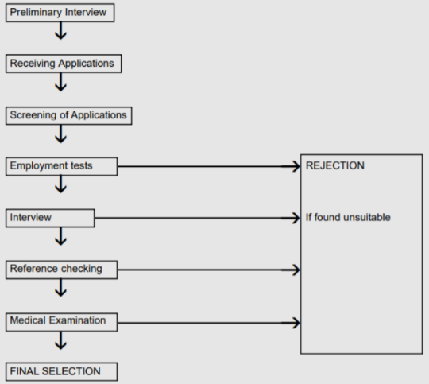
Figure 3: Selection process
(Source: As inspired by Ahlemeyer-Stubbe and Coleman, 2018)
Technique of selection refers to short listing of candidates who would be considered as hired employees in a particular organisation. However, in case of Apex Hotels, the selection process would be supportive in terms of gaining participation of qualified and skilful employees. A proper form of a section of staff for Apex Hotels would be gaining positive outcomes as skilful and qualified employees would be able to understand proposed objectives. Moreover, selection of suitable candidates would help in managing business operations of Apex Hotels conveniently. Bennett et al. (2019) asserted that improvement of workforces majorly depends on recruitment and selection process. In this manner, it guides in acknowledging that following norm of selection would aid Apex Hotels in improving customer services with the help of hired skilful staff. However, selection of candidates in the recruiting session needs to be done properly so that Apex Hotels would be able to manage functions regarding accomplishment of objectives. Initial proposition of a preliminary interview is an ethical manner for selection of candidates for improving and increasing the number of staff in Apex Hotels.
Selection process can be managed effectively by receiving a number of applications from applicants in the interview process. In terms of selection of skilful candidates, it is necessary to review applicant's forms prior to selection of next rounds of interviews. In this manner, the selection procedure for the recruitment process in Apex Hotels can be efficiently managed. Ahlemeyer-Stubbe and Coleman (2018) opined that improvement of business operations could be efficiently managed by screening the number of applicants that appeared in recruiting and selection process. From this, it has been understood that conducting screening tests followed by employment tests would be beneficial in presenting valuable outcomes in part of Apex Hotels. Due to this, proposed objectives would be appropriately accomplished and ensured to increase quality of customer services, which would help in maintaining a remarkable position in competitive markets. Other than this, processing of selection can be applied by checking references, and conducting medical tests would aid in ensuring that selected candidate is physically fit to work under norms and regulations. In this manner, health and safety measures towards selection of staff would also be maintained by human resource professionals in Apex Hotels.

HR functions for accomplishing operations
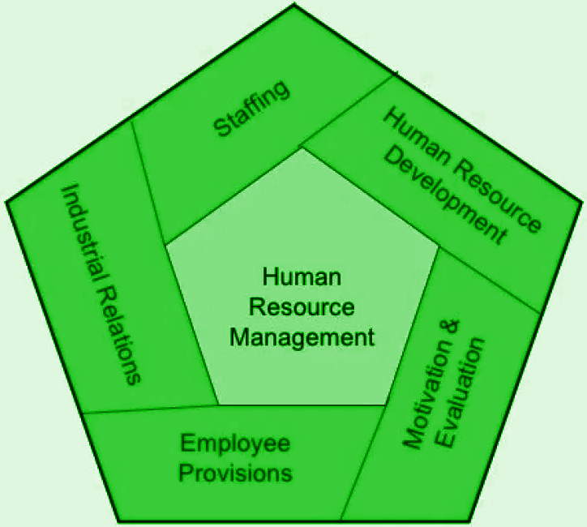
Figure 4: Functions of human resource professionals
(Source: As inspired by Mendy and Rahman, 2019)
Imposition of objectives in an organisation is key to present opportunities for further improvement. However, in case of Apex Hotels, objectives related to an increase in customer touch points, which can be accomplished by the active participation of employees with commitment and dedication. Other than employees, human resource professionals' involvement is equally important as employee performance and management of functions majorly depend on HR. Farris (2020) explained that functions of human resource professions help in improving employees' performance by conducting training, recruiting, and staffing. In this manner, evaluation of functions like recruiting, planning, staffing, and directing from human resource professionals would help Apex Hotels for accomplishment of objectives. From this, it has been understood that human resource professionals work efficiently towards completion of objectives so that businesses are able to retain in markets for a longer time period.
Proper working techniques can also be managed by human resources as HR leads to motivating employees, and this result in an elevation of employee performances in an organisation. Boussebaa (2020) noted that involvement of motivational methods to employees helps in resolving issues related to employee layoffs from organisations. Thus, it can be conveyed that human resource professionals are required to encourage employees, which helps in boosting self-confidence of employees and ensures to development of performance quality. In accordance with motivating employees by human resource professionals in Apex Hotels, it would aid in accomplishment of objectives as per requirement. From this, it has been understood that human resource professional participation is necessary to focus on effective programs based on training to employees, followed by recruitment, staffing, directing, and motivating. A collaboration of all these functions would provide profitable results to Apex Hotels, and it would become easier to appropriately execute organisational objectives.

Conclusion
This study has broadly discussed major involvement of human resource professionals in selected tourism business of Apex Hotels, which is situated in UK regions. However, it has been understood that application for CIPD professional maps helps in directing and elaborately acknowledging functions of human resources. Due to this CIPD profession map, human resources receive positive outcomes and can perform effectively to manage different kinds of functions in workplaces. Apart from this, study has helped analyse that active involvement of resource activities comprising planning, recruiting, and selecting would guide Apex Hotels to improve service quality. Additionally, human resource professions' function would aid in managing business functions and operations in Apex Hotels so that organisational objectives can be accomplished within a stipulated time frame. In a nutshell, it can be validated that human resource professions positively impact taking the CIPD profession map into consideration. Engagement of human resource professions also supports businesses to accomplish objectives so that possibilities of market share can be achieved.

References
Ahlemeyer-Stubbe, A. and Coleman, S., (2018). Monetizing Data: How to Uplift Your Business. John Wiley & Sons.
APEXHOTELS (2020). Official Website. Available at: https://www.apexhotels.co.uk/ [Accessed on: 7 November 2020].
Armstrong, M. and Taylor, S., (2020). Armstrong's handbook of human resource management practice. Kogan Page Publishers.
Bennett, R.J., Smith, H., Van Lieshout, C., Montebruno, P. and Newton, G., (2019). The Age of Entrepreneurship: Business proprietors, self-employment and corporations since 1851. Routledge.
Best Companies (2020). About Apex Hotels. Available at: https://www.b.co.uk/company-profile/?54441 [Accessed on: 3 November 2020].
Bibb, S., (2016). Strengths-based recruitment and development: a practical guide to transforming talent management strategy for business results. Kogan Page Publishers.
Boussebaa, M., (2020). In the shadow of empire: Global Britain and the UK business school. Organization, 27(3), pp.483-493.
Boyce, G. and Ville, S., (2017). The development of modern business. Macmillan International Higher Education.
CIPD (2020). The CIPD Profession Map. Available at: https://www.cipd.co.uk/learn/profession-map [Accessed on: 4 November 2020].
Farris, S.R., (2020). The business of care: Private placement agencies and female migrant workers in London. Gender, Work & Organization.
Kew, J. and Stredwick, J., (2016). Human resource management in a business context. Kogan Page Publishers.
Mendy, J. and Rahman, M., (2019). Application of human resource management's universal model: An examination of people versus institutions as barriers of internationalization for SMEs in a small developing country. Thunderbird International Business Review, 61(2), pp.363-374.
Tosey, P. and Marshall, J., (2017). The demise of inquiry-based HRD programmes in the UK: Implications for the field. Human Resource Development International, 20(5), pp.393-402.
Villares-Varela, M., (2020). Religion, Migration and Business: Faith, Work And Entrepreneurialism in the UK. Springer Nature.
Wehrmeyer, W. ed., (2017). Greening people: Human resources and environmental management. Routledge.

