Professional Career Development in Health and Social Care (LCHS 4009)

ASSIGNMENT2
Student Name:
Cathy Salumu
ID Number:
2441715
Name of Tutor:
Odette Jack

Acknowledgement of AI use: I confirm that I have not used AI to complete my work.
Table of Contents
Introduction 3
Task 1 (CV) 4
Curriculum Vitae 4
Task 2 (Personal Statement) 7
Task 3 (SWOT & PDP) 9
Swot Analysis 9
PDP 11
Task 4: Critical Reflection (Gibbs’ Reflection Cycle) 14
Description 14
Feelings 14
Evaluation 14
Analysis 15
Conclusion 15
Action Plan 15
References 16

Introduction
A portfolio is a set of materials that displays the talents, achievements and professional experiences of an individual that is carefully selected. This will be my portfolio where I will explain how I am suitable for the support worker position in the field of Health and Social Care. This will include my CV, my personal statement, my SWOT analysis, my personal development plan (PDP) and a critical reflection as part of my LCHS4009 Component 1 presentation evaluation.

Task 1 (CV)
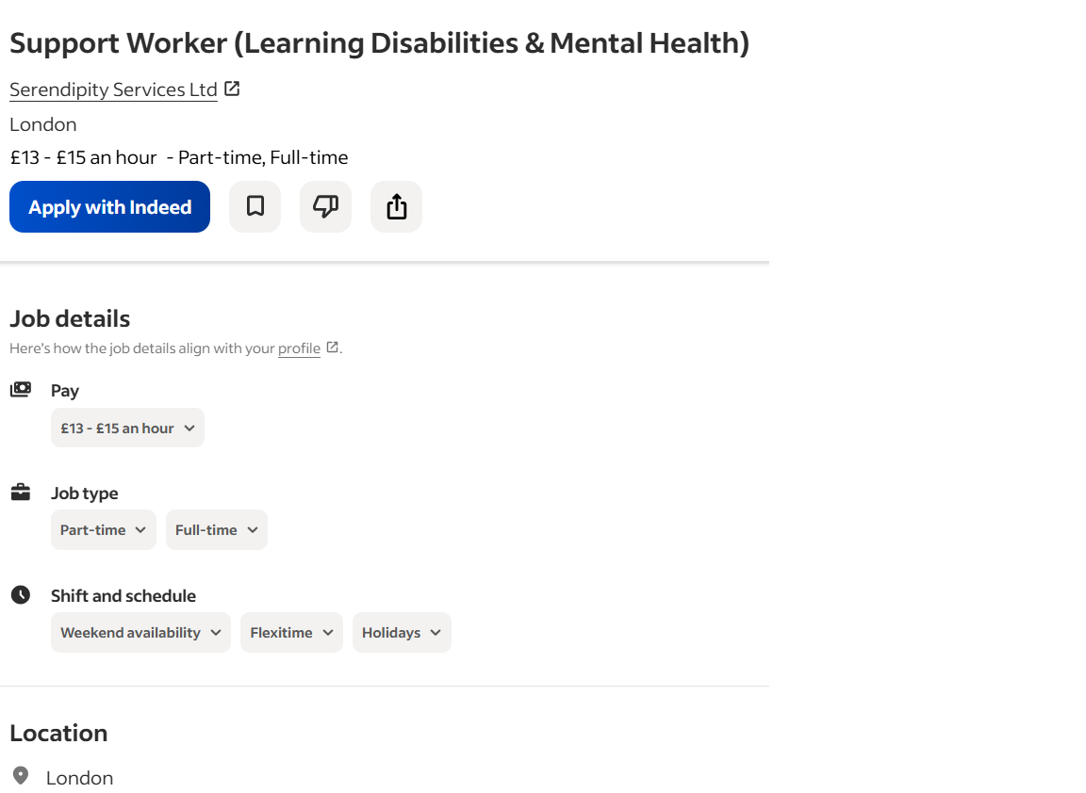

Curriculum Vitae
Name: Cathy Salumu
Address: London, UK
Phone: 07951 710358
Email: glondiomari26@gmail.com

Personal Profile
I am a dedicated Health and Social Care professional with hands-on experience supporting individuals with mental health conditions, learning disabilities, autism, physical health needs, and palliative care. Skilled in both lone working and team environments, I am passionate about delivering high-quality, person-centred care that promotes dignity, independence, and wellbeing. I am currently studying Level 4 Health and Social Care at the University of Wales Trinity Saint David, and I hold a Level 3 Health and Social Care Diploma from Croydon College.

Key Skills
- Person-centred care delivery
- Mental health (complex needs) support
- Learning disabilities & autism support
- Palliative and end-of-life care
- Strong communication and interpersonal skills
- Lone working experience
- Safeguarding awareness
- Teamwork and collaboration
- Time management and organisation
- Empathy, patience, and resilience

Employment History
Support Worker – Mental Health (Complex Needs)
London | 2021 - Present
- Supported individuals with complex mental health needs, ensuring independence and emotional well-being.
- Assisted with daily living activities and care plans.
- Took on lone worker responsibilities and maintained accurate care records.
Support Worker – Learning Disabilities & Palliative Care
Care Home, London | 2020 - 2021
- Provided support to residents with learning disabilities and in palliative care.
- Ensured comfort, dignity, and respect in personal care and emotional support.
Care Assistant – Physical Health
Care Home, London | 2019 - 2020
- Assisted residents with personal care, mobility, and monitoring health conditions.

Education
Level 4 Health and Social Care
University of Wales Trinity Saint David (Ongoing)
Modules include: Academic & Employability Skills, Public Health, Psychology in Health and Social Care, and Professional Career Development.
Level 3 Health and Social Care Diploma
Croydon College | 2021 - 2022
ESOL Qualifications
Croydon College | 2018 - 2019

Hobbies & Interests
Reading, keeping active, spending time with family and friends, helping others, and creating positive and respectful environments.

References
Available upon request.

Task 2 (Personal Statement)
I am a hard-working and dedicated practitioner in the course of pursuing Level 4 Health and Social Care at the University of Wales Trinity Saint David, since I have already acquired a Level 3 Health and Social Care Diploma at Croydon College. I aspire to have a career in health and social care that will help individuals enhance their wellbeing, independence, and quality of life, particularly those with complex mental health requirements. One area that I am particularly keen on is that of mental health assistance, in which I will enter to help individuals who might be unable to live decently and have fulfilling lives.
What I have gathered throughout my studies and work as well has provided me with a wonderful idea of what mental health is and how it must be protected, and the importance of a person-centred approach to deliver care. I have been able to work with individuals with mental health problems, learning disabilities, and autism, and I have also been working in palliative care, where I got to learn how to give them personalised and compassionate care. The experiences have not solely made me more aware of the intricate needs, but have also helped me become more effective, both working alone and in a team environment.
Besides my technical knowledge, I have gained various skills in my profession, such as excellent communication skills, problem-solving and time management skills. As a Support Worker, I now have the understanding of how to accurately record patients in care and ensure a positive emotional state, and offer security. I have also learned to be able to work under stress, multitask, and be a crisis taker. I am highly interested in these skills because I can apply them in my practice as a mental health support worker who will be able to make a great difference in the lives of vulnerable individuals.
My key strength as a candidate is that I am able to establish a good rapport with service users and co-workers. I have also realised to empathise with others, be patient and respond effectively to challenging situations. This is shared with my values, which include offering high-quality care but not infringing on the privacy and dignity of people. Also, my existing studies in health and social care are still supplying me with newer knowledge in the sphere of public health, psychology and professional development, which will all assist me in being the best in this area.
I feel I am able to do this job well simply because I am a good candidate in my knowledge, professional experience and possess personal strengths. I am looking forward to continuing to learn and grow in this area, and I wish I could be given an opportunity to contribute to the work of a team focused on improving the lives of the people that we have in our care.

Task 3 (SWOT & PDP)

Swot Analysis
Strengths | Weaknesses
Strong communication skills. | Limited direct housing experience.
Experience in mental health support. | Need further training in housing legislation.
Empathy, patience, and resilience. | Professional confidence is still developing.
Safeguarding awareness and care delivery. | Limited exposure to case management tasks.
Opportunities | Threats
Training and development in housing. | High demand for housing and limited supply.
Opportunity to work in specialised areas (e.g., homelessness support). | Complex needs of tenants (mental health, financial hardship).
Opportunities to gain more experience in housing-related services. | Time pressures in high workload environments.

I have managed to include my Strengths, Weaknesses, Opportunities and Threats within the scope of my career, as a Support Worker in the Health and Social Care sector (mental health and housing support) using this SWOT analysis. Being aware of these aspects will allow me to be more aware of where I have succeeded, what I need to work on and how I could overcome the potential challenges and opportunities in my career (Gürel & Tat, 2017).
Strengths
I am also aware that there are a host of strengths that I have bearing in my role that will enable me to become a successful person. One of my key strengths is my communication skills. I am good at what I do, engaging with others, I am a good listener, and my ability to communicate effectively is essential in my work with mentally ill people or any people in a housing crisis. My understanding and tolerance with tenants will help me create huge, trusting relationships with them that will play a crucial part in creating a supportive atmosphere in which residents feel safe.
Additionally, my engagement in mental health provisions has allowed me to form a realistic outlook on taking care of challenging care needs. I am also skilled in the sphere of person-centred care, and this aspect allows me to offer assistance to each individual based on his/her personal needs. I also possess a good knowledge of the protection and need to enhance dignity, respect and independence in care. These benefits will render me an effective health and social care professional.
Weaknesses
However, no matter how good a person may be, I find that I have certain weaknesses which I have to work on. My disadvantage is related to the fact that I have no experience in housing services. Though my background in mental health care is solid, I am equally learning about policies, legislation and procedures that govern tenancy management and housing. The gap in experience in the housing sector could limit my service capability to provide full services to tenants in this sector, as housing services might require a new repertoire of legal and practical skills.
The other thing that I have not succeeded in doing yet is that I have yet to establish professional confidence, particularly when I am under a lot of stress. Despite the fact that I can cope with a lot of duties, there are cases when I simply do not want or cannot make a decision, especially in some situations that I am not used to or feel awkward about. Personal development is what concerns me, as I would enhance my self-confidence under these circumstances.
Opportunities
I have a number of opportunities that could assist me in developing professionally and personally. One of the largest opportunities is that a considerable portion of the organisations within the health and social care industry provide training and professional development. Another opportunity I will seize is the opportunity to take courses and certifications in the area of housing, managing cases, and conflict resolution, because this will elevate my knowledge and skills that will help me become more flexible in my employment.
Besides this, the growth of community-based housing programs and other mental health positions in support provides opportunities for me to specialise in either homelessness cases or offering mental health programs in the community housing services. They are great areas that are in demand, and after experience in these special areas, I could be in a position to make a more directional career. Connecting with other expert professionals and being a part of professional bodies will also provide an opportunity to network with mentors, who can provide advice and guidance.
Threats
Inasmuch as opportunities are there, threats, which have the potential to influence my career, are present. Restraints in the inaccessibility of the housing in the majority of areas, as well as high demand for housing, are also one of the key challenges and can increase the burden of the support services. Meeting the rigour of care demanded by tenants may be difficult due to the diversity of needs, especially mental and monetary issues, and social concerns. This has the potential to cause workload stress or burnout unless handled appropriately.
The other risk that I would be exposed to would be the dynamic housing policies and inadequate funds. The resources available to support housing can be subject to change owing to changes in government policies and rebalancing of budgets. This ambiguity can have an impact on offering uniform care and services to tenants. Moreover, the adjustment of policy in housing laws might compel me to change swiftly and familiarise myself with new rules, which might be very difficult without being prepared.

PDP
Goal | SMART Description | Importance | Development & Evaluation
Improve knowledge of housing policies | By Dec 2026, complete 2 online courses and read guidance on housing law and tenancy agreements. | Understanding housing rules ensures I support tenants correctly. | Study online, read from credible sources, and discuss with mentors. Evaluate by completing courses.
Develop case management skills. | By June 2027, practice managing cases using sample case studies. | Accurate records and organisation are crucial for safe practice. | Use case studies, attend training, and get supervisor feedback. Review progress every 3 months.
Enhance communication & conflict resolution. | By Dec 2027, attend workshops and shadow staff to improve skills. | Effective communication helps build trust and manage disputes. | Attend workshops, shadow staff, and use a reflective journal. Monitor through feedback.

To help me not just widen my personal growth but also enhance my professional growth in the area of Health and Social Care, I have specific and outlined goals in my Personal Development Plan (PDP). Specifically, as a Support Worker, particularly in the area of mental health/housing service, I would like to improve my skills and knowledge related to the housing policies, case management, and communication.
Goal 1: Improve Knowledge of Housing Policies
Two housing laws and a tenancy agreement web-based course credits, I will try to accomplish by December 2026. This will assist me in having the legislative context of what governs the housing services and make sure that I will be able to offer accurate and informed services to tenants. I would like to be prepared to deal with housing issues and be able to be helpful to tenants who have to manoeuvre their way through housing matters.
To do this, I will be reading about reliable sources such as Shelter and local councils, and I will have mentors or colleagues more familiar with the field. I would gauge my progress by taking the courses and applying my learning justifications to real-life situations, such as helping the tenants to see what they need to know and can do to their rights and responsibilities. Using the successful completion of these courses as an indicator of my learning will assist me in making sure I am on top of housing laws and practices.
Goal 2: Develop Case Management skills
I will work to enhance my case management skills in June 2027 by engaging in the practice of handling cases involving tenants and improving my record-keeping skills. Case management is also a key component of my role, as I would be able to take care of cases efficiently, keeping myself well-organised, with the ability to track the needs of the tenants. This will also help to protect and, at the same time, give the appropriate services and care to tenants.
This will be achieved through sample case studies, attendance at workshops about case management and having my supervisors assist me in knowing whether I am achieving the standards or not. I will also comment on my progress with each passing few months to determine whether I was able to handle the increasing list of tasks and would continuously improve my ability to organise, so I could someday be in the position to tackle multiple cases and not lose attention to quality care.
Goal 3: Enhance the dynamics of Communication and Conflict resolution
By December 2027, I will be able to better communicate and manage conflict. The mentioned skills are essential, especially in the scenario where I will be collaborating with vulnerable tenants who may have a mental condition or complex personal issues. I also wish to be more successful at engaging with the tenants, colleagues, and other external agencies in a professional and respectful manner when approaching conflict.
I will accomplish this through a communication workshop, shadowing of the experienced personnel and through a reflective journal where I will look back on how I have applied what I am learning. As part of constant evaluation of my progress, I will seek mentors and colleagues to give me feedback on how I am doing in resolving the conflicts, my good relations with tenants and my team members. Among the things that I would notice when I have reached success would be that I am able to approach sensitive situations in a calm, empathetic and effective manner (Merriam Webster Dictionary).

Task 4: Critical Reflection (Gibbs’ Reflection Cycle)
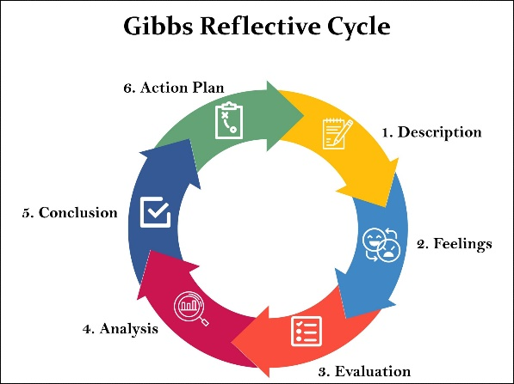

Description
In my LCHS4009 Component 1 presentation, I gave a presentation about the value of critical thinking in health and social care. The session was 5 minutes long, and I focused on defining critical thinking, its role in decision-making and how healthcare professionals can apply it to provide safety and effectiveness in healthcare. I gave a real-life situation of a healthcare professional who saw a slight change in the state of the patient, thus prompting him to reconsider how he dealt with patients, which ultimately led to better results in the patients (Gibbs, 1988).

Feelings
The constrained time that was associated with the presentation contributed to my being nervous before the presentation because I had some uncertainties regarding the ability to deliver the presentation in a clear manner. I was so eager to present a valuable idea, but I feared that I would be in a hurry and miss some important points. However, I started to feel a lot more confident when going through the presentation and especially when I was describing the practical example. Then I felt relieved, but I knew what I would have done to improve, like my pacing and audience engagement (Cottrell, 2019).

Evaluation
All in all, the presentation was a success. The demonstration was understandable, and the practical example pertaining to the real world helped the audience understand how critical thinking is when in a care facility. Nevertheless, I got a review that I talked too fast, especially when giving out the theoretical explanation. The other thing that the lecturer suggested, which I could have done better, is to engage the audience by asking them some questions or making it more engaging with the use of visual aids that would have helped me elaborate on more points.

Analysis
Looking back at the feedback, I understand that it is essential to pace in order to make sure that the audience gets the most out of it. Brookfield (2017) emphasises the importance of understanding when communicating about critical thinking, and I came to know that talking too fast could be a barrier to effective communication. The audience also needs to be addressed, to create interest, as well as cement the message. I did not have the opportunity to engage the audience, making the session more dynamic and interactive.

Conclusion
This experience made me realise that my content was not inappropriate, but I should continue to work on better pacing and involvement of an audience. The use of visual aids and interactions with the audience will assist in presenting the complex ideas in a more comprehensive way and engaging the audience. My speech has to be slow and slow-moving as well so that my points can be heard and understood easily (Facione, 2015).

Action Plan
- When making future presentations, I will:
- Practice pacing and time management, rehearse.
- The interest can be hooked by questions and answers, and interactive sessions.
- Use drawings to assist in elaborating ideas.
- Having other students comment on my preparation before presentation to perfect it.

References
Brookfield, S. (2017). Becoming a critically reflective teacher (2nd ed.). Jossey-Bass.
Cottrell, S. (2019). The study skills handbook (5th ed.). Red Globe Press.
Facione, P. A. (2015). Critical thinking: What it is and why it counts. Insight Assessment.
Gibbs, G. (1988). Learning by doing: A guide to teaching and learning methods. Oxford Polytechnic.
Gürel, E., & Tat, M. (2017). SWOT analysis: A theoretical review. Journal of International Social Research, 10(51), 994–1006.
Merriam Webster Dictionary (nd). Portfolio. Online: https://www.merriam-webster.com/dictionary/portfolio {accessed: 08/03/2025}

