
MODULE NAME | Academic Skills for the Digital Era
Assignment Title | Reflective Essay
Student Name | ALI AHMED SULIMAN 2326008
Lecturer Name | Jaliya de Silva
Submission deadline | Monday 8th December 23:59PM  2025

Table of Contents
1. Introduction 3
1.1 Description 4
1.2 Feelings 5
1.3 Evaluation 6
1.4 Analysis 7
1.5 Conclusion 8
1.6 Action Plan 9
2. Reference 10

Introduction
The transition to university is both exciting and challenging, resulting in outstanding personal and academic improvement. Many students face the transition from an organised high school environment to the more independent, self-directed learning required in higher education. This transition needs not only academic skills, but also ability to manage many obligations, such as time management, computer literacy, and social integration.
A good framework was offered by Gibbs' Reflective Cycle (1988) for considering these difficulties. The cycle comprises six stages: description, feelings, evaluation, analysis, conclusion, and action plan
For the Description phase, I'll cover about my first-term experiences, focusing on academic and digital issues. Secondly, for the Feelings stage will examine my emotional reactions to these problems. In evaluation, I will consider both the positive and negative parts of my experience. The analysis will link these experiences to relevant academic theories. In the Conclusion, I will create major discoveries, and in the Action Plan, I will describe goals for improving my skills over the next term.
The following diagram shows how Gibb’s Reflective Cycle made of:
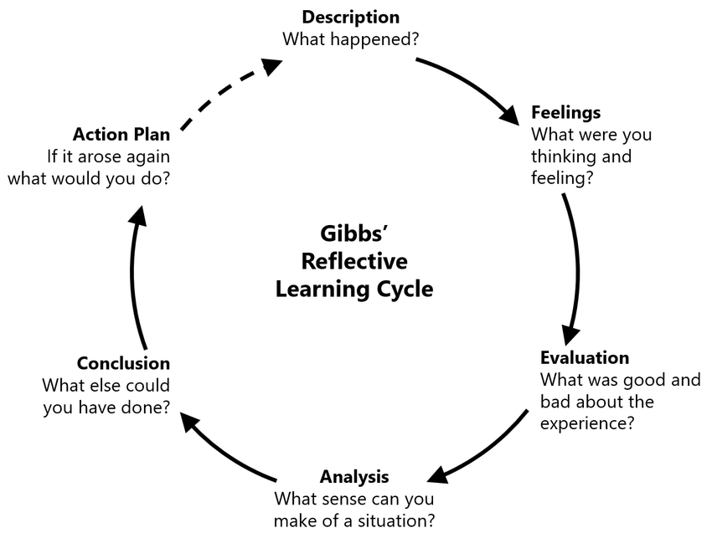
Figure 1.1: Gibbs’ Reflective Cycle (Source https://images.app.goo.gl/8QgNbDRe8JkVnQq37)

1.1 Description
When I first entered university, I was filled with excitement and anticipation, but also a deep sense of uncertainty. The greatest challenge I encountered was adapting to the self-directed nature of university study. In high school, learning was structured, and teachers provided clear guidance and timelines for assignments. At university, however, I was expected to manage my own learning. This shift in responsibility initially overwhelmed me, particularly when it came to managing multiple deadlines from coursework, part-time work, and personal obligations.
Time management was my primary struggle. I often found myself procrastinating, which led to stress as deadlines approached. Without a clear structure in place, I had trouble balancing My university duties overlap with other elements of my life, such as work and social activities. This poor time management has an impact on both the quality of my work and my overall well-being. In addition to time management, academic writing posed another significant challenge. University-level writing was far more demanding than I had anticipated. The expectation for critical analysis, proper referencing, and well-structured essays was much higher than in high school. My early assignments received lower grades than I had hoped, which led to frustration and self-doubt. It became clear that I needed to develop my academic writing skills to meet university standards.
Another challenge I faced was the digital tools and platforms required for coursework. The university relied heavily on online learning management systems, digital libraries, and citation tools. At first, I felt overwhelmed by these unfamiliar tools and struggled to find the information I needed for assignments. I spent a significant amount of time trying to navigate research databases and citation software, which further delayed my academic progress.
Lastly, social integration was a barrier that affected my mental health and overall university experience. As a new student, I initially found it difficult to connect with others. I lacked the social networks I had in high school, and the pressure to form new relationships in a short time created a sense of anxiety and isolation. These social struggles compounded the stress I already felt from my academic challenges

1.2 Feelings
Throughout my first few weeks at university, I was going through a range of emotions. Initially, a sense of excitement, prospect of new academic challenges, and the independence that came with university life. However, as the reality of self-directed learning set in, I quickly began to feel overwhelmed. The pressure of managing coursework, adjusting to the new academic expectations, and trying to balance work and social commitments made me feel anxious and stressed.
I also felt frustrated with my academic performance. The lower grades I received on early assignments were a blow to my confidence, and I started to question my abilities. I compared myself to my peers, many of whom seemed to adapt more easily to university life, and this comparison exacerbated my feelings of inadequacy. I often found myself feeling like I wasn’t measuring up to the expectations of university.
On a social level, I felt isolated. I struggled to make connections with others, which led to feelings of loneliness. I wanted to participate in student organizations and attend social events, but I felt too overwhelmed to do so. As the weeks went on, I felt more and more disconnected from my peers, which made it harder to overcome the academic pressures I was facing.

1.3 Evaluation
Despite the challenges I faced, there were positive experiences that helped me gradually adjust to university life. One of the most helpful resources was the academic writing workshops and digital skills training provided by the university. These sessions helped me improve my ability to conduct research, organize my thoughts, and structure my assignments. The workshops also taught me how to use referencing tools, such as Zotero, and access research databases, which improved the efficiency of my work.
Another positive experience was joining study groups. Initially, I was hesitant to participate in group study sessions, but once I did, I found that they were incredibly helpful. Engaging in discussions with peers allowed me to gain new perspectives on difficult topics, and it also helped build my confidence. I learned that collaborating with others not only improves academic understanding but also creates a sense of community.
I also sought support from university services, including academic advisors and mentors. These conversations helped me develop strategies for managing my workload and improving my study habits. Through these discussions, I realized that seeking help is a normal part of the university experience and that I didn’t have to face challenges alone.
However, my initial reluctance to reach out for help and engage with others delayed my progress. I was often hesitant to ask questions in class or approach professors for clarification, which caused unnecessary stress. My poor time management also led to last-minute work, which negatively impacted the quality of my assignments. I now recognize that seeking help earlier and implementing better time management practices would have significantly improved my academic experience.

1.4 Analysis
Looking back, I can see that many of the difficulties I encountered are common among first-year university students. Effective time management is critical for academic success, and research shows that procrastination and poor planning lead to increased stress and reduced performance (Britton & Tesser, 1991). Had I adopted a more structured approach to managing my time, such as using Google Calendar or creating a weekly study schedule, I would have been able to reduce the stress associated with overlapping deadlines.
Academic writing was another area where I struggled. Cumming (2024) emphasizes that developing strong academic writing skills requires consistent practice, feedback, and engagement with academic resources. By attending workshops earlier in the semester and seeking more feedback from professors and peers, I could have improved my writing skills more efficiently.
Social integration helps students feel connected. According to Astin (1999) ‘‘students who actively involved in social and extracurricular activities experience better outcomes, both academically and personally’’. My reluctance to engage socially hindered my ability to build a support network, contributing to my feelings of isolation. Engaging with student organizations and attending events earlier would have helped me feel more connected to the university community.
Lastly, digital literacy is an essential skill for academic success in the modern university setting. Eshet (2004) argues that proficiency in digital tools and platforms enables students to conduct research more efficiently and manage their academic work more effectively. My early struggles with these digital resources only added to the stress I was already experiencing. Had I attended digital literacy workshops sooner, I would have become more comfortable with the tools and technologies required for my coursework.

1.5 Conclusion
Reflecting on my academic experience, I recognize that better preparation could have facilitated a smoother transition. Seeking academic support sooner, attending digital literacy programs, and adopting structured time management techniques would have helped me overcome my initial challenges. Engaging with study groups and social activities earlier could have also enhanced my university experience.
Research shows that students who actively seek academic support services and mentorship programs perform better and integrate more effectively into university life (Kuh et al., 2005). Understanding these challenges has enabled me to develop a more effective strategy for addressing similar obstacles in the future.

1.6 Action Plan
To enhance my academic and personal growth, I have developed the following strategies:
Specific | Measurable | Attainable | Relevant | Time Bound
Improve my homework management using Google Calendar, Notion, and Zotero. | Over the next month, I will complete three online tutorials and attend two university sessions to strengthen my skills | Each week, I’ll schedule 30 minutes to practice using these tools | Strengthening research and organizational skills begins with digital literacy. | Six weeks from now, I’ll be confident and skilled with Calendar, Notion, and Zotero.
Participating in writing seminars and receiving feedback will strengthen my research and analytical writing skills. | Each month, I will attend a writing class and seek feedback on at least two assignments at the university writing centre. | Each week, I’ll dedicate two hours to practicing academic writing methods. | With strong academic writing, I can rise to university standards and achieve higher grades. | By the end of this semester, I aim to see clear improvements in the feedback on my assignments.
I will build a support network by actively engaging in study groups and student organizations. | Each month, I will participate in two student events and attend at least one study group. | I’ll invest an hour weekly to grow through networking and meaningful conversations. | Building relationships will enhance my wellbeing and enrich my academic journey. | Within three months, I aim to establish a strong social and academic support network.
I will establish organized study schedules and apply efficient methods such as the Pomodoro Technique and SMART goal setting. | By committing to a schedule and using Pomodoro, I’ll sharpen my focus in three or more study sessions weekly. | Each Sunday, I will review my progress and organize my assignments using Google Calendar. | With stronger time management skills, I will meet deadlines without last‑minute stress. | Within eight weeks, I will establish a consistent and organized study schedule.
I intend to integrate concentration practices, regular exercise, and healthy sleep habits into my daily regimen. | I will dedicate 10 minutes daily to mindfulness, exercise three times weekly, and maintain 7–8 hours of sleep. | I will gradually adjust my daily routine to incorporate these habits effectively. | By maintaining both mental and physical wellness, I can enhance my academic performance. | Within two months, I aim to establish a sustainable wellness regimen for long-term balance.

Through these strategies, I aim to overcome past challenges and cultivate a more rewarding, successful university experience.

Reference
- Astin, A.W., 1999. Student involvement: A developmental theory for higher education. Journal of College Student Development, 40(5), pp.518–529.
- Britton, B.K. & Tesser, A., 1991. Effects of time-management practices on college grades. Journal of Educational Psychology, 83(3), pp.405–410.
- Cumming, J., 2024. Improving academic writing skills for university students. Oxford: Oxford University Press.
- Drucker, P., 1954. The Practice of Management. New York: Harper & Row.
- Eshet, Y., 2004. Digital literacy: A conceptual framework for survival skills in the digital era. Journal of Educational Multimedia and Hypermedia, 13(1), pp.93–106.
- Gibbs, G., 1988. Learning by Doing: A Guide to Teaching and Learning Methods. Oxford: Further Education Unit.
- Kuh, G.D., Kinzie, J., Buckley, J.A., Bridges, B.K. & Hayek, J.C., 2005. What matters to student success: A review of the literature. Commissioned Report for the National Symposium on Postsecondary Student Success. Washington, DC: National Postsecondary Education Cooperative.
- Lee, S.Y. & Williams, M., 2014. Procrastination, stress, and academic performance. International Journal of Academic Research in Education, 3(2), pp.142–150.
- Mason, M., 2021. Social anxiety and student well-being in higher education. Journal of College Student Mental Health, 18(2), pp.102–113.
- McKeachie, W.J. & Svinicki, M.D., 2014. McKeachie’s Teaching Tips: Strategies, Research, and Theory for College and University Teachers. Boston: Cengage Learning.
- McMillan, J.H. & Weyers, J.D., 2010. Assessing and Improving Academic Skills. Harlow: Pearson Education.
- Moos, R.H. & McCluskey, S.P., 2002. Improving academic performance through time-management practices. Educational Psychology Review, 14(2), pp.225–246.
- O’Neill, G. & McMahon, T., 2014. Student-centred learning: What does it mean for students and lecturers? In: G. O’Neill & T. McMahon, eds. Supporting student learning: Theory and practice. Dordrecht: Springer, pp.1–20.
- Zimmerman, B.J., 2000. Attaining self-regulation: A social cognitive perspective. In: M. Boekaerts, P.R. Pintrich & M. Zeidner, eds. Handbook of Self-Regulation. San Diego: Academic Press, pp.13–39.
- Zepke, N., 2015. Building Student Engagement in Higher Education. Dordrecht: Springer.

