University of Wales Trinity Saint David
Wales Institute of Science and Art


Analytical Assessment of
Engine Internal Components

ACHA6006 Contemporary Powertrain Design

Word count: 2746

Rhys Thomas
2303931
March 2026
Contents
1 Table Of Figures 1
2 Introduction 2
3 Background 3
4 Engine Internal Load Analysis 4
4.1 Ford Sigma Engine Geometry 4
4.2 Ford EcoBoost 1.6 GDTI Engine Geometry 4
4.3 Stress Determination of Critical Components 5
4.3.1 Connecting rod midpoint 5
4.3.2 Gudgeon pin 6
4.3.3 Connecting rod bolt 7
5 Extended Engine Speed Analysis to 9000 RPM 8
5.1 Interpolation of Pressure Data for Extended RPM Range 8
6 Connecting Rod Bolt Redesign 10
6.1 Design Requirements and Target Safety Factors 10
6.2 Bolt Geometry Modification and Material Change 10
6.3 Recalculated Stress and Fatigue Safety Factors 11
7 Crankshaft Torque Analysis 12
7.1 Crank Torque Analysis 12
7.2 Cross-Plane Torque Behaviour 12
7.3 Cylinder Torque Contribution 14
7.4 Mean Engine Torque Comparison 15
8 Conclusion 15
9 References 16

Table Of Figures
Figure 1 - Diagram of Piston, conrod and crank. 4
Figure 2 - Fatigue Safety Factor Connecting Rod Goodman Diagram 5
Figure 3 - Fatigue Safety Factor Gudgeon Pin Goodman Diagram 6
Figure 4 - Fatigue Safety Factor Connecting Rod Cap Goodman Diagram 7
Figure 5- Fatigue Safety Factor Connecting Rod Cap with Gas Goodman Diagram 7
Figure 6 - Extended Gas Force Interpolated RPM to 9000RPM 8
Figure 7 - Fatigue Safety Factor Cap Bolt 9000RPM Goodman Diagram 9
Figure 8 - Fatigue Safety Factor Bolt Redesign Goodman Diagram 11
Figure 9 - Inertia Torque Vs Crank Angle 12
Figure 10 - Inertia Torque Vs Crank Angle 13
Figure 11 - Cross Plane Torque Vs Crank Angle 14
Figure 12 - Mean Torque Comparison Graph 15

Introduction
This report evaluates the internal loading of key components within a Ford Sigma 1.6 L engine, focusing on the connecting rod, gudgeon pin, and connecting rod bolt. Using pressure data and engine geometry, stresses are calculated and assessed using Goodman fatigue analysis to determine component performance and failure risk.
The analysis is extended to 9000 RPM to investigate the effect of increased inertial loading. Based on these findings, a redesign of the connecting rod bolt is proposed to improve fatigue performance. Crankshaft torque behaviour is also analysed to provide context for the loading conditions experienced within the engine.

Background
Internal combustion engine components experience cyclic combustion and inertial loading, which can lead to fatigue failure. Analytical methods are used to estimate these stresses, although results depend on simplifying assumptions.

Engine Internal Load Analysis

Ford Sigma Engine Geometry
The internal forces experienced within an engine are governed by its geometric configuration. The Ford Sigma 1.6 L engine operates using a conventional crank–slider mechanism, where crankshaft rotation converts into reciprocating piston motion through the connecting rod. Key geometric parameters including cylinder bore, stroke, connecting rod length and reciprocating mass directly influence piston kinematics and therefore the magnitude of forces transmitted through the engine’s bottom-end components.
Consequently, engine geometry directly governs the magnitude and distribution of forces acting within bottom-end components. Understanding these geometric relationships forms the foundation for the force and stress analysis carried out in the following sections.
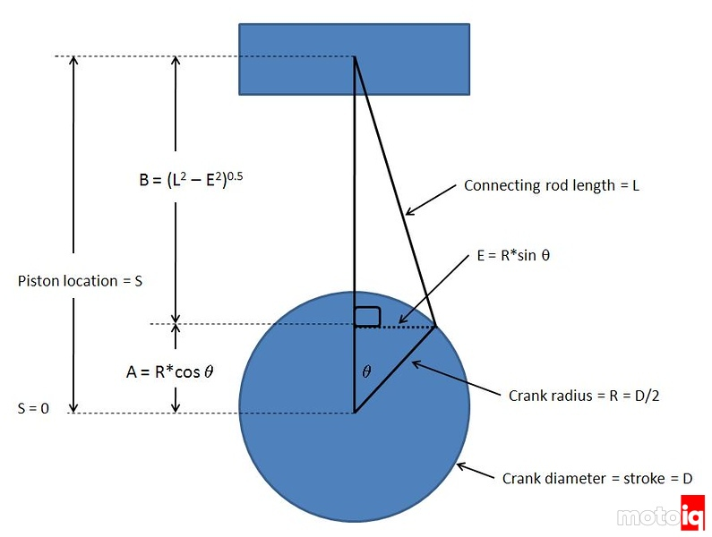
Figure 1 - Diagram of Piston, conrod and crank.

Ford EcoBoost 1.6 GDTI Engine Geometry
Table 1 - Ford EcoBoost 1.6 GDTI Engine Geometry
Parameter | Value | Unit
Bore Diameter | 79 | mm
Stroke | 81.4 | mm
Crank Radius | 40.7 | mm
Connecting Rod Length | 134 | mm
Reciprocating Mass | 347 | g
Rotational Mass | 268 | g
Piston Mass | 268 | g
Gudgeon Pin Mass | 28 | g
Piston Ring Mass | 9 | g
Circlip Masses | 5 | g

Stress Determination of Critical Components
Critical engine components experience the highest mechanical loads within an internal combustion engine. In this study the primary components analysed are the connecting rod, gudgeon pin and connecting rod bolts, as these elements transmit the combustion and inertial forces generated during engine operation. The stresses experienced by these components are assessed using Goodman fatigue analysis, which compares the operating stress range with the material endurance limits to determine the fatigue safety factor and likelihood of failure. (Nisbett & Shigley, 2008)

Connecting rod midpoint
The midpoint of the connecting rod represents a critical location due to the combined loading experienced during the engine cycle. At this position the rod is subjected to alternating tensile and compressive forces generated by combustion pressure acting on the piston as well as inertial forces from the reciprocating mass. These forces vary with crank angle and engine speed, producing cyclic stresses within the rod which must be evaluated to determine the likelihood of fatigue failure. (Xu W, 2024)
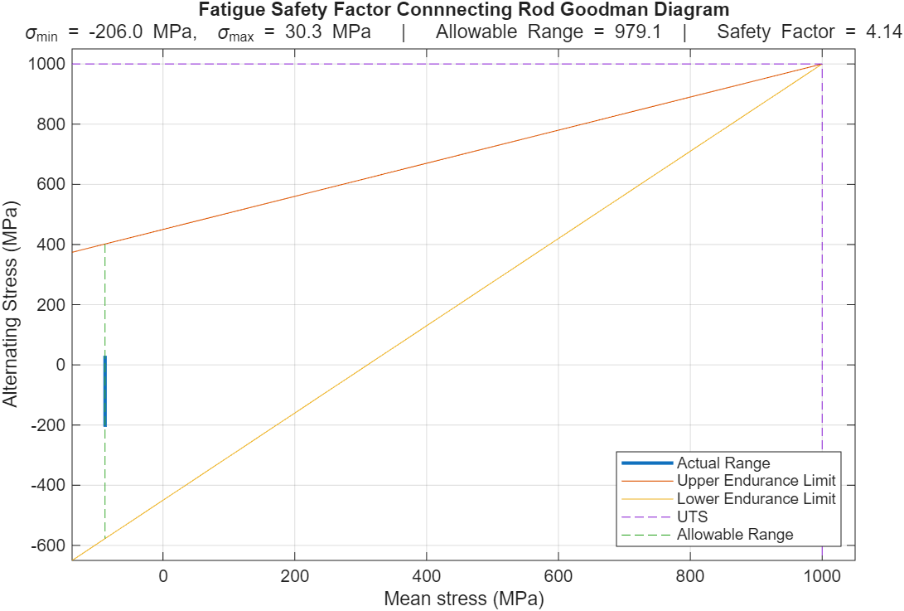
Figure 2 - Fatigue Safety Factor Connecting Rod Goodman Diagram

As shown in Figure 2, the calculated stress range at the connecting rod midpoint lies within the allowable fatigue region, resulting in a fatigue safety factor of 4.14. While this indicates a substantial fatigue margin, the magnitude of this value is high for a production component and may suggest that the connecting rod is overdesigned for the predicted loading case. However, this result is dependent on the assumptions of the analytical model, which does not account for stress concentrations, misalignment, or secondary bending effects that would increase the local stress state and reduce the true fatigue strength. Additionally, ideal combustion behaviour is assumed, neglecting transient pressure spikes such as knock. Therefore, although the results suggest the component is not the limiting factor, the true safety margin is likely lower than predicted, and therefore it may be too conservative.

Gudgeon pin
As shown in Figure 3, the operating stress range for the gudgeon pin lies within the allowable fatigue region, with stresses varying between 1.8 MPa and 205.9 MPa, resulting in a fatigue safety factor of 3.95. This indicates a substantial fatigue margin under the predicted loading conditions. However, again this value should be interpreted with caution due to the simplified nature of the analytical model.
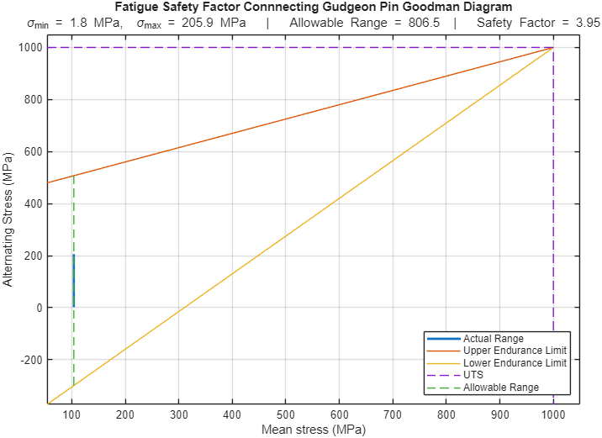
Figure 3 - Fatigue Safety Factor Gudgeon Pin Goodman Diagram

The current analysis primarily considers global bending stresses and does not account for localised contact stresses between the pin and small-end bearing, which are typically significant in real engine operation and often cause failure (A. Strozzi, 2018). Additionally, dynamic effects such as piston slap and high-frequency loading at elevated engine speeds are not calculated, which may increase the effective stress range. As a result, the true fatigue performance of the gudgeon pin is likely less favourable than predicted.
Therefore, while the results suggest the gudgeon pin is not the limiting component, its performance is highly dependent on local stress conditions and wear behaviour, which are not fully represented in this model.

Connecting rod bolt
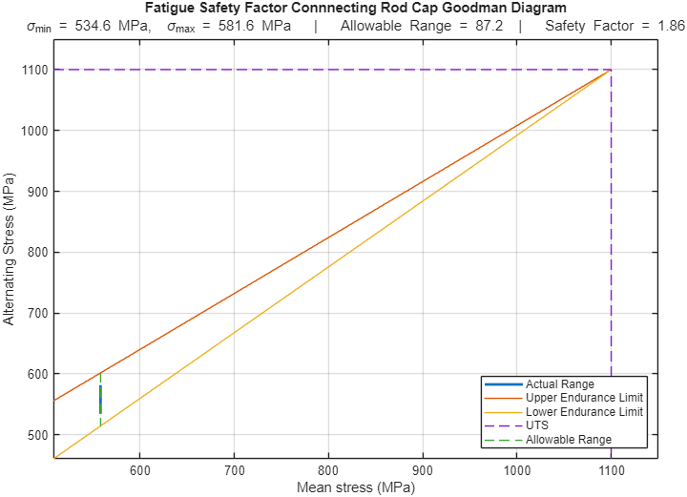
As shown in Figure 4, the connecting rod bolt operates significantly closer to the Goodman failure boundary compared to the other components, with stresses ranging from 534.6 MPa to 581.6 MPa and a fatigue safety factor of 1.86. This relatively low safety factor highlights the bolt as the most critical component within the assembly, primarily due to the high tensile mean stress introduced by bolt preload, which shifts the operating point towards the upper region of the Goodman diagram.
Figure 4 - Fatigue Safety Factor Connecting Rod Cap Goodman Diagram

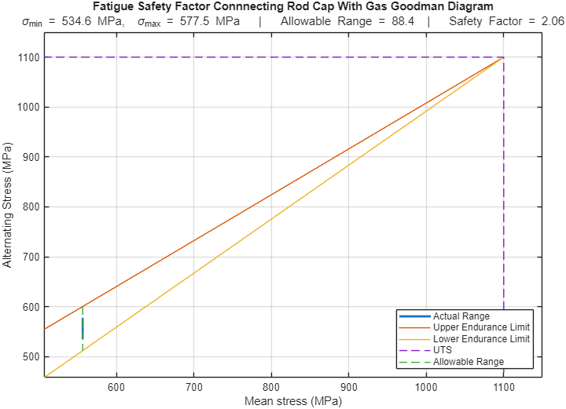
However, this result is highly sensitive to the assumed preload condition. In practice, variations in tightening torque, thread friction, and assembly methods can lead to significant changes in preload, potentially reducing the fatigue safety factor further. Additionally, the analysis does not account for stress concentrations at thread roots, which are common initiation sites for fatigue failure in bolted joints (S. Griza, 2009) and would increase the local stress beyond the nominal values calculated.
Figure 5- Fatigue Safety Factor Connecting Rod Cap with Gas Goodman Diagram

When gas forces are included, the slight increase in fatigue safety factor reflects the beneficial effect of combustion pressure in reducing bolt tension. However, this assumes consistent combustion behaviour and does not consider abnormal events such as detonation, although the results indicate acceptable performance under ideal conditions, the connecting rod bolt remains the most critical and failure-sensitive component, with its true fatigue margin likely lower than predicted.

Extended Engine Speed Analysis to 9000 RPM
The original pressure data provided for the analysis covered engine speeds up to 6000 RPM. However, higher engine speeds are commonly encountered in performance applications and can significantly increase inertial loading within the reciprocating assembly. As inertial forces increase with the square of engine speed, even modest increases in RPM can lead to substantially higher stresses in critical components. To investigate the effect of higher operating speeds, the pressure data was interpolated to extend the analysis up to 9000 RPM.

Interpolation of Pressure Data for Extended RPM Range
To extend the analysis beyond the available engine speed data, the cylinder pressure curves were interpolated to generate pressure profiles for engine speeds up to 9000 RPM. Initially, a piecewise cubic Hermite interpolation (PCHIP) method was considered to maintain a smooth pressure curve between data points. However, due to the structure and spacing of the provided dataset, this method could not be reliably implemented. As a result, a linear interpolation approach was adopted to estimate the pressure values. While this method does not perfectly reproduce the curvature of real combustion pressure traces, it provides a reasonable approximation for the dataset and allows the effect of increased engine speed on internal forces to be evaluated.
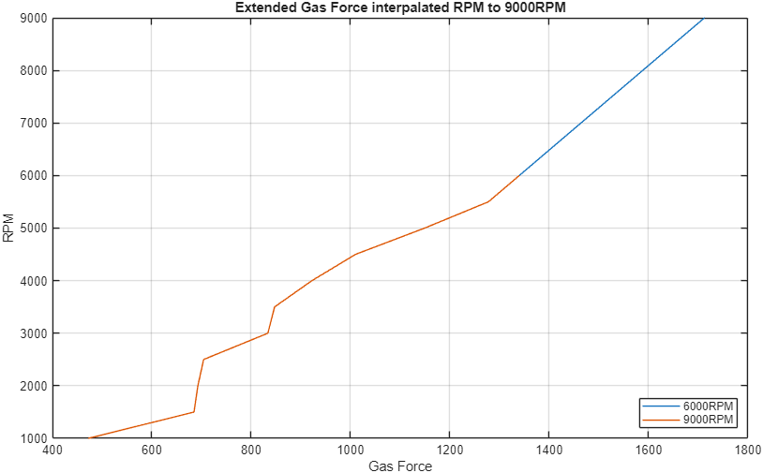
Figure 6 - Extended Gas Force Interpolated RPM to 9000RPM

When the engine speed is increased to 9000 RPM, the stresses within the connecting rod bolt rise significantly due to the increase in inertial forces. Under these conditions, stresses range between 534.6 MPa and 635.1 MPa, resulting in a fatigue safety factor of 0.83. This indicates that the bolt no longer satisfies infinite life fatigue criteria and would be susceptible to fatigue failure under sustained operation at this speed.
However, a safety factor below one does not necessarily imply immediate failure, as the component may still achieve a finite fatigue life depending on the number of load cycles and operating conditions. In practical applications, engine speeds approaching 9000 RPM are often transient rather than continuous, which may reduce fatigue damage. Despite this, the result clearly demonstrates that the existing bolt design is not suitable for high-speed operation.
It is also important to recognise that this result is influenced using linearly interpolated pressure data, which may not accurately capture peak combustion pressures at higher engine speeds. Any underestimation of peak pressure would further increase the calculated stresses, meaning the true fatigue safety factor could be lower than predicted. Therefore, while the exact value of 0.83 should be treated with caution, the overall trend confirms that the connecting rod bolt becomes the limiting component at elevated engine speeds, justifying the need for redesign.
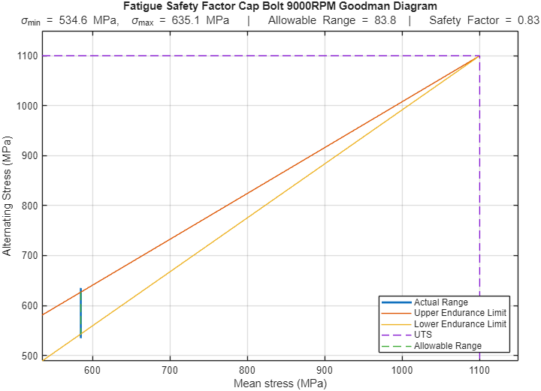
Figure 7 - Fatigue Safety Factor Cap Bolt 9000RPM Goodman Diagram

Connecting Rod Bolt Redesign

Design Requirements and Target Safety Factors
The previous analysis demonstrated that the connecting rod bolt does not meet acceptable fatigue performance criteria at 9000 RPM, with a safety factor below one indicating that infinite life cannot be achieved under high-speed operation. As a result, a redesign is required to ensure reliable performance within the intended operating range.
In defining a suitable design target, it is important to consider that production engine components are typically designed with fatigue safety factors between 1.5 and 2.0 to balance durability with weight and packaging constraints (Nisbett & Shigley, 2008). Therefore, the objective of the redesign is to increase the fatigue safety factor above unity and ideally towards this range, while maintaining compatibility with the existing connecting rod assembly.
The redesign must also consider practical limitations, including geometric constraints within the rod. Consequently, the design strategy focuses on improving fatigue resistance through material selection and geometric modification, while avoiding excessive increases in weight or changes to the overall assembly.

Bolt Geometry Modification and Material Change
To improve the fatigue performance of the connecting rod bolt, both the material and geometry were modified. The original bolt material was replaced with Custom Age 625+ (Carpenter Technology, 2026), a high-strength alloy used in high-performance fastening applications due to its high ultimate tensile strength and improved fatigue resistance. The selection of this material allows for a higher allowable stress range, effectively shifting the operating point further away from the Goodman failure boundary.
In addition to the material change, the diameter of the wasted shank section was decreased from 6 mm to 5.4 mm. Decreasing the shank diameter decreases the cross-sectional area of the bolt, reducing the nominal stress experienced under the same loading conditions. However, this decrease was limited to 0.6 mm to avoid excessive decreases in mass and to ensure compatibility with the existing connecting rod geometry. A larger decrease in diameter may further reduce stress but would introduce constraints and alter the dynamic behaviour of the reciprocating assembly.
This combined approach of material enhancement and geometric modification provides an efficient method of improving fatigue performance, as it simultaneously increases material strength while reducing applied stress. The design therefore targets an improved fatigue safety factor without introducing unnecessary increases in size or mass, maintaining a balance between strength, weight, and practical implementation.
The decrease in bolt diameter was also constrained by the requirement to maintain adequate connecting rod bearing clearance, ensuring that the modified geometry does not interfere with the big-end assembly or alter lubrication conditions. Maintaining this clearance is critical (MAHLE International GmbH, 2016) to avoid increased friction, overheating, or premature `bearing wear, and therefore the redesign was limited to a dimension that preserves the original assembly constraints.

Recalculated Stress and Fatigue Safety Factors

Following the modification to the bolt material and geometry, the stresses within the connecting rod bolt were recalculated under the same 9000 RPM loading conditions. The redesigned bolt experiences stresses between 729.0 MPa and 826.8 MPa, producing a fatigue safety factor of 1.48. This represents a significant improvement compared with the original bolt design, which produced a fatigue safety factor of 0.83 under the same operating conditions and therefore fell outside the allowable fatigue region. The increase in safety factor is primarily attributed to the use of Custom Age 625+, which provides significantly higher strength and fatigue resistance, combined with the decrease in wasted shank diameter from 6 mm to 5.4 mm, which decreases the bolt cross-sectional area and reduces the effective stress experienced under the applied loads. As a result, the operating stress point is shifted back within the allowable Goodman region, indicating that the redesigned bolt can withstand the increased stresses generated at higher engine speeds. The resulting fatigue safety factor of 1.48 indicates that the redesigned bolt can operate safely at 9000 RPM while maintaining an acceptable fatigue margin, demonstrating that the modifications successfully address the limitation identified in the original bolt design.

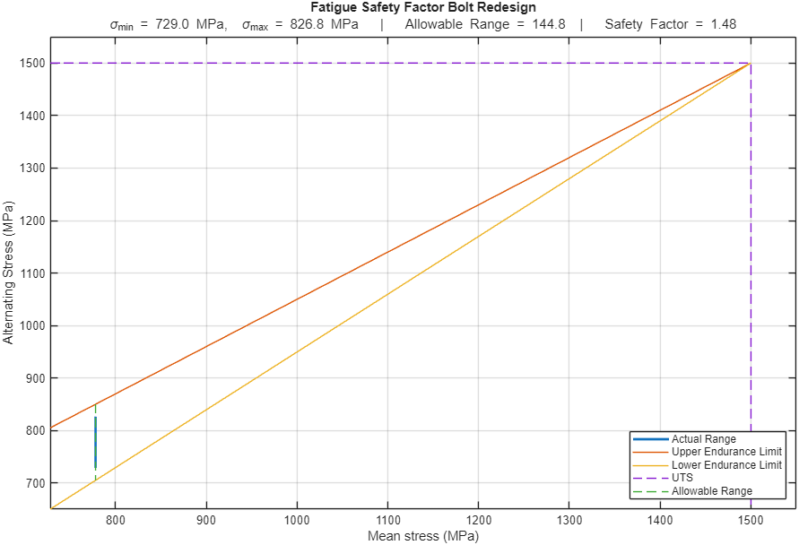
Figure 8 - Fatigue Safety Factor Bolt Redesign Goodman Diagram

Crankshaft Torque Analysis

Crank Torque Analysis
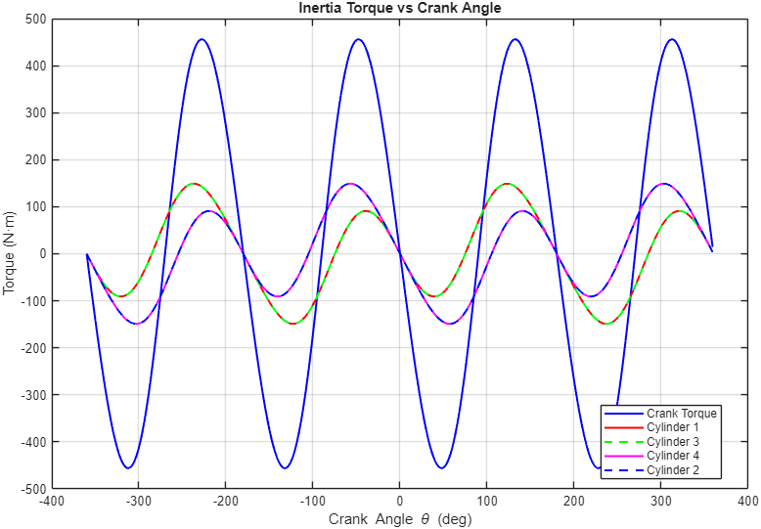
The inertia torque results demonstrate that reciprocating mass effects dominate instantaneous crankshaft loading, with peak torques approaching ±450 Nm, far exceeding the individual cylinder contributions. This highlights that the largest stresses within the crankshaft are not driven directly by combustion, but by the acceleration of the piston–rod assembly. As a result, peak mechanical loading within engine components will occur during high inertial events rather than peak cylinder pressure alone. This has important implications for fatigue analysis, as it suggests that component design must account for combined gas and inertia loading rather than considering combustion forces in isolation. Furthermore, the magnitude of these oscillations indicates that any imbalance or modelling inaccuracy in reciprocating mass assumptions could significantly affect predicted torque behaviour.
Figure 9 - Inertia Torque Vs Crank Angle

Cross-Plane Torque Behaviour
The cross-plane torque results show a significant reduction in overall torque fluctuation compared to the raw crank torque, confirming the effectiveness of phase-offset cylinder firing in smoothing engine output. The reduced amplitude of the combined torque trace indicates that individual cylinder contributions partially cancel one another, leading to a more uniform torque delivery over the engine cycle. However, the persistence of residual oscillations suggests that complete dynamic balancing is not achieved, and torsional excitation of the crankshaft remains unavoidable. This is particularly relevant for high-speed operation, where even reduced oscillations can contribute to fatigue loading and vibration issues. The results therefore demonstrate that while cross-plane configurations improve drivability and smoothness, they do not eliminate the need for careful torsional vibration management.

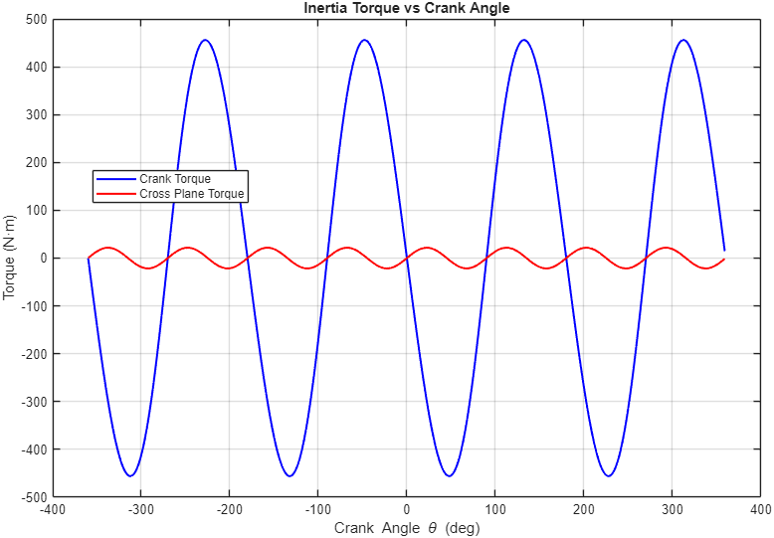
Figure 10 - Inertia Torque Vs Crank Angle

The cross-plane torque results demonstrate a clear reduction in torque fluctuation compared to the single cylinder crank torque, with the combined trace showing significantly reduced peak-to-peak amplitude. This suggests that the cross-plane configuration is well suited to the operating conditions of the Ford EcoBoost 1.6, where smooth torque delivery across the engine cycle is desirable. In applications where a more peaky, high-RPM power output was required, such as motorsport, the additional torque fluctuation of a single cylinder arrangement may be more acceptable given the reduced reciprocating mass and packaging benefits. However, based on the data generated in this analysis, the cross-plane configuration provides a more consistent torque output across the full crank angle range, making it the more appropriate choice for the road-going application this engine is designed for.

Cylinder Torque Contribution
The individual cylinder torque traces exhibit clear phase separation, ensuring continuous torque delivery throughout the engine cycle. While peak magnitudes are relatively consistent between cylinders, the presence of negative torque regions highlights that each cylinder alternates between producing and absorbing energy. These negative regions correspond to compression and inertial resistance, reinforcing that net engine output is the result of a dynamic balance rather than continuous power production. This behaviour also suggests that any imbalance between cylinders, such as variations in combustion pressure or air–fuel distribution, could lead to uneven torque delivery and increased vibration. Therefore, the assumption of uniform cylinder performance within the model may overestimate the smoothness of real engine operation.
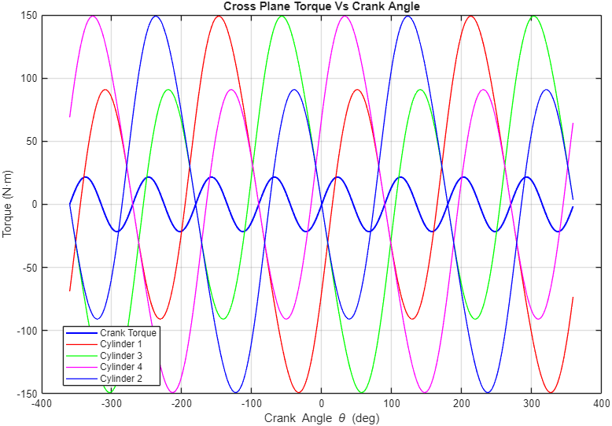
Figure 11 - Cross Plane Torque Vs Crank Angle

Mean Engine Torque Comparison
The comparison between simulated and empirical mean engine torque demonstrates that the model captures the general trend of torque production at lower engine speeds but becomes increasingly inaccurate at higher RPM. While the simulated torque aligns reasonably well with the empirical 150 PS curve up to approximately 3000–4000 RPM, it fails to reproduce the pronounced drop-off observed in real engine performance beyond this range. This indicates that the model does not fully account for speed-dependent losses such as reduced volumetric efficiency, intake and exhaust flow limitations, and combustion inefficiencies.
Although the introduction of a calculated 6% friction loss improves correlation, it remains insufficient to match the experimental data at higher speeds, suggesting that friction alone is not the dominant loss mechanism. Instead, airflow restriction and reduced cylinder filling are likely the primary contributors to the observed deviation. Consequently, the model can be considered suitable for predicting general torque trends, but its accuracy is limited when representing high-speed engine behaviour. This limitation should be considered when interpreting results used for component design and fatigue analysis.
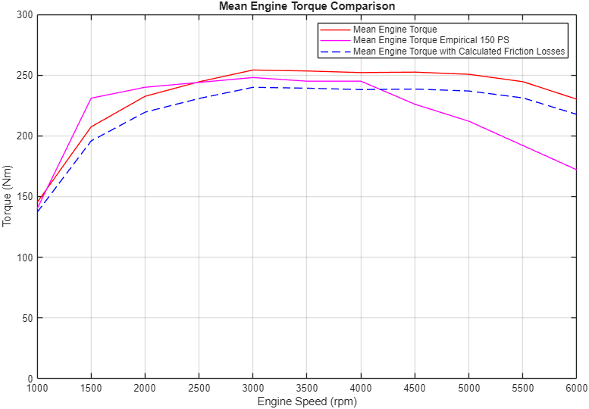
Figure 12 - Mean Torque Comparison Graph

Conclusion
The analysis identified the connecting rod bolt as the most critical component, operating closest to the fatigue failure limit. At 9000 RPM, the safety factor fell below unity, indicating that the original design is unsuitable for sustained high-speed operation. The redesigned bolt improved the safety factor to 1.48, bringing the component back within an acceptable range, although this remains sensitive to modelling assumptions such as preload and stress concentrations.
Crankshaft torque results showed that inertia forces dominate instantaneous loading, reinforcing the need to consider combined loading effects in fatigue analysis. While the model captures general trends, its accuracy is limited at higher engine speeds, suggesting that further refinement is required for more reliable prediction of real engine behaviour.

References
A. Strozzi, A. B. S., 2018. A repertoire of failures in gudgeon pins for internal combustion engines, and a critical assessment of the design formulae. 5th ed. Modena: Elsevier.
Carpenter Technology, 2026. Custom Age 625 Plus. [Online]
Available at: https://www.carpentertechnology.com/alloy-finder/custom-age-625-plus
[Accessed 16 03 2026].
MAHLE International GmbH, 2016. Cylinder components: Properties, applications, materials.. 2nd edition ed. s.l.:Springer.
Nisbett, J. K. & Shigley, J. E. M., 2008. Shigley's mechanical engineering design. 11th ed. Boston: McGraw-Hill.
S. Griza, F. B. G. Z. A. R. T. S., 2009. Fatigue in engine connecting rod bolt due to forming laps. s.l.:Elsevier.
Xu W, d. B. O. G. M. H. M. C. O. S.-H. C., 2024. Proceedings of the Institution of Mechanical Engineers, Part D: Journal of Automobile Engineering. s.l.:SAGE Publications.

