
Introduction To Web & Database Concepts
Level 4
Sophie Foyle (2506393) | 11/19/25 | ACCA4023

Contents
Introduction 3
Requirements 3
Implementation 4
Website Screenshots 4
Home Page 4
Programme Page 5
Contact Page 6
Privacy Policy 7
Data Protection 8
Code Validation 9
What is a Code Validator? 9
Why Validate Code? 9
HTML Validation 9
CSS Validation 10
Evaluation 11
Research 11
Usability 11
Accessibility 11
Search Engine Optimisation (SEO) 12
Evaluation of ‘Taste of Wales’ 12
Usefulness (Usability & Utility) 12
Search Engine Optimisation (SEO) 12
Accessibility 13
Live Website Comparison 19
Usability 19
Accessibility 19
Search Engine Optimisation 20
Mobile Friendliness 21
Conclusion 21
References 21
Appendices 23
HTML Code – Home 23
HTML Code – Programme 25
HTML Code – Contact 28
HTML Code – Privacy Policy 31
HTML Code – Data Protection 34
CSS Code – Stylesheet 36

Introduction

This report covers the design, implementation, and evaluation of Taste of Wales website, which was created to promote an annual Welsh food festival. Here I discuss my thought process in developing the HTML and the CSS code, highlight areas for improvement, and present findings from code and contrast checkers with supporting screenshots.

Requirements

Taste of Wales is a vibrant website promoting a local, family-friendly Welsh food festival celebrating traditional cuisine and culture. It provides essential details such as date, time, address, and a Google Maps location, all while remaining visually appealing and easy to use.

Highlights include:
- Local Welsh food and drink vendors
- Live music throughout the day
- Traditional Welsh entertainment
- Kids’ corner showcasing its family focus

The site displays interactive features, embedded videos, and enticing images which enhance appeal and encourage ticket purchases. Traditional Welsh colours and promotion of local vendors appeal to the local community, while links to other festivals and food imagery attract food-fanatics. The site clearly advertises live music, drinks, and family activities, appealing to those seeking a festival atmosphere and families wanting a relaxed day out.
The design of the site aims to be simple, concise, and visually engaging, with consistent use of Welsh colour throughout.

Implementation

Website Screenshots

Home Page
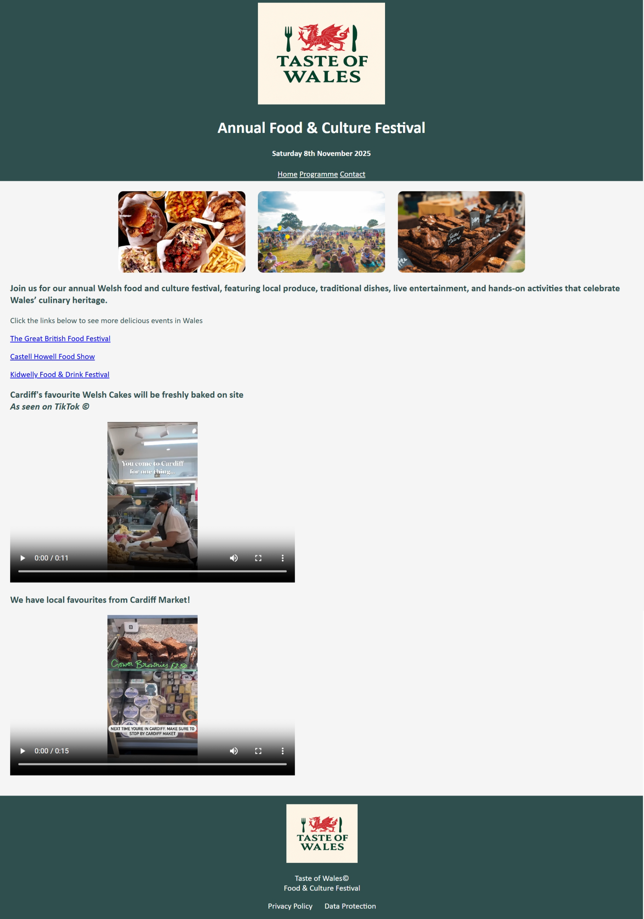

The image shows the full homepage, where users learn the event’s purpose, features, date, and location. Navigation links lead to programme and contact pages, with privacy and data protection in the footer. Each tab is accessible from every page for easy navigation. The homepage also includes links to other food festivals and embedded vendor videos to attract customers.

Programme Page
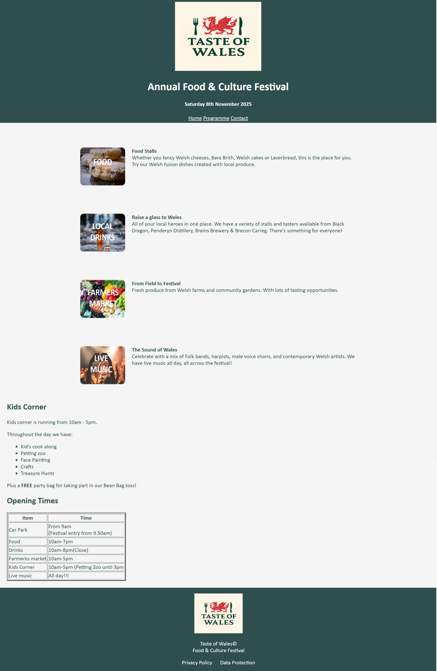

This page highlights food, drink markets, and music, with interactive hover-over elements and concise descriptions. Kids’ Corner and opening times are prominently displayed, presenting key information in a clear, appealing format. Footer and header remain consistent, and navigation links work across all pages.

Contact Page
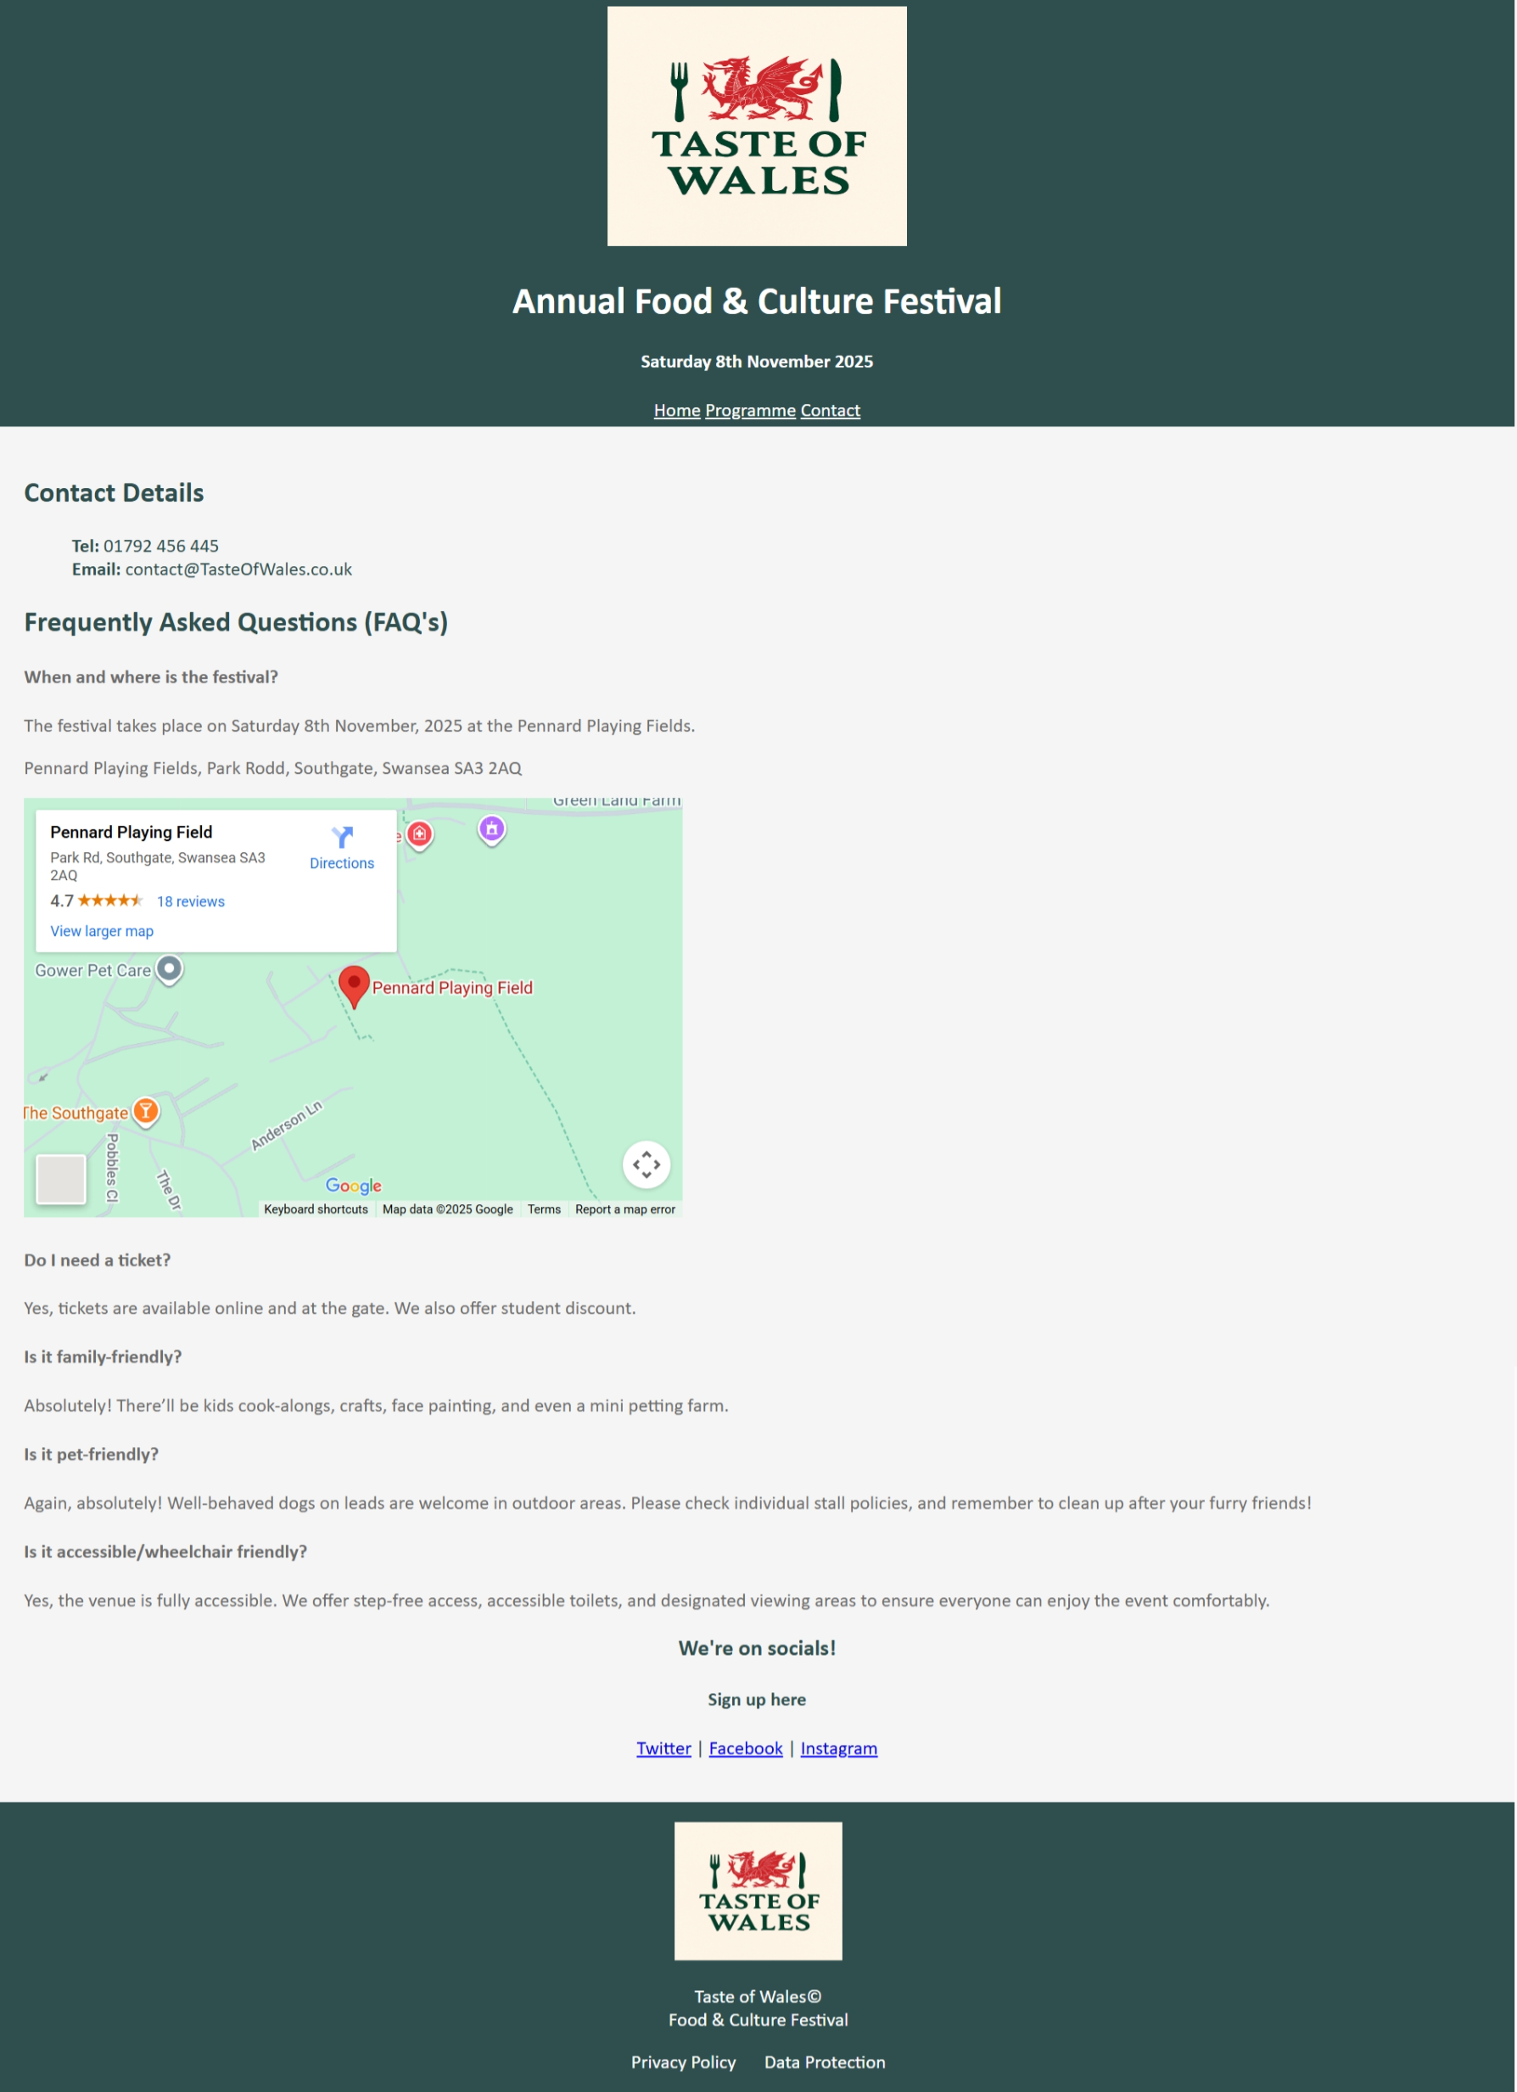

This page provides contact details, location, and an embedded Google Map. An FAQs section improves user experience, while navigation links connect to social media sign-ups. Colour themes, headers, and footers remain consistent throughout.

Privacy Policy
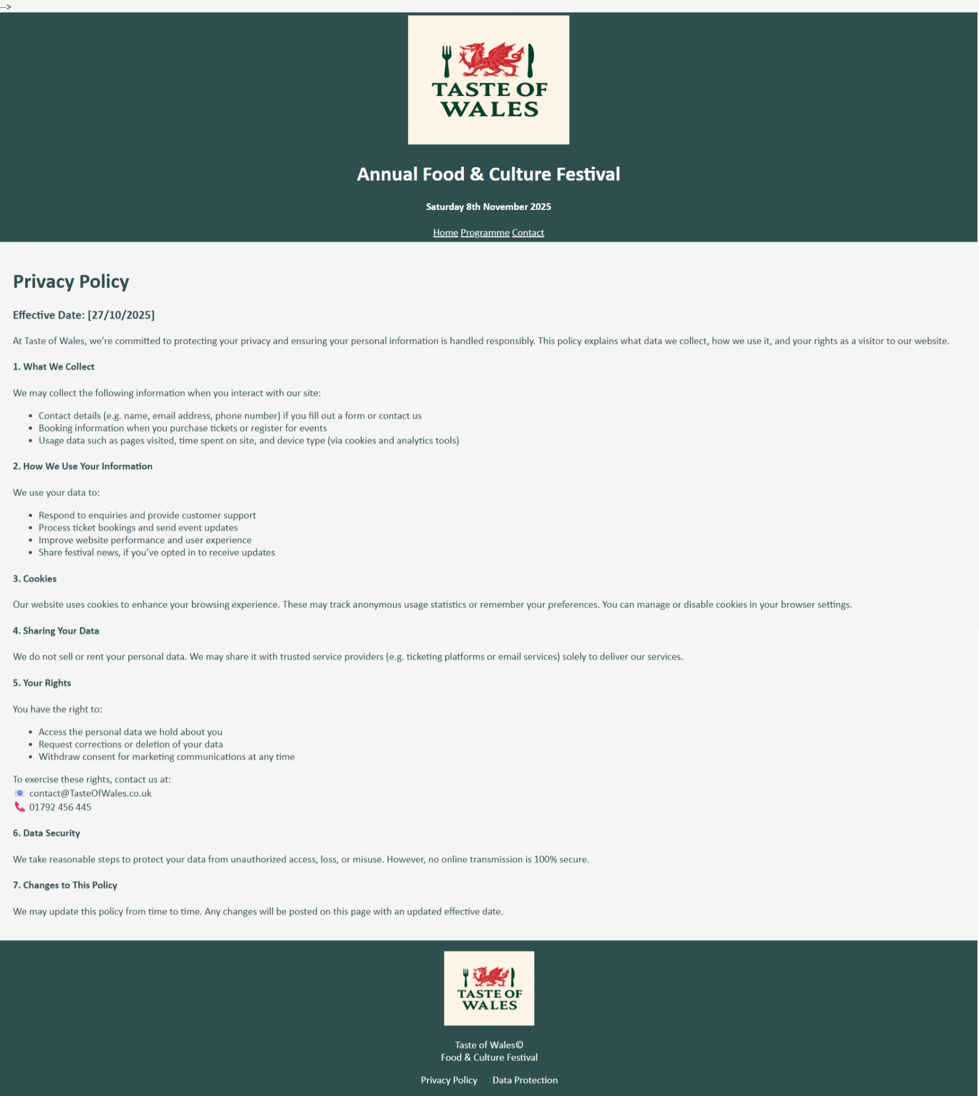

The footer links to Privacy Policy and Data Protection pages. Information is clear, relevant, and accessible, with a structured layout that stays readable despite the level of detail.

Data Protection
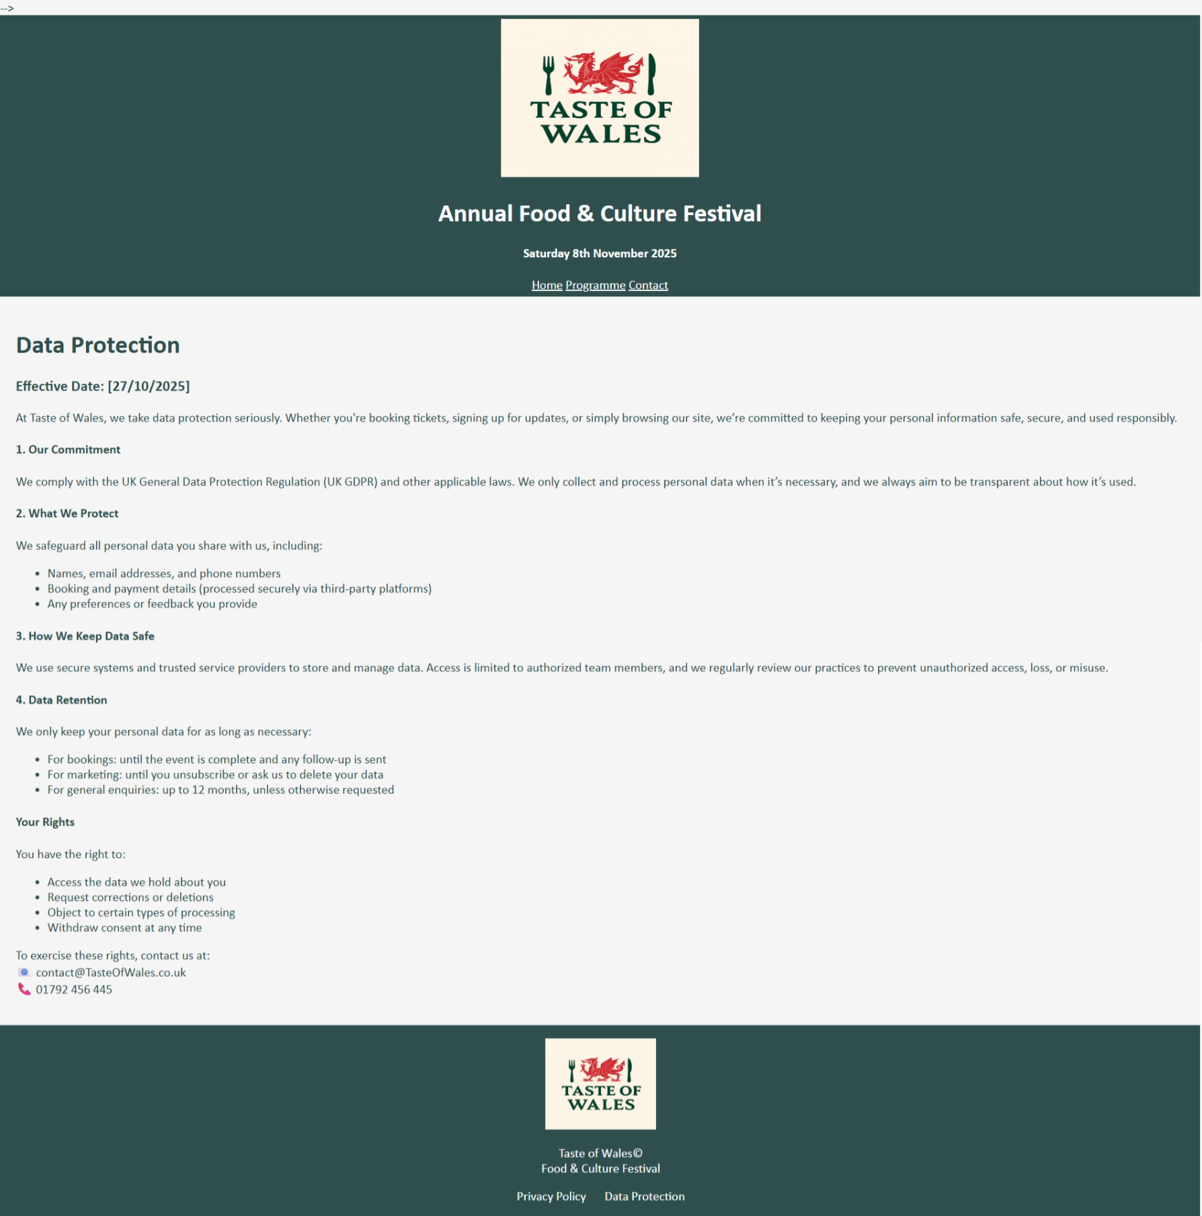

The data protection page information is clear, relevant, and accessible. Whilst detailed, the page remains readable and uncluttered. Navigation links work across tabs and maintain the site’s consistent styling and Welsh colour scheme throughout.

Code Validation

What is a Code Validator?
Code validators review the webpage code to identify errors or inconsistencies. They ensure compliance with web standards, best practices, and proper syntax [1].

Why Validate Code?
Validating website code allows us to resolve syntax errors, improving overall quality and usability of the site. [1]
Most modern browsers can display poorly coded HTML, but errors may cause style and layout inconsistencies across different platforms. Using validated code ensures reliable performance, enhanced user experience and accessibility [2].
Markup Validation Service noted that “When surveyed, a large majority of Web professionals will state that validation errors are the first thing they will check whenever they run into a Web styling or scripting bug” [2] which highlights its importance.

HTML Validation
Errors:
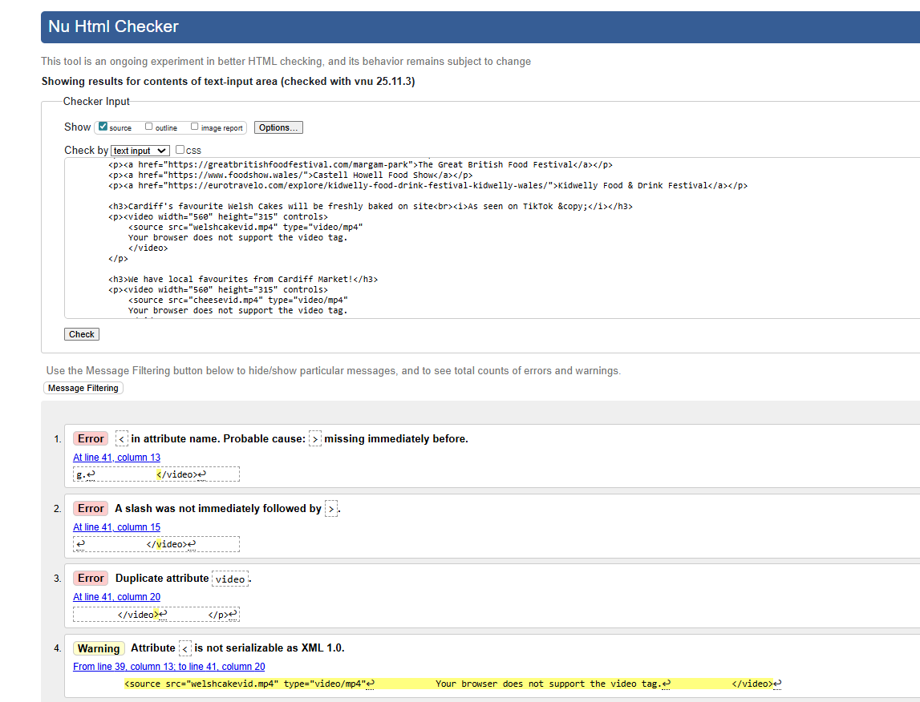
The W3C Markup Validation Service was used to check for errors and ensure compliance with my HTML code. A highlighted issue was an incorrectly closed video tag. Adding two closing brackets ‘>’ resolved this issue and the code was validated successfully.
Validated HTML:
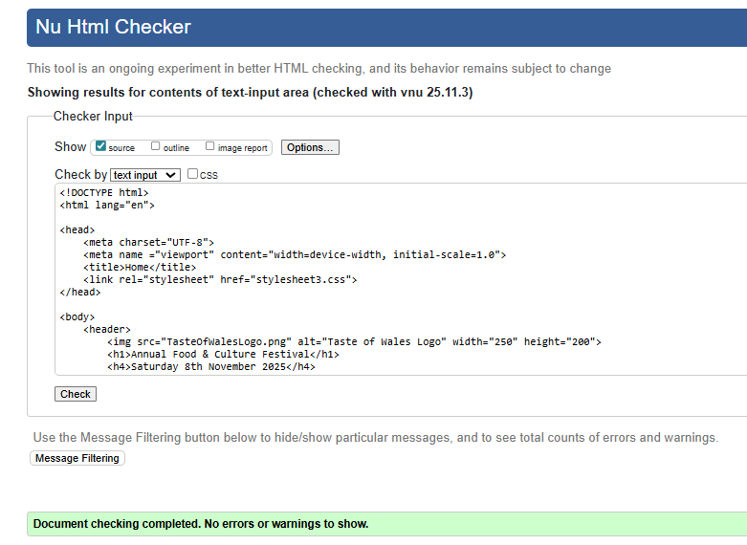

CSS Validation
Errors:
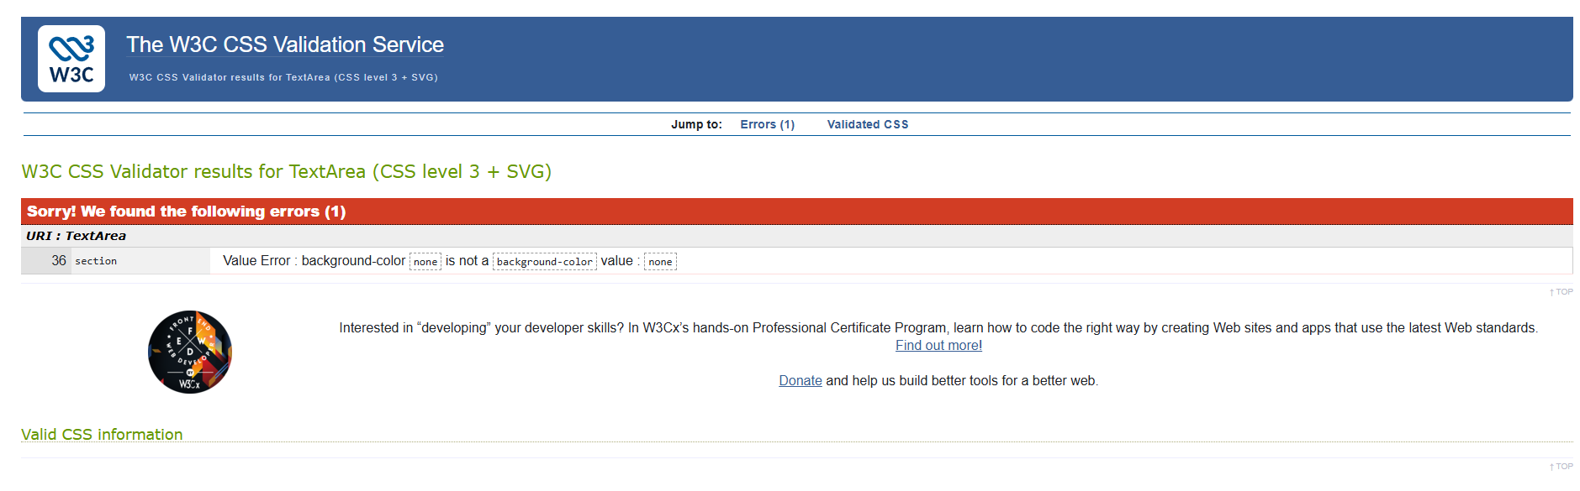
I used W3C CSS Service to validate my CSS. One error came from using none as the section background colour, which is invalid. This was resolved by setting the background colour to match the main body.
Validated CSS:
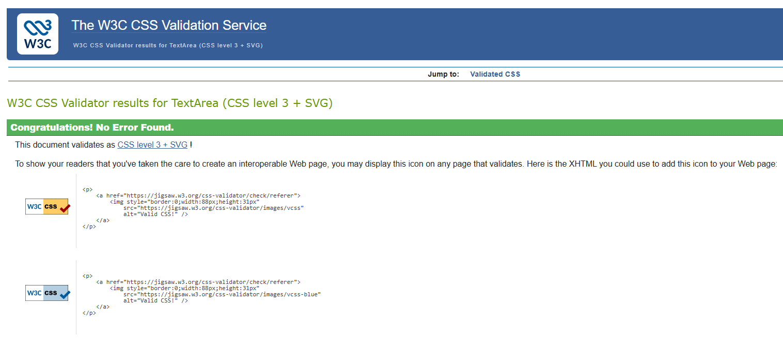

Evaluation

Research

Usability
‘Usability’ refers to how easily users interact with a site to achieve their goals. It encompasses navigation, accessibility, and overall user experience [3].
Effective usability is essential for user satisfaction, brand perception, and conversions, especially for sites aiming for sales and signups. Usability influences product discovery, account setups, checkouts and purchases. Usable sites present clear, accessible, relevant content in a structured format, supporting diverse users across devices and languages. The key principles include accessibility, clarity, recognition, credibility, relevance, mobile responsiveness, and multilingual design, which creates a seamless, inclusive experience [4].

Accessibility
‘Accessibility’ is designing and developing web content so users with disabilities or impairments can navigate, understand, and interact with the site effectively [5].
Accessibility is vital to modern web development, ensuring digital content is usable for all. Prioritising accessibility promotes inclusion, enhances user experience, and boosts engagement and conversions. It also supports legal and ethical standards while building trust with users and potential customers [6].

Search Engine Optimisation (SEO)
‘Search Engine Optimisation’ is the process of improving a webpages content and structure to increase visibility in search results for specific words, phrases, or topics. This involves quality content, backlinks from related sites, and technical code improvements. [7]
SEO enhances visibility by creating relevant, accessible, mobile-friendly content that appeals to the target audience. With voice search, conversational phrases and natural keywords are increasingly important. Local SEO attracts nearby users, while tools like Google Reverse Image Search require SEO to include multimedia content. These strategies drive traffic by connecting users with content that meets their needs [8].

Evaluation of ‘Taste of Wales’

Usefulness (Usability & Utility)
The event’s purpose is clearly advertised, the timetable provides structured information, and pages are logically organised. The bold headings assist navigation, though limited options may slow a user’s movement between pages. Dynamic features like hover effects, the embedded map, and videos are included, but there are few other interactive elements. The clean, consistent layout, inviting tone, and effective images are strengths of the site, though headers and body text can be hard to distinguish, especially in the FAQ section. The Welsh colour scheme is fitting, but more use of colour, visuals, and motion could better capture attention.
The map is currently in the FAQ section which receives little traffic and would be more suited elsewhere and adding RSVP or ticket options would improve usability. Navigation and social links could also be styled more effectively with buttons, cards, or logos for a professional feel.

Search Engine Optimisation (SEO)
The site implements effective SEO through clear headings, relevant keywords (e.g. Cardiff, Welsh cakes, festival), and a structured layout appealing to search engines and visitors. Dates, locations, and family-friendly features enhance discoverability.
Titles could be improved with terms like Welsh food festival or things to do in Wales. Homepage images feature basic alt text (e.g., food, crowds, brownies), more specific descriptions such as brownies from Cardiff market would attract a targeted audience. Links to other festivals support engagement, but local SEO would benefit from place names in hyperlink text (e.g. Kidwelly Food Festival, food festival South Wales) to boost visibility among local users.

Accessibility
Four main principles provide the foundation for web accessibility [9]
- Perceivable - All users, including those with disabilities, should be able to see, hear or feel the content.
- Operable – Users should be able to interact with the website in the way they require, such as voice commands, keyboard etc.
- Understandable – The website should be easy to read, navigate and not cause confusion.
- Robust – It should work well with different technologies, both at present and in the future.

Perceivable
The site features clear text and headings, captioned videos and strong colour contrast throughout the website. The colours of each section were input into a contrast checker for validation. [10]

Body
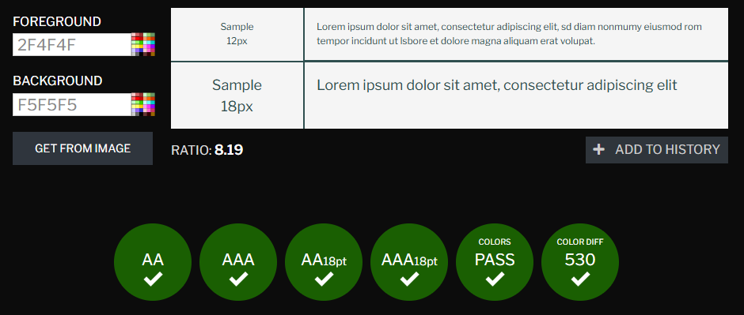

Header, Footer & Navigation List
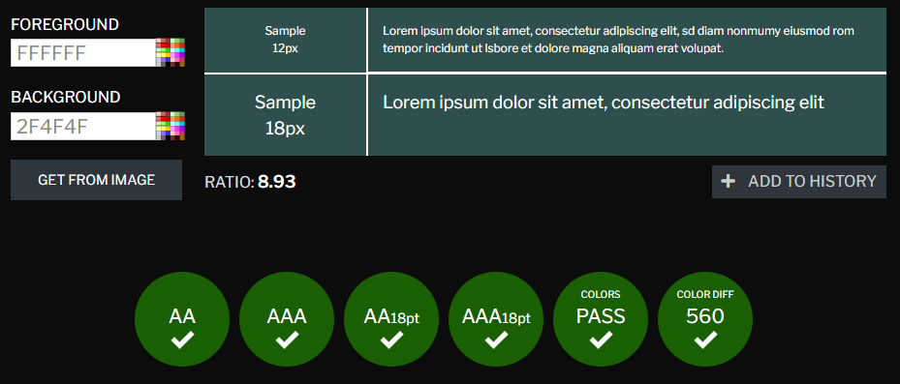

Hover-Over List
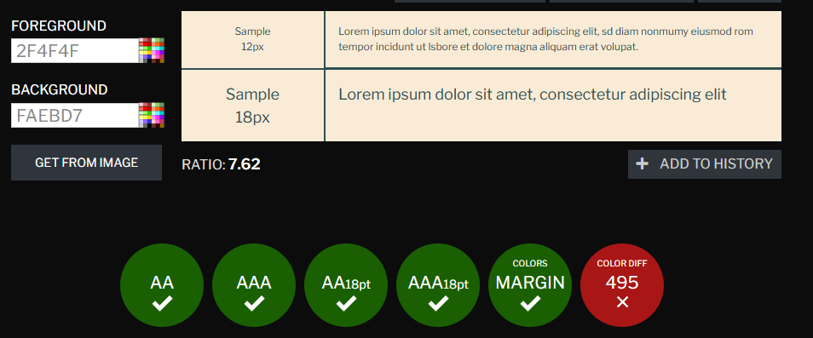

Sections
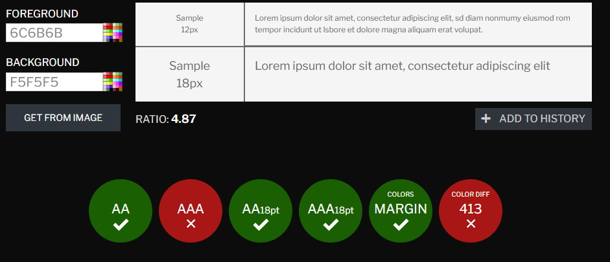

Hover-over list items and the FAQ section need improvement. Although few elements failed and most users can read the text, inclusivity is essential, and fixing these issues will strengthen accessibility. Alt text also requires clearer, more specific descriptions to provide better context and support accessibility.

Operable
The site is operable, with smooth navigation via keyboard or assistive technology. Navigation is minimal but consistent, visible, and clearly labelled. Content is logically sectioned with relevant headings, which supports screen readers. The meta-data is lacking in detail and should be expanded to help read-aloud features accurately describe the content of each page.

Understandable
The website uses clear, welcoming language, has a consistent layout, bullet points, lists, and descriptive links. There are no distracting background animations or complex language or jargon. Some header sizes could be adjusted for a more logical flow, as <h4> is sometimes used before <h2>.

Robust
The website uses semantic layout elements, which enables assistive technologies to correctly identify page structure. The viewport meta-tag allows the site to adapt to different screen sizes, and the navigation is consistent with a repeated menu and standard anchor tags. Minor code errors should be corrected to improve durability and would make the site more future proof.

Accessibility Checker
The Taste of Wales was checked using the WAVE extension. [11]
Home page
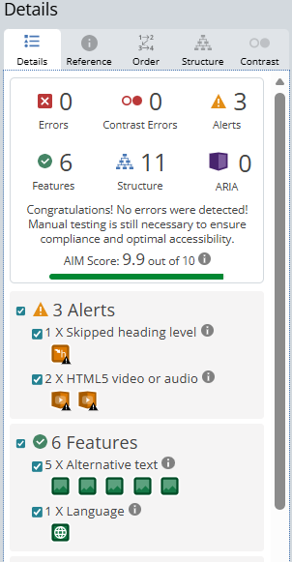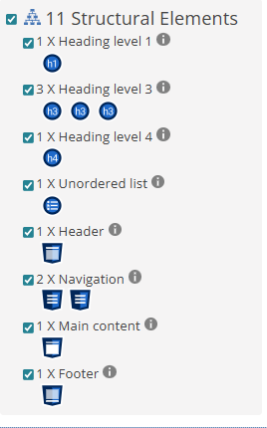

No errors or contrast issues were found and the site scored 9.9/10. The extension flagged the out of order heading sizes and advised adding a video tag, which is already present.
Programme Page
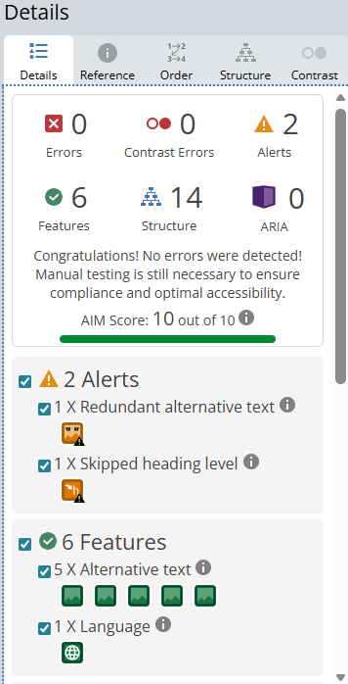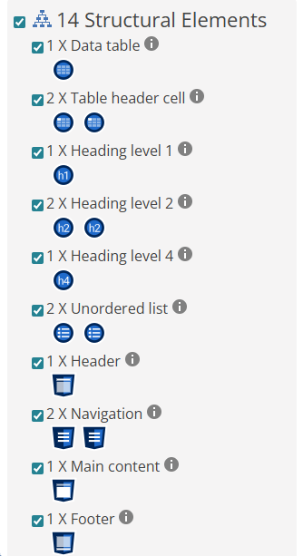

No errors found, and the site scored 10/10. Minor alerts can be resolved by adding detailed alt text and improving the heading order.

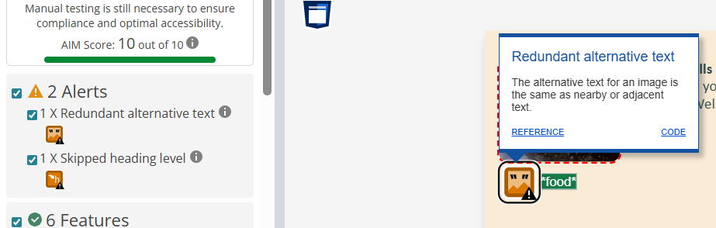

Contact Page
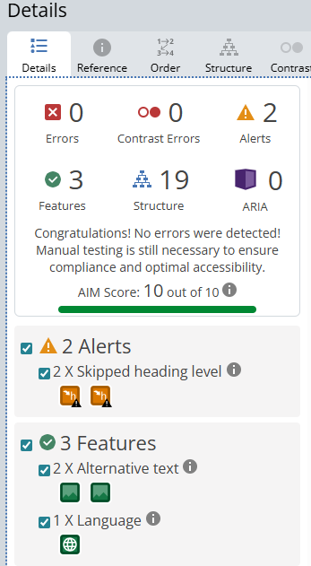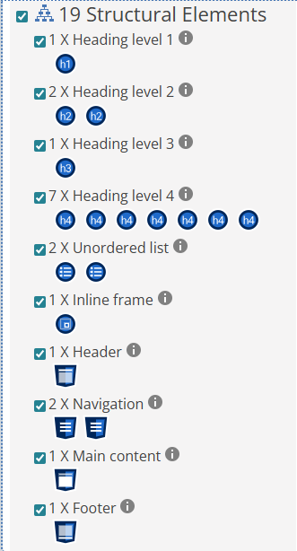
No errors were found and the site scored 10/10. The alerts flagged the heading sizes out of order, which can be easily rectified.

As shown below, navigation links were listed consistently across pages, making the site accessible for screen readers, as seen in the images below.
Home navigation order
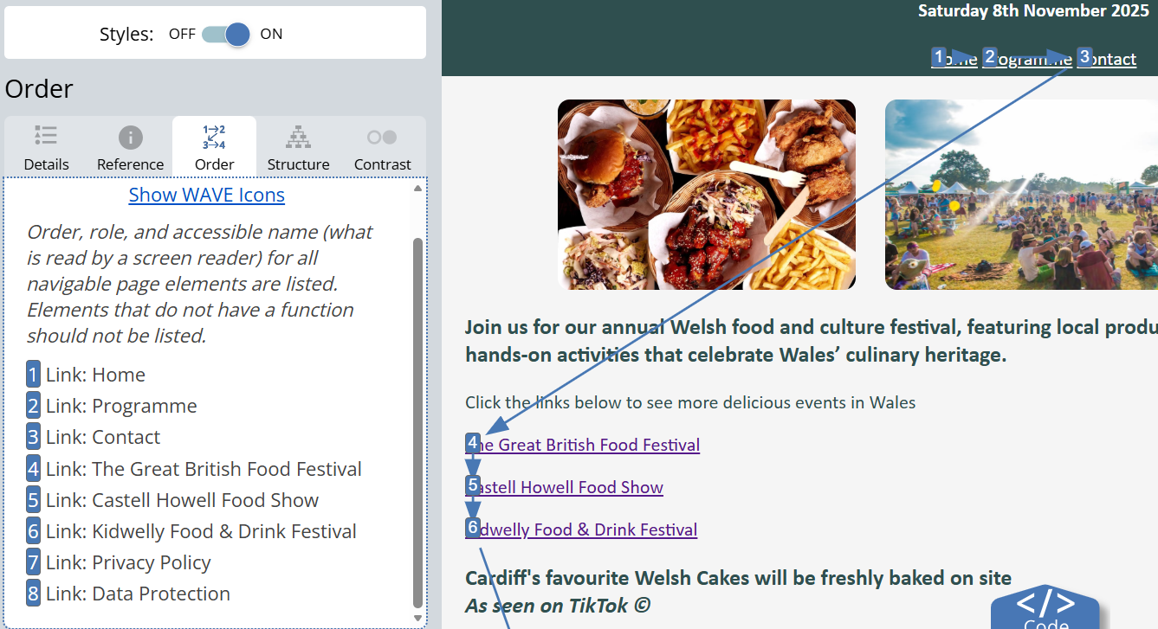
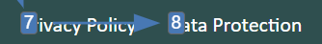
Programme navigation order
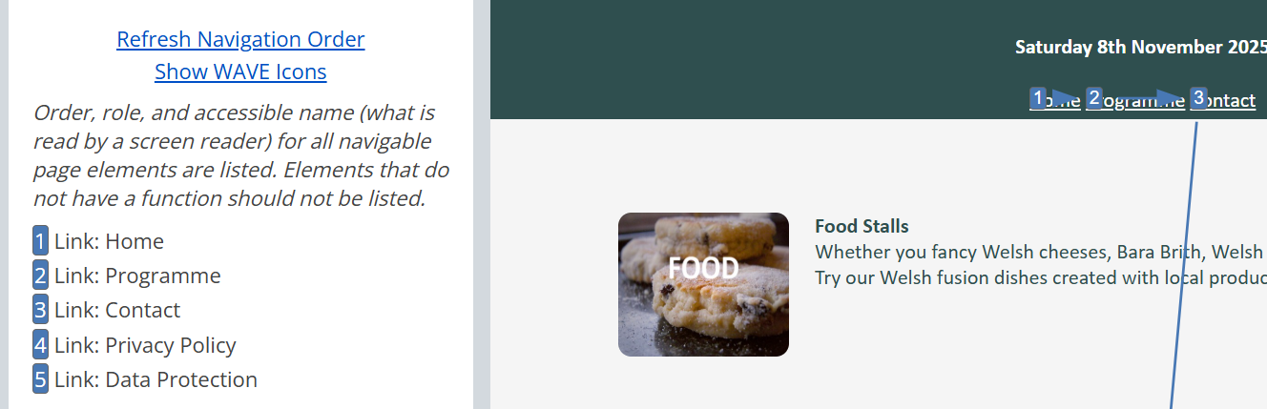

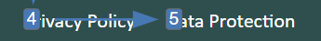

Contact navigation order
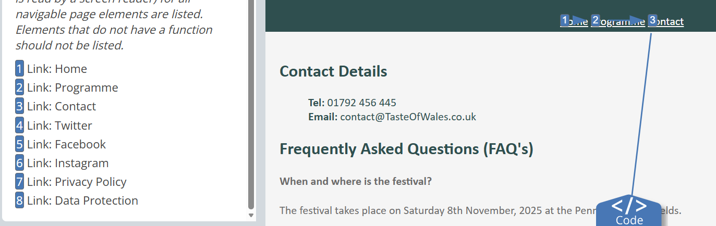

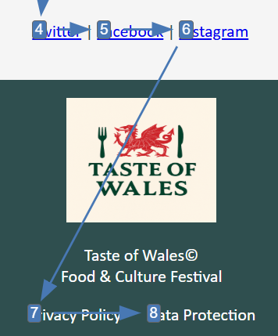

Live Website Comparison

Usability
From personal use, Amazon offers advanced filters, a search bar, detailed product pages, consistent navigation, and easy purchase options but it does have a cluttered homepage. eBay provides equally accessible search and filters with a cleaner layout, although the home page features fast moving adverts which can be hard to read. The usability can also depend more on seller quality, causing inconsistency.

Accessibility
Amazon is broadly accessible, though WAVE [11] noted there were issues such as low text to background contrast and redundant alt text. Providing alternative, more descriptive text would better support the use of screen readers. Navigation items are correctly ordered for effective screen reader and keyboard use, and users can set accessible delivery instructions or view desktop accessibility features [12].
eBay provides an accessibility statement and note their commitment to “ensuring digital accessibility for people with disabilities” [13], emphasising diversity, inclusion, and WCAG 2.1 AA compliance. Accessibility checkers reveal some errors with the eBay site, but fewer than Amazon, which is expected given eBay has fewer features.

Amazon eBay
[11] [11]
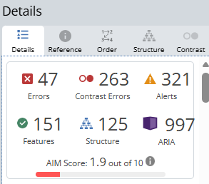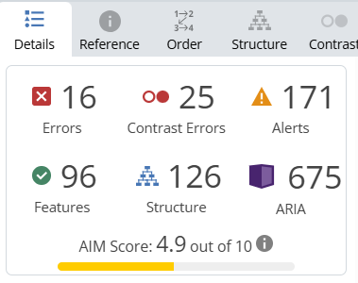

Search Engine Optimisation
Amazon uses deep architecture, extensive cross‑links, and URLs featuring keywords [14]. WAVE [11] highlighted descriptive meta data, with long titles and meta tags boosting SEO. Alt text ranges from generic to detailed, and heading structures are consistent and logical.
eBay uses a flatter structure requiring under three clicks [15], with more generalised cross‑links and a search‑driven SEO design [16]. It provides more meta data and detailed titles, but some descriptions are lacking, and many images have no alt text. Headers remain uniform and logically structured.

Amazon
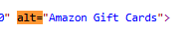

eBay
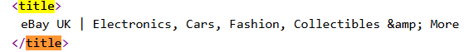

Mobile Friendliness
Amazon’s app is designed for mobile use but sacrifices some user experience for conversion rates. Browsing is easy though the home screen is cluttered. UpTech notes its mobile friendliness relies on buyers’ familiarity with Amazon’s layout, which new brands couldn’t replicate [17].
eBay’s app uses structured data helping buyers quickly find products, with a clear presentation optimised for mobile browsing, searching, and purchasing [18].

Conclusion
From the findings of my research, Amazon is stronger in SEO and usability, it features deep architecture, consistent meta tags throughout, logical headings, and reliable mobile performance. eBay’s flatter structure is driven by seller-created listings, and often results in missing or inconsistent alt text, headings, and meta descriptions, making the site less reliable for SEO and less mobile friendly. While eBay has features that will suit some uses, Amazon is stronger overall.

References
[1] N. Stuck, "Code Validator", WOLF OF SEO, https://wolf-of-seo.de/en/what-is/code-validator/ Accessed: Nov 2, 2025
[2] N. Kew and Web Authors, "Why Validate?" Accessed: Nov 2, 2025, [Online]. Available: https://validator.w3.org/docs/why.html
[3] Microsoft. "Response to query about website usability." Copilot. https://copilot.microsoft.com/chats/QqUYoByxNxe11UjRACmct
[4] S. Ntoa. “Usability and User Experience Evaluation in Intelligent Environments: A Review and Reappraisal”. Volume 41, Issue 5. Pages 2829-2858. Sep 2024. [Online]. Available: https://www.tandfonline.com/doi/full/10.1080/10447318.2024.2394724#abstract
[5] W. W. A. Initiative (WAI). "Introduction to Web Accessibility." W3C. https://www.w3.org/WAI/fundamentals/accessibility-intro/ (accessed Nov 3).
[6] D. Abhichandani, "A Systematic Review of Web Accessibility Implementation in Business Environments," Peer Reviewed Journal, vol. 187, no. 10, May 2025. Accessed: Nov 3, 2025, [Online]. Available: https://www.ijcaonline.org/archives/volume187/number10/abhichandani-2025-ijca-925058.pdf
[7] Digital Culture Network, "What is Search Engine Optimisation (SEO)?", Digital Culture Network, https://digitalculturenetwork.org.uk/knowledge/what-is-search-engine-optimisation-seo/ Accessed: Nov 3, 2025.
[8] A. U Pai, et al., "Exploring SEO Best Practices in Web Development: Enhancing Website Visibility and Traffic," International Journal of Research Publication and Reviews, vol. 5, no. 7, pp.4294–4298, July 2024. Accessed: Nov 3, 2025, [Online]. Available: https://ijrpr.com/uploads/V5ISSUE7/IJRPR31796.pdf
[9] W3, "Web Content Accessibility Guidelines (WCAG) 2.1," 06 May 2025. Accessed: Nov 14, 2025, [Online]. Available: https://www.w3.org/TR/WCAG21/
[10] P. Hartana. "WCAG." Contrast Checker Acart Communications. https://contrastchecker.com/ (accessed Nov 14).
[11] "WAVE Web Accessibility Evaluation Tool - Extensions." WebAIM. https://wave.webaim.org/extension/ Accessed: Nov 14, 2025
[12] Amazon, "How to use the Accessibility features on Amazon.co.uk and Mobile App - Amazon Customer Service," Accessed: Nov 15, 2025, [Online]. Available: https://www.amazon.co.uk/gp/help/customer/display.html?nodeId=GUUVBZ8WGVFP8R8X
[13] "Accessibility." eBay. https://www.ebayinc.com/accessibility/ Accessed: Nov 15, 2025
[14] S. Atkinson and K. Wirth, "Site architecture: Creating a website structure that ranks", Search Engine Land, https://searchengineland.com/guide/website-structure Accessed: Nov 15, 2025
[15] R. Tousseyn, "Ultimate SEO Site Structure Guide", TEAM LEWIS, https://www.teamlewis.com/magazine/seo-site-structure/ Accessed: Nov 15, 2025
[16] Microsoft. "Response to query about eBay flat SEO." Copilot. https://copilot.microsoft.com/chats/3eukgNGR9bkR2bfpmCekm
[17] O. Kryvytskyi. "Amazon Shopping App UX Case Study - An In-Depth Evaluation | Uptech." Up Tech. https://www.uptech.team/blog/amazon-shopping-app-ux-case-study Accessed: Nov 16, 2025
[18] ebay partner network, "4 Smart Ways to Optimize Your Website for Mobile Search," 2025. Available: https://partnernetwork.ebay.com/solutions/4-smart-ways-to-optimize-your-website-for-mobile-search

Appendices

HTML Code – Home
<!DOCTYPE html>
<html lang="en">

<head>
<meta charset="UTF-8">
<meta name ="viewport" content="width=device-width, initial-scale=1.0">
<title>Home</title>
<link rel="stylesheet" href="stylesheet3.css">
</head>

<body>
<header>
<img src="TasteOfWalesLogo.png" alt="Taste of Wales Logo" width="250" height="200">
<h1>Annual Food & Culture Festival</h1>
<h4>Saturday 8th November 2025</h4>
<nav>
<a href="HOME.html">Home</a>
<a href="PROGRAMME.html">Programme</a>
<a href="CONTACT.html">Contact</a>
</nav>
</header>

<main>
<div class="homepageimages">
<img src="food-home.png" alt="food" width="250" height="160">
<img src="crowd-home.png" alt="crowd" width="250" height="160">
<img src="bakery-home.png" alt="brownies" width="250" height="160">
</div>

<h3>Join us for our annual Welsh food and culture festival, featuring local produce, traditional dishes, live entertainment, and hands-on activities that celebrate Wales’ culinary heritage.</h3>
<p>Click the links below to see more delicious events in Wales</p>
<p><a href="https://greatbritishfoodfestival.com/margam-park">The Great British Food Festival</a></p>
<p><a href="https://www.foodshow.wales/">Castell Howell Food Show</a></p>
<p><a href="https://eurotravelo.com/explore/kidwelly-food-drink-festival-kidwelly-wales/">Kidwelly Food & Drink Festival</a></p>

<h3>Cardiff's favourite Welsh Cakes will be freshly baked on site<br><i>As seen on TikTok &copy;</i></h3>
<p><video width="560" height="315" controls>
<source src="welshcakevid.mp4" type="video/mp4">
Your browser does not support the video tag.
</video>
</p>

<h3>We have local favourites from Cardiff Market!</h3>
<p><video width="560" height="315" controls>
<source src="cheesevid.mp4" type="video/mp4">
Your browser does not support the video tag.
</video>
</p>
</main>

<footer>
<p><img src="TasteOfWalesLogo.png" alt="Taste of Wales logo" width="140" height="115"></p>
<p>Taste of Wales&COPY;<br>Food & Culture Festival</p>
<nav>
<ul>
<li><a href="privacy.html">Privacy Policy</a></li>
<li><a href="dataprotection.html">Data Protection</a></li>
</ul>
</nav>
</footer>
</body>
</html>

HTML Code – Programme
<!DOCTYPE html>
<html lang="en">

<head>
<meta charset="UTF-8">
<meta name ="viewport" content="width=device-width, initial-scale=1.0">
<title>Programme</title>
<link rel="stylesheet" href="stylesheet3.css">
</head>

<body>
<header>
<img src="TasteOfWalesLogo.png" alt="Taste of Wales Logo" width="250" height="200">
<h1>Annual Food & Culture Festival</h1>
<h4>Saturday 8th November 2025</h4>
<nav>
<a href="HOME.html">Home</a>
<a href="PROGRAMME.html">Programme</a>
<a href="CONTACT.html">Contact</a>
</nav>
</header>

<main>
<div class="programmeimages">
<p><img src="food.jpg" alt="food" width="130" height="110" style="vertical-align: middle;"></p>
<p><b>Food Stalls</b><br>
Whether you fancy Welsh cheeses, Bara Brith, Welsh cakes or Laverbread, this is the place for you. Try our Welsh fusion dishes created with local produce.</p>
</div>

<div class="programmeimages">
<p><img src="LOCAL DRINKS.jpg" alt="local drinks" width="130" height="110" style="vertical-align: middle;"</p>
<p><b>Raise a glass to Wales</b><br>
All of your local heroes in one place. We have a variety of stalls and tasters available from Black Dragon, Penderyn Distillery, Brains Brewery & Brecon Carreg. There's something for everyone!</p>
</div>

<div class="programmeimages">
<p><img src="farmers market.jpg" alt="farmers market" width="130" height="110" style="vertical-align: middle;"</p>
<p><b>From Field to Festival</b><br>
Fresh produce from Welsh farms and community gardens. With lots of tasting opportunities.</p>
</div>

<div class="programmeimages">
<p><img src="LIVE MUSIC.jpg" alt="live music" width="130" height="110" style="vertical-align: middle;"</p>
<p><b>The Sound of Wales</b><br>
Celebrate with a mix of Folk bands, harpists, male voice choirs, and contemporary Welsh artists. We have live music all day, all across the festival!</p>
</div>

<h2>Kids Corner</h2>
<p>Kids corner is running from 10am - 5pm.</p>
<p>Throughout the day we have:</p>
<ul>
<li>Kid's cook along</li>
<li>Petting zoo</li>
<li>Face Painting</li>
<li>Crafts</li>
<li>Treasure Hunts</li>
</ul>
<p>Plus a <b>FREE</b> party bag for taking part in our Bean Bag toss!</p>

<h2>Opening Times</h2>
<table border="2">
<thead>
<tr>
<th>Item</th>
<th>Time</th>
</tr>
</thead>

<tbody>
<tr>
<td>Car Park</td>
<td>From 9am<br>(Festival entry from 9.50am)</td>
</tr>

<tr>
<td>Food</td>
<td>10am-7pm</td>
</tr>

<tr>
<td>Drinks</td>
<td>10am-8pm(Close)</td>
</tr>

<tr>
<td>Farmerks market</td>
<td>10am-5pm</td>
</tr>

<tr>
<td>Kids Corner</td>
<td>10am-5pm (Petting Zoo until 3pm</td>
</tr>

<tr>
<td>Live music</td>
<td>All day!!!</td>
</tr>
</tbody>
</table>
</main>

<footer>
<p><img src="TasteOfWalesLogo.png" alt="Taste of Wales logo" width="140" height="115"></p>
<p>Taste of Wales&COPY;<br>Food & Culture Festival</p>
<nav>
<ul>
<li><a href="privacy.html">Privacy Policy</a></li>
<li><a href="dataprotection.html">Data Protection</a></li>
</ul>
</nav>
</footer>
</body>
</html>

HTML Code – Contact
<!DOCTYPE html>
<html lang="en">

<head>
<meta charset="UTF-8">
<meta name ="viewport" content="width=device-width, initial-scale=1.0">
<title>Contact</title>
<link rel="stylesheet" href="stylesheet3.css">
</head>

<body>
<header>
<img src="TasteOfWalesLogo.png" alt="Taste of Wales Logo" width="250" height="200">
<h1>Annual Food & Culture Festival</h1>
<h4>Saturday 8th November 2025</h4>
<nav>
<a href="HOME.html">Home</a>
<a href="PROGRAMME.html">Programme</a>
<a href="CONTACT.html">Contact</a>
</nav>
</header>

<main>
<h2>Contact Details</h2>
<ul>
<l><b>Tel:</b> 01792 456 445</l><br>
<l><b>Email:</b> contact@TasteOfWales.co.uk</l><br>
</ul>

<h2>Frequently Asked Questions (FAQ's)</h2>

<section>
<h4>When and where is the festival?</h4>
<p>The festival takes place on Saturday 8th November, 2025 at the Pennard Playing Fields.</p>
<p>Pennard Playing Fields, Park Rodd, Southgate, Swansea SA3 2AQ</p>
<p><iframe src="https://www.google.com/maps/embed?pb=!1m18!1m12!1m3!1d2479.708259064162!2d-4.0918607233759525!3d51.57358157182834!2m3!1f0!2f0!3f0!3m2!1i1024!2i768!4f13.1!3m3!1m2!1s0x486e8dadc63d466b%3A0xaf174206761d6fe3!2sPennard%20Playing%20Field!5e0!3m2!1sen!2suk!4v1761250839662!5m2!1sen!2suk" width="550" height="350" style="border:0;" allowfullscreen="" loading="lazy" referrerpolicy="no-referrer-when-downgrade"></iframe></p>
</section>

<section>
<h4>Do I need a ticket?</h4>
<p>Yes, tickets are available online and at the gate. We also offer student discount.</p>
</section>

<section>
<h4>Is it family-friendly?</h4>
<p>Absolutely! There’ll be kids cook-alongs, crafts, face painting, and even a mini petting farm.</p>
</section>

<section>
<h4>Is it pet-friendly?</h4>
<p>Again, absolutely! Well-behaved dogs on leads are welcome in outdoor areas. Please check individual stall policies, and remember to clean up after your furry friends!</p>
</section>

<section>
<h4>Is it accessible/wheelchair friendly?</h4>
<p>Yes, the venue is fully accessible. We offer step-free access, accessible toilets, and designated viewing areas to ensure everyone can enjoy the event comfortably.</p>
</section>

<div class="socials">
<h3>We're on socials!</h3>
<h4>Sign up here</h4>
<p><a href="https://twitter.com" target="_blank">Twitter</a> |
<a href="https://facebook.com" target="_blank">Facebook</a> |
<a href="https://instagram.com" target="_blank">Instagram</a>
</p>
</div>
</main>

<footer>
<p><img src="TasteOfWalesLogo.png" alt="Taste of Wales logo" width="140" height="115"></p>
<p>Taste of Wales&COPY;<br>Food & Culture Festival</p>
<nav>
<ul>
<li><a href="privacy.html">Privacy Policy</a></li>
<li><a href="dataprotection.html">Data Protection</a></li>
</ul>
</nav>
</footer>
</body>
</html>

HTML Code – Privacy Policy
<!DOCTYPE html>
<html lang="en">

<head>
<meta charset="UTF-8">
<meta name ="viewport" content="width=device-width, initial-scale=1.0">
<title>Home</title>
<link rel="stylesheet" href="stylesheet3.css">
</head>

<body>
<header>
<img src="TasteOfWalesLogo.png" alt="Taste of Wales Logo" width="250" height="200">
<h1>Annual Food & Culture Festival</h1>
<h4>Saturday 8th November 2025</h4>
<nav>
<a href="HOME.html">Home</a>
<a href="PROGRAMME.html">Programme</a>
<a href="CONTACT.html">Contact</a>
</nav>
</header>

<main>
<h1>Privacy Policy</h1>

<h3>Effective Date: [27/10/2025]</h3>
<p>At Taste of Wales, we’re committed to protecting your privacy and ensuring your personal information is handled responsibly. This policy explains what data we collect, how we use it, and your rights as a visitor to our website.</p>

<h4>1. What We Collect</h4>
<p>We may collect the following information when you interact with our site:</p>
<ul>
<li>Contact details (e.g. name, email address, phone number) if you fill out a form or contact us</li>
<li>Booking information when you purchase tickets or register for events</li>
<li>Usage data such as pages visited, time spent on site, and device type (via cookies and analytics tools)</li>
</ul>

<h4>2. How We Use Your Information</h4>
<p>We use your data to:</p>
<ul>
<li>Respond to enquiries and provide customer support</li>
<li>Process ticket bookings and send event updates</li>
<li>Improve website performance and user experience</li>
<li>Share festival news, if you’ve opted in to receive updates</li>
</ul>

<h4>3. Cookies</h4>
<p>Our website uses cookies to enhance your browsing experience. These may track anonymous usage statistics or remember your preferences. You can manage or disable cookies in your browser settings.</p>

<h4>4. Sharing Your Data</h4>
<p>We do not sell or rent your personal data. We may share it with trusted service providers (e.g. ticketing platforms or email services) solely to deliver our services.</p>

<h4>5. Your Rights</h4>
<p>You have the right to:</p>
<ul>
<li>Access the personal data we hold about you</li>
<li>Request corrections or deletion of your data</li>
<li>Withdraw consent for marketing communications at any time</li>
</ul>
<p>To exercise these rights, contact us at:<br>
📧 contact@TasteOfWales.co.uk<br>
📞 01792 456 445</p>

<h4>6. Data Security</h4>
<p>We take reasonable steps to protect your data from unauthorized access, loss, or misuse. However, no online transmission is 100% secure.</p>

<h4>7. Changes to This Policy</h4>
<p>We may update this policy from time to time. Any changes will be posted on this page with an updated effective date.</p>
</main>

<footer>
<p><img src="TasteOfWalesLogo.png" alt="Taste of Wales logo" width="140" height="115"></p>
<p>Taste of Wales&COPY;<br>Food & Culture Festival</p>
<nav>
<ul>
<li><a href="privacy.html">Privacy Policy</a></li>
<li><a href="dataprotection.html">Data Protection</a></li>
</ul>
</nav>
</footer>
</body>
</html>

HTML Code – Data Protection
<!DOCTYPE html>
<html lang="en">

<head>
<meta charset="UTF-8">
<meta name ="viewport" content="width=device-width, initial-scale=1.0">
<title>Home</title>
<link rel="stylesheet" href="stylesheet3.css">
</head>

<body>
<header>
<img src="TasteOfWalesLogo.png" alt="Taste of Wales Logo" width="250" height="200">
<h1>Annual Food & Culture Festival</h1>
<h4>Saturday 8th November 2025</h4>
<nav>
<a href="HOME.html">Home</a>
<a href="PROGRAMME.html">Programme</a>
<a href="CONTACT.html">Contact</a>
</nav>
</header>

<main>
<h1>Data Protection</h1>

<h3>Effective Date: [27/10/2025]</h3>
<p>At Taste of Wales, we take data protection seriously. Whether you're booking tickets, signing up for updates, or simply browsing our site, we’re committed to keeping your personal information safe, secure, and used responsibly.</p>

<h4>1. Our Commitment</h4>
<p>We comply with the UK General Data Protection Regulation (UK GDPR) and other applicable laws. We only collect and process personal data when it’s necessary, and we always aim to be transparent about how it’s used.</p>

<h4>2. What We Protect</h4>
<p>We safeguard all personal data you share with us, including:</p>
<ul>
<li>Names, email addresses, and phone numbers</li>
<li>Booking and payment details (processed securely via third-party platforms)</li>
<li>Any preferences or feedback you provide</li>
</ul>

<h4>3. How We Keep Data Safe</h4>
<p>We use secure systems and trusted service providers to store and manage data. Access is limited to authorized team members, and we regularly review our practices to prevent unauthorized access, loss, or misuse.</p>

<h4>4. Data Retention</h4>
<p>We only keep your personal data for as long as necessary:</p>
<ul>
<li>For bookings: until the event is complete and any follow-up is sent</li>
<li>For marketing: until you unsubscribe or ask us to delete your data</li>
<li>For general enquiries: up to 12 months, unless otherwise requested</li>
</ul>

<h4>Your Rights</h4>
<p>You have the right to:</p>
<ul>
<li>Access the data we hold about you</li>
<li>Request corrections or deletions</li>
<li>Object to certain types of processing</li>
<li>Withdraw consent at any time</li>
</ul>

<p>To exercise these rights, contact us at:<br>
📧 contact@TasteOfWales.co.uk<br>
📞 01792 456 445</p>
</main>

<footer>
<p><img src="TasteOfWalesLogo.png" alt="Taste of Wales logo" width="140" height="115"></p>
<p>Taste of Wales&COPY;<br>Food & Culture Festival</p>
<nav>
<ul>
<li><a href="privacy.html">Privacy Policy</a></li>
<li><a href="dataprotection.html">Data Protection</a></li>
</ul>
</nav>
</footer>
</body>
</html>

CSS Code – Stylesheet
body{
font-family:calibri;
background-color:#F5F5F5;
color:#2F4F4F;
margin:0;
padding:0;
}

header{
background-color:#2F4F4F;
color:#FFFFFF;
padding:5px;
text-align: center;
}

nav ul{
list-style-type: none;
padding:0;
}

nav ul li{
display: inline;
margin:10px;
}

nav ul li a{
color:#FFFFFF;
text-decoration: none;
}

nav a{
color:#FFFFFF;
}

section{
background-color:#F5F5F5;
color:#6c6b6b;
text-decoration: none;
}

main{
padding: 20px;
}

.socials{
text-align: center;
}

.programmeimages{
display: flex;
gap:20px;
padding: 15px;
max-width: 800px;
margin: 20px auto;
}

.programmeimages img{
border-radius: 10px;
}

.programmeimages:hover{
background-color: antiquewhite;
font-weight: normal;
transform:scale(1.2);
box-shadow: 5px 10px 12px rgba(0, 0, 0, 0.3);
color:#2F4F4F;
}

.homepageimages{
display:flex;
align-items: center;
justify-content: center;
gap:25px;
}

.homepageimages img{
border-radius: 10px;
}

footer{
background-color:#2F4F4F;
color: #FFFFFF;
text-align: center;
padding: 1px;
position:relative;
bottom: 0;
width:100%;
}

