Student Name: Salam Al-Masoud  Student ID: 2235444  Module Title: Foreign Languages & Cultural Awareness  Module Code: BMIH5003  Lecturer: Heidi Prosser  Date: 4th February 2024 | 
ASSIGNMENT 1: PORTFOLIO
(4 Components)

Component 1: Professional Reflection (500 words +/- 10%)

Weighting: 25%
Cultural misunderstandings with hotel guests are typical for Food and Beverage (F&B) employees in Italian culture. There are noticeable differences in language and communication techniques there. During a recent experience during dinner service at a hotel restaurant in Italy, my colleague a waiter experienced an odd problem with a guest who could not understand the Italian language properly(Yakers, 2020). The guest came from a place where direct communication is less expected and he was cautious and confused when he was placing his order. The server didn't know about these cultural differences and mistakenly gave the guest pause for uncertainty. To help the guest the waiter offered a popular local mealfrom Italy hoping that it would make the guest's decision-making process easier. However, the guest's face was uncomfortable as a result of this well-intentioned remark. This experience has pushed me to learn more about the intricacies of cross-cultural relationships in the hospitality sector(Juliane House, Kasper, and Ross, 2014).
Based on this event, it is clear that the cultural misunderstanding resulted from inequalities in communications. Individual cultures where indirect communication is popular may use social signals and nonverbal gestures to express their emotions. I understood the potential influence of this on passenger satisfaction, reputation, and overall service quality (Carroll, 2016).
To successfully overcome these cultural misunderstandings, I recognised the importance of improving my language skills. The abilityto take basic conversational phrases with anybody will help communicate more effectively. Also, cultural sensitivity training is essential for food and beverage personnel(Richardson, 2016). Knowing about the cultural norms, tastes, and expectations of customers from different backgrounds is important. Another skill that I believe is critical for avoiding cultural misconceptions is active listening. F&B workers must patiently listen, seek clarification, and genuinely adapt to diverse guest perspectives for accurate interpretation of requests. Cultural sensitivity and adaptability are also essential traits for the food and beverage sectors. Embracing cultural diversity promotes a pleasant workplace environment. It gives a peaceful interaction with both guests and staff.An additional skill need to have, creating a culturally appropriate work environment within the hotel. It promotes inclusion and diversity in the culture and provides continuing cultural training for employees for anenjoyable guest experience.
Reflecting on the Italian cultural setting in the hotel restaurant, I understood how complex cultural misunderstandings are and how they might affect the hospitality business. The interaction emphasised the necessity of language skills, cultural awareness, active listening, and adaptation in such situations. By committing to constant learning and development in these areas, I hope to help create a more inclusive and culturally competent hospitality environment. This event fueled personal growth and reaffirmed my dedication to providing outstanding service that crosses cultural barriers (Rau, 2022).
Reference
Carroll, R. (2016) Cultural misunderstandings: The French-American experience. Chicago, IL: University of Chicago Press.
Juliane House, Kasper, G. and Ross, S. (2014) Misunderstanding in social life: Discourse approaches to problematic talk. London, England: Routledge.
Rau, P.-L. P. (2022) Cross-Cultural Design. Applications in Business, Communication, Health, Well-being, and inclusiveness: 14th International Conference, CCD 2022, held as part of the 24th HCI International Conference, HCII 2022, virtual event, June 26 – July 1, 2022, proceedings, part III. Cham, Switzerland: Springer Nature.
Richardson, B. (2016) Communication skills: The ultimate guide to developing powerful communication skills for lifelong success. North Charleston, SC: Createspace Independent Publishing Platform.
Yakers, K. (2020) Communication skills: 2 Books in 1: How to improve social relationships in life. Overcome anxiety and shyness. Effective public speaking. Achieve success with active listening and empathy. Top Edition
Component 2: Training Plan (500 words +/- 10%)

Weighting: 25%

Training plan:
Why
As a Training Manager at Novotel Hotel in Sheffield City Centre, I developed a training strategy plan to provide our employees with the skills and knowledge they need to properly handle cultural issues (Dumitrascu, 2017). Italy is very well-known for its rich cultural past. So, we must ensure that our personnel understand and respect our customers' traditions. This training strategy will ensure that all of our employees are well-equipped to deal with similar situations in the future.
What
The training plan consists of the following components:
Plan Number | Plan
1 | Cultural AwarenessTraining
2 | Language Training
3 | Role-Playing Exercises
4 | Cross-Cultural Communication Training
5 | Cultural Sensitivity Workshops

Figure 1: Training Plan (Self-Generated)
The training curriculum includes a variety of components aimed at increasing cultural awareness among hotel employees in Italy. Cultural Awareness Training provides a comprehensive understanding of Italian culture, history, traditions, and social norms, with a focus on greetings, gestures, and Italian-specific etiquette (Hosmer, 2014). This training provides employees with the knowledge needed to interact with guests in a respectful and culturally aware manner.Italian language sessions concentrating on key phrases and expressions are always necessary. Learning basic Italian enables our personnel to better greet guests and assist. By doing these our staff has a good guest experience.Role-playing activities reflect cultural backgrounds and situations that workers may experience, ranging from unique guest requests at meals to traditional Italian wedding celebrations. Staff can improve and acquire confidence in dealing with difficult situations in their roles by participating in these exercises.Cross-cultural communication training helps employees improve their communication skills and sensitivity. Here we include active listening, nonverbal communication, etc. Lastly, Organising workshops to promote diversity and respect at the hotel. Cultural stereotypes and the importance of treating all guests fairly are among the topics discussed. By doing this we can create an environment in which all guests feel appreciated and respected(Kleiber, 2015).
Who
Training will be provided to all Novotel Hotel staff. This includes personnel from several areas such as the front desk, housekeeping, food and beverage, and guest services (Warren, 2017).
Where
Every training program, language class, role-playing exercise, and cultural awareness workshop will be placed on-site at the Novotel Hotel. This allows employees to use their knowledge in the hotel environment.
When
The training plan will be implemented throughout a specific timeframe. The exact schedule will be set based on employee availability and operational needs. The goal is to finish the training plan in a suitable time frame to ensure staff preparation for dealing with cultural circumstances (Upadhyay, 2022).
This table clearly shows the major components of our comprehensive training approach, with a focus on language proficiency, intercultural communication, and active listening skills. We hope to create a culturally competent team that improves the entire guest experience in our Italian hotel by taking a comprehensive approach to staff development.
References:
Dumitrascu, S. (2017) Fundamentals of cross-cultural communication.
Hosmer, D. (2014) The manager’s guide to employee development. Association for Talent Development.
Kleiber, M. (2015) Specific language training: Advanced level book one.
Upadhyay, A. (2022) Employee training and development book. Mountain View, CA: Notion Press.
Warren, T. L. (2017) Cross-cultural Communication: Perspectives in Theory and Practice. London, England: Routledge.

Component 3: Student Self-Reflection (500 words +/- 10%)

Weighting: 25%
Throughout my career as a Training Manager in the hospitality sector, I've come to realise the importance of cultural knowledge (Hodgson and Pelzer, 2024). Initially, I had a limited comprehension of the subject, viewing it solely as a technique for avoiding these misunderstandings. However, my perspective has shifted with time, and I have a greater respect for the value of this awareness in giving good service in the Italian hospitality context.I have also learned that cultural awareness is a crucial element in creating meaningful connections with guests. Understanding their main origins allows us to personalise our services to their requirements. For example, by understanding Italian dining habits, such as the value of unhurried meals and appreciating local delicacies, our team may improve customers' culinary experiences. This insight enables us to make recommendations that are consistent with their cultural expectations, resulting in a memorable and authentic experience.
Furthermore, cultural awareness encourages efficient communication (Oddy, 2024). Language is an effective tool for making connections. I saw this firsthand when a Japanese guest came to our hotel. We were able to connect right away by greeting her with a warm "Konnichiwa" and respecting her cultural traditions. This tiny act made her feel welcomed and cherished.In the Italian hospitality sector, cultural knowledge is also important in assuring guest satisfaction on special occasions and events. Understanding Italian wedding traditions gives an extra edge to the business (Gupta, 2020). Such as the bride's veil or rice throwing, allows us to create a genuinely unforgettable event for the couple and their guests.The experience emphasises the importance of cultural awareness in minimising stereotypes and biases. In a workshop, staff learned about unconscious biases that affect visitor encounters, as well as solutions for addressing problems. The ability to communicate in guests' native languages contributes to creating a customised and welcoming environment while also demonstrating a deep respect for their culture. A study demonstrates the favourable influence of cultural understanding on guest satisfaction(Plunkett, 2024). Considering these characteristics such as individualism vs. collectivism helps anticipate visitor expectations.This addresses the cultural nuances and providespersonalised experiences in our Italian hospitality context.
The importance of cultural sensitivity in the Italian hospitality business has developed more recently. I realised that this is more than merely avoiding misunderstandings it's more than this. The competitive benefits of possessing a multilingual staff transcend the positive internet evaluations and recommendations, improving the brand name and revenue. From our hotel management authority employees are receiving language training, role-playing exercises, guest speaker sessions, cross-cultural communication training, etc. These things are helping them play a great role in the hotel. It's also about promoting diversity and offering real experiences to our welcoming people. Prioritisingthese things ensures that our personnel is well-prepared to manage the complexities of our culture (Zork, 2020).
References:
Gupta, R. (2020) Managing hotels: Nuts & bolts of hotel management. Mountain View, CA: Notion Press.
Hodgson, J. L. and Pelzer, J. M. (eds.) (2024) Veterinary medical education: A practical guide. 2nd ed. Wiley-Blackwell.
Oddy, N. (2024) Writing Europe in Renaissance France: Travels in reality and imagination. Eup.
Plunkett, J. W. (2024) Plunkett’s restaurant, hotel & hospitality industry almanac 2024: Restaurant, hotel & hospitality industry market research, statistics, trends and leading companies.
Zork, A. (2020) Effective communication skills: Psychology guide to improve conversations in marriage, in relationships, in business meetings, and in public speaking. Non-violent communication skills training. Charlie Creative Lab.

Component 4: Training Presentation (6 Slides)

Weighting: 25%
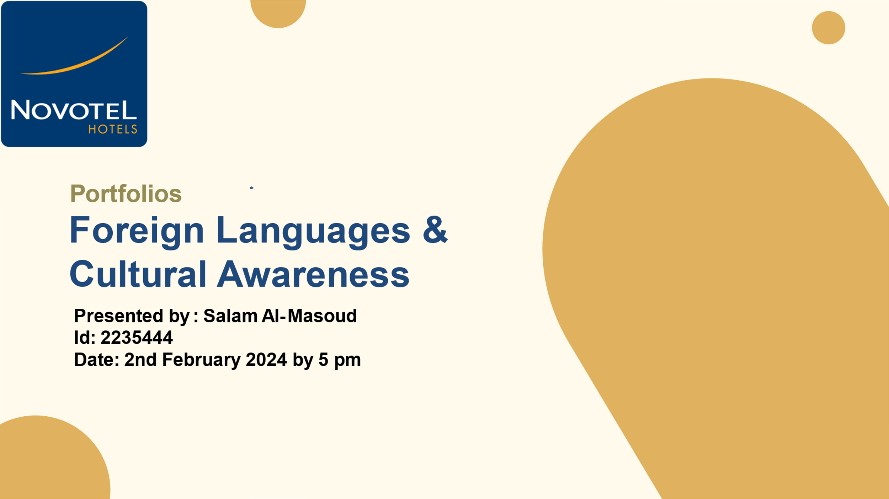
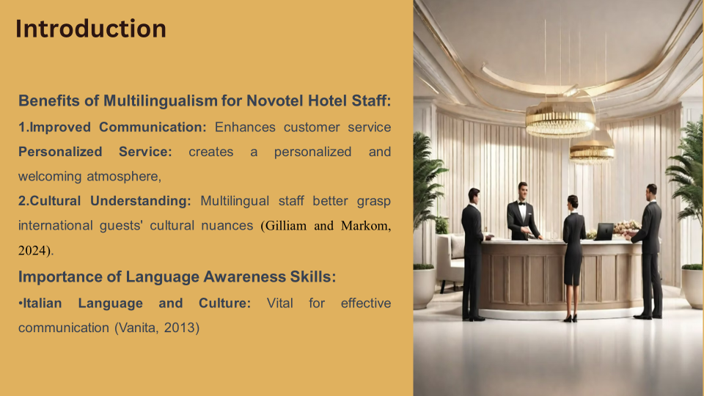
In this opening part, we look at the benefits of multilingualism for Novotel Hotel employees. Improved communication is a crucial advantage. As it promotes improved customer service and interaction with several types of people. The ability to communicate in visitors' native languages helps to create a personalised and welcoming environment throughout the whole culture. Cultural awareness is increased among multilingual professionals, resulting in an authentic and caring experience for foreign clients. The significance of language awareness abilities is emphasised with a focus on the Italian Language and Culture, emphasising its importance for efficient communication and fulfilling the needs of approximately 85 million Italian speakers.
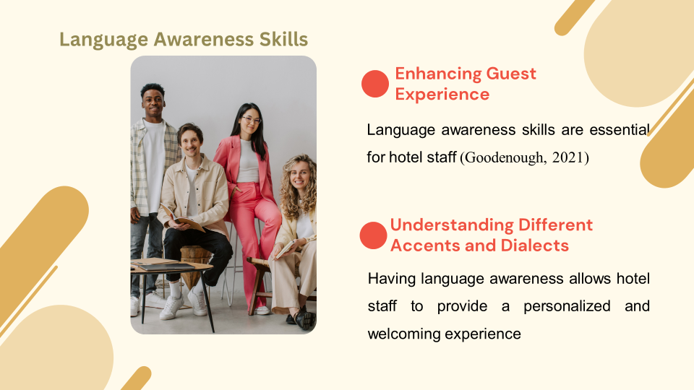
Here, language awareness abilities play a critical role in the hotel sector. Specificallygood communication with visitors from other countries. These abilities are badly needed for hotel staffs to understand properly the varity of cultures and accent. It helps resulting in a more personalised and beautiful experience for customers and motels. By doing these things it creates a critical role language awareness plays in boosting the overall guest experience.
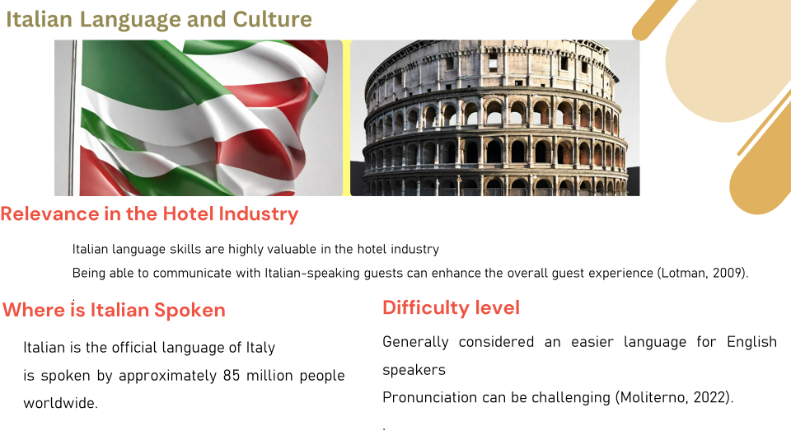
Italian language skills are highly valuable in the hotel industry, especially in popular tourist
destinations in Italy. Being able to communicate with Italian-speaking guests can enhance
the overall guest experience and improve customer satisfaction (Lotman, 2009).
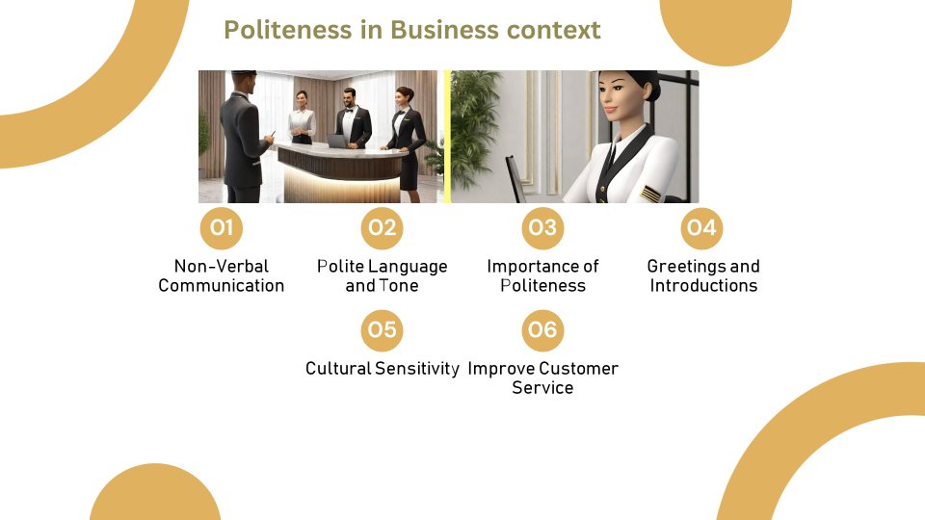
Today, I would want to express some politeness in business context. These 6 points overstate the importance of language awareness skills in the hospitality industry. Non Verbal communication , Importance of politeness , greeting , cultural sensitivity these things are also essential for effective communication with the customers who came from sevarel countries or cultures. There are also some things we need to keep in our mind like language abilities. It help to bring up a deeper cultural awareness in the hospitality sectors. Hotels that accept Italian tourists must be familiar with their language and culture.
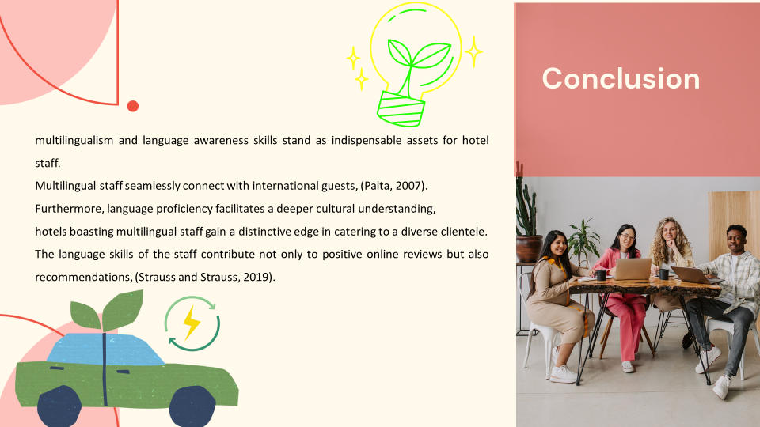
Ladies and gentlemen, some of the most emergent abilities for hotel employees, in today’s hospitality industry are multilingualism and language awareness. In 2007, these qualities were described by Palta who further iterated that they are critical for improving communication abilities. The employees who can seamlessly engage with international guests are the first priority of our hotel. We try and ameliorate the overall experiences of our guests by providing personalised care and pleasure, transcending the barriers of language.
Moreover, linguistic fluency enhances the cultural knowledge and facilitates the natural-like communication between the guests and the staff (Strauss and Strauss, 2019), especially in case of the Italian Guests. The competitive benefits of possessing a multilingual staff transcend the positive internet evaluations and recommendations, improving the brand name and revenue. One of the most thoughtful and strategic decisions of our hotel management is the investment in language training which has borne great results for the whole business and continues to promise the same in the future.
References (no screenshots):
Gilliam, L. and Markom, C. (2024) Difference and sameness in schools: Perspectives from the European Anthropology of Education. Oxford, England: Berghahn Books.
Goodenough, W. H. (2021) Culture, Language and Society. 2nd ed. Reading, PA: Benjamin-Cummings Publishing Co., Subs. of Addison Wesley Longman.
Lotman, J. (2009) Culture and Explosion. Edited by M. Grishakova. Translated by W. Clark. Berlin, Germany: Mouton de Gruyter.
Moliterno, G. (ed.) (2022) Encyclopedia of contemporary Italian culture. London, England: Routledge.
Palta, N. (2007) The Art of Effective Communication. New Delhi, India: Lotus Press.
Strauss, R. and Strauss, C. (2019) Four overarching patterns of culture: A look at common behavior. Wipf and Stock.
Vanita (2013) Effective communication in human resource development. New Delhi, India: Atlantic Publishers & Distributors.

