Individual project: RTW stench unit upgrade
Course: Mechanical HNC Year 2
Unit: Individual project SGDM5024
Student name: James Hart
Student ID: JH188046
2020

Summary
To summarise this project it could be said it did not go exactly to plan with both overlooked aspects of the project and a worldwide situation such as the corona virus pandemic that was not included in any project contingency plan. This current situation of country wide lockdown ultimately lead to the incompletion of this project within the set time period, and it just goes to show that not even large multinational companies such as Valero energy corporation are immune from the pandemic. However the project still met some of the product design specification, such as being currently under budget for components. The quality of the finished system met and exceeded the initial material specs. Moving forward from this point the project is at a stand still waiting for to come to a conclusion on the loading bay terminal software. Several spin offs could come to light from this project mainly incorporating the system into the jetty loading arms more effectively.

Contents
1 Summary i
3 Table of figures 2
4 Acknowledgements 3
5 Introduction 4
6 Literature review and background research 5
7 Project specification 9
7.1 Product design specification 9
7.2 Testing plan 10
8 Project planning 10
9 Project solutions 10
9.1 Disinvestment 10
9.2 Manually operated system 11
9.3 Automated system 11
10 Design and implementation 14
11 Analysis 19
11.1 Cost analysis 19
11.2 Evaluation 21
12 Conclusion 22
13 Recommendations 23
14 References 24
15 Appendices 25

Table of figures
Figure 1 Liquefied propane gas composition 5
Figure 2 Typical gas road tanker 6
Figure 3 Ethyl mercaptan properties 6
Figure 4 Feedback systems 7
Figure 5 open loop closed loop comparison 8
Figure 6 Timing plan chart 10
Figure 7 solution criteria analysis 12
Figure 8 criteria analysis visualised 12
Figure 9 Old mercaptan dosing system 14
Figure 10 Enraf micro dose 15
Figure 11 Enraf micro dose labelled diagram 16
Figure 12 Enraf micro dose parts table 16
Figure 13 Enraf dosing systems delivered 17
Figure 14 wiring the fusion4 controllers 18

Acknowledgements
I would like to say a huge thank you to Andrew Byrne for his expert advice on the majority of elements to do with this project. I would also like to thank the rest of the team who contributed to the project.

Introduction
Pembroke refinery was opened in 1964 and then bought by Valero in 2011. Since 1964 the refinery has undergone numerous upgrades increasing production to approximately 250,000 barrels of throughput per day. These upgrades have made it one of the more complex refineries in Europe. Producing products such as gasoline, diesel, kerosene and LPG Valero Pembroke is the last welsh refinery still in service today, this is partially down to the process improvements enabling the refinery to be more efficient and therefore stay competitive in today’s market.
The stench injection system upgrade being undertaken in this report is situated on the road tanker gas filling station, this major improvement over the existing stench injection system is a needed upgrade to the dated system currently in place. This upgrade will allow the tanker driver to be able to fill the tanker without complete assistance from operations personnel. In the future there is plans to implement this same system for filling the tankers on the jetty berths.

Literature review and background research
Ethyl mercaptan or Ethanethiol is the odorant that is used to give many gases such as propane a potent smell, propane gas on its own is odourless which presents itself as a major risk as if it were to leak it would go undetected and propane is highly flammable. For this reason gas manufacturers must add an odorant in order to meet UK health and safety executive (HSE) regulations.
(Calor gas, 2017)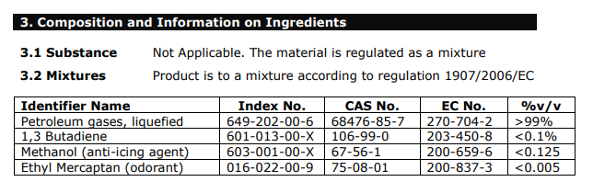
Figure 1 Liquefied propane gas composition
In the table above taken from a Calor gas safety data sheet you can see the typical ingredients that make up liquefied propane gas. The methanol alcohol is added to the propane mixture as an anti-icing agent, this means that adding the alcohol to the propane lowers the freezing point so that when the gas is being used for example a barbecue or gas hob the gas lines do not freeze where the pressurised propane undergoes a change in pressure from a high pressure in the bottle to a low pressure through a regulator. Ethyl mercaptan (odorant) makes up only 0.005% at maximum of the mixture by volume. A typical articulated lorry gas trailer load is 20,000kg, and the odorant mixture level used at Valero Pembroke refinery is 20 milligrams of ethyl mercaptan per kilogram of propane, meaning the amount of ethyl mercaptan needed to be added is:
$$amount of odorant required per load= 20×20000=400,000 mg= 400 grams$$
From this we can then use the dose weight and the density to calculate the volume of ethyl mercaptan required per lorry load.
(lakeland products, 2017)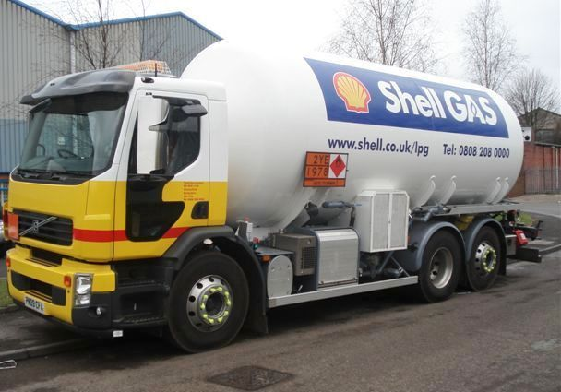
Figure 2 Typical gas road tanker
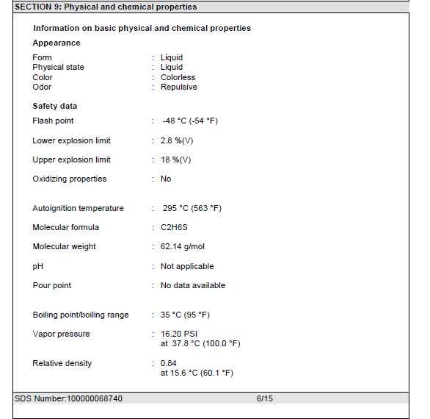
The above photo is an example of the typical road tankers that come to Valero road tanker filling station to be loaded although there are a range of sizes varying from 12 tonne capacities all the way up to 20 tonne capacities.

(Chevron Phillips chemical, 2018)
Figure 3 Ethyl mercaptan properties
From the table above you can see the relative density of ethyl mercaptan is 0.84. Relative density is the density of a fluid compared to water. Therefore if you had a litre of both fluids the water would weigh 1kg and the ethyl mercaptan would weigh 840 grams.
$$Density=\frac{Mass}{Volume }$$
$$Volume=\frac{Mass}{Density}$$
$$Volume of dose per lorry load= \frac{0.4}{840}=4.76×10^{-4} m^{3} or 0.476 litres$$
This means the pumps selected must be able to supply this quantity of odorant in the time it takes to fill the trailer. Otherwise the dosing time will add extra time onto the total filling time and reduce loading bay efficiency and overall throughput of Lorries per day.
For this ethyl mercaptan injection system upgrade the desired control is closed loop, this means the controller adjusts according to feedback from sensors which in this case would be flow meters. Compared with the other type of control called open loop the system still measures the required process parameters and displays these readings however the controller does not adapt to obtain the desired readout and it is down to the operator to manually adjust the process to achieve the correct parameters.
(instrumentation tools, 2020)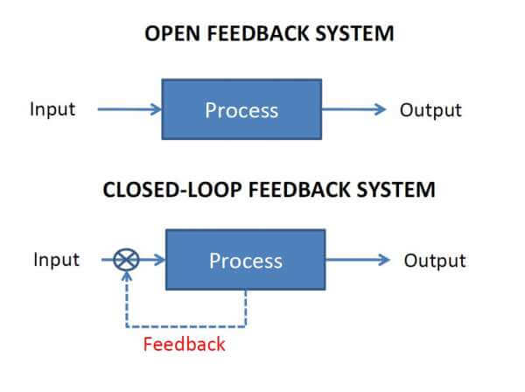
Figure 4 Feedback systems
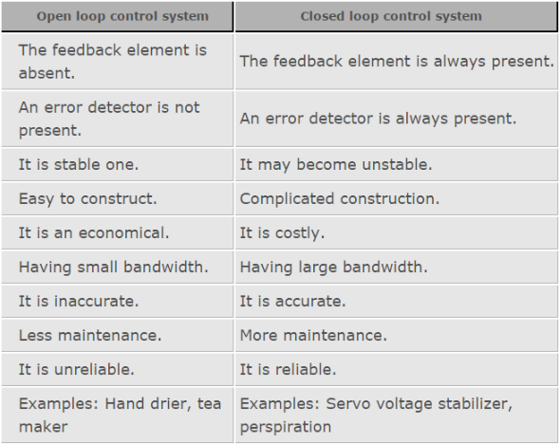
The illustration above of a block diagram shows this perfectly; in the first block diagram the output has no influence on the input. On the second diagram you can see there is a feedback loop which returns back to the controller and then any adjustments can be made. Closed loop is the preferred control method for this project because it is required for automated systems so it would not be possible with an open loop control. There are however some trade-offs when choosing a closed loop control system over an open loop control system. The figure below shows a comparison between the two types of control.

(instrumentation tools, 2020)
Some of the main advantages of closed loop control are the reliability and accuracy of the operations when compared to open loop; however this does come at a cost both financially and in complexity of systems. This complexity can lead to issues such as instabilities which can cause the input and output to become out of phase; ‘this is believed to be one of the causes of the Chernobyl nuclear meltdown in 1986’. (Wray, 2017) More maintenance is also required compared with an open loop control system due to the added complexity, however is required to run an automated system.
Dosing pumps or commonly known as injection pumps are small positive displacement or sometimes diaphragm pumps that can very accurately add small quantities of chemicals in an industrial process scenario as well as other applications such as medicine and agriculture. In the case of this project the pumps
Figure 5 open loop closed loop comparison

Project specification

Product design specification
Performance
- Automated system must allow simultaneous filling of two propane tankers using both filling bays.
- Must be able to dose propane tanker without the full attendance of a process operator
Materials
- All electrical equipment installed within a hazardous area are to be ATEX and must comply with explosion directive 2014/34/EU.
- All cable glands must be fitted sealing washers to meet or surpass a minimum IP rating of IP66.
- All cable trays must be hot dip galvanised to standard BS EN 1461.
- All pipe work must be constructed from 316 stainless steel and use Swagelok compression fittings to comply with site standards.

Consistency
- New system must be able to correctly add correct levels of odorant to the gas tanker in order to meet the required ratio.
Product form and function
- New dosing system controllers must fit into the existing housing enclosure.
Product Life
- New dosing system must be able to last for at least the next 20 years
Cost
- Total cost of parts must not exceed £100,000 project budget.

Testing plan

Project planning
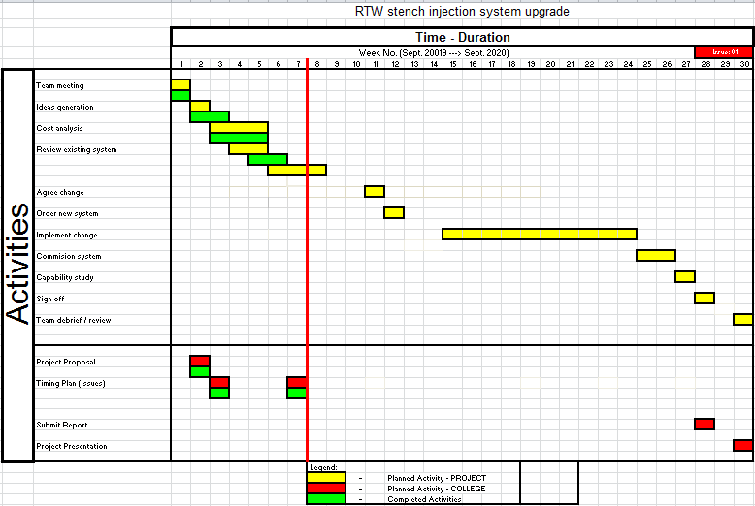
Figure 6 Timing plan chart
Timing plan found in figure six will be the schedule that the project will try to follow in order to finish on time any issues encountered will also be logged on the timing plan for as a point to reflect on in the evaluation of this project.

Project solutions

Disinvestment
Project solution one is to disinvest in the current system in place. The current ethyl mercaptan injection system which is supplied by Berdosa has become outdated and the manufacturer no longer supports the platform or provides spares and a maintenance program to go along with it. Therefore removing this system completely. However this would then require the propane and ethyl mercaptan to be premixed and stored prior to being loaded into the road tankers. This obviously is not a viable solution to the problem and challenges this project faces because not all vendors require the same concentration of mercaptan odorant meaning a gas storage sphere for each gas with a different concentration of ethyl mercaptan would be required.

Manually operated system
The second solution would be to replace the existing injection system with a similar system to the current Berdosa dosing setup with new equipment that would be supported by the manufacturer. Instead of using a sight glass on the ethyl mercaptan storage tank in order to interpret the level drop by the operator. A flow meter in an open loop feedback system could be implemented so that the amount of odorant being added would then be displayed on a digital read eliminating human error from the measurement. This solution however would still require an operator in attendance for the whole duration of the tanker filling.

Automated system
A fully automated system implementing a closed loop feedback system is the ideal setup for improved efficiency and repeatability. This system would consist of different injection pumps with a variable stroke which would allow the mercaptan to be added continuously throughout the loading period to ensure proper mixture was achieved. This automation would also require a PLC or (programmable logic controller) this would be used in conjunction with two flow meters. One flow meter would be measuring the propane gas filling the tanker and a separate flow meter on ethyl mercaptan injection point would measure the flow from the injection pump. The tanker driver would then input required information into the loading bay terminal such as the load size required and the ratio of propane to odorant. From this information as well as the flow meter reading for the propane the controller would then adjust the injection dose size to suit the desired ratio. The flow meter on the ethyl mercaptan line would verify that the pump stroke adjustment was correct to achieve the desired the flowrate to suit the propane flow rate.
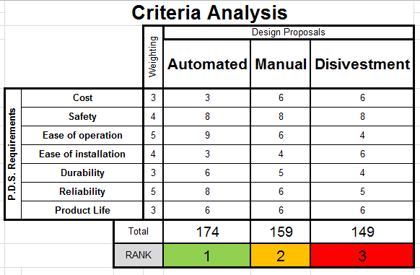
Figure 7 solution criteria analysis
Both figures six and seven represent the criteria analysis comparing the three possible solutions for this project. As seen in these figures the top ranking solution is the fully automated stench injection system with the manually operated system coming in second with 159 points only losing out by 15 points. Finally the disinvestment strategy came in last with 149 points from all the categories.
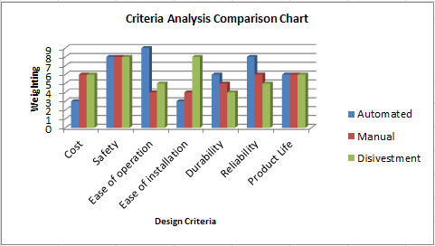
Figure 8 criteria analysis visualised
Looking closer at figure eight surprisingly the automated system scored the lowest in some of the categories. Unsurprisingly the automated system scored the lowest on the cost category due to the overall complexity of the system. The other category where the automated solution did not excel was the ease of installation, again due to the complexity of all the components and having to tie in all the instruments that are situated in the loading bay to the controllers result in far more work . Furthermore calibration of all the instruments will need to be carried out in order for the system to work, this is a time consuming task which would not have to be done if all the equipment was manually operated such as valves and pumps.

Design and implementation
The first step of implementing the new stench system was to remove the old Berdosa pumps. Only the pumps and existing mercaptan lines need to be removed to make way for the replacement systems. The holding tank will be re used with the new pumps; however the residual mercaptan in the tank still needed to be drained. Due to how potent the mercaptan is in its fully concentrated form breathing apparatus was required to be worn whilst draining the last of what remained in the tank.
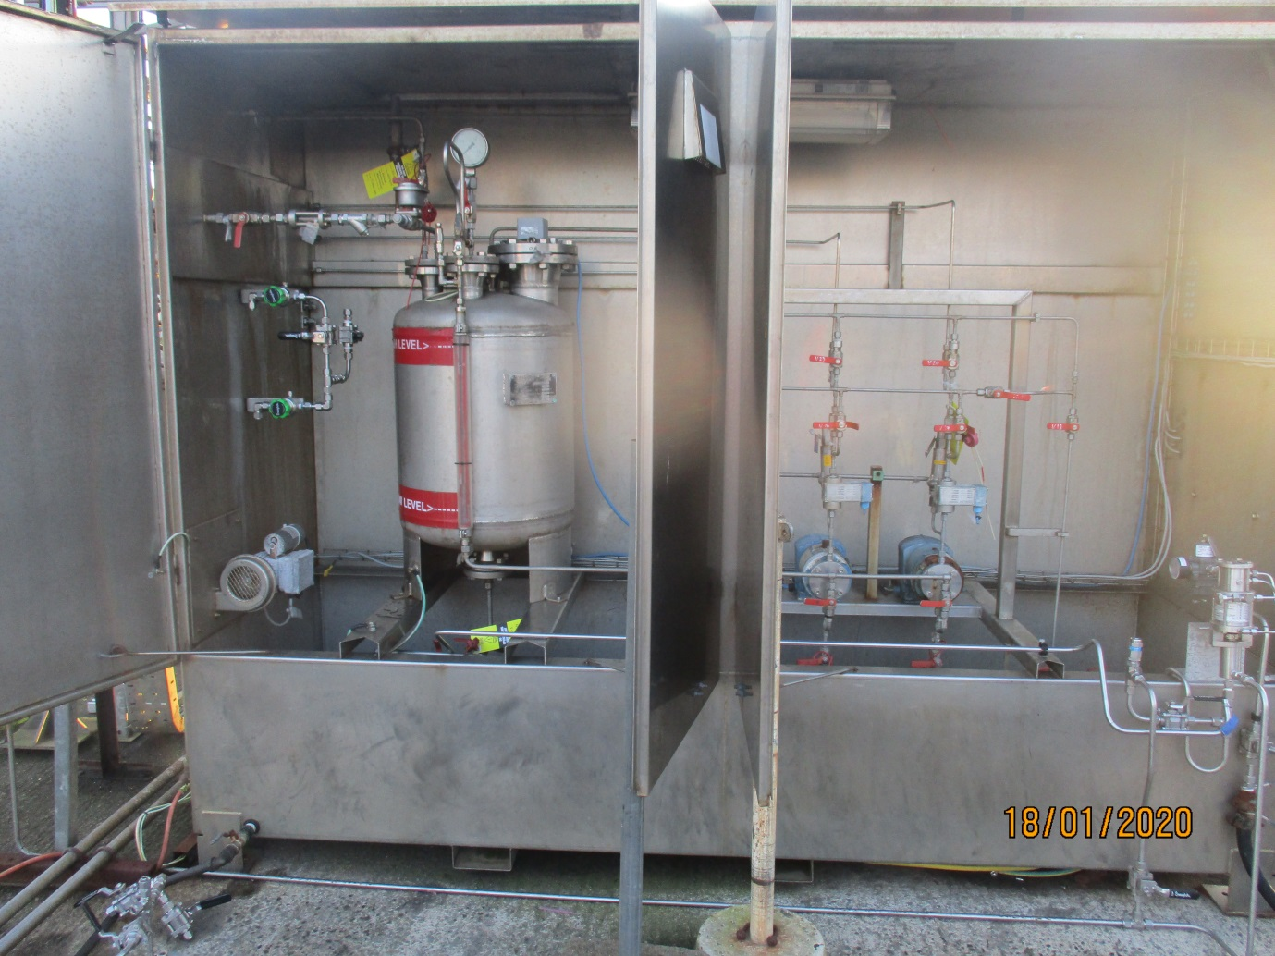
Figure 9 Old mercaptan dosing system

The automated system that we are going implement for the RTW stench (odorant) injection system upgrade is the Honeywell Enraf micro dose. For this there will be three complete separate Enraf micro dose systems, one for each loading bay of which there are a total of two and then one for the more micro dose system for the propane filling for the jetty berth loading arms to load the gas sea tankers. The figure below is a photo of a single Honeywell Enraf Micro dose with a fusion 4 controller this is the exact setup that will be used for the Valero propane loading bay upgrade.
Figure 10 Enraf micro dose
To explain the implementation of this system with the Valero gas loading bay better please see the figure below of the orthographic projections of the Honeywell Enraf micro dose. Looking at the figure below, the ethyl mercaptan will be will be fed from the storage tank to the micro dosing pump by the pressurised nitrogen blanket at point C (pump inlet) from here the pneumatic pump will pump it through the flow meter which will communicate with the fusion4 controller. The odorant then comes to the three way valve, port one is blanked off, port two is the to the closed loop calibrator. The closed loop calibrator simply a measuring cylinder with a scale on the sight glass using this reading the flow meter can be calibrated to the individual stroke volume of the pneumatic injection pump. Port three of the valve is the to the injection line for the actual dosing of propane filling the road going propane tankers. At this point on the propane line there is a flow meter, the flow meter is also connected to the fusion4 controller. The solenoid on the airline is attached to a valve this valve open and closes when required to turn the pump on and off so that the injection of mercaptan is not all at once and is injected at intervals throughout the filling period.
(Honeywell, 2019)
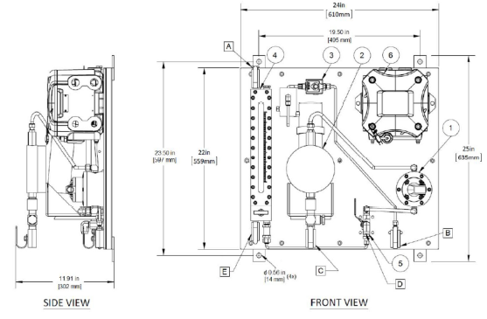
Figure 11 Enraf micro dose labelled diagram
Item No | Description
1 | Flow Meter
2 | Pneumatic Pump
3 | Solenoid
4 | Closed loop calibrator (CLC)
5 | 3-Way valve
6 | Single stream controller (SSC)
A | Blanket pressure (nitrogen supply)
B | Air inlet
C | Product inlet (mercaptan)
D | Product outlet (mercaptan)
E | Return to storage (mercaptan)
Figure 12 Enraf micro dose parts table

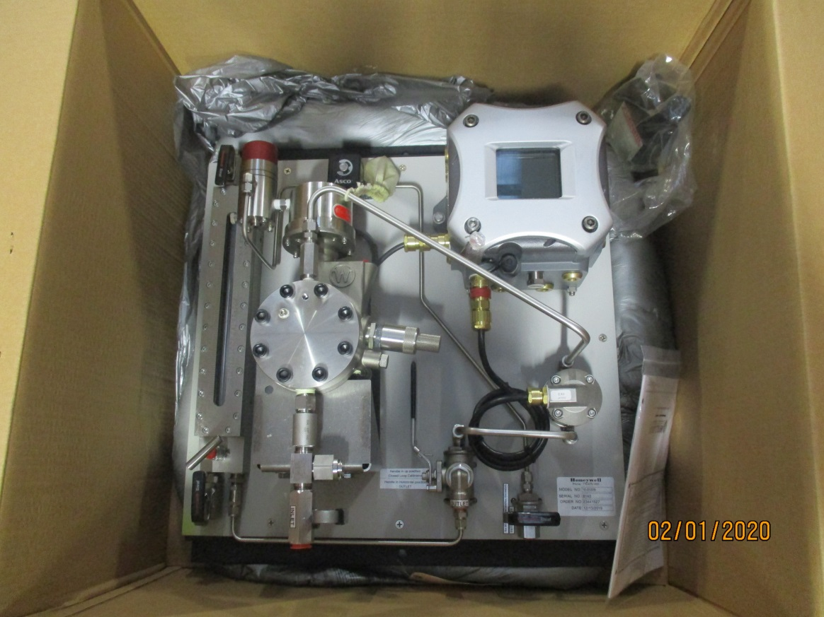
Figure 13 Enraf dosing systems delivered
Once the existing pumps were removed the new pumps on their backing plates could be mounted into the existing cabinet. Once the all three pumps were mounted it was then just a case of making the 3/8 and 1/2 stainless steel Swagelok pipe work to tie into the existing pipe work and holding tank.
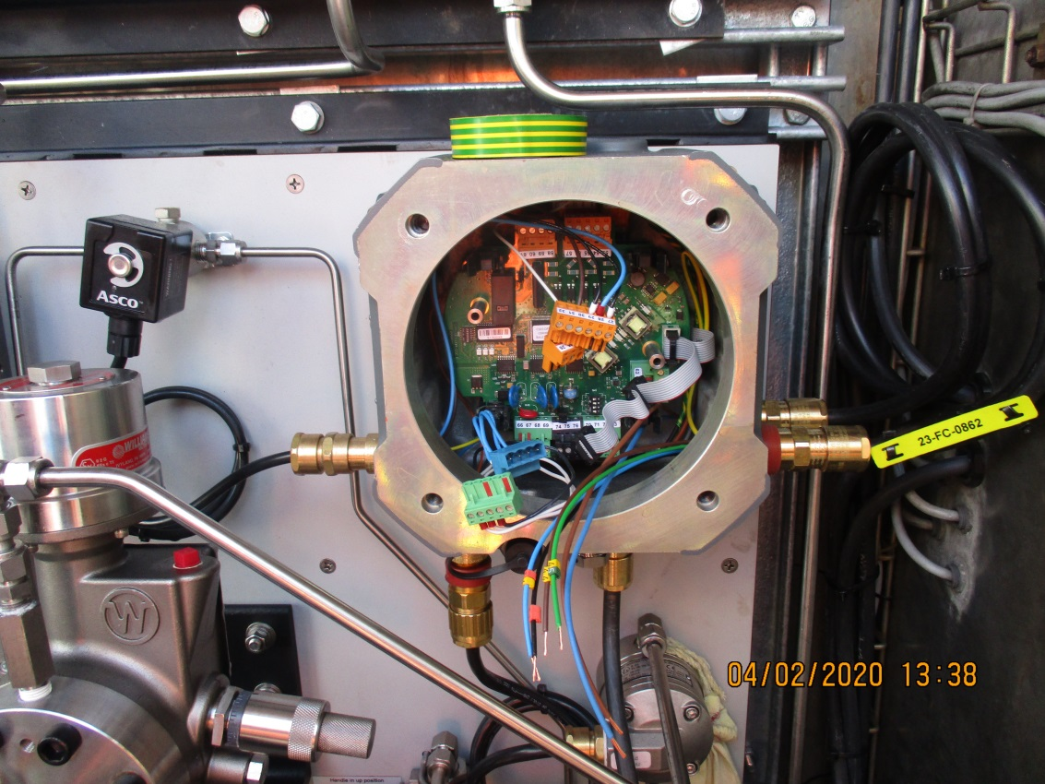
Figure 14 wiring the fusion4 controllers
The pump control modules were then wired up to the 110v supply from the existing distribution box. 110v is predominantly used on the refinery sight instead of 230v due to the inherent dangers of working in an explosive atmosphere.

Analysis

Cost analysis
Figure below is the quote received from Honeywell Enraf. This quote includes the three Enraf micro dose setups for each loader as well as the fusion4 access device. With all shipping costs included the costs comes to a total of $64,036 (United States dollars). Converting the costs from US dollars to great British pounds results in approximately £50,800 for cost of parts. This is all the components that were required for this project as the existing infrastructure of the ethyl mercaptan injection system such as the holding tank, PSVs (Pressure safety valves) and extraction fan for the cabinet were all adequate to be used with the new injection pumps.

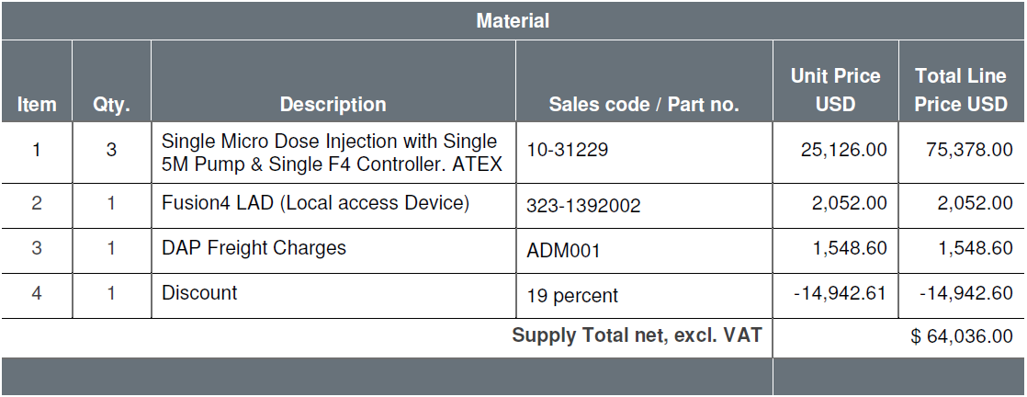
This comes well under budget for parts however at this point in time there is still one issue with remaining with the project, this is to do with the loading bay terminal user interface (Accuload panel).the accuload panel is where the lorry driver inputs his personal identification number and load type/size. Unfortunately the accuload system is becoming out dated and is being phased out by the manufacturer. This means the project is currently at a standstill and while a decision is made whether to convert both propane loading over to the new fuelfax software that the petrol/diesel and heating oil loading bays have been using for the last couple of years. This update would allow the lorry drivers to simply scan their ID badge to access the terminal from the terminal all the load information is then uploaded to the Fuelfax website. In the project proposal one of the main objectives of the project was to improve traceability of the loading. The road tanker loading is managed from London and not Pembroke due to it being classed as distribution not refining, having all the information automatically uploaded, traceability of things such as the mercaptan dosages of each load could be recorded and that would be easier to manage from the London office then. As well as that Valero could not be held accountable for any discrepancies with loads if they have records of the mercaptan doses in each load.

Evaluation
This project was on track to be completed on schedule in line with the timing plan initially made. However due to unforeseen issues such as the accuload system not being able to support the fusion4 controllers has delayed the commissioning of the stench injection system. I believe the system put in place would have been adequate to meet the product design specification. And still did hit the majority of them apart from the performance section. All materials met or exceeded the design spec. The parts cost was under budget by almost half if the cost of the potential Fuelfax software is not taken into consideration. The only questionable that is not to do with the incompletion of the project is whether or not the life of the project would be met at 20 years if the accuload system was made to work with the new controllers and then they stopped supporting the platform resulting in required rework instead of just replacing the accuload for the more up to date Fuelfax initially.

Conclusion
Unfortunately the project did not meet its initial specification within the given time scale. Due to issues that were perhaps overlooked in the meetings the as well as things that could not have had contingency plans for such as the corona virus outbreak. This global pandemic disrupted the Valero Pembroke refinery tremendously now working on two separate shifts to help remain socially distant from work colleagues. This also makes communication harder having to do online digital meetings to replace normal human interaction results in the project moving at a slower pace than originally.

Recommendations
Perhaps if the simpler manually operated system had been used instead of the more complex fully automated stench units then the project would have been completed be before the corona virus pandemic caused not just Valero to come to a halt but the whole world. The installation team worked well as a whole on the project each department focusing on their specific task to complete the system. My biggest criticism of my self was my time management, finding time to put aside to update the report as the project progressed was hard to achieve when still being scheduled on the normal maintenance work plan day in day out.
Once the decision has been made whether or not to go for the fuel fax system rather than manage in the meantime with accuload the project can then be seen out and the system can be commissioned outside of the specified time.
Future improvements of the system will be mainly to do with the jetty dosing line; this will be the last one to be commissioned as it is not always required for the international propane exports as they often add their own odorant once it is distributed in that country . The jetty is situated roughly one mile from the road tanker filling bays, the small injection pumps can reach the berths as it is mostly sloping downhill towards the coast, however a future project could be to fit an inline booster pump to ensure the mercaptan can reach the berths without fault.

References
Calor gas, 2017. Propane safety data sheet. [Online]
Available at: https://www.calor.co.uk
[Accessed 16 April 2020].
Chevron Phillips chemical, 2018. ethyl mercaptan safety data sheet. [Online]
Available at: http://www.cpchem.com
[Accessed 16 April 2020].
Honeywell, 2019. Process measurement and controll. s.l.:s.n.
instrumentation tools, 2020. open loop and closed loop animation. [Online]
Available at: https://instrumentationtools.com
[Accessed 16 January 2020].
lakeland products, 2017. LPG tanker manufacture. [Online]
Available at: http://www.rtnltd.co.uk
[Accessed 12 January 2020].
Wray, R., 2017. instrumentation and control. Haverfordwest: Pembrokeshire college.

Appendices
Appendix A Enraf micro dose block diagram
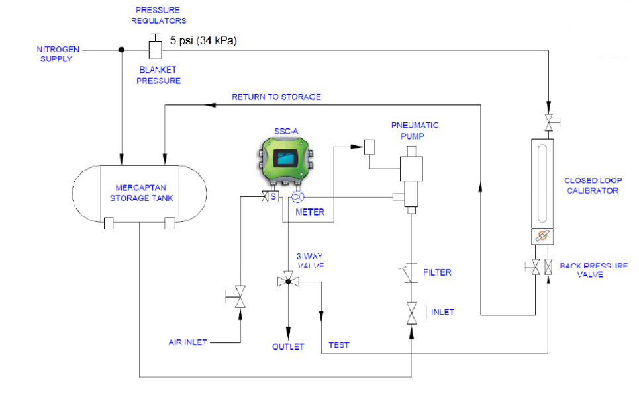

Appendix B dosing cabinet P&ID

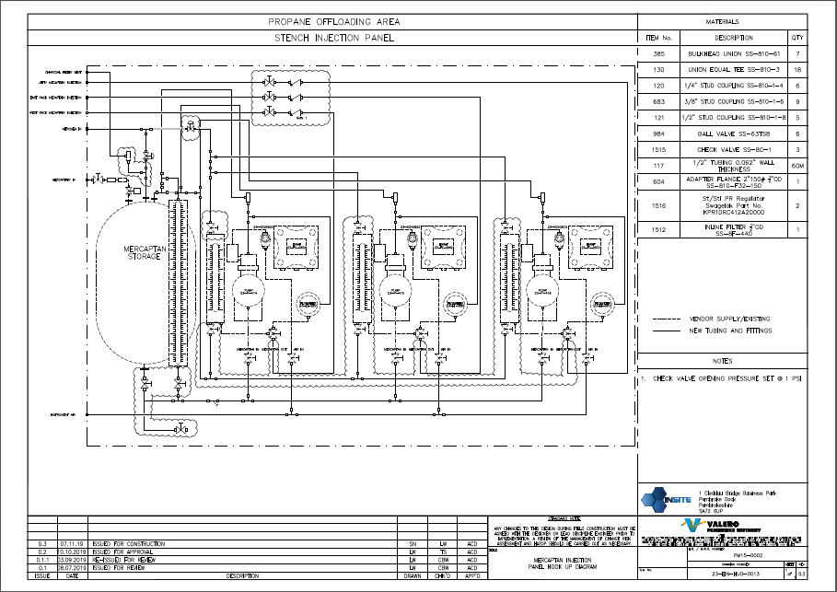

Appendix C Final timing plan issue
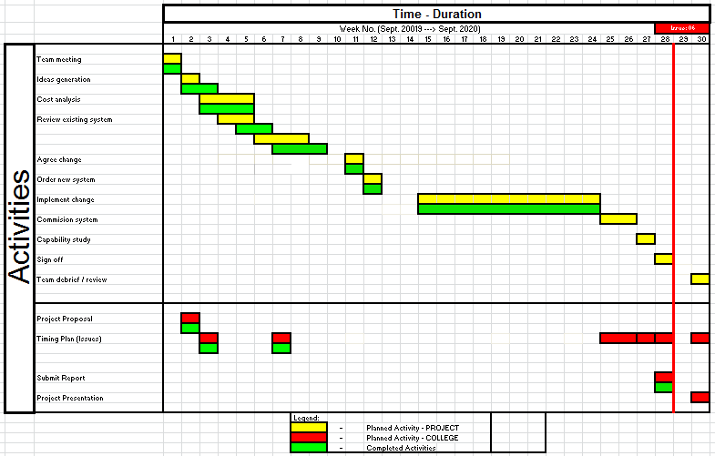

Appendix D Project proposal


