Chapter 3
Research Methodology.
3.0. Introduction
The research methodology chapter is an essential component of any research project, as it outlines the approach, methods and techniques used to collect, analyse, and interpret data. Defined as ‘the systematic collection and interpretation of information with a clear purpose, to find things out’ (Saunders, et al., 2007, p. 488), research is essential in obtaining and reviewing data in order to inform the evidence base relevant to this research project.
The choice of methodology should be determined by the research objectives and questions, as well as the researcher's own beliefs and assumptions about the nature of reality and the best way to study it. This chapter will discuss the research methodology chosen for this study, justifying the adoption of the pragmatist approach and a survey methodology by which to undertake primary research. Furthermore, the approach to secondary research will also be set out, utilising pre-existing CoP data alongside unpublished SWP programme documentation. It will also discuss the benefits and potential drawbacks of this approach and how they will be mitigated. It is important to note that as a senior police officer within the force being researched, the researcher has a personal interest and is considered an insider researcher.
3.1. Research Aims
The aim of this research is to identify, review and evaluate the elements of the SWP PEQF programme and to synthesise the same with the themes identified within the literature review in the previous chapter. To deliver against these aspirations, the researcher has set out a series of objectives (first set out in chapter 1) in accordance with Saunders’ appraisal in that they be “precisely written and lead to observable outcomes” (2007, p. 40).
3.2. Objectives
- Review and understand the existing academic and empirical evidence base relating to PEQF.
- Identify and study the existing academic and empirical evidence base relating to design and delivery of degree level work-based qualification.
- Explore existing South Wales Police programme documentation and College of Policing survey data.
- Obtain and analyse additional data from existing South Wales Police officers and staff.
- Assess the findings from existing surveys with current South Wales officers to understand the factors relevant to PEQF.
- Identify and articulate the factors that impact on optimum PEQF delivery within South Wales Police.
- Critically evaluate this information to make a series of recommendations to South Wales Police with regards to optimum PEQF delivery within South Wales Police.
3.3. Research Design
Developed by Saunders, et al (2007), the research onion sets out the different stages to be considered when designing research and identifying the optimum approach. The onion analogy provides a visual representation of the way in which each layer needs to be ‘peeled away’ in order to reach the next. The layers within the onion represent different considerations – all of which are dealt with individually within this chapter. In this case the researcher has adopted an overall phenomenological approach. Described as the ‘common meaning for several individuals of their lived experiences of a concept’ (Creswell, 2013, p. 76), phenomenological research deals with lived experience of individuals which is critical to this study.
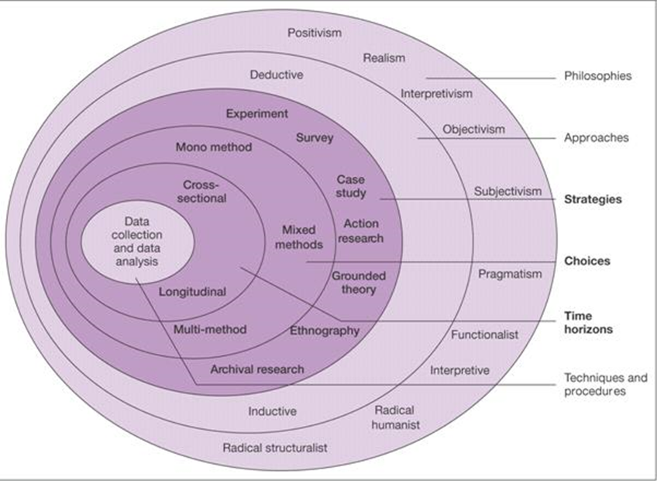
Fig 3.
The research onion.
(Saunders, Lewis & Thornhill, 2017).
3.4. Research Philosophy
As is seen from the first layer of Saunders’ research onion, one can consider several research philosophies.
The researcher has utilised a pragmatism philosophy as a research paradigm, because this considers research activity from a practical sense and will ‘bridge the gap between the scientific method and structuralist orientation of older approaches, and the naturalistic methods and freewheeling orientation of newer approaches’ (Kaushik & Walsh, 2019, p. 255). Pragmatism isn’t limited to a single philosophy and focusses on problem-solving and practical applications of knowledge, which emphasises the importance of context and encourages researchers to consider practical implications of their findings (Creswell 2013; Creswell and Plano Clark 2011). This approach offers further benefits including flexibility, practicality, and the ability to incorporate mixed method data collection (Creswell, 2014). Using a mixed methods approach that combines both quantitative and qualitative data collection techniques enables the researcher to gain a more comprehensive understanding of the research problem (Creswell, 2014). The use of pragmatism in this study also acknowledges the social context in which the research is conducted, and the multiple perspectives of the participants involved (Bryman, 2016). In short, by adopting a pragmatic approach, the researcher recognises the subjective experiences of the participants, alongside the quantitative data provided.
3.5. Research Approach
The researcher has considered both deductive and inductive approaches as articulated within the onion. The inductive approach is adopted and considered most appropriate within the context of this work. The inductive approach is described as a ‘bottom up’ approach whereby research moves from specific understanding and how that informs a more generalised conclusion (Trochim & Donelly, 2006). In the case of this research, the approach seeks data on specific elements to inform a successful PEQF programme more generally.
3.6. Research Strategy
In determining research strategy, the researcher must identify the method which best delivers the data required while considering additional parameters, such as timescales and available sample size.
The primary research design selected for this study is a survey, which aligns with the aims and is suited to the research question. A survey is a research method that collects data from a sample of individuals using a standardised questionnaire and is a commonly used method of data collection in social sciences. This provides a structured approach to gathering information from a large sample in different locations within a relatively short time frame (Babbie, 2017; Bryman & Bell, 2015). Furthermore, surveys are cost-effective compared to other data collection methods, such as interviews or focus groups (Groat & Wang, 2013).
Secondary data is obtained from grey literature consisting of previous surveys with police officers undertaken by the CoP, alongside unpublished SWP programme design documentation. The CoP conducted a survey with police officers, focusing on their perceptions of the PEQF programme. The survey collected data on various aspects of the programme, including its structure, content, and delivery.
3.7. Research Choice
As this study obtained data from both primary and secondary sources, the research choice adopted is described as mixed method. The use of closed and open ended survey questions is consistent with this (Saunders, et al., 2016).
3.8. Time Horizon
This study adopts a cross sectional approach to data collection. The study is conducted at a moment in time as opposed to a longitudinal approach where subject’s experiences are researched over time (Saunders, et al., 2016). A longitudinal design is difficult to justify within the context of this research and would require a much longer period than the time available to complete this piece of work (Sedgwick, 2014).
The approach taken gives confidence that the cross sectional experiences of the interviewees can be considered as representative of the sample cohort with validity (Collis & Hussey, 2014).
3.9. Data collection.
Primary data collection surveys capture the experiences of police officers and staff, to obtain both quantitative and qualitative data. The survey is administered through the online survey platform SLIDO, which allows easy distribution and data collection while ensuring confidentiality and anonymity of the participants. The survey link is to be distributed to the sample audience via email, with an additional reminder sent approximately ten days later.
The primary data survey contains both closed and open-ended questions and is distributed to student police officers that are undertaking or have completed the PEQF programme, along with trainers delivering the programme. In this case, closed questions provide quantitative data while open-ended questions generate qualitative data. Closed questions employ a four-point Likert scale, which provides a higher degree of differentiation compared to the traditional five-point Likert scale. The use of a four-point Likert scale has been shown to improve response accuracy, reduce respondent fatigue and avoid mid point bias (Jamieson, 2004). Whilst closed questions can be analysed statistically, open-ended questions elicit more detailed and nuanced responses to the research questions, allowing participants to provide personal experiences and opinions and to explain their responses to the closed questions. Those questions are structured to enable participants to provide comprehensive feedback, while ensuring that their responses are easily analysed. By using both types of questions, the researcher can collect a rich and varied set of data, providing a deeper understanding of the research topic. Furthermore, the use of mixed methods research can help mitigate some of the drawbacks of using surveys as a data collection method. The themes identified within the literature review informed the basis of the survey questionnaire in order to deliver against the first five objectives highlighted earlier within this chapter. The remaining two objectives are dealt with through the analysis of pre-existing data including previous CoP survey feedback and SWP programme PEQF documentation.
This study aims to establish the views of student police officers and police trainers regarding the integration between their police force and the university, alignment of academic and operational elements, relevance of curriculum, levels of abstraction from operational duty, and effectiveness of communication throughout the programme.
3.10. Data Analysis
The use of SLIDO to host the survey questionnaire provides the researcher with ability to collate, analyse and present the data within this research project. The SLIDO platform collates, codes, and presents quantitative data within chart format, whilst qualitative data will be presented in word cloud and narrative form aligned to the themes set out within the literature review.
3.11. Reliability and Validity
Validity and reliability are essential components of any research study. Validity refers to the extent to which a study measures what it is intended to measure. Reliability refers to the extent to which a study produces consistent results over time (Lobiondo-Wood & Haber, 2018).
To maximise the validity and reliability of this study the researcher has taken several actions. The primary data collection methods selected are designed to elicit accurate and honest responses from the participants via a combination of closed and open-ended questions. These questions were informed by the themes identified within the literature review to maintain relevance. One of the primary drawbacks of using survey research is the potential for response bias, where participants may provide socially desirable responses or be influenced by external factors, such as the wording of the questions or the order in which they are presented. This can lead to biased or inaccurate data (Fowler, 2103).
To mitigate this potential bias, the survey questionnaire was pre-tested with a small sample of participants before it was distributed to the larger sample. The use of pretesting enables the identification of any issues with the questionnaire, such as unclear or ambiguous questions, which can be rectified before the survey is distributed to the larger sample. Following pretesting, no issues were identified. Surveys may also suffer from low response rates, which can affect the representativeness of the sample (Dillman, et al., 2014). To reduce this nonresponse bias, the researcher will utilise reminders to encourage participation, enhancing the validity and reliability of the survey results.
The CoP secondary data also consisted of both closed and open-ended questions like those used in the self-administered survey questionnaire, allowing for a comparison of the views and opinions of SWP student police officers with those of other police officers who had previously undertaken the programme. The use of this secondary data is also subject to the same validity and reliability considerations.
The appositeness of using SWP unpublished data has been considered. The use of unpublished data makes further research, validation and evaluation by other researchers more difficult; however, the specific SWP approach to PEQF is central to the research question posed and its absence would acutely impact the quality of this work. SWP programme information has been included through diagrams, tables and infographics within the body of this research project so as to ensure validity over time. SWP provided permission for the data to be used.
Studies have shown that combining primary and secondary data collection methods can further increase the validity and reliability of the findings (Bryman, 2016). The use of both primary and secondary data within this study is designed to enhance the accuracy and robustness of the findings through triangulation to increase the validity and reliability of the findings. The data collected will be analysed using both descriptive statistics and thematic analysis.
3.12. Ethical Considerations
The ethical considerations are crucial in any research project, and this study is no exception. Ethics in the context of research were defined by Saunders et al as, ‘the standards of behaviour that guide our conduct in relation to the rights of those who become the subject of your work or are affected by it’ (2007, p. 178). As the study involves human participants, ethical considerations are carefully addressed throughout the research process. This study considers the principles of ethical research as outlined by the British Sociological Association (BSA) (2017) and the University's research ethics guidelines, who provided approval for the research activity. The survey questionnaire is designed to be straightforward and not cause distress to the participants either psychologically or physically during the data collection process. The principle of voluntary participation was upheld by ensuring that participants were given information about the study, were informed that participation was voluntary, and assured that participation would remain confidential. The data collected will be used only for the purposes of the research study, and any identifying information will be removed from the data.
The use of secondary data obtained from previous surveys conducted by the CoP was also considered with regard to ethical considerations. The CoP obtained informed consent from all participants and their data was anonymised to protect their identities. The use of this secondary data will be undertaken in accordance with the same ethical guidelines.
In summary, the ethical considerations in this study are carefully considered and upheld throughout the research process, with the aim of ensuring that the rights and wellbeing of all participants were protected.
3.13. Conclusion
In summary, this research sets out to obtain, analyse and evaluate research data against the themes identified within the available literature. The researcher adopts a pragmatic philosophy, which affords flexibility in both primary and secondary data collection methods and further justifies the mixed methods approach taken. Primary data will be obtained using online anonymous surveys by police officers and staff that have either completed / are completing the SWP PEQF programme or are training those officers. Utilisation of the online survey platform SLIDO helps to collate and present both quantitative and qualitative data obtained through the use of both closed and open ended questions. Previous CoP surveys and SWP PEQF programme documentation has been collated, reviewed and evaluated as secondary data. Finally, the research is undertaken in line with the ethical approval granted by UWTSD.

