

Emerging Trends

Module Code: | ACCB6019
Assignment Title: | Hackathon 2026
Student Name: | Ioana Catalina Sava
Student number: | 2329918
Lecturer’s name: | Ihsan Ul Haq
Submission Deadline: | Friday 3rd July, 2026 14:00 (2PM)

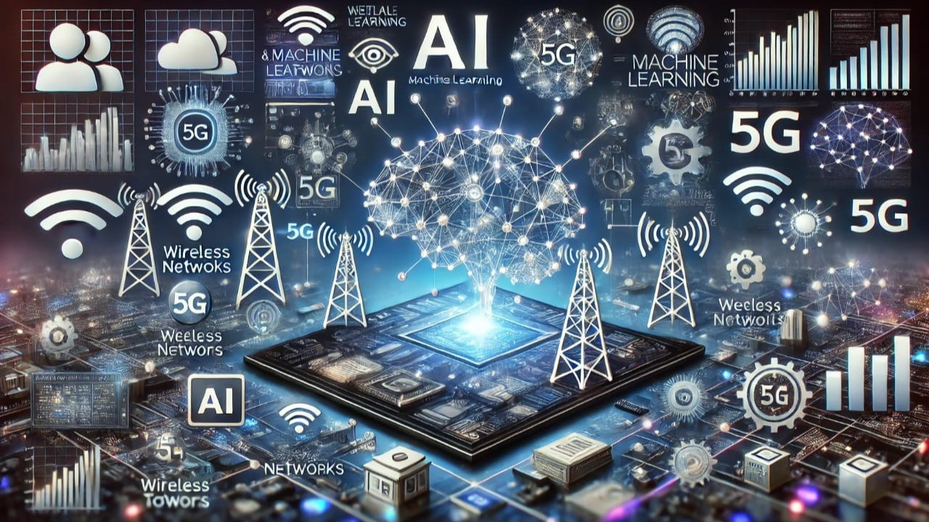
Table of Contents

Introduction 3
Teamwork Reflection 4
Team Performance Rating 5
Technical Reflection 6
Limitations and Risks 6
Future Improvements 7
Conclusion 8
References 9

Introduction

This reflective journal discusses my experience of working on the Blue Line AI project, an AI-based solution designed to improve ambulance response times by combining real-time traffic analysis, intelligent route optimisation, and hospital availability into a single platform. The project was developed to explore how emerging technologies can support faster and more effective emergency response while addressing some of the limitations of existing navigation systems [1].
Within the team, I was responsible for the system design of the proposed solution. My role focused on planning the overall architecture, defining how the different components would interact, and ensuring that the proposed design was practical, scalable, and suitable for a minimum viable product. Throughout the project, I also contributed to technical discussions, shared ideas during team meetings, and worked closely with the rest of the group to ensure our final proposal was consistent and achievable.

My contribution

My main responsibility throughout the project was designing the overall system architecture for Blue Line AI. I worked on defining how the different components of the platform would interact, including the mobile application, backend server, AI engine, mapping service, and hospital availability module. My goal was to ensure that the proposed solution was technically realistic, scalable, and suitable for a minimum viable product. Designing the system architecture also helped the team visualise how data would flow between components and how AI could support real-time decision-making in emergency situations [2].
Alongside the technical design, I contributed to preparing and reviewing the presentation slides to ensure the information was organised, accurate, and easy to understand. I also carried out research into existing AI-based emergency response systems and intelligent transportation technologies to better understand current approaches and identify areas where our solution could offer additional value. During team meetings, I actively participated in discussions about system features, technology selection, and the overall direction of the project. Although each member had a specific role, we regularly shared ideas, provided feedback, and made important decisions together. This collaborative approach helped us develop a more balanced and practical solution while improving my own technical understanding of system design and teamwork.

Teamwork Reflection
Working as part of this team was a positive experience and helped me develop both my technical and communication skills. From the beginning of the project, we divided the workload according to each person's strengths and agreed on clear responsibilities. This made it easier to manage our tasks and ensured that everyone contributed to the final outcome. We held regular meetings to discuss our progress, share ideas, and solve any issues that arose during the planning and design stages. Everyone was willing to listen to different opinions, and important decisions were made collectively rather than by one individual. This collaborative approach created a supportive working environment and helped us stay focused on our common goal.
Communication within the team was consistent throughout the project. We stayed in contact between meetings to update each other on our progress and provide feedback whenever necessary. I appreciated that every team member completed their assigned tasks on time and was willing to help if someone needed additional support. This level of commitment made the project run smoothly and reduced the likelihood of misunderstandings or delays. Looking back, I believe our teamwork was one of the strongest aspects of the project.
Although the collaboration was successful, there are still areas where we could improve in future projects. For example, scheduling meetings was sometimes difficult because everyone had different academic and personal commitments. We could also document technical decisions in more detail to make it easier to track changes throughout the development process. Overall, I believe our team worked effectively, respected each other's contributions, and maintained a professional attitude throughout the project, which reflects the importance of multidisciplinary collaboration when developing AI solutions for healthcare [3].
This project also helped me become more confident when discussing technical ideas within a team and improved my ability to collaborate on larger software projects.

Team Performance Rating
Based on my experience throughout the project, I believe that every member of the team made a valuable contribution and completed their assigned responsibilities. Although we had different roles, everyone remained committed to the project and worked together to achieve our shared objectives.
- Aubin – 5/5. He did an excellent job leading the project and keeping the team organised. He ensured that everyone understood their responsibilities, coordinated discussions during meetings, and helped keep the project on schedule. His leadership contributed to maintaining a positive and productive working environment.
- Adnan – 5/5. He was responsible for the development aspects of the project and consistently contributed useful technical ideas. He completed his tasks on time, actively participated in discussions, and was always willing to explain technical concepts when needed. His contribution helped strengthen the technical foundation of our proposal.
- Dragomir – 5/5. He focused on testing, deployment planning, and the overall project timeline. He paid attention to detail and helped ensure that our proposal remained realistic and well structured. He was reliable throughout the project and regularly contributed constructive feedback during team meetings.
- Self-assessment – 5/5 .I was responsible for the system design and contributed to planning the overall architecture of the proposed solution. I also supported the team by preparing presentation materials, carrying out technical research, and participating in discussions about the project's direction. I remained engaged throughout the project and worked closely with the rest of the team to ensure that our final proposal was clear, consistent, and technically achievable.
Overall, I believe our team worked well together because everyone respected each other's ideas, communicated openly, and fulfilled their responsibilities. While we each had different strengths, our willingness to collaborate allowed us to produce a stronger final solution than we could have achieved individually.

Technical Reflection
One of the most valuable aspects of this project was the opportunity to explore technologies that I had previously only studied in theory. While designing Blue Line AI, I gained a much better understanding of how different technologies can work together to create a complete software solution rather than functioning as separate components. For example, I learned how React Native could be used to develop a cross-platform mobile application, while Spring Boot provides a reliable backend capable of handling communication between the application, external services, and the database. I also became more familiar with OpenStreetMap as an alternative mapping platform and recognised its flexibility for projects that require custom navigation features.
Another area that significantly improved my understanding was the use of AI within emergency response systems. Before starting this project, I mainly viewed AI as a tool for generating information. Through our research, I realised that AI can also analyse traffic conditions, support route optimisation, and assist decision-making in situations where every minute is important. Learning about Claude AI helped me understand how large language models could be integrated into broader software systems rather than being used only as standalone applications. At the same time, I also recognised that AI should support human decision-making instead of replacing it completely, especially in healthcare where accuracy, reliability, and ethical considerations are essential [4] Looking back, I now have a better appreciation of the importance of system integration, data quality, and careful planning when designing AI-powered applications [5].

Limitations and Risks
Although I believe that Blue Line AI has the potential to improve emergency response, the project also has several limitations and risks that would need to be addressed before it could be implemented in a real healthcare environment. One of the biggest limitations is the system's dependence on real-time data. The quality of route recommendations depends on accurate traffic information, hospital availability, and incident updates. If this information is delayed or inaccurate, the AI could recommend a route that is no longer the fastest or most appropriate.
Another challenge is the reliability of AI-generated recommendations. While AI can process large amounts of data much faster than humans, it cannot guarantee perfect decisions in every situation. Unexpected events, such as severe weather, road closures, or communication failures, may reduce the effectiveness of the system. For this reason, I believe AI should support paramedics rather than replace their professional judgement [6].
There are also practical considerations that could affect the project's feasibility. Integrating with hospital information systems would require cooperation between different organisations, and differences in software infrastructure could make this process complex. The solution would also rely on third-party APIs for mapping and AI services, which could increase operational costs as the number of users grows. In addition, the system would require a stable internet connection to function effectively, meaning that poor network coverage could reduce its reliability during emergencies. Finally, because the platform would process sensitive patient and location data, it would need to comply with GDPR requirements and implement strong security measures to protect user privacy and prevent unauthorised access [7].

Future Improvements
If the project were developed further, I believe there are several improvements that could make Blue Line AI more effective and practical for real-world use. One of the most valuable additions would be integration with smart traffic lights, allowing emergency vehicles to receive priority at busy intersections. Adding a weather API could also improve route planning by considering conditions such as heavy rain, snow, or flooding. A fleet management dashboard would help emergency service operators monitor multiple ambulances in real time and allocate resources more efficiently.
Another important improvement would be the integration of IoT technologies, enabling ambulances to transmit live vehicle and patient data directly to hospitals before arrival. In addition, predictive AI models could analyse historical traffic patterns and emergency data to anticipate congestion and recommend optimal routes before delays occur. These enhancements would transform the current MVP into a more intelligent, scalable, and proactive emergency response platform while supporting faster and better-informed decision-making [8], [9], [10].

Conclusion
Overall, this project was a valuable learning experience that allowed me to improve both my technical knowledge and my teamwork skills. It gave me a better understanding of how emerging technologies can be combined to address real-world problems while highlighting the challenges involved in developing AI-powered healthcare solutions. Although Blue Line AI is still a concept, I believe it has strong potential for future development. This experience has also reinforced my understanding that AI should be used to support healthcare professionals, helping them make faster and more informed decisions rather than replacing their expertise.

References

[1] Zhao, J., Wang, Y. and Zhang, H. (2022) Artificial intelligence for emergency medical services: A systematic review. Journal of Medical Systems, 46(9), pp. 1–15.
[2] Boukerche, A. and Wang, J. (2022) ‘Machine learning-based traffic prediction for intelligent transportation systems: A survey’, IEEE Transactions on Intelligent Transportation Systems, 23(8), pp. 9872–9894.
[3] World Health Organization (2024) Ethics and Governance of Artificial Intelligence for Health: Guidance on Large Multi-Modal Models. Geneva: World Health Organization.
[4] European Commission (2024) Artificial Intelligence Act (Regulation (EU) 2024/1689). Brussels: European Union.
[5] Rejeb, A., Keogh, J.G., Treiblmaier, H. and Rejeb, K. (2022) ‘Internet of Things in healthcare: Applications, benefits and challenges’, Healthcare, 10(2), Article 238.
[6] Treiber, M., Kesting, A. and Thiemann, C. (2022) ‘Recent advances in intelligent traffic management using AI’, IEEE Access, 10, pp. 118523–118541.
[7] OpenStreetMap Foundation (2025) OpenStreetMap Documentation. Available at: https://wiki.openstreetmap.org (Accessed: 3 July 2026).
[8] Anthropic (2025) Claude API Documentation. Available at: https://docs.anthropic.com (Accessed: 3 July 2026).
[9] Project Management Institute (2021) A Guide to the Project Management Body of Knowledge (PMBOK® Guide). 7th edn. Newtown Square, PA: Project Management Institute.
[10] World Health Organization (2024) Ethics and Governance of Artificial Intelligence for Health: Guidance on Large Multi-Modal Models. Geneva: World Health Organization.

