University of Wales Trinity Saint David
Wales Institute of Science and Art


Electronics Circuits Testing and Applications
Vehicle Electronics ACHA4031

James Barnard
2501656

Contents
1 Task 3 1
1.1 Scope Time Division Calculations (6) 1
1.2 Function Generator output square wave (6) 1
1.3 Capacitor charge and discharge wave marked at correct points. (6) 1
1.4 Basic Capacitor Calculations (6) 1
1.5 Capacitor discharge table (5) 1
1.6 Plot log(V) Gradient (5) 1
1.7 Gradient Calculations and Compare(8) 1
1.7.1 Gradient Calculations 1
1.7.2 Comparison table 1
1.8 Capacitor Uses (5) 1
1.9 Inaccuracies Question (4) 1
1.10 Risk Question (10) 1
2 References 2

Task 3

Scope Time Division Calculations (6)
In order to fit 1 full waveform spanning 4 time constants across the screen of the oscilloscope screen, the time constant 0.004s must be equal to the number of divisions (8) multiplied by the time per division. Therefore, the time per division must be equal to the time constant divided by the number of divisions.
t = 0.004/8 = 0.0005s
f = 1/T = 1/0.004 = 250Hz
knowing the frequency at which the signal should switch is important as if the frequency is too high the capacitor will not be fully charged or discharged meaning that it is being used inefficiently.

Function Generator output square wave (6)
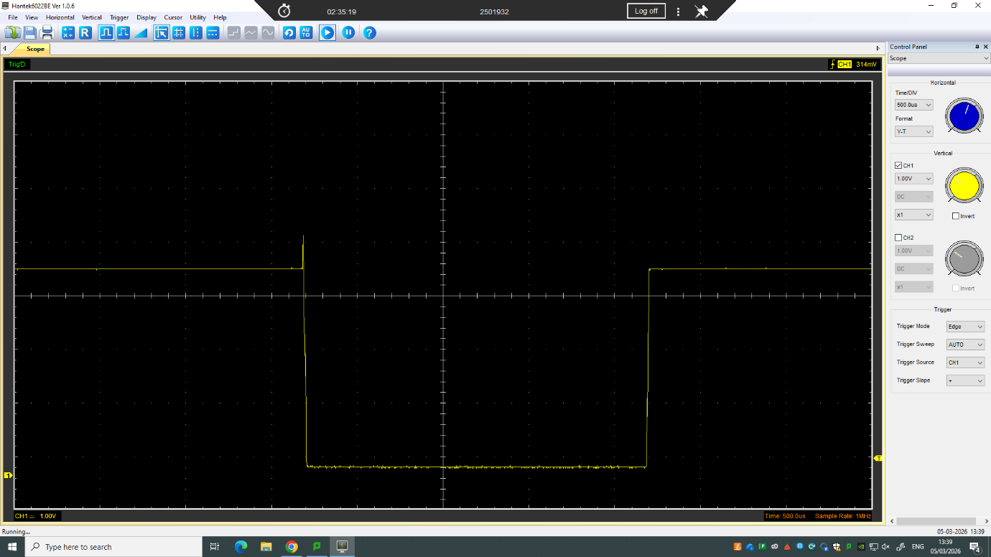
Rising edge
Low voltage (0v)
High voltage (1.25v)
Falling edge
This image depicts the square wave produced by the RC circuit. Showing the input signal of the circuit. The square wave shows the high and low voltages demonstrating the charging and discharging of the capacitor. The amplitude of the wave signal indicates the maximum voltage while the trough of the wave indicates the minimum voltage (0V). By using a square wave, it provides a clear transition between the high and low voltages.

Capacitor charge and discharge wave marked at correct points. (6)
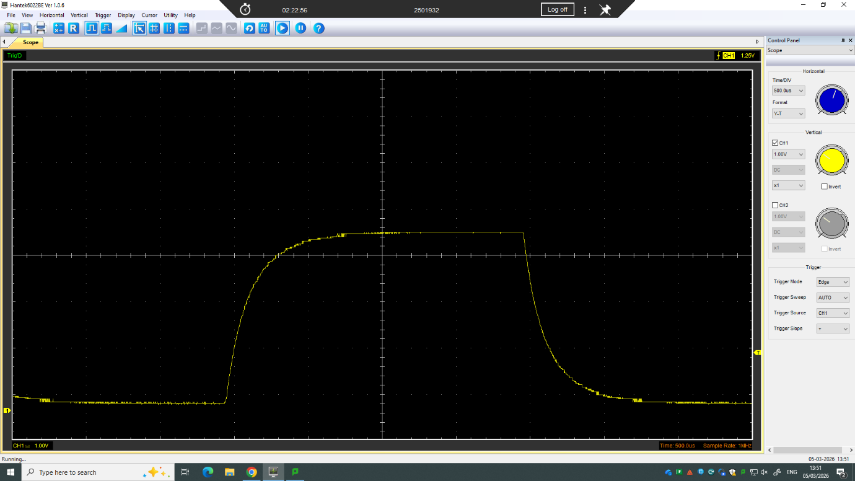
Fully discharged 0v (min)
Discharging curve
Start of discharging
Fully charged 1.25 v (max)
Charging curve
0v start of charging
This image depicts the charge and discharge curve of the capacitor used in the circuit. The charging and discharging curve are both exponential, as the charge within the capacitor increases it takes longer to completely charge. While as it discharges it takes longer for the charge to completely dissipate from the capacitor. While charging it increases rapidly until it reaches 63% of the maximum voltage after 1 time constant, the inverse occurs when discharging, with the charge rapidly decreasing until it reaches 37% of the initial value of the stored voltage also at 1 time constant.(Macdonald & Brachman, 1955)

Basic Capacitor Calculations (6)
To calculate the time constant, the total time for the capacitor to reach full charge should be multiplied by the portion of which it takes to reach 63% of the total charge.
At full charge the time taken is roughly 2ms, the time constant is seen at 1/5 of full charge.
2 x 1/5 = 0.4ms = 0.0004s

Capacitor discharge table (5)
Time (s) | Voltage (V) | ln (V) | dy = y2 – y1  dy = ln(V)2-ln(V)1 | dx = x2- x1  dx = Time2 – Time1 | dy/dx
0.0000 | 3.8588 | 1.3504 | x | x | x
0.0005 | 3.5137 | 1.2567 | -0.0937 | 0.0005 | -187.37
0.0010 | 2.7922 | 1.0268 | -0.2298 | 0.0005 | -459.68
0.0015 | 2.2902 | 0.8286 | -0.1982 | 0.0005 | -396.38
0.0020 | 1.8824 | 0.6325 | -0.1961 | 0.0005 | -392.18
0.0025 | 1.5686 | 0.4502 | -0.1824 | 0.0005 | -364.73
0.0030 | 1.2863 | 0.2528 | -0.1984 | 0.0005 | -396.83
0.0035 | 1.1294 | 0.1217 | -0.1301 | 0.0005 | -260.17
0.0040 | 0.9725 | -0.0279 | -0.1496 | 0.0005 | -299.14
0.0045 | 0.8157 | -0.2037 | -0.1758 | 0.0005 | -351.65

As time increases the voltage decreases exponentially, this is why the natural log of the voltage is used to make it more efficient when plotting on a graph.

Plot log(V) Gradient (5)

The graph indicates a negative gradient as the capacitor is discharging and the voltage stored is decreasing. The trendline indicated is linear as the graph depicts the natural log of the voltage, is the voltage stored were to be plotted the trendline shown would be difficult to follow is it would decrease exponentially.
The decay equation for a capacitor is V=V0^-t/RC, by using the natural log of the voltage it gives a linear gradient with the equation being ln(V)=ln(V0)-t/RC meaning the of the discharge is the negative time constant divided by the resistance of the circuit multiplied by the capacitance.

Gradient Calculations and Compare(8)

Gradient Calculations

Comparison table
 | Capacitance | Delta | Percentage difference
Actual | 1 µF | x | X
Marker Calculation
Gradient Calculation

Capacitor Uses (5)
Capacitors have many uses across cars, motorcycles and other vehicles due to their ability to store and release electrical energy. Some uses for capacitors in cars include ECU power stabilisation, ignition systems and alternator ripple smoothing. In order to protect the sensitive components found within an ECU, capacitors are used to smooth voltage fluctuations as well as helping protect from sensitive electronics from noise spikes (Capacitors in Power Supply Filtering – Tricky Circuit, n.d.). As well, in an ignition system a capacitor is used to store energy to be released quickly to turn the engine over. Aiding in generating a high enough voltage for the spark plugs to function correctly (Williamson et al., 1971). While in alternators a capacitor is used to reduce voltage ripple as AC is stored as DC helping to keep the many electrical systems in modern cars stable. Due to the versatility of a capacitor, they are becoming increasingly more vital as technology improves and is being used more commonly in cars.

Inaccuracies Question (4)
Some inaccuracies in measurements occur due to the equipment used, by using more precise equipment it would be possible to gather more accurate readings to help determine the correct values. However, by using more precise equipment it means the costs increase drastically as the components used would have to be of a higher quality.
As well, the capacitance calculated may differ from values given by the manufacturing due to the fact that capacitors can often have wide tolerances often being 10-20% above or below the given value. Furthermore, using a breadboard and other equipment can often add resistance and capacitance to a circuit which will cause the readings to be slightly inaccurate.

Risk Question (10)
CANBUS systems are used more frequently as technology improves. With regards to modern day vehicles, CANBUS systems are used to communicate with ECU’s, transmission systems, ABS systems, dashboards and other sensors. They are useful as they are fast and reliable as well as sending messages to different components as opposed to connecting the 2 components together directly.
With cars now becoming more advanced cybersecurity is becoming more vital, with hackers and other attackers looking to exploit weaknesses in the systems. One of these weaknesses include a lack of authentication of messages to replay valid messages which the CANBUS recognises to overload the system preventing vital messages from other systems such as the braking system from getting through. With cars transitioning to being more digital it is becoming more possible to wirelessly connect to a car to flood the CANBUS system with messages (Lokman et al., 2019).
To help improve safety different measures can be taken to reduce the risk of accidents occurring. For example, by limiting access to the OBD port while a vehicle is in motion mitigates the chance of unnecessary signals being sent to the CANBUS system so vital components such as the braking system and ECU preventing accidents from occurring. As well, by using message authentication codes which are specific to the module ensure that the messages being relayed are real and unchanged. This means that any forged signals are prevented from being sent between components. To help prevent any cybersecurity threats the software must follow ISO/SAE 21434 regulations (ISO/SAE 21434:2021 - Road Vehicles — Cybersecurity Engineering, n.d.). This ensures that during the design phase threat and risk assessments are done as well as continuous updates during the vehicles lifetime to help update the software to combat more modern malware. For the cybersecurity to be most effective it should be provided from the design and building phase not added later during its lifetime (Costantino et al., 2022).
Even with precautions taken it is still possible for cars to be hacked and for cybersecurity breaches to happen. In 2015 security researchers remotely accessed Jeep Cherokees and were able to send fake signals through the CANBUS to affect steering, braking and engine control. Ultimately Jeep later recalled around 1.4 million vehicles to have the vulnerability patched to prevent further attacks in this manner from being possible. As a result, this proved that remote cyber attacks on vehicles can directly affect vehicles and impact the safety of those in the car and those on the road with the affected vehicle (Miller et al., 2015).

References
Capacitors in Power Supply Filtering – Tricky Circuit. (n.d.). Retrieved April 19, 2026, from https://trickycircuit.com/components/capacitors/capacitors-in-power-supply-filtering/?utm_so
Costantino, G., De Vincenzi, M., & Matteucci, I. (2022). In-Depth Exploration of ISO/SAE 21434 and Its Correlations with Existing Standards. IEEE Communications Standards Magazine, 6(1), 84–92. https://doi.org/10.1109/MCOMSTD.0001.2100080
ISO/SAE 21434:2021 - Road vehicles — Cybersecurity engineering. (n.d.). Retrieved April 19, 2026, from https://www.iso.org/standard/70918.html
Lokman, S. F., Othman, A. T., & Abu-Bakar, M. H. (2019). Intrusion detection system for automotive Controller Area Network (CAN) bus system: a review. EURASIP Journal on Wireless Communications and Networking 2019 2019:1, 2019(1), 184-. https://doi.org/10.1186/S13638-019-1484-3
Macdonald, J. R., & Brachman, M. K. (1955). The Charging and Discharging of Nonlinear Capacitors. Proceedings of the IRE, 43(1), 71–78. https://doi.org/10.1109/JRPROC.1955.277920
Miller, C., USA, C. V.-B. H., & 2015, undefined. (2015). Remote exploitation of an unaltered passenger vehicle. Academia.Edu, 7–14. https://www.academia.edu/download/53311546/Remote_Car_Hacking.pdf
Williamson, T. L., Adler, R. W., & Springfiold, V. (1971). Ignition System Requirements and Their Application to the Design of Capacitor Discharge Ignition Systems.

