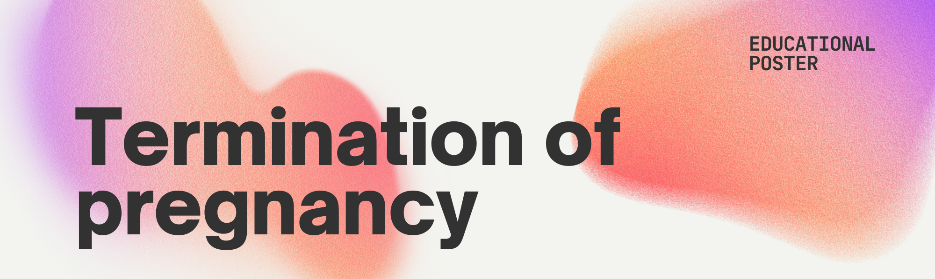

Termination of pregnancy
The medical or surgical procedure used to terminate an unwanted pregnancy is known as an abortion.
It is permitted and accessible to pregnant women in the UK up until week 24, with a few limitations after that.
Options:
Medical Abortion:
- Requires taking two different kinds of pills over an extended period.
- The pregnancy is prevented from growing by taking the initial tablet.
- The woman’s pregnancy terminates as a result of the second set, typically in a matter of hours to days.
- Based on your circumstances, it can be performed at a hospital or at your house.

Surgical Abortion:
- A simple operation in which the foetus is extracted.
- Depending on the operation, it is carried out with either locally or general anaethesia in a medical facility or clinic.
- It normally just takes one doctor visit and is secure and fast.

Target audience
Demographic:
Age: 18-25
Gender: Female

For the target audience of 18-25 year olds, it’s important to understand the context and concerns that are relevant to this age group when discussing the topic of termination of pregnancy. This age range is often in a traditional state of life, navigating education, career development, relationships, and the exploration of personal values and independence. When it comes to an abortion whether you choose to continue your pregnancy, end it, or explore other options such as abortion, it’s your choice to do so.

What to expect when choosing to have an abortion in the UK:
Emotional support | Experiencing a variety of emotions is natural. Consult a therapist or someone in the assistance team if you are not confident.
No one is judging you | In the UK, abortion facilities are private and open-minded. At every stage, you will be given respectful and kind treatment.
The process is quick and reliable | The procedure is secure and quick if you choose to move forward with the termination. Everything you must understand will be explained to you, and if you require follow-up care, it is available.

How to access an abortion:
Self Referral | A reference from a doctor is not required. You can get in touch with groups like Marie Stopes or BPAS immediately.
Free/Accessible | Services at no cost are offered all around the United Kingdom. Regardless of your situation or history, you will receive the attention your require.
Private and secure | Your personal information is secured. If you don’t want to, you don’t have to include anybody else. The choice is entirely yours.

Key Points to Remember about abortion in the UK (18-25)

It’s your decision | What happens to your body is up to you to decide. Whenever you choose to keep the pregnancy going or end it completely up to you. You shouldn’t be forced to make a decision by anyone else.
Abortion is legal and Safe | In the UK, abortion is allowed up until 24 weeks into a pregnancy. Provided by certified medical doctors, it is a safe process with high levels of care. Hundreds of people get the surgery annually, making it extremely prevalent.
Confidentiality is 100% guaranteed | Your choice and private details will remain hidden. In the United Kingdom, termination of pregnancy facilities are completely private, therefore you are under no need to include anybody else if you choose to. Your privacy and well-being are secured by law.
No one can force you into a decision | You still have the right to make choices regarding the baby’s development if you are below the age of 18, even if your doctor may occasionally include your guardians if they think you need more help.
You are not alone | Many people decide to end their pregnancies after becoming pregnant accidentally. There are assistance lines, discussion boards, and support communities where you can meet people who have been through similar things. On this adventure, you are not alone.

Get Help:
BPAS (British Pregnancy Advisory Service)
www.bpas.org | Call 03457 30 40 30
Marie Stopes UK
www.mariestopes.org.uk | Call 0345 300 8090
NHS Pregnancy Choices
www.nhs.uk | Call 111 for advice on pregnancy options

