Reading & Note-Taking

Part 01: A3 Mind Map
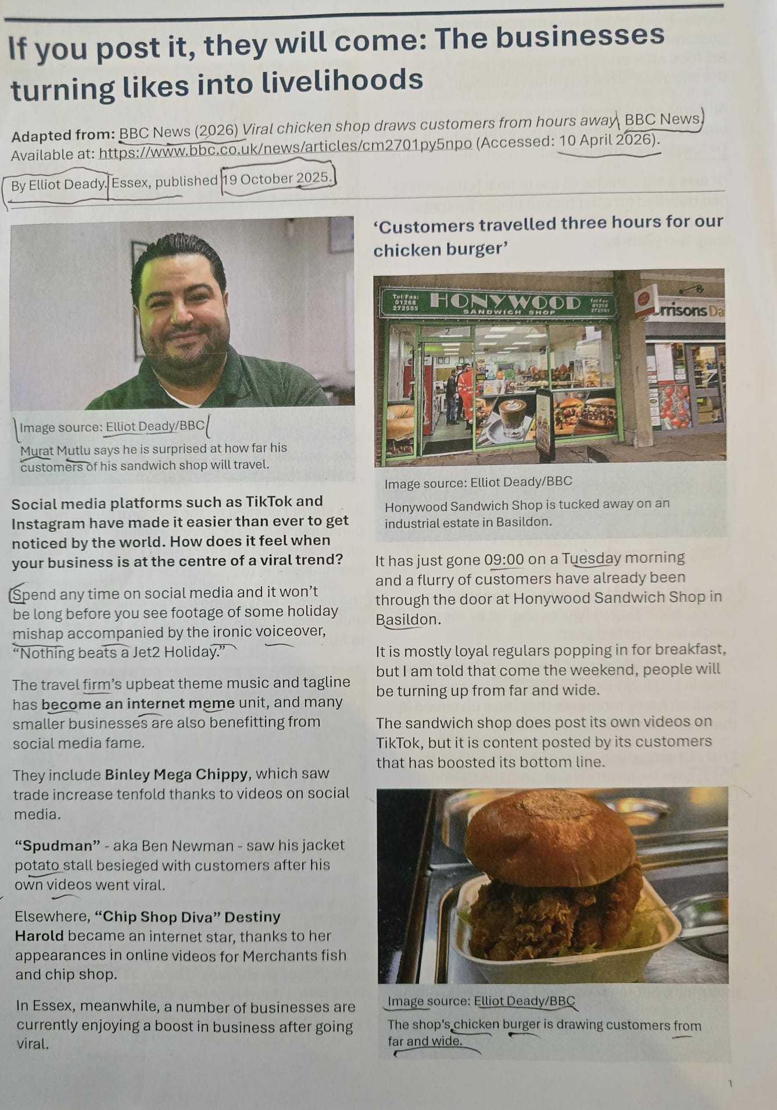
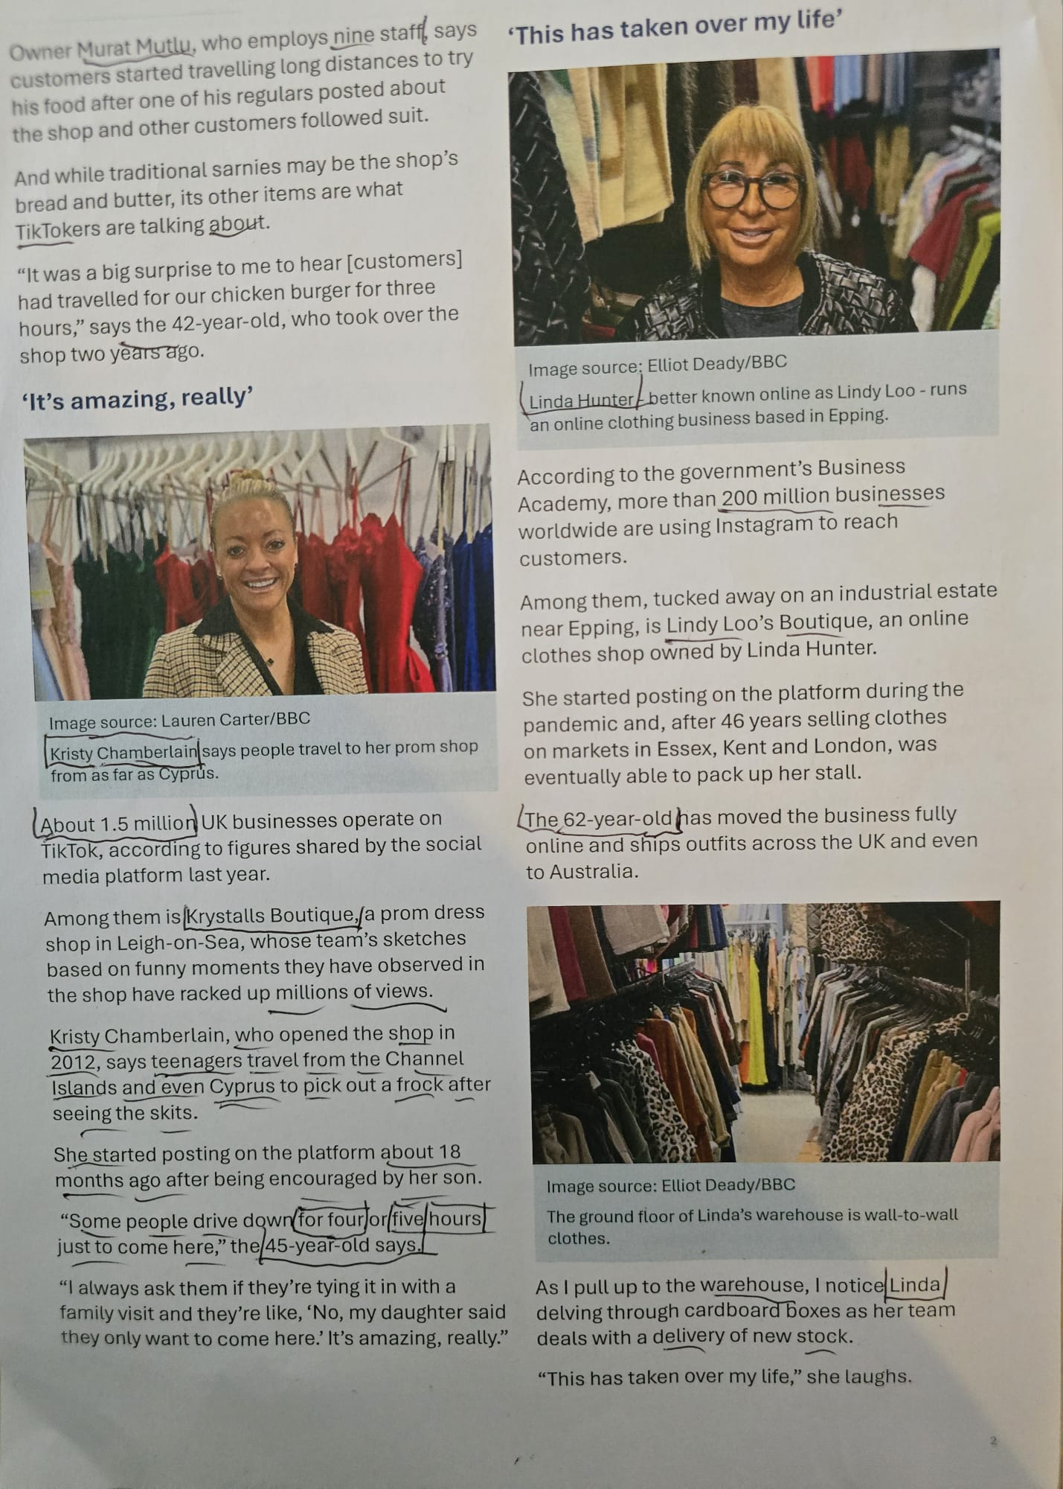
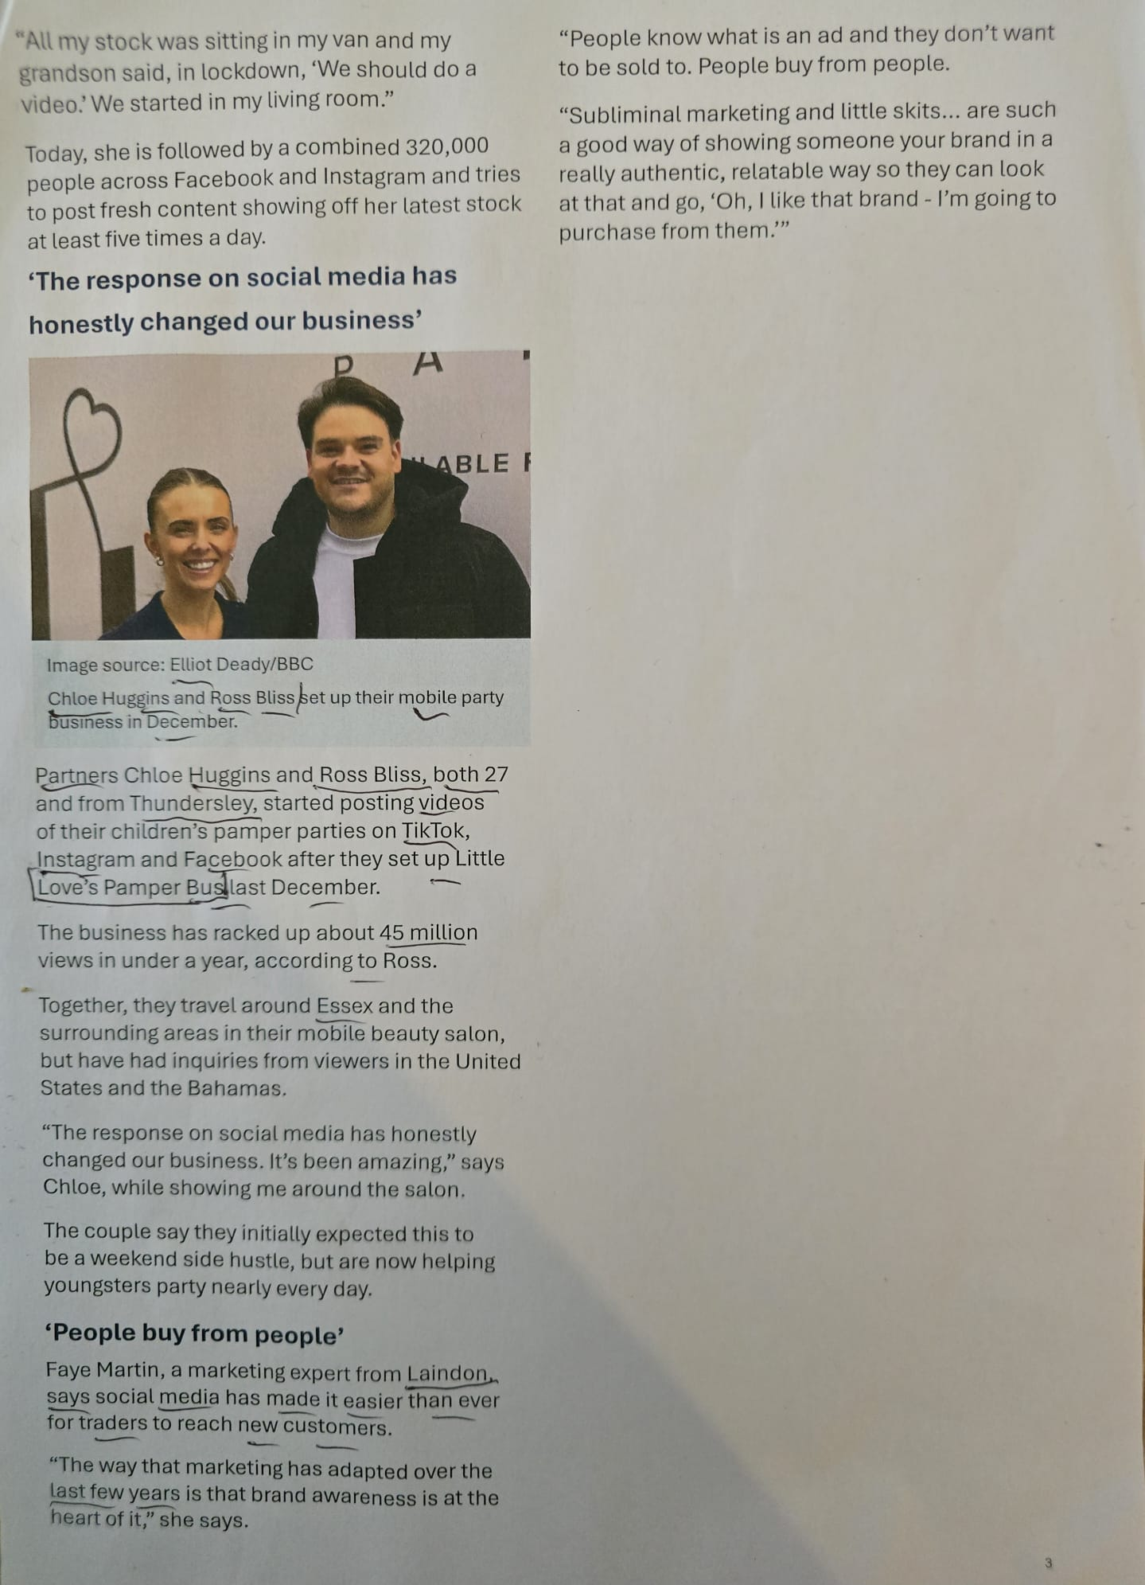
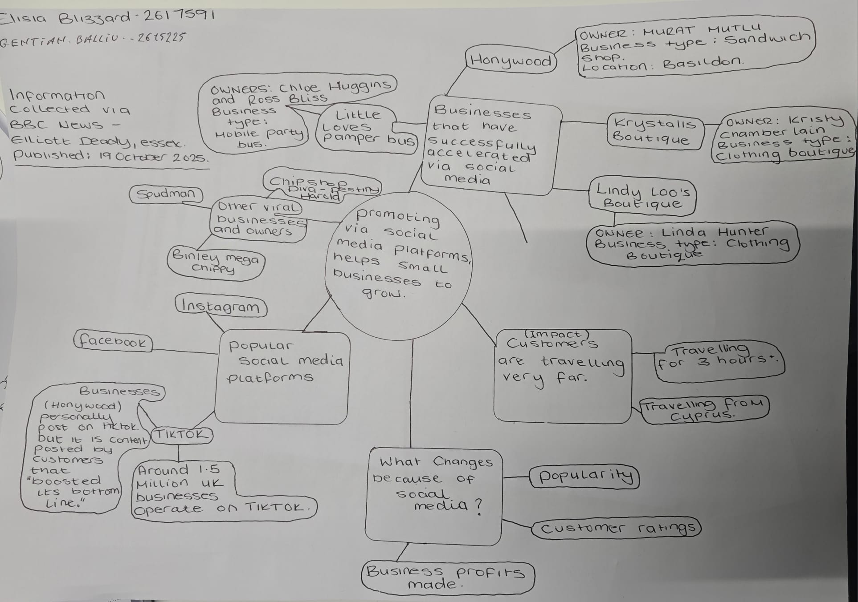

Part 02: Answers to Questions (1 to 6)

1. What is the main idea of the text?
Throughout the text the author's main argument is that small companies can achieve success through the use of social media, by making their products and services much more visible to a much greater audience. Social media platforms such as Facebook, Instagram, and TikTok can help businesses achieve success and grow their clientele base, increase their sales and enhance their reputation in some instances, which is not easy with traditional advertising.

2. What is one key point that helps the main idea and what is the text example that illustrates it?
An important factor is that social media can attract customers from outside of a company's geographical reach. For example, Honywood Sandwich Shop in Basildon is run by proprietor Murat Mutlu, who said he had a customer who travelled three hours to sample the chicken burger and make a purchase just after the blogger got comments about his business online.

3. What is a different key point that supports the main idea, and which specific example from the text shows this?
Another significant factor is that interesting and inventive web copy can help a small business to gain recognition and gain new customers. For example, Krystalls Boutique in Leigh-on-Sea had millions of views of their funny pictures depicting things that happened at their shop. Once the movies had been seen, buyers were as far as Cyprus and the Channel Islands and bought prom dresses under Chamberlain's ownership.

4. Which part of the text do you think is most important, and why?
The evidence that online popularity may result in actual business growth rather than just likes and views is, in my opinion, the most crucial component. Customers who come great distances to visit Krystalls Boutique and Honywood Sandwich Shop are examples of how engaging content may affect consumers' purchasing decisions and generate profitable prospects for small companies.

5. What parts of this assessment were difficult, and why (including in class parts)?
The essay was packed with companies, different social media sites, and tons of success examples to select the most important information. It was also challenging to select the key points without rewording the same ideas and/or to separate the main idea from the supporting details.

6. What and how did it help you "solve" this problem?
Making a mind map made it easier for me to comprehend and retain the material by grouping the core idea, supporting details, and instances into related parts. I was also able to choose pertinent data and create more lucid responses in my own words by connecting each business example to a specific argument.

