Engineering Project Management

60GHz Radar for improved passenger experience

Jacob Newman
Student number: 2515825
Electrical and Electronic
Engineering Degree Apprentice

L5 Engineering Project management ACDA5025

Table of Contents
List of Figures 4
List of Tables 5
Abstract 6
1.0 Introduction 7
1.1 Aim of project 7
1.2 SMART Objectives 7
1.3 Background & Problem statement 7
2.0 Design 8
2.1 Technical Specifications 8
2.1.1 60 GHz Radar: Infineon: BGT60CUTR13 Vs Texas Instruments: IWRL6432AOP 8
2.1.2 Microcontroller: STM32N6 8
2.1.3 Accelerometer: BMA580 8
2.2 Block Diagram 9
3.0 Resources 10
3.1 Man Hours 10
3.2 Table of Resources 10
3.3 Costs of testing 11
4.0 Risk Assessment & Management 11
4.1 Risk matrix 11
4.2 Risk Identification and Mitigation 11
4.2.1 Radio waves interfering with aircraft communications 11
4.2.2 Radars interfering with each other 12
4.2.3 Detection time and recognition accuracy of passengers 12
4.2.4 Aircraft vibration causing inaccurate radar readings 12
4.3 Risk reduction leverage 12
4.3.1 Radio wave interfering with aircraft communications 12
4.3.2 Radars interfering with each other 12
4.3.3 Detection time and passenger accuracy 13
4.3.4 Aircraft vibration causing inaccurate radar readings 13
4.4 Compliance with Standards 13
4.5 Cost-Benefit Analysis 13
4.5.1 Benefits 13
4.5.2 Costs 14
4.5.3 Analysis 14
5.0 Project Planning 14
5.1 Gantt Chart 14
5.2 Milestones and Deliverables 16
5.3 Program Evaluation and Review Technique analysis 16
5.4 Critical Path analysis 18
6.0 Ethical Considerations 19
6.1 Passenger Information 19
6.2 Employing Staff 19
6.3 Equipment Lifetime and Disposal 19
6.4 Designing Equipment 19
6.5 Cyber security 19
7.0 Environmental Impact 19
8.0 Societal Impact 20
9.0 Conclusion 20
10.0 References 21
11.0 Appendix 23
11.1 Appendix 1: PREVENT training 23
11.2 Appendix 2: Equality and Diversity Training 24

List of Figures
Figure 1: Block Diagram of proposed circuit 9
Figure 2: Conducting initial studies into 60 GHz radar timeline 14
Figure 3: TRL 1 Gantt Chart 14
Figure 4: TRL 2 Gantt Chart 15
Figure 5: Evaluation of products Gantt Chart 15
Figure 6: TRL 3 Gantt Chart 15
Figure 8: TRL 4 Gantt Chart 15
Figure 7: TRL 5 Gantt Chart 15
Figure 9: TRL 6 timeline 16
Figure 10: Z Value, probability of meeting target date 17

List of Tables
Table 1: BGT60CUTR13 Vs IWRL6432AOP 8
Table 2: Man-Hours estimates 10
Table 3: Bill of materials if IWRL6432 is selected 10
Table 4: Bill of materials if BGT60CUTR13 is selected 11
Table 5: Certification Costs 11
Table 6: Risk Matrix 11
Table 7: Milestones and Deliverables 16

Abstract
This project proposal defines and itemises a timeline to implement a 60 GHz radar solution which can detect and localise passengers with the suite allowing for automated control of the suite. This addresses the issue within the aerospace industry of the increasingly complex interaction between the passenger and an aircraft suite. The project proposal uses Gantt charts, Risk reduction leverage and PERT analysis to create and evaluate the timeline for the development of an aerospace ready product. PERT analysis predicts a 25% chance of achieving the timeline proposed for this project. The upfront cost of the project being outweighed by the benefits it provides for the company, financially and as a key differentiating technology from its competitors.

1.0 Introduction
The following proposal outlines the integration of a 60 GHz Frequency Modulated Continuous Wave (FMCW) radar into an aircraft suite to improve passenger experience by reducing the initial learning curve the passenger faces to interact with all the technology available when flying in a business-class or first-class suite.

1.1 Aim of project
- To propose the benefits and risks of developing and implementing a 60 GHz radar solution within the aircraft cabin environment.
- Evaluate and identify a market viable 60GHz FMCW radar that is most suitable for the application of detecting and localising passengers within a first class and business class suite.
- Create a roadmap to develop the technology until it is production ready
- Evaluate societal, ethical and environmental impacts, presenting a mitigation for all.

1.2 SMART Objectives
The project’s success will be gauged by the following:
- Reduced passenger interaction with the physical controls in the suite by 25%.
- Increased passenger utilisation of the technology within the suite by 10%.
- Detect Passengers position within 200ms at 98% accuracy.
- TRL 6 Achieved within 12 months from the start date and no more than 7% over budget.

1.3 Background & Problem statement
As aircraft have become bigger, first class and business class suites have followed suit. A number of luxury and comfort technologies have also been integrated into the suite to enhance the passenger experience [12], However, this has led to a steep learning curve for the passenger when they first embark on a flight, due to an array of buttons to control the technologies being spread out across the suite. This proposal aims to reduce the learning curve when for the passenger.

2.0 Design

2.1 Technical Specifications

2.1.1 60 GHz Radar: Infineon: BGT60CUTR13 Vs Texas Instruments: IWRL6432AOP
Table 1: BGT60CUTR13 Vs IWRL6432AOP
Parameter | BGT60CUTR13 | IWRL6432AOP
Rx antenna | 3 [2] | 3 [3]
Tx antenna | 1 [2] | 2 [3]
Antenna shape | L [2] | L [3]
Frequency range | 58 – 63.5 GHz [2] | 57 GHz to 63.5 GHz [3]
Operating Temperatures | -20 °c to +70 °c [2] | -40 °c to 105 °c [3]
Hardware accelerated | Yes [2] | Yes [3]
Minimum detection range | 0.2 Meters [2] | N/A
Maximum detection range | 20 Meters [2] | 20 Meters [3]

The IWRL6432AOP offers more accurate localisation capability [10] [11] through the 6 virtual channels compared to the BGT60CUTR13AIP’s 3 improving angular resolution and therefore making passenger localisation achievable without increasing the number of physical antennae. Final selection will depend upon practical evaluation of software maturity, development support and measured localisation performance.

2.1.2 Microcontroller: STM32N6
The STM32N6 is a 32-bit Cortex-M55 with a neural-ART accelerator [1], enabling local inference and AI assisted algorithms, future proofing the project. Yet, enough power for current digital signal processing without the need of cloud connectivity, reducing the latency and improving passenger privacy. The processor has ample SRAM [1] which allows for the processor to buffer multiple radar frames, avoiding external memory and reducing system latency.

2.1.3 Accelerometer: BMA580
The Bosch BMA580 has been selected due to its compact size, and lightweight, enabling a small form factor solution, with simple PCB integration. It is integrated because aircraft vibrations are a continuous operational condition, so this will enable accurate radar compensation.

2.2 Block Diagram
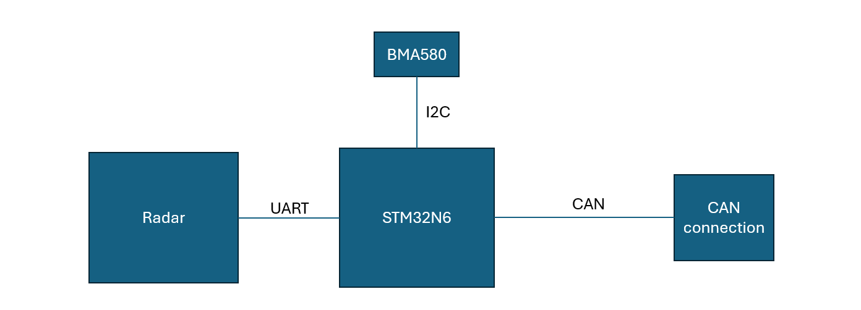
Figure 1: Block Diagram of proposed circuit
CAN is used to communicate with the suites electrical control unit and is how it will interact with the other parts of the suite to autonomously control them. It has been selected for its ease of integration and its compliance with ARINC 664[9]. I2C and UART have been selected for the communication between the components and the processor to ensure reliable, relevant bandwidth connections, with minimal PCB complexity.

3.0 Resources

3.1 Man Hours
Table 2: Man-Hours estimates
Activities | Discipline | Position | Hours | Rate (£)
Problem Understanding | Management | Principal innovation manager | 12 | 50
Project timeline development | Management | Project manager | 7 | 35
TRL 1 | Electronics | Engineer | 75 | 30
TRL 2 | Electronics | Engineer | 75 | 30
Radar Comparison | Electronics | Engineer | 50 | 30
PCB design | Electronics | Designer | 200 | 40
PCB manufacture | Electronics | Technician | 45 | 22
TRL 3 | Electronics | Engineer | 300 | 30
Support | Management | Principle Innovation manager | 100 | 50
TRL 4 | Electronics | Engineer | 250 | 35
TRL 5 | Electronics | Engineer | 300 | 37
TRL 6 | Electronics | Engineer | 275 | 40
 |  |  | 1689 | 58435

3.2 Table of Resources
Table 3: Bill of materials if IWRL6432 is selected
Description | Quantity | Cost
Evaluation board for BGT60CUTR13 | 2 | £141.40
Evaluation board for IWRL6432AOP | 2 | 152.71
STM32N6 | 35 | £20.57
Bosch BMA580 | 35 | £1.64
IWRL6432AOP selected | 35 | £10.07
PCB (including resistors etc) | 35 | £150
 | TOTAL | £6967.02

Table 4: Bill of materials if BGT60CUTR13 is selected
Description | Quantity | Cost
Evaluation board for BGT60CUTR13 | 2 | £141.40
Evaluation board for IWRL6432AOP | 2 | 152.71
STM32N6 | 35 | £20.57
Bosch BMA580 | 35 | £1.64
BGT60CUTR13 selected | 35 | £12.29
PCB (including resistors etc) | 35 | £150
 | TOTAL | £7044.72

3.3 Costs of testing
Table 5: Certification Costs
Description | Quantity | Cost
DO-160 | 2 | £100000
FAR/CS 25.853 | 2 | £2000
DO-178c | 1 | £50000
 | TOTAL | £152000

The estimated project cost is approximately £217,000 ±7% with minimal difference between the radar options.

4.0 Risk Assessment & Management

4.1 Risk matrix
Table 6: Risk Matrix
 | Negligible | Low impact | Moderate | High | Catastrophic
Highly unlikely | 1 | 2 | 3 | 4 | 5
Unlikely | 2 | 4 | 6 | 8 | 10
Possible | 3 | 6 | 9 | 12 | 15
Likely | 4 | 8 | 12 | 16 | 20
High likely | 5 | 10 | 15 | 20 | 25

A risk matrix is used to score each risk, multiplying its likelihood rating by its impact rating, giving a score between 1 and 25.

4.2 Risk Identification and Mitigation

4.2.1 Radio waves interfering with aircraft communications
Due to the nature and importance of aircraft systems, no effect on the aircraft system can be noted because of the radars emitted frequencies. To mitigate this a thorough understanding of the theory of the radar will be captured alongside a simulation and testing to make sure no interference with aircraft communications happens. Scoring a 10 on the risk matrix as the consequences could be catastrophic but the event is unlikely to happen.

4.2.2 Radars interfering with each other
Radio waves can travel through walls and objects; this means there is potential for radars to interfere with each other if rogue signals bounce around the cabin environment. The mitigation of this risk is to get each radar to operate at a different chirp bandwidth. This risk scores a 4 on the risk matrix as interference is likely to occur, but with the mitigations the effect will be negligible.

4.2.3 Detection time and recognition accuracy of passengers
The time taken for a passenger to be detected by the system is essential to meet the requirements of the system to enhance the passenger experience. To mitigate this risk, the software run time will be optimised to run as quickly and efficiently as possible to increase the accuracy of the system and reduce the detection time. This risk scores a 6 on the risk matrix as it is unlikely to occur but will have a moderate impact on the passenger experience.

4.2.4 Aircraft vibration causing inaccurate radar readings
Commercial aircraft routinely experience continuous vibration throughout all phases of flight, making this an almost certain operational condition. To Mitigate this issue an Accelerometer has been added to the system to calculate the movement of the system and account for the movement in the radars calculations. This risk scores a 25 on the risk matrix as it is highly likely to happen ruining the usability of the radar, however, with the mitigations in place this reduces the risk down to a score of 5.

4.3 Risk reduction leverage
Risk reduction leverage calculates whether a risk mitigation is economically justified by diving the reduction in risk exposure by the cost of the mitigation. A value above 1 shows the mitigation is worth implementing. The costs outlined below are preliminary engineering estimates and will be refined throughout the prototyping and testing stages.

4.3.1 Radio wave interfering with aircraft communications
Based on an Airbus A380 potential damage is valued at £450 million for the aircraft alone, With the Probability of this occurring at 1 % before mitigations and 0.000001% after mitigations. The costs of testing, simulation and certification are around £500,000.
The RRL = $\frac{4.5 M-45000}{500,000}$ = 8.91 (1)
From equation 1 we can deduce, the mitigations are worth implementing.

4.3.2 Radars interfering with each other
Potential damage is caused per unit in the aircraft; on average there will be 10 per aircraft at £20000 retail value that’s £200,000 worth of functional damage plus the reputational damage. The risk of this occurring before mitigations is set to 10% and after the mitigations is set to 0%. The cost of implementing the mitigations is £10,000.
The RRL = $\frac{20,000- 0}{10,000}$ = 2 (2)
Therefore, from Equation 2, the mitigations are worth implementing for this risk.

4.3.3 Detection time and passenger accuracy
The damage that could be caused by slight inaccuracies and delayed passenger detection are minimal and costed at £15000. The cost of the mitigation which reduce the risk from 5% to 1% are £10000.
The RRL = $\frac{750-150}{10000}$ = 0.06 (3)
Therefore, from equation 3, the risks mitigations are monetarily not worth implementing. Although formal mitigations are not cost effective, detection accuracy will be determined and monitored during TRL 3 testing and addressed reactively if thresholds are not met.

4.3.4 Aircraft vibration causing inaccurate radar readings
The damage caused by the vibrations affecting the radar are mostly reputational and valued at £1.2 Million. The costs of the mitigations are £100,000 and reduces the risk from 80% to 2%.
The RRL = $\frac{960,000-24000}{100000}$ = 9.36 (4)
Concluded from equation 4, the risk mitigations are worth doing.

4.4 Compliance with Standards
Aerospace is a highly regulated industry. The device will be designed and tested to the following specifications:
- DO-160 ensures aviation equipment will function appropriately in the environmental and EMI conditions found on aircraft [4].
- DO-178c gives software design assurance guidelines [4].
- FAR/CS 25.853 gives guidelines to ensure fire safety within the cabin environment [5].
- AS9100 is the standard required for the supply chain of an aerospace product, ensuring the highest standard and quality management systems for aerospace. [6] AS9100 mandates a quality management system, continuous improvement process and corrective action procedures which will be applied throughout this project, alongside document design and performance reviews at each TRL gate the project will be rigorously quality managed.
- GDPR is the standard for how personal data should be handled within the Uk and Europe, to ensure compliance this system will collect no identifiable information about the passenger. [8]
Compliance to all these standards has a direct impact on budget, schedule, testing and increases the overall risk of the project.

4.5 Cost-Benefit Analysis

4.5.1 Benefits
Enhanced passenger experience strengthens market differentiation, increasing airline confidence and repeat business.

4.5.2 Costs
The expected development costs, including certification is around £217,000.

4.5.3 Analysis
This technology has a net benefit for the company as it is a clear differentiator amongst other seat manufacturers, enhancing the passenger experience in no way done before. Despite the high initial investment, the cost will be paid back financially through customers purchasing the product but also airlines trust and repurchase of other products.

5.0 Project Planning

5.1 Gantt Chart
The project comprises of 8 stages, 6 of which are TRL progression. A waterfall methodology is used due to the TRL dependencies on one another, meaning little parallel work is possible. Each stage has a corresponding Gantt chart.
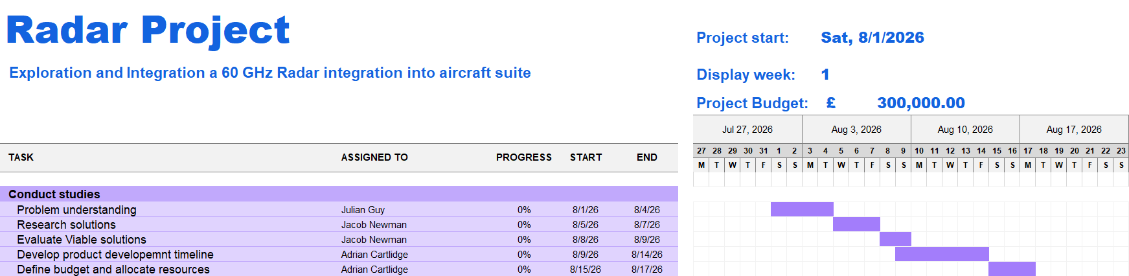
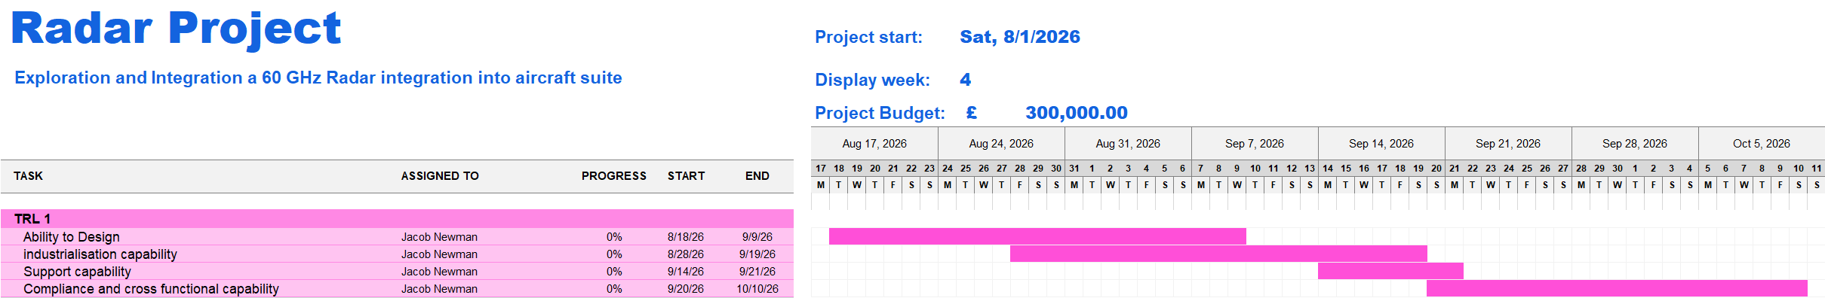
Figures 2-9 illustrate the projects progression from initial studies through TRL 6. Early TRL’s contain parallel theoretical work, whereas later stages become sequential because progression depends on the successful completion of the previous TRL. The PCB rework is considered at the end of each TRL to improve the technology once the weaknesses have been discovered. This may not be needed in all cases. Each TRL stage is dependent on the last TRL being passed, this timeline does not account for any TRL to fail, increasing the pressure on the development of the technology
Figure 2: Conducting initial studies into 60 GHz radar timeline
Figure 3: TRL 1 Gantt Chart

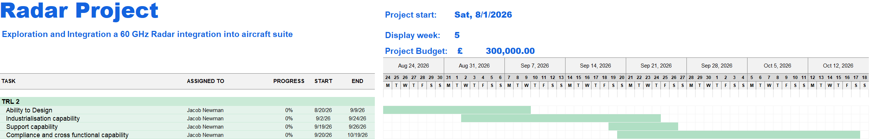
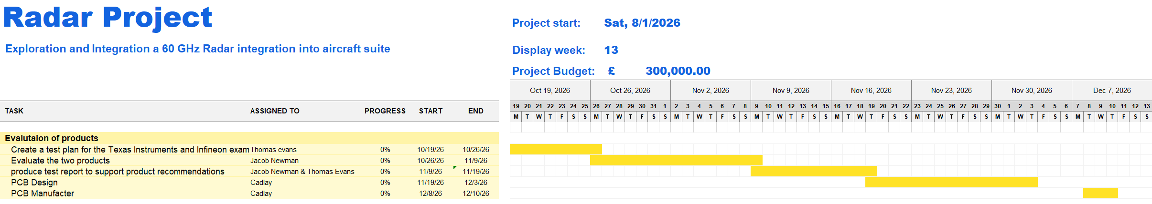
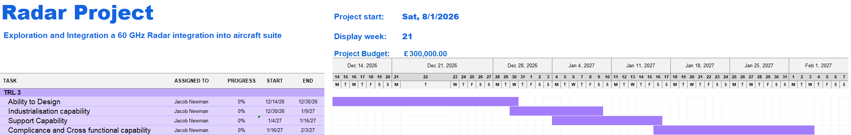
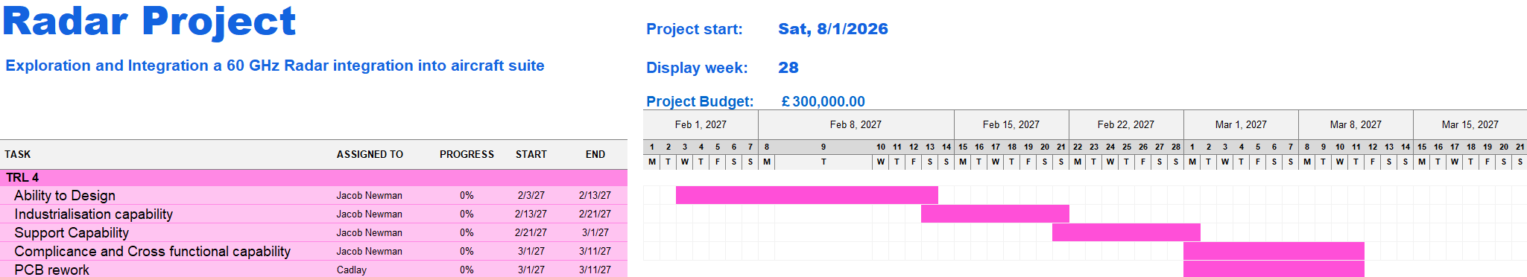
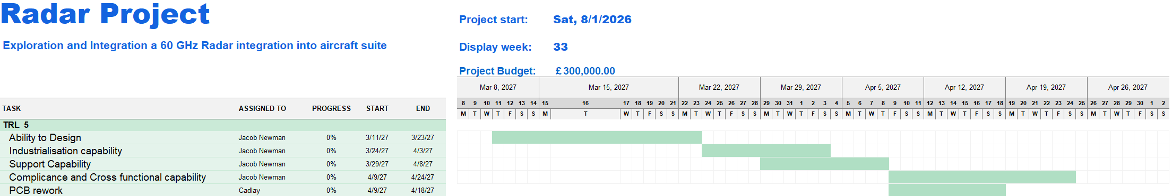
Figure 4: TRL 2 Gantt Chart
Figure 5: Evaluation of products Gantt Chart
Figure 6: TRL 3 Gantt Chart
Figure 8: TRL 4 Gantt Chart
Figure 7: TRL 5 Gantt Chart
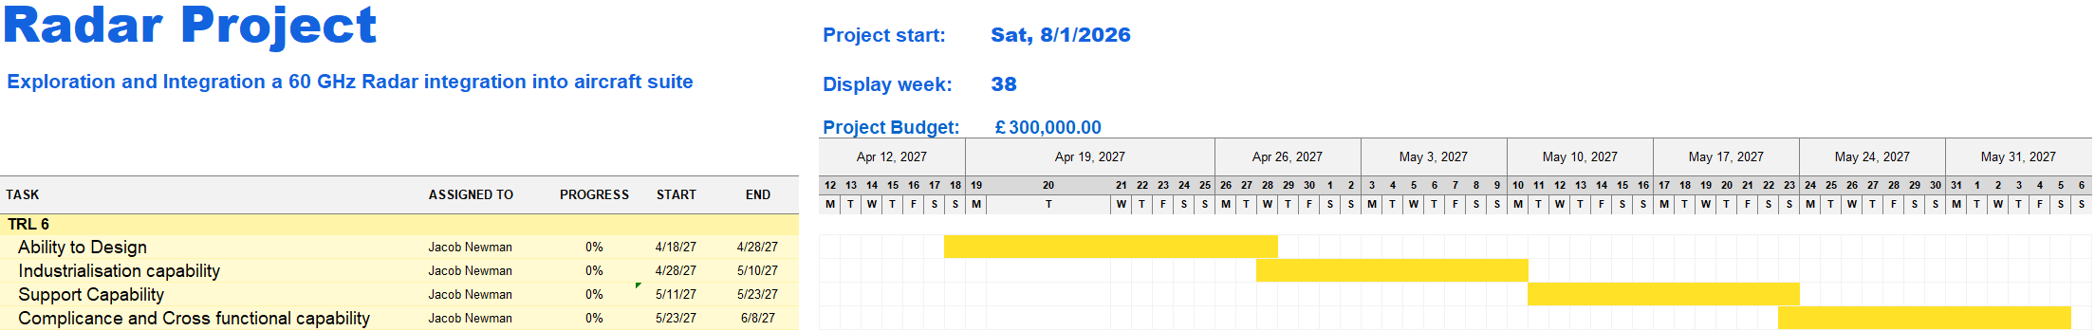
Figure 9: TRL 6 timeline

5.2 Milestones and Deliverables
Table 7: Milestones and Deliverables
# | Milestone | Deliverable | Target Date | Predecessor
M1 | Initial Study | Feasibility study | 17th August 2026 | -
M2 | TRL 1 | TRL 1 report | 10th October 2026 | M1
M3 | TRL 2 | TRL 2 report | 19th October 2026 | M1
M4 | Radar Selected | Comparison and evaluation report | 10th December 2026 | M3
M5 | TRL 3 | Protype and TRL 3 report | 3rd February 2027 | M4
M6 | TRL 4 | Developed Prototype and TRL 4 report | 11th March 2027 | M5
M7 | TRL 5 | Improved prototype and TRL 5 report | 24th April 2027 | M6
M8 | TRL 6 | Fully tested and functioning prototype with TRL 6 report | 8th June 2027 | M7

5.3 Program Evaluation and Review Technique analysis
Program Evaluation and review Technique (PERT) analysis will be carried out across the entire estimated timeline to be able to assess the risk of completing the project on time, as shown in equation 5. [7]
most likely time: m
Optimistic time: a
Pessimistic time: b

$t_{e}= \frac{a+4m+b}{6}$ (5)
The standard deviation will then be calculated as outlined in equation 6:
$S= \frac{b-a}{6}$ (6)
The standard deviation will then be used to calculate the Z value. This is used to determine the likelihood of achieving the project on time by comparing to the Z-value probability chart shown in Figure 10.
$$Z= \frac{T- t_{e}}{S}$$
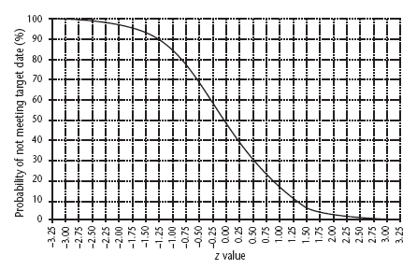
Figure 10: Z Value, probability of meeting target date

The following values have been calculated for this project:
m: 311 days
a: 273 days
b: 360 days
$t_{e}= \frac{273+4\left(311\right)+360}{6}=312.83$ (7)
$S=\frac{360-273}{6}=14.5$(8)
The Z value has been determined as:
$Z= \frac{304-312.83 }{14.5}= -0.608$ (9)
A target date of 304 days was set by the business to align with a program’s integration window, the likelihood of not meeting the project date is around 75%, determined from Figure 10. This is reflective of the sequential nature of the TRL process, each stage reliant on the previous stage. Additional engineering resource is the most likely lever for maintaining the schedule.

5.4 Critical Path analysis
The Critical path for the development of the 60 GHz radar is highlighted in Red. This analysis highlights the weakness of the waterfall methodology for this project development, if one part of the project slips, then this will have a knock-on effect throughout the project. For example, if TRL 3 takes longer than expected the whole project slips because TRL 4 depends on it. [7]
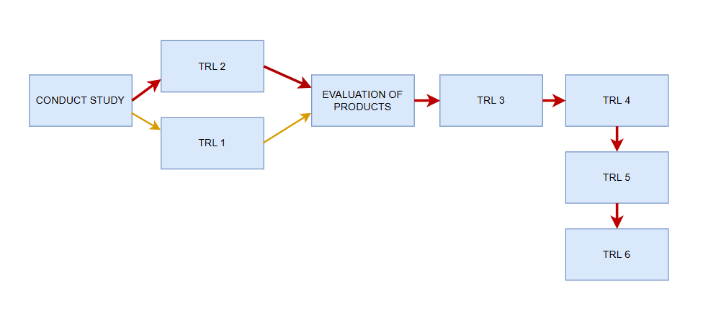

6.0 Ethical Considerations

6.1 Passenger Information
This solution works by receiving the reflected radio waves, which gather no identifiable information about the passenger within the suite, this makes it compliant with GDPR [8] and maintains passenger privacy to the highest standard. To enhance the perception of privacy for the passenger an opt out option will be available.

6.2 Employing Staff
Operating in teams requires everyone to be tolerant and inclusive of one another no matter their background, religion, belief or race. For this project recruiting a team member with radar signal processing and embedded software experience is essential, a wider talent pool will also increase the ability of the team in the long run. The manager is responsible for making sure the whole team completes PREVENT and DEI courses.

6.3 Equipment Lifetime and Disposal
Development inevitably produces test modules unfit for flight with a reduced life span yet are essential for safe development of the flight technology. The testing modules will be disposed of responsibly and recycled where possible. [13]

6.4 Designing Equipment
When designing the PCB for this project, the PCB should be designed to be as compact as possible for both the optimal functionality and ease of placement of it within an aircraft suite, but also to reduce the waste generated by destroyed or broken beyond repair modules.

6.5 Cyber security
As the system will be able to control elements of the suite, cyber security is to be taken seriously to ensure passenger and aircraft safety. The Texas Instrument option contains a secure bootloader, making it a good option to reduce the risk of malicious firmware from being able to control the suite. To comply with ARINC 664 [9] this device will be isolated from the aircrafts main control network and to comply with DO-160 [4] will have no open ports to be able to connect devices into.

7.0 Environmental Impact
Environmental impact will be minimised by reducing the module weight, which has a long-term fuel consumption and therefore environmental impact. It will maximise service life and be designed for recycling. PCB manufacture remains the main environmental impact because of the aviation-grade coatings required.

8.0 Societal Impact
This project will have a net positive effect on society. This project will create jobs for the people designing and installing the product into the suite. Another societal benefit of this project is the positive effect it will have on the passengers on the aircraft by improving their experience, improve accessibility into the suite by reducing the physical engagement needed with the suite to operate it and will have passenger options to turn the system on and off, increasing passenger trust and increasing their privacy perception. However, one drawback of this project is the risk of the technology being adapted so that it can be used maliciously. The cybersecurity mitigations outlined in section 6.5 are designed to reduce this risk.

9.0 Conclusion
In conclusion, this project proposes a feasible project on a tight timescale to increase passenger satisfaction within an aircraft suite. It faces the major risk of the aircraft vibrations causing inaccurate readings, but mitigations have been presented which reduce this risk to an acceptable level, there are major costs in the certification and development of this technology to make it aerospace worthy but given this will increase passenger satisfaction while providing a clear competitive differentiator. This project has a 75% risk of not completing in time, so a contingency plan is essential. The next step is formal TRL gate reviews under the guidance from AS9100 quality management.

10.0 References
[1] | “STM32N6 Datasheet.” ST microelectronics, Dec. 01, 2025. Accessed: July 20, 2026. [Online]. Available: https://www.st.com/resource/en/datasheet/stm32n657a0.pdf
[2] | “BGT60CUTR13AIP Datasheet.” Infineon, Apr. 01, 2026. Accessed: July 20, 2026. [Online]. Available: https://www.infineon.com/assets/row/public/documents/24/49/infineon-bgt60cutr13aip-datasheet-en.pdf
[3] | “IWRL6432AOP Single-Chip 57 to 63.5GHz Industrial Radar Sensor with Antenna On Package (AOP).” Texas Instruments, Apr. 01, 2024. Accessed: July 20, 2026. [Online]. Available: https://www.ti.com/lit/ds/symlink/iwrl6432aop.pdf?ts=1784546619090&ref_url=https%253A%252F%252Fapp.ultralibrarian.com%252Fdetails%252F7faca744-c1a2-11f0-9eb7-024899f9dfe1%252FTexas-Instruments%252FIWRL6432BRQAAMY
[4] | C. Spitzer, U. Ferrell, and T. Ferrell, Digital Avionics handbook, 3Rd Edition. Boca Raton, 2017.
[5] | “Easy Access Rules for Large Aeroplanes (CS-25) - Revision from January 2023 | EASA,” Jan. 2023. Accessed: July 20, 2026. [Online]. Available: https://www.easa.europa.eu/en/document-library/easy-access-rules/online-publications/easy-access-rules-large-aeroplanes-cs-25?page=68
[6] | T. Kannattumadom, Implements AS 9100 D/EN (100:2018 for business excellence, 1st ed. River Publishers, 2025.
[7] | E. W. P. Ramdani, P. Tutuko, H. Budiyanto, and S. Susanto, “The Role of Time and Cost Control in CPM, PERT, and EVA Methods in Construction Projects: A Meta-Analysis Study on Evaluating Project Performance,” Applied Engineering and Technology, vol. 1, no. 1, pp. 33–43, Apr. 2022, doi: 10.31763/aet.v1i1.668.
[8] | Information Commissioner’s Office, “What Is Personal Information: A Guide,” May 2023. Accessed: July 20, 2026. [Online]. Available: https://ico.org.uk/for-organisations/uk-gdpr-guidance-and-resources/personal-information-what-is-it/what-is-personal-information-a-guide/
[9] | “ARINC 664” Sae-Itc.com, 2026. https://aviation-ia.sae-itc.com/standards/arinc664p7-1-664p7-1-aircraft-data-network-part-7-avionics-full-duplex-switched-ethernet-network (accessed July 20, 2026).
[10] | S. KANG, S. LEE, J.-E. LEE, and S.-C. KIM, “IEICE Transactions on Communications,” IEICE Transactions on Communications, vol. E110.B, no. 5, pp. 771–778, 2017, doi: https://doi.org/10.1587/transcom.2016EBP3368.
[11] | Y. Li, C. Gu, and J. Mao, “4-D Gesture Sensing Using Reconfigurable Virtual Array Based on a 60-GHz FMCW MIMO Radar Sensor,” IEEE Transactions on Microwave Theory and Techniques, vol. 70, no. 7, pp. 3652–3665, July 2022, doi: 10.1109/tmtt.2022.3174075.
[12] | “The Evolving Passenger Journey: Global Satisfaction Trends for Airlines,” 2025. Accessed: July 20, 2026. [Online]. Available: https://www.iata.org/en/publications/newsletters/iata-knowledge-hub/the-evolving-passenger-journey-global-satisfaction-trends-for-airlines/
[13] | UK Government, “Regulations: Waste Electrical and Electronic Equipment (WEEE),” Jan. 2018. Accessed: July 20, 2026. [Online]. Available: https://www.gov.uk/guidance/regulations-waste-electrical-and-electronic-equipment

11.0 Appendix

11.1 Appendix 1: PREVENT training


11.2 Appendix 2: Equality and Diversity Training


