Lesson Reflection

Upon completion of the Welsh lesson I noticed that I had missed some things out and included some extra bits. This was mainly due to my knowledge of Welsh coming almost entirely from conversation. I felt like I tried to do it too scripted which was unnatural for me, so when I go to include Welsh in my classroom lessons I’m going to aim for an outline of what I want to say rather than something almost entirely scripted. I felt like it was useful trying to speak solely Welsh although it felt a little forced at times. I want to develop my fluency so that I can conduct larger sections of my lessons in Welsh in the future.

Self-Evaluation
Listening: B1 – I am confident at understanding the majority of everyday conversation and the context.
Speaking: B1 – I am confident at discussing everyday situations although I need to put English words in some places.
Reading: A2 – I am confident at reading the text however I am sometimes unsure of pronunciations.
Writing: A2 – I am comfortable to write short passages in Welsh however I am not confident in writing a lot.

Evidence
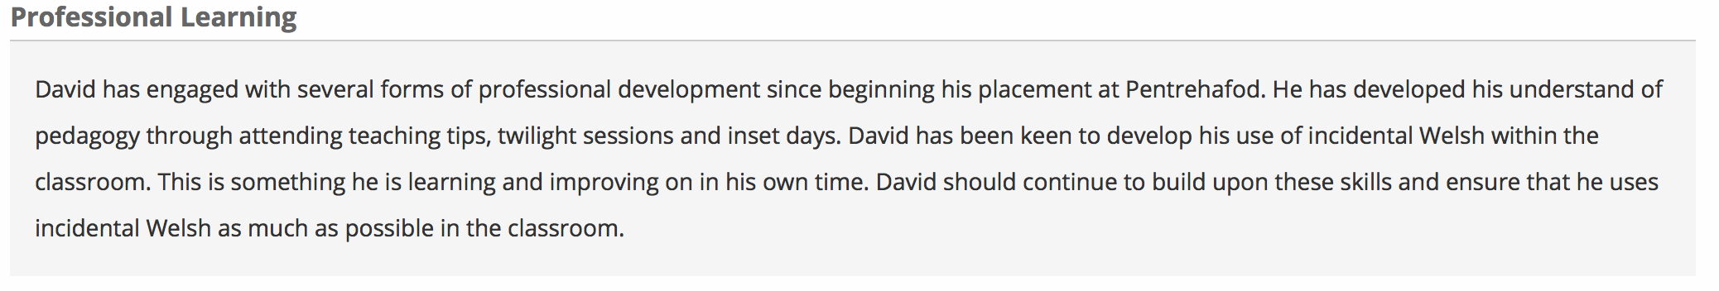
This was taken from my mid-term review.

