University of Wales Trinity Saint David
School of Engineering



PLC Control Systems
Control Technology
(ACMA6001)

Tia Ball
2220258
September 2025

Abstract
The main objective of this report is to evaluate the design, implementation, and performance of a programmable logic controller (PLC) system developed to control an automated material handling process in Factory I/O. The system is required to sort four categories of packages based on weight and size, while also meeting strict operational and safety requirements. To achieve this, the report critically reviews fluid power as a medium for actuation and control in automated manufacturing environments, defines and justifies the control requirements of the PLC system, including its inputs, outputs, constraints and operational flow, and documents the PLC program with clear annotations and code snippets that demonstrate how these requirements were fulfilled. Furthermore, the report verifies and validates the logic against the defined specifications, evaluates the strengths and weaknesses of the implementation while suggesting potential improvements, and concludes with an assessment of the overall effectiveness of the PLC design for automated material handling.

Contents
Abstract 2
Table of Figures 4
1 Introduction 5
2 Literature Review – Fluid Power in Automation 6
3 Control System Requirements 7
4 PLC Program Documentation 9
4.1 Emergency Stop Logic 9
4.2 Conveyor Start-Up Sequencing 10
4.3 Counters and Classification 11
4.4 HMI Root Screen 12
5 Verification and Validation 12
6 Evaluation of Control Logic 14
6.1 Strengths 14
6.2 Weaknesses 14
6.3 Potential Improvements 14
7 Conclusion 16
8 References 17

Table of Figures
Figure 1 - Operational Flow Diagram 10
Figure 2 - Emergency Stop Procedure Flowchart 11
Figure 3 - Ladder Logic for Emergency Stop Override 11
Figure 4 - Sequential Start-Up Flowchart 12
Figure 5 - Ladder Logic Timers for Conveyor Sequencing 12
Figure 6 - Ladder Logic for Package Weighing and Classification 13
Figure 7 - Ladder Logic for Counters with Reset 13
Figure 8 - HMI Root Screen (with buttons and counters) 14

Introduction
Programmable logic controllers (PLCs) are at the core of modern industrial automation, offering a reliable and flexible method for controlling manufacturing and material handling processes. Their ability to integrate inputs from sensors, execute logical decision-making in real time, and control outputs such as actuators and motors makes them essential for applications requiring both precision and robustness (Bolton, 2021).
This report analyses the development of a PLC control program for a simulated material handling system in Factory I/O. The system was tasked with sorting four types of packages based on both weight and size while incorporating safety features, sequencing constraints, and effective operator interaction. The following sections provide a critical review of fluid power technologies as a background to control and actuation, define the control requirements of the modelled system, document the developed PLC program through selected snippets, and present verification and validation results. The discussion also evaluates the strengths, weaknesses, and potential improvements of the system before concluding with an overall reflection on the effectiveness of the PLC design.

Literature Review – Fluid Power in Automation
Fluid power, encompassing both hydraulics and pneumatics, has long been a central component of industrial automation. Hydraulics use pressurised fluid, while pneumatics rely on compressed air. Both remain widely applied due to their effectiveness in transmitting energy.
Hydraulic systems provide very high force density in compact units, making them suitable for heavy lifting and pressing (Esposito, 2018). Pneumatics, although less powerful, offer rapid response and are well-suited to high-speed material handling (Watton, 2019). Their durability and relatively low cost also support widespread use.
However, limitations include compressibility in pneumatics, which reduces positional accuracy, and hydraulic systems that require pumps, reservoirs, and maintenance infrastructure. Both are prone to leakage, noise, and energy losses (Pan & Yang, 2015).
Electric actuation increasingly outperforms fluid power in many applications. Electric drives offer greater precision, programmability, and efficiency, with studies showing higher consistency and lower energy consumption than hydraulics or pneumatics (Pustavrh, Hocevar, Podrzaj, Trajkovski, & Majdic, 2023). Energy efficiency is a key concern; hydraulics often achieve only 40–50% efficiency, and pneumatics can lose up to 90% of input energy, while electric systems exceed 80% (Jeong, Back, & Shin, 2020).
Fluid power technologies are evolving to stay competitive. Hybrid electro-hydraulic actuators (EHAs) maintain hydraulic force density but offer electric precision. Digital hydraulics and smart pneumatics enable subtler control and integration into Industry 4.0 environments, supporting predictive maintenance and cyber-physical connectivity (Sciatti, Tamburrano, Distaso, & Amirante, 2024).
In summary, fluid power offers robustness, force density, and speed but suffers from inefficiency and reduced accuracy. Critical evaluation suggests that electrical actuation is increasingly dominant, while hybrid and digital systems allow hydraulics and pneumatics to remain relevant in modern automation (Control Design, 2025).

Control System Requirements
The automated material handling system was designed to classify and sort packages based on size and weight, while satisfying requirements for safety, operator interaction, and reliability.
Inputs included the start and stop buttons, an emergency stop button, diffuse sensors for package detection, a conveyor scale for weight measurement, and HMI buttons for counter reset. Outputs included conveyor motors, warning sirens, stack lights, pushers, a pop-up sorter, and HMI displays for counters and warnings.
Safety constraints were a central consideration in the design. The emergency stop was required to override all other functions, immediately shutting down conveyors and actuators. A two-second siren warning had to precede conveyor start-up, and conveyors were needed to start sequentially with a 0.5-second gap to limit inrush current. Conflicting actuator outputs were to be prevented, and physical guarding was assumed within the simulation model.
The operational flow began with the operator pressing the start button, followed by a two-second siren and the activation of the staggered conveyor. Packages were then detected, weighed, classified, diverted to the correct lane, and counted on both the HMI and internal counters. The system halted if the stop or emergency stop was pressed.

Figure 1 illustrates the overall operational flow of the system, from package emission to classification and counter updates.
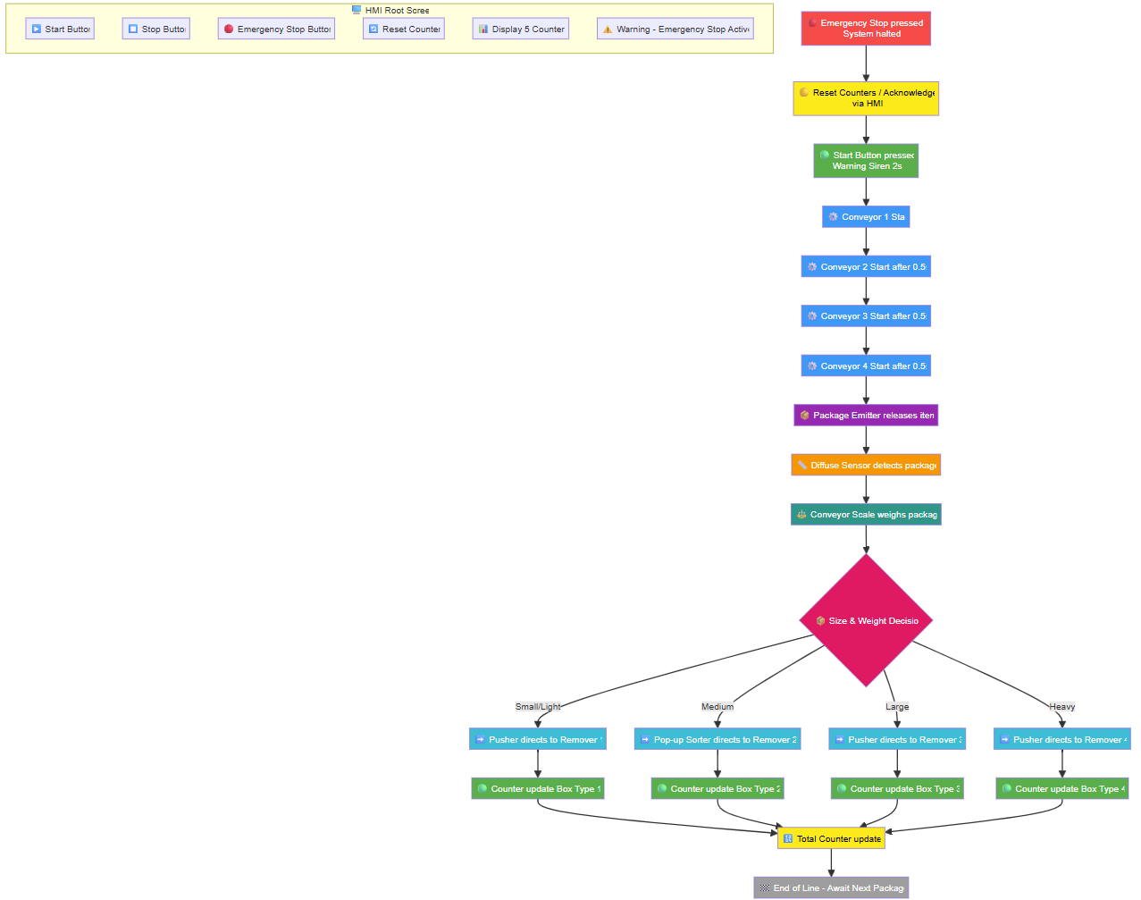
Figure 1 - Operational Flow Diagram

PLC Program Documentation

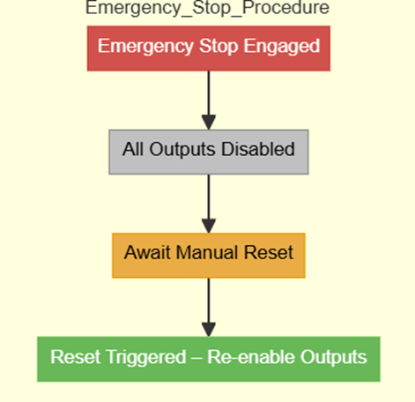
Emergency Stop Logic
Figure 2 - Emergency Stop Procedure Flowchart
As shown in Figure 2, the emergency stop procedure flowchart illustrates how all outputs are disabled when the stop is engaged, requiring a manual reset to re-enable operations.
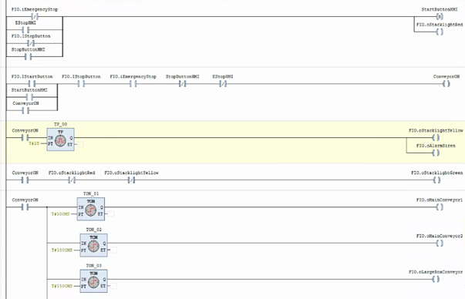
The ladder logic in Figure 3 implements this override directly in Factory I/O, ensuring immediate de-energisation of all conveyors and actuators.
Figure 3 - Ladder Logic for Emergency Stop Override

By structuring the emergency stop as a single overriding condition, the design ensures that all conveyors and actuators are de-energised immediately once the input is triggered. This aligns with the concept of fail-safe design, where systems are engineered to default to a safe state under fault or emergency conditions (All About Circuits, 2021).

Conveyor Start-Up Sequencing
The logic for sequential start-up is visualised in Figure 4, where a two-second siren is followed by staggered conveyor activation every 0.5 seconds.
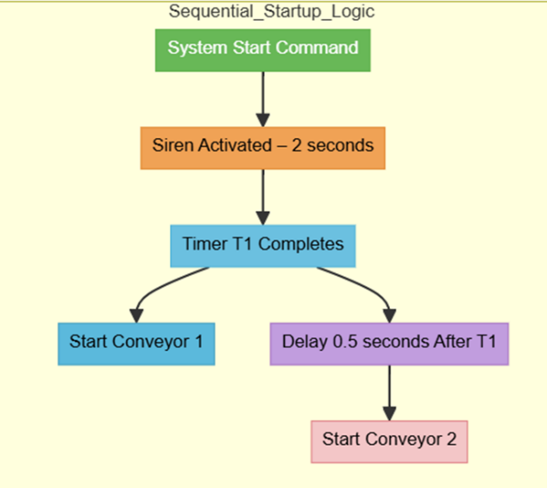
Figure 4 - Sequential Start-Up Flowchart

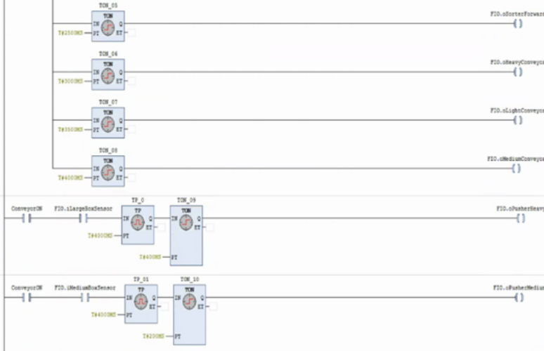
The detailed ladder logic with timers controlling conveyor start-up is shown in Figure 5.
Figure 5 - Ladder Logic Timers for Conveyor Sequencing

Counters and Classification
The classification logic and weighing thresholds are handled in the rung diagram shown in Figure 6, where the conveyor scale reading is used to sort packages into “light” or “heavy” categories.
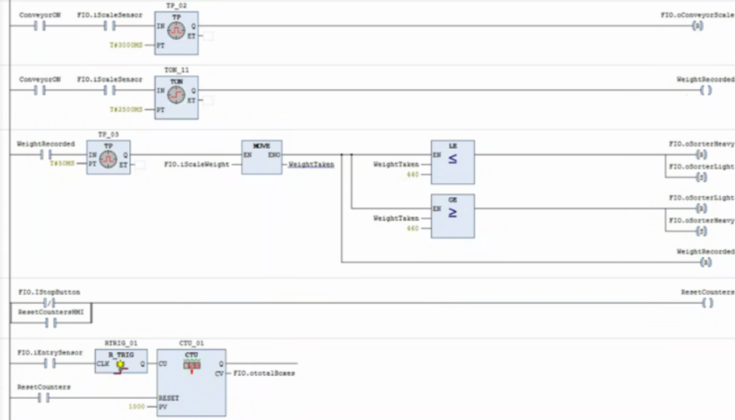
Figure 6 - Ladder Logic for Package Weighing and Classification

Category-specific counters, each with reset functionality, are displayed in Figure 7.
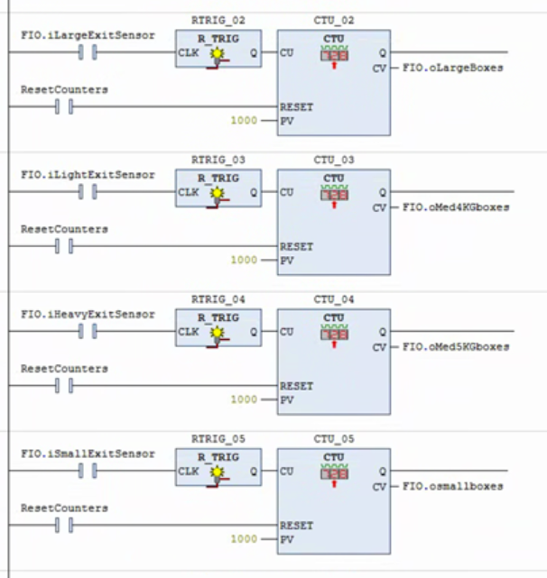
Figure 7 - Ladder Logic for Counters with Reset

HMI Root Screen
Finally, the operator interface is illustrated in Figure 8, featuring start, stop, emergency stop, and counter reset buttons, alongside live displays for package counts.
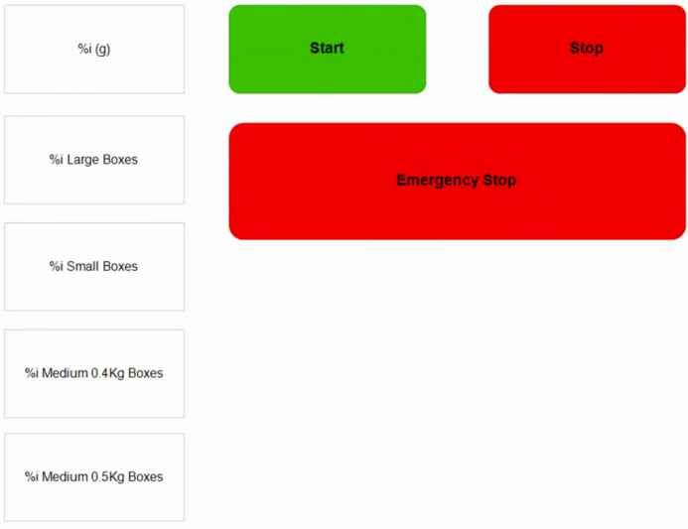
Figure 8 - HMI Root Screen (with buttons and counters)

Verification and Validation
Verification was conducted by systematically testing each logic segment in Factory I/O, while validation confirmed that the system met real-world requirements. The emergency stop was shown to disable all actuators, even mid-operation, immediately. Conveyor sequencing was validated by observing the siren warning and staggered activation of each conveyor with correct timing intervals.
Counters were validated by processing packages of each category and confirming that increments occurred in the correct variables. The total counter consistently matched the sum of category counters, and the reset button cleared all values as expected. Stress tests were also conducted, such as triggering the stop or emergency stop mid-sequence, which confirmed the system halted safely without producing miscounts or unsafe states.
Boundary and fault conditions were also considered. Packages were introduced in rapid succession to test whether sensors could consistently detect and classify them. The counters updated accurately even under high throughput. Packages near classification thresholds were tested for consistent allocation. Safety tests included halting the system mid-transfer, where the emergency stop froze conveyors immediately, and restarting resumed counters correctly without duplication.
Long-term stability was assessed through repeated cycle tests, confirming no drift in counter values or failure of timers. These practices align with industrial best practice, where verification requires both normal and abnormal conditions to be tested (Koondhar, 2023). Overall, testing confirmed that the system was robust and dependable under diverse scenarios.

Evaluation of Control Logic
PLC CTU (count up) functions track package counts. One CTU records total entries; four others increment when a package reaches the respective removal point. A reset button resets all counters to zero.

Strengths
The system’s main strength lies in its strong emphasis on safety. The emergency stop function immediately disabled all outputs, ensuring compliance with fail-safe design. The conveyor start-up sequence was modular and flexible, enabling simple modifications to timing or the addition of new conveyors. Classification and counters were logically structured and linked effectively to the HMI, providing operators with valuable real-time production data.

Weaknesses
The system’s reliance on fixed delays for sequencing is a weakness, as real-world conveyor motors may not behave consistently under all load conditions. Classification logic also assumes perfect sensor accuracy, with no built-in error detection. Additionally, reliance on manual counter resets introduces the potential for operator error if a reset is missed.

Potential Improvements
Future improvements could include condition-based conveyor sequencing, such as starting each conveyor once current stabilisation is detected rather than after fixed timers. Counters could be integrated with automatic data logging, ensuring shift totals are recorded without requiring a manual reset. Diagnostic logic could also be added to identify and display specific faults, such as sensor errors or jams, providing operators with actionable information.
From a maintainability perspective, the program demonstrates readability and modularity but could benefit from additional structure. Using function blocks for conveyors, counters, and safety routines would make the program easier to troubleshoot and adapt to larger systems. Scalability is also limited: while four categories are supported, industrial systems may require more. Adopting parameterised arrays for counters could allow flexible expansion. Finally, integration with SCADA systems or Industry 4.0 frameworks would enable data logging, predictive maintenance, and remote monitoring, adding value beyond the basic simulation. Potential improvements should also be aligned with relevant industrial standards to ensure compliance and safety. For example, (British Standards Institution (BSI), 2015) specifies requirements for the design and operation of emergency stop functions, and incorporating this standard would strengthen the robustness of the system’s safety architecture. Similarly, adherence to (International Electrotechnical Commission (IEC), 2010) (Functional Safety of Electrical/Electronic/Programmable Systems) would provide a structured framework for analysing risks and ensuring that safety-related control functions are reliable. Embedding these standards into the design would not only make the system more technically capable but also compliant with global best practices in industrial automation.

Conclusion
The development and evaluation of the PLC control system for an automated material handling process in Factory I/O demonstrated that the program successfully met its core functional and safety requirements. Emergency stop routines provided immediate shutdown of all actuators, conveyor start-up sequencing effectively reduced current draw while maintaining operator awareness, and the classification and counting logic accurately tracked throughput. The integration of counters and HMI displays further enhances usability, enabling operators to monitor and reset production data easily.
In conclusion, the project not only demonstrated how PLCs can effectively control an automated sorting process but also highlighted the importance of safety, modularity, and usability in industrial design. While the implementation performed reliably in simulation, the evaluation suggests clear pathways for enhancing scalability, maintainability, and integration with modern Industry 4.0 systems. These improvements would enable the system to transition from a functional simulation to an industrially robust, future-ready solution.

References
All About Circuits. (2021). Fail-safe Design. London: All About Circuits. Retrieved September 24, 2025, from https://www.allaboutcircuits.com/textbook/digital/#fail-safe-design
Bolton, W. (2021). Programmable Logic Controllers (7th ed.). London: Routledge. Retrieved September 24, 2025, from https://www.routledge.com/Programmable-Logic-Controllers/Bolton/p/book/
British Standards Institution (BSI). (2015). Safety of machinery. Emergency stop function. Principles for design. London: BSI Standards Limited. Retrieved September 24, 2025
Control Design. (2025, September 24). The evolution of fluid power and the future of industrial actuation. Retrieved from Control Design: https://www.controldesign.com/motion/hydraulics/article/55313102/evolving-fluid-power-technologies-trends-and-future-opportunities
Esposito, A. (2018). Fluid Power with Applications (9th ed.). Harlow: Pearson. Retrieved September 24, 2025, from https://www.pearson.com/en-gb/subject-catalog/p/fluid-power-with-applications
International Electrotechnical Commission (IEC). (2010). Safety of machinery. Emergency stop function. Principles for design. London: BSI Standards Limited. Retrieved September 24, 2025
Jeong, J., Back, J., & Shin, H. (2020). A review of energy-saving technologies in hydraulic systems. Energies, 13-65. Retrieved September 24, 2025, from https://www.mdpi.com/1996-1073/13/1/65
Koondhar, M. (2023). The Role of PLC in Automation, Industry and Education Purpose: A Review. International Journal of Emerging Trends in Engineering Research, 32-40. Retrieved September 24, 2024, from https://www.researchgate.net/publication/379937523_The_Role_of_PLC_in_Automation_Industry_and_Education_Purpose_A_Review
Pan, M., & Yang, H.-Y. (2015). Engineering research in fluid power. Chinese Journal of Mechanical Engineering, 1-10. doi:10.3901/CJME.2015.0706.074
Pustavrh, J., Hocevar, M., Podrzaj, P., Trajkovski, A., & Majdic, F. (2023). Comparison of hydraulic, pneumatic and electric linear actuation systems. Scientific Reports, 13. Retrieved September 24, 2025, from https://www.nature.com/articles/s41598-023-47602-x
Qu, S., Zappaterra, F., Vacca, A., & Liu, Z. (2023). Research on novel electro-hydraulic actuators with fixed displacement hydraulic units. International Journal of Fluid Power, 24. doi:10.13052/ijfp.0973-5763
Sciatti, F., Tamburrano, P., Distaso, E., & Amirante, R. (2024). Digital hydraulics: a review of digitally controlled hydraulic valves and applications. Heliyon, 10(5), 10. Retrieved September 24, 2025, from https://www.sciencedirect.com/science/article/pii/S240584402403295X
Watton, J. (2019). Fundamentals of Fluid Power Control. Cambridge: Cambridge University Press. Retrieved September 24, 2025, from https://www.cambridge.org/core/books/fundamentals-of-fluid-power-control

