31/07/2025

Building Survey Plan

Produced by Louis James (2415463)
Digital Surveying and Highway Design (ACBA4017)
Table of Contents
Introduction to building surveying 5
Building survey objectives and scope 6
Digital tools and Technologies 8
Drones 8
LiDAR Scanners 9
BIM 9
Survey Plan 10
Challenges and solutions 11
Conclusion 12
References 13

Figure list
Figure 1: Visual of building surveying (online) Available at: Complete Measured Building Survey Service today | Kent [Accessed 30/07/2025]
Figure 2: Difference between RICS surveys (online) Available at: Level 3 building structural surveyor | Websters Surveyors [Accessed 30/07/2025]
Figure 3: Street view of the Dylan Thomas centre, Swansea (online) Available at: 8 Somerset Pl - Google Maps [Accessed 30/07/2025]
Figure 4: Visual of drone with LiDAR (online) Available at: Exploring LiDAR Drones: Applications & Industry Uses [Accessed 30/07/2025]
Figure 5: Visual of LiDAR Scanners on-Site (online) Available at: A Guide to Laser Scanning | GPRS [Accessed 30/07/2025]
Figure 6: Visual of BIM (online) Available at: BIM: A New Model for Surveyors | GIM International [Accessed 30/07/2025]
Figure 7: HSE fatalities statistics 2023-2024 (online) Available at: Work-related fatal injuries in Great Britain - HSE [Accessed 30/07/2025]

Glossary of Terms
RICS – Royal Institution of Chartered Surveyors
LiDAR – Light Detection and Ranging
3D – Three-Dimensional
BIM – Building information modelling
Hi-Vis – High visibility
PPE – Personal Protective Equipment
RPE – Respiratory Protective Equipment
ACM’s – Asbestsos Containing materials

Introduction to building surveying
A building survey is a vital method local councils, housing associations and home buyers use before purchasing commercial or industrial properties. Building surveys are essential as they provide the client with an in-depth report of the property’s condition at the specific time of the inspection. The surveyor will identify any areas of deterioration of defects past and present, additionally areas that require further inspections will be stated to pre-empt potential defects or deterioration within those elements. Finally, the report will include conservation and maintenance suggestions, along with an estimated cost for all works deemed as necessary.
Over recent years, the role of digital technology used within building surveys has abled the surveyor to provide the client with more in-depth and accurate information, as the report is only completely accurate to the date in which it was carried out, the use of the modern technologies are more efficient compared to traditional methods, benefiting both the surveyor and client. As the time in which the report will be received is decreased, the client will have a clear understanding of potential defects of deterioration arising since the survey was carried out.
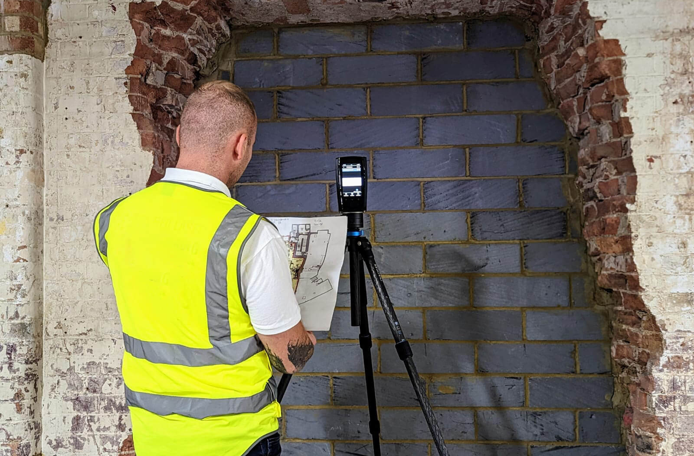
Figure 1: Visual of Building surveying
This report aims to identify the use and benefits of modern technology within building surveying, furthermore the report will provide objectives and a scope of survey required for the Dylan Thomas centre, and potential challenges faced during the survey and strategies used to reduce or eliminate all identified challenges.

Building survey objectives and scope
The primary objective of a building survey is to provide documentation of the condition of the property, as stated in (Jackson-Kirby, R., n.d) the report must also provide the purpose of inspection as well as the weather conditions the day of the inspection, furthermore the surveyor must note the type of building, age, rooms, surrounding environment and services. Additionally, internal, and external elements including chimneys, walls and finishes, foundation and areas highlighted for concern or disrepair can be visualised through 3D scans removing the need for future surveys or planned work. Finally, the surveyor will provide a summary of the condition and current and future repairs required, including a projected cost.
To establish the scope of survey conducted, the clients’ requirements are to be identified. There are four surveys available RICS level 1, RICS level 2, RICS level 3 and a historic building survey. As highlighted from (Local building Surveyors, n.d, a) the RICS level 1 condition report provides the client with a clear overview of the properties condition, this survey is designed for newer builds, the report evaluates areas of the property and is put into traffic light rating green, amber or red if areas are highlighted for concern or in urgent need of repair the surveyor does not include advice or a valuation.
As interpreted from (AMS SURVEYS, 2024) the RICS level 2 Home survey was designed for home buyers and is suited for typical properties in reasonable condition, the report will be in depth on all visible and accessible elements within the property, similar to the level 1 survey the report will be rated in a colour coded system however the surveyor will include maintenance advice and a property valuation.
The RICS level 3 survey is the most comprehensive and detailed building survey available. As stated from (Local building Surveyors, n.d, b) although its suitable for all types of property, it is recommended for older, unusual buildings, during the survey the surveyor will carry out a thorough examination of the property as a whole providing the client with an highly detailed report of the construction and condition of the building, unlike the level 1 and 2 survey this report will feature a more in depth rating system including the severity and implications. The differences between the three surveys can be identified and visualised as shown in figure 2.0.
Finally, an historic building survey can be carried out as highlighted from (‌Icon Surveyors, 2023) this survey provides the client with potential legal restrictions with listed building or structures in conservation areas, additionally the traditional materials and the historic significance are assessed. The surveyor who conducts the survey will have an expertise in historic structures and will typically be in house, such as in Wales, Cadw the Welsh Governments historic environment service. As stated from (AMS SURVEYS, n.d) a historic building survey will follow the same report format as the RICS level 3 survey as it is widely recognised as reporting standard for properties, including an inspection of all internal and external elements, a report of the condition and defects or concerns within the structure, furthermore the surveyor will provide maintenance advice with an estimation of cost. Finally, the surveyor will review previous repairs and decide if the listed building consent is required.

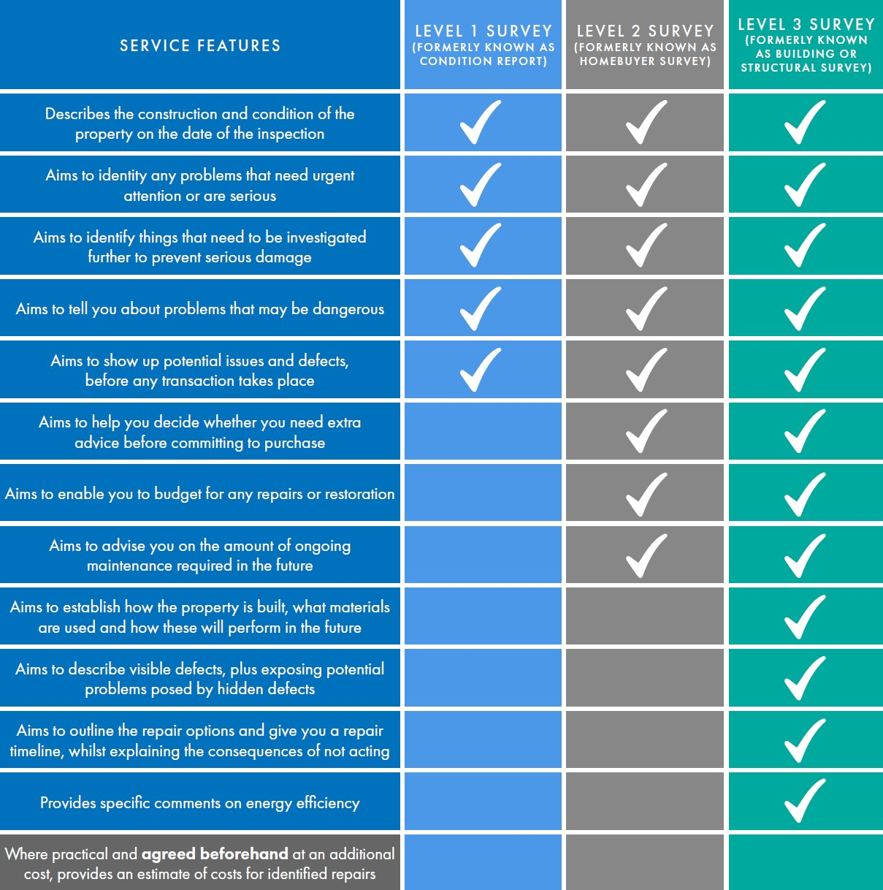
Figure 2: Difference between RICS surveys
The building we propose to survey is the Dylan Thomas Centre which is a grade II* listed neoclassical building located within the Maritime Quarter, Swansea, Wales. As documented in (‌Augustyn, A. n.d) a neoclassical building is an architectural style that was constructed throughout the 18th century, characterized by the simplicity and symmetry inspired from Greek and roman architecture, this can be visualised in figure 3.0. The Dylan Thomas Centre was constructed between 1825-1829 and during this period in south Wales natural materials such as stone, earth, brick, wood, and lime were commonly used (Whitear, H. & Duxbury, T. n.d). Additionally, when conducting a building survey, the location is to be considered as it may pose specific hazards and restrictions affecting the structure.
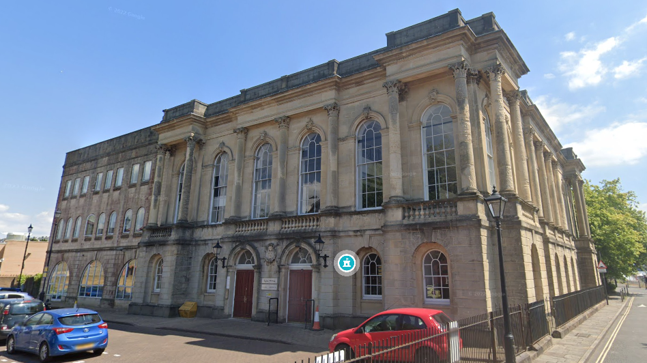
Figure 3: Street view of the Dylan Thomas Centre, Swansea
The key focus of the survey should be to identify the condition of all internal and external elements including roof, wall, floor and openings to ensure there is no structural defects, furthermore, the survey should state present or future maintenance works including a cost providing the client with clear understanding of urgent repairs to reduce further implications.

Digital tools and Technologies

Drones
Digital technology such as drones tends to be used when surveying large historic structures, due to the size and location of the Dylan Thomas centre accessing the roof can lead to a plethora of potential limitations. According to (RICS, 2023) drones can be used to collect data and provide high quality images and videos allowing the surveyor to inspect and visualise the elements from the ground as a result of this the use of drones are far more efficient and reduce cost scaffolding and training whilst eliminating potential dangers of working at height.
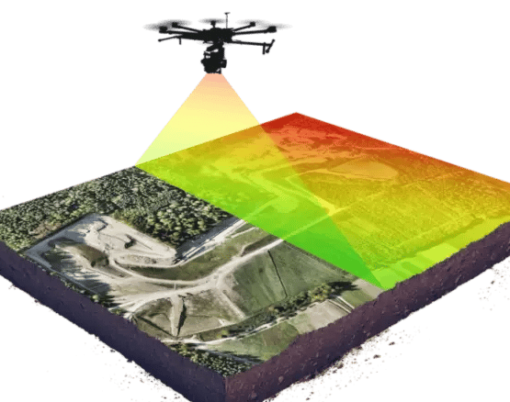
Finally, Drones can be modified to include modern technology for example LiDAR sensors, as evidenced by (DJI Enterprise, 2022) LiDAR sensors in drones allows for greater accuracy of the structure and surrounding environment, furthermore, once the drone has mapped out the structure it can be inputted into a 3D model with centimetre-level accuracy allowing the surveyor to review and identify nearby services such services that may affect the structure or any remedial work required.
Figure 4: Visual of Drone with LiDAR

LiDAR Scanners
Another form used of technology used when carrying out building surveys is LiDAR scanners which uses laser light to measure distances to a target area and records the time taken until the light has returned, creating an accurate 3D model of the structure and its characteristics (Jackson, P. 2025). Due to the size of the Dylan Thomas centre the time required to survey and record all dimensions could take multiple site visits, however LiDAR can collect all necessary data required for the client at a more efficient rate, finally as stated in the survey objectives a 3D model will benefit the client, removing the need for future surveys.
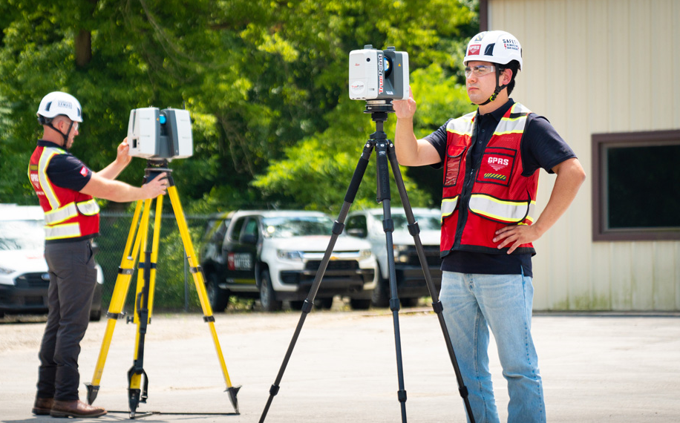
Figure 5: Visual of LiDAR Scanners on-site

BIM
BIM is also another method commonly used within construction and building surveys. As interpreted from (Jackson, P. 2024) BIM is a software-based technology that creates and stores a 3D model of the structure, because of this, the report provided will be comprehensive. There are multiple benefits when using BIM in building surveys, such as cost estimation, as the software measures dimensions and the amount of materials needed the client they will have a clear overview of potential works and to resolve elements identified of concern. Finally, BIM surveys can pinpoint clashes, conflicts and identify safety concerns of planned remedial or future works, because of these delays on site are minimised and site safety is improved.
The use of BIM will meet the objectives set at the start of the requirements, as it provides a clear visual of the structure, and identifies potential issues if future works are to occur.
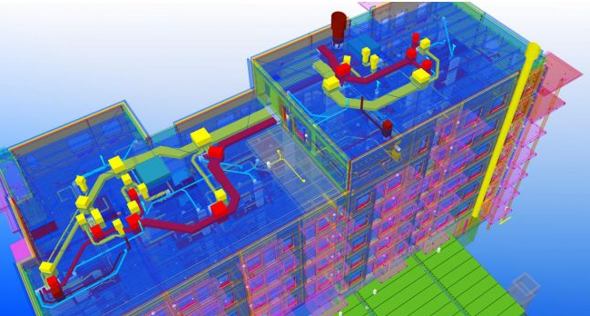
Figure 6: Visual of BIM

Survey Plan
Before a survey is carried out, the surveyor must have an understanding of the location, type of building and the clients’ requirements. As the Dylan Thomas centre, a grade II* listed neoclassical building located within the Maritime Quarter, Swansea, Wales is the building proposed for a survey, it is suggested a historic building survey is carried out, from this the surveyor will provide a detailed report on the structure and condition.
Once the surveyor has been informed of the client’s requirements, the surveyor can start to prepare. The surveyor will need to arrange access to the building prior to the survey, furthermore, the surveyor will need to acquire appropriate PPE including Hi-Vis, hard hats. As the surveyor has been informed of the client’s requirements, they should identify all equipment needed, in this situation the surveyor will need to attain drones equipped with LiDAR sensors, LiDAR scanners and BIM additionally the surveyor would bring a ladder, note pad etc.
A desktop survey would be required prior to the survey being carried out. As identified from (Peck, R. 2021) a desktop survey is a remote method of a building survey, this would be carried out by a RICS registered valuer. The desktop survey will locate information of the property using available data, removing the need for a physical inspection, the information found can include as-built plans, ordnance surveys, geological maps and reviewing previous surveys if available.
After a desktop survey has been completed, the surveyor would undertake on-site reconnaissance. (Williams, H. 2025a) stated on-site reconnaissance establishes the physical and spatial perspectives of the building. The surveyor will assess the land, surrounding structures, site access and the natural environment that could affect the structure.
After the surveyor has established the physical and spatial perspectives of the building, the on-site survey will take place. The on-site survey consists of three individual stages exterior overview, interior inspection and review of exterior and surrounding site. As noted from (Williams, H. 2025b) the external overview focuses on the main elements of the external structure, all significant defects are recorded. After the exterior inspection has been carried out the surveyor will survey the interior, this tends to be done working on a room-to-room basis, during this inspection the surveyor will identify and record all issues relating to the use and condition of the building as well as recording internal defects caused by the external elements. If no records of plans or measurements were found during the desktop survey, the on-site inspection may require a measured survey.
Finally, once the survey has been carried out the surveyor will produce a report containing images and a plan identifying the material, condition and a description of all elements. The report should be comprehensive and provide the client with a clear understanding of the condition throughout the building with advice and an estimated cost of required works.
The drone should be used during the external overview stage, the use of the drone will provide clearer view for the surveyor to inspect elements such as the roof and chimney, as a camera is attached to the drone all imagery can be included within the report to allow the client to visualise potential defects.
During the external overview and internal inspection, a LiDAR scanner can be used, this technology can be used handheld or on a tripod, when a LiDAR scanner is used it significantly reducing time on-site surveying. The use of LiDAR will provide accurate dimensions and cost for remedial works.
The use of BIM on site increases the efficiency as information can be stored and delivered quicker and clearer compared to traditional methods. BIM also enables the creation of an accurate 3D model, providing the surveyor and client with a clear understanding of the buildings structure and condition, similar to LiDAR, BIM will provide an estimation of cost for works required, furthermore, BIM can identify potential safety concerns.

Challenges and solutions
As shown in figure 7.0 the bar chart has identified the main cause of fatalities for workers in 2023/2024.
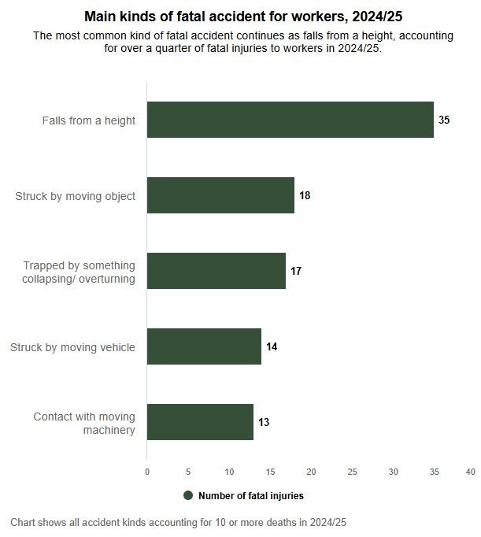
Figure 7: HSE fatalities statistic 2023-2024
As the Dylan Thomas centre does have a road adjacent with a car park, a hazard identified will be traffic and moving vehicles, to reduce this risk the surveyor must wear appropriate PPE including Hi-Vis, this will make the surveyor easier to identify reducing likelihood of collisions. Falls from height is also a hazard as the surveyor will need to inspect the roof of the building, however this risk can be significantly reduced through the use of digital technologies, by using technology such as drones the need for the surveyor to access the roof is removed, if the surveyor does need to access the roof appropriate training must be provided. Finally, as the building was constructed between 1825-1829 there is the risk for ACM’s within the structure, to reduce this risk an asbestos survey can be carried out before the building survey takes place, additionally, the surveyor must wear appropriate RPE and undertake asbestos awareness courses before entering the site.

Conclusion
To conclude, a historical building survey is recommended as the Dylan Thomas Centre is a grade II* listed building, therefore the survey conducted provides the client with information of the materials and condition as well as legal restraints. The use of digital technology within the building survey will improve the efficiency, accuracy and safety on-site. Finally, before the surveyor conducts the survey it is important for all hazards to be identified with procedures and training, this can be done through a risk assessment minimising the likelihood and severity of each individual hazard.

References
AMS SURVEYS (2024). Understanding the RICS Level 2 Survey: A Comprehensive Guide for Homebuyers. [online] Available at: Understanding the RICS Level 2 Survey: A Comprehensive Guide for Homebuyers [Accessed 30/07/2025]
AMS SURVEYS. (n.d). ARRANGE YOUR HISTORIC BUILDING SURVEY. [online] Available at: Historic Building Survey | Heritage Surveyors | AMS SURVEYS [Accessed 30/07/2025]
‌Augustyn, A. (n.d) Neoclassical architecture [online] Available at: Neoclassical architecture | Definition, Characteristics, Examples, & Facts | Britannica [Accessed 30/07/2025]
DJI Enterprise (2022) LiDAR Drone Systems: Using LiDAR Equipped UAVs [online] Available at: LiDAR Drone Systems: Using LiDAR Equipped UAVs [Accessed 30/07/2025]
‌Icon Surveyors (2023). Comprehensive Guide to Building Surveys: Types, Significance, Processes, and Selecting the Right Surveyor [online] Available at: Comprehensive Guide to Building Surveys [Accessed 30/07/2025]
Jackson, P. (2024) Understanding the functions of BIM surveys within construction [online] Available at: BIM Surveys in Construction | Key Functions Explained [Accessed 30/07/2025]
Jackson, P. (2025) The advantages of using LiDAR technology in surveying [online] Available at: The Advantages of Using LiDAR Technology in Surveying [Accessed 30/07/2025]
Jackson-Kirby, R. (n.d). What Is A Building Survey (RICS Level 3)? [Online]. Available at: What Is A Building Survey (RICS Level 3)? - HomeOwners Alliance [Accessed 30/07/2025]
Local building Surveyors (n.d) Find Local RICS Surveyors - Compare Survey Quotes [Online]. Available at: Find Local RICS Surveyors - Compare Survey Quotes - Local Building Surveyors [Accessed 30/07/2025]
Peck, R. (2021) Desktop surveys – A surveyors take [online] Available at: Desktop Valuations – A Surveyor's Take — Richard Russell [Accessed 30/07/2025]
RICS (2023) How have drones impacted building surveying? [online] Available at: RICS Find a Surveyor - How have drones impacted building surveying? [Accessed 30/07/2025]
Whitear, H. & Duxbury, T. (n.d) Understanding traditional buildings [online] Available at: tywileaflet1-eng-final.pdf [Accessed 30/07/2025]
Williams, H. (2025) Building surveys (Presentation) ACBA4017: Digital Surveying and Highway Design [Accessed 30/07/2025]

