Fundamentals of Construction Technology
Assignment 1



Name; Thomas Poole
12/12/2019

Introduction
For this assignment I will assume that I work as a junior construction professional, employed by a local company tendering for the work, requested to initiate a full site investigation as part of the feasibility study. I have chosen the suitable foundation for a project that with go underway on Swansea foreshore. The county of Swansea has jointed an agreement with Marriot Hotels to create a new 300sq meter restaurant and ice cream parlor. The site is located in between the Swansea County Hall and the Marriot Hotel.
The research for this assignment was done to understand the historic background of the site and how we will build given the information. My aim in this written work is to state the building regulations/ codes of practice and which elements of the site investigation I consider being significant to the site.
I will be using various methods to gather my research for the assignment such as Gigi maps to discover the soil type under the site, different survey to understand the foundation we are building on e.g. GPR survey and plate load test and boring. I will also use various construction books to fully understand what foundations are best suited for the building and its materials for this project.
In task 1, I will be giving the historic background of the site. To find this information I completed desktop research, reading books and articles on the history of Swansea. The data and information found will then allow me to recommend the best surveys to understand what soil type is under the particular area of build.
For task 2, I listed in my opinion the best fit surveys for the site. Given the historic background of the area I could work off that to understand what survey is best suited. I have explained for each survey the importance, strengths and what the surveys do. I will also be using Gigi maps to understand the types of soil under the site. This information is important as it will allow me to recommend the best foundation for the building.
For my task 3, I will state the various building regulations and codes of practice from which my recommendations are derived and by the research I have collected in task 1 and 2.
In task 4, I will be using the aid of sketching to describe a suitable foundation detail for the building based on my preliminary. The sketches give a visual understanding of what the foundation will look like at the very start to the end of the project. My sketches will include the layout of foundation that is best suited for the project. The sketches include measurements and will be referenced to understand the size, material and components of the foundation. I would build the foundation going off my sketches.

Task 1
After desktop study, I have collected information about the historic background of the site. After study, we are shown from article ‘The rare photos showing the final day of Swansea's iconic Mumbles train’ by Dalling, R. (2019). The rare photos showing the final day of Swansea's iconic Mumbles train. [online] walesonline. Available at: https://www.walesonline.co.uk/lifestyle/nostalgia/rare-photos-showing-final-day-17003953 [Accessed 13 Dec. 2019] shows us that a railway used to run through Mumbles road to SA1 for 60 years. With this Information we can suggest that there could be a large amount of metal in the area of the site from the train tracks, storage tanks, fuel tanks and old components of train parts.
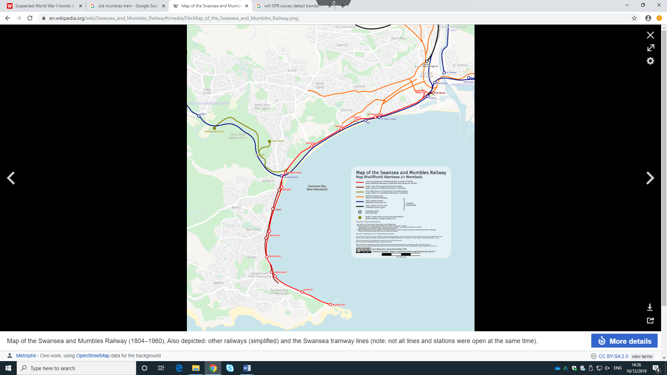

With further desktop research I have learnt that metal underground can be problematic to construction as it needs to be removed or it will result to problems e.g. laying down pipework for drainage and water, cables going into the building and pouring concrete for the foundation.

The red box indicates the area of the build.
As you can see by the red box the old train of Mumbles used to run through the area of the site.

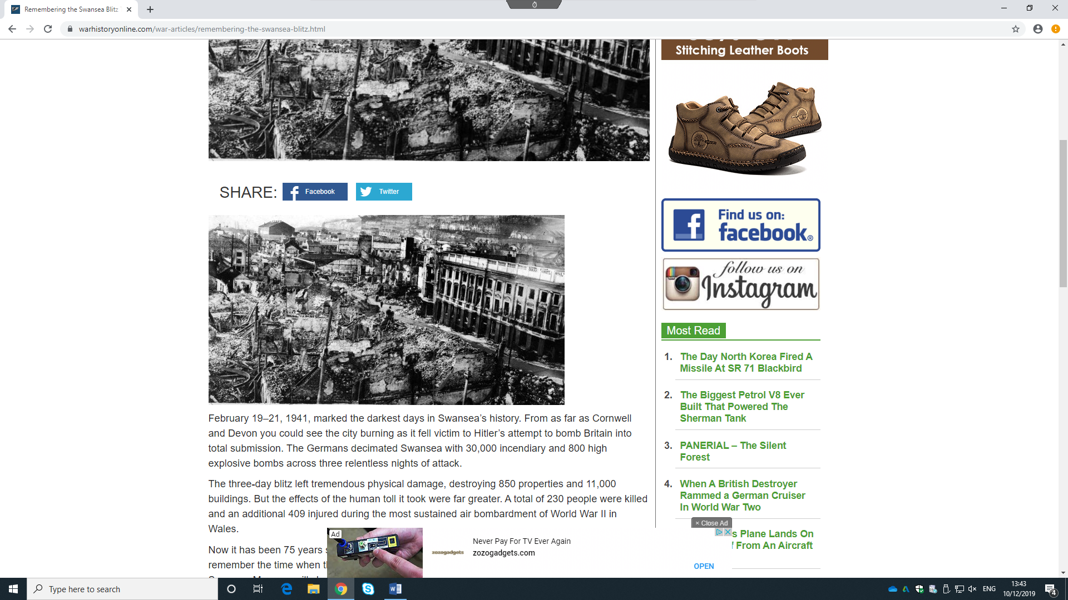
With my research into the history of Swansea and the certain site area, I have found information that Swansea was heavily struck in the war by bombing from Germany.
In the article by Winston, G. (2019). Remembering the Swansea Blitz That Destroyed 11,000 Buildings and Left 230 People Dead. [online] WAR HISTORY ONLINE. Available at: https://www.warhistoryonline.com/war-articles/remembering-the-swansea-blitz.html [Accessed 12 Dec. 2019]. We are shown that 11,000 building were destroyed by the bombing. With this high amount of destruction in the area it has resulted to many different types of materials being buried in the soils.

Also looking into the three-day blitz of Swansea, I have found an article leading to recent discovery of an unmarked bomb in Briton Ferry. From the article ‘Suspected World War II bomb is found at Briton Ferry recycling centre’ by walesonline. (2019). Suspected World War II bomb is found at Briton Ferry recycling centre. [online] Available at: https://www.walesonline.co.uk/news/wales-news/live-updates-suspected-world-war-15546653 [Accessed 13 Dec. 2019]. After the finding of this crucial information, I recommend that we do a GPR survey to detect any bombs laying under the area of the project. This has to be taken into consideration when construction of the project.
Some images from the scence (Briton Ferry)
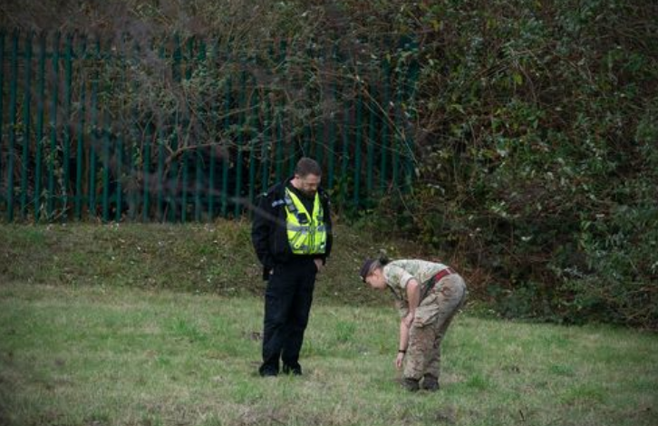
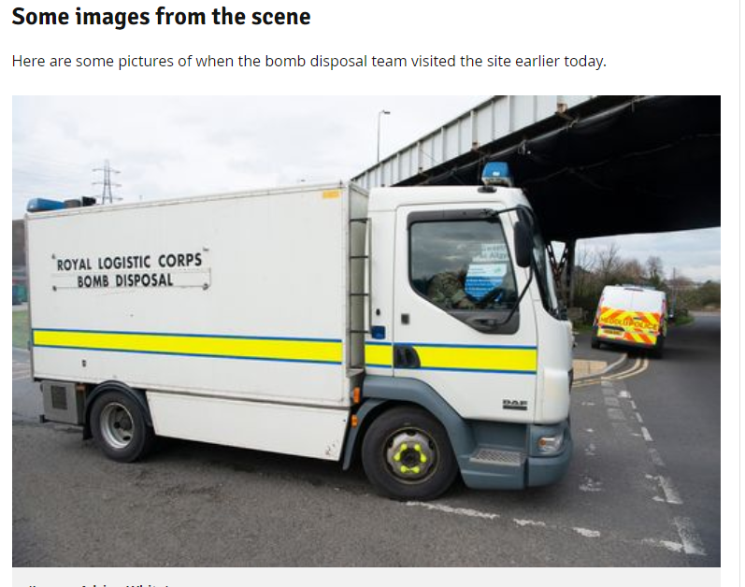

Task 2
Given the historic background of the site I advise that the most significant and applicable site investigation for this site are GPR survey, Plate load test and boring.
A GPR survey would be useful for this site as it is used to locate ‘buried lines, storage tanks, pipes and conduits’. This information was gathered from Sensoft.ca. (2019). Ground Penetrating Radar | Georadar | GPR Survey | Scanning. [online] Available at: https://www.sensoft.ca/blog/what-is-gpr/ [Accessed 12 Dec. 2019]. The historic background leaves us to believe that the site could contain steel and storage tanks because of the Swansea and Mumbles railway. The historic background of the area also leaves us with information of bombing. The GPR survey is used in Military jobs to detect unmarked bombs.
Plate load test will be very necessary for this site as it used to ‘determine the ultimate bearing capacity of the ground and the likely settlement under a given load’. I used the information given by the publisher Associates, J. (2019). Plate Bearing Test | Southern Testing. [online] Southern Testing. Available at: https://www.southerntesting.co.uk/services/ground-site-investigation-consultants/plate-bearing-test/ [Accessed 13 Dec. 2019]. The survey is crucial for this site because it will allow us to understand what materials we should use for the building given the settlement under a given load.
As we can see by The Constructor. (2019). Boring Methods for Soil Sampling for Soil Investigation. [online] Available at: https://theconstructor.org/geotechnical/boring-methods-soil-sampling/31869/ [Accessed 12 Dec. 2019] we are shown that ‘Boring methods are widely used for subsurface investigations to collect samples, in almost all types of soil, for visual inspection or laboratory testing’. There are many types of boring methods when it comes to construction, I believe the best method for this site is rotary drilling. We use rotary drilling to form a deep observation boar or for discovering rock. A powered rotary cutting head is used to drill through the foundation as is being rotated. For this machine you need lubrication such as water and air. These lubrications will keep the cutting head cool. Rotary drilling will also allow us to see in first person what foundation we have laying beneath the site. The drill will show layers of the soil under the foundation.
The importance and purpose of a soil investigation is to evaluate the load- bearing capacity of the foundation, selection of the type and the depth of foundation suitable for a given structure. The site investigation also gives us an understanding what material are buried below the site, this is important as the projects involves excavation of soil and rock.
I have used Digimaps to find out the layers of soil under the site. Digimap is a web mapping and online data delivery service developed by the EDINA national data centre for UK academia. It offers a range of on-line mapping.

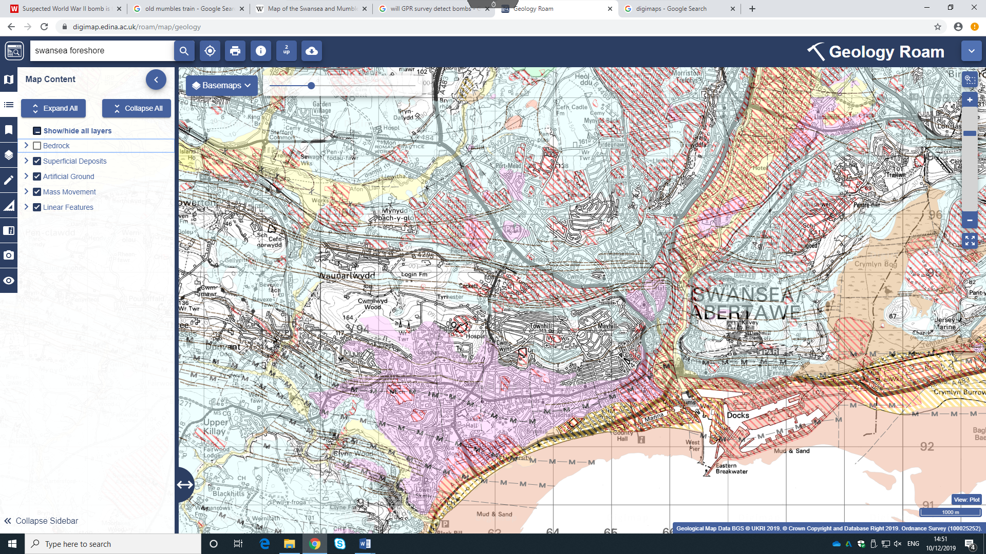
I have clicked on the bedrock tab to identify if there is any in the area of the site, which there is. Bedrock is ideal for building on as it solid and will not change shape and size in the presence of water. From the online article by Morris, T. (2019). What Soils Best Support Structures Such As Buildings. [online] HUNKER. Available at: https://www.hunker.com/12415148/what-soils-best-support-structures-such-as-buildings [Accessed 12 Dec. 2019]. We are told that ‘Bedrock does not slide, shift or move’. This is perfect for the project as the building will weigh a considerable amount because of the size.
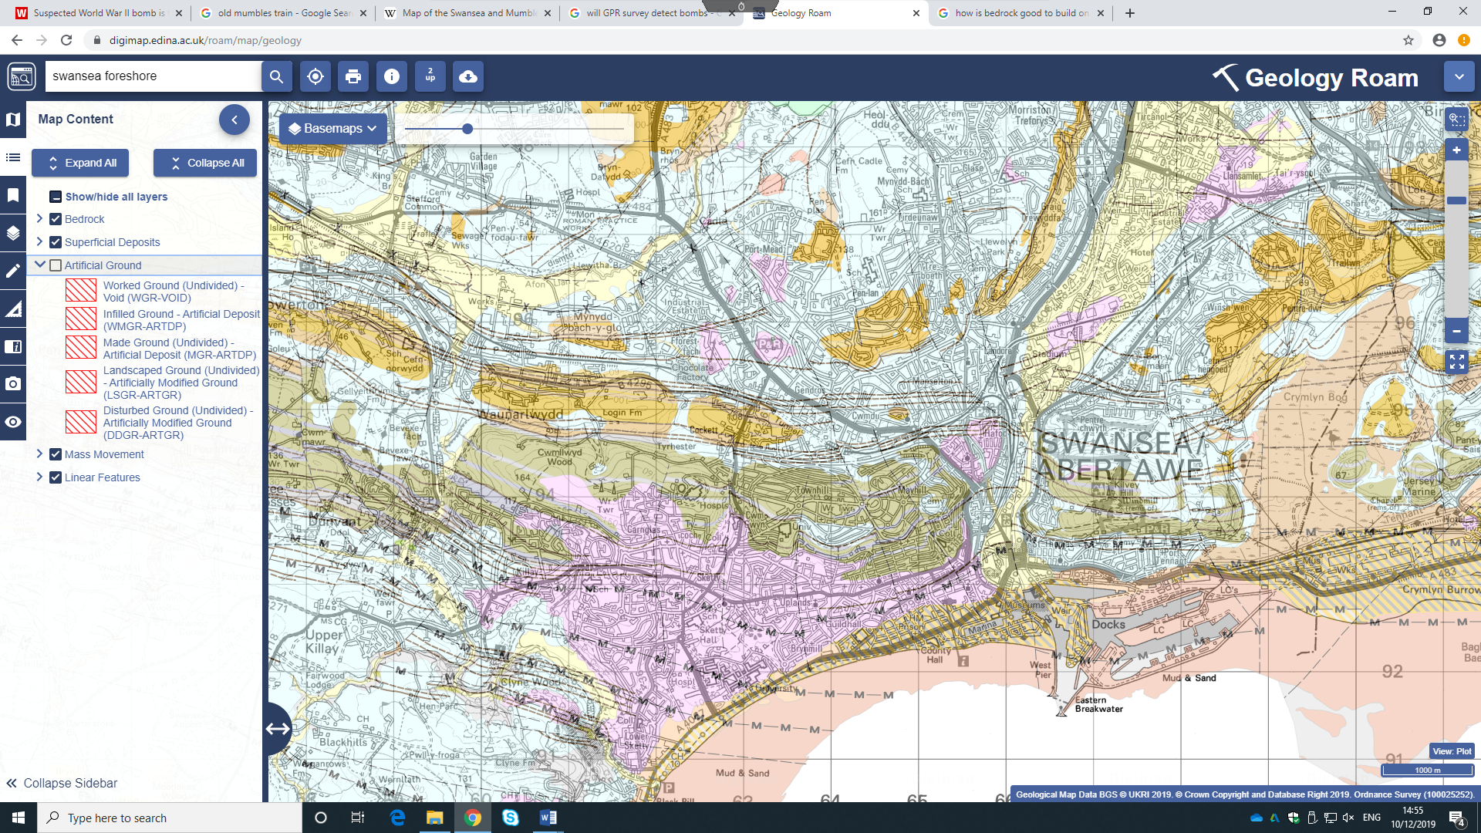
In this screenshot I have clicked on the ‘Artificial Ground’ tab. This tab shows if there are any made ground, disturbed ground and worked ground. The problem with building on disturbed ground is rain water. With the building so close to sea water and high amount of rain fall in South Wales it can cause concrete to become soft. This can ‘decrease the abrasion resistance and strength of the concrete, while increasing the tendency for dusting and cracking to develop. The key to preventing damage to the concrete surface by a rainstorm is proper preparation and timing’ this information was taken from Writer, S. (2012). [online] Etc-web.com. Available at: http://www.etc-web.com/pouring-concrete-vs-pouring-rain/ [Accessed 12 Dec. 2019].
It can also be a risk building on made ground as it is land ‘where natural and undisturbed soils have largely been replaced by man-made or artificial materials. It may be composed of a variety of materials including imported natural soils and rocks with or without residues of industrial processes (such as ash) or demolition concrete (such as crushed brick or concrete)’. Designingbuildings.co.uk. (2019). Made ground. [online] Available at: https://www.designingbuildings.co.uk/wiki/Made_ground [Accessed 12 Dec. 2019].’ This results into unstable ground and weak areas in the soil.
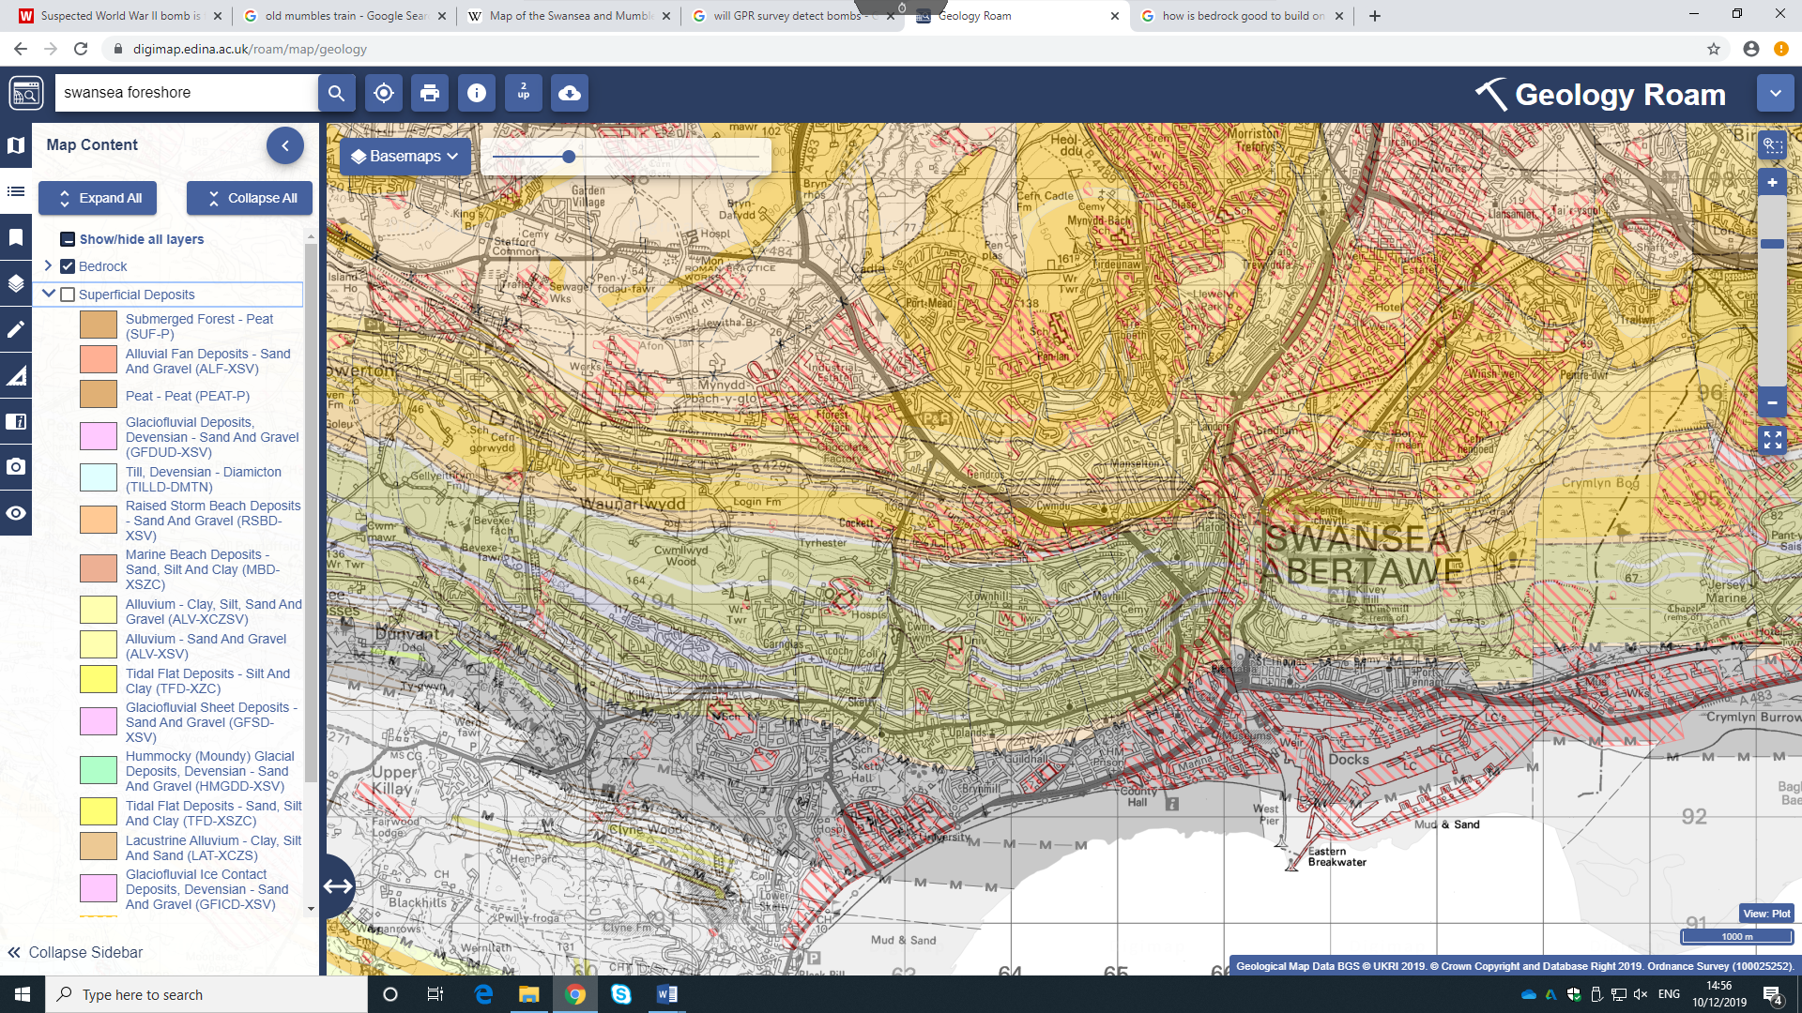
I am shown in this screenshot that sand and gravel are the main soil types that make up the ground under the site. Sand is a very good soil to build on as it allows water to drain through it quickly from a building site and it will not shift or move. Sand can be compacted so it adds additional strength and stability to the soil. But there is always a risk to build on sand because not all sand is created equally, some sand can act like and some can act like gravel or like silt.

Task 3
There are many regulations and codes of practice when it comes to the construction of the building and its foundation. Through my historic background research, I was shown that there was mass bombing on Swansea’s foreshore and a railway running through the site. For the regulations of the bombs we must use a GPR survey to detect if there are any bombs in the area. Work can not start if we don’t have the all clear by the specialists. Swansea county council must section of the site for the safety of the public.
If the GPR survey des detect a bomb we must call out the bomb disposal team. Regulations for finding an unmarked bomb is ‘Facility search, lock-down, or evacuation is not necessary unless the item is determined to be suspicious’ I collected this information from the website by Department of Homeland Security. (2019). What to Do - Bomb Threat. [online] Available at: https://www.dhs.gov/what-to-do-bomb-threat [Accessed 12 Dec. 2019]. The facilities around the area must be notified for the public’s safety.
To discover the metal in the area we also use a GPR survey, this survey must be held out by professionals. There are many professional companies in the area of south wales that specialize in GPR surveys. Cellular telephones, two-way radios, television, and radio and microwaves transmitters may cause noise on GPR record. We must keep all of the technology above away from the site when undergoing to survey.
When boring holes we must know what we are drilling through. We must collect all record of electricity cables, drainage systems and data cables running through the site. This is important to HSE as we know that the workers are completely safe when construction.

Task 4
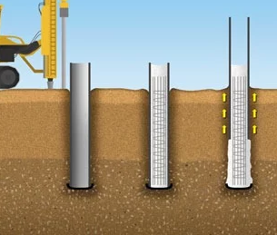
I recommend that Pile foundation will be best suited for this site as we will be building on sand. Piled foundation is designed to transfer loads through weak soils onto stronger more stable and stiffer soil or rock at a deeper depth. This will then increase the effective size of the buildings foundation and will resist the horizontal loads.as concrete is weak in tension, reinforced steel in the concrete will help its durability and strength.

‘Piles are constructed by drilling holes in the ground to the required depth and then filling the hole with concrete. Reinforcements are also used in the concrete as per the requirements.’ Misher, G. (2019). Types of Pile Foundations Based on Construction Method. [online] The Constructor. Available at: https://theconstructor.org/geotechnical/types-of-piles-based-on-construction-method/10707/ [Accessed 12 Dec. 2019].
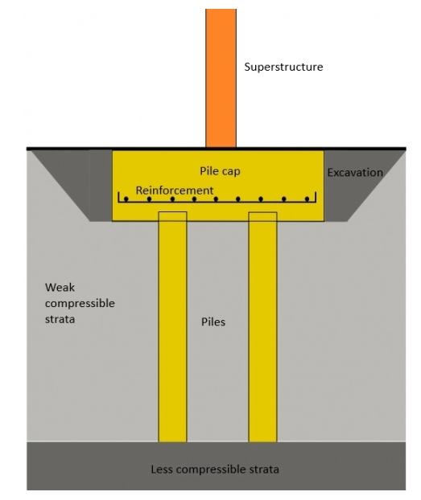
There is a lot of time and cost that go into the making of a pile foundation. Firstly, the concrete is poured down a cylinder tube via a pile machine. The machine pours the concrete down to a certain point where the soil is stronger and more compact. When the concrete has set the excavation of soil will begin. This allows the pile cap to sit above the concrete columns in the soil. The pile cap then carries the load of the building.

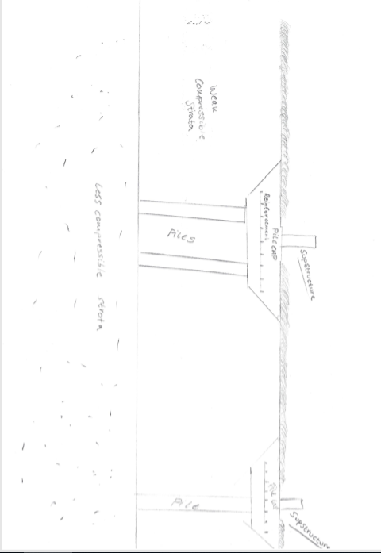
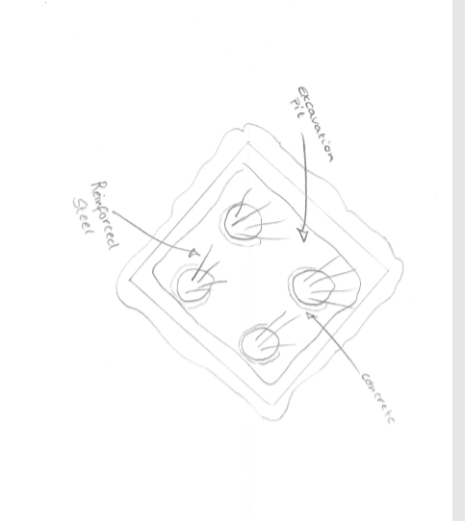

Assignment 1 construction reference page
Reference 1
‘The rare photos showing the final day of Swansea's iconic Mumbles train’
Dalling, R. (2019). The rare photos showing the final day of Swansea's iconic Mumbles train. [online] walesonline. Available at: https://www.walesonline.co.uk/lifestyle/nostalgia/rare-photos-showing-final-day-17003953 [Accessed 13 Dec. 2019].
https://www.walesonline.co.uk/lifestyle/nostalgia/rare-photos-showing-final-day-17003953

Reference 2
Remembering the Swansea Blitz That Destroyed 11,000 Buildings and Left 230 People Dead
Associates, J. (2019). Plate Bearing Test | Southern Testing. [online] Southern Testing. Available at: https://www.southerntesting.co.uk/services/ground-site-investigation-consultants/plate-bearing-test/ [Accessed 13 Dec. 2019]. Plate load
https://www.warhistoryonline.com/war-articles/remembering-the-swansea-blitz.html

Reference 3
‘Suspected World War II bomb is found at Briton Ferry recycling centre’
walesonline. (2019). Suspected World War II bomb is found at Briton Ferry recycling centre. [online] Available at: https://www.walesonline.co.uk/news/wales-news/live-updates-suspected-world-war-15546653 [Accessed 13 Dec. 2019].
https://www.walesonline.co.uk/news/wales-news/live-updates-suspected-world-war-15546653

Reference 4
‘Boring methods are widely used for subsurface investigations to collect samples, in almost all types of soil, for visual inspection or laboratory testing’.
The Constructor. (2019). Boring Methods for Soil Sampling for Soil Investigation. [online] Available at: https://theconstructor.org/geotechnical/boring-methods-soil-sampling/31869/ [Accessed 12 Dec. 2019]
https://theconstructor.org/geotechnical/boring-methods-soil-sampling/31869/
Reference 5
‘Bedrock does not slide, shift or move’
Morris, T. (2019). What Soils Best Support Structures Such As Buildings. [online] HUNKER. Available at: https://www.hunker.com/12415148/what-soils-best-support-structures-such-as-buildings [Accessed 12 Dec. 2019].
https://www.hunker.com › what-soils-best-support-structures-such-as-buildings
Reference 6
‘Decrease the abrasion resistance and strength of the concrete, while increasing the tendency for dusting and cracking to develop. The key to preventing damage to the concrete surface by a rainstorm is proper preparation and timing’
Writer, S. (2012). [online] Etc-web.com. Available at: http://www.etc-web.com/pouring-concrete-vs-pouring-rain/ [Accessed 12 Dec. 2019].
www.etc-web.com › pouring-concrete-vs-pouring-rain
Reference 7
‘Where natural and undisturbed soils have largely been replaced by man-made or artificial materials. It may be composed of a variety of materials including imported natural soils and rocks with or without residues of industrial processes (such as ash) or demolition concrete (such as crushed brick or concrete)’
Designingbuildings.co.uk. (2019). Made ground. [online] Available at: https://www.designingbuildings.co.uk/wiki/Made_ground [Accessed 12 Dec. 2019].
https://www.designingbuildings.co.uk/wiki/Made_ground
Reference 8
‘Facility search, lock-down, or evacuation is not necessary unless the item is determined to be suspicious’
Department of Homeland Security. (2019). What to Do - Bomb Threat. [online] Available at: https://www.dhs.gov/what-to-do-bomb-threat [Accessed 12 Dec. 2019].
https://www.dhs.gov/what-to-do-bomb-threat
Reference 9
‘These piles are constructed by drilling holes in the ground to the required depth and then filling the hole with concrete. Reinforcements are also used in the concrete as per the requirements’
Misher, G. (2019). Types of Pile Foundations Based on Construction Method. [online] The Constructor. Available at: https://theconstructor.org/geotechnical/types-of-piles-based-on-construction-method/10707/ [Accessed 12 Dec. 2019].
https://theconstructor.org/geotechnical/types-of-piles-based-on-construction-method/10707/

