Resource pack to support elements of effective
classroom management

At the start of every lesson:
-Make sure you have all the equipment you need– pen/pencil/ruler
-Collect your book
-Write down the date, Gwaith Dosbarth and copy the title from the board. See how many different words you can make using the letters from the title.
-Pen down, facing the front ready to learn
In today’s lesson all pupils…
MUST:
Learning objective 1 ________________________________________________
SHOULD:
Learning objective 2 ________________________________________________
COULD:
Learning objective 3 _____________________________________________

_________________________________________________________

_________________________________________________________

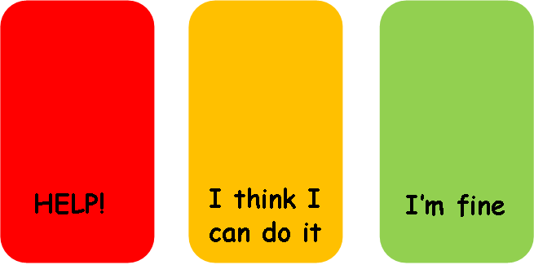

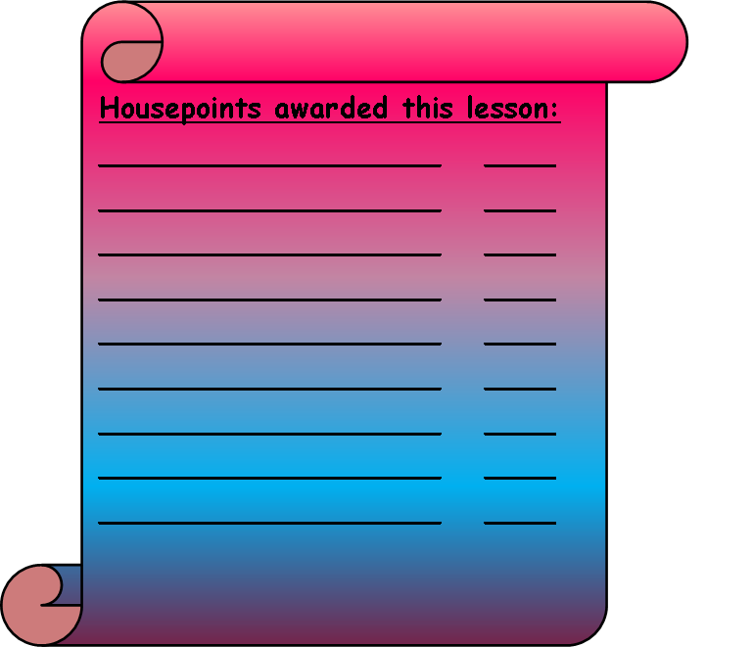

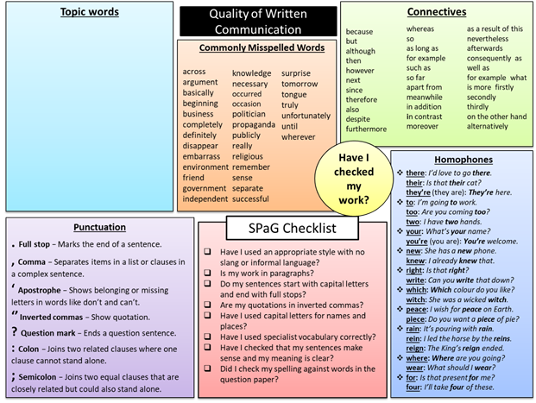

These resources are to be used in a mainstream year 8 mixed ability class. But can be adapted for any mainstream class.
- Lesson routines- Clearly displayed on the board at the front of the class, the pupils know what they need to do when they first enter the classroom. This also sets the starter task, meaning the pupils will quickly get settled and will be busy while the teacher gets organised and does the register etc.
- Lesson Objective- Displayed on the board at the front of the class. This will enable pupils to understand exactly what they are learning about each lesson and what is expected of them to have learned by the end of the lesson. This can be added to and wiped off at the end of the lesson to reuse.
- Housepoint award list-This is displayed at the front of the classroom, every time the pupil receives housepoints for achieving a good standard of work or behaviour then their name and the amount of points awarded can be written here, at the end of the lesson the teacher can use this to input the points onto the system. If the pupil has had an exceptionally good lesson, then a postcard can be sent home from the teacher to inform parents/carers of their achievement.
- Traffic light cards- Each pupil has a set of traffic light cards on the desk. These are to be used during every lesson to enable the teacher to gauge the understanding of a task. Pupils can display the appropriate card according to how they are finding the task. Red if they are struggling and need support, amber if they are managing but slightly unsure and green is if they are working well and understand what to do. This will enable the teacher and TA to provide appropriate levels of support where is needed.
- Literacy spelling and grammar placemat- Laminated and is placed on each desk to improve literacy during writing tasks. Specific topic key words can be added using a dry wipe marker pen.

Resource pack to support elements of effective
classroom management- Rationale

Having a well-organised classroom and structure to each lesson is essential in keeping a calm and positive environment for learning. There are several things that need to be taken into consideration when managing a class. There will often be a variety of different abilities, some lessons will need to be differentiated for some pupils. Behaviour between pupils can vary and preparing for the lesson in advance can help to prevent any unwanted behaviour which can be displayed due to boredom or lack of understanding. This rationale aims to explore the different classroom management strategies available and what may work better than others. The resource pack that this is based on have been produced to support with learning, and in turn should improve the behaviour in the classroom overall.
The resources that are included in this pack have been designed to provide clarity and understanding of boundaries within the classroom whilst also providing clear rewards for positive behaviour. Sometimes a lack in confidence can result in the pupil being too scared to put their hand up and ask for help, they will sit and struggle with the task discreetly or sometimes will start to become bored and restless and begin disrupting the rest of the class.
The traffic light cards included are a simple design which are given to each pupil on entry to the classroom, and they are all aware that they can display which colour they feel is appropriate for them without drawing any attention to themselves. By simply displaying a red card in front of them on their desk, they are making the teacher aware that they are struggling and need some extra help. It is then that the learning support assistant may sit with the child, break down the task into manageable chunks to help them understand. If a child is displaying an amber coloured card, the teacher may just be able to offer the pupil some prompts or answer a couple of questions to put them onto the right track. For the pupils displaying the green card, they should be getting on with the task unaided.
At the start of each lesson, the pupils are expected to collect their books, equipment, and everything they need before they sit down. These expectations are clearly displayed at the front of the classroom which the pupils are all aware of.
According to Strange, Tucker and Hindman (2004) , Classroom management and organization are intertwined. While rules and routines influence student behaviour, classroom organization affects the physical elements of the classroom, making it a more productive environment for its users. How the classroom environment is organized influences the behaviour in it.
In the resource pack, is a housepoints awards board which can be displayed on the whiteboard at the front of the classroom. It can be laminated, and the teacher can add to it each lesson with a marker pen, these names can then be recorded onto the system. If a pupil has done exceptionally well, the teacher can choose to send a post card home to parents to inform them of the child’s achievement, this reward reinforces positive behaviour and is an incentive to the other pupils to achieve the same. BH Skinners theory of operant conditioning outlined that behaviour is determined by consequences. In skinners theory, one of the aspects important to human behaviour, though, is the feelings associated with behaviour that is controlled by conditioning. When previous behaviours have been rewarded, children are likely to repeat those behaviours happily and willingly, feeling that they are doing what they 'want' to be doing. (Grace, 2019).
In the resource pack, there is an awards chart for housepoints, these get rewarded to pupils who display positive behaviour or good classwork, it has been shown to be more effective to focus on positive behaviour and ignore the negative. Some teachers are guilty of singling a child out when they display negative or disruptive behaviour however, this usually results in the child’s behaviour worsening and focuses all the teacher’s attention on the bad behaviour. It will also interrupt the education of the pupils who are behaving and wanting to learn. By focussing on the positive behaviour, it does not give the disruptive pupils the power to gain the attention of the whole class.
One of the resources also included in this pack is a lesson objectives poster, which is clearly displayed at the front of the class in view of every pupil. This is divided into three tasks, one that every pupil must do, one that the pupils should do and another which they could do. By setting the learning objectives into sections, this enables differentiation in this mixed ability class. Some of the pupils may just get the first task done, whereas some of the more able members of the class might go onto complete all three tasks. This will take the pressure off the pupils who are lower ability and will help them to feel comfortable going at their own pace. This can be linked to Piagets theory (1936) of cognitive development, a child must have developed and learned one thing before they can progress onto the next, this is an example of it as the first task is easy, and the second and third tasks in the lesson get progressively more difficult. The child will take charge of their own learning and work through each task as they are able to. This child centred approach used by Piaget and Vygotsky has proven to be successful in giving the pupils responsibility for their own learning. There is strong evidence to suggest that children are more emotionally invested when they take a more active role in their learning. Its been since the mid year 2000’s that teachers have gradually been discouraged from standing at the front of the class for long periods of time, instead its now encouraged as part of a lesson for pupils to take charge of their own learning, and form a partnership with the teacher by doing this. (wooley, 2018).
Lastly in this resource pack is a literacy spelling and grammar placemat, these are large, laminated cards placed on each desk and provides tips and help on literacy strategies for when the pupils are doing writing tasks. There is a blank box which, using a dry wipe marker the teacher can write down some key words specifically for what topic is being discussed. There are also examples of connectives, spelling and grammar checklist and some examples of different homophones on there. This will enable the pupils to carry out written tasks more independently and will develop their own literacy skills. Some pupils will prefer to have these literacy tips in front of them as a visual aid, however others may still prefer to ask for support and hear it rather than look at it visually. At the start of each lesson, the teacher puts the title on the board, once the pupils have copied it into their books, the starter task is to see how many different words they can come up with using the letters in the title. This is good to improve literacy skills also and gets their brains working and ready to learn. It encourages them to have some healthy competition as to who can come up with the most words, The pupil who can make the longest word will be rewarded housepoints and this is a great way to start each lesson. The pupils really enjoy it and it sets a positive mood for the lesson.
Part of classroom management is differentiation and realising that all pupils will have different learning styles, the lessons will run smoother once the teacher works out what learning styles work better for certain pupils and adjusts the tasks accordingly. There is no “one size fits all” regarding classroom management, what might work for one class may not work for another. And what might work for a class one day, may no longer work for the same class the following week. Its all about being flexible in the approach to strategies that are used in the classroom and the lessons. Pupils will feel more valued and the teacher/student relationship will become stronger if they feel their needs are being met and successful learning is taking place. With lower ability classes, they usually prefer a visual way of learning so work more efficiently when they can work on sheets and get given a hard copy with instructions or pictures on.
Bandler and grinder developed the concept of visual, auditory, and kinaesthetic learners. Some pupils will learn better by seeing visual resources such as PowerPoint presentations or paper handouts, auditory learners are the pupils who will gain more knowledge from a class discussion, or when the teacher is stood at the front of the class discussing a topic. Kinaesthetic learners are the pupils who will generally perform and learn better by doing and experiencing things such as when the class visits a castle for a history lesson and gets to experience the place itself. Regarding classroom management, it’s much more effective to takes these learning styles and combine them all frequently. This makes the lesson more interesting and engaging for the pupils.

Bibliography

Bolton, G.(2010) Reflective Practice: Writing and Professional Development. (3rd Ed). London: Sage

Dalcour, J.(2009) What Is a Child-Centered Constructivist Approach to Early Childhood Education? Available at: https://classroom.synonym.com/childcentered-approach-early-childhood-education-8614207.html Accessed 18/07/20]
Ghaye, T. (2010) Teaching and Learning through Reflective Practice: A practical Guide for Positive Action.London: Routledge.
Grace, E. (2019). B.F. Skinner's Behavioural Theory. Available at: http://www.kidsdevelopment.co.uk/bfskinnersbehaviouraltheory.html [Accessed 2/8/20]
Sutton Trust Report. Available at: https://www.suttontrust.com/wp-content/uploads/2014/10/What-Makes-Great-Teaching-REPORT.pdf [Accessed 2/8/20]
Personel Today (2013). Changing behaviour with neuro-linguistic programming. Available at: https://www.personneltoday.com/hr/changing-behaviour-with-neuro-linguistic-programming/ [Accessed 29/7/20]
Spelling and Grammar placemat resource. Available at: https://www.tes.com/teaching-resource/spelling-punctuation-and-grammar-spag-placemat-6317103 [Accessed 29/7/20]

Stronge, J.H, Tucker. P, Hindman, J L. Handbook for Qualities of Effective Teachers.

Zwordiak- Myers, P. (2012) The teachers Reflective Practice Handbook.London

