Trinity Saint David University of Wales
Introduction to Web and Database Concepts (ACCA4023)

Author: | Tutor:
Chris Hampton | Gareth Jones
2116517@student.uwstd.ac.uk | gareth.jones@uwtsd.ac.uk

03/05/2022

Contents
Table of Figures 2
Introduction 4
Abstract 4
Requirements 4
Implementation 4
Website Planning 4
Initial Design 4
Validation 9
Evaluation 9
Usability 9
Accessibility 11
Perceivable 11
Operable 12
Understandable 12
Robust 12
Search Engine Optimisation 13
Conclusion 14
References 15
Appendix 16

Table of Figures
Figure 1 - Basic Design Layout 4
Figure 2 - Design Layout Further pages 5
Figure 3 - File Structure 6
Figure 4 - Mobile Version of Landing Page 7
Figure 5 - Desktop Landing Page 7
Figure 6 - Example of Further Pages – Desktop Version 7
Figure 7 - Example of Further Pages - Mobile Version 8
Figure 8 - Bootstrap incorporation 8
Figure 9 - Initial Errors from HTML Validator 9
Figure 10 - Error Presented in Code 9
Figure 11 - Error Resolved 9
Figure 12 - Initial Errors from HTML Validator 9
Figure 13 - Initial Error from HTML Validator 9
Figure 14 - Error Resolved 9
Figure 15 - Errors Resolved from HTML Validator 9
Figure 16 - No CSS Errors present 9
Figure 17 - Jump to Dropdown Subpages 10
Figure 18 - Jump to Dropdown 10
Figure 19 - Image Selected 11
Figure 20 - Next Image Selected 11
Figure 21 - Image without alt text 11
Figure 22 - axe linter error 11
Figure 23 - Colour Contrast Ratio 12
Figure 24 - Language Meta 12
Figure 25 - Example of SEO in the project 13
Figure 26 - Interest of Time: source link 13

Introduction

Abstract
This report contains details of a hand-coded website that illustrates a personal hobby. The report can guide the reader to understand the implementation of the code and the process that was undertaken to arrive at the conclusions and decisions made during the development process.

Requirements
The website illustrates the hobby of travelling, explicitly showing images of various places that have been visited. The purpose of the website is to show the user various areas that can be visited. The intended audience is for anyone that wants inspiration of where to go or to travel to for their next holiday. The website is easy to navigate and self-explanatory to enable to user to extract the full user experience with a simple user interface.

Implementation

Website Planning

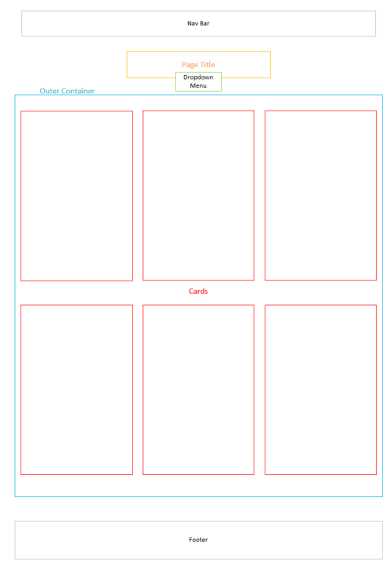
Initial Design
Figure 1 - Basic Design Layout
The basic design layout shows a high-level design layout of what the website landing page will look like.
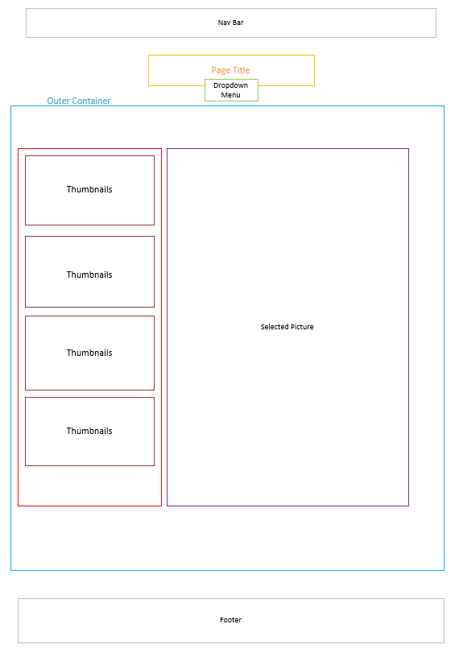
This is a high-level design of what the additional pages will look like. This will be used as a template for each subpage within the website entirety. The use of similar layouts will familiarise the use with the website and allow the user to navigate without further knowledge.
Figure 2 - Design Layout Further pages

Web Page
The website and folder structure will follow a uniform approach. This will allow further developments to be implemented at a more substantial pace with the descriptive and semantic approach taken.
Each section as been implemented with descriptive folder names, clearly showing which scripts are external, i.e., from open-source projects, and internal scripts that have been hand-coded by the author.
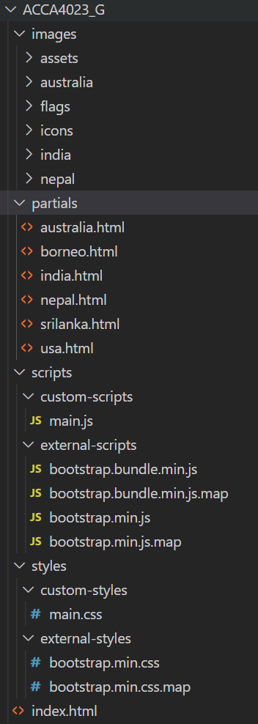
Figure 3 - File Structure

These following figures show the website once completed – showing the similarities between the initial design layout and the final product.
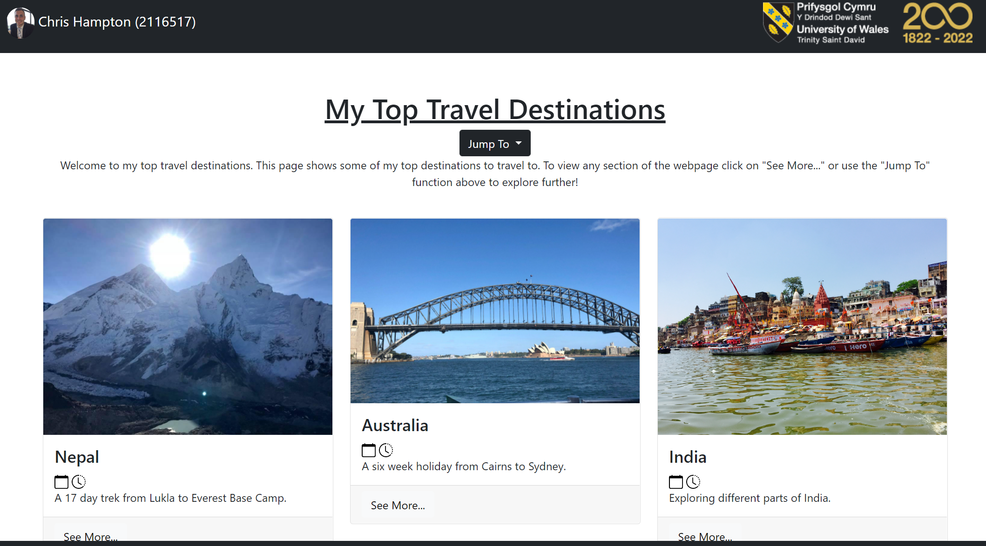

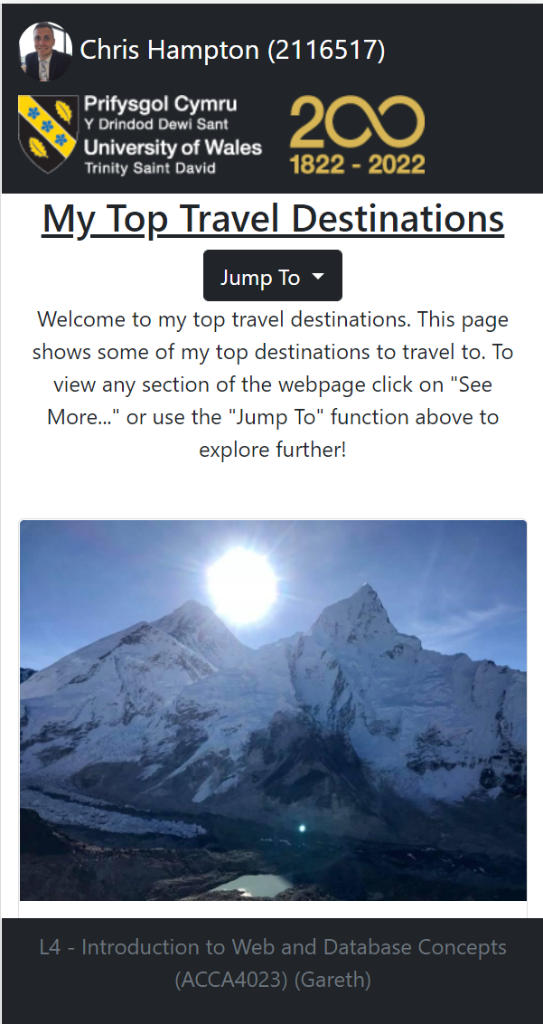
Figure 5 - Desktop Landing Page
Figure 4 - Mobile Version of Landing Page

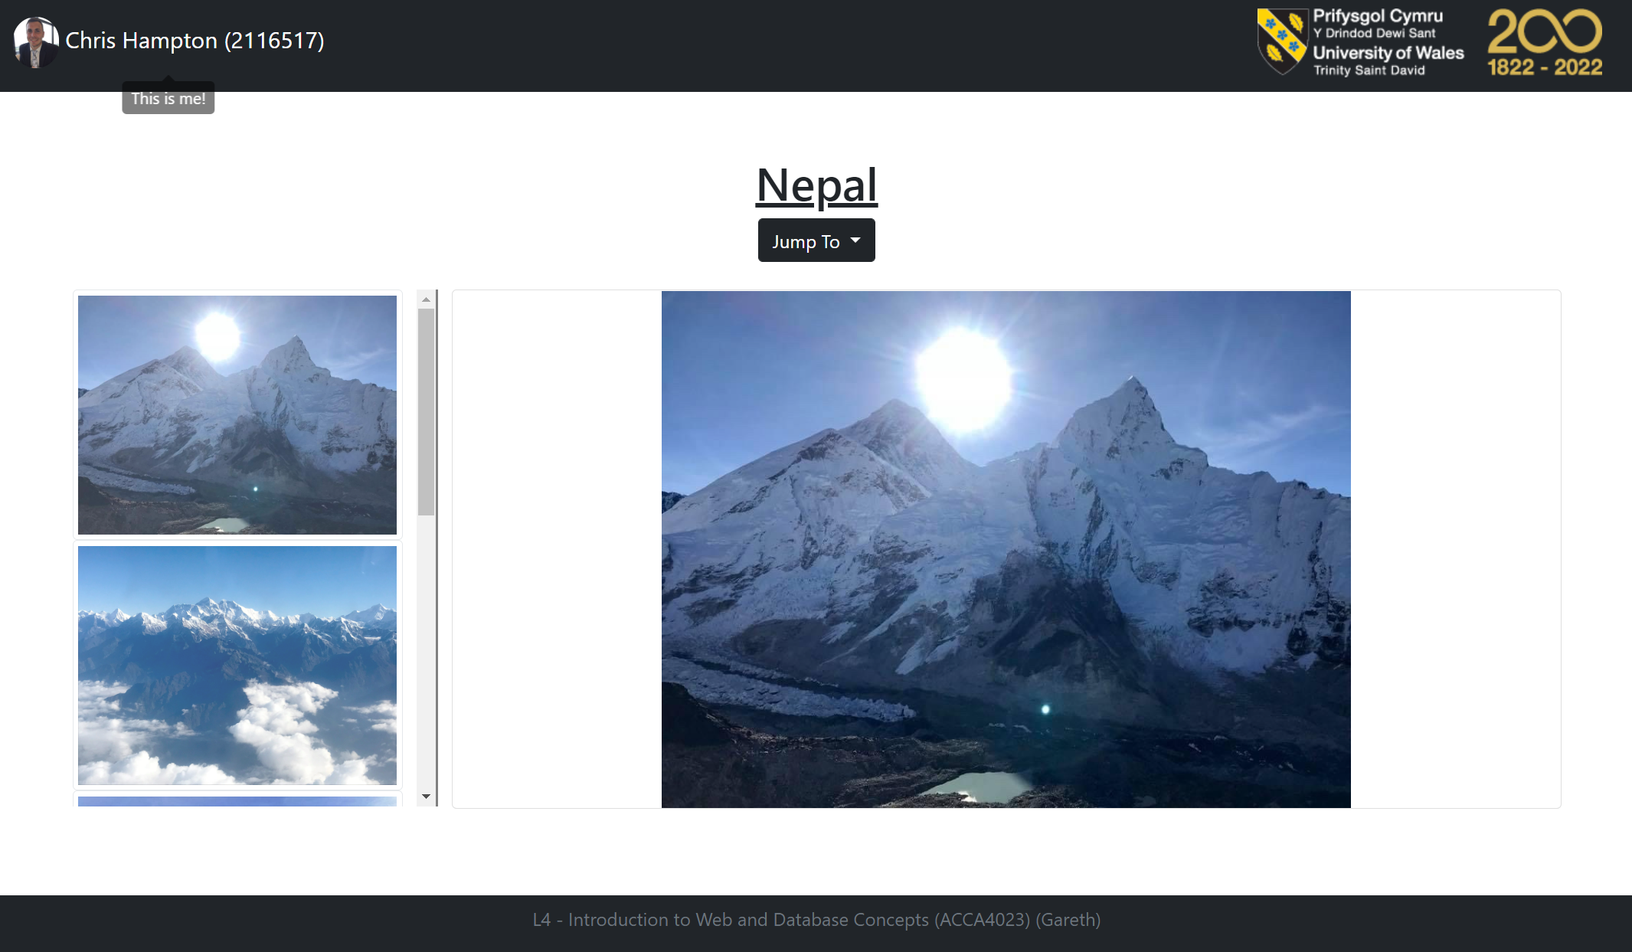
Figure 6 - Example of Further Pages – Desktop Version
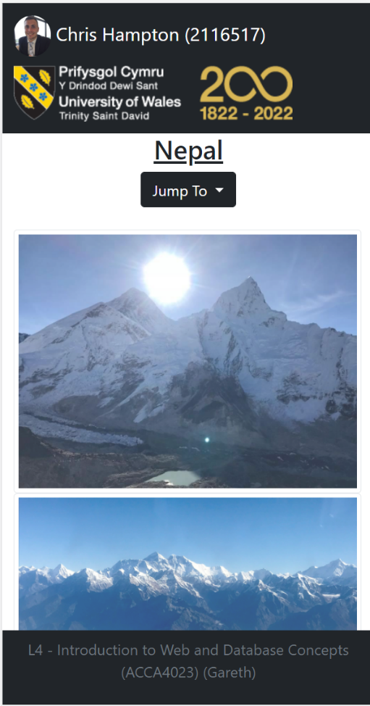
To ensure that the layout is appropriate for whatever device the user is using the project employs a framework called Bootstrap.
Figure 7 - Example of Further Pages - Mobile Version

Bootstrap
Bootstrap is an open-source development framework to apply to web development that ensures responsive and dynamic webpages by using templates derived from its source code. The use of bootstrap in this project allows quick development whilst maintaining the frameworks standards across the product life cycle.
To incorporate bootstrap into the project the following code snippet has been applied to ensure that elements of the framework are available to the project. [1]
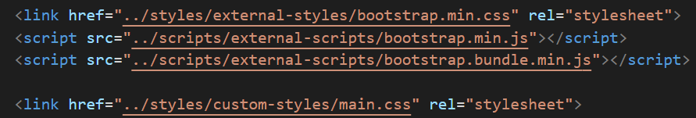
Figure 8 - Bootstrap incorporation
By deploying Bootstrap, the webpages are responsive and flexible to ensure that all elements are scaled to the device used.

Validation

The use of validators in web development helps the developer to understand semantics of the languages they are using. Ensuring that their code is compliant with web standards [2] [3].
These figures below show the use of the validator and the corrections made to ensure that the code is sufficient.
Figure 9 - Initial Errors from HTML Validator
Figure 10 - Error Presented in Code
Figure 11 - Error Resolved
Figure 12 - Initial Errors from HTML Validator
Figure 13 - Initial Error from HTML Validator
Figure 14 - Error Resolved
Figure 15 - Errors Resolved from HTML Validator
Figure 16 - No CSS Errors present

Evaluation

Usability
The usability of a website often determines its success. By designing and creating a website that is user friendly and easy to navigate will ensure the user will return, whilst gaining more views to the webpage [4]. The study referenced concluded that the website had poor usability. This was determined by user tests and referenced the output as ‘clickability’ within the website. This is where the user made more clicks to access the information that was determined necessary by human behaviour. By reducing the amounts of clicks needed to navigate the website in this project will keep the user engaged and spend more time browsing.
The end goal of most website creators is to drive traffic to the webpage. This can be for monetary reasons or providing a service to ensure there is visibility of the topic that is presented by the webpage.
To allow the user to navigate the website with ease a simple and straight forward approach has been taken.
Some examples of the usability include:
- The “Jump To” dropdown allows the user to navigate to pages that they are interested in. the use of flags will give the user a colourful and friendly indicator of what is available within the webpage. The dropdown function on the subpages has an additional ‘Home’ icon that the user can use to navigate back to the homepage.
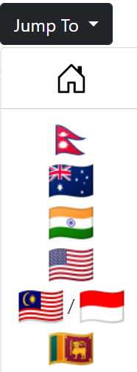
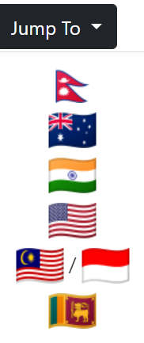
Figure 17 - Jump to Dropdown Subpages
Figure 18 - Jump to Dropdown

The flags have been procured from an open-source resource [5] with a free licence to use for non-commercial reasons.

- Hovering over the icons  will show the user some information regarding the trip that was taken. For the calendar icon it will show the date in which the trip was taken. To clock will show the duration of the trip.

- The figures below show how the user can select a image in the thumbnail bar on the left to display that particular image in the viewing pane on the right.

Figure 19 - Image Selected
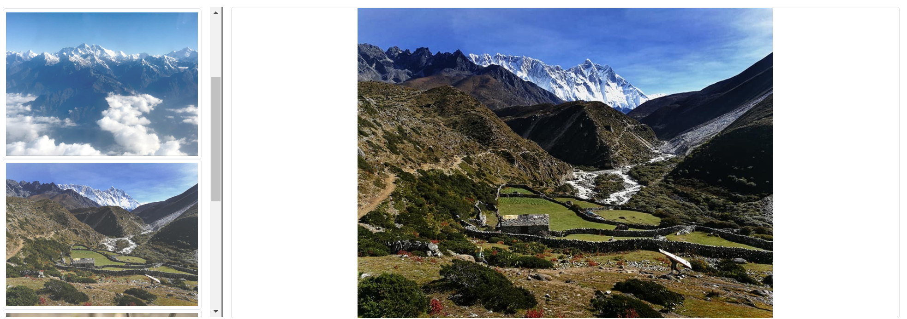
Figure 20 - Next Image Selected
- As with figures 5-8 above it shows the usability of the webpage in desktop format and mobile format. This will allow the user to have a greater experience which ever device they use.
Further recommendations for the website could include more detailed descriptions on where the images were taken and give the user more information regarding the trip details.

Accessibility
Accessibility to websites is based on the Web Content Accessibility (WCAG 2.1) – these are recommendations for improving web access at an international standard. The WCAG 2.1 is based on 4 principles. These are Perceivable, Operable, Understandable and Robustness. [6]

Perceivable
The first principle of perceivable is to ensure that the user can recognise aspects of the webpage using the senses that the user has available to them. Using the “aXe: The Accessibility Engine” extension in Visual Studio Code I was able to identify errors and apply a fix to them. For example, the linter picked up that an image has no ‘alt’ tag to give the image alternative text.
Figure 21 - Image without alt text
Figure 22 - axe linter error
In conjunction with the HTML validator discussed above, I was able to fix the issues so that it meets this requirement.

Contrast Ratio [6]
By using a colour contrast tool, I can test the ratio of the colour that is used in the styling. This will allow the user to view to content more easily without having to strain their eyesight. I have a applied a neutral background, as shown below, to all pages to ensure this consistency is available through the interaction with the webpage.
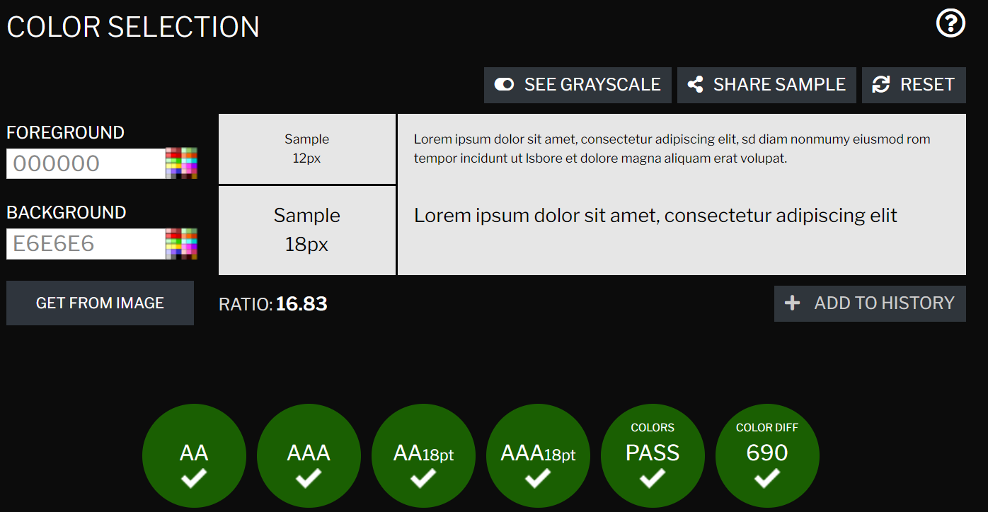
Figure 23 - Colour Contrast Ratio

Operable
The second principle of operable defines that the webpage is easy to understand and navigate. Ensuring that any links that are clicked informs the user of where they are being directed to.
In this project, whenever a user hovers over a link a tooltip is displayed to ensure the user knows where the link will take them.

Understandable
To ensure the understandability of the webpage certain aspects need to be taken into consideration. For example, ensuring that spelling and grammar is correct, and that sentence are short and make sense.
Within the head of the webpage the language is defined so that the browser is able to interpret the language used within the website.
Figure 24 - Language Meta

Robust
To ensure robustness of the webpage semantic HTML has been used to ensure that assistive technologies can perform appropriately. For example, in the project code each page uses header and footer tags and ensuring that the content is held within section tags.

Search Engine Optimisation
Search Engine Optimisation, or SEO, is the term used in which internet search engines can present the search results from a user based on the content within the website. A large portion on the population use the internet and in particular search engines, such as google, to find the relevant information they want to view.
Often, successfully SEO is pertinent to the website design and how the search engine can index and read the webpage to return the URL in the top results when a user is searching on key words. [7]
In the example below, taken from the index.html page of the project, the use of ‘meta’ tags is utilised to ensure that key information is delivered to the search engine to determine the relevance of the information.
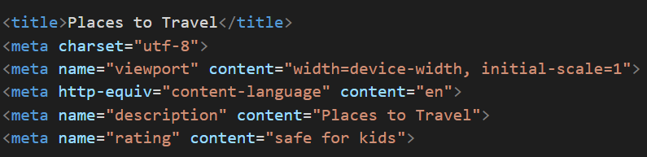
Figure 25 - Example of SEO in the project
In the figure above the meta tags can give relevance to the search. For example, the rating is described as “safe for kids”. This will allow this page to be presented to users that are age appropriate, in this case all ages, to return in the results. [8]
Also, the title and meta description has keys words that can be assist the search engine to show relevant pages to the user. [9]
Below is an example of the interest in the term ‘travel’. This shows the interest of UK users over a five-year period.

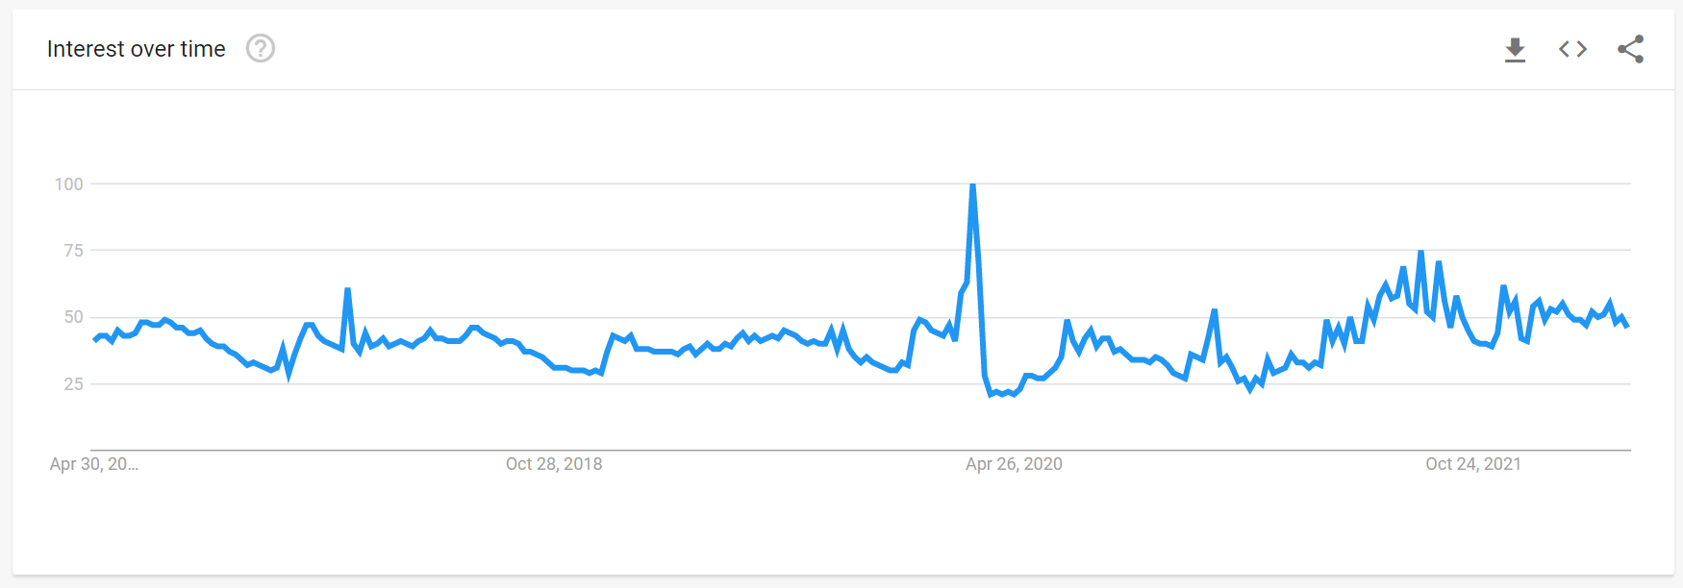
Figure 26 - Interest of Time: source link

Conclusion
In conclusion, this project has allowed the potential in overcoming the modern-day problems with web development. Ensuring that the webpage is of a high standard and matches the requirements needed to design and code a webpage. To be able to utilise open source functions to create and deliver web development projects that always keeps the end user in focus and strive to make sure that the development life-cycle follows common practices and structures to maintain the integrity of multiple dimensions of the internet.

References

[1] | https://getbootstrap.com/, “Introduction · Bootstrap v5.0,” [Online]. Available: https://getbootstrap.com/docs/5.0/getting-started/introduction/. [Accessed April 2022].
[2] | w3, “Markup Validation Service,” [Online]. [Accessed April 2022].
[3] | w3, “Why Validate,” w3, [Online]. Available: https://validator.w3.org/docs/why.html. [Accessed April 2022].
[4] | A. &. O. J. &. H. S. Almansour, “Website Usability, Case Study: Shura System.,” International Journal of Academic Scientific Research, vol. 3, 2015.
[5] | flagpedia.net, “flagpedia.net,” [Online]. Available: https://flagpedia.net/index. [Accessed April 2022].
[6] | U. Governement, “Understanding WCAG,” [Online]. Available: https://www.gov.uk/service-manual/helping-people-to-use-your-service/understanding-wcag. [Accessed April 2022].
[7] | D. &. H. M. &. R. S. Ghulam, “ On-Page Search Engine Optimization (SEO) Techniques Model: A Use Case Scenario of a Business Entity Website.,” 2017.
[8] | Google, “SEO Guide for Web Developers,” [Online]. Available: https://developers.google.com/search/docs/advanced/guidelines/get-started-developers. [Accessed 2022 April].
[9] | Google, “How to Wrtie Meta Descriptioons,” [Online]. Available: https://developers.google.com/search/docs/advanced/appearance/snippet#meta-descriptions. [Accessed April 2022].
[10] | w3schools, “W3Schools Online Web Tutorials,” [Online]. Available: https://www.w3schools.com/. [Accessed April 2022].

