Qualification: CIPD Diploma in Applied Human Resources

Module Name: 5ARTP

Contributing to Resourcing and Talent Planning

Word Count (excluding LO headings):
LO1: 1,061
LO2: 705
LO3: 846
Total: 2,612

Student Name: Sharon Richards
Student Number: 2014447
CIPD Membership Number: 57493181

By signing below, I confirm that the work/evidence presented is my own, unaided work. I understand the regulations pertaining to candidate malpractice and the action that may be taken as a result.

Signed: 

Date: 2022

Contents Page

Evidence Matrix 1
Personal Statement for Learning Objective 1 3
Reference List for Learning Objective 1 6
Evidence for Learning Objective 1 7
Personal Statement for Learning Objective 2 14
Reference List for Learning Objective 2 16
Evidence for Learning Objective 2 17
Personal Statement for Learning Objective 3 22
Reference List for Learning Objective 3 24
Evidence for Learning Objective 3 25

Candidate name: Sharon Richards |  |  |  |  | CIPD Membership/registration No.:  57493181
Qualification title: CIPD Level 5 Diploma in Applied Human Resources |  |  |  |  | Unique Learner No. (ULN): 2014447
Unit code | Unit title |  | Assessment criteria no. | Evidence description | Evidence reference number |  | Assessor  initials | I/V initials if sampled
5ARTP | Contributing to Resourcing and Talent Planning |  | 1.1 | Extract from Workforce, Organisational Development & Education Strategy 2020-2030 | 1.1
5ARTP | Contributing to Resourcing and Talent Planning |  | 1.1 | Extract from Workforce Technical document for IMTP 2022-25 | 1.2
5ARTP | Contributing to Resourcing and Talent Planning |  | 1.1 | Key outcomes for success | 1.3
5ARTP | Contributing to Resourcing and Talent Planning |  | 1.1 | Workforce Planning and Transformation Team Structure | 1.4
5ARTP | Contributing to Resourcing and Talent Planning |  | 1.1 | Regeneration Framework | 1.5
5ARTP | Contributing to Resourcing and Talent Planning |  | 1.1 | Notes of meeting with Head of Workforce Planning and Transformation | 1.13
5ARTP | Contributing to Resourcing and Talent Planning |  | 1.2 | Assessment of workforce gap statement from Workforce Technical document for IMTP 2022-25 | 1.6
5ARTP | Contributing to Resourcing and Talent Planning |  | 1.3 | Extract from Workforce Strategy on being an employer of choice | 1.7
5ARTP | Contributing to Resourcing and Talent Planning |  | 1.3, 3.1 | Recruitment Planning Objective ‘Plan on a page’ | 1.8
5ARTP | Contributing to Resourcing and Talent Planning |  | 1.3 | Focus groups evidence | 1.9
5ARTP | Contributing to Resourcing and Talent Planning |  | 1.3 | Job Description research | 1.10
5ARTP | Contributing to Resourcing and Talent Planning |  | 1.3 | Slides showing good practice suggestions | 1.11
5ARTP | Contributing to Resourcing and Talent Planning |  | 1.3 | Email expressing concerns about quality of job descriptions | 1.12
5ARTP | Contributing to Resourcing and Talent Planning |  | 2 | Job description template | 2.1
5ARTP | Contributing to Resourcing and Talent Planning |  | 2 | Communication regarding lack of information on Job Descriptions | 2.2
5ARTP | Contributing to Resourcing and Talent Planning |  | 2 | Evidence of discriminatory language | 2.3
5ARTP | Contributing to Resourcing and Talent Planning |  | 3.4 | Email correspondence with All Wales JE Lead | 3.1
5ARTP | Contributing to Resourcing and Talent Planning |  | 3.4 | Email correspondence with Staff Side JE Lead | 3.2
5ARTP | Contributing to Resourcing and Talent Planning |  | 3.4 | Email correspondence with other NHS JE Leads | 3.3
5ARTP | Contributing to Resourcing and Talent Planning |  | 3.4 | Research undertaken on Manager guides | 3.4
5ARTP | Contributing to Resourcing and Talent Planning |  | 3.4 | Slide from presentation to WOD Strategic Group on 5th May 2022 | 3.5
5ARTP | Contributing to Resourcing and Talent Planning |  | 3.5 | Communication with line manager on action plan | 3.6
5ARTP | Contributing to Resourcing and Talent Planning |  | 3.5 | Draft structure of Manager’s Guide | 3.7
Candidate declaration:
- I confirm that the work/evidence presented for assessment is my own unaided work.
- I have read the assessment regulations and understand that if I am found to have ‘copied’ from published work without acknowledgement, or from other candidate’s work, this may be regarded as plagiarism which is an offence against the assessment regulations and leads to failure in the relevant unit and formal disciplinary action.
- I agree to this work being subjected to scrutiny by textual analysis software if required.
- I understand that my work may be used for future academic/quality assurance purposes in accordance with the provisions of the Data Protection Act 1998.
- I understand that the work/evidence submitted for assessment may not be returned to me and that I have retained a copy for my records.
- I understand that until such time as the assessment grade has been ratified through internal and external quality assurance processes it is not final.
Signature: |  |  |  |  |  | Date: | 2022

Learning Objective 1

Be able to review and evaluate an organisation’s approach to talent planning

1.1 Assess how and to what extent the organisation undertakes workforce and talent planning

To enable the delivery of the Health and Care Strategy A Healthier Mid and West Wales (Hywel Dda UHB, 2020), Hywel Dda University Health Board (HDdUHB) recognised and set out its obligations to workforce and talent planning in its Workforce, Organisational Development & Education Strategy 2020 – 2030 (HDdUHB, 2019) (Evidence 1.1). Workforce Planning is one of four key programmes of work that that will enable the delivery of the Health and Care Strategy, along with Education and Development, Resourcing and Apprenticeships (HDdUHB, 2022a) (Evidence 1.2).

Whilst the Strategy initially described workforce planning as being supported via a Business Partner model (Evidence 1.3), a new dedicated Workforce Planning team was established during 2021 to lead on the strategic workforce planning and transformation (Evidence 1.4).

HDdUHB’s approach to workforce planning is evolving as work has started to embed workforce activities within service planning activities. Workforce planning activities focus on supply and demand (CIPD, 2021a, p1), acknowledging that there are known gaps and risks within our future workforce.

HDdUHB have adopted a 6-step Regeneration Workforce Planning Framework (Evidence 1.5) which considers:
- Resource and replenish (Buy) – internal and external recruitment
- Redevelop and reskill (Build) – developing existing staff
- Reposition and renew (Borrow) – temporary staffing
- Retain and reward (Bind) – recognising and rewarding talent
- Resolve and revive (Bounce) – accessing advice and support and working in partnership
- Rediscover and reinvent (Boost) – collaboration and innovation

I met with the Head of Workforce Planning and Transformation to discuss how the Regeneration Framework would be taken forward by the Health Board (Evidence 1.13). Whilst some of the elements in the Regeneration Framework clearly align with Health Board functions / teams, others require a much wider discussion across the Health Board and with our partners.

In terms of the ‘Borrow’ element the Health Board need to consider what processes or mechanisms it puts in place to enable people to move into other roles, within the Health Board and across our partners and what that means for integrated structures.

The ‘Boost’ element is linked to workforce redesign and digital solutions. The Health Board need to consider the impact of Artificial Intelligence on our workforce, particularly in terms of reduction or reskilling of staff.

A critical task for the Health Board is to fully implement the Regeneration Framework within our culture.

1.2 Analyse internal and external information relating to the organisation’s future people and skills needs and the availability of talent

A significant amount of work has been done over recent months to assess our future workforce gap. Already in a deficit position, without taking action the situation is likely to worsen (Evidence 1.6). Whilst there are gaps across most staff groups, unsurprising the most significant gaps and risk lies within clinical staff groups including nursing, medical and therapies (HDdUHB, 2022b, p6).

As of 31st January 2022, HDDUHB had a deficit of 989.3 whole time equivalent workers, 845.4 of the gap relates to clinical staff groups (HDdUHB, 2022b, pp19-20). This gap represents a critical workforce challenge an unsustainable position (HDdUHB, 2022b, p17).

Using the Population Pyramid for Wales (ONS, 2020), HDdUHB conclude that over the next 10 years it will experience an increase in retirements that will create a further gap due to the smaller population of younger entrants (HDdUHB, 2022b, p18).

As well as population changes impacting on the future supply of NHS workers, there is no doubt that the lasting impact of the pandemic will further exacerbate the gap, as more people leave the NHS. In their article for iNews, Saunders and Duggan (2022) cite a record number of medics leaving the NHS in 2021, with Collins (2022) referring in the HSJ to the record number of healthcare staff leaving the NHS as the The Great Resignation.

HDdUHB recognises that getting the right skill mix to enable the delivery of our future service model is a huge challenge and that both the pandemic and Brexit have impacted on our supply routes (HDdUHB, 2022b, p19).

Across the UK, the NHS is experiencing a critical shortfall of nursing staff (Holmes, 2021) and in response NHS England are turning to international recruitment to increase their nursing workforce (NHS England, n.d.). HDdUHB has recognised international recruitment as a potential route to increasing its workforce and so has recently explored options (Hywel Dda UHB, 2022c, p2) with the first cohort of international nurses expected to arrive within the next month.

  - Assess the extent to which the current organisational planning activities are addressing potential needs

The remainder of this assignment will focus on step 1 of the Regeneration Framework – resource and replenish.

In the context of the Regeneration Workforce Planning Framework adopted by HDdUHB, the ‘Resource and Replenish’ step focuses on the recruitment of new or experienced individuals on a medium to long-term basis, either from the internal talent pool or external labour market.

In its Workforce Strategy, HDdUHB clearly sets out its ambition to be an employer of choice (Higgs, 2004) and acknowledges that recruiting and attracting people is crucial to the delivery of its Health and Care Strategy (Evidence 1.7). The CIPD (2021b, p1) define recruitment and resourcing as an end-to-end process which includes role definition, job analysis, development of a job description, candidate attraction, selection and appointment.

To deliver this ambition, one of our strategic planning objectives is to co-design how we recruit new staff to the organisation and set out how this will be achieved (Evidence 1.8). One of the key actions identified for this objective was to implement a revised job description and person specification by March 2022. Unfortunately, due to a number of factors, the work around this objective has been delayed (HDdUHB, 2022c, p9).

Activities have taken place to date include:
- Feedback on current JD template sought at Focus Groups (Evidence 1.9)
- Research undertaken by a group of volunteer staff to identify examples of attractive JDs (Evidence 1.10)
- Quick desk top research undertaken on good practice when writing Job Descriptions/Person Specifications (JD/PS) (Evidence 1.11)

As well as implementing a JD/PS template that will attract candidates, the content of the JD/PS must also be sufficient to enable a robust assessment of the role banding in the NHS Job Evaluation scheme (NHS Employers, 2018). Feedback has been received from the organisation’s job matchers that many Job Descriptions are of poor quality and not in the required format to allow an assessment against the job evaluation criteria (Evidence 1.12).

In summary, the Health Board has clear ambitions to improve its resourcing process and whilst there has been some progress in terms of the objective around job descriptions and person specifications, further action is required to deliver any real benefit.

Reference List
CIPD (2021a) Workforce Planning. Available at Workforce Planning | Factsheets | CIPD. (Accessed: 1st May 2022)

CIPD (2021b) Recruitment: an introduction. Available at Recruitment Process Overview | Factsheets | CIPD. (Accessed: 1st May 2022)

Collins, A (2022) The Ward Round: The Great Resignation. Available at The Ward Round: The Great Resignation | Expert Briefing | Health Service Journal (hsj.co.uk). (Accessed: 1st May 2022)

Higgs, M (2004). ‘Future Trends in HRM’ cited in Taylor, S. and Woodhams, C. (2016) Managing People and Organisations, London, CIPD.

Holmes, J (2021) Brexit and the end of the transition period: what does it mean for the health and care system? Available at Brexit and the end of the transition period | The King's Fund (kingsfund.org.uk). (Accessed: 1st May 2022)

Hywel Dda University Health Board (2019) Workforce, Organisational Development &
Education Strategy 2020 – 2030. Internal document, unpublished.

Hywel Dda University Health Board (2020a) A Healthier Mid and West Wales. Available at https://hduhb.nhs.wales/about-us/healthier-mid-and-west-wales/healthier-mid-and-west-wales-folder/documents/a-healthier-mid-and-west-wales-strategy/. (Accessed: 1st May 2022)

Hywel Dda University Health Board (2022a) Workforce Technical document for IMTP 2022-25. Draft internal document, unpublished.

Hywel Dda University Health Board (2022b) Workforce Plan. Available at https://hduhb.nhs.wales/about-us/governance-arrangements/board-committees/people-organisational-development-and-culture-committee-podcc/people-organisational-development-and-culture-committee-meeting-4-april-2022/item-3-2-workforce-plan-incorporating-health-education-and-improve/. (Accessed: 1st May 2022)

Hywel Dda UHB (2022c) Planning Objective Update. Available at https://hduhb.nhs.wales/about-us/governance-arrangements/board-committees/people-organisational-development-and-culture-committee-podcc/people-organisational-development-and-culture-committee-meeting-4-april-2022/item-3-1-planning-objectives-update/. (Accessed: 1st May 2022)

NHS Employers (2018) NHS Job Evaluation Handbook. Available at NHS Job Evaluation Handbook | NHS Employers. (Accessed: 1st May 2022)

ONS (2020) National population projections: 2020-based interim. Available at National population projections - Office for National Statistics. (Accessed: 1st May 2022)

Saunders, T and Duggan, J (2022) Record numbers of NHS staff quit as frontline medics battle Covid pandemic trauma. Available at Record numbers of NHS staff quit as frontline medics battle Covid pandemic trauma (inews.co.uk). (Accessed: 1st May 2022)

Evidence List

Evidence 1.1 – Extract from Workforce, Organisational Development & Education Strategy
2020 – 2030

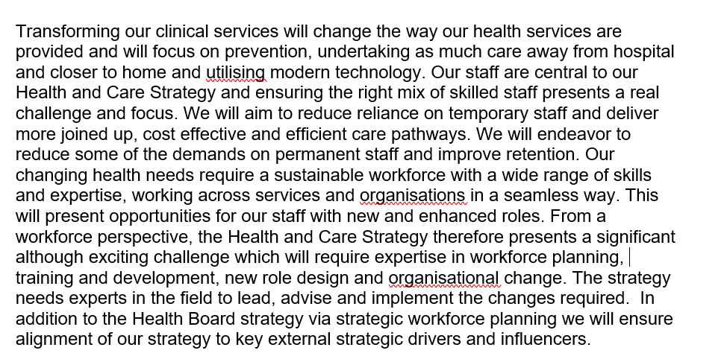

Evidence 1.2 – Extract from Workforce Technical document for IMTP 2022-25

Evidence 1.3 – Key outcomes for success

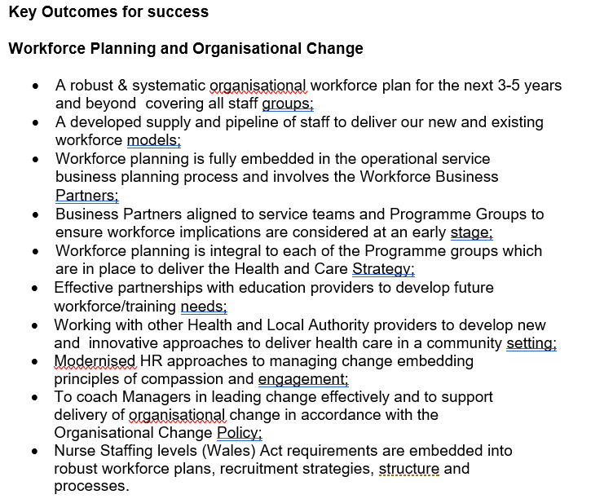
Evidence 1.4 – Workforce Planning and Transformation Team structure

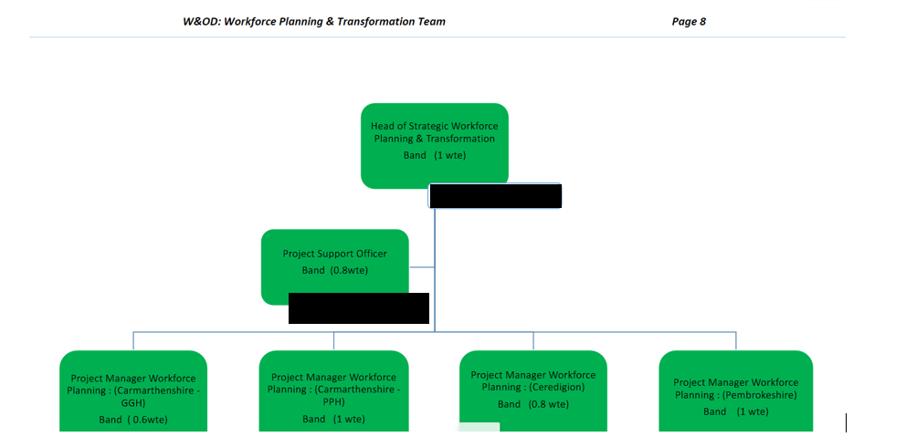

Evidence 1.5 – Regeneration Framework
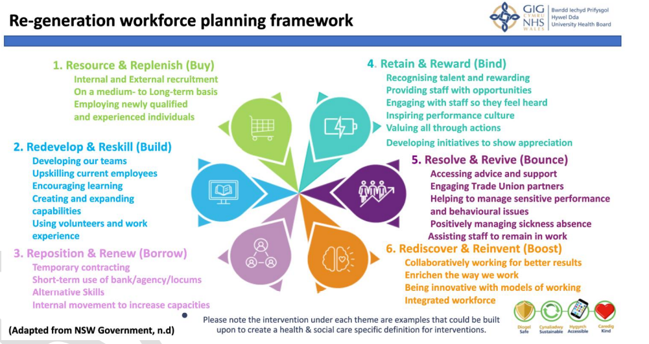

Evidence 1.6 – assessment of workforce gap statement from Workforce Technical document for IMTP 2022-25.

Evidence 1.7 – Extract from Workforce Strategy on being an employer of choice

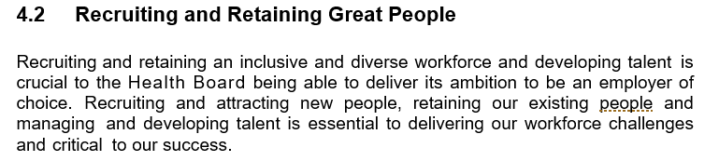

Evidence 1.8 – Recruitment Planning Objective ‘Plan on a Page’

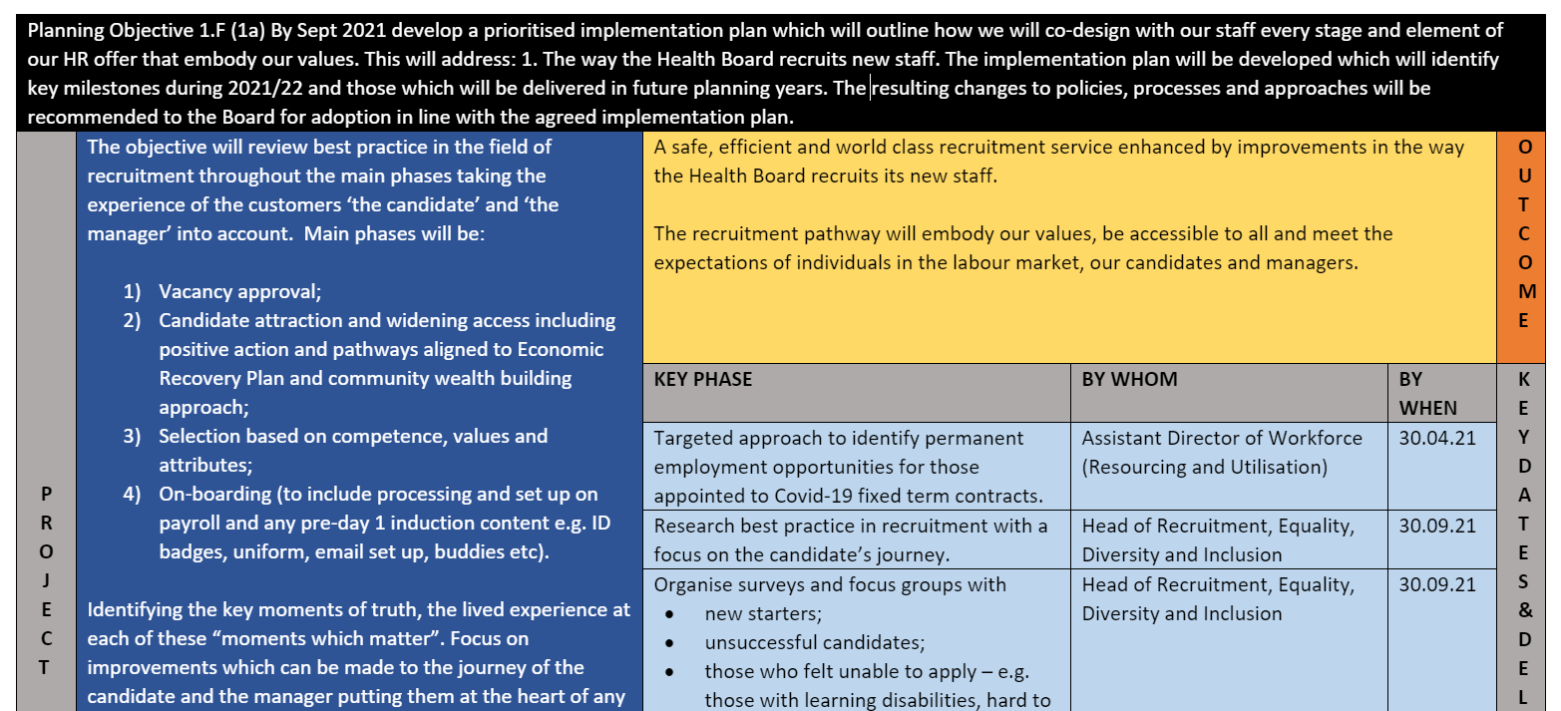
Evidence 1.9 – Focus groups evidence

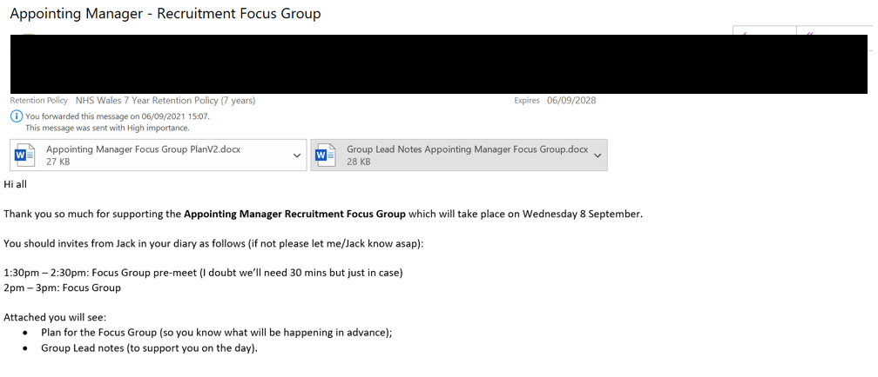
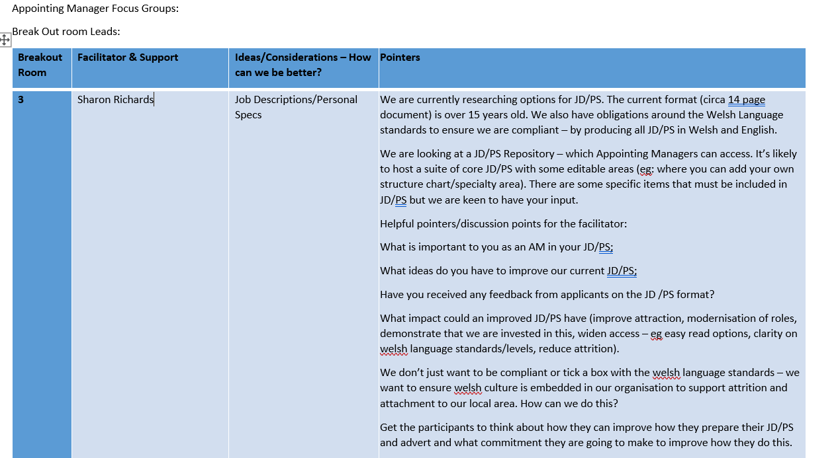

Evidence 1.10 – Job Description Research

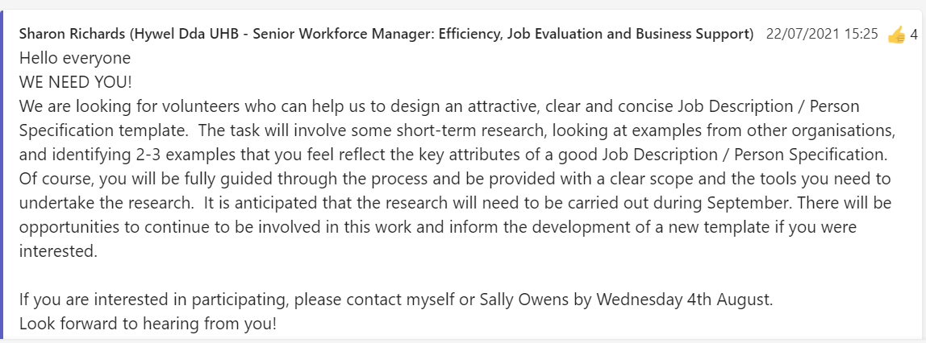

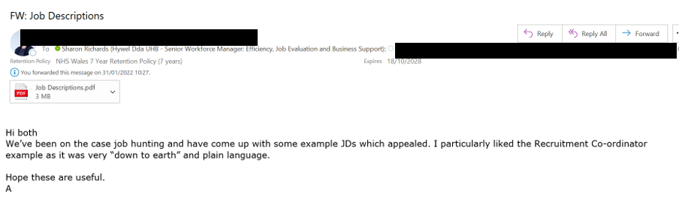
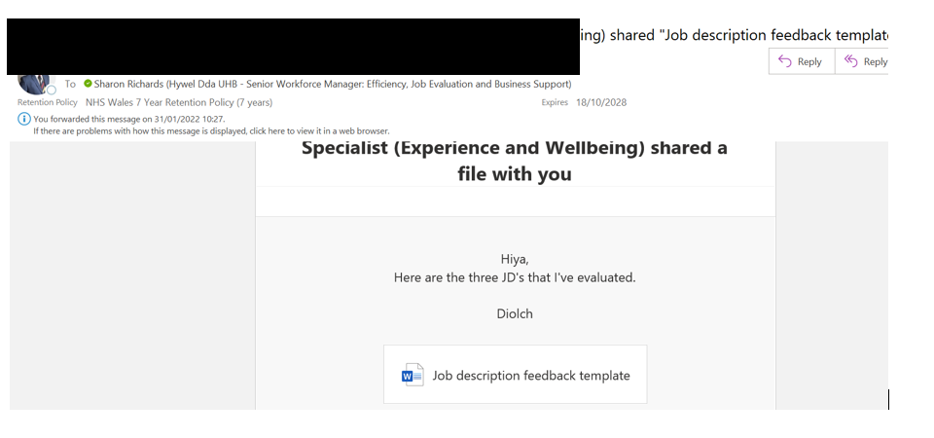
Evidence 1.11 – slides showing good practice suggestions when writing job descriptions and person specifications

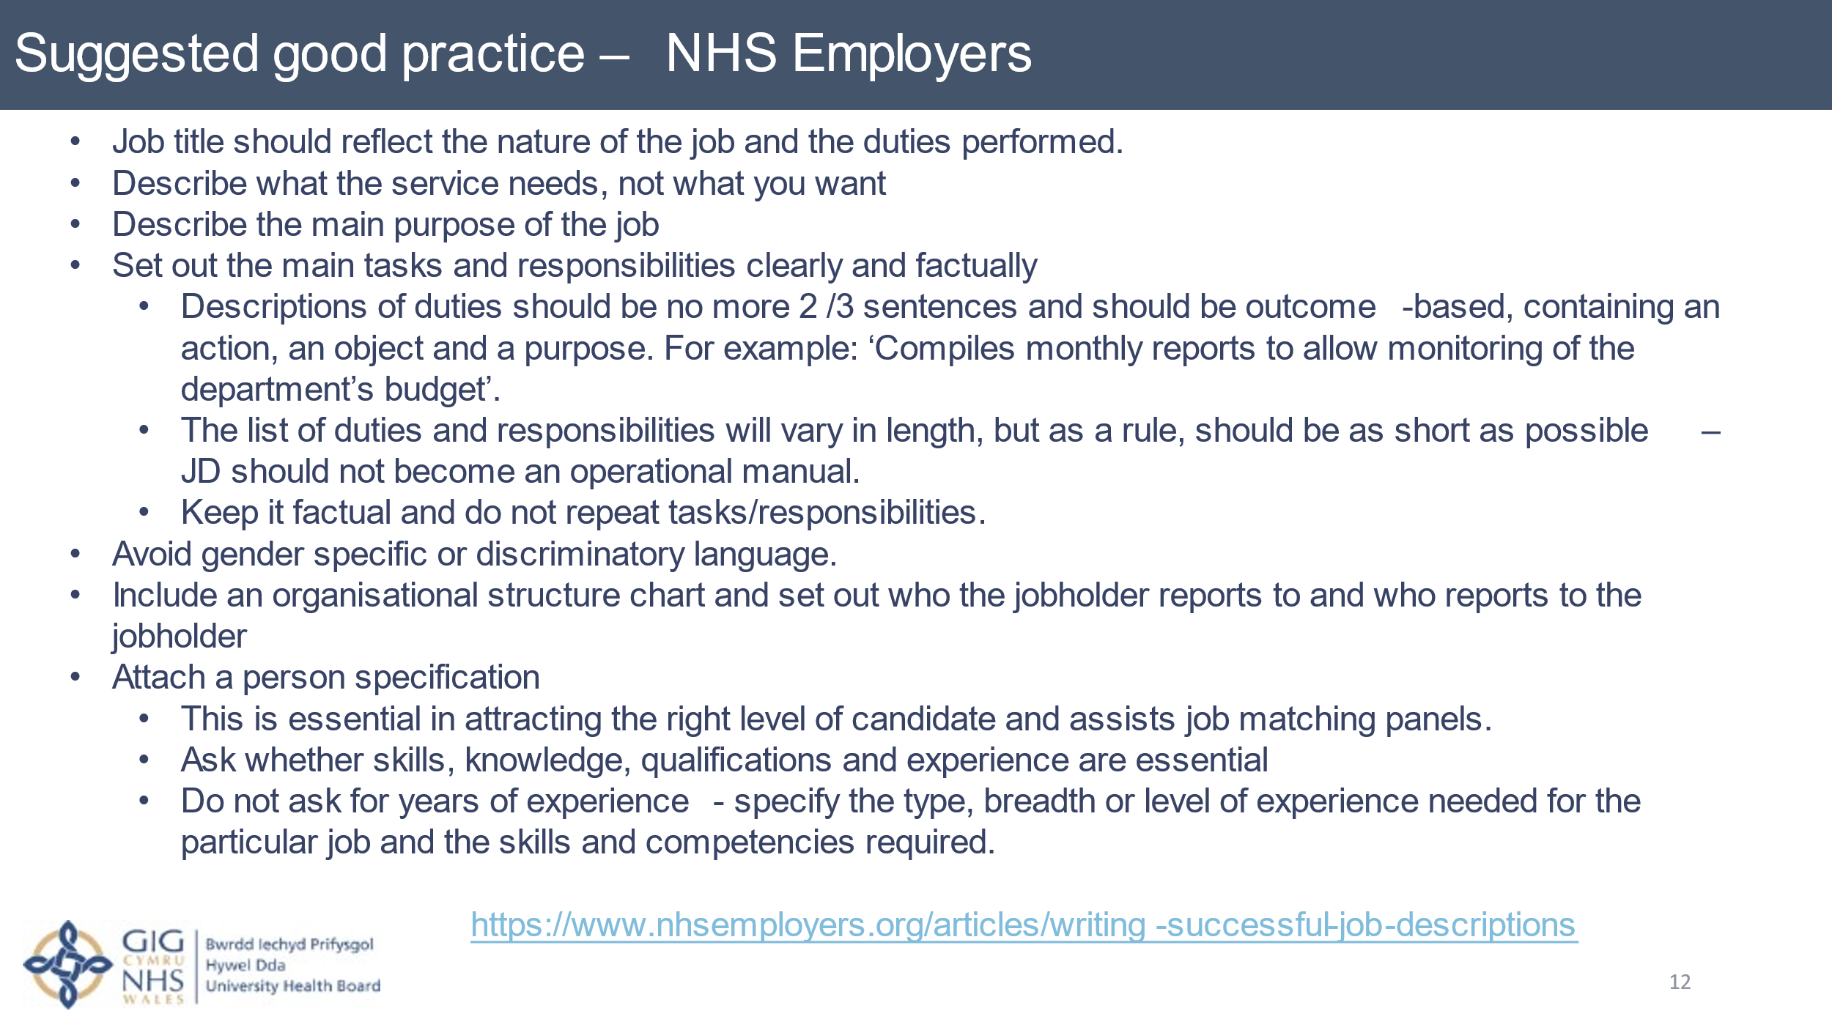

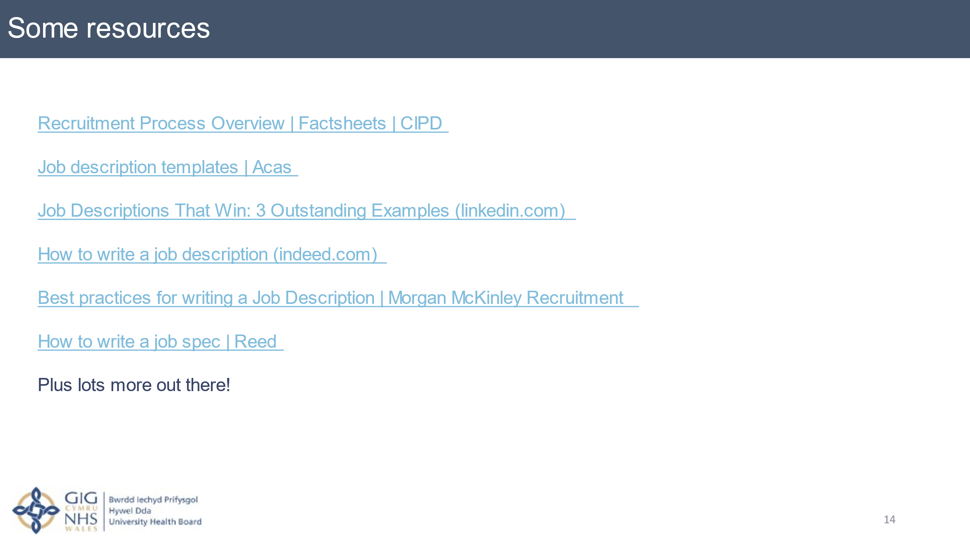
Evidence 1.12 – email expressing concerns about quality of job descriptions

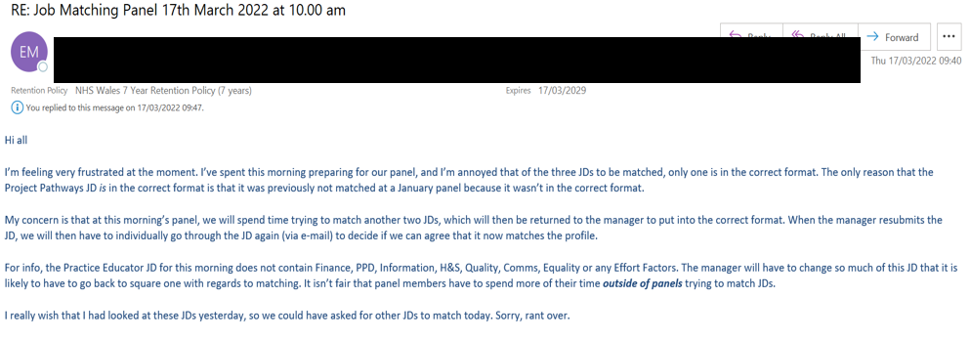

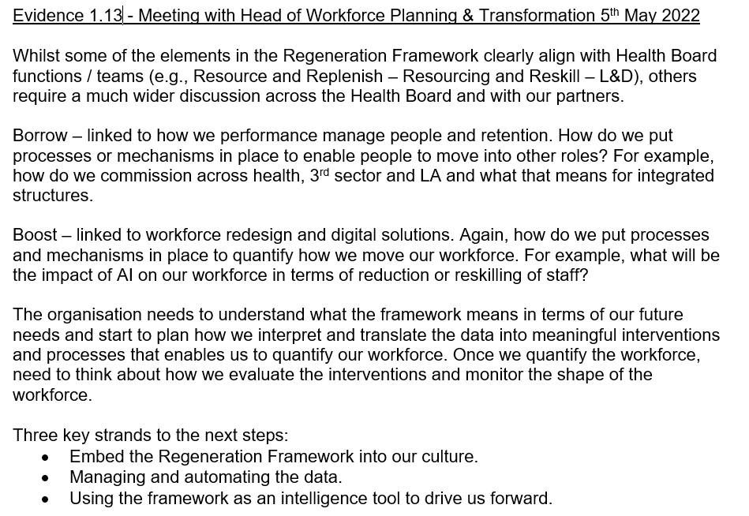

Learning Objective 2

Be able to recommend ways to improve an organisation’s approach to talent planning

2.1 Make reasoned recommendations for how the organisation can maintain an appropriate number of people with the skills required by the organisation

HDdUHB has acknowledged that it has a lack of supply of skilled workforce which is set to worsen without new intervention. With a significant workforce challenge, the organisation needs to make progress in delivering the actions set out in its Recruitment planning objective to support the increase of supply and skills to the organisation.

Job descriptions are an important part of an organisation’s attraction strategy, offering the organisation the opportunity to outline the job requirements to potential candidates in a clear and concise way (Barretto, 2021).

NHS Employers (2020) suggest that successful job descriptions should:
- Have a job title that reflects the nature and duties of the job.
- Explain what the service needs, not what you are looking for.
- Includes the main purpose of the job.
- Includes clear, succinct and factual main tasks and responsibilities.
- Avoids bias and discriminatory language.
- Include an organisational structure chart.

HDdUHB has a job description template that all managers are required to complete for new roles (Evidence 2.1). The headings in the template help to provide the information required to match a role to an NHS National Job Profile (NHS Employers, 2021). Unfortunately, as the template is a Word document, Managers often delete sections that mean a job description cannot be fully matched against the profile (Evidence 2.2).

Whilst the template structure supports the NHS Employers recommendations above, Managers will often include as much information as they can to evidence the required criteria for it to match with a national profile. A search on jobs with HDdUHB on NHS Jobs will illustrate that many of our Job Descriptions and Person Specifications run to at least 8 pages, 11 pages with the additional ‘generic statements’ section. Managers will also often repeat sentences within job descriptions or provide excessive detail that will mean nothing to the lay person.

Sanchez (2020) offers a number of suggestions for writing effective job descriptions, based on data analysis undertaken by Textio, including:
- Keep job descriptions to one and a half pages in length or less
- Keep sentences short
- Use bullet points
- Punctuation matters
- Avoid using the third person
When advertising a job, organisations must ensure that they do not use language that discriminates unfairly against a protected characteristic (Acas, n.d.). As well as being unlawful, discrimination can result in a poor reputation and the ability to attract and recruit staff (Benjamin, n.d.). Some examples of potentially discriminatory language used in Job Descriptions received by Managers in HDUHB, include the requirement for a specified number of years’ experience and the requirement to hold a driving licence (Evidence 2.3).

Research also suggests that organisations may unwittingly be discouraging applicants from applying for jobs through the use of gender bias language when advertising (Warnham, n.d). Whilst this is not something that has yet been considered in HDdUHB, there are several Gender Bias Decoder applications that could be explored, e.g. Katmatfield.

As well as ensuring that the quality and accuracy of Job Descriptions, attractive job descriptions can encourage applications from the right candidates and sell the organisation as one they want to work for (Bevegni, 2016). Bevegni provides links to a number of organisations that use specific tactics in their job descriptions to attract the right candidates, such as:
- Highlighting the benefits and opportunities of the role
- Describing what it’s like to work there, giving an insight into the culture of the organisation
- Clear description of the skills required for the role
- Explaining how the role fits, and the contribution it makes, in the wider organisation
- Using language that resonates with the target audience
- Advertising via a job description video
- ‘Hooking’ the reader in right at the start of the Job Description

Based on the assessment of our current Job Description and Person Specification against best practice highlighted above, I propose the following recommendations to help improve the organisation’s attraction strategy:
- Develop a manager’s guide for writing quality job descriptions and person specifications.
- Deliver masterclass ‘drop in’ style training sessions for managers to seek advice on writing quality job descriptions and person specifications and understanding the job evaluation process
- Implement a pre-formatted Job Description template with locked fields
- Agree changes to the JD/PS and develop an action plan for a phased approach to start to implement changes to the JD/PS.

Reference List
Acas (n.d.) How to advertise a job. Available at How to advertise a job: Recruitment: hiring someone - Acas. (Accessed: 1st May 2022)

Barretto, W (2021) 5 Innovative Talent Attraction Strategies. Available at 5 Innovative Talent Attraction Strategies in 2022 - Jobsoid. (Accessed: 1st May 2022)

Benjamin, T (n.d.) The Ways Discrimination Negatively Affects Businesses. Available at The Ways Discrimination Negatively Affects Businesses (chron.com). (Accessed: 1st May 2022)

Bevegni, S (2016) 7 Real-life Examples of Job Descriptions That Stand Out. Available at 3 Real-life Examples of Job Descriptions That Stand Out (linkedin.com). (Accessed: 1st May 2022)

Katmatfield. Available at Gender Decoder: find subtle bias in job ads (katmatfield.com). (Accessed: 1st May 2022)

NHS Employers (2020) Writing successful job descriptions. Available at Writing successful job descriptions | NHS Employers (Accessed: 1st May 2022)

NHS Employers (2021) NHS National Job Profiles. Available at National job profiles | NHS Employers. (Accessed: 1st May 2022)

NHS Jobs Available at NHS Jobs - Candidate Homepage. (Accessed: 1st May 2022)

Sanchez, C (2020) How to write a job description in 2020: Best practices from half a billion job postings. Available at How to write a job description in 2020: Best practices from half a billion job postings (textio.com). (Accessed: 1st May 2022)

Evidence List

Evidence 2.1 – HDdUHB Job Description template

JOB DESCRIPTION

Job Title:

Pay Band: Subject to A4C Banding

Directorate:

Department:

Managerial Accountable to: (Who is the manager of this post?)

Reports to: (Who does the post holder report to?)

Professionally Responsible to: (Who is professionally responsible for this post?)

Responsible For: (Who does this post manage?)

Please do not list the areas the post is responsible for but only the other posts / departments that this person will manage.

Organisation chart:

JOB SUMMARY / PURPOSE

In this section you should describe as concisely as possible the overall purpose of the job. The aim is to convey in a few sentences a broad picture of the job, main roles and autonomy of the post.

You should not use this section to list the duties and responsibilities of the post, as this is done in the ‘Duties and Responsibilities’ section of the Job Description.

MAIN DUTIES AND RESPONSIBILITIES

In this section you should identify in sufficient detail the main duties, tasks, activities and responsibilities of the post holder including the level of autonomy of the roll.

The job description should be comprehensive enough to enable the job matching panel to understand the main tasks etc. It is important that only factual information about the role is included as information provided will result in the outcome of the pay band.

Please do not copy sections from the A4C job evaluation handbook or job profiles or write the job description under the A4C factor headings. They are not helpful in assessing and the job description will be returned.

You will find the following sub-headings useful in summarising the tasks and enabling a knowledge and skills framework post outline to be compiled (KSF).

Service Management
e.g. policy development, operational management, freedom to make decisions within framework, facilitation of meetings, involvement /investigation of complaints resource or service planning, on-call duties

Service Improvement
e.g. modernisation work, service reviews, audits to evaluate impact of service improvement, project work related to this area, collaborative work/partnership work

Communications
e.g. range of people communicated with – internal/external – and at what level
Type of communication e.g. written or oral, negotiation, training, sensitive, report writing, presentations, minute taking – in relation to which staff/groups and how often.

Finance and Resources
Specific financial tasks in relation to the role
e.g. budget monitoring, resource or budget management, budget setting, ordering goods or services or signing off timesheets, expenses or overtime

Personal and People Development and People Management
e.g. supervision or management responsibilities, training responsibilities, staff and personal development e.g. KSF/PDR.

Information Processing
e.g. analysis, interpretation, maintenance of systems, data input, record keeping, audit or research, reports for whom and how often, minutes for whom and how often

Health, Safety and Security
Put any special tasks directly related to the role e.g. maintaining own H&S or monitoring / improving.

Quality
e.g. continuous improvement audit, clinical governance, maintaining or improving quality.

Equality and Diversity
What level of responsibility does this post have for equality and diversity issues e.g. acts in ways that support equality and value diversity.

Effort and Environmental
Please include details of any physical, mental or emotional effort required for the post and any environmental / working conditions that staff may be exposed to.
eg. lifting, concentration, imparting unwelcome news to patients or about performance targets, exposure to dirt, fluids, use of road transport or VDU etc. It would be helpful it you could indicate how often this occurs – occasional / frequent.

General
Other tasks and duties may be determined by appropriate line manager as the role develops

PERSON SPECIFICATION

The knowledge is the minimum needed to carry out the full duties of the job to the required standards. Qualifications should be used to provide an indicator of the level of knowledge required. Training and experience is also a means of acquiring the knowledge required for a job such as on-the-job training, short courses and experience to an equivalent level of knowledge which should be specified.

Please do not use the number of years’ experience as this is potentially discriminatory

In a bid to ensure that the Health Board values are weaved throughout the whole recruitment process, values statements are now be included all new person specification in the essential column. Including these statements in the essential criteria will then enable shortlisters to measure values demonstrated in application forms.

ATTRIBUTES | ESSENTIAL | DESIRABLE | METHOD OF ASSESSMENT
Qualifications and Knowledge | Professional, technical or academic qualifications or knowledge required or the training they should have undertaken or equivalent experience. |  | Application form
Experience | Experience required to fulfil the post.  Use types of achievements and activities that would be likely to predict success in the role rather than ‘years’ eg Extensive previous experience of working with health finance systems. |  | Application form and interview.
Language Skills
  Welsh Speaker
  (Level 1)
  Full details around the expectations associated with level 1 may be found at the bottom of this page
Aptitude and Abilities | Abilities required to perform effectively in the role eg -  Able to demonstrate situations where effective leadership and management skills have been used  or  Be able to demonstrate tact and diplomacy when working with others  or  Evidence of undertaking presentation to groups |  | Interview
Values | Ability to embrace the following personal values and behaviours on a daily basis -  - Dignity, Respect and Fairness  - Integrity, Openness and Honesty  - Caring, Kindness and Compassion  Ability to demonstrate a commitment to our organisational values -  - Working together to be the best we can be  - Striving to develop and deliver excellent services  - Putting people at the heart of everything we do
Other | As required -  Ability to travel between sites in a timely manner  or  Flexible approach to needs of the service

Evidence 2.2 – communication regarding lack of information on Job Description

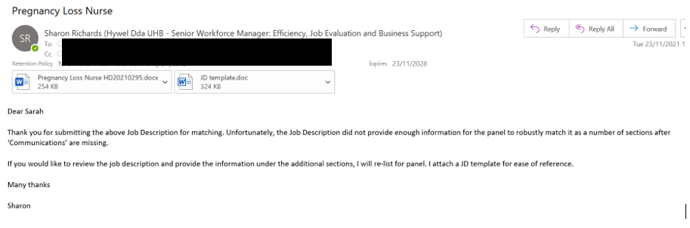

Evidence 2.3 – evidence of discriminatory language

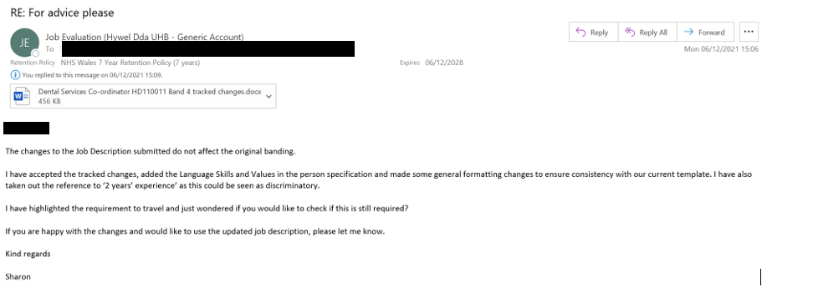
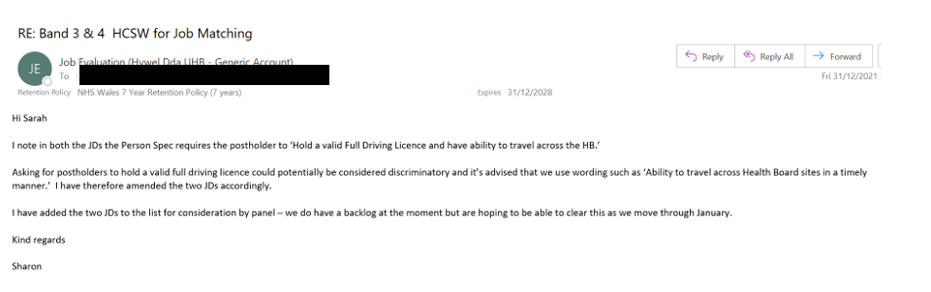

Learning Objective 3

Be able to contribute to people resourcing activities

3.1 Identify and explain the rationale for a specific resourcing activity within the organisation

My first recommendation in Learning Objective 2 was to develop a manager’s guide for writing quality job descriptions and person specifications.

Whilst there is clearly a business need and a mandate (Evidence 1.8) to review the Job Description and Person Specification template, some initial work is needed to ensure that content is accurate, succinct and meaningful.

It is intended that the Manager’s Guide will be equally applicable to the current JD/PS template and any future revised versions.

3.2 Agree roles and responsibilities with other contributors to the activity

As the Health Board lead for Job Evaluation, I provide specialist advice on the Agenda for Change National Job Evaluation Scheme, work with the NHS Wales Job Evaluation Lead on policy, best practice and developments, manage the job matching and job evaluation process in partnership, manage the Health Board’s Re-evaluation of pay band process and I am an accredited job matcher.

Therefore, the responsibility for all the recommendations identified in Learning Objective 2 sit with me and I will take the lead in the development of the Manager’s Guide. The implementation of a revised JD/PS template will be one of my work objectives for 2022/23.

Other stakeholders include the Staff Side (Union) representative for Job Evaluation, the All-Wales Job Evaluation Lead, appointing managers and the Workforce Advisor for Job Evaluation who has the responsibility for the operational management of the service.

3.3 Identify organisational procedures and legislative requirements which underpin the activity

Job evaluation determines the value of a job in relation to other jobs in an organisation and is a key part of the pay system that covers NHS staff under Agenda for Change (NHS Employers, n.d.). The NHS Job Evaluation scheme ensures equal pay for work of equal value.

The NHS Job Evaluation Handbook (NHS Employers, 2018, p7) sets out 16 scored and weighted factors that job descriptions must be assessed against. The rationale for the number of factors is to ensure that all significant job features can be assessed fairly.

The 16 factors are:
- Knowledge, Training and Experience
- Skills
  - Communication and Relationship
  - Analytical and judgment
  - Planning and Organisation skills
  - Physical skills
- Responsibilities
  - Patient care
  - Policy and service development implementation
  - Financial and Physical resources
  - Human Resources
  - Information Resources
  - Research and Development
  - Freedom to Act
- Effort and Environment
  - Physical effort
  - Mental effort
  - Emotional effort
  - Working conditions
The detail required to enable a robust assessment against these 16 factors needs to be balanced against the aspiration to produce a succinct Job Description. There is little room for repetition or long sentences if we want to deliver a job description that meets best practice.

3.4 Plan and prepare for agreed role, ensuring the availability of any materials or resources required

As a result of the work undertaken for this portfolio, producing a manager’s guide for writing quality job descriptions and person specifications has become one of my objectives for 2022/23 (Evidence 3.5). The agreed timescale for this is 30th June 2022.

I have identified the following actions, timescales and dependencies required to achieve this objective.

 | Action | By when | Dependencies | Status | Evidence
1 | Confirm if there is an All-Wales Good Practice Guide | 01/05/2022 | Availability of All Wales JE Lead | Complete – no All Wales guidance currently in place | 3.1
2 | Engage with Staff Side Job Evaluation representation | 01/05/2022 | Availability of Staff Side JE rep | Complete – SS rep confirmed support for guide and happy to review draft | 3.2
3 | Link with other Wales Job Evaluation Leads to see what they have in place | 01/05/2022 |  | Complete – copy of Swansea Bay guidance received. | 3.3
4 | Research other organisation’s Managers guides to writing Job Descriptions | 06/05/2022 | Availability of other organisation’s internal documents | Complete | 3.4
5 | Draft Manager’s guide | 27/05/2022
6 | Undertake consultation on draft guide (with appointing managers, TU reps, All Wales lead, ADWIS) | 10/06/2022 | Availability and responsiveness of consultees
7 | Make agreed amendments and produce final guide | 17/06/2022
8 | Publish guide on intranet | 30/06/2022

3.5 Undertake agreed role in a timely and accurate manner, in line with the organisational procedures and legislative requirements

The action table and status has been shared with and agreed by my line manager (Evidence 3.6).

Due to the research, writing and consultation activities required to deliver this objective, I am unable to share a final product. However, at the time of writing this report, I have completed actions 1- 5 and made some progress on action 6, drafting a structure of content (Evidence 3.7).

I can also confirm that delivery against this objective is on track.

3.6 Reflect on the effectiveness of the resourcing activity in meeting required objectives and report back to stakeholders

The actions taken to date provide a good foundation for the development of a Manager’s Guide within the agreed timescale.

My observations following the research I have undertaken on existing guides had led me to conclude:
- The need to keep it succinct, relatively short and well-structured.
- To include an introduction explaining how the Job Evaluation process works in our organisation, including timescales etc – experience suggests that many managers do not understand the process
- To provide generic advice rather than referring to the content of required for the JD template headings, particularly as the JD template is likely to change.
- Refer readers to the National Profiles and Job Evaluation Handbook rather than including the content in the guide to avoid managers using the Handbook ‘speak’ rather than evidencing job description statements.
I intend to evaluate the impact of the Manager’s Guide after 6 months by
- comparing the number of job descriptions being returned to managers to update before and after the guide.
- feedback from appointing managers.
- timeliness of the job evaluation process.

Reference List
NHS Employers (n.d.) NHS terms and conditions of service (Agenda for Change) NHS terms and conditions of service (Agenda for Change) | NHS Employers. (Accessed: 1st May 2022)

NHS Employers (2018) NHS Job Evaluation Handbook. Available at NHS Job Evaluation Handbook | NHS Employers. (Accessed: 1st May 2022)

Evidence List

Evidence 3.1 – email correspondence with All Wales JE Lead

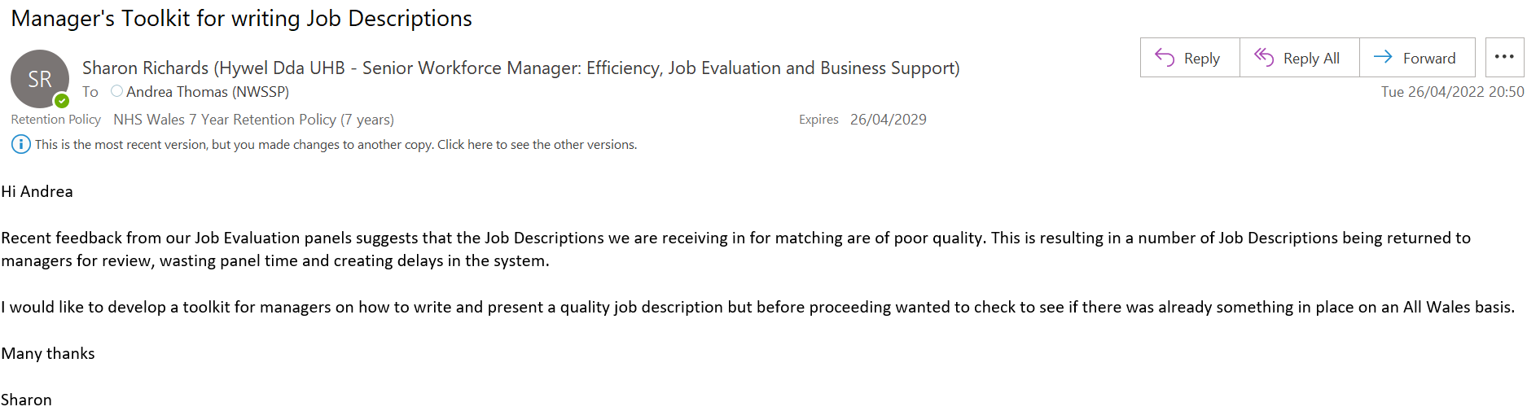

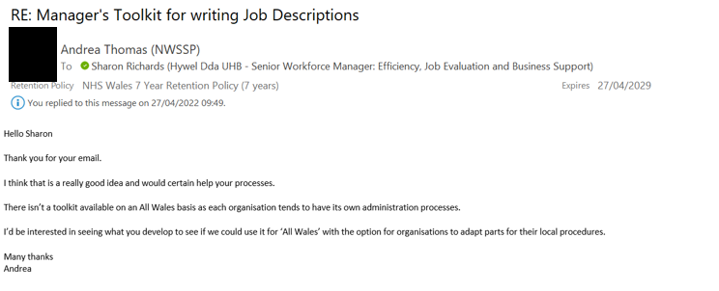

Evidence 3.2 – email correspondence with Staff Side JE Lead

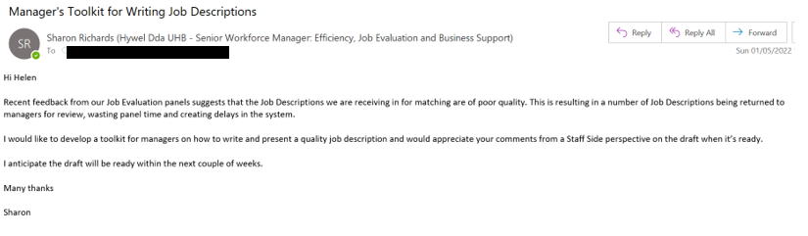

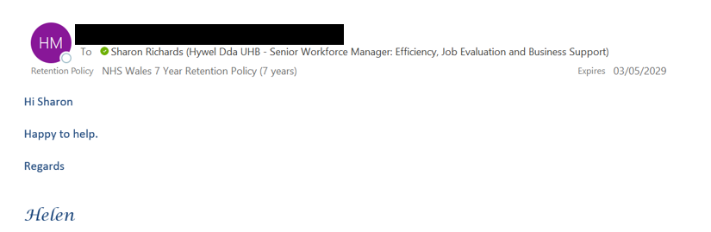

Evidence 3.3 – email correspondence with other NHS JE Leads

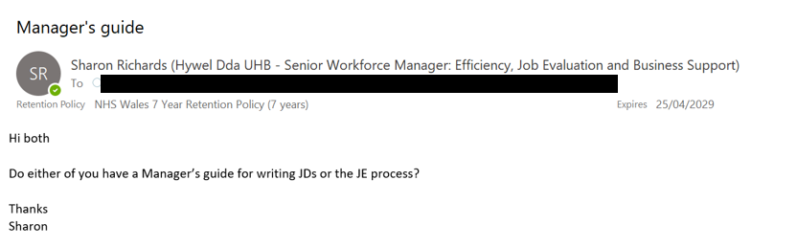

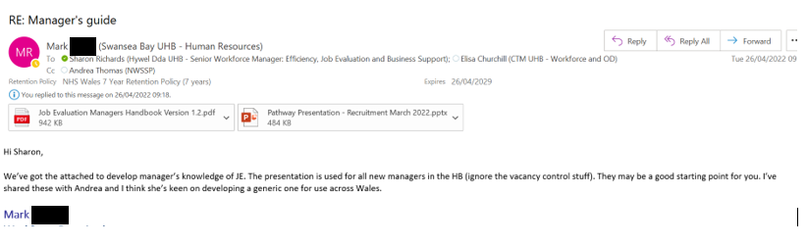

Evidence 3.4 - Research undertaken on Manager’s Guides to writing Job Description

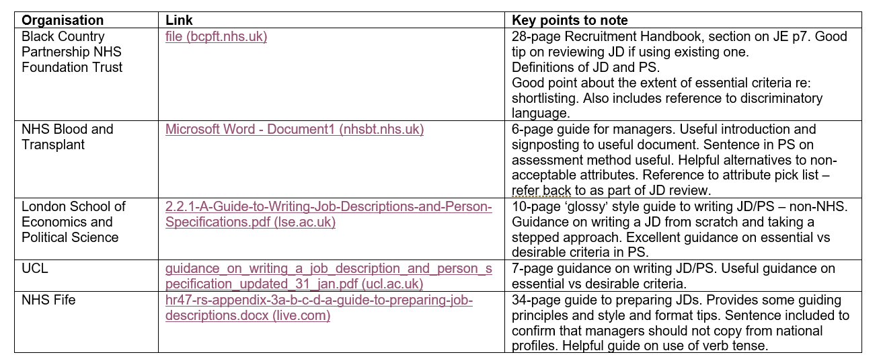

Evidence 3.5 – Slide from presentation to WOD Strategic Group on 5th May 2022

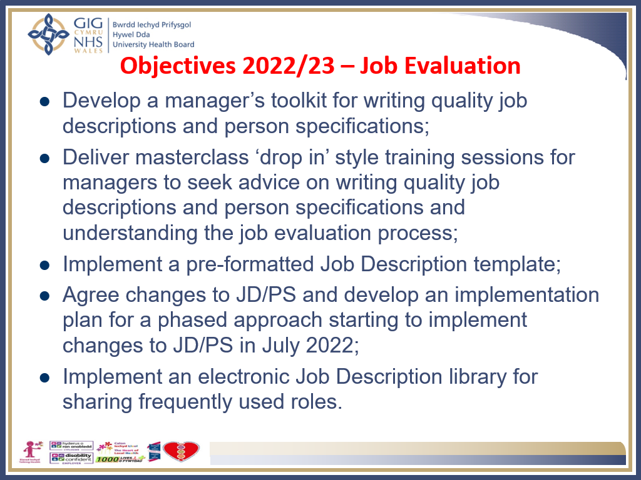

Evidence 3.6 – communication with line manager on action plan

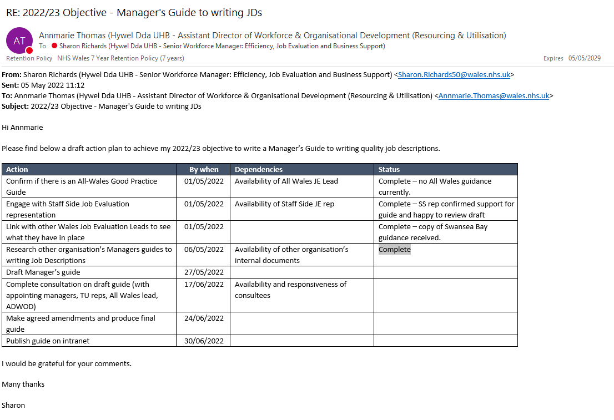

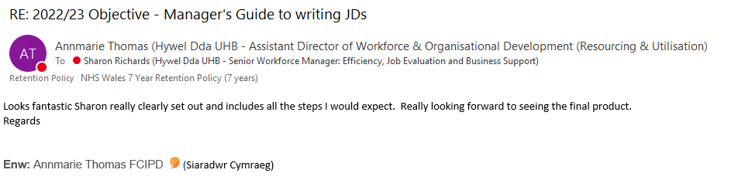

Evidence 3.7 – Draft structure of Manager’s Guide



