Contemporary global issues in Business tourism

Covid threats to hospitality sector
Contemporary global issues in Business tourism
When looking at job security this relates mostly to the hospitality industry, by looking at the local case study which is the café and bistro of the LC, all staff were put on furlough which was a scheme introduced by government back in April to help with the loss of jobs in the UK. By looking at stats and figures given by BBC news (2020) that 1/5 of jobs could be lost. Comparing the furlough scheme to another similar scheme by Germany in an article written by DW.com (2020) explains whilst interviewing a business owner Vincenzo Berenyi he explained that he put his staff on the Kurzarbeit scheme which is similar to the furlough scheme but has been running in Germany since the early 20th century, this allows him to reduce hours and still pay staff. The government pay 60% comparing to the UK which is 80%.

Introduction
This article will be looking at how covid has impacted the hospitality industry, by looking at the industry in Swansea, Wales, UK, and other nations to compare what the industry is doing to be covid safe. the article will also be looking at strains and challenges that have hit the industry and how the industry has met the criteria that is facing them every day. It will be looking at a coffee shop and Bistro that is located in Swansea as a case study and comparing the challenges and issues with similar businesses in the hospitality industry. The local café in question based in Swansea is the café and bistro of the leisure facility in the LC in Swansea. The LC (2020) themselves which mention that before covid the business was working with a capacity of customers of roughly 800,000 a year which in turn is the biggest attraction in Wales. According to ukhospitality.org.uk (2018) the hospitality sector contributed £72 billion gross value to the UK GDP and is the third biggest employer industry in the UK.

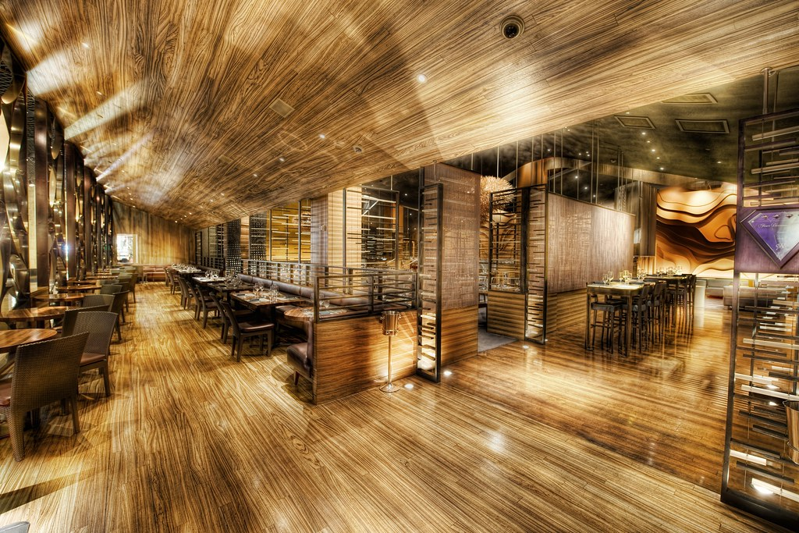
Since March 2020 coronavirus has been an issue for the industry where a national lockdown was an introduced from the 23rd of March Until June 2020. The café and bistro on average with figures given by the LC (2020) were making roughly £200,000 annually before covid now that is down to roughly £20,000 as the café is open but the bistro is not. The graph is showing the decrease of the number of hours worked in the hospitality industry since lockdown on the 23rd of March 2020 which was given by coronavirusandtheeconomy.com (2020). There is a dramatic decrease in the numbers from 2019 with roughly a 40% decrease on average. When taken this into account this shows the dramatic impact not only job security in the industry but the industry itself.
.
Boutiquehotelier.com (2020) mentions since then covid has impacted the industry with the loss of roughly £30 billion in 2020 alone. The picture below shows the percentage like for like sales for pubs bars and restaurants in the UK given by statista.com (2020).

Competition in the industry, Potential of new entrants into the industry, Power of
suppliers, Power of customers and Threat of substitute products. By looking at all of these aspects this could help the LC’s café and bistro survive.

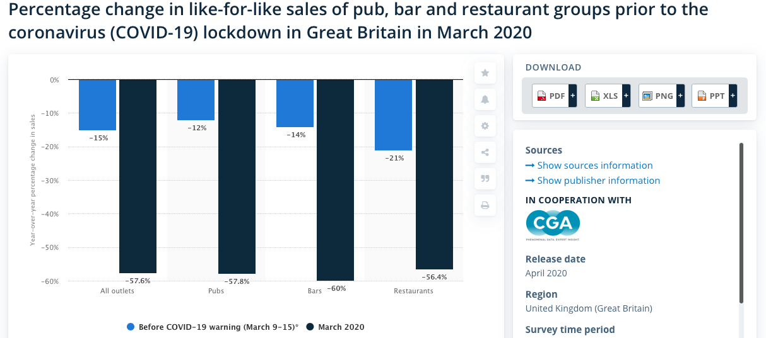

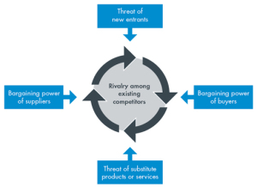
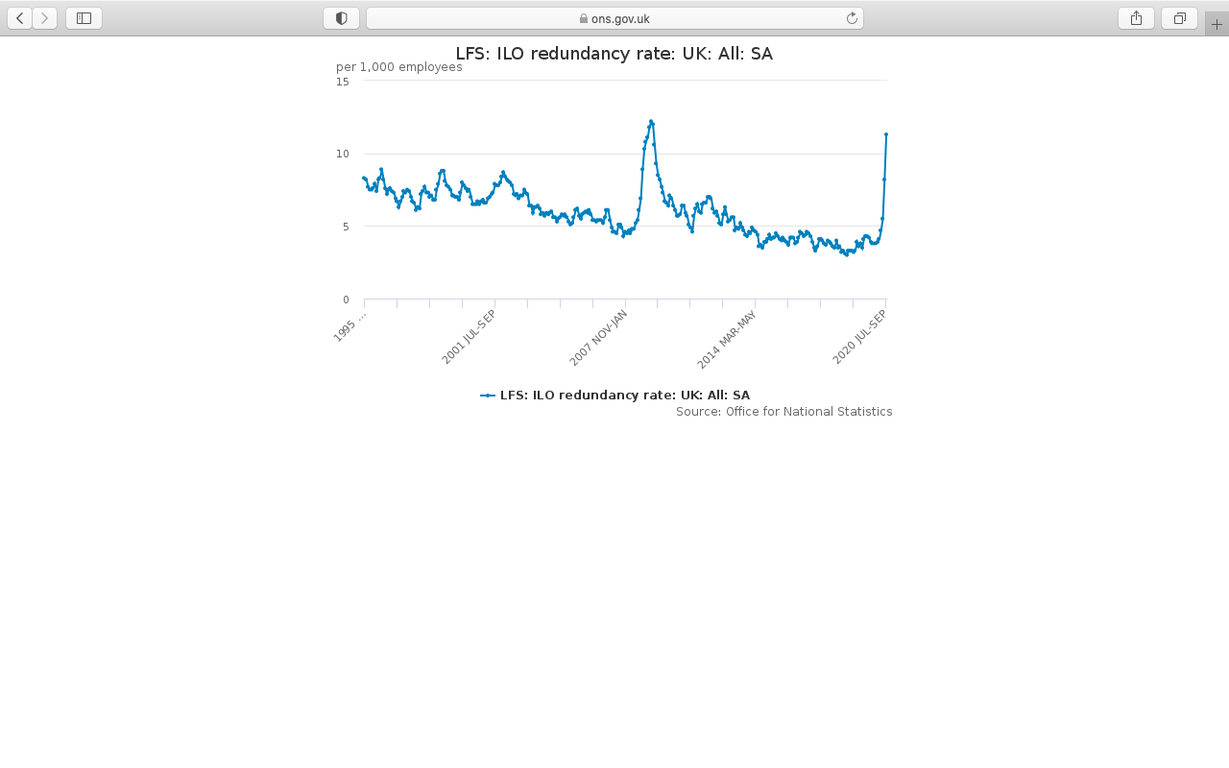
Looking at the figures by the ONS (2020) for the job loss in the UK, it works out that 11.3 out of 1000 employees have lost their job. According to coronavirusandtheeconomy.com (2020) there are two main reasons for the uncertainty of the hospitality sector especially food based such as pubs, bars and restaurants. The first one is the social distancing the article mentions that because of the social distance, this impacts on business negatively because of the measures and the amount being spent.

the graph shows how severe the figures are and how concerning for the industry and its survival. there are many ways to reduce the impacts to industry such as strategic management planning.
Competition in the industry, Potential of new entrants into the industry, Power of
suppliers, Power of customers and Threat of substitute products. By looking at all of these aspects this could help the LC’s café and bistro survive.

Porters Five Forces
One option is porters five forces, according to Harvard Business School (2008) the five forces is a strategic plan by Michael Porter has five key aspects that can be used to help a business survive these are ,Competition in the industry, Potential of new entrants into the industry, Power of suppliers, Power of customers and Threat of substitute products. By looking at all of these aspects this could help the LC’s café and bistro survive.

Looking at Loxton, Mary et al, (2020) explains due to fear of covid worldwide consumer behaviour changed more than what is normally expected of purchasing, this expands by looking at the natural survival psychological impact that takes over to respond to things like natural disasters and global pandemics. This in turn shows that with psychological needs and wants of consumers changing behaviour which in turn leads to change explained by Maslow’s Hierarchy which shows the change in consumer behaviour to prioritize spending this is linked with the café and bistro being the biggest secondary spend for the LC.

Another reason is regulation changes during the pandemic for the hospitality sector by government in in March for all restaurants and bars were told to shut unless serving takeaways in Wales according to BBC (2020). By looking at another of porter’s forces this looks at threats of new entrants which was new government guidelines this included safety measures, when businesses could open, new procedures. On July the 12th bars and restaurants were allowed to be back open if followed the procedures and measures that have been put into place, this in theory allowed the companies to open for outdoor use but not for indoor to keep the spread low.

By looking at those factors and mix it with small income margins which the industry operate on it makes it more vulnerable. This in turn correlates to the point already spoken about already which is security of jobs and income, the article by coronavirusandtheeconomy.com (2020), explaining that once people see a drop or impact on their income, they will reduce on the disposable income available.
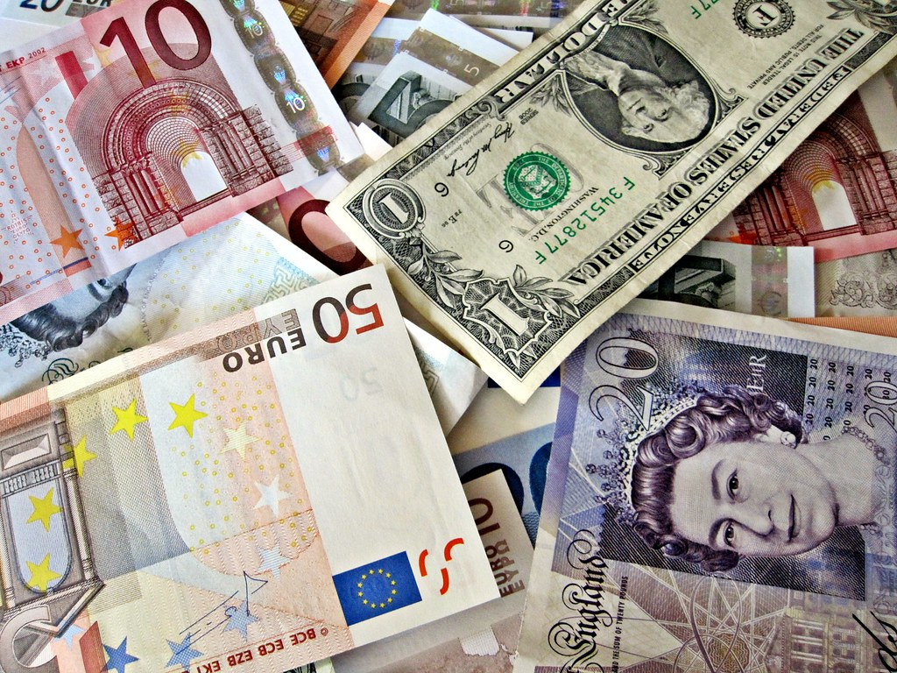



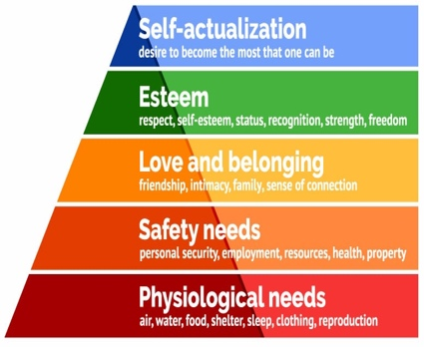
In turn this still impacted many venues as the restrictions allowed smaller footfall and the demand was not enough to pay staff. According to big hospitality.co.uk (2020) The hospitality industry since coronavirus was worth 32.7% of lost GDP for the UK overalls GDP, it goes on to say the eating and drinking out fell by 90% in April. Link this to an article by BBC News (2020) it explains that 1/5 of hospitality sector jobs could be lost because of coronavirus in 2020. This was just one of many factors that was emerging after restaurants were starting to open back up.

porters five forces by Harvard Business School (2008) explains why by looking at one key force is down to consumers and the power they have, this correlates with simplypsychology.org (2020) which explains Maslow’s hierarchy of needs. There is a connection to Maslow’s hierarchy on needs and wants and porters five forces, when looking at the physiological needs in Maslow’s Theory and consumer behaviour in porters 5 forces, it shows changes from normal everyday shopping to panic buying became a trend which in theory lowers the amount of disposable income for luxuries such as eating out. This impacts all other tiers in Maslow’s theory such as safety which includes financial safety and yet the reduction on disposable income which in turn shows that consumers have a high impact on the selected business such as the café and bistro in the LC.

Porters five forces & Maslow’s hierarchy

In comparison to the eat out to help out scheme in the UK, Spain adopted a sustainable scheme for the hospitality industry. According to José Miguel Rodríguez-Antón (2020) with measures taken by government which relates to the hospitality sector some companies are undertaking initiatives to try and recover the economic side to the industry whilst being as sustainably effective. In the article some companies are using basic but effect marketing strategies just by using the 7ps of marketing by smartinsights.com (2020), looking at evidence which suggests what are the key issues and the type of audience needed to target to get the business running again.

u The theory looks at several types which not only the café but the business itself which includes a decision maker who reacts to issues such as flow of income to staff, they also need to informational which means to update the all aspects of the business to stakeholders, also be interpersonal which liaises with all aspects of the business. In turn combine this with consumer needs, staff needs and business needs there could be a chance of survival.
Eat out to help out was a scheme introduced back in august of 2020, according to gov.uk (2020) the scheme was to bring an incentive for customers to eat at a participating restaurant and other eating facilities by the discount of 50% which the restaurants could claim back from the government this would help with income on quieter days of business. By looking at figures given by The Guardian (2020) the scheme did not help the industry at all as a recent survey by over 6410 companies employing 580,000 staff said that 66% of the industry see a decrease of sales between June and September. The article goes on to mention that companies in the industry are reporting an increase of sales from -64% to -25%. This shows in turn a relatively small boost as there are still restrictions on the industry and there is no proper help from the government.

Compare these stats before Covid, the hospitality industry in the UK before covid contributed to roughly £133.5 billion towards the UK economy in 2019 with a growth of 3.9% according to boutiquehotelier.com (2020).
In august according to the BBC (2020) restaurants were allowed to open for indoor service with other hospitality and leisure facilities also back, this was good news for the LC café and bistro as they could finally open if procedures were followed such as social distancing was in place. This in turn will determine on how effective managers would work, the best way would be using Mintzberg’s theory which is explained on open.edu (2020), it explains the type of mangers and how to be a good manager.

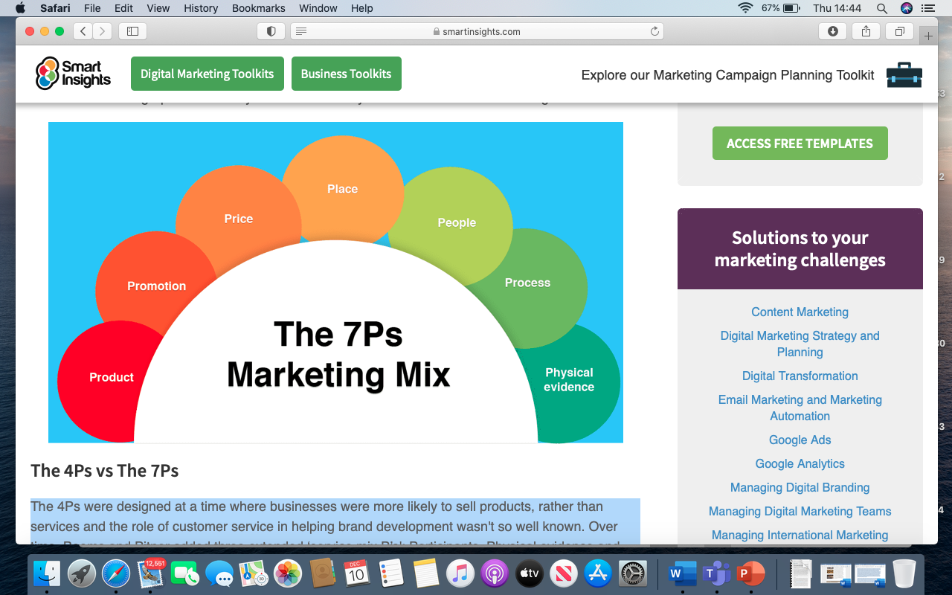

It also explains that using the 7ps instead of 4 there is stronger physical evidence and processes to create a new strategy. Spain’s industry is working together by creating initiatives that are sustainable that reach the targeted audience which are local and international tourists by marketing the nation as a safe environment and working hard to get facilities Covid safe for when tourism opens up in the country. In theory Spain is marketing by reaching to an audience for when it’s safe to try and generate income for the future in a sustainable way by working with the government. This is an ideal example on how the UK industry could look at regenerating income for the near future.




Recommendations
There are many factors in the article that could be changed and recommended.
- Looking at schemes such as eat out to help out from the gov.uk (2020) explains that the scheme cost £522 million and Instead of this scheme being a promotion for a month this should be enforced until Covid in under control and when the business can decide when it can survive purely on income from consumers and not the scheme. Looking at options for businesses to further the scheme would be looking at ways to promote healthy living whilst consumers save money. This could be using vouchers from the government which promotes healthy living and eating out as there are links to obesity according to bmj.com (2020) in July public health England estimate that people who have been diagnosed with Covid and are obese can increase the rate of death by 40. By using this scheme, it would promote healthy eating and helping the hospitality sector by working together.

- Consumer expectations are a key role in the success on a business and believe that by taking the approach of Spain which have used the marketing mix of the 7ps of marketing provided by smartinsights.com (2020). The 7ps of marketing theory has been around 1960 and clearly works with every type of business. then businesses can look at serving Covid and build a stronger and more successful business. Whilst Spain has been working with the government to provide as much help financially UK government have not. Whilst looking at the 7ps the government give no physical evidence to suggest the scheme help businesses and also what processes are there to market the industry in the UK. The Product could be linked to recommendation 1 which is to promote healthy products to reduce the risk of obese people suffering from covid.

u with schemes like eat out to help out trying to rejuvenate the industry, as a result of poor management from the government which seen the increase of cases due to the scheme, they decided to introduce the nation with “Circuit Brakers”. According to the BBC (2020) a circuit braker is a set of restrictions for a fixed amount of time lasting weeks not months to reduce the surge of cases in wales and the first minister said “ it would be a sharp, shock to the system and to coronavirus here in Wales”. Once again this would also mean the closure of the industry including the café/ bistro of the LC in turn means once again staff being affected and loss of business.
According to the mangers of the LC (2020) they had lost income down to produce going out of date which they donated to food banks and loss of income as when they reopen they would need to refill stock, not knowing how much stock needed to reopen down to the loss of demand. This correlates to both Mintzberg and an article by DW.com (2020) as it looks how the manager works, and the decisions being made and then at the owner in the article. the owner had previously stated that due to restrictions such as the ones facing the LC the loss of income is significant and goes on to say that the restaurant did not even reach 40% of income that was managed the same time last year.
Conclusion
To conclude by the evidence given throughout this article there is evidence that not only the case study of the café in the Lc is at risk of closure, down to many factors because of covid. Such as new and continuous pressure from the government, consumer change in needs and wants. There is also a lack of clarity and help to keep the industry afloat. There is evidence to suggest that more could be done for the industry such as schemes and taking examples from other nations that can be adopted. Another point to look at is that each nation is taking a different approach and this needs to be considered before any recommendation as Covid is an ongoing issue and will be for the foreseeable future.

- Mangers directions are a key role in a business and not only for the café at the LC but in the hospitality sector. There needs to be a strategic business plan such as the one that follows Porters five forces combined with open.edu (2020) information on Mintzberg managerial roles. This could be a key aspect on how a business could perform. As it stands there is no specific plan for the café as covid is an on-going issue with food and beverage outlets. There needs more of a hands-on approach where a plan can promote the café with possible promotions with coffees and other products such as buy one get one half price with every child swimming ticket. Also look at what the competitors are doing to help their food outlets and create a competitive plan to increase awareness and attract more consumers.

