Assessment Component 2

BA Business Management
Data Handling & Business Intelligence (LCBB5000_BIRM)
Student Name: Marian Giani Jianu
Student ID: 2231436
Lecturer: Dr Abdallah Naser
Dr Zahra Mohammadnazari

Table of Contents
Introduction 3
Part 1: Coffee Consumption and Effects 2023 3
1.1 Dataset Explanation and Analysis 3
1.1.1 Mean Value for Reading Score 3
1.1.2 Median Value for Reading Score 3
1.1.3 Mode of the Reading Score 4
1.1.4 Standard Deviation for Writing Score 4
1.1.5 Variables with Larger Variance and Standard Deviation 4
1.1.6 Interpretation of Results for the last three outcome 4
1.2 Data Presentation using Excel 5
1.2.1 Pivot Table 5
1.2.2 Pivot Chart 6
1.3 SPSS Analysis 8
1.3.1 Correlation between Writing Score and Reading Score 8
1.3.2 Scatterplot Analysis 11
1.4 Conclusion for the Analysis 13
Part 2 Discussion on Software Tools 14
2.1 Advantages and Disadvantages of SPSS, Excel, and Tableau 14
2.2 Data Mining Cycle 15
2.3 Conclusion for the Discussion 16
References 17

Introduction
This report investigates variables that can affect academic achievement. This analysis will use Excel, and SPSS for visualising the data and get suitable findings from the data. It will focus on important metrics related to the score gained by the student in the subjects of reading and writing. In this report, correlations between the scores will be examined using SPSS. This can help in finding information from the collected data, and this can be further used by educational institutions so that the outcome of the students can be improved. This report attempts to identify trends that can shed light on the possible effects of coffee drinking on academic achievement, and it will do objective by looking at both statistical data and graphic representations. The learnings from this report can be further used in strategising how to improve the well-being of the students.

Part 1: Coffee Consumption and Effects 2023

1.1 Dataset Explanation and Analysis

1.1.1 Mean Value for Reading Score
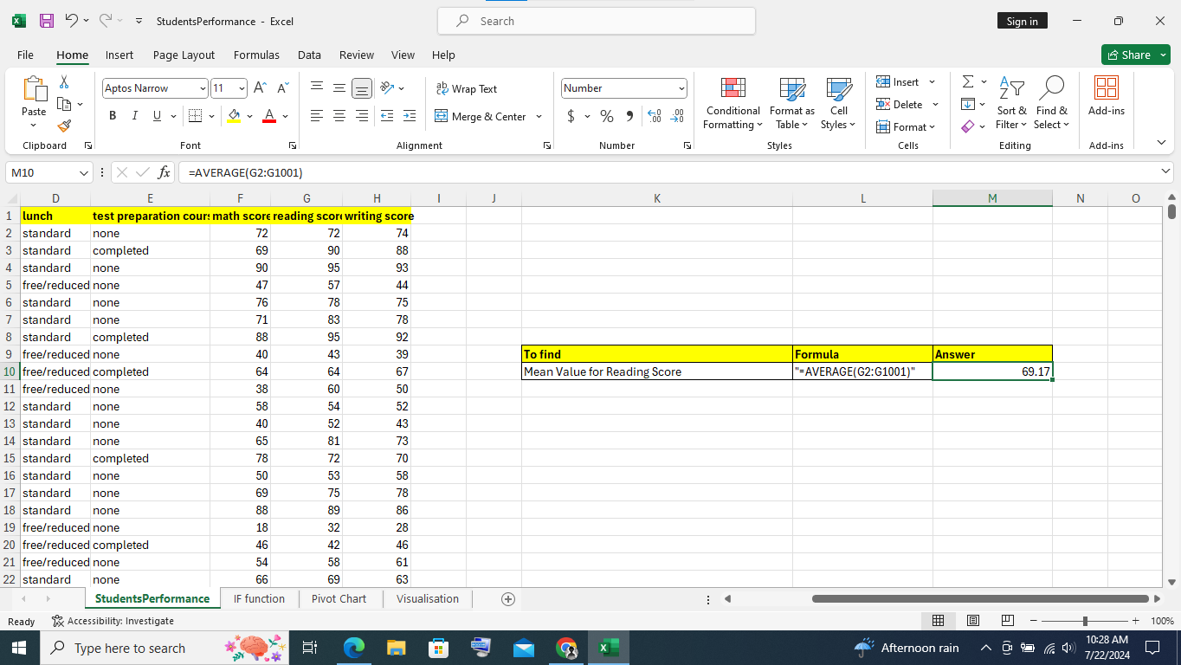
Excel Snip: 1
(Source: Learner)
It can be observed from Excel snip 1, that the mean value of the reading score is 69.17. This was calculated with the function “=AVERAGE()” of Excel.

1.1.2 Median Value for Reading Score
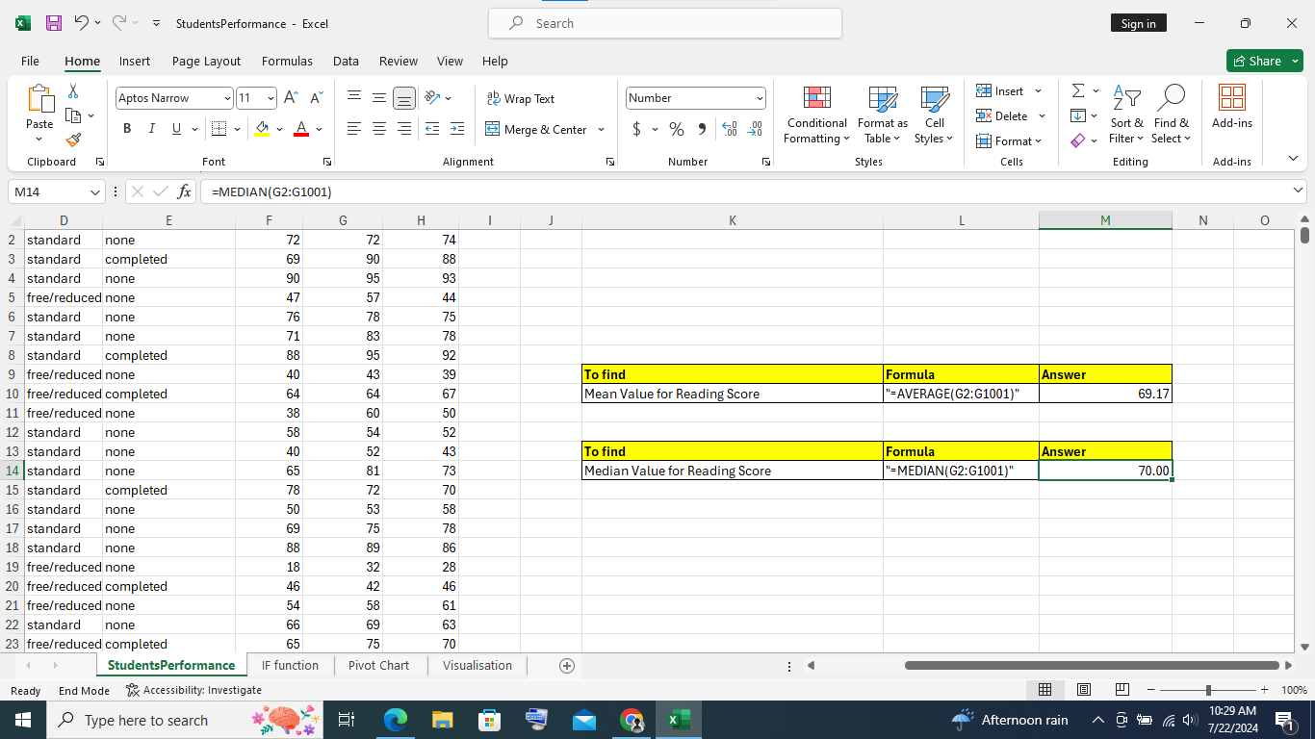
Excel Snip: 2
(Source: Learner)
As can be seen from Excel snippet 2, the reading score's median value, which was determined using Excel's "=MEDIAN()," is 70.0.

1.1.3 Mode of the Reading Score
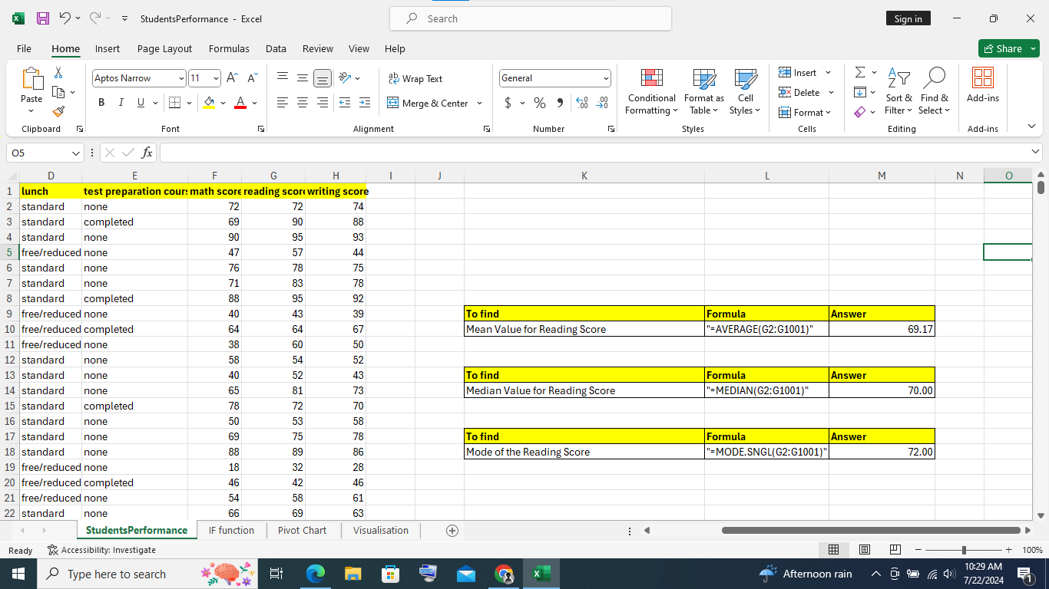
Excel Snip: 3
(Source: Learner)
It can be observed in Excel Snip 3, that the mode of the reading score is 72.00. And, it was calculated with the help of the Excel formula, “=MODE.SNGL()”.

1.1.4 Standard Deviation for Writing Score
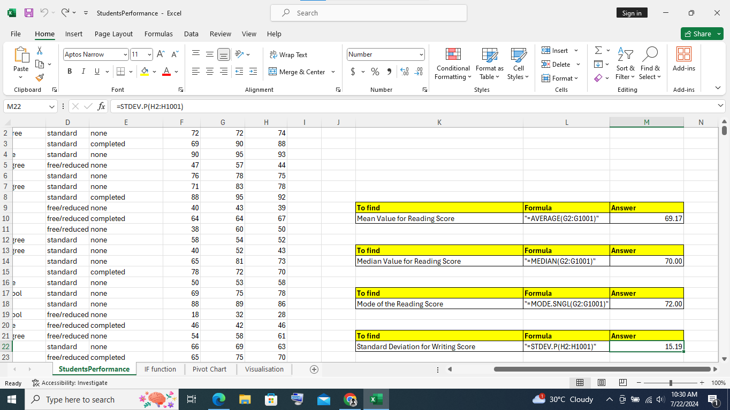
Excel Snip: 4
(Source: Learner)
The Excel Snip 4 shows that the standard deviation for the writing score is 15.19, which was determined using the Excel formula "=STDEV.P()."

1.1.5 Variables with Larger Variance and Standard Deviation
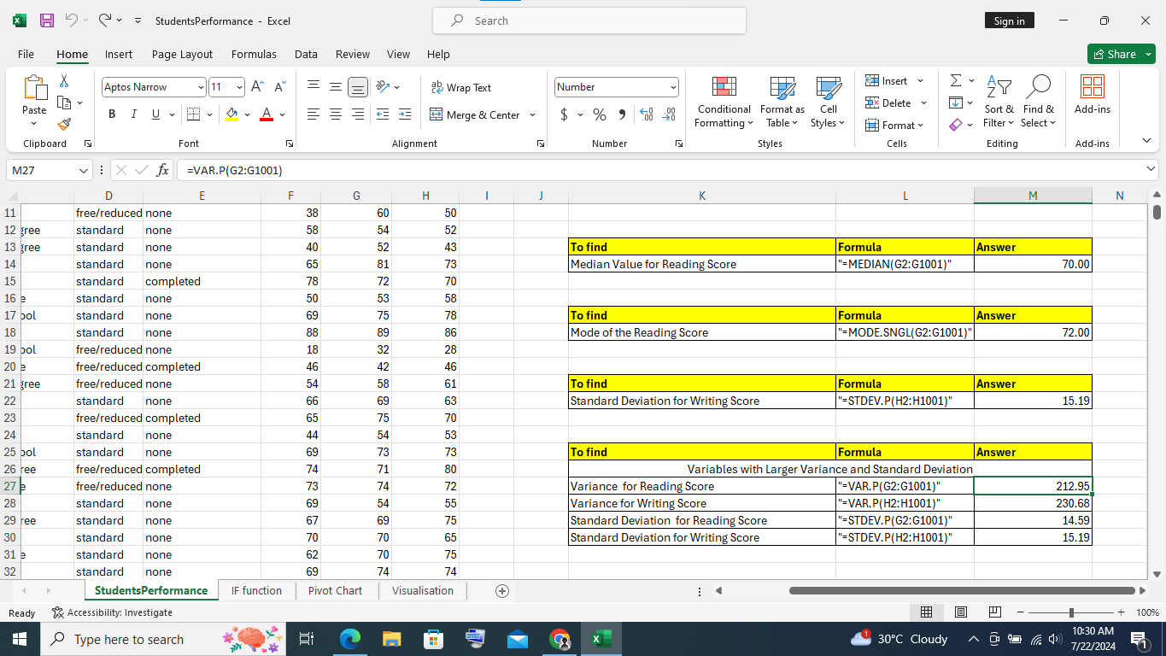
Excel Snip: 5
(Source: Learner)
It can be observed from Table 5, that the writing score has a higher variance (230.68) and the writing score also has a higher standard deviation (15.19).

1.1.6 Interpretation of Results for the last three outcome
From Excel snip 4, the calculation "=STDEV.P()" yielded the standard deviation for the writing score, which is 15.19. This suggests that there is a 15.19-point spread in writing scores around the mean. Also, evidence of the increased variability and dispersion in writing scores was provided by the writing score's larger variance (230.68). The writing score also has a larger standard deviation (15.19) when compared to other variables. Thus, based on a variety of performance levels, these measurements demonstrate that the writing scores of the students vary widely.

1.2 Data Presentation using Excel
In order to improve comprehension and decision-making, data presentation in Excel entails organising and visualising data. Excel provides a variety of chart formats, including pie, line, and bar charts to visually depict data. These parts of Excel will be used in this section for visualisation purposes.

1.2.1 Pivot Table
When analysing data, pivot tables are a very useful tool. This table is helpful in swiftly identifying patterns and trends by converting unstructured data into insightful summaries, and it will be used for the purpose of data visualisation in this case.
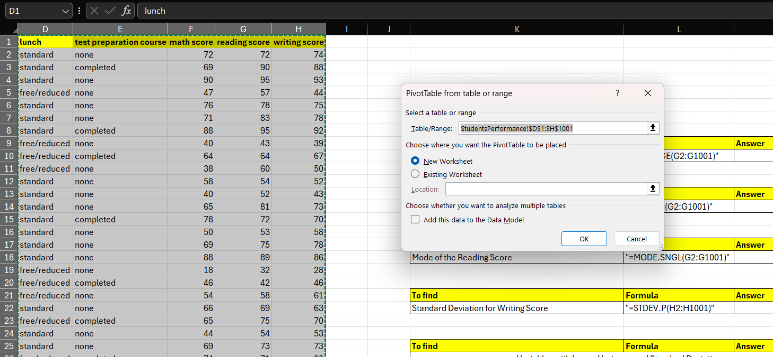
Excel Snip: 6
(Source: Learner)
It can be observed from Excel Snip 6, that for creating a pivot table, the data was selected at first. After the selection the insert ribbon was used to make a pivot table, which created a pop-up, asking to choose where the table will be placed.
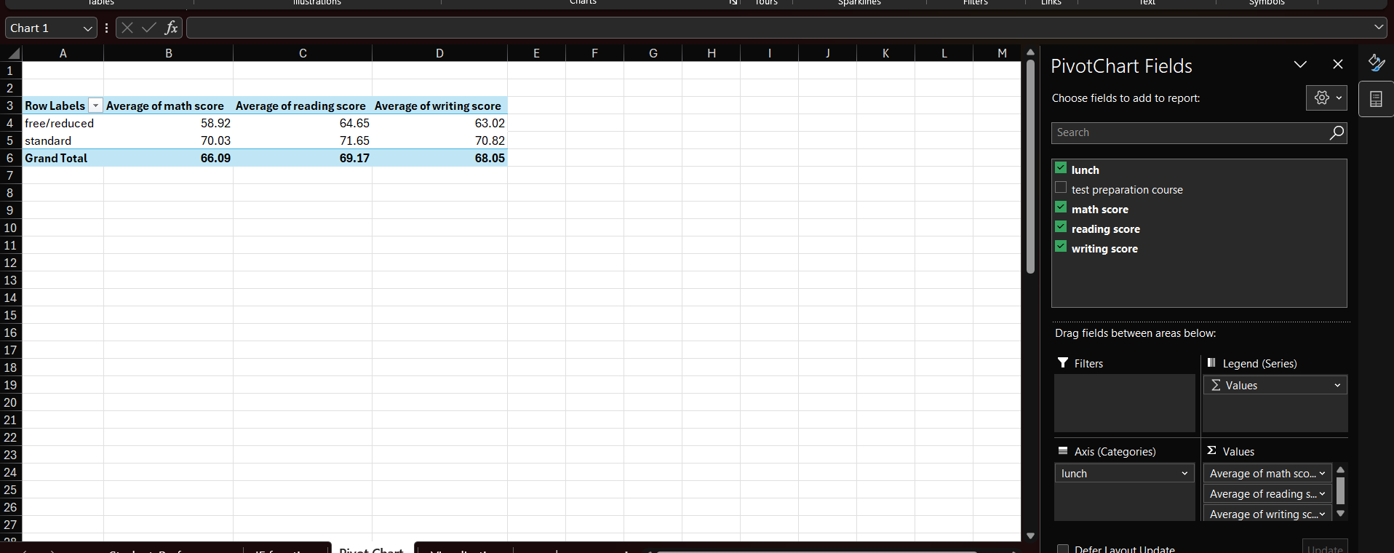
Excel Snip: 7
(Source: Learner)
On choosing a new worksheet creation for the pivot table, a new sheet was created which contains pivot chart fields. It can be observed from Excel snip 7, that the field values were changed to make the pivot table.
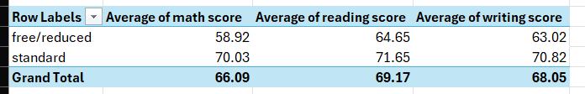
Table 1: Pivot Table With Averages of Each of Subjects With Division Of Lunch Type
(Source: Learner)
It can be observed in Table 1 that the average reading, writing, and math results for the pupils divided into lunch status categories are displayed in the table. In all three subjects—math (58.92), reading (64.65), and writing (63.02)—students who get free or reduced lunches do worse on average. Students who eat a regular lunch, on the other hand, score higher on average in maths (70.03), reading (71.65), and writing (70.82). The overall averages for all pupils are 68.05 in writing, 69.17 in reading, and 66.09 in maths. Based on average performance, these results imply that lunch status may be related to academic achievement, with kids who eat a normal lunch performing better.

1.2.2 Pivot Chart
Complex data can be visually told using pivot charts. They provide a dynamic means of perceiving connections, patterns, and trends in your data and these charts can help in simplifying complex information by graphically displaying the condensed data from pivot tables. 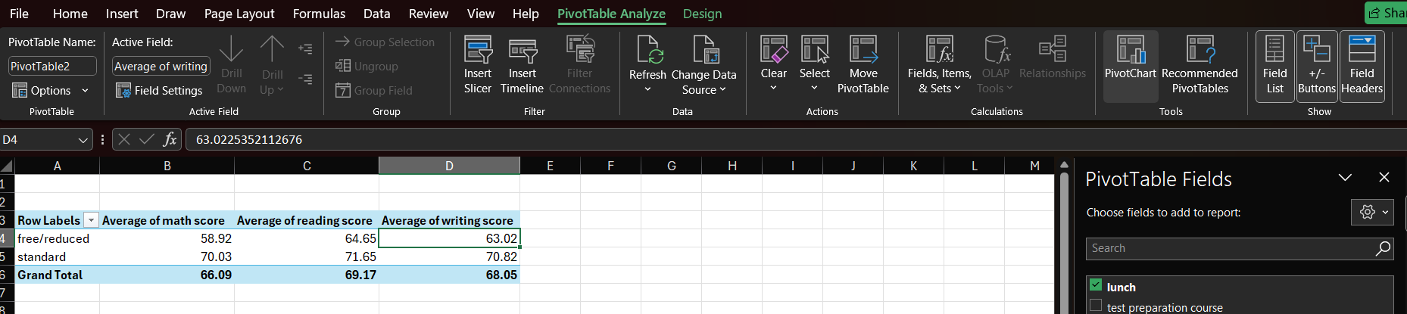
Excel Snip: 9
(Source: Learner)
It can be observed in Excel Snip 9, that the pivot chart option was used in the PivotTable analyze ribbons for making a visual for the pivot table.
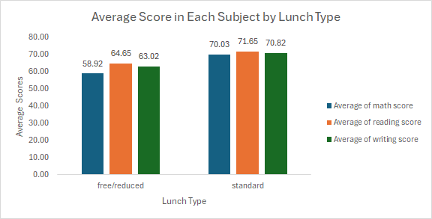
Chart 1: Average Score in Each Subject by LunchTime
(Source: Learner)
It can be observed from chart 1 that the bar graph displays the average reading, writing, and math scores for pupils divided into two lunch categories: standard and free/reduced. The average score for students who get free or reduced lunch is lower in all subjects—58.92 in math, 64.65 in reading, and 63.02 in writing. On the other hand, pupils who receive a regular meal score higher on average in every subject—math being 70.03, reading being 71.65, and writing being 70.82. This striking difference indicates that academic performance is higher for pupils on standard lunch than for those on free or reduced lunch programmes. The notable variation in average scores suggests that lunch choice and academic attainment may be related, underscoring the influence that socioeconomic conditions may have on student outcomes. The aforementioned research emphasises the significance of tackling nutritional and economic inequalities in order to promote academic achievements for every student. Thus, Chart 1 shows that students receiving standard lunch have higher average scores in math, reading, and writing compared to those on free/reduced lunch and this suggests a potential link between socioeconomic conditions and academic performance.

1.3 SPSS Analysis
One powerful program that is widely used in many different sectors for data analysis is SPSS. The principal benefits of this tool lie in its extensive collection of statistical capabilities and its intuitive interface. This tool is helpful in intricate data manipulation and analysis of that data (IBM, 2021).

1.3.1 Correlation between Writing Score and Reading Score
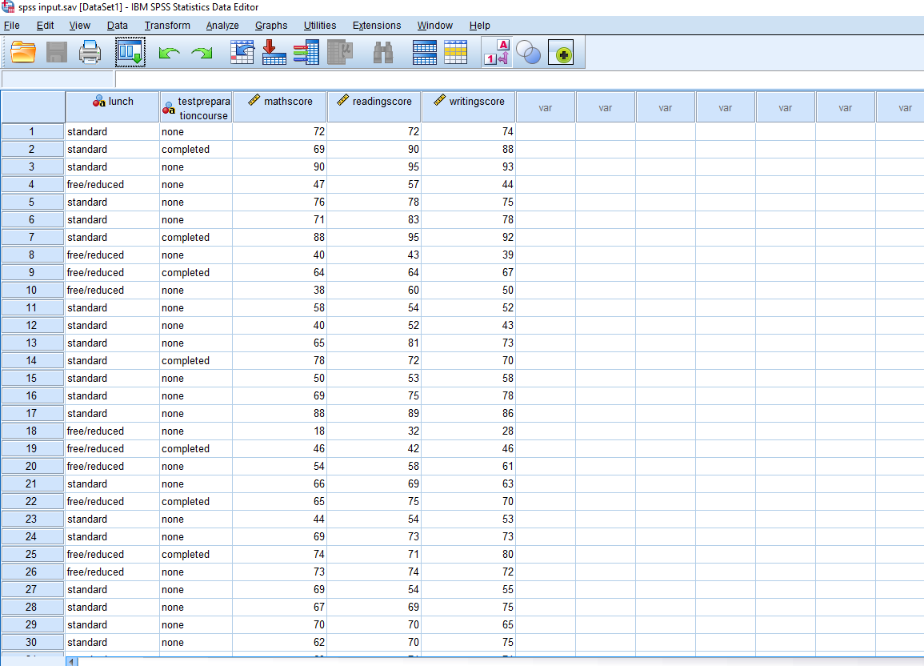
Spss Snip: 1
(Source: Learner)
It can be observed from SPSS snip 1, that for the purpose of finding the correlation between the writing score and reading score, the data was initially provided in the spss software.
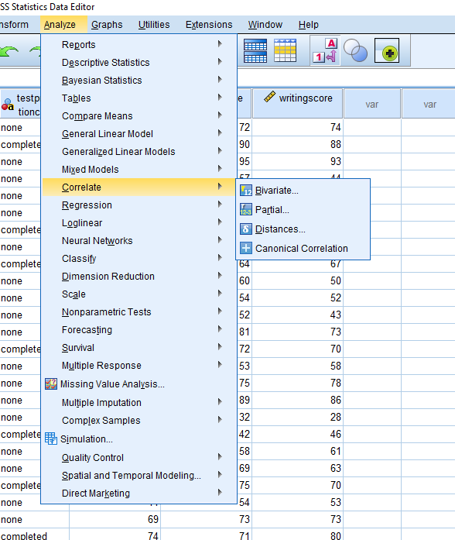
Spss Snip: 2
(Source: Learner)
It can be observed from SPSS Snip 2, that after loading the data in SPSS, the analyze menu was used in the toolbar, which presented a dropdown menu, and the correlate option was used specifically for bivariate correlation for the purpose of correlation.
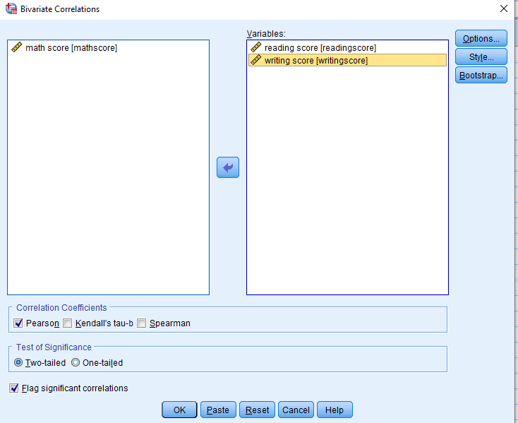
Spss Snip: 3
(Source: Learner)
This correlate option presented a popup which asked for the variables to be analysed, as can be observed in SPSS snip 3.
Correlations
 |  | reading score | writing score
reading score | Pearson Correlation | 1 | .955**
reading score | Sig. (2-tailed) |  | .000
reading score | N | 1000 | 1000
writing score | Pearson Correlation | .955** | 1
writing score | Sig. (2-tailed) | .000
writing score | N | 1000 | 1000
**. Correlation is significant at the 0.01 level (2-tailed).
Table 2: Correlation Table
(Source: Learner)
It can be observed from Table 2 that the correlation table, which displays a Pearson correlation coefficient of 0.955, demonstrates a high positive association between reading and writing scores. This value, which is very near to 1, shows that the two variables have a very strong linear connection. The statistical significance of the association is confirmed by the significance level (Sig.) of 0.000, which is significantly less than the 0.01 threshold. This implies that writing scores typically rise in tandem with increases in reading scores, and vice versa. With 1000 samples for each of the two variables, the correlation finding is guaranteed to be robust. Thus, table 2 shows a Pearson correlation coefficient of 0.955, indicating a strong positive relationship between reading and writing scores, and along with this, the significance level of 0.000 confirms this association is statistically significant.

1.3.2 Scatterplot Analysis
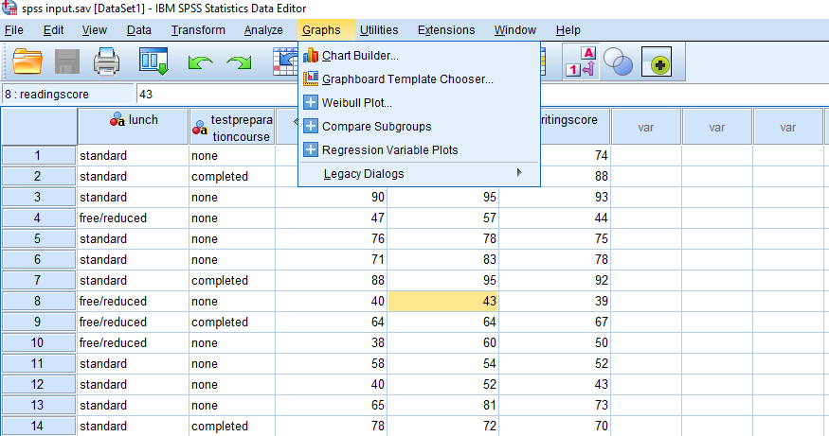
Spss Snip: 5
(Source: Learner)
In this case, the graph menu was used as can be observed in the SPSS Snip 5, and then the chart builder option was used for making the required plot.
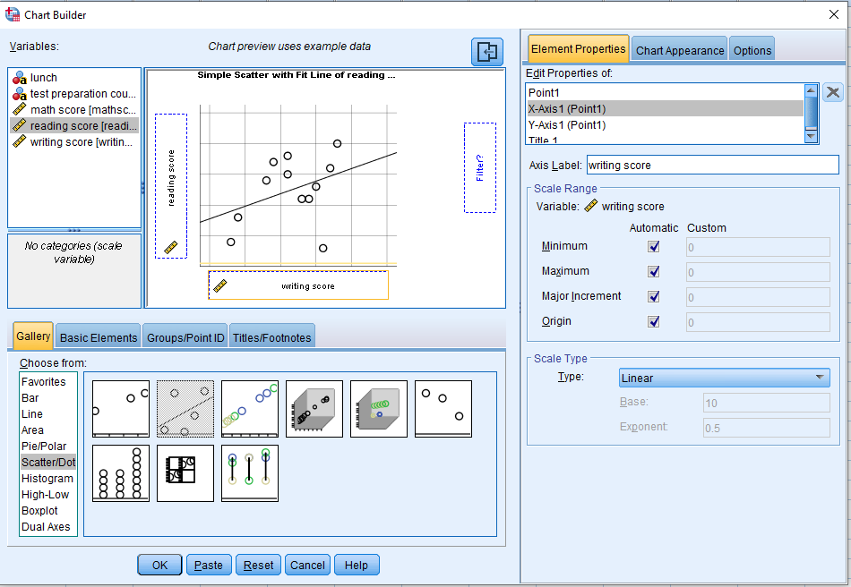
Spss Snip: 6
(Source: Learner)
Then from the gallery, the scatter plot with line was used, as observed in SPSS Snip 6, and the variable writing score was on the x-axis and the variable reading score was used on the y-axis.
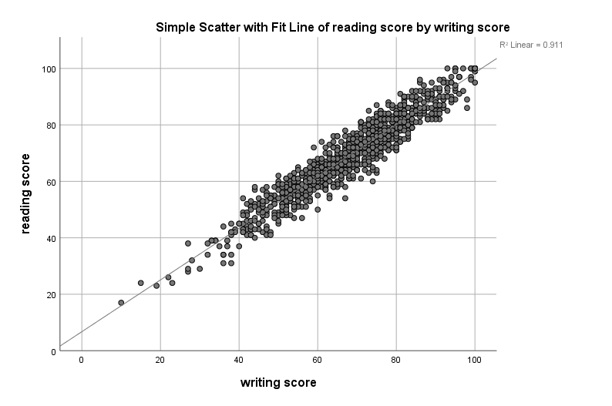
Chart 2: Scatterplot for Reading Score and Writing Score
(Source: Learner)
It can be observed in chart 2, that writing and reading scores show a favourable association, as seen by the scatter plot. greater writing scores tend to correlate with greater reading scores, as indicated by the data points clustering around an upward-sloping line. The correlation coefficient (R²) of 0.911 indicates that the intensity of this link is significant. The two factors appear to have a strong positive association based on this. It is important to recognise the variety within the data, even while the main trend is clear. Not every student who does well on writing assessments also does well on reading assessments. However, there is a strong positive correlation shown by the dominant pattern. Reading and writing skills are linked, indicating that mastery of one ability frequently precedes mastery of the other, according to interpretations of this fact. On the other hand, pupils who have trouble writing could also have trouble reading. Therefore, it is imperative that educational establishments give precedence to the enhancement of writing and reading proficiencies. Thus, chart 2, shows a strong positive correlation between the two variables, reading score and writing score, with an R^2 of 0.911, and this suggests that mastery in one often predicts mastery in the other.

1.4 Conclusion for the Analysis
There are several important conclusions from the study of coffee drinking and how it affects the performance of the students. The information shows that students who eat a standard meal outperform those who receive free or reduced lunches on average in all disciplines, including arithmetic, reading, and writing. This implies that a person's nutritional state might affect their intellectual achievement. The statistical analysis also reveals a significant degree of positive correlation (Pearson coefficient of 0.955) between writing and reading scores, suggesting that gains in one domain are probably related to gains in the other. The scatterplot analysis backs this up, showing a distinct rising trend in the scores. Thus, the results highlight the significance of tackling dietary inequalities and emphasising the development of reading and writing abilities to raise academic attainment as a whole, in addition to this, to encourage higher student results, future interventions should focus on addressing these dietary and educational demands.

Part 2 Discussion on Software Tools

2.1 Advantages and Disadvantages of SPSS, Excel, and Tableau
All three tools, in this case, Excel, Spss and Tableau can help in the analysis of the data for the company, but each has its own advantages and disadvantages. Academic research and complicated data analysis benefit greatly from the powerful statistical analysis features provided by SPSS (Statistical Package for the Social Sciences). The point-and-click feature of its interface makes it easy to use, especially for people with basic statistical understanding (IBM, 2021). Strong data management tools are another quality that SPSS offers; it can handle huge datasets with efficiency and supports a variety of data formats for import/export compatibility (Jackson, 2023). However, SPSS has high licensing costs, which can be prohibitive for small businesses or lone researchers, in addition to this, though SPSS has an intuitive interface, it takes a lot of training and experience to fully utilise all of its features. Moreover, SPSS offers fewer customisation choices for visual outputs than Tableau, making it less adaptable in data visualisation. Comparatively, Tableau outperforms SPSS in data visualisation skills, while Excel is more adaptable and accessible for simple data tasks. However, SPSS is superior in complex statistical operations and dependability. Thus, although the spss software is very effective in statistical analysis, it has its disadvantages, such that the licencing cost of the software is too high and this can bring difficulties in small businesses.
Excel, on the other hand, is a popular tool for basic data analysis and visualisation activities because it is generally available, in addition to this, its adaptability facilitates a range of tasks, such as data management, basic statistical analysis, and visualisation. It can handle different kinds of data and guarantee interoperability with a wide range of data sources (Microsoft, 2021). Excel, as part of the Microsoft Office suite, is reasonably priced, especially for businesses that currently use Microsoft products. But when dealing with really huge datasets, Excel can frequently become unresponsive or sluggish, which makes it unsuitable for intensive big data analytics. Although Excel is capable of basic statistical analysis, it is not equipped with advanced statistical tools that are included in specialised software such as SPSS. Also, compared to Tableau, the data visualisation capabilities of Excel are more constrained, lacking sophisticated features and interactive dashboards. The cost-effectiveness of Excel and its versatility are matched by neither the superior visualisation tools of Tableau nor by the depth of statistical analysis which can be done in SPSS.
The third tool, Tableau, is very effective in making visualisations with the help of data. With its wide range of choices for building dynamic and interactive visualisations, Tableau excels in data visualisation. Users may create complex dashboards that improve data interpretation (Tableau, 2021). The user-friendly drag-and-drop interface of this tool allows even non-technical people to explore data quickly and effectively (www.datacamp.com, 2023). Apart from these, the tool also easily interfaces with a wide range of data sources, such as databases, spreadsheets, and cloud services, increasing its adaptability and usefulness. However, small enterprises or individual users may be discouraged by Tableau's hefty licensing fees and premium nature. While learning the fundamental functions is simple, gaining proficiency with additional features and designing intricate visualisations calls for extensive training, which demands more resources from the business management, and this can be a problem for resource-starved businesses. Furthermore, unlike programmes like SPSS, Tableau is essentially a visualisation tool and does not have the same extensive statistical analysis features. While Tableau interacts effectively with multiple data sources, it lacks the extensive statistical tools that SPSS offers. In comparison to Excel, Tableau delivers superior data visualisation, but at a higher cost. Thus, Tableau excels in the visualisation of data, and this tool is also helpful in creating interactive dashboards, it also has the benefit that it can take data from various sources, but the drawback of this tool is that it has a high cost with less statistical features than SPSS.

2.2 Data Mining Cycle
Data mining can be very helpful in synthesising the insights gained from data. The process of identifying valuable patterns, connections, and insights from massive datasets through iterative analysis is called the Data Mining Cycle (Twin, 2023). The conversion of unprocessed data into meaningful information and useful knowledge depends critically on this cycle. Data collection, preprocessing, exploration, evaluation of patterns, and knowledge representation are the main phases of the data mining cycle. In the phase of data collection, pertinent information from a range of sources is calculated, including external datasets, databases, and data warehouses. Good data collection guarantees the availability of thorough and high-quality data, both of which are essential for further analysis (Kumar, 2022). Then, in the phase of data preprocessing, after being gathered, data is cleaned up and made ready for analysis. This phase is crucial to enhance data quality and remove any potential biases that can influence the analysis (Buhl, 2023). Preprocessing could entail, for example, normalising patient data in a healthcare study to guarantee consistency between records. Thus, the concept of the data mining cycle consists of many phases, also, it can be very effective in accurately analysing large datasets, which can be very important for collecting knowledge from the data.
In the state of data exploration, the underlying patterns and features of the data are understood through the application of exploratory data analysis (EDA) methodologies. In the next phase of the evaluation of Patterns, data mining techniques are used to find patterns, correlations, and connections in the data. Clustering, classification, regression analysis, association rule mining, and other techniques are frequently employed (IBM, 2023). For example, association rule mining in market basket research can identify products that customers often buy together, which aids businesses in streamlining their inventory and advertising plans. The last phase of knowledge presentation entails putting the knowledge that has been found into an understandable and useful shape. Effective stakeholder communication involves the use of dashboards, reports, and visualisation tools. A business intelligence report, for instance, can include an overview of consumer segmentation data, emphasising important demographics and preferences to guide marketing initiatives that are specifically targeted. The Data Mining Cycle is valuable because it can reveal trends and insights that help make well-informed decisions (IBM, 2023). Organisations may learn more about their markets, consumers, and operations by methodically processing and analysing big datasets. Thus, this cycle also involves the exploration of data with the help of EDA, so that the patterns can be explored, and the techniques of clustering are used to uncover important findings, which are presented with the help of reports.

2.3 Conclusion for the Discussion
To sum up, Each software program that was discussed in this report, Tableau, Excel, and SPSS, has particular benefits and drawbacks when it comes to data analysis. Although SPSS has a steep learning curve and expensive licensing, it excels in advanced statistical analysis and data management. For simple data jobs, Excel is flexible and easy to use. However, it becomes difficult to handle enormous datasets and does not have sophisticated statistical or visualisation features. Tableau is notable for its interactive dashboards and strong data visualisation, although it is more expensive and does not have as many statistical tools as SPSS. Through steps including data collection, preprocessing, exploration, pattern evaluation, and knowledge representation, the Data Mining Cycle methodically transforms raw data into usable insights, complementing these technologies. In order to identify patterns of decision-making in a variety of industries, this cycle is essential.

References
Buhl, N. (2023). Mastering Data Cleaning & Data Preprocessing for Machine Learning. [online] encord.com. Available at: https://encord.com/blog/data-cleaning-data-preprocessing/.
IBM (2021). User Experience - IBM SPSS Statistics. [online] www.ibm.com. Available at: https://www.ibm.com/products/spss-statistics/user-experience [Accessed 13 Jul. 2024].
IBM (2023). What is Data Mining? | IBM. [online] www.ibm.com. Available at: https://www.ibm.com/topics/data-mining.
Jackson, C. (2023). Getting Started with SPSS: A Comprehensive Guide. [online] Onthehub.com. Available at: https://onthehub.com/blog/getting-started-with-spss-a-comprehensive-guide.
Kumar, A. (2022). How to Choose the Best Data Collection Methods and What are They? [online] Emeritus Online Courses. Available at: https://emeritus.org/blog/data-science-data-collection-methods/.
Microsoft (2021). Using access or excel to manage your data. [online] support.microsoft.com. Available at: https://support.microsoft.com/en-us/office/using-access-or-excel-to-manage-your-data-09576147-47d1-4c6f-9312-e825227fcaea.
Tableau (2021). What Is Data Visualization? Definition, Examples, And Learning Resources. [online] Tableau Software. Available at: https://www.tableau.com/learn/articles/data-visualization.
Twin, A. (2023). Data Mining: How Companies Use Data to Find Useful Patterns and Trends. [online] Investopedia. Available at: https://www.investopedia.com/terms/d/datamining.asp.
www.datacamp.com. (2023). What is Tableau - The Complete Guide to Tableau. [online] Available at: https://www.datacamp.com/blog/all-about-tableau.

