DS 1 Template

My Screenshots/Photos

Screenshot/Photo 1
Microsoft Outlook calendar
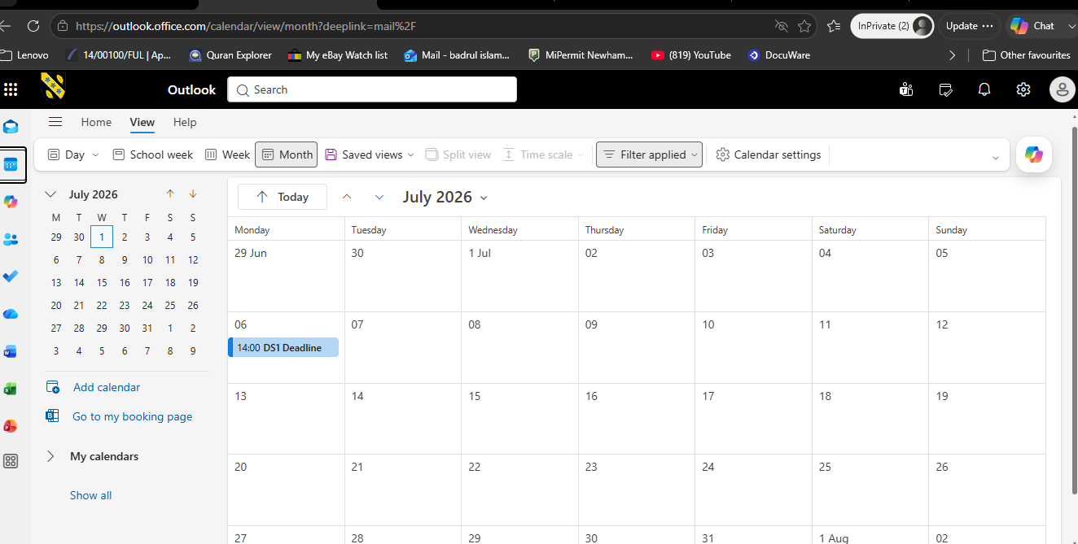

I have used Microsoft Outlook Calendar to set up the deadline reminder a day before.

Screenshot/Photo 2
YouTube
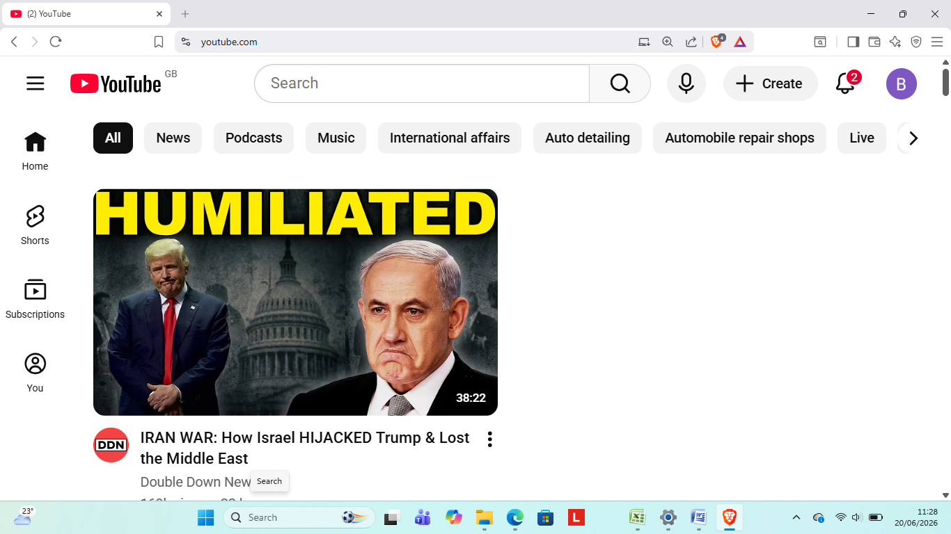
I used YouTube to catch up on current news
]

Screenshot/Photo 3
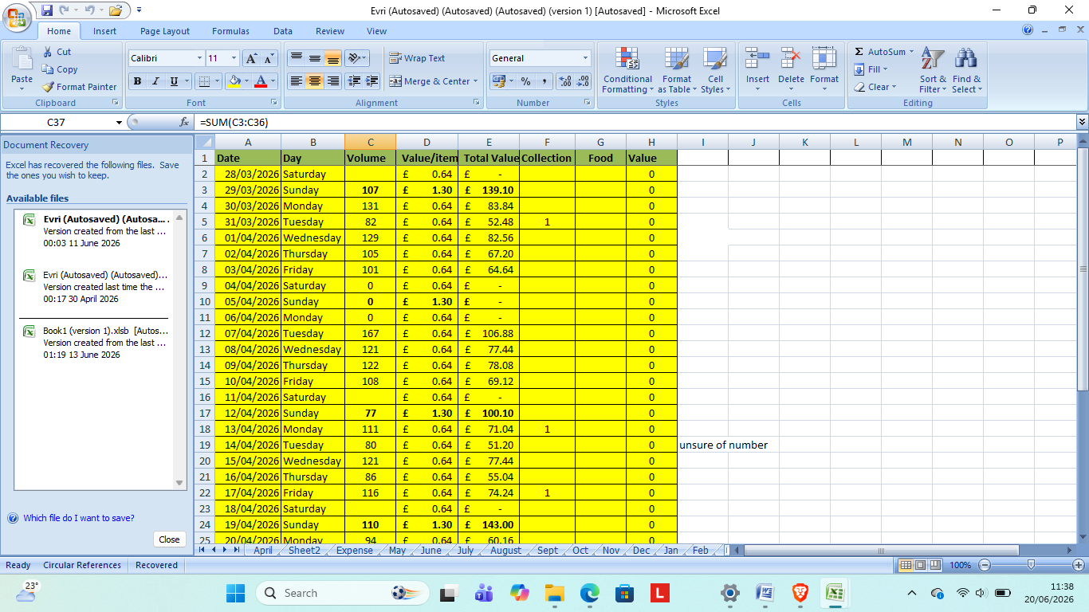I use Excel Spreadsheet to keep a record of my work

Screenshot/Photo 4
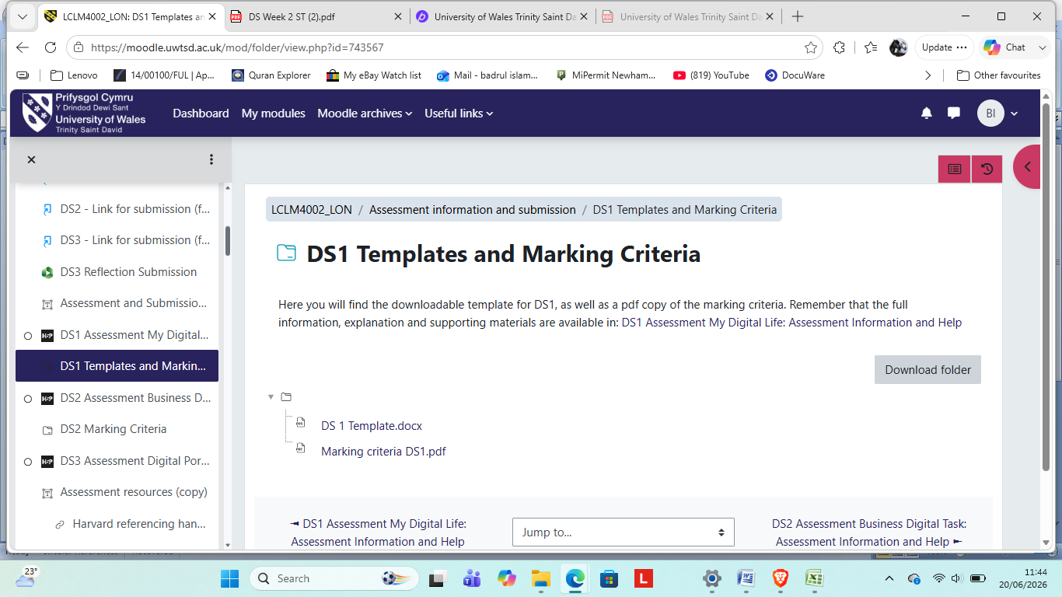
I use Moodle for all my course work

Screenshot/Photo 5
[Insert Photo/Screenshot below]

[Write what this shows of your digital life]

Screenshot/Photo 6
[Insert Photo/Screenshot below]
[Write what this shows of your digital life]

My Short Reflection
- Write 5–8 simple sentences about your digital life.
- You can use the sentence starters below if helpful.

Sentence starters
- I use digital tools to …
- I feel confident when I …
- I want to improve …
- I often use these tools: …
- I sometimes feel nervous about …
- I hope this module will help me …
- Digital skills are important for me because …
You can write more if you want.

Submission Checklist
Before you submit, please check:
​​​ ☐ I added 4–6 screenshots
☐ I wrote short sentences for each screenshot
☐ I wrote my short reflection
☐ My work is my own
☐ My file opens correctly
​​☐ My file opens correctly

